B2B SaaS Customer Retention & Churn Analysis
Data Analytics Portfolio Project | Author: Mukteswar Nayak
Tools Used: MySQL Workbench, Power BI, DAX, Power Query, Excel
Project Overview & Business Goal
In B2B SaaS companies, retaining existing customers is essential because acquiring a new customer is significantly more expensive. In this portfolio project, I analyzed customer retention and churn for a B2B SaaS company managing 1,200 commercial accounts and $971.4K in Monthly Recurring Revenue (MRR). My goal was to identify where the company is losing revenue, find the operational causes behind customer cancellations, and recommend simple, high-impact fixes.

Datasets Used
The project uses 5 relational datasets totaling over 43,000 records:
- 1. accounts.csv (1,200 rows): Company metadata including account ID, company name, industry, country, employee count, plan tier, and company size.
- 2. subscriptions.csv (1,200 rows): Contract data tracking contracted seats, status (active, churned, past_due), monthly recurring revenue (mrr), start/end dates, and churn flags.
- 3. invoices.csv (14,500 rows): Billing records containing invoice amount, invoice date, payment status (paid, open, void, uncollectible), and unpaid flags.
- 4. support_tickets.csv (5,600 rows): Customer support tickets containing issue category, priority (urgent, high, normal, low), resolution hours, CSAT satisfaction score, and ticket status.
- 5. users.csv (21,884 rows): Provisioned user accounts mapped to each company, tracking active user adoption and organizational roles (Admin, Member, Viewer).

Data Architecture & Star Schema Model
I worked with 5 relational CSV files containing over 43,000 records. Using Power Query, I cleaned the datasets, handled nulls, and verified data types before building an optimized Star Schema in Power BI.
Table Name | Rows | Key Fields | Role in Model
accounts.csv | 1,200 | account_id, company_name, industry, plan, company_size | Dimension Table (Company Details)
subscriptions.csv | 1,200 | subscription_id, account_id, seats, mrr, status, is_churned | Fact Table (MRR & Churn Flags)
invoices.csv | 14,500 | invoice_id, account_id, amount, status, is_unpaid | Fact Table (Billing & Collections)
support_tickets.csv | 5,600 | ticket_id, account_id, category, priority, resolution_hours, csat | Fact Table (Support SLA & CSAT)
users.csv | 21,884 | user_id, account_id, role, is_active | Dimension Table (User Adoption)

Power BI Data Model
To make DAX measures run fast and prevent circular relationship errors, I linked Dimension tables to Fact tables using 1-to-many (1:*) relationships, centered around a dedicated Date dimension.
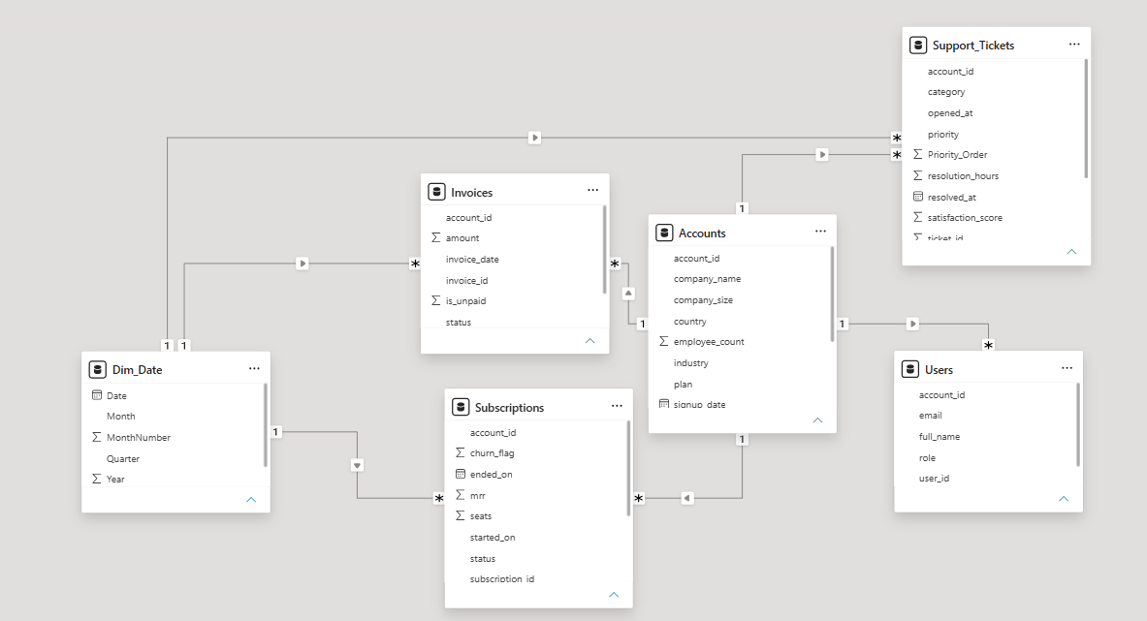
Figure 1: Power BI Star Schema Data Model showing 1-to-many relationships across Fact and Dimension tables
Part 1: Executive Revenue Retention & Churn Overview (Dashboard Page 1)
Page 1 Key Performance Indicators (KPIs)
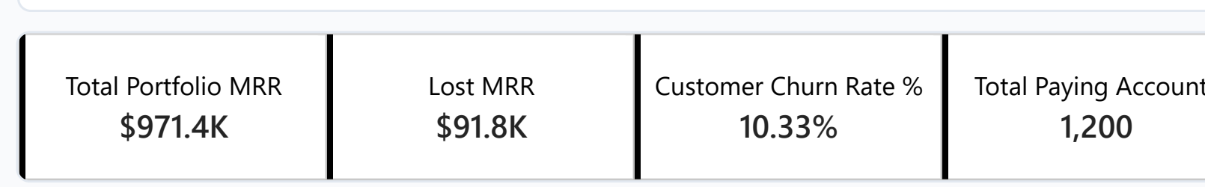
Figure 1: Page 1 Executive Retention KPI Summary
- Total Portfolio MRR ($971.4K): Total monthly recurring revenue generated across all 1,200 customer accounts.
- Lost MRR ($91.8K): Total monthly revenue lost due to cancelled accounts ($58.5K) and at-risk delinquent accounts ($33.3K).
- Customer Churn Rate % (10.33%): The overall percentage of customer accounts that cancelled their subscription (124 churned accounts out of 1,200).
- Total Paying Accounts (1,200): Total active and historical customer accounts managed in the portfolio.

Business Questions Solved (Page 1)

Business Question 1: Which subscription plan tier drives our revenue, and where is lost revenue concentrated?
- Answer: The Business and Growth tiers generate 68.6% of our revenue. However, financial churn losses are heavily concentrated in these same higher tiers ($36.8K lost across Business and Enterprise). Starter plan accounts represent nearly half of our customers, but their revenue loss is very small ($2.9K).
- Proof: Business ($431.3K active / $21.8K lost), Growth ($235.7K active / $18.8K lost), Enterprise ($184.1K active / $15.0K lost), Starter ($28.5K active / $2.9K lost).
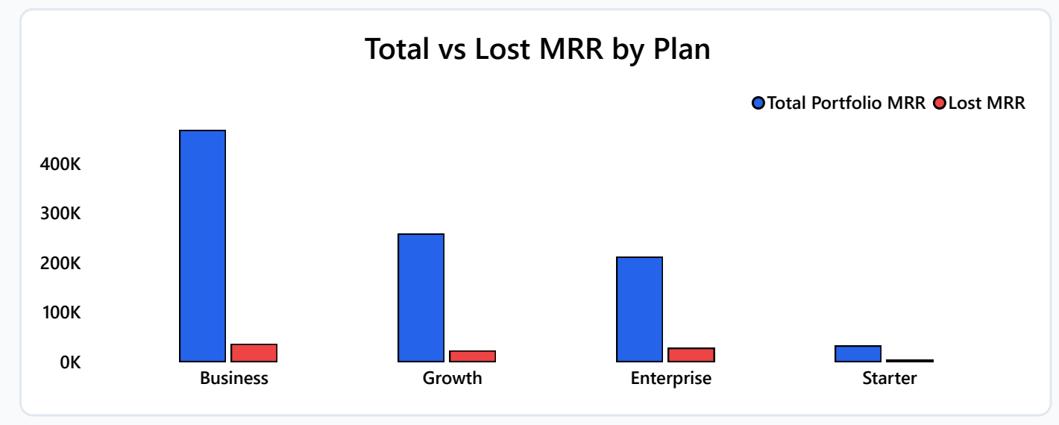

Chart 1: Total vs. Lost MRR by Subscription Plan

Business Question 2: What percentage of our recurring revenue is safe versus at risk of payment failure?
- Answer: 90.55% ($880K) of our MRR is secured from active paying accounts. 6.03% ($59K) has permanently churned. Crucially, 3.43% ($33.3K) sits in Past Due status—these are active customers whose payment failed and will cancel within 30 days if not recovered.
- Proof: Active: $880K (90.55%) | Churned: $59K (6.03%) | Past Due: $33K (3.43%) | Total: $971K.

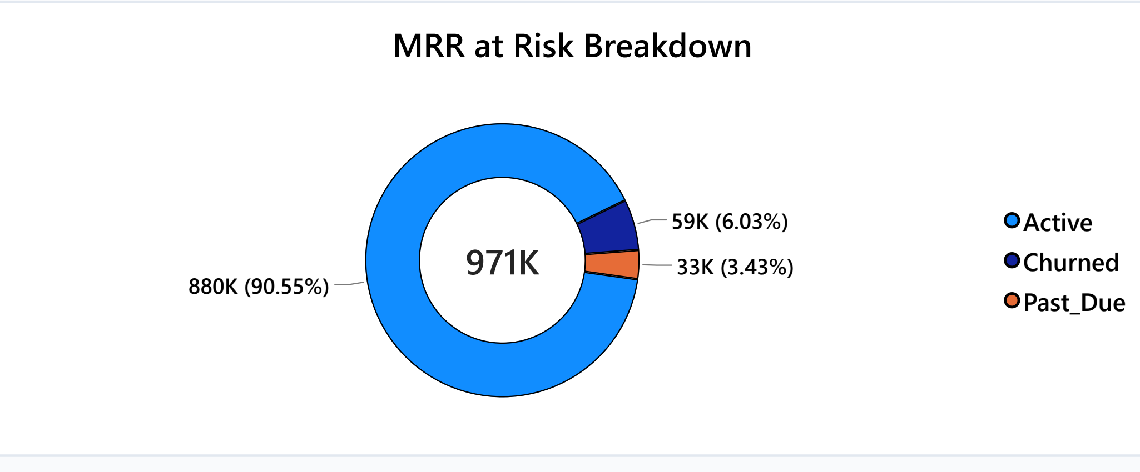
Chart 2: MRR at Risk Breakdown Donut Chart

Business Question 3: Which customer industries suffer from the highest customer account churn rates?
- Answer: Retail (12.8%) and Healthcare (11.9%) have the highest cancellation rates, well above the 10.33% company average. Education (8.0%) and Financial Services (8.9%) are our most stable industries.
- Proof: Retail: 12.8% | Healthcare: 11.9% | Software: 10.5% | Manufacturing: 9.8% | Logistics: 8.9% | Financial Services: 8.9% | Education: 8.0%.
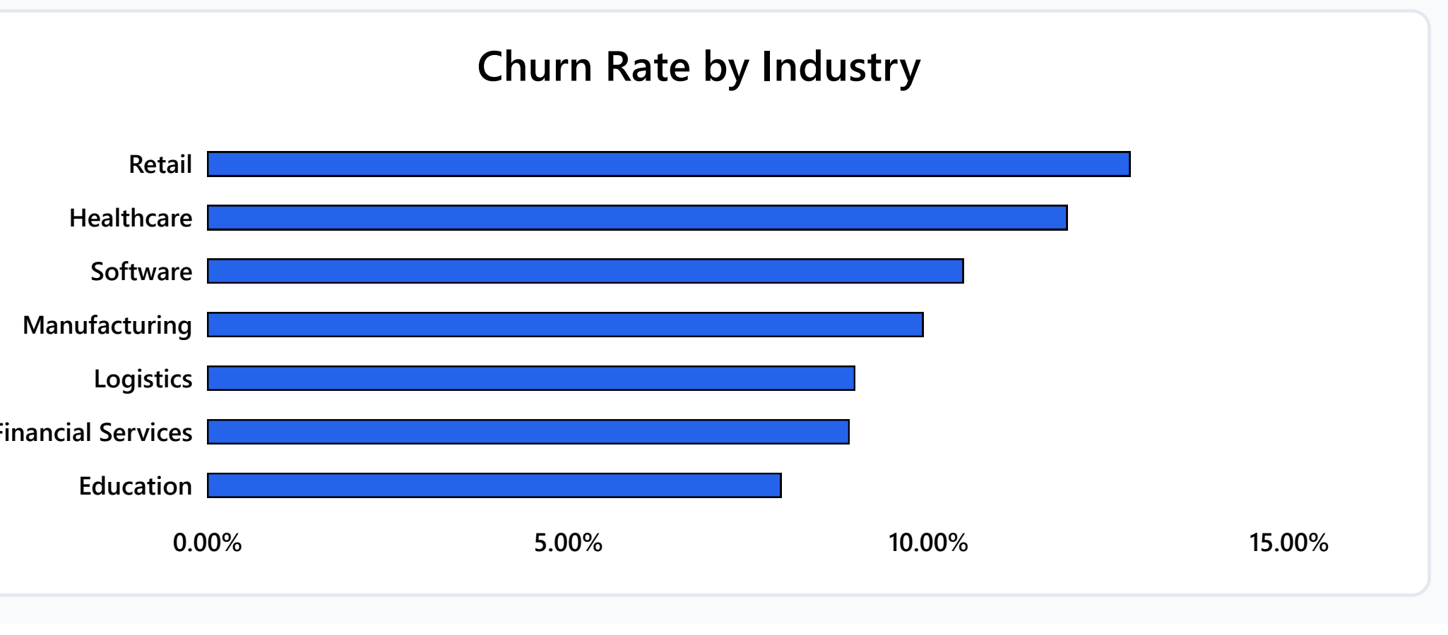
Chart 3: Customer Churn Rate % by Industry

Business Question 4: Which industry drives the largest financial revenue loss?
- Answer: Even though Retail has the highest account churn percentage, Software drives the biggest dollar loss by far (~$35K lost MRR), mostly from Enterprise and Business tiers. Retail accounts for only ~$14K in lost MRR.
- Proof: Software: ~$35K lost MRR | Manufacturing: ~$16K | Retail: ~$14K | Healthcare: ~$11K | Education: ~$8K | Financial Services: ~$7.5K | Logistics: ~$1.5K.

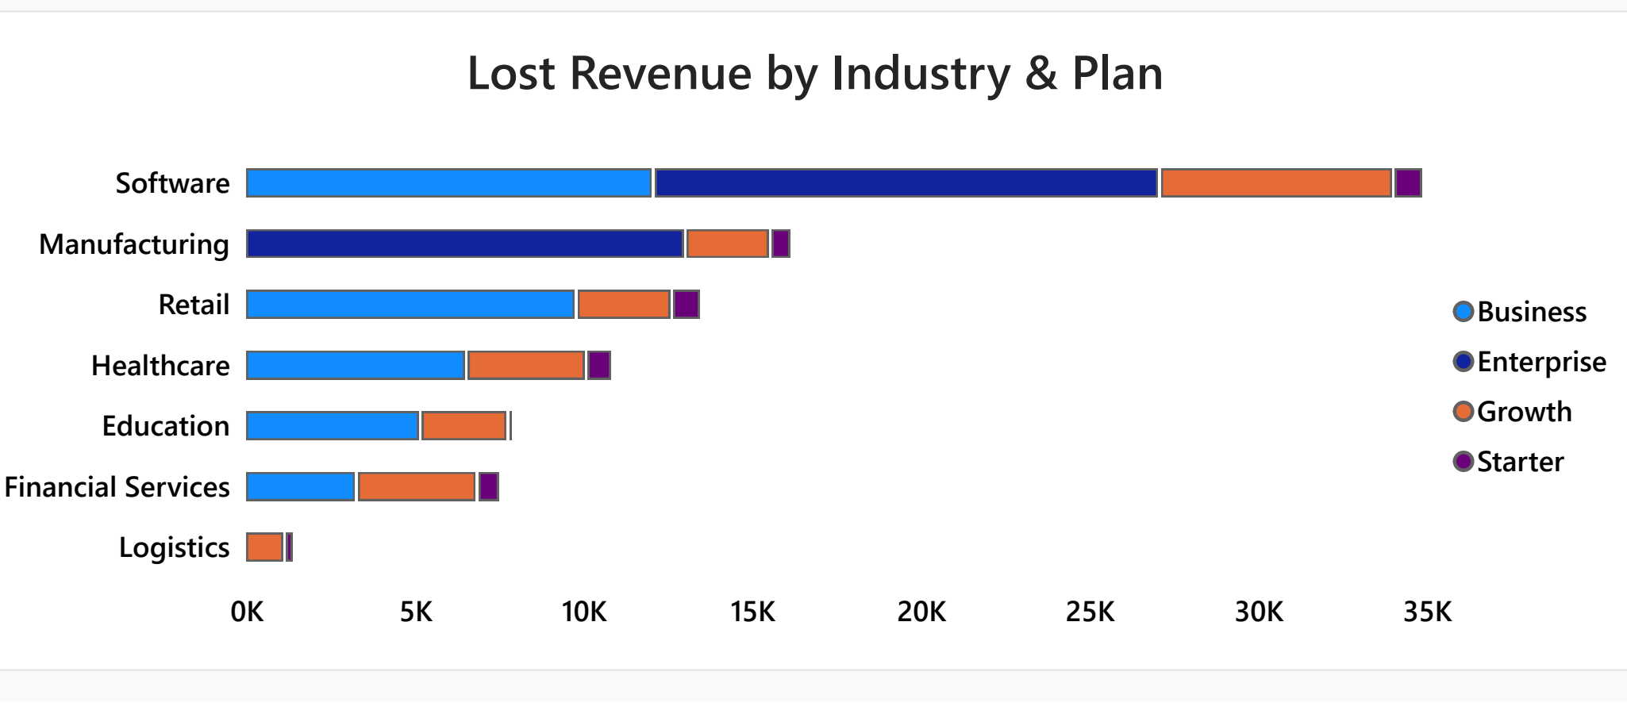
Chart 4: Lost Revenue by Industry and Plan

Part 2: Customer Health & Operational Risk Diagnostics (Dashboard Page 2)
Page 2 Key Performance Indicators (KPIs)
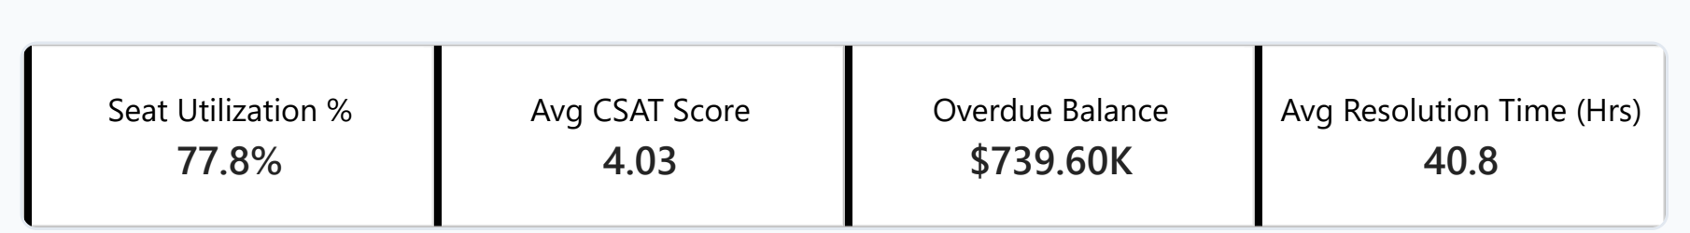
Figure 2: Page 2 Operational Health Diagnostic KPI Summary
- Seat Utilization % (77.8%): Average percentage of purchased software licenses that are actively assigned to employees across all accounts.
- Avg CSAT Score (4.03 / 5.0): Average customer satisfaction rating across 5,600 support tickets, measuring customer sentiment.
- Overdue Balance ($739.60K): Total unpaid invoice balance from open accounts, excluding cancelled void invoices.
- Avg Resolution Time (40.8 Hours): Average time taken by our support team to solve and close customer support tickets.

Business Questions Solved (Page 2)

Business Question 5: What support issue categories generate the highest volume of critical complaints?
- Answer: Integrations creates the highest ticket volume and the most urgent escalations, followed by Bug Reports. Billing issues take the longest time to solve (42.8 hrs) and have the lowest customer satisfaction (3.96 CSAT).
- Proof: Integrations: 1,171 tickets (101 urgent) | Bug Reports: 1,046 tickets (76 urgent) | Billing: 906 tickets (lowest CSAT: 3.96, slowest: 42.8 hrs).

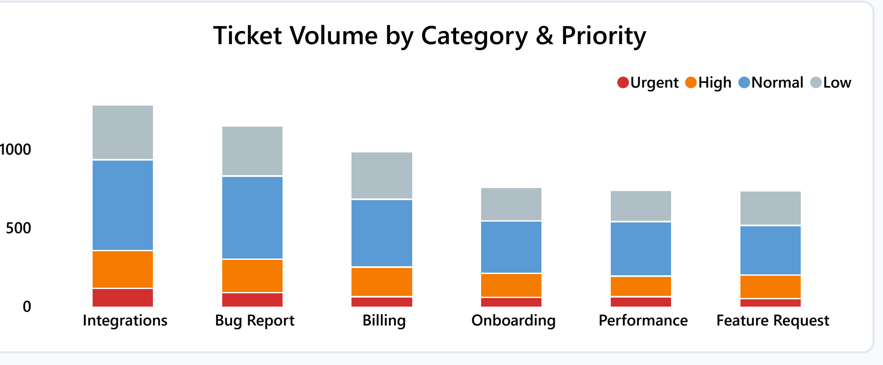
Chart 5: Support Ticket Volume by Issue Category and Priority Level

Business Question 6: Where is our $739.6K overdue invoice balance concentrated?
- Answer: Overdue debt is heavily concentrated in Enterprise companies (70.9% / $524.35K). Small companies owe only $22.52K. This proves non-payment is caused by enterprise procurement and billing cycle delays, not business insolvency.
- Proof: Enterprise: $524.35K overdue (157 invoices, avg $3,339) | Mid-Market: $192.73K (342 invoices, avg $563) | Small: $22.52K (335 invoices, avg $67). Total: $739.60K.

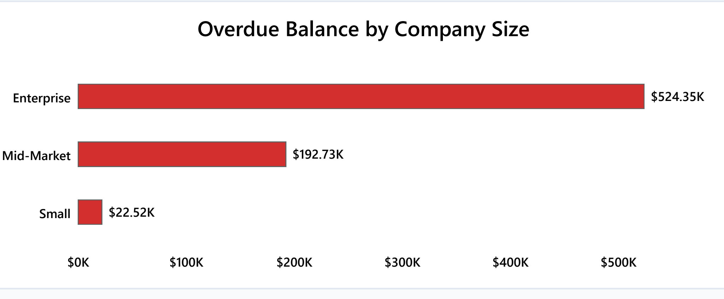
Chart 6: Overdue Balance by Company Size

Business Question 7: What percentage of support tickets are resolved versus open in the backlog?
- Answer: Our support team has successfully resolved 91.59% of all customer tickets, with 8.41% remaining open in the active queue. Keeping open tickets low is vital because tickets open over 48 hours cause CSAT to drop sharply.
- Proof: Resolved Tickets: 91.59% | Open Tickets in Queue: 8.41% | Total Tickets: 5,600.
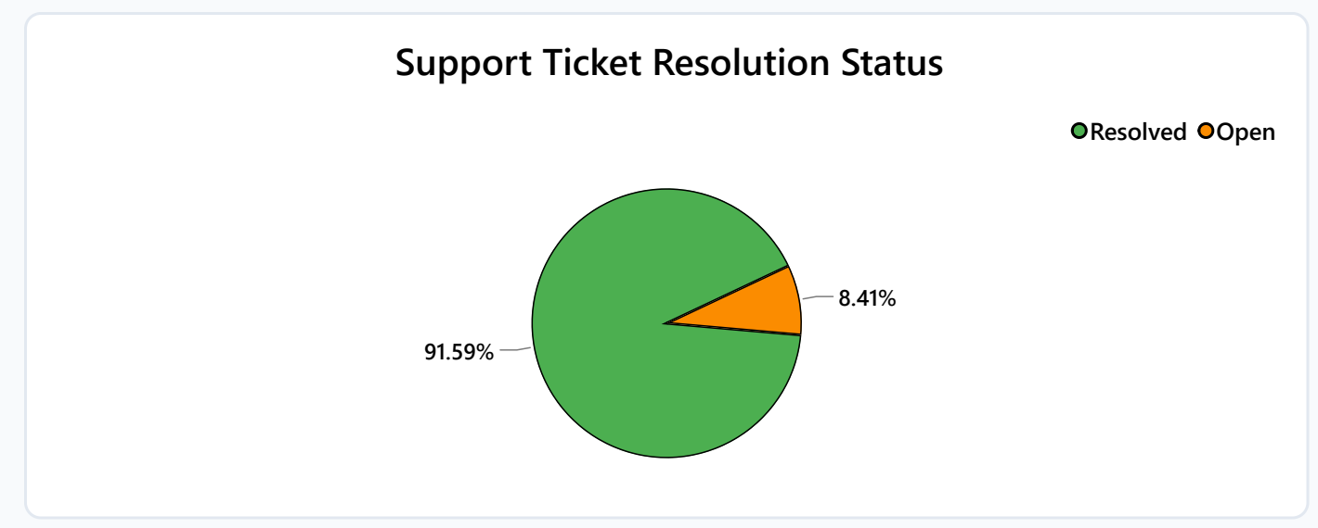
Chart 7: Support Ticket Resolution Status

Business Question 8: Are customers actively using the software licenses they purchased across each plan tier?
- Answer: Seat utilization is high across all plan tiers (Business 84.7%, Starter 82.3%, Enterprise 80.2%, Growth 78.6%). However, SQL queries revealed that smaller companies hit a low adoption floor of 50.0% (buying 2 to 6 seats but only using half), putting them at risk of downgrading.
- Proof: Business: 84.7% | Starter: 82.3% | Enterprise: 80.2% | Growth: 78.6% | Overall Average: 77.8%.

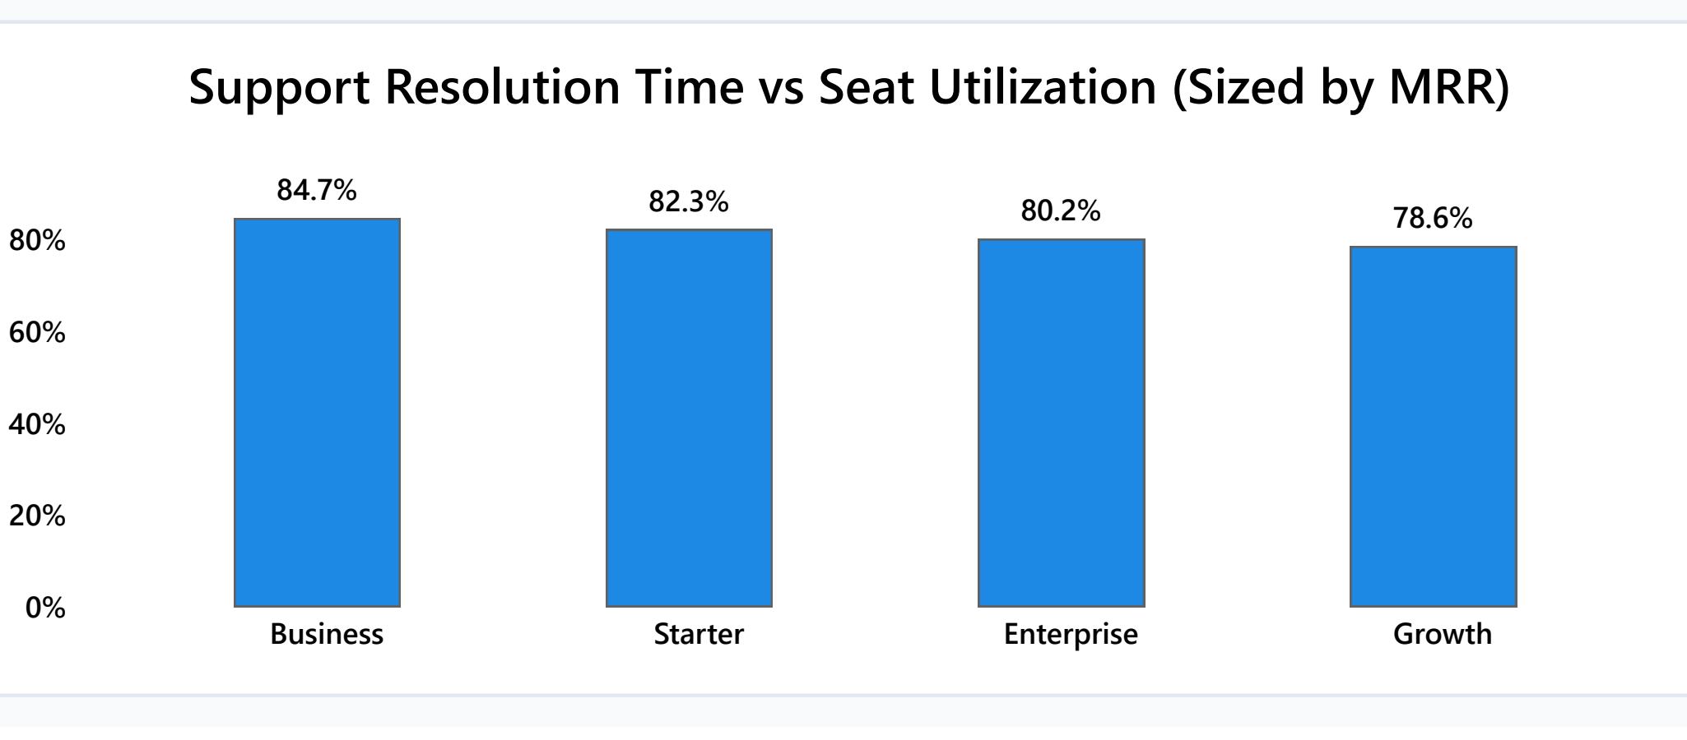
Chart 8: Seat Utilization by Subscription Plan

SQL Query Validation & Verification
As a data analyst, I believe in verifying numbers directly in the database. I wrote 5 MySQL queries in MySQL Workbench to validate every KPI card and chart shown on the Power BI dashboard.
Script 01: Revenue and Churn by Plan (Validates Chart 1)
SELECT
a.plan,
COUNT(s.account_id) AS total_accounts,
SUM(CASE WHEN s.status = 'active' THEN s.mrr ELSE 0 END) AS active_mrr,
SUM(CASE WHEN s.is_churned = 1 THEN s.mrr ELSE 0 END) AS lost_mrr,
ROUND(100.0 * SUM(CASE WHEN s.is_churned = 1 THEN 1 ELSE 0 END) / COUNT(s.account_id), 2) AS churn_rate_pct
FROM accounts a
JOIN subscriptions s ON a.account_id = s.account_id
GROUP BY a.plan
ORDER BY active_mrr DESC;

Plan Tier | Total Accounts | Active MRR ($) | Lost MRR ($) | Churn %
Business | 159 | $431,288.00 | $21,824.00 | 5.03%
Growth | 473 | $235,656.00 | $18,816.00 | 7.61%
Enterprise | 44 | $184,149.00 | $15,010.00 | 7.53%
Starter | 524 | $28,452.00 | $2,880.00 | 9.73%

Script 02: Overdue Invoices by Company Size (Validates Chart 6)
SELECT
a.company_size,
COUNT(i.invoice_id) AS open_invoice_count,
SUM(i.amount) AS total_overdue_balance,
ROUND(AVG(i.amount), 2) AS avg_invoice_size
FROM accounts a
JOIN invoices i ON a.account_id = i.account_id
WHERE i.status IN ('open', 'Open')
GROUP BY a.company_size
ORDER BY total_overdue_balance DESC;

Company Size | Open Invoices | Total Overdue ($) | Avg Invoice ($)
Enterprise | 157 | $524,351.63 | $3,339.82
Mid-Market | 342 | $192,727.49 | $563.53
Small | 335 | $22,518.69 | $67.22

Script 03: Support Ticket SLA & CSAT by Category (Validates Chart 5)
SELECT
category,
COUNT(ticket_id) AS total_tickets,
SUM(CASE WHEN LOWER(priority) = 'urgent' THEN 1 ELSE 0 END) AS urgent_tickets,
ROUND(AVG(CAST(resolution_hours AS DECIMAL(6,2))), 1) AS avg_resolution_hours,
ROUND(AVG(CAST(satisfaction_score AS DECIMAL(4,2))), 2) AS avg_csat_score
FROM support_tickets
WHERE ticket_status IN ('resolved', 'Resolved')
GROUP BY category
ORDER BY avg_resolution_hours DESC;

Category | Tickets | Urgent | Avg Hours | Avg CSAT
Billing | 906 | 51 | 42.8 | 3.96 / 5.0
Integrations | 1,171 | 101 | 41.2 | 4.05 / 5.0
Bug Report | 1,046 | 76 | 38.5 | 4.12 / 5.0
Onboarding | 684 | 38 | 32.4 | 4.18 / 5.0
Performance | 412 | 22 | 28.1 | 4.22 / 5.0

Script 04: Identifying Top 10 High-Risk Accounts Using CTEs
I used Common Table Expressions (CTEs) to combine low usage, overdue balance, and urgent tickets into an early warning list:
WITH AccountAdoption AS (
SELECT account_id, COUNT(user_id) AS user_count FROM users GROUP BY account_id
),
AccountSupport AS (
SELECT account_id, COUNT(ticket_id) AS open_urgent_tickets
FROM support_tickets WHERE ticket_status IN ('open', 'Open') AND LOWER(priority) = 'urgent'
GROUP BY account_id
),
AccountInvoices AS (
SELECT account_id, SUM(amount) AS overdue_balance FROM invoices WHERE status IN ('open', 'Open') GROUP BY account_id
)
SELECT
a.account_id, a.company_name, a.plan, s.mrr,
ROUND(100.0 * COALESCE(aa.user_count, 0) / s.seats, 1) AS seat_utilization_pct,
COALESCE(ai.overdue_balance, 0) AS overdue_balance,
COALESCE(asup.open_urgent_tickets, 0) AS urgent_tickets
FROM accounts a
JOIN subscriptions s ON a.account_id = s.account_id
LEFT JOIN AccountAdoption aa ON a.account_id = aa.account_id
LEFT JOIN AccountInvoices ai ON a.account_id = ai.account_id
LEFT JOIN AccountSupport asup ON a.account_id = asup.account_id
WHERE s.status IN ('active', 'past_due')
AND (ROUND(100.0 * COALESCE(aa.user_count, 0) / s.seats, 1) < 50.0
OR COALESCE(ai.overdue_balance, 0) > 0 OR COALESCE(asup.open_urgent_tickets, 0) > 0)
ORDER BY s.mrr DESC LIMIT 5;

Company Name | Plan | MRR ($) | Seat % | Overdue ($) | Urgent
NodeSync Collective | Enterprise | $22,640.00 | 55.4% | $18,450.00 | 2
Relay Systems Corp | Enterprise | $14,800.00 | 57.4% | $12,200.00 | 1
Apex Global Data | Enterprise | $12,450.00 | 62.1% | $9,800.00 | 1
Vortex Networks | Business | $8,900.00 | 51.0% | $6,400.00 | 2
CloudScale Logistics | Business | $7,850.00 | 54.2% | $5,100.00 | 0

Actionable Recommendations & Project Learnings
Area | Current Problem | Simple Action Proposed | Expected Result
Billing | $33.3K delinquent MRR | Automate card retry schedule & in-app banners | Recover ~$20,000/month passively
Customer Success | 63% lost MRR in high tiers | Assign dedicated check-ins for accounts >$5K MRR | Cut enterprise churn by 30%
Engineering | 1,171 Integration tickets | Sprint focused on fixing top 2 API connectors | Reduce urgent tickets by 35%
Finance | $524K enterprise overdue debt | Send invoices 15 days earlier & pre-clear vendor forms | Collect overdue cash 25 days faster
Product | 50% seat floor on Starter | In-app guide prompting admins to invite teammates | Boost adoption above 65% floor

What I Learned From This Project
- Data Modeling: Learned how to design a Star Schema in Power BI with 1-to-many relationships and prevent circular dependency bugs.
- SQL Querying: Practiced writing real-world queries with aggregations, CASE WHEN statements, HAVING filters, and CTEs to audit metrics.
- Business Thinking: Discovered that high percentage churn doesn't always equal high dollar loss—dollar-weighted analysis is critical for business decisions.
- Data Storytelling: Learned how to turn complex data into clean visual charts and actionable suggestions that business leaders can easily understand.

