**Question 1**

data = xlsread('question_1.csv');

x = [1:9]

y = question1.NumberofPeptides

bar(x,y)

set(gca, 'XTickLabel', FunctionalSites)

xtickangle(45)

xlabel('Functional Sites')

ylabel('Number of Peptides')

title('Barplot of Functional Sites and the Number of Peptides')

hold off

**Plot**

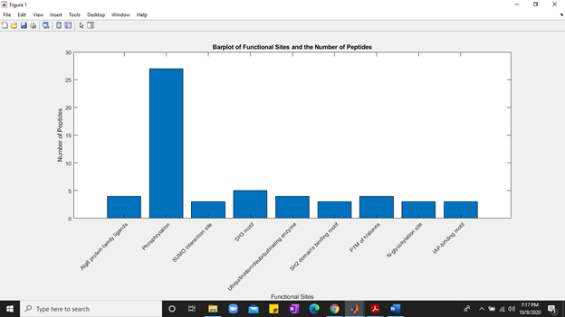

**Question 2**

% read the file

data = readtable('question_2.csv');

figure

boxplot(question2.Values,question2.Identifiers)

xlabel('Identifiers');

ylabel('values')

title('Multiple group plot')

figure

stem(question2.Identifiers,question2.Values,'magenta')

xlabel('Identifiers');

ylabel('values')

title('Multiple group plot')

**Plot**

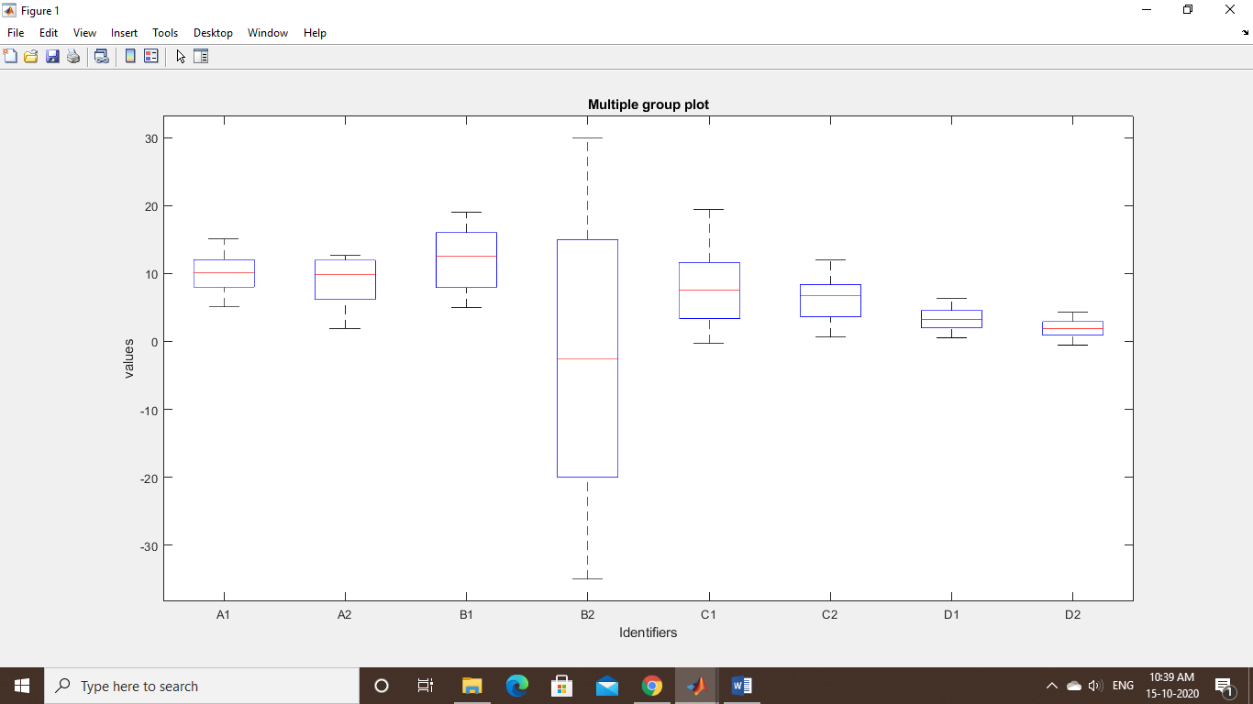

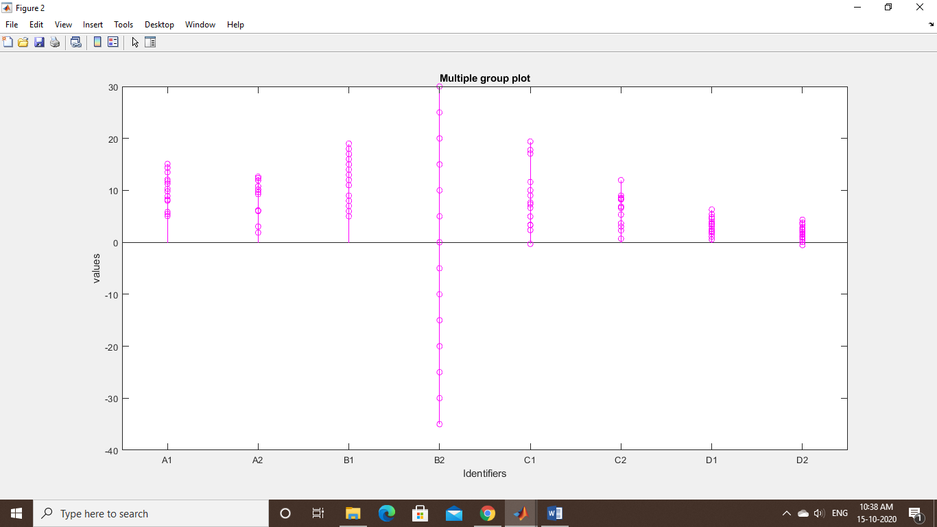

**QUESTION 3**

T = readtable('question 3 and 4.csv');

Top_20 = table2array(T(1:20,2));

x = "Log2FoldChange";

Top_20_genes = table2array(T(1:20,1));

h = heatmap(Top_20);

h.Colormap = autumn;

h.XDisplayLabels = x;

h.YDisplayLabels = Top_20_genes;

ylabel("Genes")

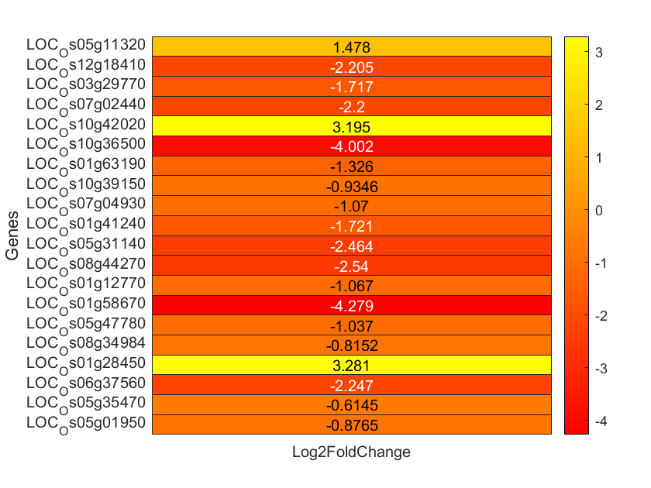**Plot**

**QUESTION 4**

% read the file

data = readtable('question 3 and 4.csv');

data = (data(2:end,4:end))

figure

scatter(question3and4.BC_1,question3and4.BC_2,'green','filled')

xlabel('BC_1')

ylabel('BC_2')

title('Scatter Plot')

axis([0 100000 0 100000])

## Plot

## https://lh3.googleusercontent.com/71I-vXZVsk8kCO6iuRRbXPg_NMqSDHqDbOOOpfHopon38X_a1Se29jAgr_ZTmtpNng9lUKzWw62XqxZb8k-uGd5pPgyiVt9XE0KMCQUo1TEHrA6TDFm0zVeSRMTbTRb-euWMBj1b

## QUESTION 5

data = xlsread('q5.xlsx');

% remove the last column since it has Nan

data =(data(2:end,1:end-1))';

% assign the labels to value

z = {'1a1m','1a1n','1a1o','1a6z','1a9b','1a9e','1agb','1agc','1agd','1age' ,'1agf' ,'1akj' ,'1ao7' , '1ce6','1cg9','1efx','1exu','1gzp','1hhh','1hsa','1hsb','1i4f','1i3m','1jgd','1jge','6ghn','6ggm' ,'6fgb','6ewo','6ewc','6ewa','6at5','6at9','6bj2','6bj3','6bxp','6c97','6c98','6c99','5vwj','5vz5','5w6a','5w67','5w69','5whk','5wjn','5wkf' ,'5wkh','5wmp'};

% plot the modified data

plot(data)

% add labels title and adjust the legend on the plot

xlabel('Different sections of gene')

ylabel('Different genes')

title('Relation between different genes(Q 5 )')

legend(z','Location','northeast','NumColumns',10)

**Plot**

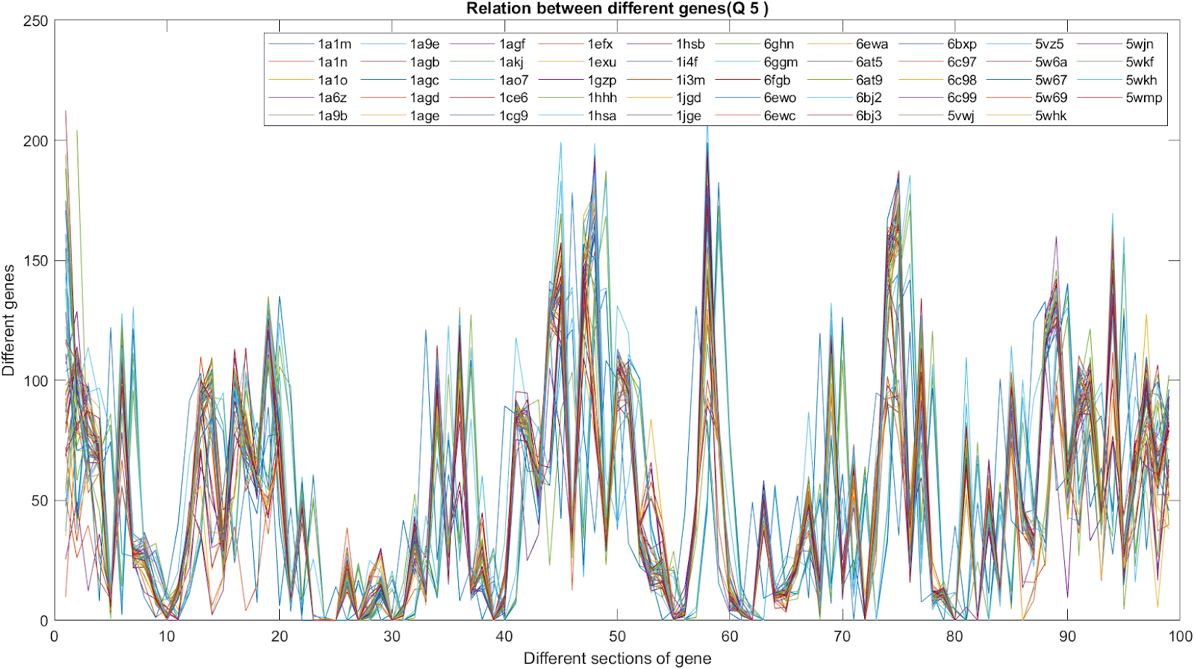

## QUESTION 6

## ATC=abs(fft(CH00));

## plot(f,ATC)

ATC1=abs(fft(CH01));

plot(f,ATC1)

 ATC2=abs(fft(CH02));

plot(f,ATC2)

plot(f,ATC,ATC1,ATC2)

**Plot**

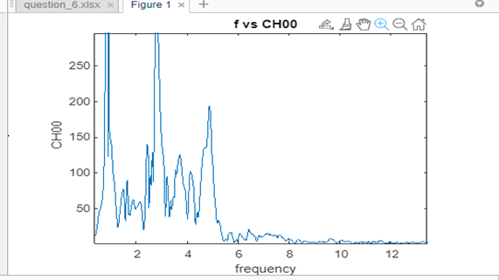

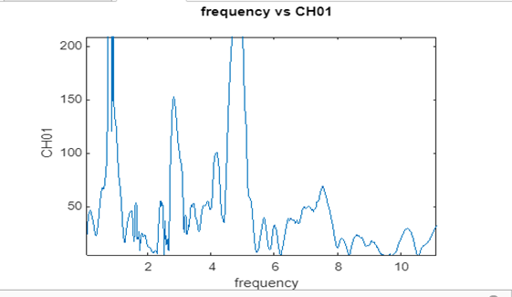

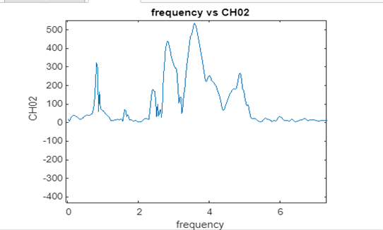

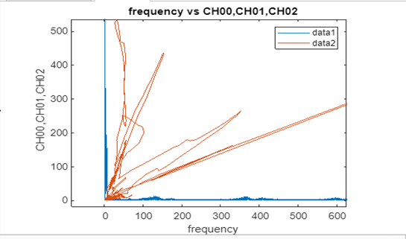

## QUESTION 7

data=getgenbank("NC_001854");

features = featureparse(data);

featureview(data,{'gene'},'fontsize',10,'showpositions',true)

title(' Borreliella burgdorferi B31 plasmid lp28-4 (complete sequence)')

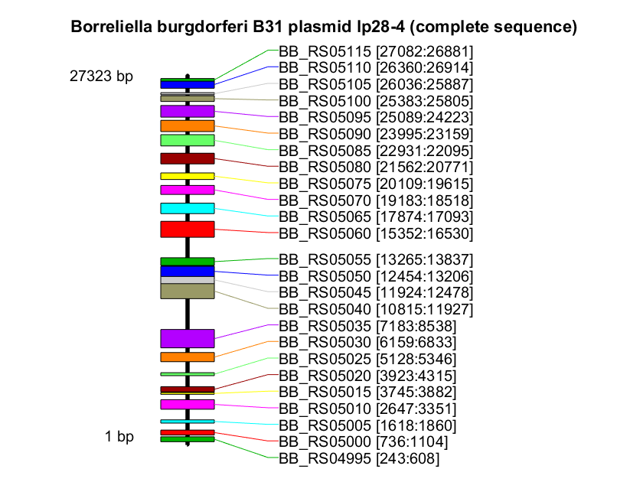

## QUESTION 8

% === Predict secondary structure in bracket notation

phe_seq = 'GCGGAUUUAGCUCAGUUGGGAGAGCGCCAGACUGAAGAUCUGGAGGUCCUGUGUUCGAUCCACAGAAUUCGCACCA';

phe_str = rnafold(phe_seq)

% === Plot RNA secondary structure as tree

rnaplot(phe_str, 'seq', phe_seq, 'format', 'tree');

title('RNA Secondary Structure Tree')

**Plot**

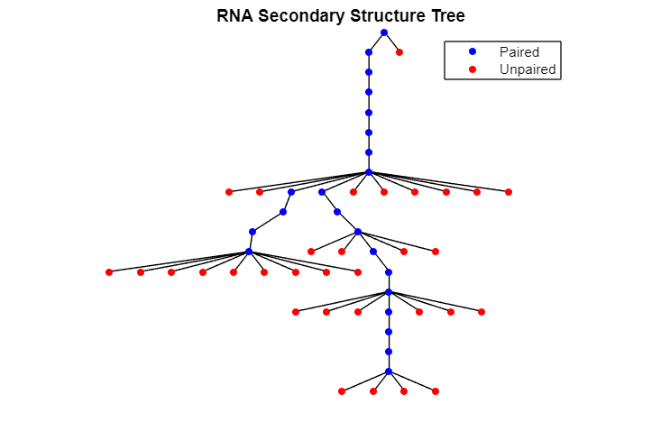

## QUESTION 9

T = readtable('question_9.xlsx');

T_array = table2array(T);

xnames = T.Properties.VariableNames;

m = gplotmatrix(T_array,[],[], [],[],[],[],'variable',xnames);

**Plot**

