WEEK 4 TASK
TREND ANALYSIS AND FORECASTING IN FINANCIAL REPORTING
Junior Financial Analyst Portfolio Project
ABC Manufacturing Ltd.
Prepared By | Mukti Patel
Historical Period | January 2025 – December 2026
Forecast Period | January 2027 – June 2027
Data Status | Hypothetical / Educational

1. Executive Summary
This project performs a forward-looking financial analysis for ABC Manufacturing Ltd. using 24 months of hypothetical historical financial data. The analysis focuses on identifying trends in revenue, cost of sales, operating expenses, EBITDA, net profit and operating cash flow, and then translating those trends into short-term forecasts.
Two quantitative techniques are applied: a three-month simple moving average and a simple linear regression model. The moving-average method smooths short-term fluctuations, while the regression model estimates the underlying linear time trend. Historical revenue shows an estimated annualised growth rate of approximately 21.9%, while EBITDA margin increases from 24.0% at the beginning of the period to 23.8% at the end.
The regression model has an R-squared of approximately 0.83, indicating how much of the variation in historical revenue is explained by the linear time trend. The forecasts are intended as management planning inputs rather than guaranteed outcomes.

2. Introduction
Trend analysis examines the direction and pattern of historical financial performance, while forecasting uses historical information and analytical techniques to estimate future outcomes. For a junior financial analyst, these activities extend financial reporting beyond describing what happened and help management consider what may happen next.
The project uses a controlled hypothetical dataset so that the methods can be demonstrated clearly. The analysis is deliberately designed to resemble a recurring monthly finance process, where actual results are reviewed, trends are identified, forecasts are updated and recommendations are communicated.

3. Objectives
- Identify significant trends in historical financial performance.
- Measure growth and profitability movements over time.
- Apply a three-month moving-average forecasting method.
- Apply simple linear regression to estimate a time trend.
- Compare the outputs of the two forecasting approaches.
- Communicate results through charts and narrative interpretation.
- Translate forecast findings into practical financial reporting and management recommendations.

4. Dataset and Scenario
ABC Manufacturing Ltd. is a hypothetical manufacturing entity. Monthly observations cover January 2025 to December 2026. The dataset includes revenue, cost of sales, operating expenses, EBITDA, net profit and operating cash flow. The figures are fictional and are not intended to represent the financial results of a real company.
The dataset includes gradual growth and moderate seasonal variation to create a realistic analytical environment. Cost of sales and operating expenses are linked to revenue so that profitability can be evaluated alongside top-line growth.

5. Methodology

5.1 Trend Analysis
Month-on-month percentage changes are calculated to identify short-term movements. Annualised growth is also considered to provide a longer-term view. Profitability margins are examined alongside revenue because revenue growth alone does not necessarily indicate improved financial performance.

5.2 Three-Month Moving Average
The three-month moving average forecast is calculated as the arithmetic mean of the latest three available observations. It is a smoothing technique: short-term peaks and troughs have less influence on the forecast than they would under a single-period observation. The approach is simple, transparent and suitable for short-range planning, although it can lag a strong trend.
The methodology is consistent with NIST guidance describing simple moving averages as a forecasting method in which historical observations are averaged to produce the next forecast; NIST also notes that the method smooths extreme values and is generally suited to short-range forecasting. citeturn0search24

5.3 Simple Linear Regression
A simple linear regression model is fitted with time period as the independent variable and revenue as the dependent variable. The estimated equation takes the form Y = a + bX, where b represents the estimated monthly trend and a represents the intercept. The model is then extended six months into 2027.
Regression is appropriate here as a complementary trend model because it provides a measurable estimate of the direction of change. NIST describes regression functions as tools that can be used for estimation and prediction. citeturn0search5

5.4 Model Selection
The project intentionally uses two simple methods rather than presenting one forecast as definitive. Moving averages are useful for smoothing recent fluctuations, whereas regression provides a clearer estimate of the long-term linear trend. Financial forecasting guidance commonly identifies moving averages and simple linear regression among practical quantitative forecasting approaches. citeturn0search0

6. Historical Trend Analysis
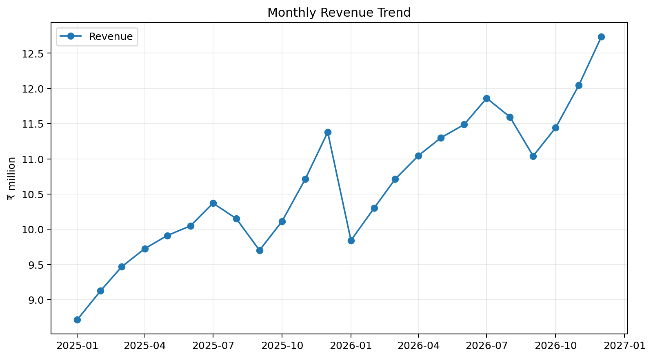
Figure 1. Monthly Revenue Trend
Revenue displays an overall upward trajectory across the 24-month period, with recurring monthly variation. The estimated annualised growth from the first to the last observation is approximately 21.9%. The upward pattern provides a reasonable basis for testing a trend-based forecast, although the seasonal pattern means management should avoid interpreting every month-to-month movement as a structural change.
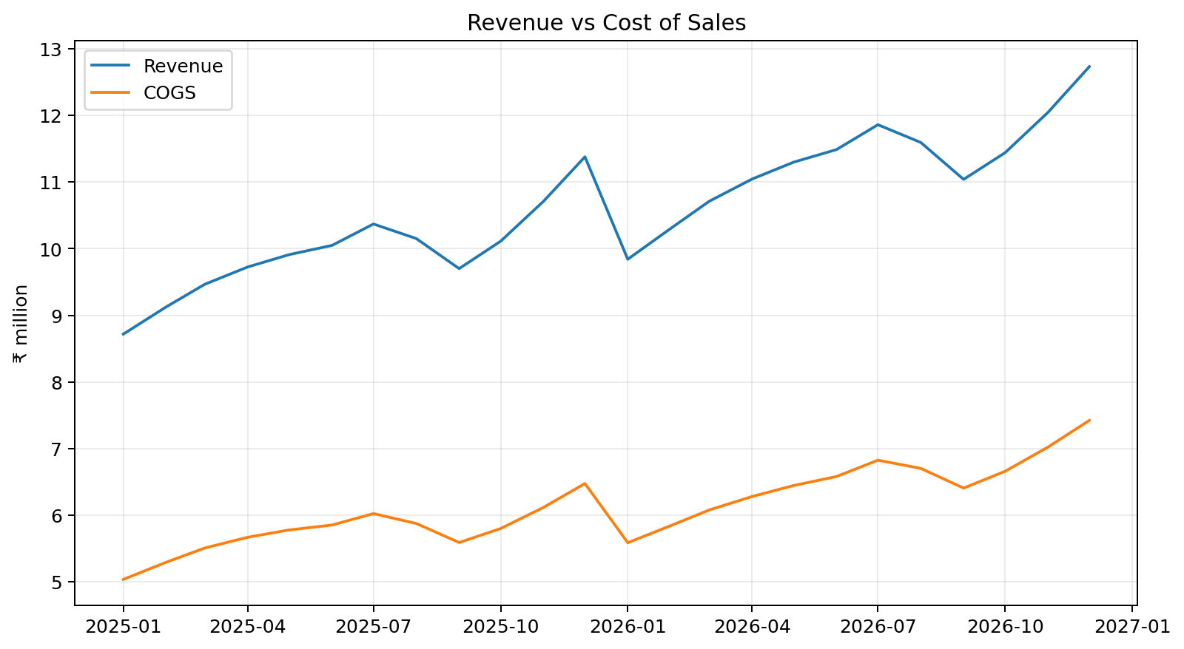
Figure 2. Revenue versus Cost of Sales
Cost of sales increases alongside revenue, which is expected in a manufacturing environment. The key analytical question is whether cost growth is controlled relative to revenue growth. Monitoring the relationship between the two measures can highlight pressure on gross profitability.
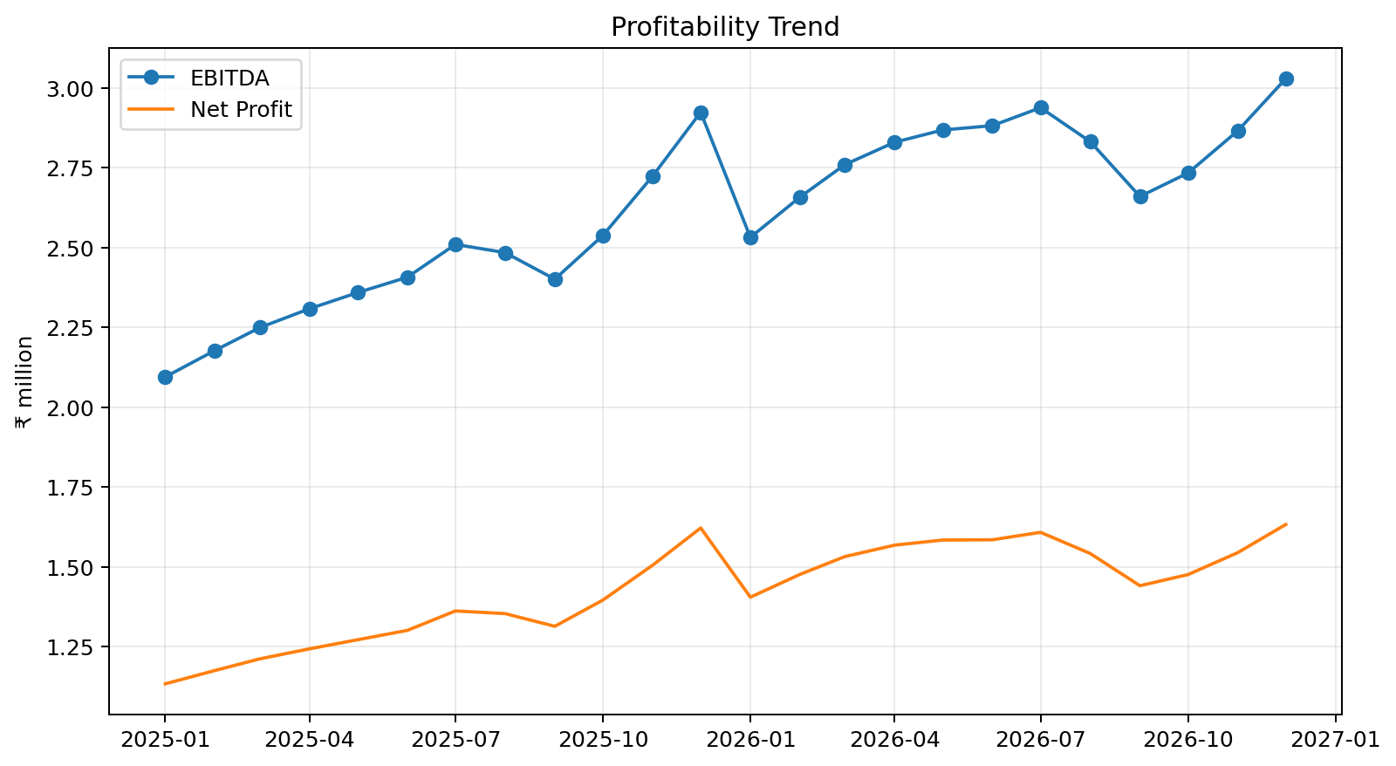
Figure 3. Profitability Trend
EBITDA and net profit broadly follow the revenue trend. This suggests that revenue growth is translating into improved operating performance rather than being entirely absorbed by the cost base.
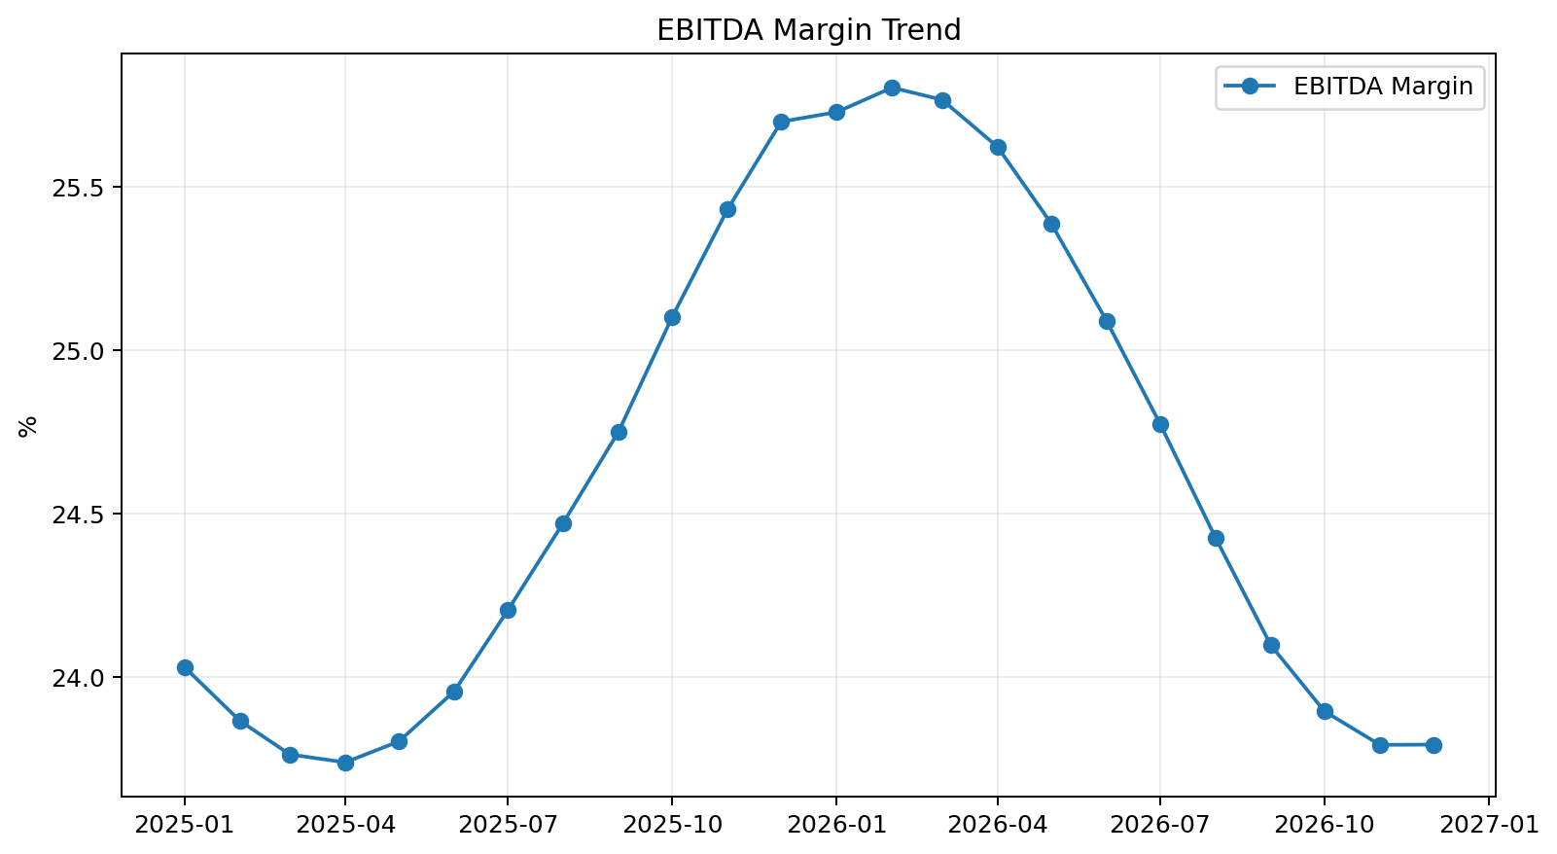
Figure 4. EBITDA Margin Trend
EBITDA margin improves from approximately 24.0% to 23.8%. This indicates improving operating leverage in the hypothetical scenario. In a real reporting environment, the analyst would investigate whether this improvement results from pricing, volume, procurement savings, productivity or changes in the cost mix.
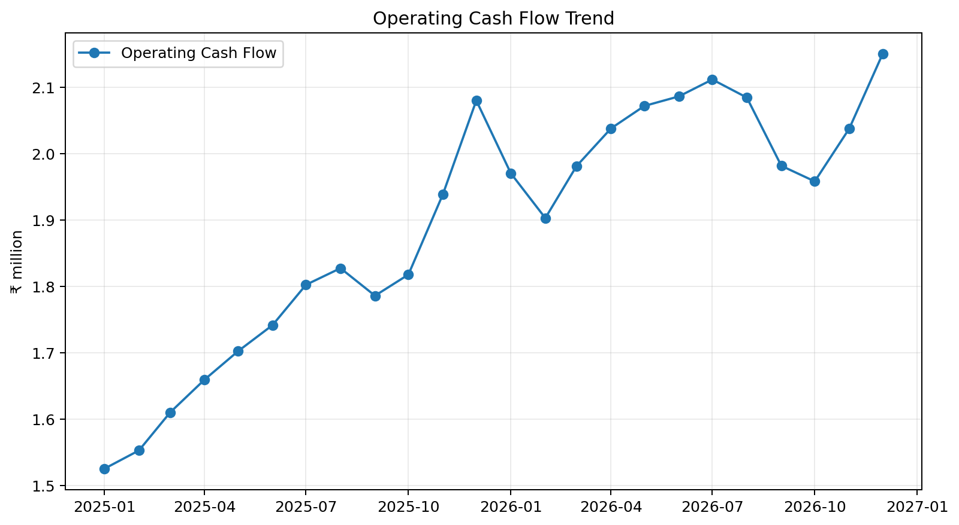
Figure 5. Operating Cash Flow Trend
Operating cash flow generally tracks profitability but is affected by working-capital movements. This demonstrates why a reporting analyst should not rely on profit alone when assessing financial performance.

7. Moving Average Forecast
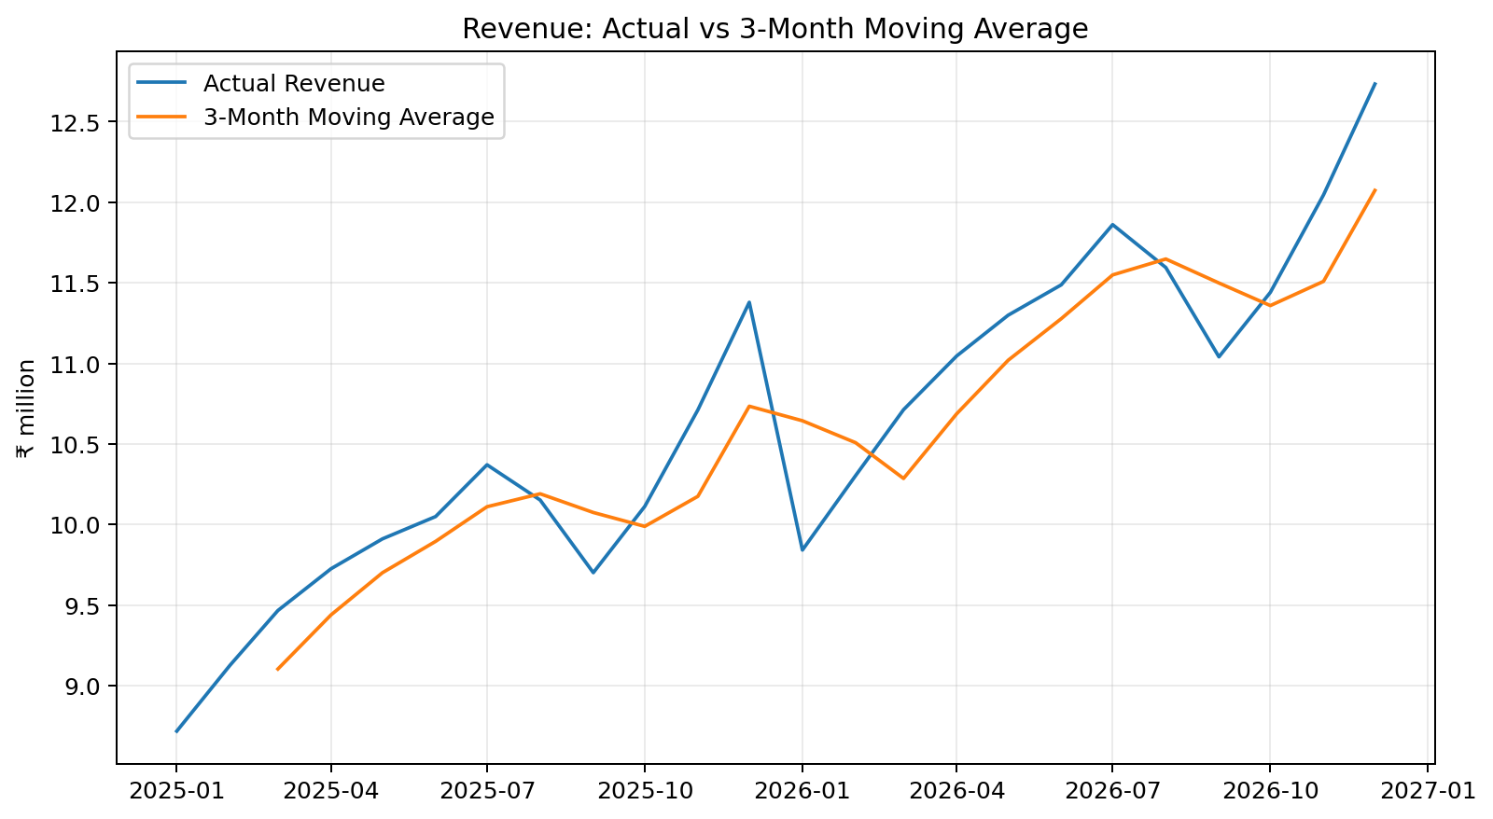
Figure 6. Actual Revenue versus Three-Month Moving Average
The three-month moving average smooths short-term volatility and provides a conservative short-range view. Because the forecast uses recent observations, it responds gradually to changes and can lag a rapidly accelerating or declining trend.
Month | 3M MA Forecast (₹m) | Regression Forecast (₹m)
Jan-2027 | 12.07 | 12.22
Feb-2027 | 12.28 | 12.35
Mar-2027 | 12.36 | 12.47
Apr-2027 | 12.24 | 12.60
May-2027 | 12.30 | 12.73
Jun-2027 | 12.30 | 12.86

8. Regression Forecast
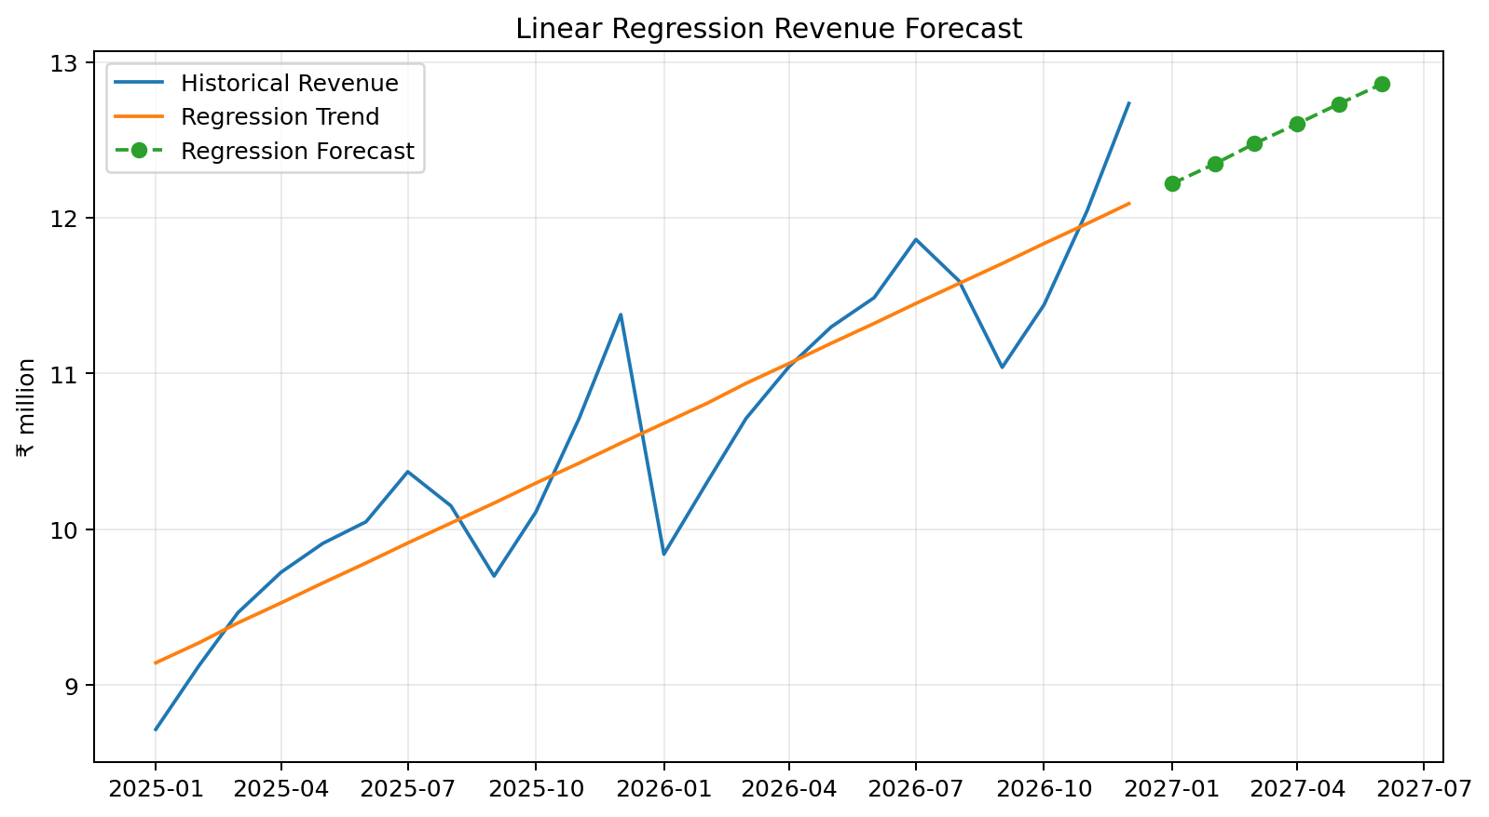
Figure 7. Linear Regression Revenue Forecast
The fitted linear trend has a slope of approximately ₹128,104 per month and an R-squared of 0.83. The R-squared value indicates the proportion of historical revenue variation explained by the model's linear time relationship. The regression forecast therefore provides a useful directional benchmark, but it should not be treated as a complete forecasting model because it does not explicitly model seasonality, market shocks or causal business drivers.

9. Forecast Comparison
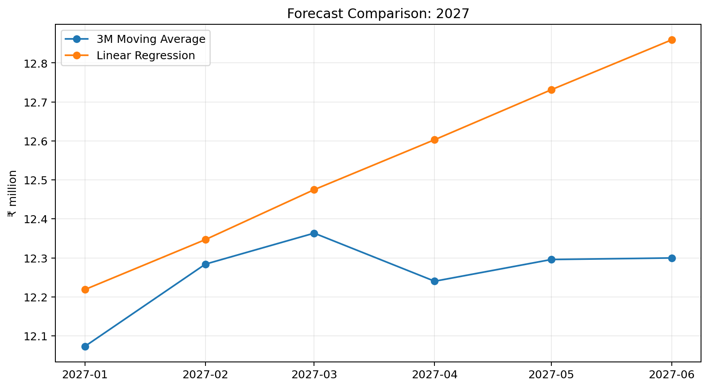
Figure 8. Six-Month Forecast Comparison
The moving-average and regression forecasts provide different perspectives. The moving average is more anchored to the most recent three observations and therefore reacts to recent changes. Regression is anchored to the full 24-month history and therefore provides a smoother structural trend.
For monthly management reporting, the moving-average result can be useful as a short-term reference point. For longer-term planning, the regression trend can provide an additional directional benchmark. In practice, the finance team should combine quantitative outputs with business knowledge and scenario analysis.

10. Key Findings
- Revenue demonstrates a sustained upward trend, with an estimated annualised growth rate of approximately 21.9%.
- EBITDA margin improves from 24.0% to 23.8%, indicating improving operating leverage in the hypothetical scenario.
- Cost of sales rises with revenue, so gross-margin monitoring remains important.
- Operating cash flow broadly follows profitability but shows the effect of working-capital movements.
- The three-month moving average smooths short-term volatility and is appropriate as a simple short-range benchmark.
- The regression model provides a longer-history trend benchmark with an R-squared of 0.83.
- The two methods should be compared rather than treating either model as an unquestionable forecast.

11. Recommendations
- Update the forecast monthly using the latest actual results and investigate material forecast-to-actual variances.
- Use the three-month moving average as a short-term planning reference while retaining regression as a longer-term directional benchmark.
- Monitor revenue and cost-of-sales growth together to identify emerging margin pressure.
- Track EBITDA margin as a KPI so management can distinguish revenue growth from profitable growth.
- Include operating cash flow in management reporting to prevent decisions being based solely on accounting profit.
- Add base, upside and downside scenarios when forecasts are used for budgeting or strategic decisions.
- Review forecast assumptions when there are structural changes such as major pricing changes, supply disruptions, new competitors or changes in customer demand.
- Document the assumptions and methodology used for each reporting cycle so that forecasts remain transparent and reproducible.

12. Implications for Future Financial Reporting
The analysis suggests that recurring financial reporting can be enhanced by adding a forward-looking layer. A monthly reporting pack can show actual performance, budget variance, historical trend, latest forecast and management commentary in a single workflow.
This creates a progression from backward-looking reporting to forward-looking decision support: actual results explain what happened, trend analysis helps explain direction, forecasting estimates what may happen next, and management recommendations identify potential actions.

13. Risks and Limitations
- The dataset is hypothetical and therefore cannot be used to predict a real company's performance.
- Simple moving averages assume that recent historical observations remain relevant and can lag sudden changes.
- Linear regression assumes a stable linear relationship between time and the financial variable and does not explicitly capture seasonality.
- Forecasts can be affected by factors not represented in historical data, including inflation, competition, changes in customer demand, input prices and regulatory developments.
- A high R-squared does not by itself prove that the model is causally correct.
- Forecast accuracy should be evaluated against subsequent actual results and the model should be recalibrated when performance changes.
NIST materials emphasise model diagnostics and the importance of examining residual behaviour when using forecasting models. citeturn0search26

14. Conclusion
This project demonstrates how a junior financial analyst can convert historical financial data into forward-looking insight. The combination of trend analysis, moving averages, regression, visualisation and management recommendations provides a structured approach to forecasting.
The analysis indicates sustained revenue growth and improving profitability in the hypothetical ABC Manufacturing Ltd. scenario. However, the forecasts should be treated as planning tools rather than guarantees. The strongest reporting process would combine quantitative models with management judgement, scenario analysis and regular forecast-versus-actual review.

15. References and Publicly Available Sources
National Institute of Standards and Technology (NIST), Guide on Workload Forecasting — discussion of simple moving averages, smoothing and forecasting considerations. citeturn0search24
National Institute of Standards and Technology (NIST), Engineering Statistics Handbook — discussion of process models for estimation and prediction. citeturn0search5
Corporate Finance Institute (CFI), Forecasting Methods: Top Techniques for Budget Predictions — overview of moving average and simple linear regression methods and their practical uses. citeturn0search0
Corporate Finance Institute (CFI), Forecasting Techniques — overview of quantitative forecasting methods used in financial modelling. citeturn0search1

16. Appendix — Forecast Data
Month | 3M MA Forecast | Regression Forecast | Difference
Jan-2027 | 12.07 | 12.22 | -0.15
Feb-2027 | 12.28 | 12.35 | -0.06
Mar-2027 | 12.36 | 12.47 | -0.11
Apr-2027 | 12.24 | 12.60 | -0.36
May-2027 | 12.30 | 12.73 | -0.44
Jun-2027 | 12.30 | 12.86 | -0.56

