|  |  |  |
| --- | --- | --- |
| |  |  | | --- | --- | |  | This document summarizes the students’ evaluation of teaching performance for the courses taught by Mukto Akash during the five-year period 2016-2020. The raw data that was used to generate this summary is [available by request.](mailto:muktoakash@gmail.com?subject=Teaching%20Evaluations%20Raw%20Data) |   **Mukto Akash** Summary of Teaching Evaluations Student Testimonials (Top 5)  * Akash did not make any assumptions of the students' knowledge when they asked for explanations. Explanations were easy to follow for a "dummy" which is an important talent for instructors to have. * Always made sure that everyone’s questions were answered before moving on. Had online office hours before Waterloo shut down (which I found to be helpful) * Clearly understands material very well. In addition to simple explanations, goes above and beyond to give additional remarks, observations, applications, and other insight. Helps students to achieve a much greater understanding and appreciation for the course content. * Good presentation, speaks clearly, very neat writing on blackboard so taking notes is easy to follow along with. * I found the lectures to be very well organized in terms of introducing new ideas and interconnecting different areas of content. I also felt the assignments and quizzes were very good representations of bigger evaluations and so I was rarely surprised when it came to the midterms.  Summarized Scores |

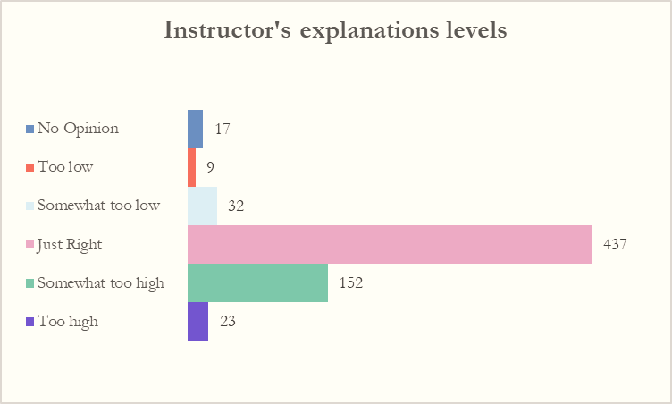As per my teaching philosophy, I always strive to provide the student an additional perspective to what is available in the textbook or course notes. The explanations, examples and in-class activities are carefully crafted to engage everyone. As a result. students feel confident that they are in the right learning environment.

# 

# Examples: Improvements made based on feedback

| Student comment | Changes Made | student validation |
| --- | --- | --- |
| Could teach a bit faster [Fall 2016] | Revised lecture content to trim down unnecessary details and explanations. Worked hard to find the sweet balance of speed vs. rigor. | The instructor presents the information in a way that is helpful for students (not too much theory, more examples). [Fall 2017] |
| Give more visualized examples [Winter 2017] | Surveyed several textbooks, websites, videos, etc., to come up with examples that connected better with visual learners. | Explained concepts well. Added examples outside of course notes are very helpful. [Fall 2018] |
| May be provide some material for revision. [Winter 2019] | In addition to a brief review before lecture, started adding summarized lecture content online. | The flexibility, as well as the lecture content online. Also, the professor was very easy to connect with online and to discuss course content with whenever I required clarification. |

# Remarks

The way teaching is evaluated is fundamentally a flawed process. The students grade the instructor on a very limited set of questionnaires, and any issues mentioned in these evaluations is not communicated to the instructor until the middle of the following term. As a result, the responses and adjustments that need to be made are delayed, and the reassessment of these changes are even further delayed by the fact that the evaluations related to the changes are not available until the middle of the next term. Therefore, it is important to compare teaching evaluations over several terms to properly assess any improvements to teaching techniques.

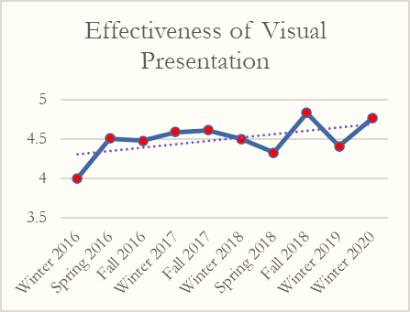After every teaching term, I eagerly wait to receive the student evaluations. Using a self-developed framework to append the new existing ones, the evolution of my teaching performance is tracked term over term for each factor. For example, the following graph1 shows the how the students perceived the effectiveness of visual presentation in my lectures. A quick analysis of the graph shows overall gradual improvement. However, there is a sharp decline in Winter 2019, which, upon further retrospection, was due to using overhead document projectors for the first time, compounded by the fact that it was a new course and a new lecture location. Such analysis is important to maintain and improve quality of all aspects of teaching. Ideally, this should not be a personal project rather than an institutional standard. Nevertheless, I am happy to put in this effort to improve myself as an educator.

Finally, I also carry out textual analysis on student comments. The objective is to identify for overall sentiments, as well as key issues pointed out by students. It is important to see whether the same concern was flagged by multiple students or across multiple terms. These concerns are thein categorized by ease of remediation, immediacy of action, and finally, perceived effectiveness of the suggested solution. A sample of such concerns was presented in the previous section. Once some concrete adjustments have been made, I then look to see if there are validations in the student comments from proceedings terms. Overall, the goal is to improve the student learning experience along my teaching journey. This is always a work-in-progress, but one that I am happy to implement and share.

|  |  |  |  |
| --- | --- | --- | --- |
|  | Mukto akash |  |  |

*Notes:*

1. *The appendix in the following page shows similar graphs for a few other categories of Teaching Evaluations*

# Appendix: Selected Visualizations of Teaching Effectiveness term-by-term

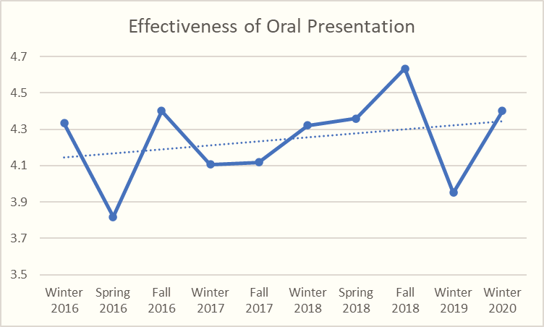Gradual improvement when verbally communicating with students.

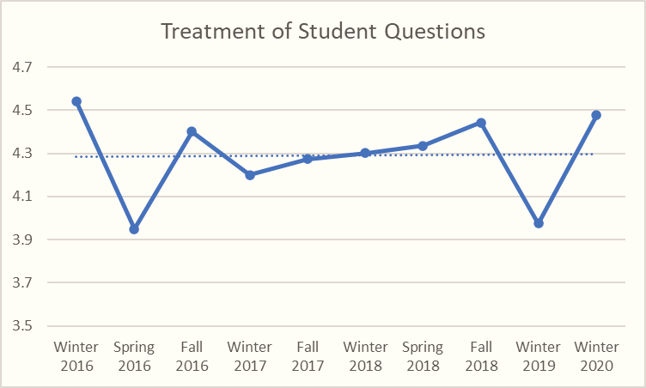

Consistency is key when it comes to addressing student questions. Always maintain a high level of respect and clarity when responding to students.

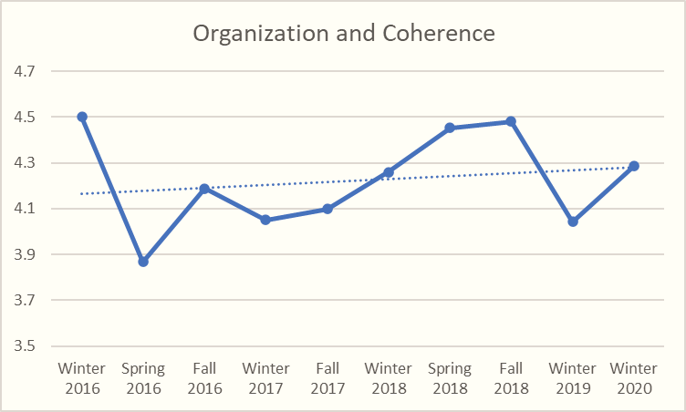

Gradual improvement in organization of lecture content shows a drive to revise lecture notes every term.

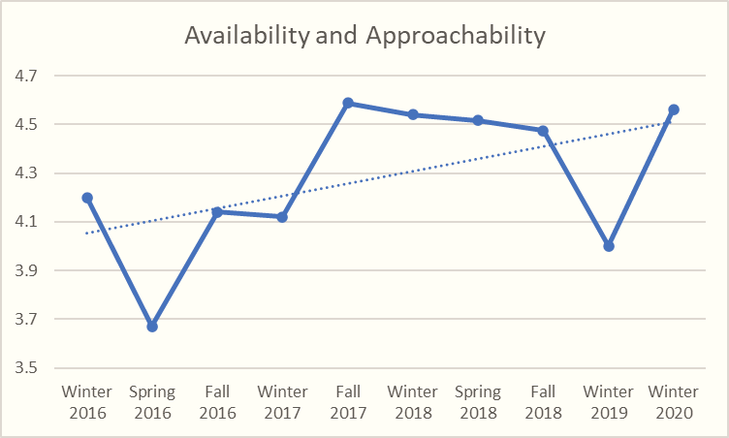

Having and “open-door” policy conveys to students that they can approach their instructor freely to ask any question. Asking questions and learning from mistakes is a fundamental aspect of learning.