Saxon Municipal Government

New Perspectives Excel 2019 | Modules 1-4: SAM Capstone Project 1b



FORMATTING, FORMULAS, AND CHARTS

# GETTING STARTED

* Open the file **NP_EX19_CS1-4b_*FirstLastName*_1.xlsx**, available for download from the SAM website.
* Save the file as **NP_EX19_CS1-4b_*FirstLastName*_2.xlsx** by changing the “1” to a “2”.

If you do not see the **.xlsx** file extension in the Save As dialog box, do not type it. The program will add the file extension for you automatically.

* With the file **NP_EX19_CS1-4b_*FirstLastName*_2.xlsx** still open, ensure that your first and last name is displayed in cell B6 of the Documentation sheet.

If cell B6 does not display your name, delete the file and download a new copy from the SAM website.

* PROJECT STEPS

1. Abdul Rassim is a financial analyst for the Saxon Municipal Government. Abdul is building a workbook that summarizes budget and staffing data for the city.   
   Change the theme of the workbook to **Office**.
2. On the *Employees* worksheet, change the width of columns D through I to **11.00** characters.
3. Change the height of rows 2 and 6 to **30** points.
4. Merge and center the contents of the range B3:K3.
5. Format the merged range B3:K3 as described below:
   1. Apply the **40% - Accent 2** cell style.
   2. Apply **bold** formatting.
   3. Change the font size to **12**.
6. Enter the values shown in Table 1 into the corresponding cells in the range B6:F6.

* Table 1: Data for the Range B6:F6

|  |  |  |  |  |  |
| --- | --- | --- | --- | --- | --- |
|  | B | C | D | E | F |
| 6 | **Code** | **Department** | **Directors** | **Clerks** | **Staff** |

1. Format the range B6:K6 as described below:
   1. Center cell contents.
   2. Change the font size to **11** point.
   3. Change the background color to **Orange, Accent 2, Lighter 80%** (6th column, 2nd row on the Theme Colors palette).
   4. Apply **Wrap Text** to the text in cell K6.
2. Select the range B7:K17 and then add a **Light Gray, Background 2, Darker 10%** (2nd row, 3rd column in the Theme Colors palette) border to all sides of each cell.
3. Select the range B18:K18 and then add a thin top border to each cell using **Orange, Accent 2** (1st row, 6th column in the Theme Colors palette).
4. Select the range I7:I17 and then format the range as described below:
   1. Format the range with the **Percentage** number format with **zero** decimal places.
   2. Add a **Highlight Cells** conditional formatting rule that formats cells that are greater than **20%** as **Light Red Fill with Dark Red Text**.
5. Select the range J7:J17 and then use conditional formatting to add gradient fill red data bars.
6. Select the range K7:K17 and then add top/bottom conditional formatting rules to format the top 5% of values as Green Fill with Dark Green Text and the bottom 5% of values as Light Red Fill with Dark Red Text.
7. Enter a formula in cell N8 using the **VLOOKUP** function to find an exact match for the department code. Look up the department code (cell **N7**) using an absolute reference, search the employee table data (the range **B7:K17**) using absolute references, and return the department name (the **2**nd column).
8. Copy the formula in cell N8 to the range N9:N16, pasting the formula only, and then edit the copied formulas to return the value from the column indicated by the label in column M.
9. In cell D21, enter a formula using the **TODAY** function that displays the current date.
10. Delete column P.
11. Hide row 22.
12. On the *Department Comparison* worksheet, create a 2-D pie chart based on the non-adjacent range B12:B16 and F12:F16. Modify the chart as described below:
    1. Resize and reposition the chart so that the upper-left corner is located within cell J4 and the lower-right corner is located within cell P17.
    2. Apply **Chart Style 4** to the chart.
    3. Enter **Bottom Five Depts - 2022** as the chart title.
13. In the Bottom Five Depts - 2019 2-D pie chart (located in the range J19:P38), make the following changes:
    1. Change the data labels to display only the percentage and a label position of Inside End.
    2. Reposition the legend on the right side of the chart.
14. Update the Top Five Departments column chart in the range B19:H39 as follows:
    1. Change the maximum bound of the left vertical axis to **13,000,000**.
    2. Add axis titles to the chart. Use **Budgeted $** as the left vertical title, use **Total Budget** as the right vertical title, and remove the horizontal axis title.
    3. Apply a shape fill to the plot area using the **Gray, Accent 3, Lighter 80%** fill color.
15. Delete the *Projections* worksheet.

Your workbook should look like the Final Figures on the following pages. Save your changes, close the workbook, and then exit Excel. Follow the directions on the SAM website to submit your completed project.

* Final Figure 1: Employees Worksheet

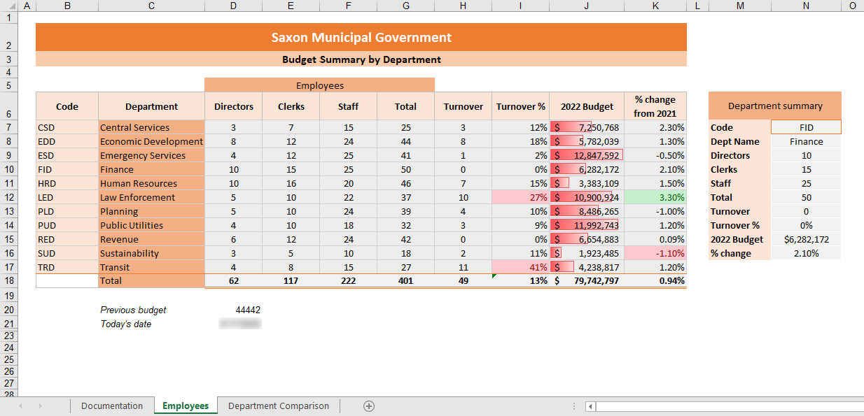

* Final Figure 2: Department Comparison Worksheet

