New Perspectives Excel 2019 | Module 12: SAM Project 1b

Piedmont Riverfront Festival

DEVELOP AN EXCEL APPLICATION

# GETTING STARTED

* Open the file**NP_EX19_12b_*FirstLastName*_1.xlsm**, available for download from the SAM website.  
    
  Files downloaded from the SAM website are safe and do not contain viruses, but due to a recent Microsoft policy update, macros in downloaded files are disabled by default. To complete this project, you will need to enable macros in the file. To enable macros on this file:

For PC: Open Windows File Explorer and go to the folder where you saved the file. Right-click the file and choose Properties from the context menu. At the bottom of the General tab, select the Unblock checkbox and select Apply, and then click OK.

For Mac: If a dialog box about macros appears, click Enable Macros.

* Save the file as **NP_EX19_12b_*FirstLastName*_2.xlsm** by changing the “1” to a “2”.

If you do not see the **.xlsm** file extension in the Save As dialog box, do not type it. The program will add the file extension for you automatically.

* With the file **NP_EX19_12b_*FirstLastName*_2.xlsm** still open, ensure that your first and last name is displayed in cell B6 of the Documentation sheet.

If cell B6 does not display your name, delete the file and download a new copy from the SAM website.

* To complete this project, you need to add the Developer tab. If this tab does not display, right-click any tab on the ribbon, and then click Customize the Ribbon on the shortcut menu. In the Main Tabs area of the Excel Options dialog box, click the Developer check box, and click OK.
* PROJECT STEPS

1. Kiara Banerjee is coordinating the volunteers for the Piedmont Riverfront Festival in Piedmont, Virginia. She is developing an Excel workbook to track and record the volunteers' information, including registration information. She asks for your help in automating the workbook.  
   Go to the *Volunteer Overview* worksheet and then unprotect it so you can edit the contents.
2. Kiara wants to include an eye-catching title on the worksheet, which she plans to share with the other festival coordinators.   
   Insert and format WordArt as follows:
   1. Insert WordArt using the **Fill: Brown, Accent color 4; Soft Bevel** style.
   2. Type **Festival Volunteers** in the WordArt to make the worksheet title.
   3. Change the text fill of the WordArt to **Brown, Accent 4, Darker 25%**.
   4. Move the WordArt to row 1 so that it spans columns A:H.
3. Kiara created a macro to insert a plain worksheet title, and then attached the macro to the Title button. She no longer needs the button.   
   Delete the **Title** button in the range H4:H5.
4. Kiara plans to print the *Volunteer Overview* worksheet before the first day of the festival. She wants to use the Print Layout button to prepare the worksheet for printing.  
   Record a macro that sets up the worksheet for printing as follows:
   1. Record a macro named **Print_Layout** stored in the current workbook.
   2. With the macro recording, click the **File** tab on the ribbon, and then click **Print**.
   3. Change the page orientation to **Landscape Orientation**.
   4. Change the scaling setting to **Fit Sheet on One Page**.
   5. Return to the *Volunteer Overview* worksheet.
   6. Stop recording the macro.
5. Kiara created the Print Layout button using a Rounded Rectangle shape. She wants to be able to click the shape to run the Print_Layout macro.  
   Assign the **Print_Layout** macro to the Print Layout shape.
6. Go to the *Volunteer Records* worksheet, where Kiara tracks volunteer assignments. She and her staff usually enter the volunteer details directly on the worksheet. She wants to make sure everyone enters the data correctly, especially the dates in the Date column. The festival begins on May 28, 2021 and ends on May 31, 2021.  
   Create a data validation rule as follows:
   1. In the range C3:C16, create a data validation rule that accepts only **date** values between **5/28/21** and **5/31/21**.
   2. Create an input message that uses **Volunteer Assignment Date** as the title and the following text as the input message:  
      **Enter the date of the volunteer assignment.**
   3. Create a Stop style error alert that uses **Invalid Date** as the title and the following text as the error message:  
      **Enter a date between May 28 and May 31.**
7. Kiara wants to make sure all of the dates entered in the Date column are valid.   
   Identify and correct any invalid values as follows:
   1. In the range C3:C16, circle invalid data.
   2. Change the first invalid date to **5/28/21** and change the second invalid date to **5/30/21** to correct the errors.
8. Go to the *Volunteer Registration* worksheet. Before the festival, Kiara and her staff will register volunteers using the form on this worksheet. Kiara has created two macros to automate this form, but they are not working correctly.   
   View and edit the macros as follows:
   1. Open the **Clear_Data** macro in the Visual Basic Editor. The macro should delete the values in the range D4:D8, but specifies the range C3:C9.
   2. In the Clear_Data macro VBA code, change the statement between the "'Edit the code below" and "'Edit the code above" comments to the following statement:  
      **Range("D4:D8").Select**
   3. Scroll down to display the code for the Add_Volunteer macro, the second macro Kiara created. This macro calls, or runs, the Clear_Data macro at the end of the code, so it should now work correctly. Save the code and then close the Visual Basic Editor.
   4. Assign the **Clear_Data** macro to the Clear Data button so that Kiara and her staff can use the button to clear the form.
   5. Use the Clear Data button to clear the form and test the macro.
9. The Add_Volunteer macro should copy the data in the range D4:D8 on the *Volunteer Registration* worksheet, go to the *Volunteer Records* worksheet, find the next blank row, and then paste the copied data, transposing it to fit in a row instead of a column. Then the macro should return to the *Volunteer Registration* worksheet and run the Clear_Data macro, which deletes the data in the range D4:D8.  
   Kiara wants to assign the Add_Volunteer macro to a new button to make it easy to run the macro. Create the button as follows:
   1. Insert a **Button (Form Control)** button in column D to the right of the Clear Data button.
   2. Change the height to **0.3"** and the width to **1.5"**.
   3. Align the top of the new button with the top of the Clear Data button.
   4. Edit the text to display **Add Volunteer** on the button.
   5. Format the button control to use **Rockwell 12 point** text, if necessary.
   6. Assign the **Add_Volunteer** macro to the new button.
10. Insert the tutor registration data shown in Table 1, and then use the **Add Volunteer** button to run the Add_Volunteer macro. Verify that it added a record on the *Volunteer Records*worksheet.

* Table 1: Volunteer Registration Data

|  |  |
| --- | --- |
| *Volunteer Name* | **Emma Johnson** |
| *Assignment* | **Riverfront Park** |
| *Date* | **5/30/21** |
| *Station* | **First aid** |
| *Gift* | **Mug** |

Your workbook should look like the Final Figures on the following pages. Save your changes, close the workbook, and then exit Excel. Follow the directions on the SAM website to submit your completed project.

* Final Figure 1: Volunteer Overview Worksheet

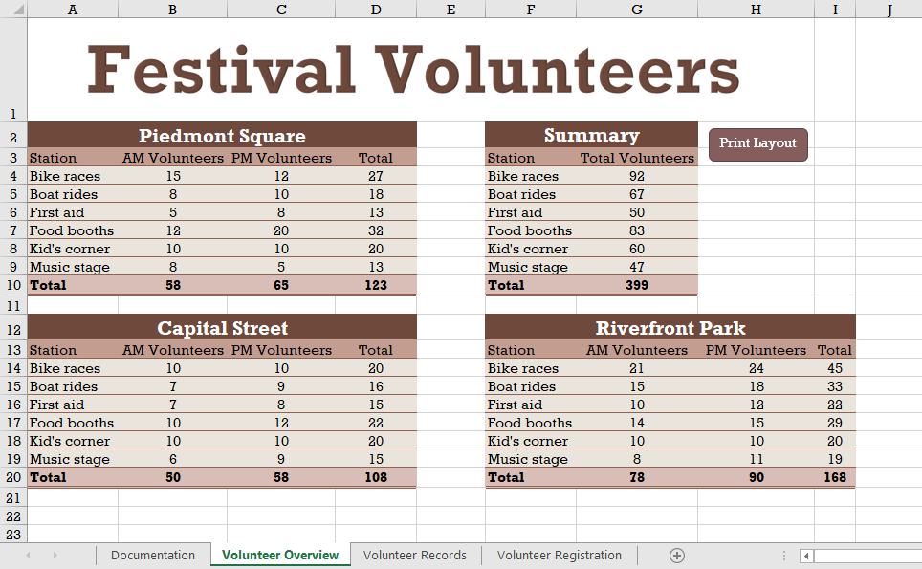

* Final Figure 2: Volunteer Records Worksheet

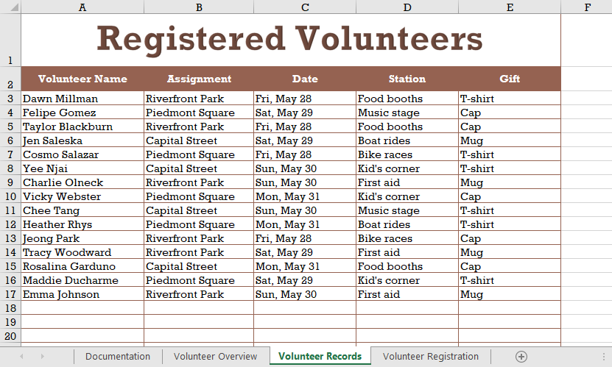

* Final Figure 3: Volunteer Registration Worksheet

