Sato Instrument Collection

New Perspectives Excel 2019 | Module 6: SAM Project 1b



MANAGING YOUR DATA WITH DATA TOOLS

# GETTING STARTED

* Open the file **NP_EX19_6b_*FirstLastName*_1.xlsx**, available for download from the SAM website.
* Save the file as **NP_EX19_6b_*FirstLastName*_2.xlsx** by changing the “1” to a “2”.

If you do not see the **.xlsx** file extension in the Save As dialog box, do not type it. The program will add the file extension for you automatically.

* With the file **NP_EX19_6b_*FirstLastName*_2.xlsx** still open, ensure that your first and last name is displayed in cell B6 of the Documentation sheet.

If cell B6 does not display your name, delete the file and download a new copy from the SAM website.

* PROJECT STEPS

1. Kaito and Naomi Sato started collecting musical instruments as a hobby a few years ago and are now organizing their collection in an Excel workbook. Naomi asks for your help in updating and analyzing the data.  
   Switch to the *Brass* worksheet. Unfreeze the top row of the worksheet.
2. Sort the data in the Brass table first in descending order by the Purchase Date field and then in descending order by the Est. Value field.
3. Insert a Total Row in the Brass table, and then use the Total row to calculate the total of the values in the Price and Est. Value fields.
4. Naomi wants to highlight the brass instruments she and Kaito bought on the same date.  
   Apply a conditional formatting rule to the range E3:E10 that uses **Green Fill with Dark Green Text** for duplicate values.
5. Switch to the *Percussion* worksheet. Freeze the first column of the worksheet.
6. Format the range B2:G10 as an Excel table with headers using the **Gold, Table Style Medium 12** table style. Enter **Percussion** as the name of the table.
7. Naomi and Kaito bought a new snare drum last week, and Naomi wants to include it in the Percussion table.  
   Add the record shown in Table 1 to the end of the Percussion table.

* Table 1: New Record for the Percussion Table

|  |  |  |  |  |  |  |
| --- | --- | --- | --- | --- | --- | --- |
|  | *B* | *C* | *D* | *E* | *F* | *G* |
| *11* | **Snare drum** | **Sousa** | **Good** | **2/16/22** | **100** | **150** |

1. Naomi and Kaito have more string instruments than any other type. Naomi wants to summarize the string instrument data using subtotals to show the value of each type. Switch to the *Strings* worksheet and add subtotals as follows:
   1. Sort the table by the Instrument field in ascending order.
   2. Convert the table to a normal range.
   3. Insert subtotals into the range B2:G12, with the subtotals appearing at each change in the Instrument column value. The subtotals should use the SUM function and include subtotals for the Price and Est. Value fields.
2. Switch to the *Wind* worksheet and remove the duplicate record based on the values in the Instrument, Manufacturer, and Condition columns. The duplicate record has an incorrect Purchase Date of 7/11/2020.
3. The data bars in the last two columns make some of the numbers hard to read and could coordinate better with the formatting of the Wind table.  
   Change the Data Bars conditional formatting for the range F3:G12 to use the **Gradient Fill Orange Data Bar** format.
4. Naomi wants to calculate the totals for the instrument collection data. Switch to the *All Instruments* worksheet, and then create the following formulas:
   1. In cell B40, use the **COUNTA** function with a structured reference to count the values in the Instrument column of the Instruments table.
   2. In cell F40, use the **SUM** function with a structured reference to total the values in the Price column of the Instruments table.
   3. In cell G40, use the **SUM** function with a structured reference to total the values in the Est. Value column of the Instruments table.
5. Naomi and Kaito are preparing to sell some of the instruments, and Naomi wants to include the sales date in the Instruments table  
   Add a table column to the end of the table.

Your workbook should look like the Final Figures on the following pages. Save your changes, close the workbook, and then exit Excel. Follow the directions on the SAM website to submit your completed project.

* Final Figure 1: Brass Worksheet

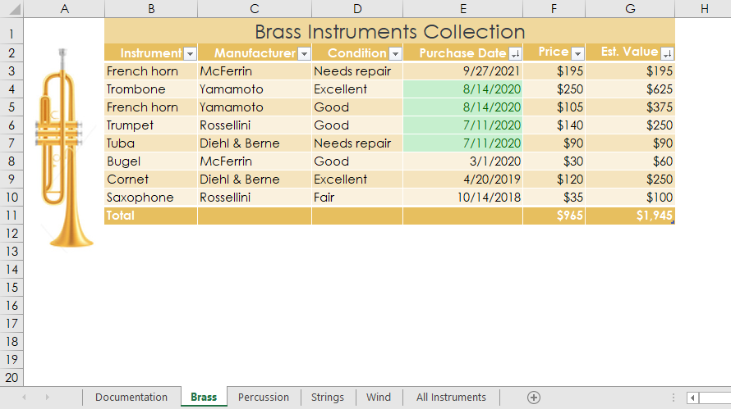

* Final Figure 2: Percussion Worksheet

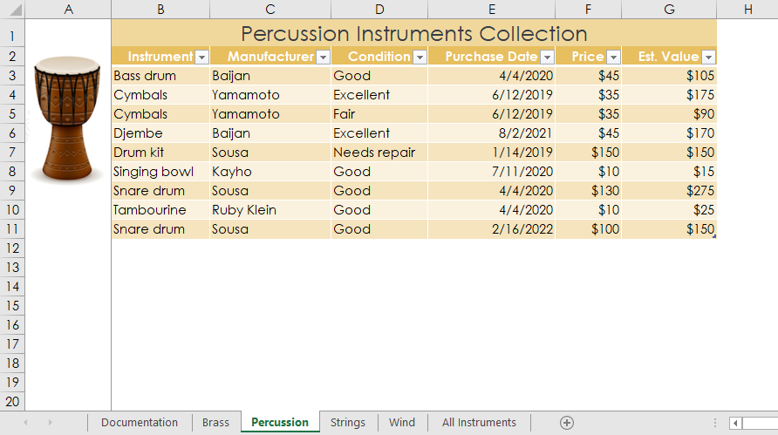

* Final Figure 3: Strings Worksheet

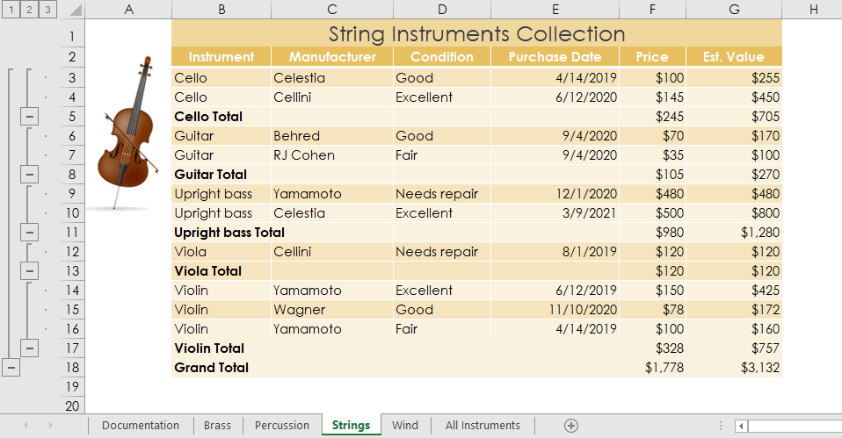

* Final Figure 4: Wind Worksheet

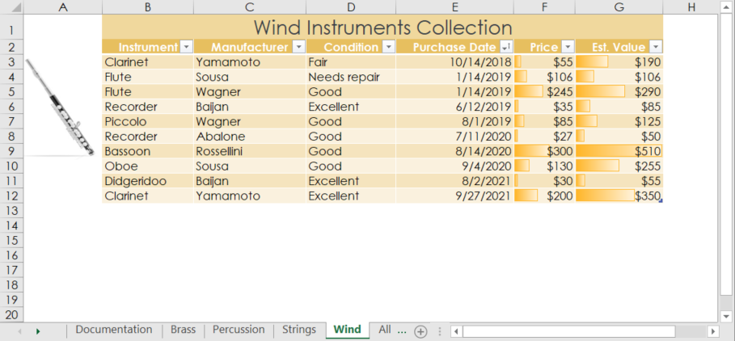

* Final Figure 5: All Instruments Worksheet

