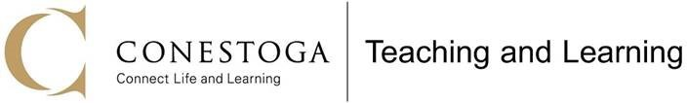

Faculty Reflections& Feedback: Developmental Observation of Teaching

Please use these questions to guide your reflections and feedback on the observation and notes that were shared with you by your observer. We ask that you please save this document with your first and last name and return it to your observer as soon as possible.

Name of Observer: David MacLennan
Name of Faculty: Mukto Akash
Date of Observation: June 17, 2025

- Of all the observations shared with you, which one resonated the most and why?
- It was great to see that my cordial relationship with the students was observable.

- Did everything go according to plan during the lesson? If you could change anything, what would you have done differently?
- I had to make some minor adjustments to the flow of the lecture on the fly, and prioritize certain concepts over others. One thing that I would definitely improve upon is to provide a bit more of a foreshadow/motivation as to why we are covering the content to such detail.

- After reflecting on your lesson and reading the observer's comments, two or three strategies/practices you will start implementing in your next classes are as follows:
- Using guided videos as bridge-in is a great idea. There are certain aspects of the lecture where the dynamic nature of videos would be of great help.
- Paired interaction is another aspect that I want to do more of
- I want to prompt students to ask more leading questions that help introduce the next part of the lecture

- What are some general teaching topics you’d like to learn more about in courses and/or workshops from Teaching and Learning?
- Cognitive load theory, specifically how to assist students’ uptake of complicated mathematical information can be improved through design of lecture content and presentation.
- Effective open discussions in class to reflect on the content being taught: when to do this, how to initiate and engage, and how to manage the discussion to stay on topic.
- Teaching Philosophy Statements and how to teach according to your philosphy

- In the debrief, I would like to discuss/learn about the following:
- Would a problem based learning approach work when teaching very pedantic content?

