***FRACKTAL WORKS COURSE SUBMISSION  
CONTENTS: FUSION 360 CAD, FRITZING SCHEMATIC, MICROCONTROLLER SKETCH***

**Introduction:**

One of the best aspects of this course is how it emphasizes the need of getting started with building projects. No matter how much knowledge one gains, it will always play second fiddle to one’s building skills. I am someone who is quite familiar with the basics of engineering, but without any significant project to bring everything together, I often felt underconfident whenever I was asked to carry out a hands-on task. I’d be clumsy, slow, underconfident and shaky trying to do pretty much anything. It was clear to me that I needed some hands-on experience and I set out to rectify this. To that end, I put together my very own MiniBot.

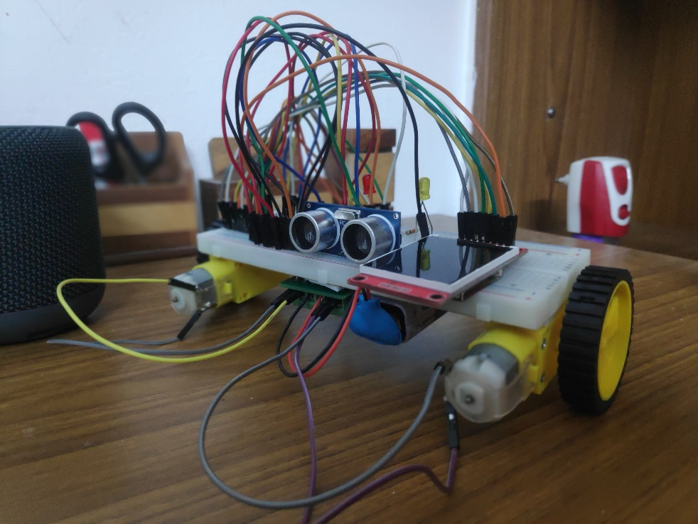  
  
**Inspiration:**   
  
There are several lessons I learned from my experience building the MiniBot. Namely, the importance of making my build as streamlined as possible, having a few backup plans in case I’m unable to put together my most desirable build and most importantly, not being afraid of cutting out features that slow down progress too much. With a few sensors, a breadboard and a couple of wheels, one can easily bring together something tangible, and considering this is my first solo project, I’d say it turned out pretty well.   
  
**Description:**

The MiniBot uses an Arduino Nano, an SR04 ultrasonic sensor and a TFT screen. It drives its two DC motors using the L293D breakout board. The entire setup is powered using a 9V battery.   
It was initially planned that the bot would be controlled remotely. Unfortunately, the NRF24L01 modules that would facilitate radio comms turned out to be bootlegs, and I couldn’t get them to work.   
  
As for the bot’s operation, it’s quite simple. Once a button is pressed, the motors and the ultrasonic sensors are activated. If the SR04 reading drops below a certain value, the motors stop rotating until the obstacle is removed. The TFT screen displays the mode of operation of the bot, either standby or active.   
  
**Conclusion:**

This was an incredibly fun exercise and helped me gain confidence in building my own projects. Despite its simplicity, the MiniBot will always hold a special place in heart as the first robotics project I undertook.   
  
Note: Please see the attached documents for added information, like the 3D model (Desired), the circuit schematic and the code.  
  
