**Cantilever Support:**

**Initial (Unrefined) Design:**

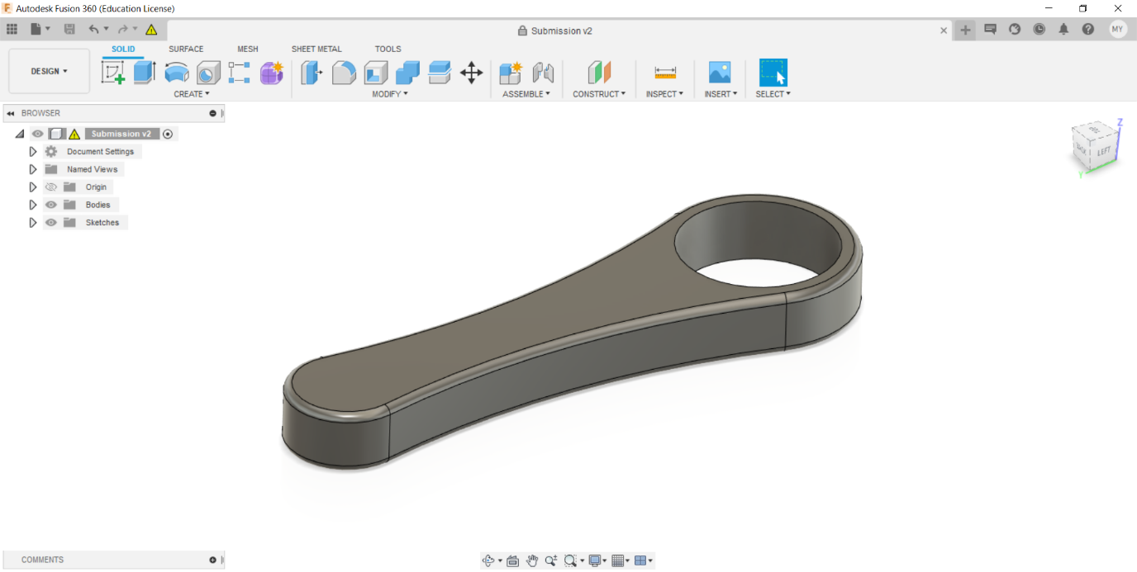

**Topology Optimization Study:  
  
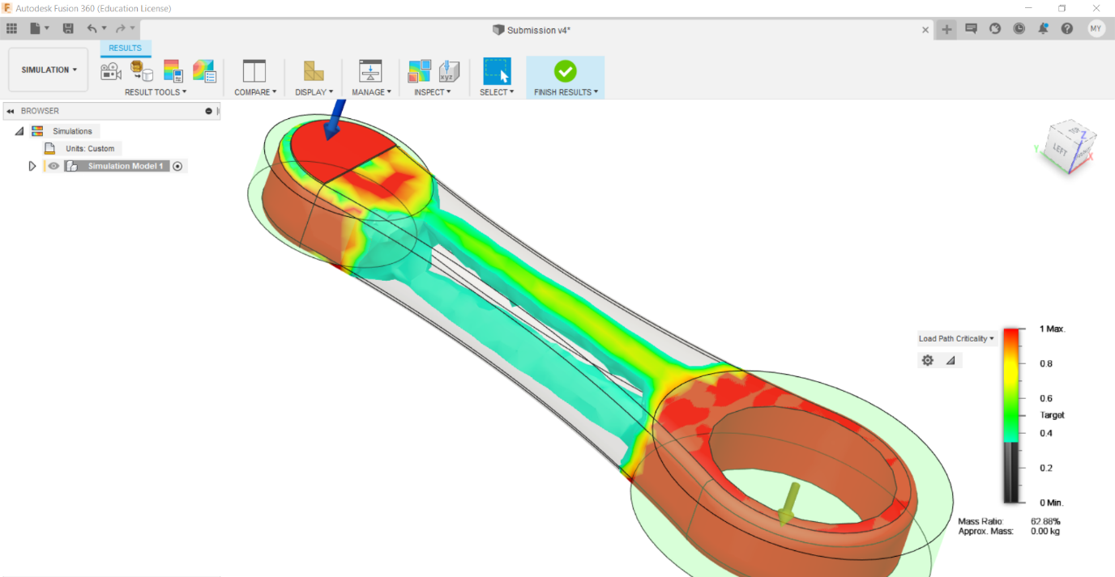  
  
Load: 10N, Gravity turned ON. Fixed support on the larger cylindrical face. Material: ABS plastic, Mass Target: 60% or lower.**

**Design Modification/Mesh Promotion:  
  
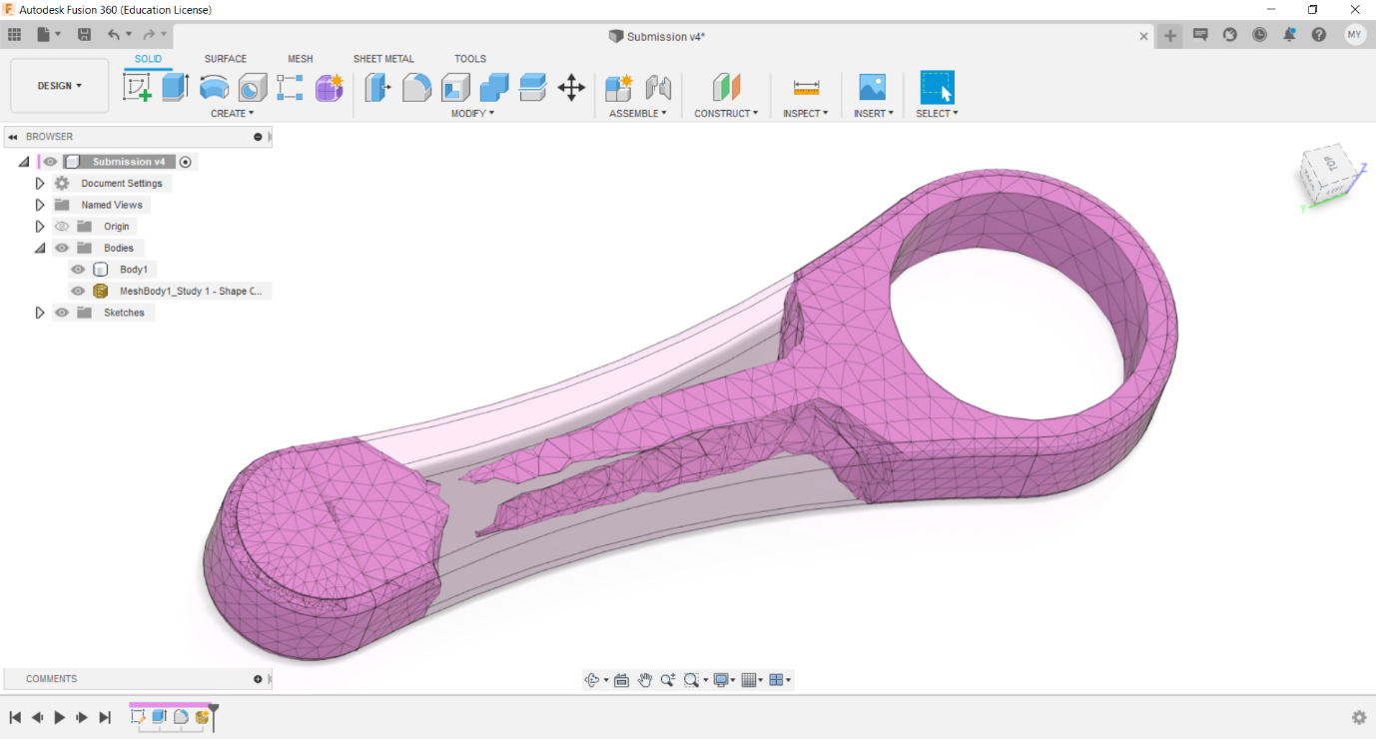  
  
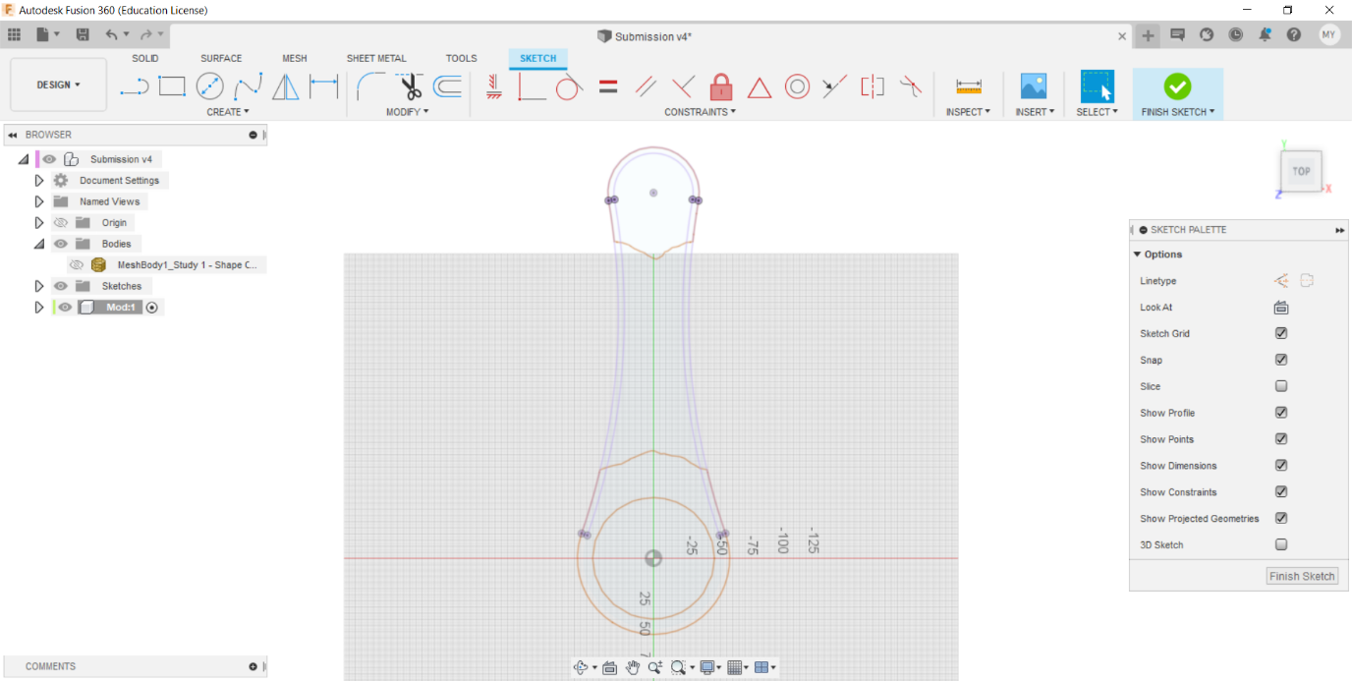**

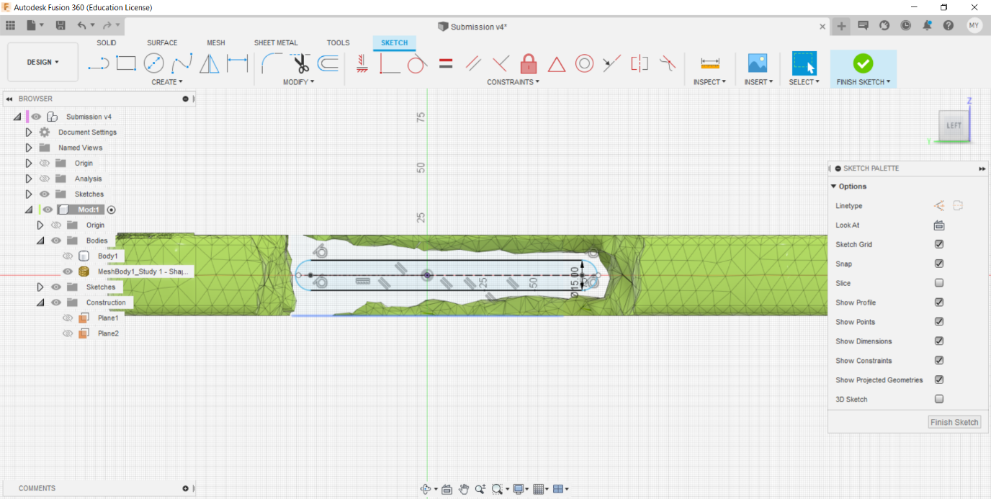

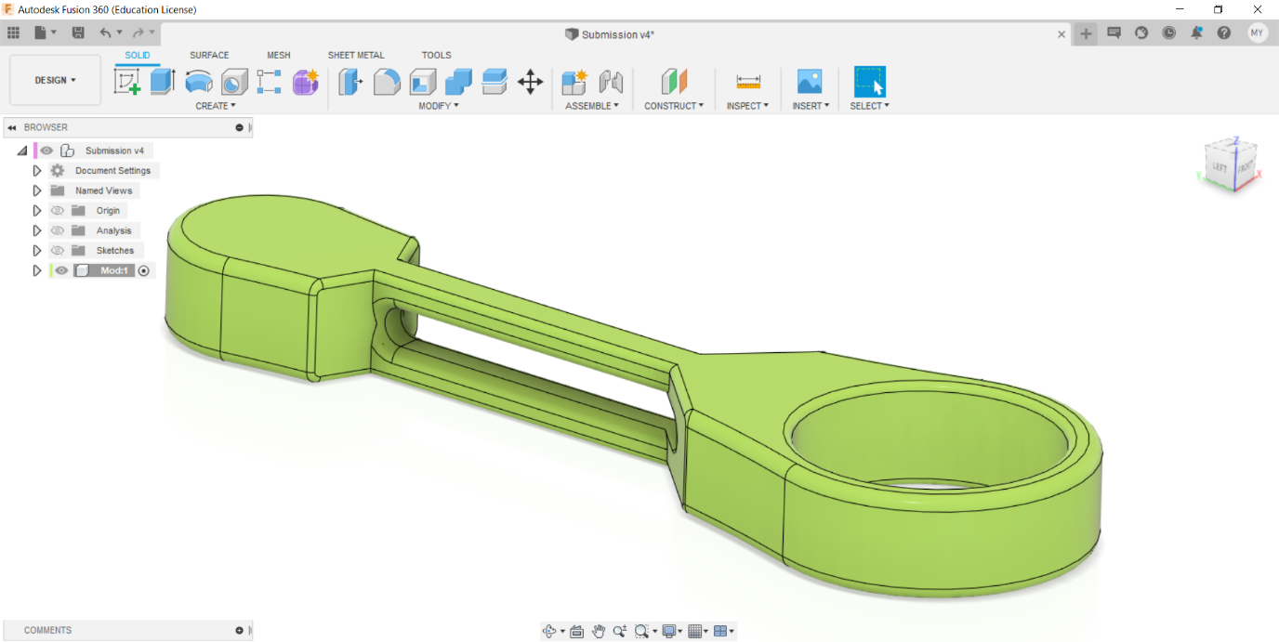

**Static Stress Study Results:  
  
