PROGRAM-12

AIM : Implementation of Bellman Ford Algorithm in C Language.

ALGORITHM:

Bellman_Ford(g[][],s,n)
1. for i=0 to v-1
2. d[i]=32000
3. p[i]=0
4. d[s]=0
5. p[0]=0
6. for k=0 to v-2
7. for i=0 to v-1
8. for j=0 to v-1
9. if (d[j]>d[i]+a[i][j])
10. d[j]=d[i]+a[i][j]
11. p[j]=i

PROGRAM SOURCE CODE:

#include<stdio.h>
int main()
{
int a[100][100],v,i,j,d[100],s;
int p[100],k;

printf("Enter the no. of vertices ");
scanf("%d",&v);

for(i=0;i<v;i++)
{
for(j=0;j<v;j++)
{
scanf("%d",&a[i][j]);
}
}

printf("\nEnter the source node: ");
scanf("%d",&s);

for(i=0;i<v;i++)
{
d[i]=32000;
p[i]=0;
}
d[s]=0;
p[0]=0;

for(k=0;k<v-1;k++)
{
for(i=0;i<v;i++)
{
for(j=0;j<v;j++)
{
if(d[j]>d[i]+a[i][j])
{
d[j]=d[i]+a[i][j];
p[j]=i;
}
}
}
}

for(i=0;i<v;i++)
{
printf("%d ",d[i]);

}
printf("\n");
return 0;
}

OUTPUT:

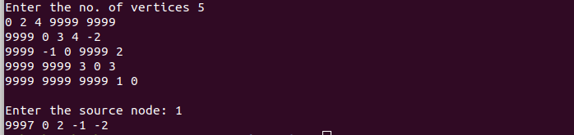

PROGRAM-13

AIM : Implementation of Dijkstra Algorithm in C Language.

ALGORITHM:

Dijkstra( g[][], s, n)
1. for u=0 to n-1
2. d[u]=INT_MAX
3. p[u]=0
4. d[s]=0
5. for u=0 to n-1
6. q[u]=0
7. i=0
8. while i<n-1
9. u=Extract_min(d,q,n)
10. for v=0 to n-1
11. if(d[v]>d[u]+g[u][v])
12. d[v]=d[u]+g[u][v]
13. p[v]=u
14. i++

PROGRAM SOURCE CODE:

#include<stdio.h>
#define INT_MAX 9999
int Extract_min(int d[],int q[],int n)
{
int index,min=INT_MAX,i;
for(i=0;i<n;i++)
{
if(q[i]==1)
continue;
else {
if(d[i]<min)
{ min=d[i];
index=i;
}
}
}
q[index]=1;
return index;
}
void Dijkstra(int g[20][20],int s,int n)
{
int d[n],p[n],u,i,v,q[n];
for(u=0;u<n;u++)
{
d[u]=INT_MAX;
p[u]=0;
}
d[s]=0;
for(u=0;u<n;u++)
{
q[u]=0;
}
i=0;
while(i<n)
{
u=Extract_min(d,q,n);
for(v=0;v<n;v++)
{
if(d[v]>d[u]+g[u][v])
{
d[v]=d[u]+g[u][v];
p[v]=u;
}
}
i++;
}
for(i=0;i<n;i++)
printf("%d ",d[i]);
}
int main()
{
int n,a[20][20],s,i,j;
scanf("%d",&n);

for(i=0;i<n;i++)
{
for(j=0;j<n;j++)
{
scanf("%d",&a[i][j]);
}
}
scanf("%d",&s);
Dijkstra(a,s,n);
return 0;
}

OUTPUT:
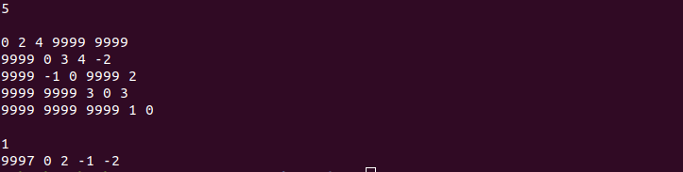
PROGRAM-14

AIM : Implementation of Floyd Warshall Algorithm in C Language.

ALGORITHM:

Floyd_Warshall(g[][],n)

1. for i=1 to n
2. for j=1 to n
3. a[0][i][j]=g[i][j]
4. for k=1 to n
5. for i=1 to n
6. for j=1 to n
7. a[k][i][j]=min(a[k-1][i][j],a[k-1][i][k]+a[k-1][k][j])

PROGRAM SOURCE CODE:

#include<stdio.h>
#define min(a,b) a<b?a:b
void Floyd(int g[20][20],int n)
{
int a[20][20][20],i,j,k;

for(i=1;i<=n;i++)
for(j=1;j<=n;j++)
a[0][i][j]=g[i][j];

for(k=1;k<=n;k++)
{
for(i=1;i<=n;i++)
{
for(j=1;j<=n;j++)
{
a[k][i][j]=min(a[k-1][i][j],a[k-1][i][k]+a[k-1][k][j]);
}
}
}

for(i=1;i<=n;i++)
{
for(j=1;j<=n;j++)
{
printf("%d ",a[n][i][j]);
}
printf("\n");
}

}
int main()
{
int n,a[20][20],i,j,A;
scanf("%d",&n);

for(i=1;i<=n;i++)
for(j=1;j<=n;j++)
scanf("%d",&a[i][j]);

Floyd(a,n);
return 0;

}

OUTPUT:

