***Organic Tutorial 1***

***Write the problem in the board first and ask the student to solve themselves, after some time you solve it or give the answer, most of the students are expected to know.***

**Q 1. Iron is extracted from its ore using carbon. The reaction is shown below. Calculate the atom economy of the reaction (MWt of Fe= 56)**



**Q 2. Molecular weight of (Ti = 48 and Mg = 24 to be used) for the following reaction**

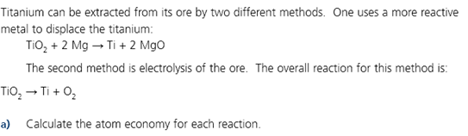



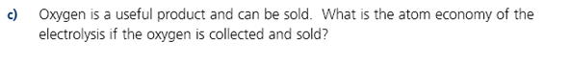

**Q 3. In a chemical synthesis of CaO, calcium carbonate is roaster in an oven. The equation for the reaction is**



If 50 kg of CaCO3 is used and 21 kg CaO is made, what is the percentage yield of the reaction and atom economy of the reaction?

**Q.4. Calculate the E-factor for the preparation of the following catalyst (Pt-GLY) obtained in 1.328.**

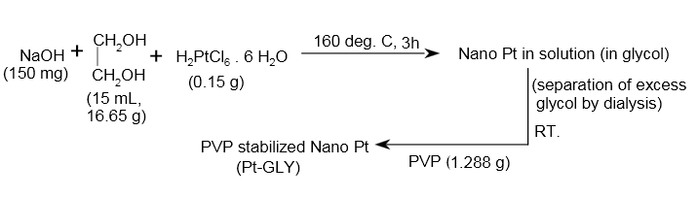

**5. Calculate the E-factor for the preparation of the Catalyst 1 and Catalyst 2.**

