

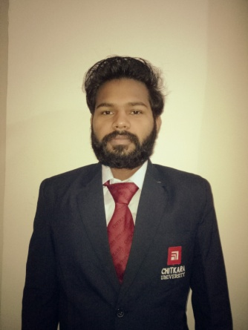

**CHITKARA INSTITUTE OF ENGINEERING & TECHNOLOGY**

Mukul Chauhan

#937/8 Mohalla Chaudhiran

Dera Bassi, Punjab

+91-8146393459

[mukulchauhan1997@gmail.com](mailto:mukulchauhan1997@gmail.com)

https://github.com/mukulchauhan97

**EDUCATION:**

|  |  |  |  |  |
| --- | --- | --- | --- | --- |
| **Qualification/Degree** | **School/College** | **University or Board** | **Year** |  |
| B. E. (CSE) | Chitkara School of Engg. & Tech., Punjab | Chitkara University | 2016-2020 |  |
| Class XII | Sri Sukmani International School , Dera | C.B.S.E | 2014-2015 |  |
| Bassi |  |
|  |  |  |  |
| Class X | Sri Sukmani International School , Dera | C.B.S.E | 2012-2013 |  |
| Bassi |  |
|  |  |  |  |

**PROFESSIONAL SKILLS:**

* **Languages:** C++(Intermediate) , HTML(Intermediate) , CSS (Intermediate) , CoreJAVA(Intermediate) , Javascript(Beginner)
* **Concepts:** Data Structures (Intermediate)
* **DBMS:** SQL/PL SQL
* **Online Certifications in :** HTML

**(Mukul Chauhan)**