ECE 4263

Lab3 (part A)

Mukul Deshpande

Msd153

Working of ALU:

1. AND :

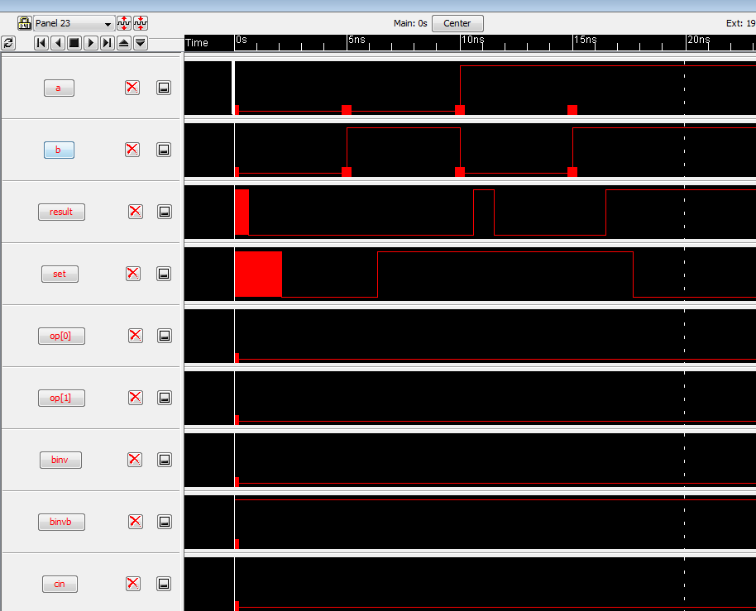

Simulation of AND operation

Annotation:

l binv

h binvb

l op[1]

h opb[1]

l op[0]

h opb[0]

| 0 & 0 = 0

l a

l b

s 5

assert result 0

| 0 & 1 = 0

l a

h b

s 5

assert result 0

| 1 & 0 = 0

h a

l b

s 5

assert result 0

| 1 & 1 = 1

h a

h b

s 5

assert result 1

1. OR:

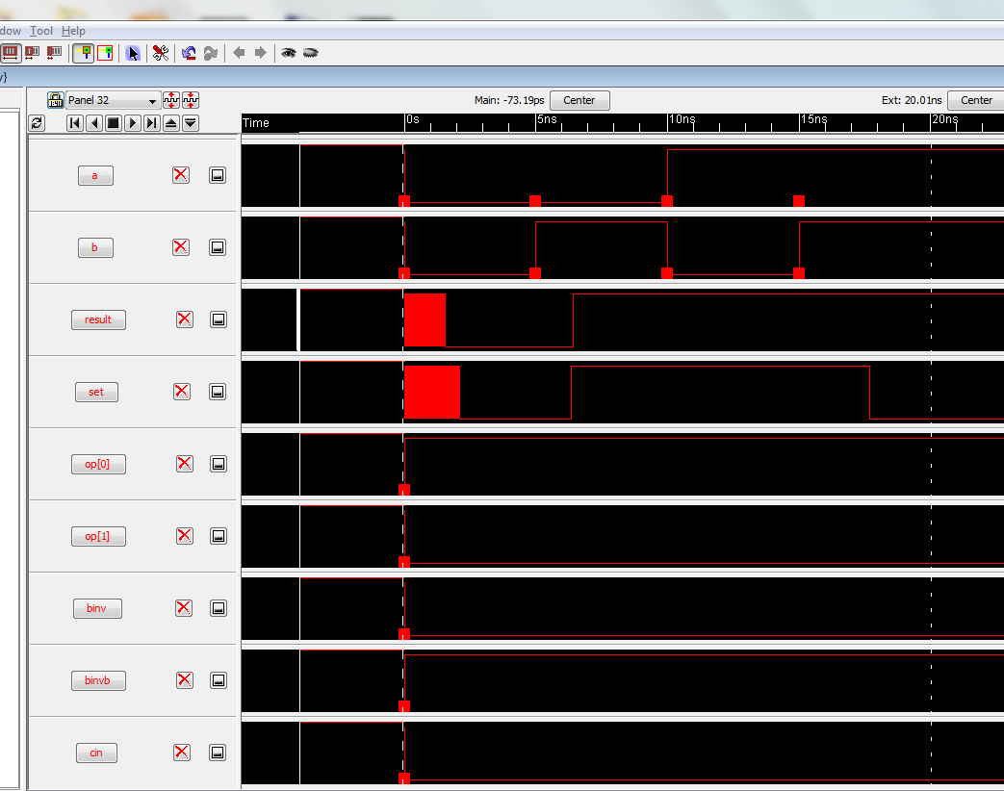

Simulation of OR operation

Annotation:

l binv

h binvb

l op[1]

h opb[1]

h op[0]

l opb[0]

| 0 | 0 = 0

l a

l b

s 5

assert result 0

| 0 | 1 = 1

l a

h b

s 5

assert result 1

| 1 | 0 = 1

h a

l b

s 5

assert result 1

| 1 | 1 = 1

h a

h b

s 5

assert result 1

1. ADD:

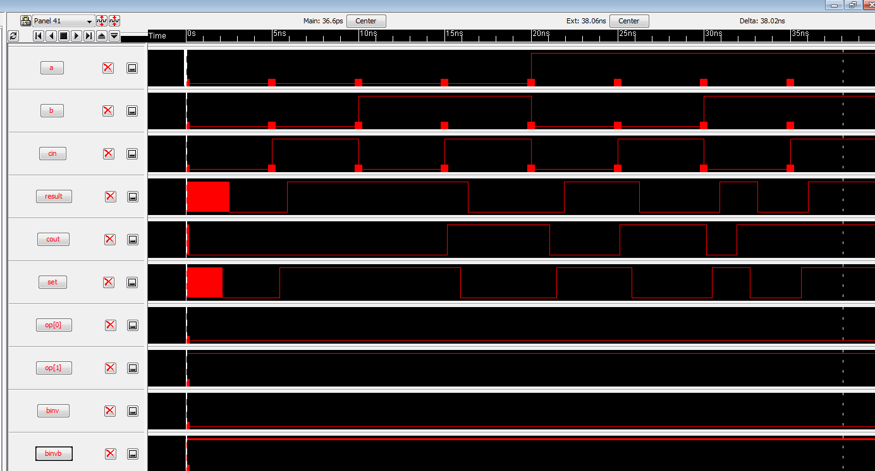 Simulation of ADD

Annotation:

l binv

h binvb

h op[1]

l opb[1]

l op[0]

h opb[0]

| 0 + 0 + 0 = 00

l a

l b

l cin

s 5

assert result 0

assert cout 0

| 0 + 0 + 1 = 01

l a

l b

h cin

s 5

assert result 1

assert cout 0

| 0 + 1 + 0 = 01

l a

h b

l cin

s 5

assert result 1

assert cout 0

| 0 + 1 + 1 = 10

l a

h b

h cin

s 5

assert result 0

assert cout 1

| 1 + 0 + 0 = 01

h a

l b

l cin

s 5

assert result 1

assert cout 0

| 1 + 0 + 1 = 10

h a

l b

h cin

s 5

assert result 0

assert cout 1

| 1 + 1 + 0 = 10

h a

h b

l cin

s 5

assert result 0

assert cout 1

| 1 + 1 + 1 = 11

h a

h b

h cin

s 5

assert result 1

assert cout 1

SUB:

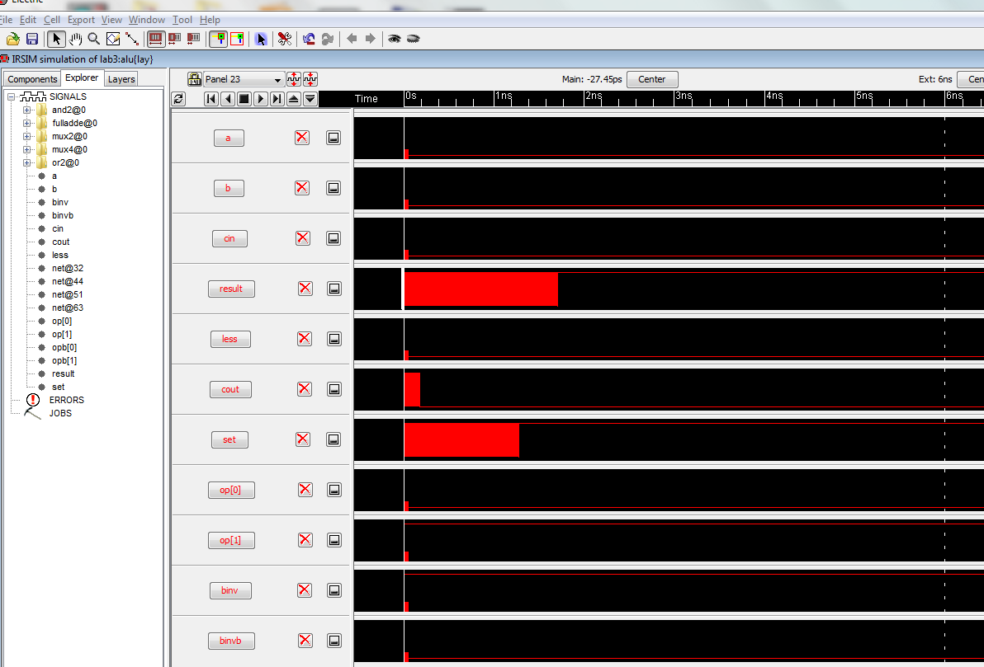 simulation of SUB

Annotation:

h binv

l binvb

h op[1]

l opb[1]

l op[0]

h opb[0]

| 0 + 0b + 0 = 01 (just test one case to verify inversion works)

l a

l b

l cin

s 5

assert result 1

assert cout 0

SLT:

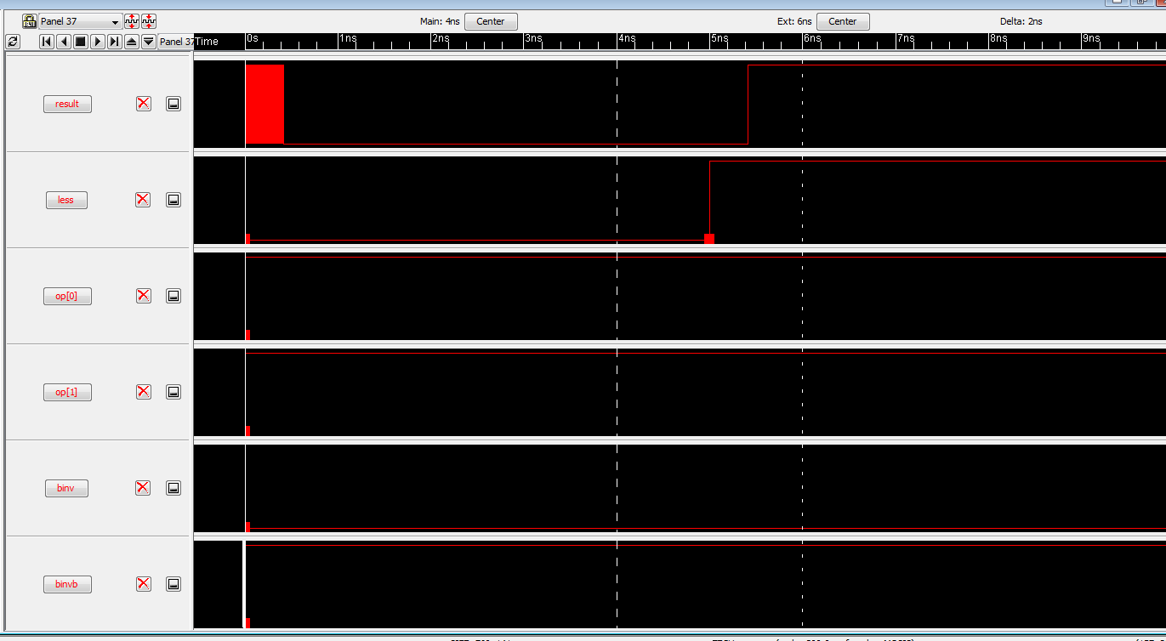 simulation of SLT

Annotation:

l binv

h binvb

h op[1]

l opb[1]

h op[0]

l opb[0]

| less = 0

l less

s 5

assert result 0

| less = 1

h less

s 5

assert result 1

Hours Spent on the lab: Around 1-1.5 hours.