ECE 4263

Lab-6(A) Gate Family

Mukul Deshpande

Msd153

1)Schematics

A) Static_Cmos

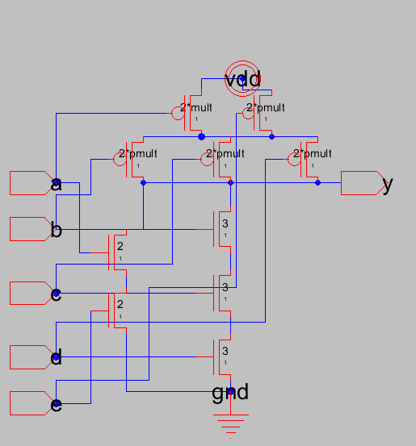

subckt static_cmos_gate (a b c d e y vddc gndc)

parameters size=1

m1 (y a net29 gndc) n_def ws=2*size ls=1

m2 (net29 e gndc gndc) n_def ws=2*size ls=1

m3 (y b net28 gndc) n_def ws=3*size ls=1

m4 (net28 c net27 gndc) n_def ws=3*size ls=1

m5 (net27 d gndc gndc) n_def ws=3*size ls=1

m6 (y b net26 vddc) p_def ws=2*p_mult*size ls=1

m7 (y c net26 vddc) p_def ws=2*p_mult*size ls=1

m8 (y d net26 vddc) p_def ws=2*p_mult*size ls=1

m9 (net26 a vddc vddc) p_def ws=2*p_mult*size ls=1

m10 (net26 e vddc vddc) p_def ws=2*p_mult*size ls=1

ends static_cmos_gate

B) Pseudo_nmos

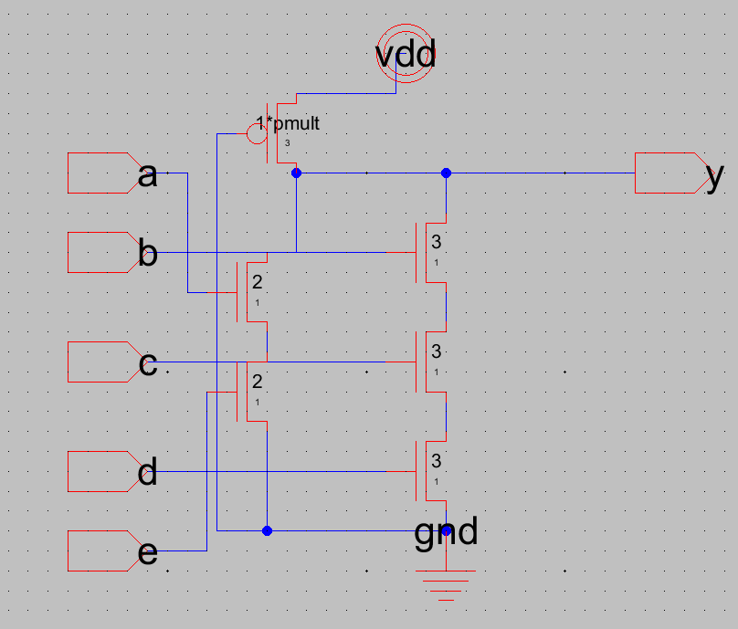

subckt psuedo_nmos_gate (a b c d e y vddc gndc)

parameters size=1

m1 (y a net29 gndc) n_def ws=2*size ls=1

m2 (net29 e gndc gndc) n_def ws=2*size ls=1

m3 (y b net28 gndc) n_def ws=3*size ls=1

m4 (net28 c net27 gndc) n_def ws=3*size ls=1

m5 (net27 d gndc gndc) n_def ws=3*size ls=1

m6 (y gndc vddc vddc) p_def ws=1*p_mult*size ls=3

ends psuedo_nmos_gate

2) Truth_table

|  |  |  |  |  |  |  |
| --- | --- | --- | --- | --- | --- | --- |
| Case | A | B | C | D | E | Y=NOT(AE+BCD) |
| 1 | 0 | 0 | 0 | 0 | 0 | 1 |
| 2 | 0 | 0 | 0 | 0 | 1 | 1 |
| 3 | 0 | 0 | 0 | 1 | 0 | 1 |
| 4 | 0 | 0 | 0 | 1 | 1 | 1 |
| 5 | 0 | 0 | 1 | 0 | 0 | 1 |
| 6 | 0 | 0 | 1 | 0 | 1 | 1 |
| 7 | 0 | 0 | 1 | 1 | 0 | 1 |
| 8 | 0 | 0 | 1 | 1 | 1 | 1 |
| 9 | 0 | 1 | 0 | 0 | 0 | 1 |
| 10 | 0 | 1 | 0 | 0 | 1 | 1 |
| 11 | 0 | 1 | 0 | 1 | 0 | 1 |
| 12 | 0 | 1 | 0 | 1 | 1 | 1 |
| 13 | 0 | 1 | 1 | 0 | 0 | 1 |
| 14 | 0 | 1 | 1 | 0 | 1 | 1 |
| 15 | 0 | 1 | 1 | 1 | 0 | 0 |
| 16 | 0 | 1 | 1 | 1 | 1 | 0 |
| 17 | 1 | 0 | 0 | 0 | 0 | 1 |
| 18 | 1 | 0 | 0 | 0 | 1 | 0 |
| 19 | 1 | 0 | 0 | 1 | 0 | 1 |
| 20 | 1 | 0 | 0 | 1 | 1 | 0 |
| 21 | 1 | 0 | 1 | 0 | 0 | 1 |
| 22 | 1 | 0 | 1 | 0 | 1 | 0 |
| 23 | 1 | 0 | 1 | 1 | 0 | 1 |
| 24 | 1 | 0 | 1 | 1 | 1 | 0 |
| 25 | 1 | 1 | 0 | 0 | 0 | 1 |
| 26 | 1 | 1 | 0 | 0 | 1 | 0 |
| 27 | 1 | 1 | 0 | 1 | 0 | 1 |
| 28 | 1 | 1 | 0 | 1 | 1 | 0 |
| 29 | 1 | 1 | 1 | 0 | 0 | 1 |
| 30 | 1 | 1 | 1 | 0 | 1 | 0 |
| 31 | 1 | 1 | 1 | 1 | 0 | 0 |
| 32 | 1 | 1 | 1 | 1 | 1 | 0 |

3) waveform

A)Static_CMOS

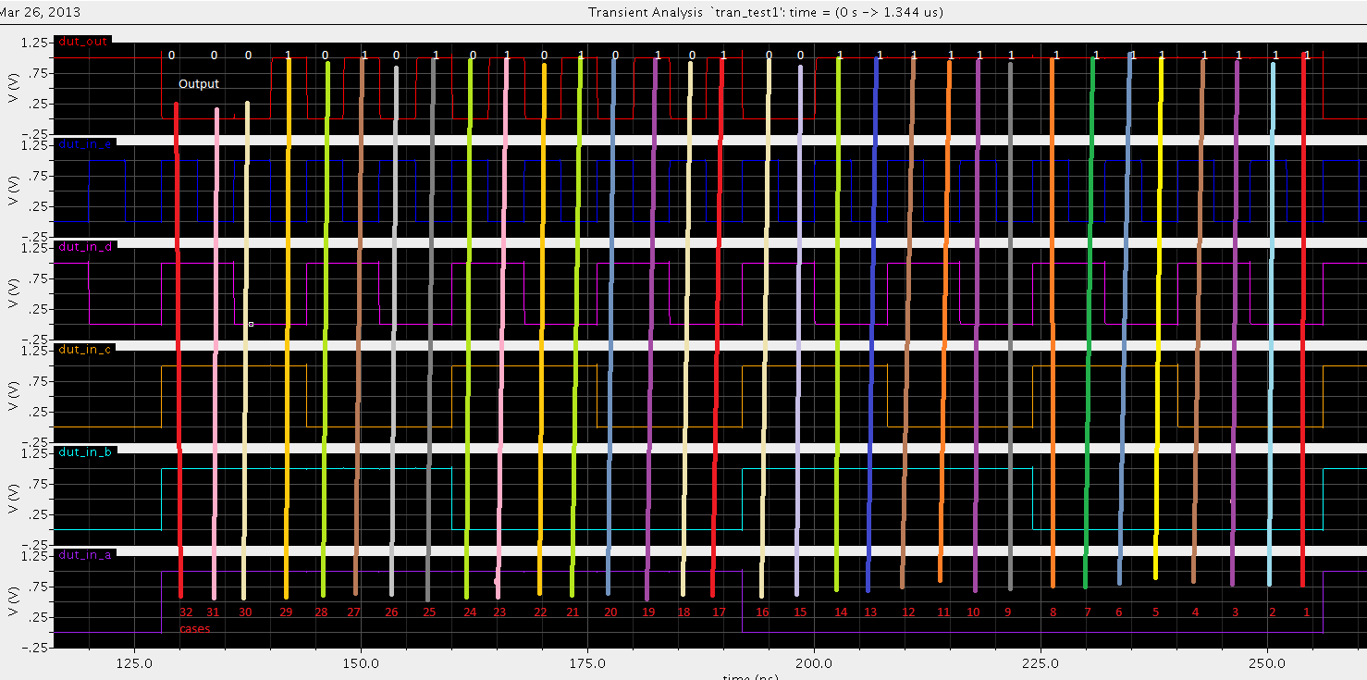

B) Psuedo_NMOS

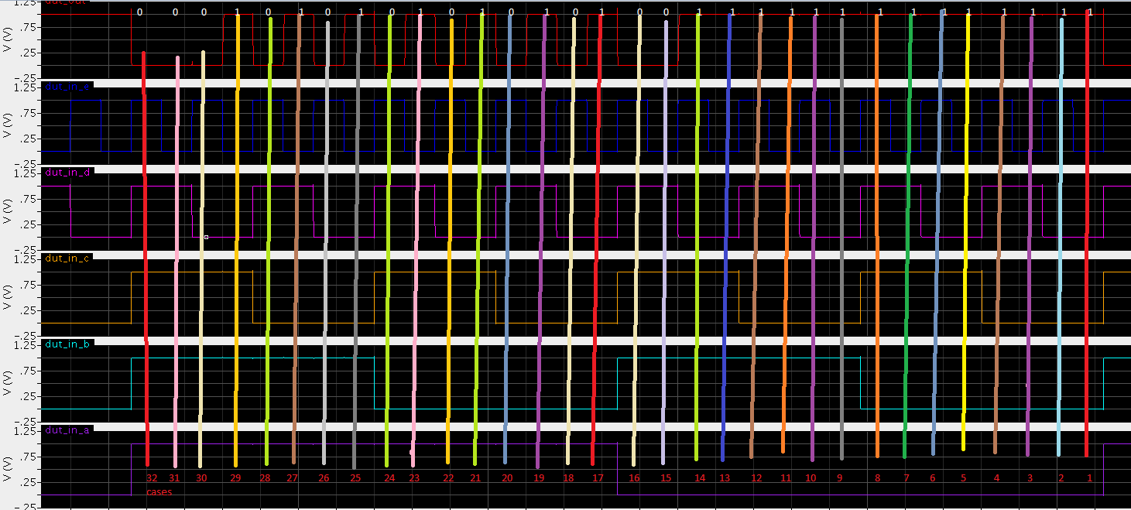

4) I spent around 19-20 hours on this lab as I had figure out the instructions needed thinking.