AI20001 — The Essentials of Machine Learning
Complete Exam Guide
Theory in easy language • Formulas explained • Derivations • How to use each formula • Every PYQ & slide question solved step-by-step • Traps, twists and new-question practice • Master formula sheet • Summary

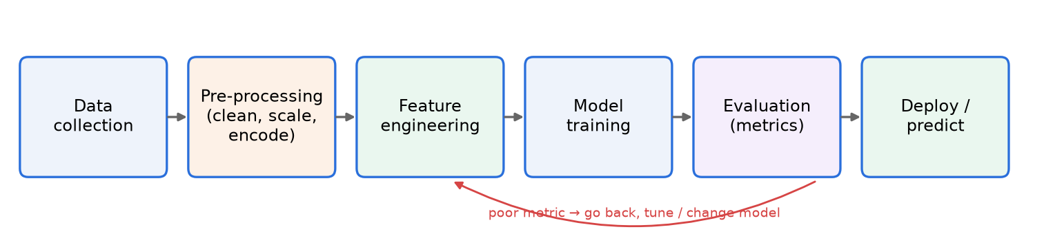

What is inside | Where
Part A — Midsem syllabus (Lectures 1–7): Intro & metrics, KNN, Linear/Logistic regression & Gradient Descent, Perceptron, Decision Trees, Naïve Bayes, SVM, Bias–Variance, AdaBoost | Chapters 1–9
Part B — Topics that appear in your PYQs from later in the course: Clustering (K-means, Hierarchical, GMM), PCA/SVD & feature selection, Neural Networks, CNN, RNN/Transformer | Chapters 10–13
Part C — Master formula sheet, one-page summaries, exam-day checklist | Chapters 14–15
Part D — ALL solved PYQs & slide questions, paper by paper in the original question order (theory first, questions at the end) | Part D (end)

Built from your slides (Lectures 1, 2, 3, 4, 6, 6-bias-variance, 7 by Dr. Shreya Ghosh) and ALL the question papers in your zip: Midsem Autumn 2025, Midsem Spring 2026, End-sem Autumn 2025, End-sem Spring 2026, Class Tests 1A/1B/2A/2B (Spring 2026), Class Test 2 Sets 1 & 2, Class Test II (Autumn 2025 MCQ) and the 2025 CT-2 MCQ sheet.

How to use this guide (read this first — 2 minutes)
💡 In easy language
Theory comes first (Parts A–C); all solved questions are at the end (Part D). Every chapter follows the SAME pattern:
1. Theory in easy language — what the idea is and why it exists.
2. Keywords — words the examiner loves; use them in written answers.
3. Formulas + what every symbol means.
4. Derivation of the important formulas (the ones asked as "derive…").
5. How to use — a fixed recipe you can follow in the exam hall.
6. Use cases — where the method is used in real life (good for theory questions).
7. Solved PYQs — at the END (Part D), paper by paper in the original question order — each with: How to think → Step-by-step solution → Final answer → Edge cases/traps → How it can be twisted → Make your own new question.

Which exam is this for?
Your Lecture 3 & 6 slides say the quiz was on 7 Sep 2026 (syllabus: Intro, KNN, Linear Regression, Decision Tree, Naïve Bayes, SVM) and the course plan puts the Midsem in week 8. So the paper in two days is almost certainly the Autumn 2026 Midsem. Part A covers exactly that syllabus in full depth.
📌 Exam tip
Do NOT skip Chapter 9 (AdaBoost) and Chapter 10 (K-means + Hierarchical clustering). The Autumn 2025 midsem — the same semester last year — asked K-means (8 marks), Single-link dendrogram (6 marks) and AdaBoost (7 marks). That is 21 of 50 marks from topics taught near the midsem boundary.
Part B (PCA, NN, CNN, RNN) is included so that every question in your files is solved — read it after Part A if time permits.

Exam blueprint — what has been asked (from your PYQs)
Topic | Where it was asked (marks) | Priority
Decision Tree: Entropy, Information Gain, ID3, Gain Ratio | Midsem-25 Q4 (12), Midsem-26 Q3 (10), CT-1A Q3 (10), Endsem-26 Q2b (5) | ★★★★★
Linear Regression + Gradient Descent (full / mini-batch / SGD) | Midsem-25 Q3 (9), Midsem-26 Q1A,B (6), CT-1A Q2 (5), Endsem-25 Q6d | ★★★★★
SVM (hyperplane, SVs, α, soft margin, kernel) | Midsem-25 Q2 (8), Midsem-26 Q2A,B (5), Endsem-26 Q1c (4) | ★★★★★
Perceptron / Logistic regression / Cross-entropy / loss matrix | CT-1B Q1 (8), CT-1B Q3 (5), CT-1A Q1 (5), Midsem-26 Q1C (4), Endsem-26 Q1a,b (6) | ★★★★☆
K-Means + Hierarchical clustering | Midsem-25 Q1 (8) & Q6 (6), CT-2A/2B, Endsem-26 Q3 | ★★★★☆
KNN (distances, K choice, imputation) | Midsem-26 Q2C (5), CT-1B Q2 (7) | ★★★★☆
Naïve Bayes (counting, Gaussian, parameters) | Midsem-26 Q4A (4), Endsem-26 Q2a (5) | ★★★★☆
AdaBoost | Midsem-25 Q5 (7), Midsem-26 Q4C (3) | ★★★☆☆
Bias–Variance | Midsem-26 Q4B (3), Endsem-25 Q6b, MCQs | ★★★☆☆
PCA / SVD / NN / CNN / RNN | Class tests 2, End-sems | after midsem

2-day study plan
When | What to do
Day 1 morning | Ch 1–3 (Intro, KNN, Regression + GD). Re-solve Midsem-25 Q3 and Midsem-26 Q1 on paper without looking.
Day 1 afternoon | Ch 4–5 (Perceptron/Logistic, Decision Trees). Re-solve the house-listing ID3 tree fully.
Day 1 night | Ch 6–7 (Naïve Bayes, SVM). Re-solve Midsem-25 Q2 and Midsem-26 Q2A.
Day 2 morning | Ch 8–10 (Bias-Variance, AdaBoost, K-means, Hierarchical).
Day 2 afternoon | Do the "Make your own question" boxes for your weakest 3 topics. Read the traps boxes again.
Day 2 night | ONLY the Master Formula Sheet (Ch 14) + Summary (Ch 15). Sleep early.

Table of Contents
(In Word: right-click the line below → Update Field → Update entire table, to show page numbers.)
Right-click → Update Field to build the table of contents.

PART A — MIDSEM SYLLABUS

Chapter 1. Introduction to ML, the ML Pipeline & Evaluation Metrics

1.1 What is Machine Learning?
💡 In easy language
Normal programming: you write the rules → computer applies them.
Machine learning: you give the computer examples (data) → it learns the rules itself → applies them to new data.
Arthur Samuel (1959): "Field of study that gives computers the ability to learn without being explicitly programmed."
Tom Mitchell (1998): A program learns from experience E with respect to task T and performance measure P, if its performance at T (measured by P) improves with E. A well-defined learning task = ⟨P, T, E⟩.

Example | Task T | Experience E | Performance P
Spam filter | classify email spam / not spam | emails labelled by users | % emails correctly classified (or precision)
Checkers program (Samuel) | play checkers | games played against itself | % games won
Self-driving car | drive on roads | recorded driving + sensor data | distance without error / safety
House price model | predict price | past sales with prices | MSE / R² on new houses

AI vs ML vs DL: AI is the big goal (machines acting intelligently). ML ⊂ AI: learning from data. Deep Learning ⊂ ML: learning with many-layer neural networks. Why is ML hard? pose, illumination, occlusion, intra-class variation (same class looks very different), plus bias in data (e.g., gender bias in translation) and adversarial examples.

1.2 Data, variables and the ML pipeline
Figure 1.1 — The ML pipeline from the slides.
- Dataset = table. Instance / event = a row. Feature = a column used as input. Target / label = what we predict. Used for learning → called training data.
- Categorical variable: finite groups, maybe no order (gender, payment method). Discrete: countable numbers (students in class, dice outcome). Continuous: any value in a range (height, weight, time).
- Dataset split: training set (learn parameters), validation set (tune hyper-parameters like K, depth, λ), test set (final unbiased score — never touch while training).

Pre-processing (data cleaning + transformation)
Problem | Technique | Formula / idea
Missing value | Mean / Median / Mode imputation, deletion | median is better when outliers exist; mode for categorical
Outliers | Z-score method | z = (x − μ)/σ ; |z| > 3 ⇒ outlier
Noisy data | Binning, regression smoothing | group values into bins and replace by bin mean
Duplicates | Duplicate detection | remove repeated rows
Different scales | Min-Max normalisation | x′ = (x − x_{min}) / (x_{max} − x_{min}) ∈ [0,1]
Different scales | Z-score standardisation | x′ = (x − μ)/σ → mean 0, std 1
Text categories | One-hot / Label encoding | Red,Blue,Green → [1,0,0],[0,1,0],[0,0,1] ; or 0,1,2

Feature engineering
- Feature creation — domain-specific (business rules), data-driven (patterns), synthetic (combine features, e.g., BMI = weight/height²).
- Feature transformation — scaling, encoding, log transform for skewed data.
- Feature extraction — make new compact features, e.g., PCA (Chapter 11).
- Feature selection — keep a subset of original features: Filter (statistics like correlation), Wrapper (use model accuracy — e.g., forward selection / backward elimination), Embedded (inside training, e.g., Lasso, decision trees).

1.3 Types of learning
Type | Data | Goal | Examples
Supervised | (x, y) pairs — labelled | learn f: x → y | Classification (categorical y), Regression (continuous y)
Unsupervised | only x — no labels | find structure | Clustering, dimensionality reduction (PCA)
Semi-supervised | few labels + many unlabelled | use both | label propagation
Self-supervised | labels made from data itself | pre-training | predict masked word/image patch

- Classification: binary (spam / not spam) or multi-class (cat/dog/horse). Classification threshold = lowest probability at which we say "positive" (e.g., P(diabetic) > 0.5 → True).
- Regression: predict a continuous quantity (price, temperature, marks).
- Parametric model: fixed number of parameters, strong assumption about the shape of f (linear regression, logistic regression, Naïve Bayes). Non-parametric: parameters grow with data, few assumptions (KNN, Decision Tree).

1.4 Evaluation metrics
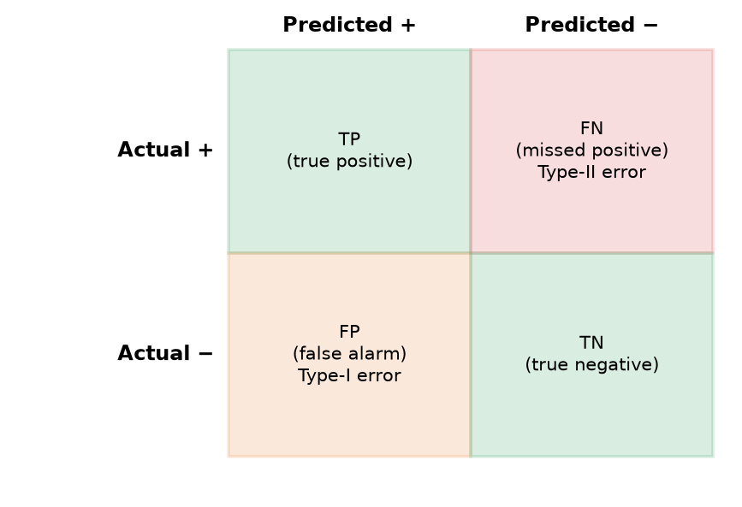
Figure 1.2 — Confusion matrix. Rows = actual, columns = predicted.
Classification metrics
Accuracy = (TP + TN) / (TP + TN + FP + FN)
Precision = TP / (TP + FP) Recall (Sensitivity, TPR) = TP / (TP + FN)
F1 = 2 · Precision · Recall / (Precision + Recall) Specificity (TNR) = TN / (TN + FP)

- Precision answers: "Of everything I called positive, how many really were?" → important when false positives are costly (spam filter should not throw away real mail).
- Recall answers: "Of all real positives, how many did I catch?" → important when missing a positive is costly (disease, fraud, pedestrian detection).
- F1 = harmonic mean → balances both; harmonic mean punishes if either one is small.
- Accuracy is misleading for imbalanced data (see the spam example in Part D).
Regression metrics
MSE = (1/n) Σ (y_{i} − ŷ_{i})² RMSE = √MSE MAE = (1/n) Σ |y_{i} − ŷ_{i}|
R² = 1 − SS_{res}/SS_{tot} = 1 − Σ(y_{i} − ŷ_{i})² / Σ(y_{i} − ȳ)²
R² ∈ [0,1] for a least-squares fit with intercept: fraction of variability of y explained by the model; bigger = better fit (it equals the square of the correlation R).

🔑 Keywords
P-T-E, instance, feature, target, training/validation/test split, imputation, normalisation, standardisation, one-hot encoding, feature extraction vs selection, supervised/unsupervised, parametric/non-parametric, confusion matrix, precision, recall, F1, specificity, class imbalance, overfitting, underfitting, generalisation.

1.5 Overfitting & underfitting (preview of Chapter 8)
- Overfitting: training accuracy very high (e.g. 99%), test accuracy poor → the model memorised noise. Cause: model too complex / too little data. Cure: simpler model, regularisation, more data, pruning, larger K in KNN.
- Underfitting: poor on both training and test → model too simple (high bias). Cure: more complex model, more features, less regularisation.
- Simple model → high bias, low variance; complex model → low bias, high variance. There is always a trade-off.

Chapter 2. K-Nearest Neighbours (KNN)

2.1 Theory
💡 In easy language
"Tell me who your friends are and I'll tell you who you are." To classify a new point, look at the K closest training points and take a majority vote of their labels. For regression, take the average of their values.
KNN does no training — it just stores all data (lazy learner / instance-based learning / memory-based). All the work happens at prediction time. It is non-parametric.

KNN needs three things: (1) the stored training records, (2) a distance metric, (3) the value of K. A rote learner only classifies if the test record matches a training record exactly; KNN relaxes this to "closest".
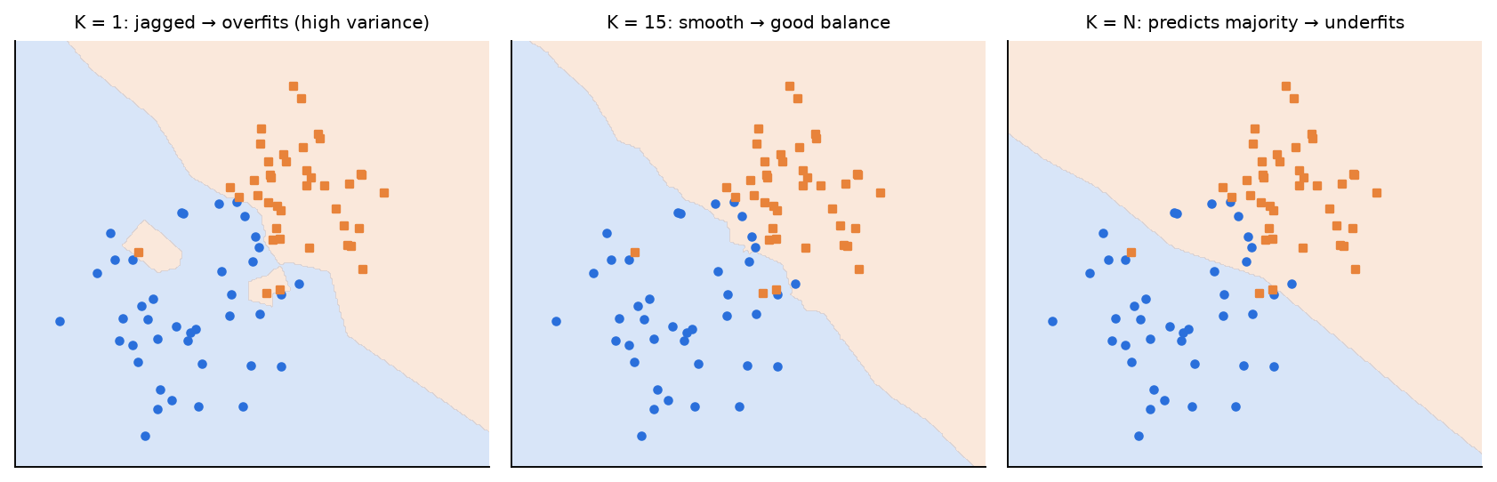
Figure 2.1 — Effect of K. Small K = noisy, jagged boundary (overfit). Large K = too smooth (underfit).
🔑 Keywords
instance-based, lazy learner, non-parametric, distance metric, Euclidean, Manhattan, Minkowski, majority vote, distance-weighted KNN, Voronoi diagram (1-NN), curse of dimensionality, feature scaling / z-score, VDM (nominal distance), HVDM, condensed nearest neighbour, kd-tree, LSH.

2.2 Formulas
Distance metrics
Euclidean (L2): d(x, z) = √( Σ_{j} (x_{j} − z_{j})² )
Manhattan (L1): d(x, z) = Σ_{j} |x_{j} − z_{j}|
Minkowski (Lp): d(x, z) = ( Σ_{j} |x_{j} − z_{j}|^{p} )^{1/p} (p=1 Manhattan, p=2 Euclidean, p→∞ Chebyshev = max_{j}|x_{j} − z_{j}|)

Prediction rules
Plain vote: y′ = argmax_{v} Σ_{(xᵢ,yᵢ) ∈ Dz} I(v = y_{i})
Distance-weighted: y′ = argmax_{v} Σ_{(xᵢ,yᵢ) ∈ Dz} w_{i} · I(v = y_{i}), w_{i} = 1 / d(x_{i}, z)²
KNN regression: ŷ = Σ w_{i} f(x_{i}) / Σ w_{i} (unweighted: all w_{i} = 1 → plain average)
D_z = set of the K training points closest to test point z; I(·) = 1 if true else 0.

Distance for nominal (categorical) & mixed data
VDM: d(v₁, v₂) = Σ_{c=1}^{C} | N(v₁,c)/N(v₁) − N(v₂,c)/N(v₂) |^{q}
HVDM(x, y) = √( Σ_{a} d_{a}(x_{a}, y_{a})² ), d_{a} = 1 if unknown; normalised VDM if nominal; normalised |diff| if numeric
Two category values are "close" if they lead to similar class distributions. q is usually 1 or 2.

Choosing K and other practical issues
- K too small → sensitive to noise, overfits (high variance). K too large → neighbourhood includes other classes, underfits (high bias). Pick K by validation / cross-validation. Use odd K for 2 classes to avoid ties; K = 1 is the "nearest-neighbour rule".
- Scale features! A feature with a big range (weight in kg, 50–200) dominates one with a small range (−3 to 3). Fix: z-score each feature.
- Cost: prediction needs distance to all N training points → O(N·d). Speed-ups: kd-trees, approximate distance (LSH), condensing (remove redundant points), vector databases.
- Curse of dimensionality: in high dimensions all points look almost equally far, needed data grows exponentially, partitioning trees degrade to linear search.
- 1-NN decision regions = Voronoi diagram (each cell = region closer to one training sample). Built in O(n log n) by Fortune's algorithm.
- Condensed NN (CNN): start store S with one random point; for every point in R, classify with 1-NN using S; if misclassified → move it to S. Repeat until a full pass adds nothing. Result depends on the order of points. Goal: smallest decision-boundary-consistent subset.
- Traditional KNN limitation: a far neighbour gets the same vote as a very close one → use distance-weighted KNN.
🛠️ How to use / step-by-step recipe
1. Scale features if ranges differ (z-score).
2. Compute the distance from the test point to every training point (make a table).
3. Sort distances; pick the K smallest (watch for ties at the K-th position).
4. Vote (or weighted vote with w = 1/d²) for classification; average for regression.
5. State the predicted class/value clearly.

🌍 Use cases
Recommendation systems ("people like you bought…"), missing-value imputation, handwriting / image retrieval, anomaly detection, medical diagnosis from similar patients.

Chapter 3. Linear Regression & Gradient Descent

3.1 Theory
💡 In easy language
We believe the output is (roughly) a straight-line function of the inputs: study hours ↑ → marks ↑. Linear regression finds the best-fit line / plane / hyperplane — the one with the smallest total squared error between actual y and predicted ŷ.
Why squared? It makes all errors positive, punishes big errors more, and gives a smooth bowl-shaped loss that is easy to minimise (one global minimum).

Model
F(x) = θ₀ + θ₁x₁ + θ₂x₂ + … + θ_{n}x_{n} = w^{T}x (with x₀ = 1 for the bias)
Matrix form: y = Xw + e , X is m × (n+1) (first column all 1s), w is (n+1) × 1
θ₀ = intercept (value of y at x = 0), θⱼ = slope: change in y for a unit change in xⱼ. With n features there are n+1 parameters (slide quiz: 10 features → 11 parameters).

Least-squares objective
Error of one sample: E = (y^{i} − F(x^{i}))²
Total error: E_{t} = Σ_{i=1}^{m} (y^{i} − F(x^{i}))² (MSE = E_{t}/m)

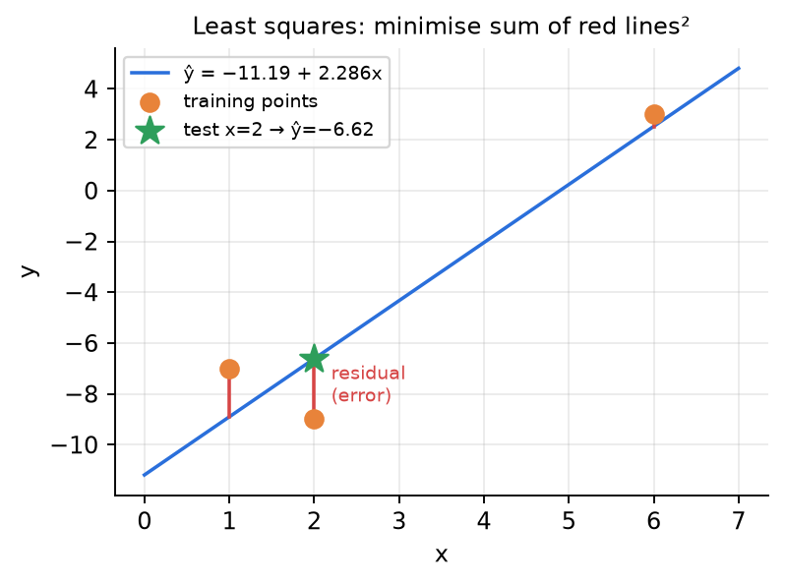
Figure 3.1 — Least squares minimises the sum of the squared red residuals (Class Test 1A Q2 data).

3.2 Derivations
📐 Derivation: Closed-form least squares for one feature (ŷ = θ₀ + θ₁x)
Step 1. Write the total squared error.
E(θ₀,θ₁) = Σ_{i} (y_{i} − θ₀ − θ₁x_{i})²
Step 2. Set the derivative w.r.t. the intercept to zero. So the line always passes through (x̄, ȳ).
∂E/∂θ₀ = −2 Σ (y_{i} − θ₀ − θ₁x_{i}) = 0 ⇒ θ₀ = ȳ − θ₁ x̄
Step 3. Derivative w.r.t. the slope.
∂E/∂θ₁ = −2 Σ x_{i}(y_{i} − θ₀ − θ₁x_{i}) = 0
Step 4. Substitute θ₀ and simplify.
θ₁ = Σ (x_{i} − x̄)(y_{i} − ȳ) / Σ (x_{i} − x̄)² = S_{xy} / S_{xx}

📐 Derivation: Normal equation (any number of features)
Step 1. Write the error in matrix form and expand.
E(w) = (y − Xw)^{T}(y − Xw) = y^{T}y − 2w^{T}X^{T}y + w^{T}X^{T}Xw
Step 2. Use ∇(wᵀa) = a and ∇(wᵀAw) = 2Aw for symmetric A.
∇_{w}E = −2X^{T}y + 2X^{T}Xw
Step 3. Set to zero. Needs XᵀX invertible (features not perfectly correlated).
X^{T}X w = X^{T}y ⇒ ŵ = (X^{T}X)⁻¹ X^{T} y

Why not always use the normal equation? Inverting an (n+1)×(n+1) matrix costs about O(n³) — too slow for many features, and it fails when XᵀX is singular. Gradient descent is iterative and scales to huge data.

3.3 Gradient Descent (GD)
💡 In easy language
You are blindfolded on a hill and want to reach the bottom. Feel the slope under your feet and take a small step downhill. Repeat. The slope = gradient; step size = learning rate η.
If dL/dθ > 0 (loss rising to the right) → move left; if dL/dθ < 0 → move right. So always move opposite to the gradient.

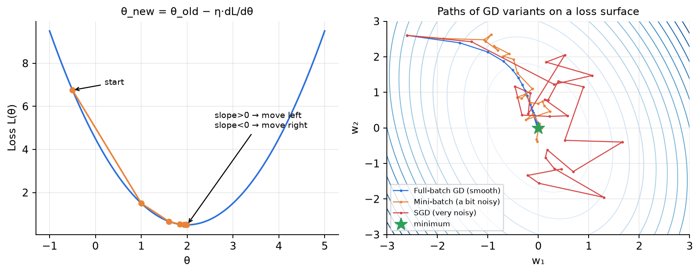
Figure 3.2 — Left: GD steps down a 1-D loss. Right: full-batch is smooth, mini-batch a little noisy, SGD very noisy (but cheap per step).
📐 Derivation: Why the update is θ ← θ − η∇L (Taylor series argument from the slides)
Step 1. Move a small step ηu (η small, so higher-order terms ≈ 0).
L(θ + ηu) = L(θ) + η u^{T}∇L(θ) + (η²/2!) u^{T}∇²L(θ) u + … ≈ L(θ) + η u^{T}∇L(θ)
Step 2. The move is good only if the new loss is smaller.
L(θ + ηu) − L(θ) = η u^{T}∇L(θ) < 0
Step 3. β = angle between u and the gradient.
u^{T}∇L(θ) = ‖u‖ ‖∇L(θ)‖ cos β , −1 ≤ cos β ≤ 1
Step 4. Move in the direction exactly opposite to the gradient.
most negative when cos β = −1, i.e. β = 180° ⇒ u = −∇L(θ)
Step 5. The gradient-descent update rule.
w_{t+1} = w_{t} − η ∂L/∂w , b_{t+1} = b_{t} − η ∂L/∂b

📐 Derivation: Gradient of the MSE loss for a linear model
Step 1.
L(w,b) = (1/m) Σ_{i} (ŷ_{i} − y_{i})², ŷ_{i} = w^{T}x_{i} + b
Step 2. Chain rule: derivative of (·)² is 2(·), derivative of ŷᵢ w.r.t. wⱼ is xᵢⱼ.
∂L/∂w_{j} = (2/m) Σ_{i} (ŷ_{i} − y_{i}) x_{ij}
Step 3. Derivative of ŷᵢ w.r.t. b is 1.
∂L/∂b = (2/m) Σ_{i} (ŷ_{i} − y_{i})
Step 4. Same thing for all weights at once.
Vector form: ∇_{w}L = (2/m) X^{T}(Xw − y)

📝 Note
Convention: some books use L = ½Σ(ŷ−y)² (then the "2" cancels) or no 1/m. All are correct — state your loss at the start; the direction of the step is the same, only its size (effectively η) changes. In this guide: L = (1/m)Σ(ŷ − y)², matching your End-sem-25 Q6(d).

Variant | Gradient computed on | Updates per epoch | Pros | Cons
Full / Batch GD | all m samples | 1 | smooth, exact direction | slow for big data
Mini-batch GD | B samples (e.g., 32) | m / B | good balance, GPU friendly | some noise, choose B
Stochastic GD (SGD) | 1 sample | m | very fast updates, can escape shallow minima | very noisy path

- Learning rate η: too small → very slow; too large → overshoots / diverges. Watch the loss: if it increases, reduce η.
- Local vs global minima: MSE for linear regression is convex (a bowl) → one global minimum. Neural networks are non-convex.
- Stopping: fixed number of iterations/epochs, or when the loss or gradient becomes very small.
🛠️ How to use / step-by-step recipe
1. Write the model and the loss (state 1/m or ½ convention).
2. Forward: compute ŷᵢ for every sample in the batch.
3. Compute errors eᵢ = ŷᵢ − yᵢ.
4. Gradients: ∂L/∂wⱼ = (2/B)Σ eᵢ xᵢⱼ, ∂L/∂b = (2/B)Σ eᵢ (B = batch size: m for full, 1 for SGD).
5. Update: w ← w − η·grad (subtract!). Report new parameters. Optionally show the loss went down.

3.4 Beyond straight lines: polynomial, locally-weighted, Ridge & Lasso
- Polynomial regression: F(x) = θ₀ + θ₁x + θ₂x² + … + θₙxⁿ — still linear in the parameters, so the same least squares / GD works (treat x², x³ as new features). Large n → too many parameters, slow, overfitting (memorises training data).
- Locally Weighted Linear Regression (LWR): for each test point, fit a line giving more weight to nearby training points. Error E = Σ wⁱ(F(xⁱ) − yⁱ)², with wⁱ = exp(−‖xⁱ − x_test‖² / (2c²)) — close points → w ≈ 1, far points → w ≈ 0. Drawback: must keep all training data and refit for every test point (non-parametric).
Regularised regression (α or λ = regularisation strength)
Ridge (L2): J(θ) = MSE(θ) + α·½ Σ_{i=1}^{n} θ_{i}² → closed form w = (X^{T}X + λI)⁻¹X^{T}y
Lasso (L1): J(θ) = MSE(θ) + α Σ_{i=1}^{n} |θ_{i}|
Bias θ₀ is usually NOT penalised. α = 0 → ordinary least squares; α → ∞ → all weights → 0.

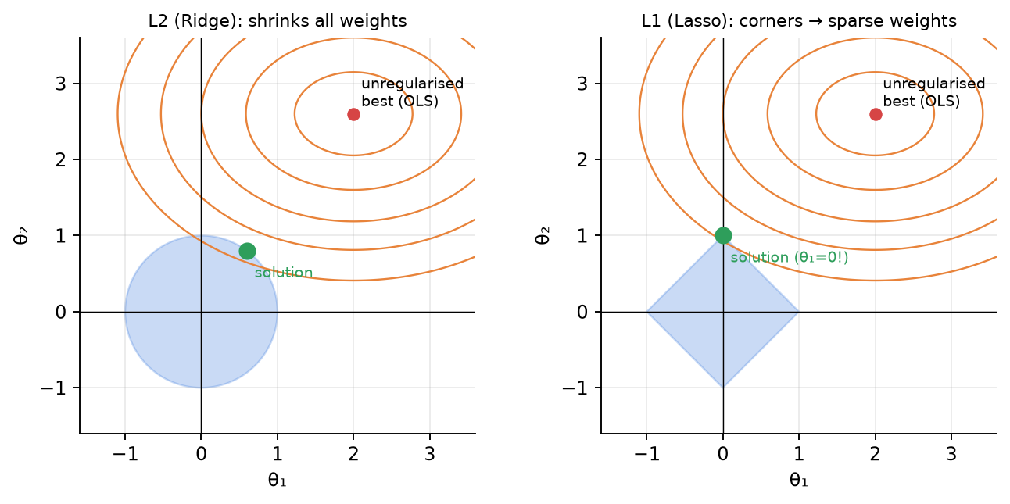
Figure 3.3 — Why Lasso gives exact zeros: the diamond-shaped L1 constraint has corners on the axes.
 | Ridge (L2) | Lasso (L1)
Penalty | sum of squares of weights | sum of absolute weights
Effect | shrinks all weights, none exactly 0 | makes some weights exactly 0
Feature selection? | No (keeps all predictors) | Yes — automatic
When | all features contribute a bit; multicollinearity | only a few features truly matter

🔑 Keywords
dependent / independent variable, best-fit line, residual, least squares, normal equation, gradient, learning rate, epoch, batch / mini-batch / stochastic GD, convex, local minimum, polynomial regression, overfitting, LWR, regularisation, Ridge (L2), Lasso (L1), sparsity.

🌍 Use cases
Forecasting sales/demand, house price prediction, trend analysis, predicting marks from study hours, risk scoring, any "how much?" question.

Chapter 4. Linear Classifiers: Perceptron, Logistic Regression & Softmax

4.1 Linear classifier & the Perceptron
💡 In easy language
A linear classifier draws a line (2-D) / plane / hyperplane wᵀx + b = 0. Points on one side are class +1, the other side −1: ŷ = sign(wᵀx + b).
The perceptron learns this line by mistakes: go through the points; whenever a point is on the wrong side, nudge the line towards it (add y·x to w). Repeat until no mistakes.

Perceptron
ŷ = sign(w^{T}x + b)
Mistake if y_{i}(w^{T}x_{i} + b) ≤ 0 (treat "= 0" — a point ON the line — as a mistake)
Update: w ← w + η y_{i} x_{i} , b ← b + η y_{i} (usually η = 1)

- Why the update works: after the update, y(w_newᵀx + b_new) = y(wᵀx + b) + η(‖x‖² + 1) → the score of that point moves towards the correct sign.
- Convergence theorem (Novikoff): if the data is linearly separable with margin γ and all ‖x‖ ≤ R, the perceptron makes at most (R/γ)² mistakes. → Bigger margin ⇒ fewer updates ⇒ faster convergence. If the data is NOT separable (e.g., XOR), it never stops.
- The result depends on the starting line and the order of points; the final line is a separating line, not the best (max-margin) one → that is what SVM fixes (Chapter 7).
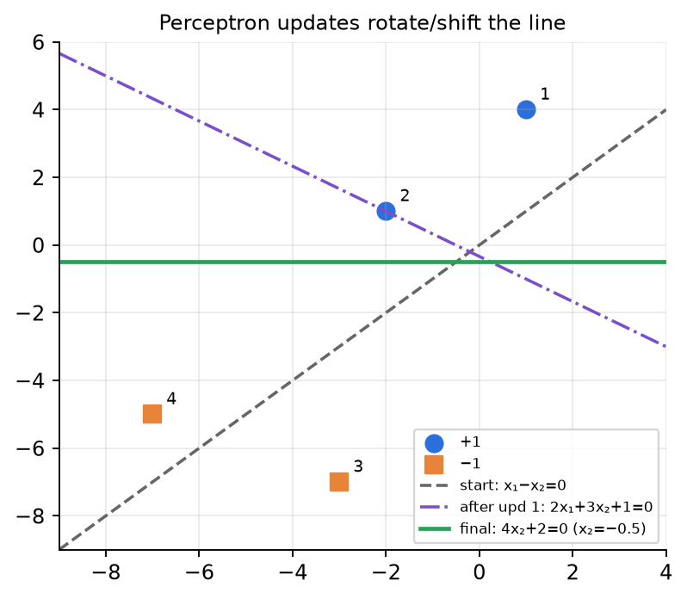
Figure 4.1 — Perceptron updates on End-sem 2026 Q1(a) data.
🛠️ How to use / step-by-step recipe
1. Write w, b. For each point in order compute f = wᵀx + b and check y·f.
2. If y·f ≤ 0 → update w ← w + y·x, b ← b + y and use the new w for the next point.
3. One "iteration/epoch" = one pass over all points. Stop after a full pass with zero updates.
4. Present as a table: point | f | correct? | new w, b.

4.2 Logistic Regression
💡 In easy language
The perceptron's step function jumps suddenly from 0 to 1 — not smooth, not differentiable. Logistic regression passes the score z = wᵀx + b through the smooth sigmoid σ(z) = 1/(1+e^{−z}) and treats the output as a probability P(y = 1 | x).
It is a classifier (despite the name "regression"), inherently 2-class, and probabilistic. Decision boundary: σ(z) = 0.5 ⇔ z = 0 → still a linear boundary.

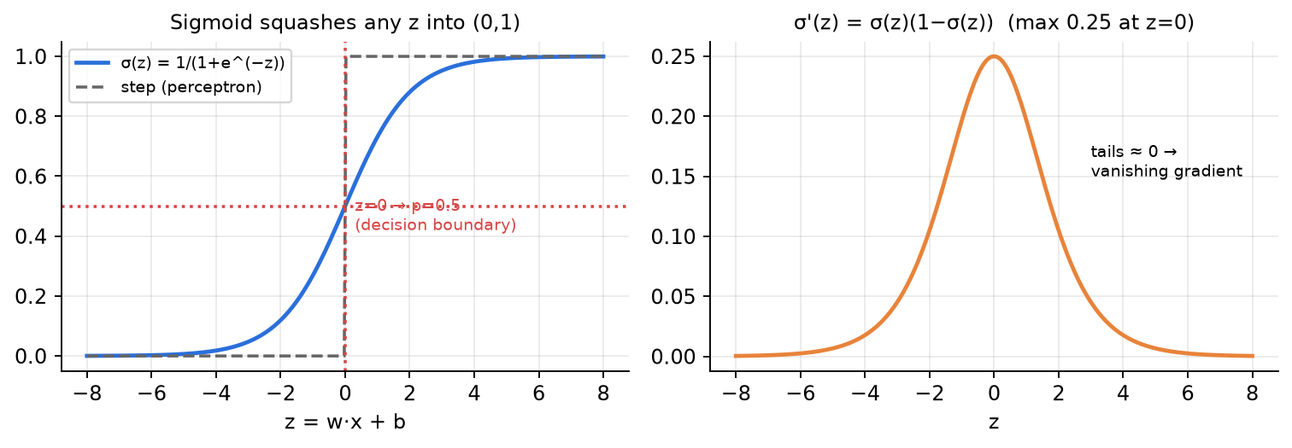
Figure 4.2 — Sigmoid and its derivative.
Logistic regression model
σ(z) = 1/(1 + e^{−z}) = e^{z}/(1 + e^{z}) , z = θ₀ + θ₁x₁ + … + θ_{n}x_{n}
log( P(y=1|x) / (1 − P(y=1|x)) ) = z (log-odds / logit is linear in x — the main assumption)
P(y|x;θ) = LR(x)^{y} · (1 − LR(x))^{1−y} (one formula for y = 1 and y = 0)
Properties: max → 1 as z → ∞, min → 0 as z → −∞, σ(0) = 0.5, σ(−z) = 1 − σ(z).

📐 Derivation: Maximum-likelihood estimation of θ (the "how to estimate parameters" derivation)
Step 1. Assume training examples are independent → multiply their probabilities (likelihood).
L(θ) = Π_{i=1}^{n} p(y^{i}|x^{i};θ) = Π LR(x^{i})^{yⁱ} (1 − LR(x^{i}))^{1−yⁱ}
Step 2. Products are hard → take log (monotonic, same maximiser).
log L(θ) = Σ_{i} [ y^{i} log LR(x^{i}) + (1 − y^{i}) log(1 − LR(x^{i})) ]
Step 3. Key fact (proof in the next box).
dσ/dz = σ(z)(1 − σ(z))
Step 4. Chain rule: ∂LR/∂θⱼ = LR(1−LR)xⱼ; the LR(1−LR) terms cancel beautifully.
∂ log L / ∂θ_{j} = Σ_{i} [ y^{i}(1 − LR^{i}) − (1 − y^{i}) LR^{i} ] x_{j}^{i} = Σ_{i} (y^{i} − LR(x^{i})) x_{j}^{i}
Step 5. Gradient ASCENT on log-likelihood (r = learning rate). Stochastic version uses one sample at a time.
θ_{j} ← θ_{j} + r · Σ_{i} (y^{i} − LR(x^{i})) x_{j}^{i}
Step 6. Equivalently, gradient DESCENT on the cross-entropy loss. No closed form exists → must iterate.
J(θ) = −(1/n) log L(θ) (binary cross-entropy) ⇒ θ ← θ − r·(1/n)Σ (LR(x^{i}) − y^{i}) x^{i}

📐 Derivation: dσ/dz = σ(z)(1 − σ(z)) (End-sem 2025 Q7c)
Step 1.
σ(z) = (1 + e^{−z})⁻¹
Step 2. Chain rule.
dσ/dz = −(1 + e^{−z})⁻² · (−e^{−z}) = e^{−z} / (1 + e^{−z})²
Step 3. because e^{−z}/(1+e^{−z}) = 1 − 1/(1+e^{−z}).
= [1/(1 + e^{−z})] · [e^{−z}/(1 + e^{−z})] = σ(z) · (1 − σ(z))
Step 4. So in a deep net, backprop multiplies many factors ≤ 0.25 → gradients shrink exponentially = vanishing gradient; saturated neurons (|z| big) barely learn.
max of σ(1−σ) is 0.25 (at z = 0); for |z| large it → 0

4.3 Softmax (multinomial logistic) regression & cross-entropy
Softmax regression
Score for class k: s_{k}(x) = x^{T}θ^{(k)}
p̂_{k} = σ(s(x))_{k} = exp(s_{k}(x)) / Σ_{j=1}^{K} exp(s_{j}(x))
Cross-entropy loss: J = −(1/m) Σ_{i=1}^{m} Σ_{k=1}^{K} y_{k}^{(i)} log p̂_{k}^{(i)} (y one-hot)
Probabilities are positive and sum to 1. For one example with true class c the loss is simply −log p̂_c. Gradient w.r.t. the scores: p̂ − y.

Binary CE is a special case (End-sem 2025 Q6e): with K = 2, y₂ = 1 − y₁ and p̂₂ = 1 − p̂₁, so Σₖ yₖ log p̂ₖ = y log p̂ + (1 − y) log(1 − p̂) → J = −(1/m)Σ[y log p̂ + (1−y) log(1−p̂)] — exactly the logistic-regression loss. (Also: softmax with 2 classes = sigmoid of the score difference: e^{s₁}/(e^{s₁}+e^{s₂}) = σ(s₁ − s₂).)
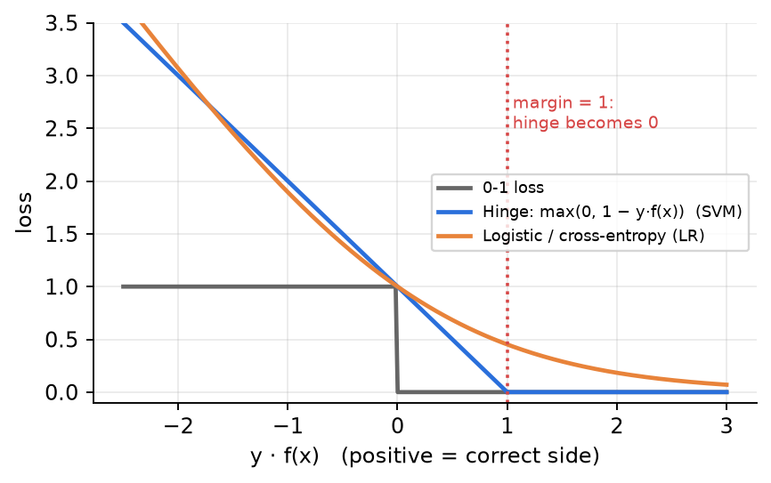
Figure 4.3 — Losses as a function of the margin y·f(x): 0-1, hinge (SVM), logistic (cross-entropy).
🔑 Keywords
linear decision boundary, hyperplane, sign function, perceptron update rule, linearly separable, convergence, margin, sigmoid / logistic function, log-odds (logit), probabilistic classifier, likelihood, log-likelihood, MLE, gradient ascent, cross-entropy, softmax, one-hot, loss matrix / cost-sensitive classification.

🌍 Use cases
Spam detection, credit default probability, disease risk (probability output is useful), click-through prediction; softmax for multi-class (digit recognition, the last layer of neural networks).

Chapter 5. Decision Trees — Entropy, Information Gain, ID3, C4.5, CART

5.1 Theory
💡 In easy language
A decision tree is a flow-chart of if-else questions. Each internal node tests one feature, each branch is one answer (value / range), each leaf gives the prediction (majority class for classification, mean value for regression).
We want short trees with pure leaves. The trick: at every node ask the question that reduces uncertainty the most — measured by entropy → information gain.

- Trees can represent any Boolean function (one path per truth-table row) and approximate any function — but a tree that memorises every training example will not generalise.
- Finding the smallest consistent tree is NP-complete → use a greedy, top-down, recursive heuristic: pick the best attribute, split, recurse on each child.
- Stop when: all examples in a node have the same class (pure) → leaf; no attributes left → majority leaf; no examples → majority of parent.
- Trees are non-parametric, need no feature scaling, handle categorical data naturally, and are easy to interpret.

5.2 Information theory you need
📐 Derivation: Why information content is −log p
Step 1. Rare events are more "surprising" → carry more information.
IC ∝ 1/p
Step 2. Information from two independent events should add up.
IC(X ∩ Y) = IC(X) + IC(Y) for independent X, Y
Step 3. Since p(X∩Y) = p(X)p(Y). The only function turning products into sums is the log.
f(p(X)·p(Y)) = f(p(X)) + f(p(Y))
Step 4. A fair coin outcome: −log₂ ½ = 1 bit.
IC(X = a) = log(1/p(a)) = −log₂ p(a) bits

Entropy & information gain
Entropy: H(X) = −Σ_{x} p(x) log₂ p(x) (expected surprise, in bits)
2 classes with fraction p: H = −p log₂p − (1−p) log₂(1−p)
Specific conditional entropy: H(Y | X = x) = −Σ_{y} p(y|x) log₂ p(y|x)
Conditional entropy: H(Y | X) = Σ_{x} p(x) H(Y | X = x)
Information Gain: IG(Y | X) = H(Y) − H(Y | X)
Convention: 0·log 0 = 0. Properties: H ≥ 0; H(Y|X) ≤ H(Y); if X, Y independent H(Y|X) = H(Y) so IG = 0; H(Y|Y) = 0; chain rule H(X,Y) = H(X|Y) + H(Y).

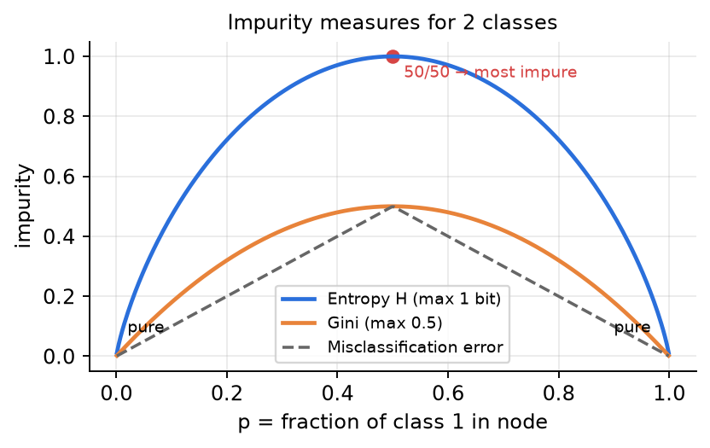
Figure 5.1 — Entropy is 0 for a pure node and maximum (1 bit for 2 classes, log₂K for K classes) for a uniform node.
Class counts (2 classes) | Entropy (bits) | Class counts | Entropy
1 : 1 (any equal split) | 1.000 | 1 : 3 | 0.811
1 : 2 | 0.918 | 2 : 3 | 0.971
3 : 5 | 0.954 | 3 : 4 | 0.985
9 : 5 | 0.940 | 6 : 2 | 0.811
4 : 0 (pure) | 0 | 1 : 4 | 0.722

📌 Exam tip
Memorise this table — these ratios appear in almost every tree question and save you 5 minutes of log calculations. Useful logs: log₂3 = 1.585, log₂5 = 2.322, log₂7 = 2.807, log₂(3/4) = −0.415, log₂(1/3) = −1.585, log₂(2/3) = −0.585.

5.3 Tree algorithms
Algorithm | Split criterion | Splits | Notes
ID3 | Information Gain (max) | multi-way (one branch per value) | categorical only; biased to many-valued attributes; overfits; no pruning
C4.5 | Gain Ratio = IG / SplitInfo | multi-way; thresholds for continuous | handles continuous & missing values; post-pruning
CART | Gini impurity (classification), variance / squared error reduction (regression) | always binary | sensitive to small data changes
CHAID | Chi-square test | multi-way | large categorical datasets
Conditional inference trees | statistical permutation tests | — | unbiased feature selection

C4.5 & CART
SplitInfo_{A}(D) = −Σ_{i=1}^{v} (|D_{i}|/|D|) log₂(|D_{i}|/|D|)
GainRatio(A) = IG(A) / SplitInfo_{A}(D)
Gini(D) = 1 − Σ_{i} p_{i}² Gini_{split} = Σ (|D_{i}|/|D|) Gini(D_{i})
SplitInfo is the entropy of the branch SIZES: an attribute that shatters data into many tiny branches (like an ID) has a huge SplitInfo, so its GainRatio is small. Gini for 2 classes: max 0.5.

Continuous features, overfitting & pruning
- Continuous attribute: sort values, try thresholds at midpoints between consecutive values (only where the class changes matters), pick the threshold with max IG → binary split "x ≤ t".
- Regression tree: leaf value = mean of targets; choose splits that minimise squared error (variance reduction).
- Problems: exponentially less data at lower levels; too big a tree overfits; greedy ≠ global optimum.
- Pre-pruning (early stopping): max depth, min samples per split, min samples per leaf, max features.
- Post-pruning: cost-complexity pruning (penalty α·|leaves|), reduced-error pruning (remove branches that don't help validation accuracy), minimum impurity decrease, minimum leaf size.
- Good tree = not too small (catch subtle distinctions), not too big (efficiency, avoid overfitting), interpretable — Occam's razor: simplest hypothesis that fits. Informative nodes near the root.
🛠️ How to use / step-by-step recipe
1. Compute H(root) from class counts.
2. For EACH attribute: split counts per value → entropy of each child → weighted average H(Y|A) → IG = H(root) − H(Y|A). Put it in a table.
3. Pick the max IG (or GainRatio if asked C4.5 / if an attribute has many values). State ties and your tie-break.
4. Pure children → leaves. Impure children → repeat steps 1–3 using ONLY the rows in that child and only the remaining attributes.
5. Draw the final tree; to classify a new row, follow its path from the root.

🔑 Keywords
entropy, information content, surprise, bits, conditional entropy, information gain, mutual information, purity/impurity, greedy, ID3, C4.5, split information, gain ratio, CART, Gini index, binary split, threshold, pre-pruning, post-pruning, cost-complexity, overfitting, Occam's razor.

🌍 Use cases
Credit approval, medical triage rules, customer churn, loan default; the base learner of Random Forests and Gradient-Boosted Trees (XGBoost) that win Kaggle competitions; decision stumps inside AdaBoost.

Chapter 6. Naïve Bayes Classifiers

6.1 Theory
💡 In easy language
Naïve Bayes asks: "Given these features, which class is most probable?" It uses Bayes' theorem to flip P(features | class) — easy to count from data — into P(class | features) — what we want.
"Naïve" because it assumes all features are independent given the class (e.g., knowing it is Sunny tells nothing extra about Humidity once we know the class). Rarely exactly true, but works surprisingly well and is super fast.

Bayes' theorem
P(y | X) = P(X | y) · P(y) / P(X)
posterior = likelihood × prior / evidence
P(y|X): posterior; P(X|y): likelihood; P(y): prior; P(X) = Σ_y P(X|y)P(y): evidence (same for all classes → can be ignored when comparing).

📐 Derivation: From Bayes to the Naïve Bayes classifier
Step 1. Bayes theorem with the full feature vector.
P(y | x₁,…,x_{n}) = P(x₁,…,x_{n} | y) P(y) / P(x₁,…,x_{n})
Step 2. Naïve (conditional-independence) assumption.
P(x₁,…,x_{n} | y) = Π_{i=1}^{n} P(x_{i} | y)
Step 3. Denominator is constant for a given input → drop it.
P(y | x₁,…,x_{n}) ∝ P(y) · Π_{i} P(x_{i} | y)
Step 4. MAP decision rule. In practice use logs: argmax [log P(y) + Σ log P(xᵢ|y)] to avoid underflow.
ŷ = argmax_{y} P(y) · Π_{i=1}^{n} P(x_{i} | y)
Step 5. To get actual probabilities, normalise the scores so they sum to 1.
P(y | X) = score(y) / Σ_{y′} score(y′)

Assumptions (from the slides)
- Feature independence given the class.
- Continuous features are normally distributed within each class (Gaussian NB).
- Discrete features follow multinomial distributions within each class.
- All features contribute equally.
- No missing data.

Three flavours
Type | Features | Likelihood P(xᵢ | y) | Typical use
Gaussian NB | continuous | N(xᵢ; μ_y, σ²_y) = (1/√(2πσ²_y)) exp(−(xᵢ − μ_y)²/(2σ²_y)) | sensor data, Iris
Multinomial NB | counts (word frequencies) | θ_{c,i} = (count(wᵢ, c) + 1)/(N_c + V) — Laplace smoothing; P(d|c) ∝ Π θ_{c,i}^{fᵢ} | text classification
Bernoulli NB | binary (present / absent) | p(xᵢ|y) = pᵢ^{xᵢ}(1 − pᵢ)^{1−xᵢ}, pᵢ = (count + 1)/(N_c + 2) | short texts, binary features
Categorical NB | categories (Sunny/Rainy) | count(xᵢ = v, y) / count(y) | tabular data like "Play Golf"

- Zero-frequency problem: if a value never occurs with a class, its probability = 0 and wipes out the whole product. Laplace (add-1) smoothing: (count + 1)/(total + number of possible values).
- Parameter count (d binary features, binary class): prior 1 + likelihoods 2d = 2d + 1; without the naïve assumption we need the full joint: 2(2^d − 1) + 1 → exponential! That is the main computational benefit.
- Pros: fast, little data needed, works for high-dimensional text, handles multi-class. Cons: independence assumption, probability estimates can be poorly calibrated, rare words can dominate.
🛠️ How to use / step-by-step recipe
1. Priors: P(y) = (# rows with class y) / N.
2. For each feature value in the TEST row, look up P(value | y) for every class (count in class / class count; Gaussian pdf for continuous). Apply Laplace smoothing if any count is 0.
3. Score(y) = P(y) × product of likelihoods.
4. Predict the class with the highest score; normalise if asked for the posterior probability.

🔑 Keywords
prior, likelihood, evidence, posterior, conditional independence, MAP, generative classifier, Laplace smoothing, zero-frequency, Gaussian / Multinomial / Bernoulli NB, log-probabilities, underflow.

🌍 Use cases
Spam filtering, sentiment analysis, document categorisation, medical diagnosis, real-time prediction (very fast).

Chapter 7. Support Vector Machines (SVM)

7.1 Theory
💡 In easy language
Many lines can separate two classes. SVM picks the line with the widest "street" (margin) between the classes — the safest boundary, so new points are less likely to fall on the wrong side.
Only the points on the edge of the street matter — the support vectors. Move any other point (without crossing the street) and the boundary doesn't change.
If the data can't be separated by a straight line, SVM (1) allows a few violations (soft margin, slack ξ) and/or (2) maps data to a higher dimension where a straight line works (kernel trick).

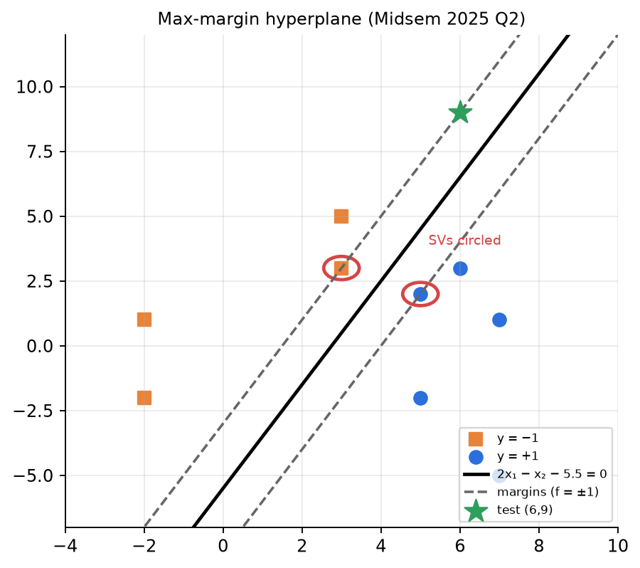
Figure 7.1 — Hyperplane (solid), margins (dashed), support vectors (circled) — Midsem 2025 Q2 data.

7.2 Geometry & the margin
📐 Derivation: w is perpendicular to the hyperplane
Step 1. Take any two points x₁, x₂ ON the hyperplane.
w^{T}x₁ + b = 0 , w^{T}x₂ + b = 0
Step 2. Subtract. x₁ − x₂ is a vector lying inside the plane.
w^{T}(x₁ − x₂) = 0
Step 3. Dot product zero ⇒ 90°. So w is the normal vector; b shifts the plane from the origin.
w ⟂ every direction in the plane

📐 Derivation: Margin = 2/‖w‖ and why we minimise ‖w‖
Step 1. Geometric distance (projection onto the unit normal).
distance(x_{i}, plane) = |w^{T}x_{i} + b| / ‖w‖
Step 2. w and b can be scaled by any constant without moving the plane, so fix the "functional margin" of the closest points to exactly 1 (canonical form).
|w^{T}x_{i} + b| = 1 for the closest points (support vectors)
Step 3. Distance from plane to each side's support vectors.
distance of SV = 1/‖w‖ , total street width = 2/‖w‖
Step 4. Squared & halved for a smooth, convex objective with a clean derivative.
max 2/‖w‖ ⇔ min ‖w‖ ⇔ min ½‖w‖²
Step 5. HARD-MARGIN PRIMAL: every point correctly classified AND outside the margin.
min_{w,b} ½‖w‖² s.t. y_{i}(w^{T}x_{i} + b) ≥ 1 ∀i

7.3 Constrained optimisation → the Dual
Detour (slides): min x² s.t. x ≥ b. Lagrangian L(x, α) = x² − α(x − b), α ≥ 0. Primal p* = min_x max_{α≥0} L; dual d* = max_{α≥0} min_x L. Weak duality: d* ≤ p* always. Strong duality: d* = p* for convex problems with linear constraints (Slater) — true for SVM. KKT conditions at the optimum: (1) ∇L = 0, (2) primal feasible, (3) α ≥ 0, (4) complementary slackness α·(constraint) = 0.
📐 Derivation: Dual SVM (linearly separable)
Step 1. One multiplier αⱼ per training point (n-dim problem instead of d-dim).
L(w, b, α) = ½ w^{T}w − Σ_{j} α_{j} [ y_{j}(w^{T}x_{j} + b) − 1 ] , α_{j} ≥ 0
Step 2. The weight vector is a weighted sum of training points.
∂L/∂w = 0 ⇒ w = Σ_{j} α_{j} y_{j} x_{j}
Step 3. Balance condition.
∂L/∂b = 0 ⇒ Σ_{j} α_{j} y_{j} = 0
Step 4. Substitute back → the DUAL (a quadratic program). Data appears only through dot products xᵢᵀxⱼ → kernel trick possible.
max_{α} Σ_{i} α_{i} − ½ Σ_{i}Σ_{j} α_{i}α_{j} y_{i}y_{j} x_{i}^{T}x_{j} s.t. Σ α_{i}y_{i} = 0 , α_{i} ≥ 0
Step 5. Complementary slackness ⇒ αⱼ > 0 only if yⱼ(wᵀxⱼ + b) = 1 → those points are the SUPPORT VECTORS. All others have αⱼ = 0 (sparsity).
α_{j} [ y_{j}(w^{T}x_{j} + b) − 1 ] = 0
Step 6. Recover the bias from a support vector.
b = y_{k} − w^{T}x_{k} for any k with α_{k} > 0 (average over all SVs for stability)
Step 7. Prediction uses only support vectors.
f(x) = sign( Σ_{i ∈ SV} α_{i} y_{i} x_{i}^{T}x + b )

7.4 Soft margin, slack variables, hinge loss
Soft-margin SVM (C = regularisation)
min_{w,b,ξ} ½‖w‖² + C Σ_{i} ξ_{i} s.t. y_{i}(w^{T}x_{i} + b) ≥ 1 − ξ_{i} , ξ_{i} ≥ 0
equivalently: min ½‖w‖² + C Σ_{i} max(0, 1 − y_{i}(w^{T}x_{i} + b)) (hinge loss)
Dual: same as hard margin but 0 ≤ α_{i} ≤ C
ξᵢ = 0: correct & outside margin; 0 < ξᵢ < 1: inside margin but correct side (margin violation); ξᵢ > 1: misclassified. ξᵢ = max(0, 1 − yᵢf(xᵢ)).

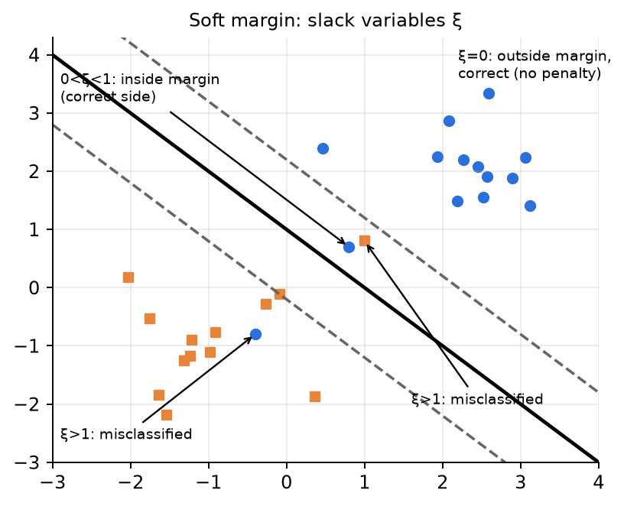
Figure 7.2 — Slack variables.
- C large → heavy penalty on violations → narrow margin, fits training data hard (risk of overfitting); C → ∞ recovers the hard margin. C small → wide margin, allows more mistakes (more regularisation). (Slides also write it as ‖w‖² + λ·Error — larger λ = stricter.)
- Primal SGD updates (slides) with objective λ‖w‖² + hinge: if yᵢ(w·xᵢ + b) ≥ 1 → w ← w − η(2λw), b unchanged; else → w ← w − η(2λw − yᵢxᵢ), b ← b + ηyᵢ.
- Why solve the dual? kernel trick (only dot products), sparse solution (only SVs), efficient when #features ≫ #samples.

7.5 Kernels
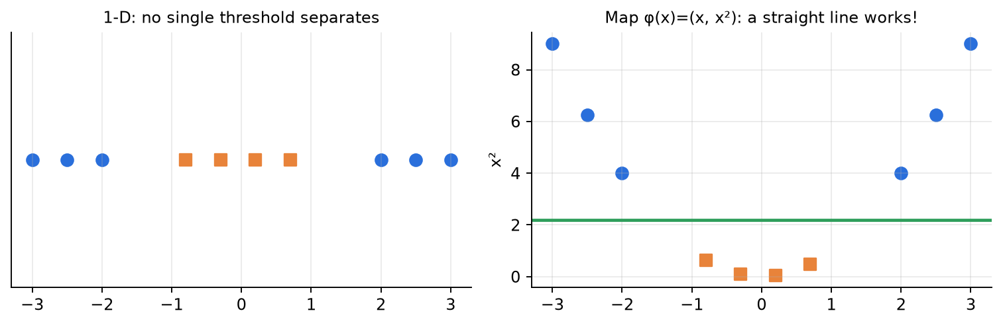
Figure 7.3 — A 1-D problem that is not linearly separable becomes separable after mapping φ(x) = (x, x²).
Kernel trick
K(x, x′) = φ(x)^{T} φ(x′) (similarity in a higher-dimensional space, computed without φ)
Linear: x^{T}x′ Polynomial: (x^{T}x′ + r)^{d} RBF/Gaussian: exp(−γ‖x − x′‖²) Sigmoid: tanh(γ x^{T}x′ + r)
Kernel SVM prediction: f(x) = sign( Σ_{i} α_{i} y_{i} K(x_{i}, x) + b )
RBF maps to infinite dimensions; γ controls how far a point's influence spreads (large γ → very local → overfit). The End-sem uses K = exp(−‖x − x′‖²/2), i.e. γ = 1/2.

- Choosing a kernel (slides): linear for linearly separable / high-dim data; polynomial for mild curvature; RBF when the shape is unknown or circular/spiral; sigmoid for neural-net-like behaviour; custom kernels for domain knowledge. Tune C, γ, degree by grid search + cross-validation.
- SVR (Support Vector Regression): fit a function with an ε-insensitive tube — errors smaller than ε are not penalised. Hard version: min ½‖w‖² s.t. |yᵢ − wᵀxᵢ − b| ≤ ε; soft version adds slacks ξᵢ, ξᵢ* with C. Metrics: RMSE, MSE.
🛠️ How to use / step-by-step recipe
Given data, find the hyperplane by hand:
1. plot the points
2. guess the support vectors (closest opposite-class points)
3. set up w = Σαᵢyᵢxᵢ with Σαᵢyᵢ = 0 (or use the "α = 1" shortcut if told)
4. b = yₖ − wᵀxₖ for each SV → average
5. verify every point has yᵢf(xᵢ) ≥ (value at SVs)
6. rescale so SVs give ±1 if asked for the canonical form / margin 2/‖w‖.
Given α's:
7. w = Σαᵢyᵢxᵢ (only α > 0 terms)
8. check Σαᵢyᵢ = 0
9. b from SVs
10. check constraints yᵢ(wᵀxᵢ + b) ≥ 1.
Kernel SVM prediction:
11. K(xᵢ, x_test) for each SV
12. multiply by αᵢyᵢ
13. add b
14. sign.

🔑 Keywords
hyperplane, normal vector, margin, maximum-margin classifier, support vectors, hard margin, soft margin, slack variable ξ, regularisation parameter C, hinge loss, Lagrange multipliers α, primal, dual, KKT, complementary slackness, sparsity, kernel trick, RBF, polynomial kernel, γ, SVR, ε-tube.

🌍 Use cases
Text / document classification (high-dimensional), face detection, handwriting recognition, bio-informatics (gene classification), image classification with small datasets.

Chapter 8. Bias–Variance Trade-off

8.1 Theory
💡 In easy language
Imagine training the same model many times on different random samples of data (the slides: 100 points, sample 25, repeat k times).
Bias = how far the AVERAGE model is from the truth (a systematic error from wrong assumptions, e.g., fitting a line to a sine curve). Variance = how much the models DIFFER from each other (sensitivity to the particular sample).
Simple model → models look alike but all are wrong: high bias, low variance → underfitting. Complex model → on average right, but each one wiggles differently: low bias, high variance → overfitting. You can't minimise both → trade-off.

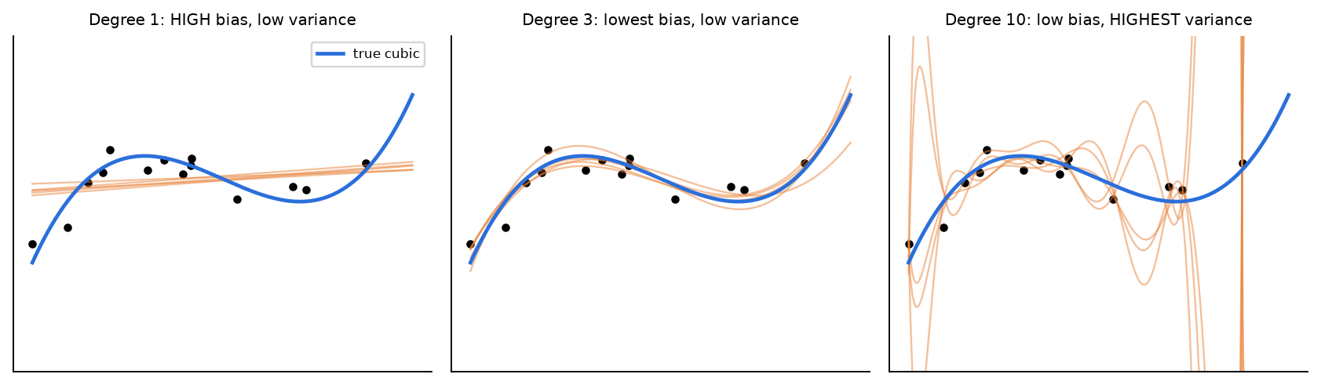
Figure 8.1 — Data from a cubic (blue). Orange = models trained on 5 different samples. Degree 1: all similar but wrong. Degree 10: right on average, wildly different.
Bias–variance decomposition (expected test error at x)
E[(y − f̂(x))²] = Bias² + Variance + σ²
Bias = E[f̂(x)] − f(x) Variance = E[(f̂(x) − E[f̂(x)])²] σ² = irreducible noise
Assumption: y = f(x) + ε, ε ~ N(0, σ²), unknown true f. Expectation is over training sets (and noise).

📐 Derivation: Bias–variance decomposition
Step 1. Substitute y = f + ε and expand.
E[(y − f̂)²] = E[(f + ε − f̂)²] = E[(f − f̂)²] + 2E[ε(f − f̂)] + E[ε²]
Step 2. Noise at a NEW test point is independent of the trained model and has mean 0.
E[ε(f − f̂)] = E[ε]·E[f − f̂] = 0 , E[ε²] = σ²
Step 3. Add and subtract the average model E f̂.
E[(f − f̂)²] = E[(f − E f̂ + E f̂ − f̂)²]
Step 4. Expand; (f − E f̂) is a constant.
= (f − E f̂)² + E[(f̂ − E f̂)²] + 2(f − E f̂)·E[E f̂ − f̂]
Step 5. Cross term vanishes. σ² can never be removed by any model.
E[E f̂ − f̂] = 0 ⇒ E[(y − f̂)²] = Bias² + Variance + σ²

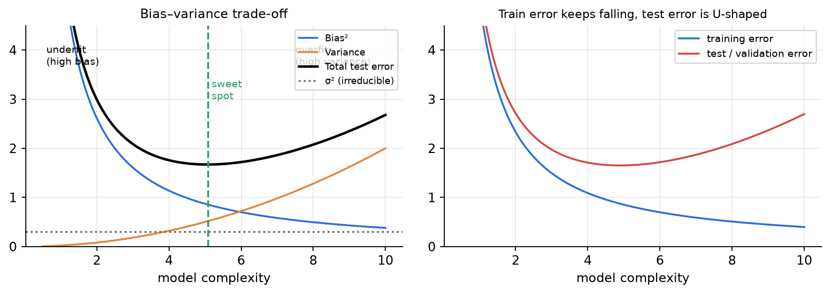
Figure 8.2 — Left: bias² falls, variance rises with complexity; total error is U-shaped. Right: training error keeps falling (optimistic) while test error rises after the sweet spot.

8.2 Train error vs test error (from the slides)
- train_err = (1/n)Σ(yᵢ − f̂(xᵢ))² over training points; test_err = (1/m)Σ over unseen points. As complexity grows, train_err becomes overly optimistic — it does not tell you how close f̂ is to f.
- Using test data: true error = empirical test error + small constant (because test noise εᵢ is independent of f̂ → covariance term = 0). → Always estimate error on a validation set independent of training.
- Using training data: the covariance term E[εᵢ(f̂(xᵢ) − f(xᵢ))] ≠ 0 because ε was used to fit f̂. By Stein's lemma it equals (σ²/n)Σ ∂f̂(xᵢ)/∂yᵢ — large when a small change in one observation changes the fit a lot, i.e. for complex models. So: true error = empirical train error + small constant + Ω(model complexity).
- Hence train by minimising L_train(θ) + Ω(θ) — the basis of all regularisation: L2, L1, early stopping, dataset augmentation, noise injection, parameter sharing, ensembles, dropout.
Symptom | Diagnosis | Fix
High train error, high test error (close to each other) | High bias (underfitting) | bigger/more complex model, more features, less regularisation, train longer. More DATA does NOT help.
Low train error, much higher test error | High variance (overfitting) | more data, regularisation (L1/L2, dropout), simpler model, pruning, larger K in KNN, ensembles/bagging, early stopping

Model | Bias | Variance
KNN with K = 1 | low | high
KNN with large K | high | low
Deep, unpruned decision tree | low | high
Decision stump | high | low
Linear regression on non-linear data | high | low
High-degree polynomial | low | high
SVM with large C / large γ | low | high
Strong L2 regularisation (large λ) | higher | lower

🔑 Keywords
bias, variance, irreducible error, underfitting, overfitting, model complexity, sweet spot, generalisation, training vs validation error, regularisation, Stein's lemma, Occam's razor.

Chapter 9. Ensembles & AdaBoost

9.1 Theory
💡 In easy language
Ensemble = combine many models to get a better one ("wisdom of crowds"). Bagging (e.g., Random Forest) trains models on bootstrap samples in parallel and averages → mainly reduces variance. Boosting trains weak models sequentially, each focusing on the mistakes of the previous ones → mainly reduces bias.
AdaBoost (Adaptive Boosting): give every training point a weight. After each round, increase the weights of misclassified points and decrease the others, so the next weak learner concentrates on the hard points. Final answer = weighted vote, where better learners get a bigger say α.

AdaBoost (labels y ∈ {−1, +1})
Initial weights: w_{i}⁽¹⁾ = 1/N
Weighted error: ε_{t} = Σ_{i: hₜ(xᵢ) ≠ yᵢ} w_{i}^{(t)}
Learner weight: α_{t} = ½ ln( (1 − ε_{t}) / ε_{t} )
Update: w_{i}^{(t+1)} = w_{i}^{(t)} · exp(−α_{t} y_{i} h_{t}(x_{i})) / Z_{t} (× e^{α} if wrong, × e^{−α} if right)
Final classifier: H(x) = sign( Σ_{t=1}^{T} α_{t} h_{t}(x) )
Zₜ = normalising constant so new weights sum to 1 (Zₜ = 2√(εₜ(1−εₜ))). Training error of H ≤ Πₜ Zₜ → decreases exponentially if every εₜ < 0.5.

- Weak learner = slightly better than random (ε < 0.5), typically a decision stump (one-level tree: "x > c → class A else B").
- ε → 0 ⇒ α large (trust it); ε = 0.5 ⇒ α = 0 (useless); ε > 0.5 ⇒ α < 0 (flip it).
- After re-weighting, the misclassified points hold exactly half the total weight (so the old learner looks like a coin-flip on the new weights).
- When to use AdaBoost: you have a simple/weak but fast base learner, want higher accuracy, data is fairly clean. Weakness: sensitive to noisy labels and outliers (their weights keep growing).
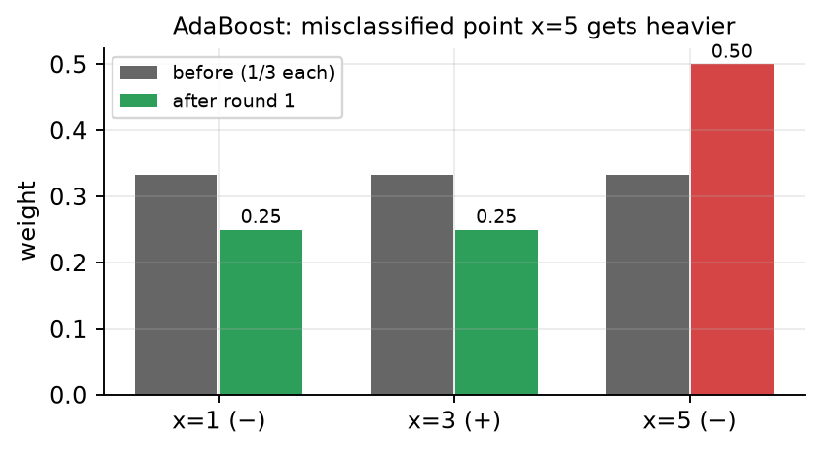
Figure 9.1 — Weights before and after round 1 of Midsem-2025 Q5.
🛠️ How to use / step-by-step recipe
1. Initial weights 1/N.
2. List candidate stumps; pick the one with the smallest WEIGHTED error εₜ.
3. αₜ = ½ ln((1−εₜ)/εₜ).
4. Multiply wrong points by e^{αₜ}, right points by e^{−αₜ}.
5. Normalise (divide by the sum).
6. Repeat; final H = sign(Σαₜhₜ).

🔑 Keywords
ensemble, bagging, boosting, weak learner, decision stump, weighted error, learner weight α, re-weighting, normalisation Z, exponential loss, weighted majority vote.

PART B — POST-MIDSEM TOPICS THAT APPEAR IN YOUR PYQs

Chapter 10. Clustering: K-Means, Hierarchical Clustering, Gaussian Mixture Models

10.1 Theory — what is clustering?
💡 In easy language
In unsupervised learning we only have inputs x₁, …, x_{N} — no labels y. Clustering asks: "which points naturally belong together?"
A good clustering has high intra-cluster similarity (points inside a group are close) and low inter-cluster similarity (different groups are far apart). Think of sorting a pile of mixed coins into heaps without being told the coin names.
Three families you must know: K-means (partition into K groups around centroids), hierarchical clustering (build a tree of merges called a dendrogram), and Gaussian Mixture Models (soft, probabilistic clustering fitted with EM).

- Partitional clustering (K-means, GMM): choose K first, get one flat partition.
- Hierarchical clustering: get a whole nested family of partitions (for every K) — cut the tree where you like.
- Hard clustering: every point belongs to exactly one cluster (K-means, hierarchical). Soft clustering: every point gets a probability / degree of membership for each cluster (GMM).
- Result depends on the distance measure (Euclidean, Manhattan, cosine…) — always scale features first if units differ.

10.2 K-Means clustering
💡 In easy language
K-means puts K "flags" (centroids) on the map. Every point walks to its nearest flag (assignment). Then every flag moves to the average position of the points standing next to it (update). Repeat until nobody changes flag.
Each cluster is represented by its mean — hence "K-means".

K-means objective and Lloyd's algorithm
J = Σ_{k=1}^{K} Σ_{x ∈ Cₖ} ‖x − μ_{k}‖² (WCSS / SSE / inertia)
Assignment step: c(i) = argmin_{k} ‖x_{i} − μ_{k}‖²
Update step: μ_{k} = (1/|C_{k}|) Σ_{x ∈ Cₖ} x
J = within-cluster sum of squares; C_{k} = set of points in cluster k; μ_{k} = centroid (mean) of cluster k; |C_{k}| = number of points in it; c(i) = cluster index of point i; K = number of clusters (chosen by you).

📐 Derivation: The mean is the best centre of a cluster (minimises SSE)
Step 1. Fix the points of one cluster C; find the centre m that makes the squared error smallest.
SSE(m) = Σ_{x ∈ C} ‖x − m‖² = Σ_{x ∈ C} (x − m)ᵀ(x − m)
Step 2. Differentiate with respect to m and set to zero.
∂SSE/∂m = Σ_{x ∈ C} −2(x − m) = 0
Step 3. Rearrange.
Σ_{x ∈ C} x = |C| · m
Step 4. Second derivative = 2|C| > 0, so this is a minimum. This is why the update step uses the MEAN. (If you use L1 / Manhattan distance, the best centre becomes the MEDIAN → K-medians.)
m_{opt} = (1/|C|) Σ_{x ∈ C} x = mean of the cluster

📐 Derivation: Why K-means always converges (but only to a local minimum)
Step 1. Assignment step: each point moves to its nearest centroid, so its own squared distance can only go down or stay the same.
J(assign_{t+1}, μ_{t}) ≤ J(assign_{t}, μ_{t})
Step 2. Update step: by the derivation above, the mean is the best centre for the fixed members, so J again cannot increase.
J(assign_{t+1}, μ_{t+1}) ≤ J(assign_{t+1}, μ_{t})
Step 3. A monotone, bounded sequence settles.
J is non-increasing and bounded below by 0
Step 4. J strictly decreases whenever an assignment changes, so no partition repeats → the algorithm stops in finitely many steps.
Number of possible partitions ≤ K^{N} (finite)
Step 5. But this is coordinate descent on a non-convex objective → it reaches a local minimum that depends on the initial centroids. Finding the global optimum of J is NP-hard.

Strengths and weaknesses
Strengths | Weaknesses
Simple, fast: O(N·K·d) per iteration | Must choose K in advance
Scales to large data | Sensitive to initial centroids (different runs → different answers)
Guaranteed to converge | Sensitive to outliers (mean is dragged towards them)
Easy to interpret (centroids = prototypes) | Assumes spherical, similar-size, similar-density clusters; boundaries are straight lines (Voronoi cells)
Works well on compact, well-separated blobs | Fails on non-convex shapes (rings, moons), very unequal sizes or densities; needs numeric data and scaling

K-means++ initialisation
💡 In easy language
Random initialisation can put two centroids inside the same true cluster and none in another. K-means++ spreads the starting centroids out: a point that is far from all the centroids chosen so far is much more likely to be picked next.

K-means++ (D² sampling)
Step 1: choose μ₁ uniformly at random from the data
Step 2: for every point, D(x) = distance from x to its NEAREST already-chosen centroid
P(x chosen as next centroid) = D(x)² / Σ_{x′} D(x′)²
Repeat Step 2 until K centroids are chosen; then run ordinary Lloyd iterations
Squaring D makes far points much more likely (twice as far → four times as likely) but it is still random, so a single outlier does not always win. Guarantee: expected cost ≤ O(log K) × optimal cost. Result: faster convergence and better, more stable local minima.

Choosing K
- Elbow method: run K-means for K = 1, 2, 3, …, plot WCSS J(K) against K. J always falls as K grows (J = 0 when K = N), but after the "right" K the drop becomes small. Pick K at the elbow / knee of the curve.
- Silhouette score: for point i, a(i) = mean distance to points in its own cluster, b(i) = mean distance to points of the nearest other cluster; s(i) = (b − a)/max(a, b) ∈ [−1, 1]. Choose K with the highest average s (near 1 = well clustered, near 0 = on a border, negative = probably in the wrong cluster).
- Gap statistic: compare log J(K) with its expected value on random uniform reference data; choose the K where the gap is largest (the real data is "much more clustered than random").
- Information criteria (with GMM): BIC / AIC trade likelihood against number of parameters.
- Domain knowledge: e.g. a company wants exactly 3 T-shirt sizes → K = 3.
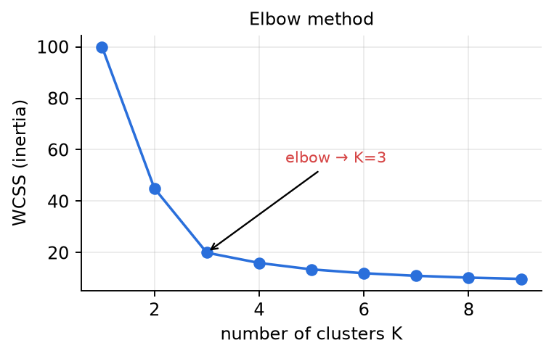
Figure 10.1 — Elbow method: WCSS falls steeply until the true K, then flattens. Pick K at the bend.

10.3 Hierarchical (agglomerative) clustering
💡 In easy language
Start with every point as its own cluster. Repeatedly merge the two closest clusters until only one cluster remains (bottom-up = agglomerative). The history of merges is drawn as a tree called a dendrogram; the height of each join = the distance at which the merge happened.
The only question is: "how far apart are two GROUPS of points?" — that is the linkage rule.

Linkage criteria (distance between clusters A and B)
Single link (MIN): d(A, B) = min_{a ∈ A, b ∈ B} d(a, b)
Complete link (MAX): d(A, B) = max_{a ∈ A, b ∈ B} d(a, b)
Average link (UPGMA): d(A, B) = (1/(|A|·|B|)) Σ_{a ∈ A} Σ_{b ∈ B} d(a, b)
Centroid link: d(A, B) = ‖μ_{A} − μ_{B}‖
Ward: merge the pair that increases total WCSS the least
A, B = clusters; a, b = individual points; |A| = number of points in A; μ_{A} = mean of A. Update after merging A∪B with any other cluster C (single): d(A∪B, C) = min(d(A,C), d(B,C)); (complete): max(…); (average): size-weighted average (|A|d(A,C) + |B|d(B,C))/(|A|+|B|).

Linkage | Behaviour | Good for / problem
Single | merges if ANY pair is close | finds long, non-convex shapes; suffers chaining (a thin bridge of points joins two big clusters); sensitive to noise
Complete | merges only if ALL pairs are close | compact, roughly equal-diameter clusters; sensitive to outliers; can break big clusters
Average | compromise of the two | robust middle ground
Centroid | distance of means | can give inversions (a later merge at a lower height) → dendrogram not monotone
Ward | min increase of WCSS | similar to K-means (spherical clusters)

📐 Derivation: 1-D single link = merge consecutive gaps in increasing order
Step 1. Sort the points on the line.
x₍₁₎ < x₍₂₎ < … < x_{(N)}
Step 2. In 1-D every cluster formed by single link is an interval of consecutive points, and the closest pair between two intervals is the adjacent pair across the gap.
d(A, B) = min distance = gap between the two ENDPOINTS that face each other
Step 3. So the only candidate distances are the N − 1 consecutive gaps.
gaps g_{i} = x_{(i+1)} − x_{(i)} , i = 1…N−1
Step 4. Single link merges across the smallest remaining gap each time → sort the gaps and merge in that order. The merge heights are exactly the sorted gaps. (Same as building a minimum spanning tree and adding edges in increasing weight — Kruskal.)

- Dendrogram cutting: draw a horizontal line at height h → the number of vertical lines it crosses = number of clusters. All merges at height < h have happened; merges above h have not.
- Boundary convention: if h equals a merge height exactly, state your rule ("merges with height ≤ h are done" is the common one).
- Divisive (top-down) clustering is the reverse: start with one cluster and split. Rarely asked numerically.
- Cost: naive agglomerative is O(N³) time (O(N²) memory for the distance matrix) → not for huge data. No need to choose K beforehand; deterministic (no random init).
🛠️ How to use / step-by-step recipe
1. Write the full distance matrix (compute Euclidean distances if points are given).
2. Find the smallest off-diagonal entry → merge those two clusters; record the height.
3. Update the row/column of the new cluster with the linkage rule (min / max / average) — write the reduced matrix.
4. Repeat until one cluster. List merges with heights; draw the dendrogram with heights on the y-axis.
5. To get K clusters or a threshold h: cut the dendrogram horizontally and read off the groups.

10.4 Soft clustering: Gaussian Mixture Models and EM
💡 In easy language
A GMM says: "the data was produced by K bell curves (Gaussians). To make one point, first roll a K-sided die with probabilities π₁…π_{K} to pick a bell curve, then draw the point from that bell curve."
Clustering = working backwards: for each point, how probable is it that each bell curve produced it? These probabilities are the responsibilities γ — a soft assignment (e.g. 70% cluster 1, 30% cluster 2) instead of a hard yes/no.

Gaussian mixture model (1-D)
p(x) = Σ_{k=1}^{K} π_{k} · N(x | μ_{k}, σ_{k}²) , π_{k} ≥ 0 , Σ_{k} π_{k} = 1
N(x | μ, σ²) = (1/√(2πσ²)) · exp(−(x − μ)² / (2σ²))
Responsibility: γ_{ik} = γ(z_{ik}) = π_{k} N(x_{i} | μ_{k}, σ_{k}²) / Σ_{j} π_{j} N(x_{i} | μ_{j}, σ_{j}²)
π_{k} = mixing weight (prior probability of component k); μ_{k}, σ_{k}² = mean and variance of component k; z_{i} = hidden (latent) label of point i; γ_{ik} = posterior P(z_{i} = k | x_{i}) by Bayes' rule. In d dimensions use N(x | μ_{k}, Σ_{k}) with covariance matrix Σ_{k}.

EM algorithm for GMM
E-step: γ_{ik} = π_{k} N(x_{i} | μ_{k}, σ_{k}²) / Σ_{j=1}^{K} π_{j} N(x_{i} | μ_{j}, σ_{j}²)
M-step: N_{k} = Σ_{i=1}^{N} γ_{ik} (effective number of points in cluster k)
μ_{k} = (1/N_{k}) Σ_{i} γ_{ik} x_{i}
σ_{k}² = (1/N_{k}) Σ_{i} γ_{ik} (x_{i} − μ_{k})²
π_{k} = N_{k} / N
Log-likelihood: ln L = Σ_{i=1}^{N} ln [ Σ_{k} π_{k} N(x_{i} | μ_{k}, σ_{k}²) ]
Initialise (e.g. from K-means clusters), then alternate E and M until the log-likelihood stops increasing. EM never decreases the likelihood but, like K-means, can get stuck in a local maximum. The M-step formulas are just the "weighted" versions of mean, variance and fraction.

📐 Derivation: M-step: where the weighted mean and πₖ = Nₖ/N come from
Step 1. We want to maximise the log-likelihood.
ln L = Σ_{i} ln Σ_{k} π_{k} N(x_{i} | μ_{k}, σ_{k}²)
Step 2. Chain rule; the fraction is exactly the responsibility γ_{ik} (N_{ik} is short for N(x_{i}|μ_{k}, σ_{k}²)).
∂ ln L/∂μ_{k} = Σ_{i} [π_{k}N_{ik} / Σ_{j}π_{j}N_{ij}] · (x_{i} − μ_{k})/σ_{k}² = Σ_{i} γ_{ik}(x_{i} − μ_{k})/σ_{k}²
Step 3. Set to zero (holding γ fixed — that is what the E-step gives us).
Σ_{i} γ_{ik} x_{i} = μ_{k} Σ_{i} γ_{ik} ⇒ μ_{k} = Σ_{i} γ_{ik} x_{i} / N_{k}
Step 4. Same idea, differentiating with respect to σ_{k}².
σ_{k}² = Σ_{i} γ_{ik}(x_{i} − μ_{k})² / N_{k}
Step 5. π must sum to 1 → Lagrange multiplier λ.
∂/∂π_{k} [ln L + λ(Σ_{j}π_{j} − 1)] = Σ_{i} γ_{ik}/π_{k} + λ = 0 ⇒ π_{k} = −N_{k}/λ
Step 6. Mixing weight = fraction of (soft) points owned by component k.
Σ_{k} π_{k} = 1 ⇒ λ = −N ⇒ π_{k} = N_{k}/N

📐 Derivation: K-means is the "hard" limit of GMM
Step 1. Assume every component has the same tiny variance.
Take all σ_{k}² = σ² (equal, spherical) and let σ² → 0
Step 2. The normalising constants cancel.
γ_{ik} = π_{k} exp(−‖x_{i} − μ_{k}‖²/2σ²) / Σ_{j} π_{j} exp(−‖x_{i} − μ_{j}‖²/2σ²)
Step 3. As σ → 0 the term with the smallest distance dominates exponentially — the soft assignment becomes the hard nearest-centroid assignment.
γ_{ik} → 1 if k = argmin_{j} ‖x_{i} − μ_{j}‖ , else 0
Step 4. The M-step becomes the K-means update. So K-means = EM for a GMM with equal, vanishing, spherical variances.
μ_{k} = Σ γ_{ik} x_{i} / Σ γ_{ik} → plain mean of the points assigned to k

 | K-means | GMM (EM)
Assignment | hard (0 / 1) | soft (probabilities γ)
Cluster shape | spherical, equal size | elliptical, different sizes/variances/weights
Parameters | centroids μ_{k} | π_{k}, μ_{k}, σ_{k}² (or Σ_{k})
Objective | minimise WCSS | maximise log-likelihood
Speed | fast | slower; can collapse (σ → 0 on a single point)
Extra | — | gives density p(x) → anomaly detection, BIC for choosing K

🛠️ How to use / step-by-step recipe
1. Initialise π, μ, σ² (from K-means clusters: π = fraction of points, μ = cluster mean, σ² = cluster variance).
2. E-step: for every point compute π_{k}N(x | μ_{k}, σ_{k}²) for every k (a table!), divide by the row sum → γ.
3. M-step: N_{k} = column sum of γ; update μ_{k}, σ_{k}², π_{k} with the weighted formulas.
4. Repeat until log-likelihood (or parameters) stops changing. Hard label if needed = argmax_{k} γ_{ik}.

🔑 Keywords
unsupervised learning, clustering, intra-/inter-cluster similarity, centroid, WCSS / SSE / inertia, Lloyd's algorithm, assignment step, update step, Voronoi cell, local minimum, K-means++, D² sampling, elbow method, silhouette score, gap statistic, agglomerative, divisive, dendrogram, single / complete / average / centroid / Ward linkage, chaining, cut height, hard vs soft clustering, Gaussian mixture, mixing coefficient, latent variable, responsibility, EM, E-step, M-step, log-likelihood, BIC.

🌍 Use cases
Customer segmentation for marketing; image colour quantisation / compression (K-means on pixel colours); document & news grouping; gene-expression and taxonomy trees (hierarchical, dendrograms); anomaly detection (points with low GMM density); speaker identification and background modelling in audio (GMMs); vector quantisation; initialising RBF networks.

Chapter 11. Dimensionality Reduction: PCA, SVD & Feature Selection

11.1 Why reduce dimensions? The curse of dimensionality
💡 In easy language
Every feature is one axis (dimension). With 2 features you can draw the data on paper; with 1000 features you cannot even imagine it. Worse, as the number of dimensions grows, the data points become thin and far apart — the space is mostly empty. This is the curse of dimensionality.
Dimensionality reduction = describe each data point with fewer numbers while losing as little useful information as possible. Two ways: keep some of the old features (feature selection) or build a few new features that summarise the old ones (feature extraction, e.g. PCA).

- Curse of dimensionality: to cover a d-dimensional space with the same density you need exponentially more samples (10 points per axis → 10^{d} points). Distances between points become almost equal, so distance-based methods (kNN, clustering) stop working well, and models with many features overfit easily.
- Speed: fewer features → faster training and prediction.
- Storage / compression: store k numbers per point instead of d (images, documents, sensor streams).
- Visualisation: project to 2-D or 3-D and plot the data to see clusters and outliers.
- Noise removal: small-variance directions are often just noise; dropping them cleans the data.
- Avoid overfitting: fewer parameters to learn → better generalisation, and correlated (redundant) features are merged.

11.2 Feature selection vs feature extraction
 | Feature selection | Feature extraction (e.g. PCA)
What it does | keeps a subset of the original features | builds new features = (linear) combinations of all original features
Output features | X₃, X₄, X₅ (same meaning as before) | z₁ = 0.63x₁ − 0.46x₂ + 0.63x₃ (new meaning)
Interpretability | high — original names kept | lower — each PC mixes all features
Uses labels? | wrapper / embedded usually yes | PCA: no (unsupervised)
Examples | forward selection, backward elimination, Lasso | PCA, SVD, LDA, autoencoders

Three families of feature selection
- Filter methods: score each feature on its own with a statistic (correlation with target, mutual information, chi-square, variance) and keep the top ones. Fast, model-independent, but ignore feature interactions.
- Wrapper methods: train the actual model on candidate subsets and use its validation accuracy as the score. Accurate but expensive. 2^{d} − 1 non-empty subsets exist, so exhaustive search is impossible for big d → use greedy search:
- – Forward (sequential) feature selection (FFS): start with no features; at each step add the ONE feature that gives the best accuracy together with the already-chosen ones; stop at k features (or when accuracy stops improving).
- – Backward (sequential) feature elimination (BFE): start with all d features; at each step remove the ONE feature whose removal gives the best accuracy; stop at k features.
- Embedded methods: selection happens inside training — Lasso (L1) drives weights to exactly 0, decision trees pick split features, tree-based feature importance.
- Greedy warning: FFS and BFE never undo an earlier decision, so they can miss the best subset when features are weak alone but strong together (interaction). They examine only O(d²) subsets instead of 2^{d}.

11.3 Principal Component Analysis (PCA)
💡 In easy language
Imagine a cloud of points shaped like a long, thin cigar in 2-D. Most of the "spread" is along the length of the cigar. If you rotate your axes so that the first axis lies along the cigar, the second axis only captures a tiny wobble. Drop the second axis and you have described the data with one number per point, losing very little.
PCA finds these new orthogonal axes automatically: the 1st principal component (PC1) is the direction of maximum variance, PC2 is the direction of maximum remaining variance perpendicular to PC1, and so on. The amount of variance along each PC is its eigenvalue.

PCA in one box
Data x₁, …, x_{N} ∈ ℝ^{d}, mean x̄ = (1/N) Σ_{i} x_{i}
Covariance S = (1/N) Σ_{i} (x_{i} − x̄)(x_{i} − x̄)ᵀ (d × d, symmetric, positive semi-definite)
PCA objective: maximise vᵀ S v subject to vᵀ v = 1
Solution: S v = λ v and variance along v = vᵀ S v = λ
v = unit direction (the principal component), vᵀx = the (scalar) projection of x onto v, λ = eigenvalue = variance of the data along v. Some books use 1/(N−1) in S — the eigenvectors are identical, eigenvalues scale by N/(N−1).

📐 Derivation: Variance of the projected data equals vᵀSv
Step 1. Project every point onto the unit vector v; z_{i} is a single number (the coordinate along v).
z_{i} = vᵀ x_{i}
Step 2. The mean of the projections is the projection of the mean (projection is linear).
z̄ = (1/N) Σ_{i} vᵀx_{i} = vᵀ ( (1/N) Σ_{i} x_{i} ) = vᵀ x̄
Step 3. Definition of variance.
var(z) = (1/N) Σ_{i} (vᵀx_{i} − vᵀx̄)² = (1/N) Σ_{i} (vᵀ(x_{i} − x̄))²
Step 4. A scalar equals its own transpose; take a = x_{i} − x̄.
(vᵀa)² = (vᵀa)(aᵀv) = vᵀ (a aᵀ) v
Step 5. v does not depend on i, so it comes out of the sum. ∎
var(z) = vᵀ [ (1/N) Σ_{i} (x_{i} − x̄)(x_{i} − x̄)ᵀ ] v = vᵀ S v

📐 Derivation: Maximising variance gives the eigenvector equation (Lagrange multiplier)
Step 1. Without the constraint we could make the variance infinite just by making v longer, so we fix ‖v‖ = 1.
max_{v} vᵀSv s.t. vᵀv = 1
Step 2. Lagrangian: objective minus multiplier × constraint.
L(v, λ) = vᵀSv − λ (vᵀv − 1)
Step 3. Use ∂(vᵀSv)/∂v = 2Sv (S symmetric) and ∂(vᵀv)/∂v = 2v.
∂L/∂v = 2Sv − 2λv = 0
Step 4. So v must be an eigenvector of S and λ its eigenvalue.
S v = λ v
Step 5. The variance captured equals the eigenvalue → to MAXIMISE it pick the eigenvector with the largest eigenvalue. That is PC1.
vᵀSv = vᵀ(λv) = λ vᵀv = λ
Step 6. Adding the orthogonality constraint gives the eigenvector of the 2nd largest eigenvalue, and so on. Eigenvectors of a symmetric matrix are automatically orthogonal.
max vᵀSv s.t. vᵀv = 1, vᵀv₁ = 0 ⇒ v = v₂

Explained variance, projection, reconstruction
λ₁ ≥ λ₂ ≥ … ≥ λ_{d} ≥ 0 , Σ_{j} λ_{j} = trace(S) = Σ_{j} var(x_{j}) (total variance)
Explained variance ratio of PC k: λ_{k} / Σ_{j=1}^{d} λ_{j}
Cumulative explained variance of first k PCs: Σ_{i=1}^{k} λ_{i} / Σ_{j=1}^{d} λ_{j}
Projection (scores): z = Wᵀ (x − μ) , W = [v₁ … v_{k}] (d × k)
Reconstruction: x̂ = μ + W z , mean squared reconstruction error = Σ_{j=k+1}^{d} λ_{j}
μ = x̄ = mean vector; W = matrix whose columns are the top-k unit eigenvectors; z = the k new coordinates. The error is exactly the variance you threw away.

Why centre? Why standardise?
- Centring (subtract the mean) is compulsory: the covariance formula and the "direction through the cloud" both assume the origin is at the data mean. Without centring PC1 would just point from the origin towards the mean of the data.
- Standardising (divide each feature by its standard deviation, i.e. z-scores) is needed when features have different units or scales. Variance depends on units: salary in rupees (variance ~10¹⁰) would completely dominate age in years (variance ~100), and PC1 would simply be "salary". After standardising every feature has variance 1, so PCA reacts to correlations, not to units. (PCA on standardised data = eigen-decomposition of the correlation matrix.)
🛠️ How to use / step-by-step recipe
1. Centre the data: x_{i} ← x_{i} − x̄ (and standardise each feature if units/scales differ).
2. Covariance: S = (1/N) XᵀX for the centred N × d data matrix X.
3. Eigen-decomposition of S: solve det(S − λI) = 0 for λ, then (S − λI)v = 0 for each v; normalise each v to length 1.
4. Sort eigenvalues in decreasing order; compute explained variance ratios; pick k (e.g. smallest k with cumulative ≥ 80–95%, or the "elbow" of the scree plot).
5. Project: z = Wᵀ(x − μ) with W = top-k eigenvectors. Reconstruct with x̂ = μ + Wz if asked.

📌 Exam tip
2 × 2 shortcut: for S = [[a, b], [b, c]], λ = (a + c)/2 ± √( ((a − c)/2)² + b² ). If a = c the eigenvectors are always (1, 1)/√2 and (1, −1)/√2, with eigenvalues a + b and a − b. Check: λ₁ + λ₂ = a + c (trace) and λ₁λ₂ = ac − b² (determinant).

11.4 Singular Value Decomposition (SVD)
💡 In easy language
SVD says: every matrix (any shape, any rank) is "rotate → stretch → rotate". A = U Σ Vᵀ: first Vᵀ rotates (or reflects) the input, then Σ stretches each axis by a singular value, then U rotates into the output space.
It is the Swiss-army knife of linear algebra: PCA, low-rank compression, least squares, recommender systems all use it.

SVD definitions
A = U Σ Vᵀ (A is m × n)
U: m × m orthogonal (UᵀU = I), columns u_{i} = eigenvectors of A Aᵀ ("left singular vectors")
V: n × n orthogonal (VᵀV = I), columns v_{i} = eigenvectors of AᵀA ("right singular vectors")
Σ: m × n diagonal, σ₁ ≥ σ₂ ≥ … ≥ 0 , σ_{i} = √( λ_{i}(AᵀA) ) = √( λ_{i}(AAᵀ) )
A v_{i} = σ_{i} u_{i} Aᵀ u_{i} = σ_{i} v_{i} rank(A) = number of non-zero σ_{i}
Singular values are never negative — a negative sign is absorbed into a column of U (or V). AᵀA and AAᵀ have the same non-zero eigenvalues.

📐 Derivation: Why U and V are eigenvectors of AAᵀ and AᵀA
Step 1. UᵀU = I because U is orthogonal.
AᵀA = (UΣVᵀ)ᵀ(UΣVᵀ) = V Σᵀ Uᵀ U Σ Vᵀ = V (ΣᵀΣ) Vᵀ
Step 2. Multiply both sides by V on the right (VᵀV = I). ΣᵀΣ = diag(σ₁², …) → columns of V are eigenvectors of AᵀA with eigenvalues σ_{i}².
(AᵀA) V = V (ΣᵀΣ)
Step 3. Same argument → columns of U are eigenvectors of AAᵀ, again with eigenvalues σ_{i}².
AAᵀ = U (ΣΣᵀ) Uᵀ
Step 4. Practical recipe: find V (the smaller Gram matrix if you like), then get each u_{i} from this formula so the signs match automatically.
u_{i} = A v_{i} / σ_{i}

Reduced SVD and low-rank approximation
- Reduced (thin/compact) SVD: keep only the r = rank(A) non-zero singular values: A = U_{r} Σ_{r} V_{r}ᵀ with U_{r} m × r, Σ_{r} r × r, V_{r}ᵀ r × n. Nothing is lost.
- Outer-product form: A = σ₁u₁v₁ᵀ + σ₂u₂v₂ᵀ + … + σ_{r}u_{r}v_{r}ᵀ — a sum of rank-1 "layers", most important first.
- Rank-k approximation: A_{k} = Σ_{i=1}^{k} σ_{i}u_{i}v_{i}ᵀ. Storage k(m + n + 1) numbers instead of mn (image compression).
- Eckart–Young theorem: A_{k} is the BEST rank-k approximation of A: ‖A − A_{k}‖_{F} = √(σ_{k+1}² + … + σ_{r}²) and ‖A − A_{k}‖₂ = σ_{k+1}. No other rank-k matrix is closer.
- Geometric meaning: a unit circle is mapped by A to an ellipse whose semi-axes are σ_{i}u_{i}; v_{i} are the input directions that land on those axes.
PCA via SVD
Centred data X (N × d) = U Σ Vᵀ
S = (1/N) XᵀX = V (Σᵀ Σ / N) Vᵀ
⇒ principal components = columns of V , λ_{i} = σ_{i}² / N
Scores Z = X V_{k} = U_{k} Σ_{k}
In practice (numpy, sklearn) PCA is computed by SVD of the centred data matrix: it is numerically more stable than forming XᵀX and never needs the d × d covariance explicitly.

11.5 Useful properties of PCA (MCQ favourites)
Change to the data | Effect on PCA
Add a constant to all points (translation) | nothing changes (centring removes it)
Rigid rotation x → Rx | S → RSRᵀ: eigenvalues unchanged, PC directions rotate by R
Multiply one feature by a constant (change of units) | eigenvalues AND directions change → standardise first
Run PCA d → j, then PCA again j → k (k < j) | same top-k PCs as running PCA d → k directly (projected covariance is diag(λ₁, …, λ_{j}))
All eigenvalues equal | no preferred direction; every direction is a PC; reduction loses a lot
Only m < d points | at most m − 1 non-zero eigenvalues (rank of centred X ≤ m − 1)

- PCs are orthonormal; the new coordinates z₁, …, z_{k} are uncorrelated (their covariance matrix is diag(λ₁, …, λ_{k})).
- Total variance is preserved under the full rotation: Σ λ_{j} = Σ var(x_{j}).
- Limitations: only linear structure (use kernel PCA / autoencoders for curved data); sensitive to scale and outliers; unsupervised — a low-variance direction might be the one that separates the classes (use LDA then); new features are hard to interpret.
🔑 Keywords
curse of dimensionality, feature selection, filter / wrapper / embedded, forward selection, backward elimination, greedy search, feature extraction, principal component, covariance matrix, centring, standardisation, Lagrange multiplier, eigenvalue, eigenvector, explained variance ratio, cumulative variance, scree plot, projection, reconstruction error, SVD, singular value, left/right singular vectors, orthogonal matrix, rank, reduced SVD, rank-k approximation, Eckart–Young, rotation-scale-rotation.

🌍 Use cases
Face recognition (eigenfaces), image compression with rank-k SVD, visualising gene-expression or customer data in 2-D, denoising sensor signals, pre-processing before kNN / SVM / clustering to speed them up, latent semantic analysis of documents (SVD of the term-document matrix), recommender systems (matrix factorisation), selecting a few lab tests out of many (feature selection).

Chapter 12. Neural Networks: Perceptron → MLP, Activations, Backpropagation

12.1 Theory — the artificial neuron and the MLP
💡 In easy language
A neuron is a tiny calculator: it multiplies each input by a weight (how important that input is), adds them up with a bias (a shift), and then passes the total through an activation function g (a "squash" or "gate") to produce its output.
A neural network is many neurons stacked in layers: the outputs of one layer are the inputs of the next. Training = nudging every weight a little in the direction that reduces the error (gradient descent), where the "direction" for every weight is found by the chain rule running backwards — backpropagation.

Artificial neuron (perceptron when g = step)
z = Σ_{i=1}^{n} w_{i} x_{i} + b = w^{T}x + b ŷ = a = g(z)
x_{i} = inputs, w_{i} = weights (strength of each connection), b = bias (shifts the threshold), z = pre-activation ("net input"), g = activation function, a / ŷ = output of the neuron.

Diagram (draw this in the exam): circles x₁, x₂, …, xₙ on the left, plus a constant "1" node for the bias. An arrow from each xᵢ to a big circle labelled Σ, each arrow labelled with its weight wᵢ (the bias arrow labelled b). The Σ circle outputs z, which enters a box g(·) (draw a small sigmoid/step curve inside), and one arrow leaves with the output ŷ = g(z).
- Perceptron (Rosenblatt): g = step function → ŷ = 1 if w^{T}x + b > 0 else 0. It draws a single straight line / hyperplane w^{T}x + b = 0 → can learn AND, OR, NOT but not XOR.
- Perceptron learning rule: w ← w + η (y − ŷ) x, b ← b + η (y − ŷ). Converges only if the data are linearly separable.
- Multi-Layer Perceptron (MLP) / feedforward network: input layer → one or more hidden layers → output layer. Information flows in one direction only (no loops — loops = recurrent network). Every neuron in a layer connects to every neuron of the next = fully connected (dense) layer.
- Layer-wise, in matrix form: a⁽⁰⁾ = x, z^{(l)} = W^{(l)} a^{(l−1)} + b^{(l)}, a^{(l)} = g(z^{(l)}); the last a^{(L)} is ŷ.
- Universal approximation theorem: an MLP with one hidden layer of enough non-linear units can approximate any continuous function on a bounded region to any accuracy (it says nothing about how many units or how easy it is to train).
Forward pass (layer l)
z^{(l)} = W^{(l)} a^{(l−1)} + b^{(l)} a^{(l)} = g^{(l)}(z^{(l)})
W^{(l)} has shape (n_{l} × n_{l−1}): row j holds the weights coming INTO neuron j of layer l. b^{(l)} = bias vector, g^{(l)} is applied element-wise.

12.2 Why activations must be non-linear
📐 Derivation: A stack of linear layers is just ONE linear layer
Step 1. First layer with identity (linear) activation g(z) = z.
h = W₁x + b₁
Step 2. Second layer, again linear.
y = W₂h + b₂ = W₂(W₁x + b₁) + b₂
Step 3. Matrix multiplication is associative, so the product W₂W₁ is just another matrix W′.
y = (W₂W₁) x + (W₂b₁ + b₂) = W′x + b′
Step 4. By induction, depth adds NOTHING: the network can only draw straight-line (hyperplane) boundaries → cannot solve XOR, cannot fit a curve like y = 5x³ − 3x² + 20.
10 linear layers = 1 linear layer

💡 In easy language
The activation function is the "bend" in the network. Without bends, gluing many straight rulers end-to-end still gives a straight ruler. With bends (ReLU, sigmoid, tanh) the network can build any curvy shape out of many small pieces.

12.3 Activation functions
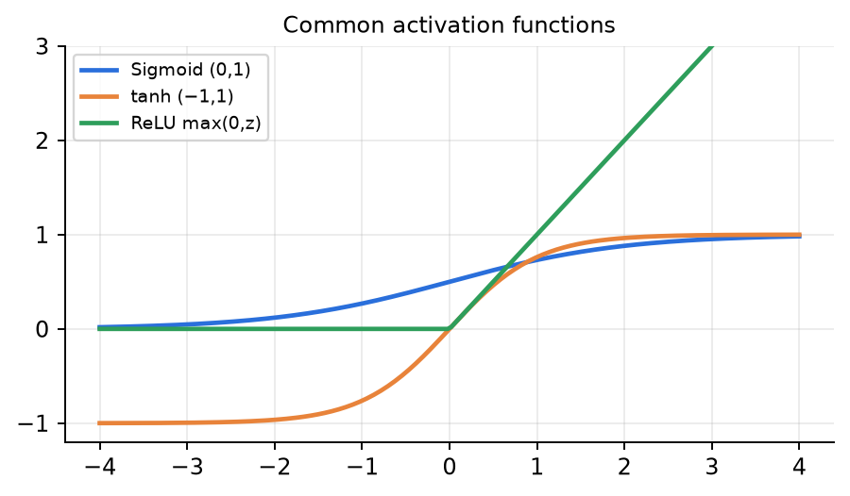
Figure 12.1 — Sigmoid (0,1), tanh (−1,1) and ReLU [0,∞).
Activation | Formula g(z) | Derivative g′(z) | Range | Pros | Cons / where used
Step (perceptron) | 1 if z > 0 else 0 | 0 (undefined at 0) | {0, 1} | simple, logic gates | no useful gradient → cannot use backprop
Sigmoid σ | 1 / (1 + e^{−z}) | σ(z)(1 − σ(z)) ≤ 0.25 | (0, 1) | output = probability; smooth | saturates → vanishing gradient; not zero-centred; exp is costly. Binary output layer.
tanh | (e^{z} − e^{−z}) / (e^{z} + e^{−z}) = 2σ(2z) − 1 | 1 − tanh²(z) ≤ 1 | (−1, 1) | zero-centred, stronger gradients than σ | still saturates for large |z|. RNN hidden units.
ReLU | max(0, z) | 1 if z > 0, 0 if z < 0 | [0, ∞) | no saturation for z > 0; very cheap; sparse activations; fast training | "dying ReLU": a unit stuck at z < 0 always outputs 0 and gets 0 gradient. Default for hidden layers / CNNs.
Leaky ReLU | z if z > 0 else αz (α ≈ 0.01) | 1 or α | (−∞, ∞) | fixes dying ReLU | extra hyper-parameter α
Softmax (layer) | p_{k} = exp(z_{k}) / Σ_{j} exp(z_{j}) | ∂p_{j}/∂z_{k} = p_{j}(δ_{jk} − p_{k}) | (0,1), Σ p_{k} = 1 | turns K scores into a probability distribution | multi-class output layer only
Linear / identity | z | 1 | (−∞, ∞) | unbounded output | regression output layer only

📐 Derivation: Derivative of the sigmoid
Step 1. Write it as a power so we can use the chain rule.
σ(z) = (1 + e^{−z})⁻¹
Step 2. Derivative of u⁻¹ is −u⁻²·u′, and u′ = −e^{−z}.
σ′(z) = −(1 + e^{−z})⁻² · (−e^{−z}) = e^{−z} / (1 + e^{−z})²
Step 3. Split the fraction into two factors.
σ′(z) = [1 / (1 + e^{−z})] · [e^{−z} / (1 + e^{−z})]
Step 4. Add and subtract 1 in the numerator.
e^{−z} / (1 + e^{−z}) = 1 − 1/(1 + e^{−z}) = 1 − σ(z)
Step 5. The famous result — only needs the forward-pass value.
σ′(z) = σ(z)(1 − σ(z))
Step 6. p(1 − p) is largest at p = 0.5. For |z| large, σ → 0 or 1 and σ′ → 0 (saturation).
max σ′ = σ′(0) = 0.5 × 0.5 = 0.25

Figure 12.2 — Sigmoid vs step (left) and σ′(z) with its maximum 0.25 at z = 0 (right).

The vanishing-gradient problem
- Backprop multiplies one factor g′(z) per layer: ∂L/∂W⁽¹⁾ ∝ g′(z^{(L)}) · W^{(L)} · g′(z^{(L−1)}) · … · g′(z⁽¹⁾).
- With sigmoid every factor is ≤ 0.25 → after 10 layers the gradient is scaled by at most 0.25¹⁰ ≈ 10⁻⁶ → the early layers stop learning.
- Cures: ReLU (g′ = 1 for z > 0), good initialisation (Xavier/He), batch normalisation, residual (skip) connections, LSTM/GRU for RNNs.
- The opposite problem — exploding gradients — occurs when the factors are > 1 (large weights, x² activations): fix with gradient clipping, smaller η, normalisation.

12.4 Loss functions
Common losses
MSE (regression): L = (1/N) Σ_{i} (y_{i} − ŷ_{i})² (often ½(y − ŷ)² for one sample → ∂L/∂ŷ = ŷ − y)
Binary cross-entropy: L = −[ y log ŷ + (1 − y) log(1 − ŷ) ] (ŷ = σ(z))
Categorical cross-entropy: L = −Σ_{k=1}^{K} y_{k} log p_{k} = −log p_{true class} (y one-hot, p = softmax(z))
y = true target (0/1 or one-hot vector), ŷ / p = predicted value / probability, N = number of samples, K = number of classes. Output-layer pairs: linear + MSE (regression), sigmoid + BCE (binary), softmax + CE (multi-class).

📌 Exam tip
Cross-entropy with a one-hot label is simply −log(probability given to the correct class). If the net outputs [0.7, 0.2, 0.1] and the truth is class 2 → L = −log 0.2 = 1.609 (natural log).

12.5 Backpropagation
💡 In easy language
Forward pass: compute every z and a, left to right, and the loss.
Backward pass: for each neuron compute its error signal δ = ∂L/∂z ("how much would the loss change if this neuron's net input changed?"), right to left. A weight's gradient is then just (δ of the neuron it enters) × (activation of the neuron it leaves).

📐 Derivation: Backpropagation equations (chain rule)
Step 1. Output layer: loss sensitivity to the output times the activation slope. For ½(ŷ − y)², ∂L/∂a = ŷ − y.
δ^{(L)} = ∂L/∂z^{(L)} = (∂L/∂a^{(L)}) ⊙ g′(z^{(L)})
Step 2. Neuron i of layer l feeds EVERY neuron j of the next layer.
z_{j}^{(l+1)} = Σ_{i} W_{ji}^{(l+1)} a_{i}^{(l)} + b_{j} ⇒ ∂z_{j}^{(l+1)}/∂a_{i}^{(l)} = W_{ji}^{(l+1)}
Step 3. Sum over all paths from a_{i} to the loss (multivariable chain rule).
∂L/∂a_{i}^{(l)} = Σ_{j} δ_{j}^{(l+1)} W_{ji}^{(l+1)}
Step 4. Hidden layer: pull errors back through the transposed weights, multiply by the local slope.
δ^{(l)} = (W^{(l+1)T} δ^{(l+1)}) ⊙ g′(z^{(l)})
Step 5. Because ∂z_{j}/∂W_{ji} = a_{i} (the input on that edge) and ∂z_{j}/∂b_{j} = 1.
∂L/∂W_{ji}^{(l)} = δ_{j}^{(l)} · a_{i}^{(l−1)} i.e. ∂L/∂W^{(l)} = δ^{(l)} (a^{(l−1)})^{T} ; ∂L/∂b^{(l)} = δ^{(l)}
Step 6. Gradient-descent update with learning rate η. Update ALL weights only after all gradients are computed (use the OLD weights in the backward pass).
W ← W − η ∂L/∂W , b ← b − η ∂L/∂b

Backprop in one line
δ_{out} = ∂L/∂a · g′(z) δ_{hidden} = (W^{T} δ_{next}) ⊙ g′(z) ∂L/∂W = δ · (input)^{T}
⊙ = element-wise product; "input" = activation of the previous layer (x for the first layer).

📐 Derivation: Softmax + cross-entropy gradient = p − y
Step 1. Set-up: K logits z, one-hot target y.
p_{j} = exp(z_{j}) / S , S = Σ_{m} exp(z_{m}) ; L = −Σ_{j} y_{j} log p_{j}
Step 2. Quotient rule; z_{k} appears in both numerator and S.
j = k: ∂p_{k}/∂z_{k} = (exp(z_{k}) S − exp(z_{k}) exp(z_{k})) / S² = p_{k}(1 − p_{k})
Step 3. z_{k} appears only in S.
j ≠ k: ∂p_{j}/∂z_{k} = (0 · S − exp(z_{j}) exp(z_{k})) / S² = −p_{j} p_{k}
Step 4. Both cases in one line (δ_{jk} = 1 if j = k, else 0) — the softmax Jacobian.
∂p_{j}/∂z_{k} = p_{j}(δ_{jk} − p_{k})
Step 5. Chain rule through every p_{j}; the p_{j} cancels.
∂L/∂z_{k} = −Σ_{j} (y_{j}/p_{j}) · p_{j}(δ_{jk} − p_{k}) = −Σ_{j} y_{j}(δ_{jk} − p_{k})
Step 6. Since Σ y_{j} = 1 (one-hot). Same form for sigmoid + BCE: ∂L/∂z = ŷ − y.
∂L/∂z_{k} = −y_{k} + p_{k} Σ_{j} y_{j} = p_{k} − y_{k}

12.6 Parameter counting, training and regularisation
Fully-connected network
# parameters = Σ_{layers} (n_{in} + 1) · n_{out} (n_{in} · n_{out} weights + n_{out} biases)
Example 8 → 10 → 6 → 3: (8+1)·10 + (10+1)·6 + (6+1)·3 = 90 + 66 + 21 = 177. Without biases drop the "+1".

- Gradient descent variants: batch GD (all data per step), stochastic GD (one sample), mini-batch (32–256 samples, the standard). One pass over the data = one epoch.
- Learning rate η: too large → loss oscillates / diverges; too small → very slow. Adam, momentum, RMSProp adapt the step.
- Initialisation: never all-zero (all hidden units would stay identical — symmetry); use small random values (Xavier for tanh/sigmoid, He for ReLU).
- Overfitting: many parameters + little data → training loss ↓ but validation loss ↑.
- L2 regularisation / weight decay: L_{total} = L + λ Σ w² → gradient gets + 2λw → weights shrink toward 0 → smoother function.
- Dropout: during training randomly switch off each hidden unit with probability p (e.g., 0.5); at test time use all units (scaled). Prevents co-adaptation — like training an ensemble of thinned networks.
- Early stopping: monitor validation loss; stop when it has not improved for "patience" epochs and keep the best weights.
- Also: data augmentation, smaller network, batch normalisation.
🛠️ How to use / step-by-step recipe
1. Draw the network; label every edge with its weight and every node with "in (z)" and "out (a)".
2. Forward pass layer by layer: z = Σ w·a_{prev} + b, a = g(z). Write the loss L.
3. Output δ: δ = ∂L/∂a × g′(z) (softmax + CE or sigmoid + BCE: δ = p − y directly).
4. Hidden δ: δ_{i} = (Σ_{j} w_{ji} δ_{j}) × g′(z_{i}) — sum over the arrows LEAVING neuron i, using OLD weights.
5. Gradient for each edge i → j: ∂L/∂w = δ_{j} × a_{i}. Put all of them in a table.
6. Update: w_{new} = w − η × gradient. State η and the loss convention (½ or not).

🔑 Keywords
neuron, perceptron, weights, bias, pre-activation, activation function, step, sigmoid, tanh, ReLU, leaky ReLU, softmax, saturation, vanishing / exploding gradient, dying ReLU, feedforward, MLP, hidden layer, fully connected, universal approximation, XOR, linear separability, loss, MSE, binary / categorical cross-entropy, logits, backpropagation, chain rule, error signal δ, gradient descent, learning rate, epoch, mini-batch, dropout, early stopping, L2 weight decay, overfitting.

🌍 Use cases
Image recognition (with CNNs), speech recognition, machine translation and chatbots (transformers), credit scoring and fraud detection (tabular MLPs), recommendation systems, medical diagnosis from scans, self-driving perception, function approximation in control and reinforcement learning.

Chapter 13. CNNs, RNNs & Transformers

13.1 Convolutional Neural Networks (CNN) — theory
💡 In easy language
A CNN looks at an image the way you do: through a small window that slides across the picture. At every position it asks "does this patch look like my pattern (an edge, a corner, a blob of colour)?" and writes the answer (a number) into a new image called a feature map.
The pattern is stored in a small grid of weights called a filter / kernel. The same filter is reused everywhere in the image, so a CNN needs very few weights and it finds a cat whether the cat is in the top-left or the bottom-right corner.

Why not a plain fully-connected (FC) network for images?
- Parameters explode. A 1600×1200 colour photo has 1600 × 1200 × 3 = 5,760,000 input values. One FC hidden layer with only 1000 neurons already needs 5.76 × 10⁹ (5.76 billion) weights — impossible to store, slow to train, and it overfits badly.
- No spatial structure. An FC layer flattens the image into a long vector, so it forgets which pixels are neighbours. Shuffling the pixels (the same way for every image) would give exactly the same network — but images are all about neighbourhoods.
- No translation awareness. An FC net that learned "eye at position (10, 20)" must separately learn "eye at (50, 80)". A CNN learns it once.

The three big ideas of convolution
Idea | What it means | Why it helps
Local connectivity | each output neuron looks only at a small F×F patch (its receptive field), not the whole image | nearby pixels are strongly related; far-away pixels rarely matter for low-level features
Weight sharing | the same filter weights are used at every position of the image | huge reduction in parameters; #params does NOT depend on image size
Translation equivariance | shift the input → the feature map shifts by the same amount | a pattern is detected wherever it appears; pooling then adds a little translation invariance

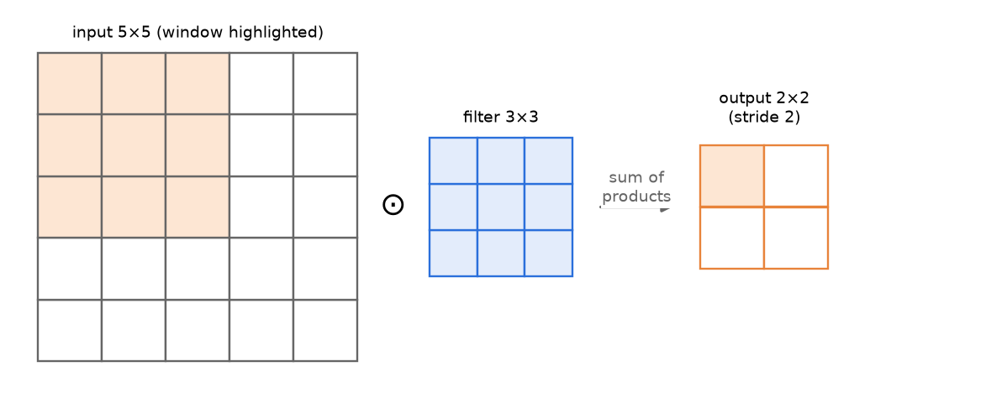
Figure 13.1 — Convolution = a sliding dot product: multiply the window element-wise with the filter, add everything up, write one number, then slide by the stride.
- Convolution (as used in deep learning, strictly cross-correlation): output(i, j) = Σ_{c} Σ_{u} Σ_{v} X(c, i·S + u, j·S + v) · K(c, u, v) + b. In words: place the filter on the window, multiply matching cells, add them all (across all channels), add the bias.
- Filter depth = input depth. On an RGB image (3 channels) a "5×5 filter" is really 5×5×3. One filter always produces one 2-D feature map (it sums over the channels).
- Number of filters = output depth. K filters → K feature maps stacked → output has K channels.
- Stride S: how many pixels the window jumps each step. Bigger stride → smaller output.
- Padding P: a border of zeros added around the input. It lets the filter sit on edge pixels and controls the output size. "Valid" = no padding (P = 0, output shrinks); "same" = pad so that output size = input size (for S = 1, P = (F − 1)/2).
- Pooling: shrinks each feature map by summarising small windows — max-pool keeps the largest value, average-pool the mean. It has no trainable parameters, works on each channel separately (depth unchanged) and gives a little robustness to small shifts.
- Receptive field: the region of the ORIGINAL image that affects one neuron. It grows as you go deeper and depends on the filter sizes and strides (and padding) of all previous layers. Two stacked 3×3 convs (stride 1) see 5×5; three see 7×7.
- Activation: a non-linearity (usually ReLU) is applied element-wise after each conv layer — no parameters, size unchanged.
📐 Derivation: Output size of a convolution / pooling layer
Step 1. After zero-padding, the input width becomes W + 2P.
W + 2P
Step 2. The filter of width F can start at positions 0, 1, …, W + 2P − F (its right edge must stay inside). So the LAST starting position is W + 2P − F.
W + 2P − F
Step 3. Starting at 0 and jumping S each time, we can make (W + 2P − F)/S jumps, plus the first position itself.
number of starting positions = (W + 2P − F)/S + 1
Step 4. If the jumps do not divide exactly, the last partial jump is not allowed → take the floor. Same formula for height, and for pooling (usually P = 0, S = F).
O = ⌊(W − F + 2P)/S⌋ + 1

CNN size & parameter formulas
O = ⌊(W − F + 2P) / S⌋ + 1 (height similarly)
Output depth = number of filters K
Conv params = (F · F · C_{in} + 1) · C_{out}
Pooling params = 0 ; FC params = (n_{in} + 1) · n_{out}
"Same" padding (S = 1): P = (F − 1)/2
W = input width, F = filter size, P = padding on each side, S = stride, C_{in} = input channels (filter depth), C_{out} = K = number of filters, the "+1" = one bias per filter, n_{in}/n_{out} = FC input/output sizes.

📐 Derivation: Why conv parameters do not depend on stride, padding or image size
Step 1. A filter must cover all input channels, and gets one bias.
one filter = F × F × C_{in} weights + 1 bias
Step 2. Each filter has its own weights.
K filters ⇒ (F·F·C_{in} + 1)·K
Step 3. Because of weight sharing, the SAME numbers are reused at every position. Stride/padding/image size only change HOW MANY positions (output size), not how many weights.
W, P, S never appear

- FC layer after conv: flatten H × W × C into one vector of length H·W·C; weights = H·W·C · n_{out}, biases = n_{out}. This is usually where most parameters live.
- Typical architecture: INPUT → [CONV → ReLU → (CONV → ReLU) → POOL] × N → FLATTEN → FC → ReLU → FC → softmax. Spatial size goes DOWN, depth (number of filters) goes UP as we go deeper.
- Hierarchy of features: early layers learn edges/colours, middle layers textures/parts, deep layers whole objects.
Layer | Trainable params? | Changes H×W? | Changes depth?
Conv (K filters) | yes: (F·F·C_{in}+1)·K | yes (unless "same") | yes → K
ReLU | no | no | no
Max / Avg pool | no | yes (usually halves) | no
Flatten | no | → 1-D vector | —
Fully connected | yes: (n_{in}+1)·n_{out} | — | —

🛠️ How to use / step-by-step recipe
1. Write down W, F, P, S and the number of filters K for each layer.
2. Output size: O = ⌊(W − F + 2P)/S⌋ + 1 for height and width; depth = K (conv) or unchanged (pool).
3. Params per conv layer: (F·F·C_{in} + 1)·K, where C_{in} = depth of the PREVIOUS layer's output. Pool/ReLU = 0.
4. FC: flatten (H·W·C), then (H·W·C)·n_{out} weights + n_{out} biases.
5. To compute a feature map by hand: for each output cell, take the window, multiply element-wise with the filter (per channel), add everything, add bias, apply ReLU if asked.
6. Show a table with columns: layer | output size | weights | biases — examiners give marks per row.

🔑 Keywords
convolution, cross-correlation, filter / kernel, feature map / activation map, channel, depth, stride, zero-padding, valid / same padding, local connectivity, weight sharing (parameter sharing), translation equivariance, translation invariance, max-pooling, average-pooling, receptive field, flatten, fully-connected layer, ReLU, LeNet, AlexNet, VGG, ResNet.

🌍 Use cases
Image classification (ImageNet, medical X-rays), object detection (YOLO, Faster R-CNN), face recognition, self-driving cars (lane and pedestrian detection), satellite image analysis, OCR / handwritten digits (MNIST), and 1-D CNNs for audio and time-series signals.

13.3 RNNs, Seq2Seq, Attention & Transformers — theory
💡 In easy language
Some data comes as a sequence: words in a sentence, frames in audio, daily stock prices. The meaning of the current item depends on what came before ("bank" in "river bank" vs "bank loan").
A Recurrent Neural Network (RNN) reads the sequence one step at a time and keeps a small memory vector (the hidden state h_{t}). At every step it mixes the new input with its old memory — using the same weights at every step.
A Transformer throws away the step-by-step loop: every word directly "looks at" every other word using attention, which is faster (parallel) and remembers long-range context much better.

Recurrent Neural Networks
Vanilla (Elman) RNN
h_{t} = tanh(W_{h} h_{t−1} + W_{x} x_{t} + b_{h})
y_{t} = W_{y} h_{t} + b_{y} (then softmax / sigmoid if needed)
#params = d′·d + d′·d′ + d′ + v·d′ + v (independent of sequence length T)
x_{t} ∈ ℝ^{d} = input at step t, h_{t} ∈ ℝ^{d′} = hidden state (memory), h₀ = 0 usually, W_{x} (d′×d) input-to-hidden, W_{h} (d′×d′) hidden-to-hidden, W_{y} (v×d′) hidden-to-output, b = biases, v = output size (e.g. vocabulary).

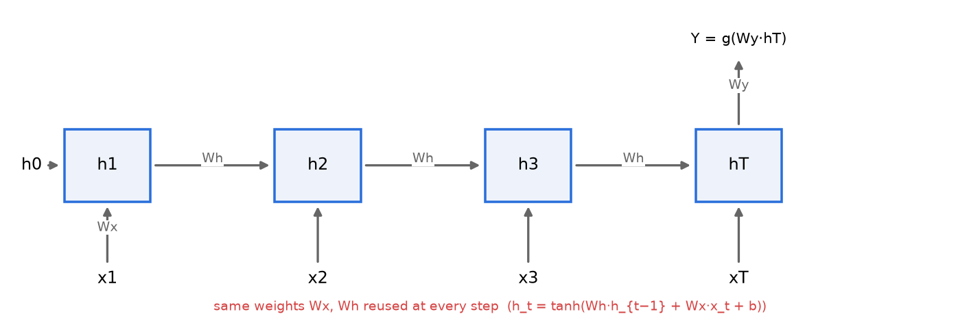
Figure 13.2 — An RNN unrolled in time: the same W_{x} and W_{h} are reused at every step; for many-to-one tasks only the last hidden state h_{T} produces the output.
- Weight sharing across time: the same W_{x}, W_{h}, W_{y} at every step → the number of parameters does not depend on T, and the network can handle sequences of any length.
- Training = Backpropagation Through Time (BPTT): unroll the RNN for T steps (it becomes a deep feed-forward net with tied weights), compute the loss, backpropagate through all steps, and add the gradients for the shared weights. Truncated BPTT limits the number of steps for speed.
- Vanishing / exploding gradients: the gradient from step T back to step k contains the product Π ∂h_{t}/∂h_{t−1} = Π diag(tanh′(·)) W_{h}. tanh′ ≤ 1 and if the largest singular value of W_{h} is < 1 the product shrinks exponentially (vanishes); if > 1 it can blow up (explodes). → A vanilla RNN cannot learn long-range dependencies (e.g., subject-verb agreement across 20 words). Exploding gradients are fixed with gradient clipping; vanishing needs a better cell.
- LSTM: adds a cell state c_{t} (a conveyor belt) and three gates (sigmoid values in 0–1): forget gate f (what to erase), input gate i (what to write), output gate o (what to reveal). c_{t} = f ⊙ c_{t−1} + i ⊙ c̃_{t}; h_{t} = o ⊙ tanh(c_{t}). The additive update lets gradients flow over long distances.
- GRU: a lighter LSTM with 2 gates — update gate z and reset gate r; no separate cell state; fewer params, similar performance.
📐 Derivation: Why gradients vanish or explode in an RNN
Step 1. Chain rule through every time step between k and T.
∂L/∂h_{k} = ∂L/∂h_{T} · Π_{t=k+1}^{T} ∂h_{t}/∂h_{t−1}
Step 2. Derivative of h_{t} = tanh(W_{h} h_{t−1} + …); tanh′ = 1 − tanh² ≤ 1.
∂h_{t}/∂h_{t−1} = diag(1 − h_{t}²) · W_{h}
Step 3. γ ≤ 1 from tanh′, λ_{max} = largest singular value of W_{h}. A number raised to a big power.
‖Π‖ ≈ (γ · λ_{max})^{T−k}
Step 4. Early inputs get (almost) no gradient → the RNN "forgets" long-range context.
γλ < 1 ⇒ → 0 (vanish); γλ > 1 ⇒ → ∞ (explode)

Sequence-to-sequence (encoder–decoder) and RNN configurations
Type | Input → output | Example
One-to-one | fixed → fixed | ordinary classifier (no recurrence)
One-to-many | single input → sequence | image captioning, music generation
Many-to-one | sequence → single output | sentiment analysis, spam detection (use h_{T})
Many-to-many (synced) | output at every step, same length | POS tagging, named-entity recognition, video frame labelling
Many-to-many (seq2seq) | sequence → sequence of different length | machine translation, summarisation, chatbots

- Encoder RNN reads the whole input and compresses it into a context vector (its final hidden state).
- Decoder RNN starts from that context and generates the output one token at a time, feeding back its previous output; stops at an <EOS> token. During training the true previous token is fed in (teacher forcing).
- Bottleneck problem: one fixed-size vector for a long sentence loses information → attention lets the decoder look back at ALL encoder hidden states and weight them at each step.

Attention and the Transformer
Transformer building blocks
Attention(Q, K, V) = softmax( Q K^{T} / √d_{k} ) V
Q = X W^{Q}, K = X W^{K}, V = X W^{V} (self-attention: all from the same X)
MultiHead(X) = Concat(head₁, …, head_{h}) W^{O}, head_{i} = Attention(X W_{i}^{Q}, X W_{i}^{K}, X W_{i}^{V})
FFN(x) = W₂ ReLU(W₁ x + b₁) + b₂ (d → 4d → d)
Sub-layer output = LayerNorm( x + SubLayer(x) )
Q = queries ("what am I looking for?"), K = keys ("what do I contain?"), V = values ("what I pass on"), d_{k} = key dimension; dividing by √d_{k} keeps dot products from growing too large and saturating the softmax; h = number of heads, W^{O} = output projection.

- Self-attention: each token builds a query, compares it (dot product) with the keys of all tokens, turns the scores into weights with softmax, and takes the weighted average of the values → every token sees the whole sentence in ONE step (path length 1 instead of T).
- Multi-head attention (MHA): run h attention "heads" in parallel with different projections (one may track syntax, another coreference), concatenate, project with W^{O}. Parameters: 4 matrices d×d (+ biases) = 4(d² + d), regardless of h.
- Encoder layer = Multi-head self-attention → Add & LayerNorm → Feed-forward (d → 4d → d) → Add & LayerNorm.
- Decoder layer = Masked multi-head self-attention (cannot see future tokens) → Add & Norm → Cross-attention (Q from decoder, K and V from encoder output) → Add & Norm → FFN → Add & Norm.
- Residual connections (x + SubLayer(x)) help gradients flow in deep stacks; LayerNorm stabilises training.
- Positional encoding: attention itself is order-blind (a "bag of tokens"), so a position vector is ADDED to each word embedding — sinusoidal (fixed, 0 params) or learned.
- Why Transformers beat RNNs: fully parallel training (no step-by-step loop), direct long-range connections (no vanishing over time), scale to huge data. Cost: attention is O(T²) in sequence length.
 | BatchNorm | LayerNorm
Normalises over | the batch, for each feature / position | the features of ONE sample (one token)
Depends on batch size? | yes — noisy for small batches | no
Variable-length sequences / padding | statistics per position become meaningless | no problem — each token on its own
Train vs test | uses running averages at test time (mismatch) | identical computation in train and test
Typical use | CNNs (images) | RNNs, Transformers (NLP)

🛠️ How to use / step-by-step recipe
1. RNN forward pass by hand: start with h₀ = 0; at each step compute a_{t} = W_{h}h_{t−1} + W_{x}x_{t} + b, then h_{t} = tanh(a_{t}) element-wise; output from h_{t} (or only h_{T}).
2. RNN params: count W_{x} (d′×d), W_{h} (d′×d′), b_{h} (d′), W_{y} (v×d′), b_{y} (v); state that it does not depend on T.
3. Transformer params: embeddings (v×d) + per layer [MHA 4(d² + d)] + [FFN 8d² + 5d] + [LayerNorm 2d each]; decoder layer has 2 MHAs and 3 LayerNorms. State your assumptions (bias, tied embeddings, positional encoding type).
4. For "why" questions: vanishing gradients → LSTM/GRU/attention; BatchNorm vs LayerNorm → variable length + batch independence.

🔑 Keywords
sequence modelling, recurrent neural network, hidden state, weight sharing across time, unrolling, backpropagation through time (BPTT), truncated BPTT, vanishing gradient, exploding gradient, gradient clipping, long-range dependency, LSTM, cell state, forget / input / output gate, GRU, update / reset gate, encoder, decoder, context vector, seq2seq, teacher forcing, attention, self-attention, query / key / value, scaled dot-product, multi-head attention, cross-attention, masked attention, positional encoding, feed-forward network, residual connection, Layer Normalisation, Batch Normalisation, Transformer, BERT, GPT.

🌍 Use cases
Machine translation (Google Translate), speech recognition, text generation and chatbots (GPT, Claude), sentiment analysis, next-word prediction on phone keyboards, time-series forecasting (stock prices, weather), music generation, protein structure (AlphaFold uses attention), Vision Transformers (ViT) for images.

PART C — REVISION

Chapter 14. Master Formula Sheet
📌 Exam tip
Print this chapter. Every formula you need for the paper is here, one table per topic, in the same notation as the chapters. Column 3 tells you when to use it — read that column the night before the exam.
Notation: m or N = number of samples, n or d = number of features, η = learning rate, ‖·‖ = Euclidean norm, log = ln unless written log₂.

14.1 Evaluation metrics
Formula / quantity | Expression | When / meaning
Confusion matrix | rows = actual, columns = predicted; TP, FN / FP, TN | Always draw it first; check which axis is "actual".
Accuracy | (TP + TN) / (TP + TN + FP + FN) | Overall fraction correct. Misleading for imbalanced classes.
Error rate | 1 − Accuracy = (FP + FN) / total
Precision | TP / (TP + FP) | Of those predicted +, how many are +. Important when FP is costly (spam).
Recall = Sensitivity = TPR | TP / (TP + FN) | Of the actual +, how many were caught. Important when FN is costly (disease, fraud).
Specificity = TNR | TN / (TN + FP) | Recall of the negative class.
FPR | FP / (FP + TN) = 1 − Specificity | x-axis of the ROC curve (y-axis = TPR).
F1 score | 2 · P · R / (P + R) = 2TP / (2TP + FP + FN) | Harmonic mean — small if either P or R is small.
Macro / micro average | macro = mean of per-class scores; micro = pool all TP, FP, FN first | Multi-class. Micro-P = micro-R = accuracy (single-label).
MSE / RMSE / MAE | (1/n) Σ (y_{i} − ŷ_{i})² / √MSE / (1/n) Σ |y_{i} − ŷ_{i}| | Regression errors. RMSE has the units of y; MAE is robust to outliers.
R² | 1 − SS_{res}/SS_{tot} = 1 − Σ(y_{i} − ŷ_{i})² / Σ(y_{i} − ȳ)² | Fraction of variance of y explained; 1 = perfect, 0 = as good as predicting ȳ.

14.2 KNN & distances
Formula / quantity | Expression | When / meaning
Euclidean (L2) | d(x, z) = √( Σ_{j} (x_{j} − z_{j})² ) | Default for continuous features.
Manhattan (L1) | Σ_{j} |x_{j} − z_{j}| | Grid / city-block; less sensitive to one big difference.
Minkowski (Lp) | ( Σ_{j} |x_{j} − z_{j}|^{p} )^{1/p} | p = 1 Manhattan, p = 2 Euclidean, p → ∞ Chebyshev = max_{j} |x_{j} − z_{j}|.
Cosine similarity | x^{T}z / (‖x‖ ‖z‖); distance = 1 − cos | Text / direction matters, length does not.
Hamming | # positions where x_{j} ≠ z_{j} | Binary / categorical strings.
Majority vote | ŷ = argmax_{v} Σ_{i ∈ Dz} I(v = y_{i}) | D_{z} = the K nearest neighbours of z.
Distance-weighted vote | w_{i} = 1 / d(x_{i}, z)²; ŷ = argmax_{v} Σ w_{i} I(v = y_{i}) | Closer neighbours count more; breaks ties.
KNN regression | ŷ = Σ w_{i} y_{i} / Σ w_{i} (plain: mean of K neighbours) | Numeric target / missing-value imputation.
Z-score scaling | x′ = (x − μ) / σ | Always scale before KNN (big-range features dominate).
Min–max scaling | x′ = (x − min) / (max − min) ∈ [0, 1] | Alternative scaling.
Cost | training O(1); prediction O(N · d) per query | Lazy learner. Speed-ups: kd-tree, LSH, condensing.
Choice of K | small K → high variance; large K → high bias | Odd K for 2 classes; tune by cross-validation.

14.3 Linear regression, normal equation, gradient descent, Ridge & Lasso
Formula / quantity | Expression | When / meaning
Model | ŷ = θ₀ + θ₁x₁ + … + θ_{n}x_{n} = w^{T}x (x₀ = 1) | n features → n + 1 parameters.
Loss (this guide) | L = (1/m) Σ_{i} (ŷ_{i} − y_{i})² | State your convention (½, 1/m or none) at the start.
Simple LR (1 feature) | θ₁ = S_{xy}/S_{xx} = Σ(x_{i} − x̄)(y_{i} − ȳ) / Σ(x_{i} − x̄)²; θ₀ = ȳ − θ₁x̄ | Closed form by hand. Line passes through (x̄, ȳ).
Normal equation | ŵ = (X^{T}X)⁻¹ X^{T} y | X is m × (n+1) with a first column of 1s. O(n³); needs X^{T}X invertible.
Gradient of MSE | ∂L/∂w_{j} = (2/m) Σ_{i} (ŷ_{i} − y_{i}) x_{ij}; ∂L/∂b = (2/m) Σ_{i} (ŷ_{i} − y_{i}) | Vector form: ∇_{w}L = (2/m) X^{T}(Xw − y).
GD update | θ ← θ − η ∇_{θ}L | MINUS sign (downhill). Use the gradient at the OLD θ for all components.
Batch / Mini-batch / SGD | gradient averaged over m / B / 1 samples; updates per epoch = 1 / m/B / m | Mini-batch & SGD: next batch uses the UPDATED weights.
Ridge (L2) | J = MSE + λ Σ_{j≥1} θ_{j}²; ŵ = (X^{T}X + λI)⁻¹ X^{T} y | Shrinks all weights, none exactly 0. Bias θ₀ not penalised.
Ridge GD step | θ_{j} ← θ_{j} − η ( ∂MSE/∂θ_{j} + 2λθ_{j} ) | "Weight decay".
Lasso (L1) | J = MSE + λ Σ_{j≥1} |θ_{j}|; sub-gradient λ · sign(θ_{j}) | Makes some weights exactly 0 → feature selection.
Polynomial regression | ŷ = θ₀ + θ₁x + θ₂x² + … + θ_{p}x^{p} | Still linear in θ: treat x², x³ as new features.
Locally weighted LR | E = Σ w^{i} (F(x^{i}) − y^{i})², w^{i} = exp(−‖x^{i} − x‖² / (2c²)) | Refit for every query point (non-parametric).

14.4 Perceptron
Formula / quantity | Expression | When / meaning
Prediction | ŷ = sign(w^{T}x + b), y ∈ {−1, +1} | Linear decision boundary w^{T}x + b = 0.
Mistake test | y_{i}(w^{T}x_{i} + b) ≤ 0 | "= 0" (point ON the line) counts as a mistake.
Update (on a mistake) | w ← w + η y_{i} x_{i}; b ← b + η y_{i} (η = 1 usually) | Use the NEW w for the next point.
0/1-label version | w ← w + η (y − ŷ) x | Same idea when labels are {0, 1}.
Effect of one update | y(w_{new}^{T}x + b_{new}) = y(w^{T}x + b) + η(‖x‖² + 1) | Score of that point moves towards the correct sign.
Convergence (Novikoff) | # mistakes ≤ (R/γ)², R = max ‖x_{i}‖, γ = margin | Only if linearly separable; bigger margin → fewer mistakes. XOR never converges.
Distance point → line | |w^{T}x + b| / ‖w‖ | Geometric margin of a point.
Stopping rule | one full pass (epoch) with zero updates | Result depends on start and order — not the max-margin line.

14.5 Logistic regression, sigmoid, softmax & cross-entropy
Formula / quantity | Expression | When / meaning
Sigmoid | σ(z) = 1/(1 + e^{−z}) = e^{z}/(1 + e^{z}) | σ(0) = 0.5, σ(−z) = 1 − σ(z), range (0, 1).
Sigmoid derivative | σ′(z) = σ(z)(1 − σ(z)) ≤ 0.25 | Max 0.25 at z = 0 → vanishing gradients in deep nets.
Model | P(y = 1 | x) = σ(w^{T}x + b) | A probabilistic 2-class CLASSIFIER.
Log-odds (logit) | ln( p / (1 − p) ) = w^{T}x + b | Boundary p = 0.5 ⇔ z = 0 → linear boundary.
Likelihood | L(θ) = Π_{i} p_{i}^{yᵢ} (1 − p_{i})^{1 − yᵢ} | Assumes independent samples; maximise log L.
Binary cross-entropy | J = −(1/m) Σ [ y_{i} ln p_{i} + (1 − y_{i}) ln(1 − p_{i}) ] | = −(1/m) log-likelihood. Convex; no closed form.
Gradient | ∂J/∂θ_{j} = (1/m) Σ_{i} (p_{i} − y_{i}) x_{ij} | Same shape as linear regression, but p = σ(z).
Update | θ ← θ − η (1/m) Σ (p_{i} − y_{i}) x_{i} (or ascent: θ + η Σ (y − p) x) | Descent on J ⇔ ascent on log L.
Softmax | p_{k} = e^{zₖ} / Σ_{j=1}^{K} e^{zⱼ}, z_{k} = θ^{(k)T}x | K classes; probabilities sum to 1. Subtract max z for stability.
Categorical CE | J = −Σ_{k} y_{k} ln p_{k} = −ln p_{c} (c = true class) | y one-hot. Average over samples.
Softmax + CE gradient | ∂J/∂z = p − y | The cleanest result in ML — memorise.
K = 2 softmax | e^{z₁}/(e^{z₁} + e^{z₂}) = σ(z₁ − z₂) | Softmax generalises sigmoid; CE generalises BCE.
Softmax parameters | K(n + 1) | One weight vector + bias per class.

14.6 Decision trees — entropy, IG, SplitInfo, Gain Ratio, Gini
Formula / quantity | Expression | When / meaning
Entropy | H(S) = −Σ_{i} p_{i} log₂ p_{i} | 0 = pure; max = log₂K (1 bit for 2 classes). 0 · log 0 = 0.
2-class entropy | H = −p log₂p − (1 − p) log₂(1 − p) | Use the value table below.
Weighted child entropy | H(S | A) = Σ_{v} (|S_{v}|/|S|) H(S_{v}) | Only the rows that reach this node!
Information Gain (ID3) | IG(S, A) = H(S) − Σ_{v} (|S_{v}|/|S|) H(S_{v}) | Pick the attribute with the MAX IG. Biased to many-valued attributes.
SplitInfo | SI_{A}(S) = −Σ_{v} (|S_{v}|/|S|) log₂(|S_{v}|/|S|) | Entropy of the branch SIZES (ignores classes).
Gain Ratio (C4.5) | GR(A) = IG(S, A) / SI_{A}(S) | Penalises ID-like attributes with many small branches.
Gini impurity (CART) | Gini(S) = 1 − Σ_{i} p_{i}² | 0 = pure; max 1 − 1/K (0.5 for 2 classes).
Gini of a split | Gini_{A} = Σ_{v} (|S_{v}|/|S|) Gini(S_{v}); ΔGini = Gini(S) − Gini_{A} | Pick the MIN weighted Gini (binary splits).
Misclassification error | 1 − max_{i} p_{i} | Used for pruning.
Continuous feature | sort values; try thresholds at midpoints where the class changes | Binary test x ≤ t; pick the t with max IG.
Regression tree | minimise Σ_{v} (|S_{v}|/|S|) Var(S_{v}) | Leaf predicts the mean of its rows.

Handy entropy values (2 classes) and logs — memorise:
Class ratio | H (bits) | Class ratio | H (bits) | Log value
1 : 1 | 1.000 | 2 : 3 | 0.971 | log₂3 | 1.585
1 : 2 | 0.918 | 3 : 4 | 0.985 | log₂5 | 2.322
1 : 3 | 0.811 | 3 : 5 | 0.954 | log₂7 | 2.807
1 : 4 | 0.722 | 9 : 5 | 0.940 | log₂6 = 1 + log₂3 | 2.585
n : 0 (pure) | 0 | 1 : 1 : 1 (3 classes) | log₂3 = 1.585 | ln x = log₂x · ln 2 | ln 2 = 0.693

14.7 Naïve Bayes
Formula / quantity | Expression | When / meaning
Bayes' theorem | P(y | X) = P(X | y) P(y) / P(X) | posterior = likelihood × prior / evidence.
Evidence | P(X) = Σ_{y} P(X | y) P(y) | Same for every class → drop it when only comparing.
Naïve assumption | P(x₁, …, x_{n} | y) = Π_{i} P(x_{i} | y) | Features independent GIVEN the class.
Decision rule (MAP) | ŷ = argmax_{y} P(y) Π_{i} P(x_{i} | y) | Log form: argmax [ln P(y) + Σ ln P(x_{i} | y)] avoids underflow.
Posterior probability | P(y | X) = score(y) / Σ_{y′} score(y′) | Normalise if the question asks for a probability.
Prior | P(y) = N_{y} / N | Count rows of each class.
Categorical likelihood | P(x_{i} = v | y) = count(x_{i} = v, y) / N_{y} | Count within the class only.
Laplace (add-1) smoothing | P(x_{i} = v | y) = (count + 1) / (N_{y} + k), k = # values of feature i | Fixes zero counts. Text: (count(w, c) + 1)/(N_{c} + V).
Bernoulli NB | P(x_{i} | y) = p_{i}^{xᵢ} (1 − p_{i})^{1 − xᵢ} | Binary present/absent features.
Gaussian pdf | N(x; μ, σ²) = (1/√(2πσ²)) exp( −(x − μ)² / (2σ²) ) | Continuous features; μ, σ² per class per feature. σ² is the VARIANCE.
Sample variance | σ² = Σ (x − μ)² / (n − 1) (or / n — state which) | Compute within each class.
Parameters — NB | 2d + 1 (d binary features, 2 classes) | 1 prior + 2 classes × d likelihoods. Linear in d.
Parameters — full joint | 2(2^{d} − 1) + 1 | Exponential in d — why the naïve assumption helps.
Gaussian NB parameters | 2dK + (K − 1) | μ and σ² per feature per class + priors.

14.8 Support Vector Machines
Formula / quantity | Expression | When / meaning
Hyperplane | w^{T}x + b = 0; classify by sign(w^{T}x + b) | w is the normal (perpendicular) vector.
Distance of a point | |w^{T}x + b| / ‖w‖ | Canonical form: |w^{T}x + b| = 1 at support vectors.
Margin (street width) | 2 / ‖w‖ | Each side 1/‖w‖. Max margin ⇔ min ½‖w‖².
Hard-margin primal | min ½‖w‖² s.t. y_{i}(w^{T}x_{i} + b) ≥ 1 ∀i | Linearly separable data.
Lagrangian | L = ½ w^{T}w − Σ α_{i} [ y_{i}(w^{T}x_{i} + b) − 1 ], α_{i} ≥ 0 | One multiplier per training point.
Stationarity | w = Σ_{i} α_{i} y_{i} x_{i}; Σ_{i} α_{i} y_{i} = 0 | ALWAYS check Σαy = 0 in numericals.
Dual | max Σ α_{i} − ½ Σ_{i}Σ_{j} α_{i}α_{j} y_{i}y_{j} x_{i}^{T}x_{j} s.t. Σ α_{i}y_{i} = 0, α_{i} ≥ 0 | Only dot products → kernel trick.
Complementary slackness | α_{i} [ y_{i}(w^{T}x_{i} + b) − 1 ] = 0 | α_{i} > 0 ⇒ point on the margin = SUPPORT VECTOR.
Bias | b = y_{k} − w^{T}x_{k} for any SV k | Average over all SVs for stability.
Prediction | f(x) = sign( Σ_{i ∈ SV} α_{i} y_{i} x_{i}^{T}x + b ) | Uses support vectors only.
Soft-margin primal | min ½‖w‖² + C Σ ξ_{i} s.t. y_{i}(w^{T}x_{i} + b) ≥ 1 − ξ_{i}, ξ_{i} ≥ 0 | Large C → narrow margin, overfit; small C → wide margin.
Soft-margin dual | same as hard dual but 0 ≤ α_{i} ≤ C | α = C: inside margin / misclassified.
Hinge loss / slack | ξ_{i} = max(0, 1 − y_{i} f(x_{i})) | ξ = 0 safe; 0 < ξ < 1 inside margin; ξ > 1 misclassified.
Kernels | linear x^{T}z; poly (x^{T}z + r)^{d}; RBF exp(−γ‖x − z‖²); sigmoid tanh(γx^{T}z + r) | K(x, z) = φ(x)^{T}φ(z) without computing φ.
Kernel prediction | f(x) = sign( Σ α_{i} y_{i} K(x_{i}, x) + b ) | Large γ (RBF) → very local → overfit.

14.9 Bias–variance
Formula / quantity | Expression | When / meaning
Data model | y = f(x) + ε, E[ε] = 0, Var(ε) = σ² | f unknown true function.
Decomposition | E[(y − f̂(x))²] = Bias² + Variance + σ² | Expectation over training sets and noise.
Bias | E[f̂(x)] − f(x) | Error of the AVERAGE model (wrong assumptions).
Variance | E[ (f̂(x) − E[f̂(x)])² ] | How much models trained on different samples differ.
Irreducible error | σ² | No model can remove it.
High bias (underfit) | train error high ≈ test error | More complex model / features, less regularisation. More data does NOT help.
High variance (overfit) | train error low ≪ test error | More data, regularisation, simpler model, pruning, bagging, larger K.
Regularised training | min L_{train}(θ) + Ω(θ) | True error ≈ train error + complexity term.

14.10 AdaBoost
Formula / quantity | Expression | When / meaning
Initial weights | w_{i}⁽¹⁾ = 1/N | Labels y ∈ {−1, +1}.
Weighted error | ε_{t} = Σ_{i : hₜ(xᵢ) ≠ yᵢ} w_{i}^{(t)} | Sum of weights of WRONG points (weights sum to 1).
Learner weight | α_{t} = ½ ln( (1 − ε_{t}) / ε_{t} ) | ε = 0.5 → α = 0; ε < 0.5 → α > 0. Natural log!
Weight update | w_{i} ← w_{i} · exp(−α_{t} y_{i} h_{t}(x_{i})) / Z_{t} | Wrong: × e^{α}; right: × e^{−α}; then NORMALISE.
Normaliser | Z_{t} = Σ unnormalised weights = 2√(ε_{t}(1 − ε_{t})) | Check: new weights must sum to 1.
Shortcut | wrong: w_{i}/(2ε_{t}); right: w_{i}/(2(1 − ε_{t})) | After update wrong points hold exactly ½ of the weight.
Final classifier | H(x) = sign( Σ_{t} α_{t} h_{t}(x) ) | Weighted majority vote.
Training-error bound | err(H) ≤ Π_{t} Z_{t} | Falls exponentially if every ε_{t} < 0.5.

14.11 Clustering — K-means, hierarchical, GMM
Formula / quantity | Expression | When / meaning
K-means objective (WCSS) | J = Σ_{k=1}^{K} Σ_{x ∈ Cₖ} ‖x − μ_{k}‖² | Within-cluster sum of squares; lower = tighter clusters.
Assignment step | c_{i} = argmin_{k} ‖x_{i} − μ_{k}‖² | Each point to its nearest centroid.
Update step | μ_{k} = (1/|C_{k}|) Σ_{x ∈ Cₖ} x | Centroid = mean of assigned points.
Convergence | J never increases; stop when assignments do not change | Local minimum only → depends on initialisation (K-means++).
Choosing K | elbow of J vs K; silhouette s = (b − a)/max(a, b) | a = mean intra-cluster distance, b = mean distance to nearest other cluster.
Single linkage | d(A, B) = min_{a ∈ A, b ∈ B} d(a, b) | Chaining; long thin clusters.
Complete linkage | d(A, B) = max_{a ∈ A, b ∈ B} d(a, b) | Compact clusters; sensitive to outliers.
Average linkage | d(A, B) = (1/(|A||B|)) Σ_{a}Σ_{b} d(a, b) | Compromise.
Centroid / Ward | d(μ_{A}, μ_{B}); Ward = increase in WCSS after merging | Ward ≈ hierarchical K-means.
Agglomerative | n points → n − 1 merges; cut dendrogram at height h | Update distance matrix after each merge.
GMM density | p(x) = Σ_{k} π_{k} N(x | μ_{k}, Σ_{k}), Σ π_{k} = 1 | Soft clustering.
E-step (responsibility) | γ_{ik} = π_{k} N(x_{i} | μ_{k}, Σ_{k}) / Σ_{j} π_{j} N(x_{i} | μ_{j}, Σ_{j}) | Probability that point i belongs to cluster k.
M-step | N_{k} = Σ_{i} γ_{ik}; μ_{k} = (1/N_{k}) Σ γ_{ik} x_{i}; π_{k} = N_{k}/N | Weighted means.
M-step covariance | Σ_{k} = (1/N_{k}) Σ_{i} γ_{ik} (x_{i} − μ_{k})(x_{i} − μ_{k})^{T} | Use the NEW μ_{k}.
Log-likelihood | ln L = Σ_{i} ln Σ_{k} π_{k} N(x_{i} | μ_{k}, Σ_{k}) | EM never decreases it.

14.12 PCA & SVD
Formula / quantity | Expression | When / meaning
Centre the data | x̃_{i} = x_{i} − x̄ | ALWAYS first. Standardise if units differ.
Covariance matrix | S = (1/(n − 1)) X̃^{T}X̃ (or 1/n) | d × d, symmetric. Diagonal = variances, off-diagonal = covariances.
Covariance entry | cov(x_{a}, x_{b}) = Σ_{i} (x_{ia} − x̄_{a})(x_{ib} − x̄_{b}) / (n − 1)
Eigen-problem | S v = λ v; det(S − λI) = 0 | v = principal direction, λ = variance along it.
2 × 2 shortcut | λ = [ tr ± √(tr² − 4 det) ] / 2 | tr = λ₁ + λ₂, det = λ₁λ₂.
Unit eigenvector | solve (S − λI)v = 0, then v ← v / ‖v‖ | PCs are orthonormal.
Explained variance ratio | λ_{k} / Σ_{j} λ_{j}; cumulative Σ_{j≤k} λ_{j} / Σ λ_{j} | Keep k components with, e.g., ≥ 95 %.
Projection (scores) | z = V_{k}^{T}(x − x̄) | V_{k} = d × k matrix of top eigenvectors.
Reconstruction | x̂ = x̄ + V_{k} z; error = Σ_{j>k} λ_{j} | Discarded variance = reconstruction error.
SVD | A = U Σ V^{T} | U: m × m, Σ: m × n diagonal, V: n × n (orthogonal).
U and V | U = eigenvectors of AA^{T}; V = eigenvectors of A^{T}A | Same non-zero eigenvalues λ_{i}.
Singular values | σ_{i} = √λ_{i} (λ_{i} of A^{T}A), σ₁ ≥ σ₂ ≥ … ≥ 0 | u_{i} = A v_{i} / σ_{i}.
Rank-k approximation | A_{k} = Σ_{i=1}^{k} σ_{i} u_{i} v_{i}^{T}; ‖A − A_{k}‖_{F}² = Σ_{i>k} σ_{i}² | Best rank-k (Eckart–Young). Compression.
PCA via SVD | X̃ = UΣV^{T} ⇒ PCs = columns of V, λ_{i} = σ_{i}²/(n − 1) | Numerically preferred.

14.13 Neural networks & backpropagation
Formula / quantity | Expression | When / meaning
Neuron | a = g(w^{T}x + b) | Weighted sum + non-linearity.
Layer (forward) | z^{[l]} = W^{[l]} a^{[l−1]} + b^{[l]}; a^{[l]} = g(z^{[l]}) | W^{[l]} has shape n_{l} × n_{l−1}.
Sigmoid | σ(z) = 1/(1 + e^{−z}); σ′ = σ(1 − σ) | Range (0, 1); σ′ ≤ 0.25 → vanishing gradient.
tanh | tanh z = (e^{z} − e^{−z})/(e^{z} + e^{−z}); tanh′ = 1 − tanh²z | Range (−1, 1), zero-centred; tanh z = 2σ(2z) − 1.
ReLU | max(0, z); derivative 1 if z > 0 else 0 | No saturation for z > 0; "dead" neurons for z < 0.
Leaky ReLU | max(αz, z), α ≈ 0.01 | Fixes dying ReLU.
Softmax | p_{k} = e^{zₖ} / Σ_{j} e^{zⱼ} | Multi-class output layer.
Output delta (softmax + CE, or sigmoid + BCE) | δ^{[L]} = ∂L/∂z^{[L]} = a^{[L]} − y = p − y | Nice cancellation.
Output delta (MSE ½(a − y)², sigmoid) | δ^{[L]} = (a − y) ⊙ σ′(z^{[L]}) | Keep the σ′ factor!
Hidden delta | δ^{[l]} = (W^{[l+1]})^{T} δ^{[l+1]} ⊙ g′(z^{[l]}) | Error flows backwards through the weights.
Weight gradients | ∂L/∂W^{[l]} = δ^{[l]} (a^{[l−1]})^{T}; ∂L/∂b^{[l]} = δ^{[l]} | Single weight: ∂L/∂w_{jk} = δ_{j} a_{k}.
Update | W ← W − η ∂L/∂W | Same GD as Chapter 3.
FC parameters | Σ_{layers} (n_{in} + 1) · n_{out} | +1 for the bias of each output neuron.
Why non-linear g | stack of linear layers = one linear layer | XOR needs ≥ 1 hidden layer.

14.14 CNN, RNN & Transformer
Formula / quantity | Expression | When / meaning
Conv output size | O = ⌊(W − F + 2P) / S⌋ + 1 | W input width, F filter, P padding, S stride. Same for height.
"Same" padding | P = (F − 1)/2 (S = 1) | Output size = input size.
Output depth | C_{out} = number of filters | Each filter spans ALL input channels.
Conv parameters | (F · F · C_{in} + 1) · C_{out} | Independent of W, stride and padding (weight sharing).
Conv multiplications | O_{h} · O_{w} · C_{out} · F · F · C_{in} | Compute cost (MACs).
Pooling output | ⌊(W − F)/S⌋ + 1; parameters = 0 | Max / average pooling; depth unchanged.
Flatten | H · W · C values | Input size to the first FC layer.
Receptive field (stacked, S = 1) | 1 + L(F − 1) | Two 3 × 3 = one 5 × 5 field, fewer params.
RNN state | h_{t} = tanh(W_{h} h_{t−1} + W_{x} x_{t} + b); y_{t} = W_{y} h_{t} + c | Same weights at every time step.
RNN parameters | H·H + H·D + H (+ O·H + O for output) | H hidden, D input, O output size. Independent of sequence length.
BPTT | ∂h_{t}/∂h_{k} = Π_{j} W_{h}^{T} diag(tanh′) → vanish / explode | Fix: LSTM/GRU gates, gradient clipping.
LSTM / GRU parameters | 4[H(H + D) + H] / 3[H(H + D) + H] | 4 gates (f, i, o, g) / 3 gates.
Q, K, V | Q = XW_{Q}, K = XW_{K}, V = XW_{V} | Queries, keys, values from the same X (self-attention).
Scaled dot-product attention | Attention(Q, K, V) = softmax( QK^{T} / √d_{k} ) V | √d_{k} keeps softmax from saturating. Cost O(n²d).
Multi-head | h heads, d_{k} = d/h; concat then W_{O} | Params independent of h.
MHA parameters | 4(d² + d) | W_{Q}, W_{K}, W_{V}, W_{O} each d × d + bias.
FFN parameters (d → 4d → d) | d · 4d + 4d + 4d · d + d = 8d² + 5d
LayerNorm parameters | 2d (γ, β) per LN; 2 LNs per layer
Encoder layer total | 4d² + 4d + 8d² + 5d + 4d = 12d² + 13d
Positional encoding | PE(pos, 2i) = sin(pos / 10000^{2i/d}); PE(pos, 2i+1) = cos(…) | Gives order information (attention is order-free).

Chapter 15. Summary — Everything in 5 minutes per topic
💡 In easy language
Read one block, close your eyes, and say the "must remember" points out loud. If you can, move on. If not, go back to that chapter. Each block ends with the most common exam question and exactly what to do.

15.1 ML basics & evaluation metrics
Machine learning = improving at a task T, measured by P, with experience E. We clean and scale data, split into train / validation / test, fit on train, tune on validation and report on test. For classification we judge with the confusion matrix; for regression with MSE / RMSE / MAE / R².
Must remember
- Precision = TP/(TP+FP) — "how many of my alarms were real"; Recall = TP/(TP+FN) — "how many real cases did I catch".
- F1 = harmonic mean of P and R; accuracy lies on imbalanced data (99 % negatives → predicting all negative gives 99 %).
- Overfitting = great on train, poor on test; underfitting = poor on both.
- Never tune on the test set.
Typical exam question → Given predictions vs truth, build the confusion matrix → compute accuracy, P, R, F1 → comment on which metric matters for the application.

15.2 K-Nearest Neighbours
KNN stores all training points. To classify a new point it finds the K closest ones and takes a (weighted) majority vote; for regression it averages their values. No training, slow prediction.
Must remember
- Scale features first (z-score) or the big-range feature decides everything.
- Small K → noisy / high variance; large K → smooth / high bias. Odd K avoids 2-class ties.
- Distance-weighted vote with w = 1/d² breaks ties and trusts close points more.
- Euclidean vs Manhattan can give DIFFERENT neighbours — use the one asked.
Typical exam question → Table of points → compute the distance from the query to each point, sort, take top K, vote (show the table), then repeat for another K or metric if asked.

15.3 Linear regression & gradient descent
We fit ŷ = wᵀx + b by minimising the squared error. For small problems use the closed form (normal equation / S_{xy}/S_{xx}); for big ones use gradient descent: repeatedly step opposite to the gradient.
Must remember
- θ ← θ − η∇L. Gradient of MSE: (2/m)Σ(ŷ − y)x (state if you use ½ or 1/m).
- Batch = all points, 1 update per epoch; mini-batch = B points; SGD = 1 point; later batches use UPDATED weights.
- Normal equation ŵ = (XᵀX)⁻¹Xᵀy; one-feature case: slope = S_{xy}/S_{xx}, intercept = ȳ − slope·x̄.
- Ridge (L2) shrinks, Lasso (L1) zeroes weights; do not penalise the bias.
- Too-large η → the loss increases / diverges.
Typical exam question → Given 3–4 points and initial w, b, η → do 1–2 iterations of batch, mini-batch or SGD in a table (ŷ, error, gradient, new w, b) and show the loss decreased.

15.4 Perceptron
A linear classifier sign(wᵀx + b) learned by correcting mistakes: whenever a point is on the wrong side (or on the line), add y·x to w and y to b. Converges only for linearly separable data.
Must remember
- Mistake ⇔ y(wᵀx + b) ≤ 0 — a point exactly on the boundary IS a mistake.
- Update w ← w + ηyx, b ← b + ηy and use the new weights for the next point.
- Stop after a full pass with no mistakes; mistakes ≤ (R/γ)².
- XOR is not linearly separable → perceptron never converges.
Typical exam question → Run the perceptron on 4–6 points in the given order; table: point | wᵀx + b | mistake? | new w, b; give the final boundary equation.

15.5 Logistic regression, softmax & cross-entropy
Logistic regression squashes the linear score through the sigmoid to get P(y = 1 | x); it is trained by maximising the likelihood (= minimising cross-entropy) with gradient descent. Softmax does the same for K classes.
Must remember
- σ(z) = 1/(1 + e⁻ᶻ), σ′ = σ(1 − σ) (max 0.25), boundary at z = 0 → linear.
- Gradient of BCE / CE w.r.t. the score is simply p − y.
- BCE is the K = 2 case of categorical CE; softmax with 2 classes = sigmoid of the score difference.
- No closed form — must iterate.
Typical exam question → Derive dσ/dz or the gradient of the log-likelihood; or compute p for a point, the loss, and one GD update.

15.6 Decision trees
A tree asks the most informative question first. "Informative" = the split that reduces impurity (entropy or Gini) the most. Repeat on each branch using only the rows that reach it, until nodes are pure or no attributes remain.
Must remember
- IG = H(parent) − weighted average H(children); choose max IG (ID3).
- Gain Ratio = IG / SplitInfo fixes the bias towards many-valued attributes (C4.5); Gini for CART (binary splits).
- Use the entropy table: 1:1 = 1, 1:2 = 0.918, 1:3 = 0.811, 2:3 = 0.971, 9:5 = 0.940.
- Deep trees overfit → pre-/post-pruning. Trees do not need feature scaling.
Typical exam question → Build the full ID3 tree from a 10–14 row table: root entropy, IG for every attribute (table), pick root, recurse on each branch, draw the tree, classify a new row.

15.7 Naïve Bayes
Pick the class with the highest P(class) × Π P(feature value | class). "Naïve" = features assumed independent given the class, which makes counting easy and the model tiny.
Must remember
- Priors from class counts; likelihoods counted WITHIN each class.
- A zero count kills the product → Laplace smoothing (count + 1)/(N_{y} + k).
- Gaussian NB: use the pdf with the class mean and VARIANCE σ² (not σ).
- Parameters: 2d + 1 vs 2(2ᵈ − 1) + 1 for the full joint.
Typical exam question → From a table, compute P(y) and P(xᵢ | y) for the test row, multiply, compare, and normalise if the posterior is asked.

15.8 Support Vector Machines
SVM chooses the separating hyperplane with the widest margin 2/‖w‖. Only the support vectors (points on the margin, α > 0) define it. Soft margin (C) allows violations; kernels give non-linear boundaries.
Must remember
- Primal: min ½‖w‖² s.t. y(wᵀx + b) ≥ 1. Dual gives w = Σαyx and Σαy = 0.
- b = y_{k} − wᵀx_{k} for a support vector; check every point has y·f(x) ≥ 1.
- Large C → narrow margin, overfit; small C → wide margin. Large RBF γ → overfit.
- Kernel = dot product in a feature space, computed without going there.
Typical exam question → Given 2-D points: plot, identify SVs, solve for w, b (or use given α), write the hyperplane, compute the margin, classify a new point.

15.9 Bias–variance trade-off
Test error = Bias² + Variance + noise. Simple models are consistently wrong (bias); complex models change a lot with the data (variance). The best model sits in the middle.
Must remember
- High bias: train and test errors both high → more complex model; more data will not help.
- High variance: train low, test high → more data, regularisation, simpler model, bagging.
- K = 1 KNN, deep trees, high-degree polynomials: low bias, high variance.
- σ² (noise) is irreducible.
Typical exam question → Derive the decomposition, or classify scenarios (e.g., "training error 2 %, test error 25 %") as high bias / high variance and propose fixes.

15.10 AdaBoost
Train weak learners (stumps) one after another. After each, increase the weight of misclassified points so the next learner focuses on them. The final model is a weighted vote; better learners (low ε) get larger α.
Must remember
- ε = sum of weights of the wrong points; α = ½ ln((1 − ε)/ε) (natural log).
- Wrong × e^{α}, right × e^{−α}, then normalise so weights sum to 1.
- Shortcut: new wrong weight = w/(2ε), new right weight = w/(2(1 − ε)).
- Boosting reduces bias; bagging reduces variance. AdaBoost is sensitive to label noise.
Typical exam question → Given 8–10 points and candidate stumps: pick the stump with the lowest weighted error, compute α, update and normalise weights (table), repeat one more round, write H(x).

15.11 Clustering (K-means, hierarchical, GMM)
Unsupervised grouping. K-means alternates "assign each point to the nearest centroid" and "move each centroid to the mean of its points". Hierarchical clustering merges the two closest clusters again and again (dendrogram). GMM is a soft, probabilistic K-means fitted by EM.
Must remember
- K-means minimises WCSS; converges to a LOCAL minimum; depends on initialisation.
- Single = min distance (chaining), complete = max, average = mean of all pairs.
- GMM E-step: responsibilities γ; M-step: weighted means, covariances, mixing weights.
- Choose K with the elbow or silhouette.
Typical exam question → Run 2 iterations of K-means from given centroids (distance table, new means, WCSS) or build a dendrogram with single / complete linkage from a distance matrix.

15.12 PCA & SVD
PCA finds new perpendicular axes along which the data varies most. They are the eigenvectors of the covariance matrix; eigenvalues are the variances. Keep the top k to reduce dimensions. SVD factorises any matrix as UΣVᵀ and gives PCA and low-rank approximations.
Must remember
- Centre data → covariance → det(S − λI) = 0 → eigenvectors → project z = Vₖᵀ(x − x̄).
- Explained variance ratio = λₖ / Σλ.
- σᵢ = √λᵢ of AᵀA; V from AᵀA, U from AAᵀ (or uᵢ = Avᵢ/σᵢ).
- Rank-k approximation keeps the top k σ's; error = Σ of discarded σ².
Typical exam question → Given 4–6 points in 2-D: covariance matrix, eigenvalues / eigenvectors, % variance of PC1, project a point onto PC1.

15.13 Neural networks, CNN, RNN & Transformer
A neural network is layers of neurons g(Wa + b). Training = forward pass, loss, backward pass (chain rule: backprop), gradient-descent update. CNNs share small filters over images; RNNs share weights over time; Transformers let every token attend to every other token.
Must remember
- δ at the output = p − y (softmax + CE); hidden δ = Wᵀδ ⊙ g′(z); ∂L/∂W = δ aᵀ.
- FC params Σ(n_{in} + 1)n_{out}; conv params (F·F·C_{in} + 1)·C_{out}; pooling has 0 params.
- Conv output ⌊(W − F + 2P)/S⌋ + 1.
- RNN h_{t} = tanh(W_{h} h_{t−1} + W_{x} x_{t} + b); vanishing gradients → LSTM/GRU.
- Attention = softmax(QKᵀ/√d_{k})V; MHA 4(d² + d), FFN 8d² + 5d, LN 2d.
Typical exam question → One forward + backward pass on a tiny 2-2-1 network with numbers; or count output shapes and parameters layer by layer for a CNN / Transformer (make a table).

15.14 Top 25 traps examiners use
- GD sign: θ ← θ − η∇L. A "+" is only for gradient ASCENT on the log-likelihood.
- Mini-batch / SGD: the second batch uses the weights UPDATED by the first batch — not the initial ones.
- Full-batch GD: compute every gradient component with the OLD weights, then update all at once.
- Loss convention: state L = (1/m)Σ, ½Σ or Σ at the start; the answer changes by a factor of 2 or m.
- Perceptron: a point exactly ON the boundary (y·f = 0) is a mistake → update.
- Perceptron order: follow the given order of points and use the new w immediately.
- Gaussian NB: the formula uses the variance σ²; if σ is given, square it. Check sample (n − 1) vs population (n).
- Zero counts in NB: one zero wipes out the whole product → Laplace smoothing (and apply it to ALL values of that feature).
- AdaBoost: normalise the weights after each round; α uses the natural log; ε is a weighted error, not a count.
- Trees: at a child node use only the rows that reach that node; an attribute used above is not reused on that path (categorical).
- Entropy: 0 · log 0 = 0; a pure node has H = 0; the maximum for K classes is log₂K, not 1.
- Gain Ratio: a "unique ID" attribute has max IG but a huge SplitInfo → low Gain Ratio.
- Precision with no positive predictions: 0/0 is undefined — say so (often taken as 0 or 1 by convention).
- Imbalanced data: high accuracy can be meaningless; talk about recall / F1.
- KNN ties: with even K, or equal distances, state your tie-break (distance-weighted vote or smaller K).
- Scaling: scale features for KNN, SVM, K-means, PCA and gradient descent — NOT needed for decision trees or Naïve Bayes.
- SVM support vectors are exactly the points with α > 0; points with α = 0 do not affect w.
- SVM check: verify Σαᵢyᵢ = 0 and yᵢ(wᵀxᵢ + b) ≥ 1 for all points before writing the final answer.
- SVM margin is 2/‖w‖ (full width), not 1/‖w‖ (half width) — read what is asked.
- High bias: more training data does NOT fix it — you need a more flexible model.
- K-means: the answer depends on the initial centroids; recompute centroids as means of the NEW clusters.
- PCA: centre the data before the covariance; eigenvectors must be unit length; PCA is unsupervised (ignores labels).
- Pooling layers have no parameters; flatten size = H · W · C.
- Conv parameters do not depend on stride, padding or input size — only on F, C_{in} and C_{out} (plus 1 bias per filter).
- Softmax / sigmoid output with CE: δ = p − y; do not multiply again by σ′ (that is only for MSE).

15.15 Exam-day checklist
- Write the formula first, then substitute numbers — method marks are given even if arithmetic slips.
- Use tables for every iterative method (GD, perceptron, K-means, AdaBoost, tree IG) — neat and easy to mark.
- State assumptions: loss convention, log base (log₂ for entropy, ln for AdaBoost / logistic), tie-breaking rule, sample vs population variance, labels {−1, +1} vs {0, 1}.
- Keep 3–4 decimals in intermediate steps; round only the final answer. Box the final answer.
- Sanity checks: probabilities sum to 1, weights sum to 1, entropy ≤ log₂K, loss decreased after the GD step, Σαy = 0.
- Time plan (2 hours, 30–50 marks): 5 min read all questions and mark the easy ones → about 2 minutes per mark → leave 10 min at the end to check.
- Answer-any-3 papers: choose the 3 questions whose numericals you have practised (usually GD, tree, SVM / NB); do not start a 4th — use the spare time to re-check.
- Start with your strongest question to build confidence; never leave a part blank — write the formula and the approach.
- Carry: calculator (practise its ln, log and e^{x} keys), pens, pencil + ruler for plots (SVM, K-means, dendrogram), ID card, admit card.
- Night before: only this Chapter 14 sheet + the traps list. Sleep 7 hours — a fresh brain beats one more hour of revision.
📌 Exam tip
When stuck on a derivation, write the objective, take the derivative, set it to zero — that is 70 % of every derivation in this course (least squares, normal equation, logistic MLE, SVM dual, bias–variance).

You have prepared well. Stay calm, show your steps, and trust the method — every mark you write down is a mark you earn. All the best!

PART D — ALL SOLVED QUESTIONS (paper-wise, in original question order)
💡 In easy language
Every question is solved exactly in the order it appears in its question paper (Q1, Q2, Q3 …), paper by paper. Lecture-slide examples come first, then the papers in date order.
Each question has: How to think → Step-by-step solution → Final answer → Edge cases & traps → How it can be twisted → Make your own new question. Try each on paper first.

# | Paper | Details
1 | Lecture slides — questions & worked examples (in lecture order) | Slides: Lecture 1, 2, 4, 6, 7
2 | Mid-Semester Examination — Autumn 2025 | AI20001 • 2 hrs • Full marks 50 • Answer all
3 | Class Test 2 (2025) — MCQ sheet | Autumn 2025 • 15 MCQs
4 | Class Test II — Autumn 2025 | Section A • 15 questions × 2 marks
5 | End-Semester Examination — Autumn 2025 (25.11.2025) | AI20001 • 3 hrs • Full marks 60 • Answer all
6 | Class Test 1 (Group A) — 16 Feb 2026 | Full marks 20
7 | Class Test 1 (Group B) — 16 Feb 2026 | Full marks 20
8 | Mid-Spring Semester Examination — 2025-26 (26.02.2026) | AI20001 • 2 hrs • Full marks 30 • Answer any three
9 | Class Test 2 (Group A) — 7 Apr 2026 | Full marks 15
10 | Class Test 2 (Group B) — 7 Apr 2026 | Full marks 15
11 | Class Test 2: SET 1 — Spring 2026 | 1 hr • Full marks 30 • Answer any three
12 | Class Test 2: SET 2 — Spring 2026 | 1 hr • Full marks 30 • Answer any three
13 | End-Spring Semester Examination — 2025-26 (28.04.2026) | AI20001 • 3 hrs • Full marks 50

Lecture slides — questions & worked examples (in lecture order)
Slides: Lecture 1, 2, 4, 6, 7
📝 PYQ — Lecture 1 slide question (Spam detection)
A dataset has 10,000 emails, of which 100 are spam. A model predicts ALL 10,000 as "not spam". Calculate TP, FP, FN, TN, Accuracy, Precision, Recall.

🧠 How to think
Positive class = spam (the rare class we care about). The model never says "spam", so it can never have TP or FP. Fill the 2×2 matrix first, then plug in.

Solution — step by step
Actual spam = 100, actual not-spam = 9,900. Predicted spam = 0.
 | Pred spam | Pred not spam
Actual spam (100) | TP = 0 | FN = 100
Actual not spam (9900) | FP = 0 | TN = 9900

Accuracy = (0 + 9900)/10000 = 99%
Precision = 0/(0+0) → undefined (taken as 0); Recall = 0/(0+100) = 0
F1 = 0
✅ Final answer
TP = 0, FP = 0, FN = 100, TN = 9900. Accuracy = 99% (looks great, misleading), Precision = 0 (no positive predictions), Recall = 0. The model is useless because of class imbalance — use precision/recall/F1 instead of accuracy.

⚠️ Edge cases & traps
- Precision = 0/0 is mathematically undefined — write "undefined, conventionally 0" to get full marks.
- Always state which class you treat as "positive".
- If the question flips to "predict everything as spam": TP=100, FP=9900, FN=0, TN=0 → Accuracy 1%, Recall 100%, Precision 1%.

🔄 How the examiner can twist it
- Give a different model: it flags 150 emails, 80 are real spam → TP=80, FP=70, FN=20, TN=9830. Precision = 80/150 = 0.533, Recall = 0.8, F1 = 0.64, Accuracy = 99.1%.
- Ask "which metric would you use for disease detection?" → Recall (don't miss sick patients). For spam → Precision (don't lose real emails).
- MCQ: "A classifier has 99% accuracy — is it good?" → Not necessarily; check the class ratio.

✍️ Make your own new question
A cancer test is run on 1,000 people; 50 have cancer. The test flags 60 people, of whom 45 truly have cancer. Compute the confusion matrix, accuracy, precision, recall, F1 and specificity. (Ans: TP=45, FP=15, FN=5, TN=935; Acc=98%, P=0.75, R=0.9, F1=0.818, Spec=0.984.)

📝 PYQ — Lecture 2 slide example — VDM distance for a nominal attribute
Car colour vs stolen: Red: 100 cars, 70 stolen (Yes), 30 not. Blue: 80 cars, 20 stolen, 60 not. Find VDM distance between Red and Blue with q = 2.

🧠 How to think
For categorical values we cannot subtract "Red − Blue". VDM compares how each value distributes over the classes: P(class | value).

Solution — step by step
P(Yes|Red) = 70/100 = 0.70, P(No|Red) = 0.30; P(Yes|Blue) = 20/80 = 0.25, P(No|Blue) = 0.75.
d(Red, Blue) = |0.70 − 0.25|² + |0.30 − 0.75|² = 0.2025 + 0.2025 = 0.405
✅ Final answer
d(Red, Blue) = 0.405

⚠️ Edge cases & traps
- With q = 1: 0.45 + 0.45 = 0.90.
- Use class-conditional proportions, not raw counts.

🔄 How the examiner can twist it
- Add a third colour and ask which colour is "closest" to Red.

✍️ Make your own new question
Green: 50 cars, 30 stolen. Compute VDM(Red, Green) and VDM(Blue, Green) with q = 2, and say which pair is most similar. (Red–Green: 0.1²+0.1² = 0.02; Blue–Green: 0.35²·2 = 0.245 → Red & Green most similar.)

📝 PYQ — Lecture 4 slide examples — entropy and a 3-feature tree
(i) Entropy of X = {a,a,a,b,b,b,b,b}. (ii) Training set with features X, Y, Z and class C: (1,1,1,I), (1,1,0,I), (0,0,1,II), (1,0,0,II). Which feature is the root?

🧠 How to think
(i) proportions 3/8, 5/8. (ii) root entropy of a 2:2 split = 1; compute IG for X, Y, Z.

Solution — step by step
H = −(3/8)log₂(3/8) − (5/8)log₂(5/8) = 0.375(1.415) + 0.625(0.678) = 0.954 bits
Split X: X=1 → {I, I, II} (H = 0.918); X=0 → {II} (H = 0). IG = 1 − (3/4)(0.918) = 0.311.
Split Y: Y=1 → {I, I}; Y=0 → {II, II} → both pure. IG = 1 − 0 = 1.
Split Z: Z=1 → {I, II}; Z=0 → {I, II} → both H = 1. IG = 1 − 1 = 0.
✅ Final answer
(i) H = 0.954 bits. (ii) Root = Y (IG = 1, children pure → tree is finished: Y=1 → I, Y=0 → II).

⚠️ Edge cases & traps
- IG = 0 (feature Z) means the feature is useless on its own — but could still help deeper in the tree in XOR-like data.

🔄 How the examiner can twist it
- Ask for Gini instead: Gini(root) = 0.5; Y split Gini = 0 → gain 0.5; X split = (3/4)(0.444) = 0.333 → gain 0.167.

✍️ Make your own new question
Entropy of {a, a, b, b, b, c}? (p = 1/3, 1/2, 1/6 → H = 0.528 + 0.5 + 0.431 = 1.459 bits.)

📝 PYQ — Lecture 6 slide example — Play Golf (categorical NB)
14-row weather table (Outlook, Temperature, Humidity, Windy → Play Golf). Yes = 9, No = 5. Predict for X = (Sunny, Hot, Normal, Windy = False).

🧠 How to think
Count, from the table, how often each test value appears within Yes rows and within No rows.

Solution — step by step
Feature value | Count in Yes (of 9) | P(·|Yes) | Count in No (of 5) | P(·|No)
Sunny | 2 (rows 5, 10) | 2/9 | 3 (rows 4, 6, 14) | 3/5
Hot | 3 (rows 1, 3, 13) | 3/9 | 1 (row 2) | 1/5
Normal | 6 | 6/9 | 1 (row 6) | 1/5
Windy = False | 6 | 6/9 | 2 (rows 4, 8) | 2/5

Score(Yes) = (9/14)(2/9)(3/9)(6/9)(6/9) = 0.02116
Score(No) = (5/14)(3/5)(1/5)(1/5)(2/5) = 0.00343
P(Yes | X) = 0.02116 / (0.02116 + 0.00343) = 0.86 , P(No | X) = 0.14
✅ Final answer
Predict Yes (play golf); P(Yes|X) ≈ 0.86.

⚠️ Edge cases & traps
- Your slide shows 0.0068 for "No" (normalised 0.756 / 0.244). Recounting the slide's own table gives Hot|No = 1/5 (only row 2), so Score(No) = 0.00343 and P(Yes) ≈ 0.86. The prediction (Yes) is the same either way — in the exam, count carefully from the table given.
- If a test value never appears in a class (e.g., Overcast never occurs with No) → probability 0 → use Laplace smoothing: (0+1)/(5+3) for a 3-valued feature.

🔄 How the examiner can twist it
- Test X = (Overcast, Cool, High, True): P(Overcast|No) = 0 → Score(No) = 0 without smoothing → ask for Laplace smoothing.
- Ask for P(X) (the evidence) = sum of scores = 0.0246.

✍️ Make your own new question
Predict for X = (Rainy, Mild, High, True) with and without Laplace smoothing.

📝 PYQ — Lecture 6 slide example — Gaussian Naïve Bayes (Iris)
Petal length: class 0 = {1.4, 1.3, 1.5}, class 1 = {4.5, 4.7, 4.6}. Classify x = 1.6 cm (equal priors).

🧠 How to think
Fit one Gaussian per class (mean, variance), evaluate the pdf at 1.6, multiply by the prior.

Solution — step by step
μ₀ = 1.4 , σ₀² = [(0)² + (0.1)² + (0.1)²]/3 = 0.0067 ; μ₁ = 4.6 , σ₁² = 0.0067
P(1.6 | C=0) = (1/√(2π·0.0067)) · exp(−(1.6 − 1.4)²/(2·0.0067)) = 4.89 × e^{−3.0} ≈ 0.24
P(1.6 | C=1) = 4.89 × exp(−(1.6 − 4.6)²/0.0133) ≈ 4.89 × e⁻⁶⁷⁵ ≈ 0
Scores: 0.24 × 0.5 = 0.12 vs ≈ 0 → class 0.
✅ Final answer
Class 0 (Iris-setosa).

⚠️ Edge cases & traps
- A pdf value can be > 1 (it is a density, not a probability) — don't panic if you get 4.89 as the constant.
- Population variance (÷n) vs sample variance (÷(n−1) = 0.01) — both accepted if stated; the answer doesn't change here.

🔄 How the examiner can twist it
- Give unequal priors (e.g., 0.1 vs 0.9) and a test point in the middle (x = 3.0) so the prior decides.

📝 PYQ — Lecture 6 slide examples — Multinomial & Bernoulli NB (spam)
Training: M1 "buy cheap now" (Spam), M2 "limited offer buy" (Spam), M3 "meet me now" (Not), M4 "let's catch up" (Not). Vocabulary V = 10. Classify "buy now".

🧠 How to think
Multinomial: word counts per class with add-1 smoothing: (count + 1)/(total words in class + V). Bernoulli: per-document presence with (docs containing word + 1)/(docs in class + 2).

Solution — step by step
Spam words: buy 2, cheap 1, now 1, limited 1, offer 1 (total 6). Not-spam words: meet, me, now, let's, catch, up (total 6).
Multinomial: P(buy|S) = (2+1)/(6+10) = 3/16, P(now|S) = 2/16; P(buy|N) = 1/16, P(now|N) = 2/16.
Score(S) = 0.5 × 3/16 × 2/16 = 3/256 = 0.0117 ; Score(N) = 0.5 × 1/16 × 2/16 = 1/256 = 0.0039 → Spam (P = 0.75)
Bernoulli (slide version, present words only): P(buy|S) = (2+1)/(2+2) = 0.75, P(now|S) = 0.5; P(buy|N) = 0.25, P(now|N) = 0.5.
Score(S) = 0.5 × 0.75 × 0.5 = 0.1875 ; Score(N) = 0.5 × 0.25 × 0.5 = 0.0625 → Spam
✅ Final answer
"buy now" → Spam under both models (multinomial posterior 0.75; Bernoulli 0.75 with the slide's shortcut).

⚠️ Edge cases & traps
- Strict Bernoulli NB also multiplies (1 − pᵢ) for every ABSENT vocabulary word. Doing that: Score(S) = 0.5·0.75·0.5·(0.5³·0.75⁵) = 0.00556, Score(N) = 0.5·0.25·0.5·(0.75³·0.5⁵) = 0.00082 → still Spam (P ≈ 0.87). Mention this for full marks.
- Multinomial counts repeated words (buy appears twice in spam); Bernoulli only asks "present or not" per document.
- Without smoothing P(buy|Not spam) = 0 → Not-spam score becomes 0 regardless of other words.

🔄 How the examiner can twist it
- Classify "meet cheap" or a message with a word not in the vocabulary (ignore it, or add to V).
- Ask for unequal priors (3 spam, 1 not).

✍️ Make your own new question
Classify "offer now now" with multinomial NB (a word that appears twice uses exponent fᵢ = 2).

📝 PYQ — Lecture 7 slide MCQ — KNN & feature scaling
A kNN fraud-detection model gets a new feature TransactionRiskScore (range 0–10,000) that is NOT scaled, while all other features are in 0–1. Accuracy drops sharply. Most likely reason?
(A) predicts only majority class (B) distance becomes dominated by TransactionRiskScore (C) overfitting due to more dimensions (D) floating-point overflow

🧠 How to think
KNN = distances. Distance = sum of squared differences. A feature whose differences are ~1000s swamps features whose differences are < 1.

Solution — step by step
E.g., two transactions differ by 0.9 in every normal feature but by 500 in the risk score: d² = 0.81·k + 250,000 → the other features contribute almost nothing. Neighbourhoods are decided by one feature only.
✅ Final answer
(B) — the unscaled feature dominates the Euclidean distance; fix by min-max or z-score scaling.

⚠️ Edge cases & traps
- (C) sounds plausible but adding ONE feature is not the "curse of dimensionality".
- Decision trees would NOT be affected by scaling (they split one feature at a time) — a common comparison question.

🔄 How the examiner can twist it
- "Which of these models needs feature scaling: KNN, SVM, Logistic regression with GD, Decision tree?" → all except the decision tree.

✍️ Make your own new question
Height in cm (150–190) and salary in ₹ (20,000–2,00,000) are used for KNN. Which feature decides the neighbours? Show with a numeric example and fix it with z-scores.

📝 PYQ — Lecture 7 slide MCQ — Decision tree & data drift
A decision tree trained last year worked (88%). This year accuracy dropped to 61% and the retrained tree no longer splits on "CustomerRegion", previously the most important feature. Most plausible reason? (A) became perfectly correlated with target (B) its distribution changed, reducing its information gain (C) depth too large (D) Gini can't handle categorical variables.

🧠 How to think
Trees choose splits by information gain on the CURRENT data. If a feature stops separating the classes, IG falls and another feature is chosen.

Solution — step by step
(A) would make it MORE likely to be chosen. (C) doesn't explain the missing feature. (D) is false. (B) matches — data/concept drift.
✅ Final answer
(B) — the distribution of CustomerRegion changed, so its information gain dropped.

⚠️ Edge cases & traps
- Drift = the reason models must be monitored and retrained.

📝 PYQ — Lecture 7 slide MCQ — Naïve Bayes & a rare word
NB suddenly marks many emails as spam. A new rare word "crypto-bond" appears in many legitimate emails. Most likely reason? (A) Laplace smoothing over-penalises rare words (B) rare words dominate posterior probabilities (C) NB can't handle unseen words (D) NB assumes equal priors.

🧠 How to think
The posterior is a PRODUCT of word likelihoods; one extreme factor can swamp all others.

Solution — step by step
If the model learned "crypto-bond" from earlier spam-heavy data, P(word | spam) ≫ P(word | ham) and this single factor dominates the product for every email containing it.
✅ Final answer
(B) Rare but class-skewed words can dominate the posterior.

⚠️ Edge cases & traps
- (C) is false: with smoothing NB does handle unseen words.
- (D) false: priors are estimated from data.

Mid-Semester Examination — Autumn 2025
AI20001 • 2 hrs • Full marks 50 • Answer all
📝 PYQ — Midsem Autumn 2025, Q1 — K-means with 15 points, K = 3 [8]
Cluster the points A1(2,10), A2(2,6), A3(11,11), A4(6,9), A5(6,4), A6(1,2), A7(5,10), A8(4,9), A9(10,12), A10(7,5), A11(9,11), A12(4,6), A13(3,10), A14(3,8), A15(6,11) into 3 clusters using K-means with Euclidean distance. Initial centroids: C1 = A2(2,6), C2 = A7(5,10), C3 = A15(6,11). Show every round until convergence.

🧠 How to think
Each round = one table (distance of every point to each centroid → pick the minimum) + one mean computation per cluster. Stop when the assignment does not change (then the centroids do not change either).
Time-saver: in later rounds only points near a border can move — but still show the full table for marks.

Solution — step by step
Round 1 — centroids C1 = (2, 6), C2 = (5, 10), C3 = (6, 11). Example: d(A1, C1) = √((2−2)² + (10−6)²) = 4.00; d(A1, C2) = √(9 + 0) = 3.00; d(A1, C3) = √(16 + 1) = 4.12 → C2.
Point | d to C1 | d to C2 | d to C3 | Assigned
A1 (2,10) | 4.00 | 3.00 | 4.12 | C2
A2 (2,6) | 0 | 5.00 | 6.40 | C1
A3 (11,11) | 10.30 | 6.08 | 5.00 | C3
A4 (6,9) | 5.00 | 1.41 | 2.00 | C2
A5 (6,4) | 4.47 | 6.08 | 7.00 | C1
A6 (1,2) | 4.12 | 8.94 | 10.30 | C1
A7 (5,10) | 5.00 | 0 | 1.41 | C2
A8 (4,9) | 3.61 | 1.41 | 2.83 | C2
A9 (10,12) | 10.00 | 5.39 | 4.12 | C3
A10 (7,5) | 5.10 | 5.39 | 6.08 | C1
A11 (9,11) | 8.60 | 4.12 | 3.00 | C3
A12 (4,6) | 2.00 | 4.12 | 5.39 | C1
A13 (3,10) | 4.12 | 2.00 | 3.16 | C2
A14 (3,8) | 2.24 | 2.83 | 4.24 | C1
A15 (6,11) | 6.40 | 1.41 | 0 | C3

C1 = {A2, A5, A6, A10, A12, A14} → μ = ((2+6+1+7+4+3)/6, (6+4+2+5+6+8)/6) = (23/6, 31/6) = (3.833, 5.167)
C2 = {A1, A4, A7, A8, A13} → μ = (20/5, 48/5) = (4, 9.6)
C3 = {A3, A9, A11, A15} → μ = (36/4, 45/4) = (9, 11.25)
Round 2 — centroids (3.833, 5.167), (4, 9.6), (9, 11.25):
Point | d to C1 | d to C2 | d to C3 | Assigned
A1 | 5.17 | 2.04 | 7.11 | C2
A2 | 2.01 | 4.12 | 8.75 | C1
A3 | 9.24 | 7.14 | 2.02 | C3
A4 | 4.40 | 2.09 | 3.75 | C2
A5 | 2.46 | 5.95 | 7.85 | C1
A6 | 4.25 | 8.17 | 12.23 | C1
A7 | 4.97 | 1.08 | 4.19 | C2
A8 | 3.84 | 0.60 | 5.48 | C2
A9 | 9.20 | 6.46 | 1.25 | C3
A10 | 3.17 | 5.49 | 6.56 | C1
A11 | 7.79 | 5.19 | 0.25 | C3
A12 | 0.85 | 3.60 | 7.25 | C1
A13 | 4.90 | 1.08 | 6.13 | C2
A14 | 2.95 | 1.89 | 6.82 | C2 (moved from C1)
A15 | 6.22 | 2.44 | 3.01 | C2 (moved from C3)

Changes: A14 → C2, A15 → C2.
C1 = {A2, A5, A6, A10, A12} → μ = (20/5, 23/5) = (4, 4.6)
C2 = {A1, A4, A7, A8, A13, A14, A15} → μ = (29/7, 67/7) = (4.143, 9.571)
C3 = {A3, A9, A11} → μ = (30/3, 34/3) = (10, 11.333)
Round 3 — centroids (4, 4.6), (4.143, 9.571), (10, 11.333):
Point | d to C1 | d to C2 | d to C3 | Assigned
A1 | 5.76 | 2.19 | 8.11 | C2
A2 | 2.44 | 4.16 | 9.61 | C1
A3 | 9.48 | 7.00 | 1.05 | C3
A4 | 4.83 | 1.94 | 4.63 | C2
A5 | 2.09 | 5.87 | 8.35 | C1
A6 | 3.97 | 8.20 | 12.97 | C1
A7 | 5.49 | 0.96 | 5.17 | C2
A8 | 4.40 | 0.59 | 6.44 | C2
A9 | 9.53 | 6.34 | 0.67 | C3
A10 | 3.03 | 5.39 | 7.01 | C1
A11 | 8.12 | 5.06 | 1.05 | C3
A12 | 1.40 | 3.57 | 8.03 | C1
A13 | 5.49 | 1.22 | 7.13 | C2
A14 | 3.54 | 1.94 | 7.75 | C2
A15 | 6.71 | 2.34 | 4.01 | C2

No point changes cluster → centroids stay the same → converged after 3 rounds.
Final WCSS (extra, for checking): J ≈ 60.44.
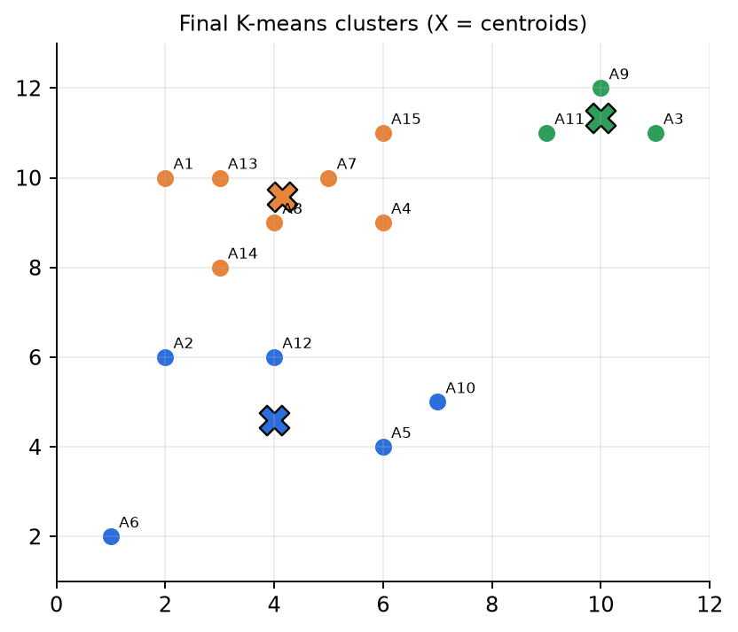
Figure 10.2 — Final K-means clusters and centroids for Midsem Autumn 2025 Q1.
✅ Final answer
Converged after Round 3 (no reassignment).
- Cluster 1 = {A2, A5, A6, A10, A12}, centroid (4, 4.6)
- Cluster 2 = {A1, A4, A7, A8, A13, A14, A15}, centroid (4.143, 9.571)
- Cluster 3 = {A3, A9, A11}, centroid (10, 11.333)

⚠️ Edge cases & traps
- A1 in Round 1: 3.00 to C2 vs 4.00 to C1 — close; do not round too early. Keep 2 decimals in distances and 3 in centroids.
- You may compare squared distances (no square roots) — the argmin is the same and it is faster. Say so in the answer.
- If a point is exactly equidistant from two centroids, state a tie-break (e.g. lower cluster index).
- If a cluster becomes empty, re-initialise its centroid (e.g. farthest point) — state it.
- "Converged" means assignments unchanged; showing one extra round with the same result is what proves convergence.

🔄 How the examiner can twist it
- Different initial centroids (e.g. A1, A5, A9): the same final clusters appear here (the data has 3 clear groups), but in general a different init can give a different local minimum.
- Ask for Manhattan distance (then the best centre is the coordinate-wise median → K-medians).
- Ask for WCSS after each round to show that J decreases.
- Ask only "the centroids after the 2nd iteration".

✍️ Make your own new question
Points (1,1), (1,2), (2,1), (8,8), (9,8), (8,9), K = 2, initial centroids (1,1) and (1,2). Run K-means. (Round 1: (1,1) and (2,1) → c1 (note (2,1) is 1 from (1,1) but √2 from (1,2)); (1,2),(8,8),(9,8),(8,9) → c2 = (6.5, 6.75); c1 = (1.5, 1). Round 2: (1,2) is 1.118 from c1 → c1 = (1.33, 1.33); rest → c2 = (8.33, 8.33). Round 3: no change.)

📝 PYQ — Midsem Autumn 2025, Q2 [8]
Nine points: (−2,−2), (−2,1), (3,3), (3,5) with y = −1; (5,−2), (7,1), (7,−5), (5,2), (6,3) with y = +1.
a) Plot the points and find the optimum separating hyperplane of a linear SVM. Set the Lagrange multipliers to 1 for all support vectors; find b by averaging over all SVs. [5] b) Which points are SVs? [1] c) Predict the class of (6, 9) and its posterior probability. [2]

🧠 How to think
The instruction "α = 1 for all SVs" means: identify the SVs geometrically, then w = Σ yᵢxᵢ (over SVs), b = average of (yₖ − wᵀxₖ). The SVs are the closest pair of opposite-class points that "face" each other: compute a few cross-class distances.

Solution — step by step
Finding the SVs. Candidate closest pairs: d((3,3),(5,2)) = √5 = 2.24; d((3,3),(6,3)) = 3; d((3,5),(5,2)) = √13 = 3.61; d((3,3),(5,−2)) = √29. The closest pair is (3,3) [−1] and (5,2) [+1], and the perpendicular bisector of this pair separates all 9 points (checked below) → these two are the support vectors.
w = Σ α_{i} y_{i} x_{i} = (1)(−1)(3, 3) + (1)(+1)(5, 2) = (2, −1) (Σ α_{i}y_{i} = −1 + 1 = 0 ✔)
b from (3,3): −1 − (2·3 − 3) = −4 ; b from (5,2): +1 − (2·5 − 2) = −7 ; b = (−4 − 7)/2 = −5.5
Hyperplane: 2x₁ − x₂ − 5.5 = 0 (i.e. x₂ = 2x₁ − 5.5).
Point | y | f = 2x₁ − x₂ − 5.5 | correct?
(−2,−2) | −1 | −7.5 | ✔
(−2,1) | −1 | −10.5 | ✔
(3,3) | −1 | −2.5 (closest) | ✔ SV
(3,5) | −1 | −4.5 | ✔
(5,−2) | +1 | 6.5 | ✔
(7,1) | +1 | 7.5 | ✔
(7,−5) | +1 | 13.5 | ✔
(5,2) | +1 | 2.5 (closest) | ✔ SV
(6,3) | +1 | 3.5 | ✔

Both SVs have |f| = 2.5 and every other point has |f| > 2.5 → the plane is exactly midway → it IS the max-margin plane. Canonical form (divide by 2.5): w = (0.8, −0.4), b = −2.2, so SVs give f = ±1; margin = 2/‖w‖ = 2/0.894 = 2.236 = √5 (equals the SV distance ✔). The true optimal multipliers are α = 0.4 for each SV.
(c) f(6, 9) = 2(6) − 9 − 5.5 = −2.5 < 0 → class −1. In canonical form f = 0.8·6 − 0.4·9 − 2.2 = −1.0: the point sits exactly on the negative margin line. SVM outputs are not probabilities; map the score through a sigmoid (Platt scaling): P(y = −1 | x) = σ(1.0) = 1/(1 + e⁻¹) ≈ 0.73.
✅ Final answer
(a) 2x₁ − x₂ − 5.5 = 0 (canonical 0.8x₁ − 0.4x₂ − 2.2 = 0, margin √5 ≈ 2.24). (b) SVs: (3, 3) and (5, 2). (c) (6, 9) → class −1; posterior ≈ 0.73 using σ(|f|) with the canonical score (≈ 0.92 if the un-normalised score 2.5 is used — state your convention).

⚠️ Edge cases & traps
- If you pick the wrong SVs (e.g., include (3,5) or (6,3)) the "α = 1" shortcut gives a wrong plane — ALWAYS verify all points afterwards.
- The b values from the two SVs differ (−4, −7) only because α = 1 is not the true scale; averaging fixes it. With the true α = 0.4 both SVs give the same b.
- "Posterior probability" is not native to SVM — say so and use Platt scaling P(y = +1 | x) = 1/(1 + exp(A·f + B)); with A = −1, B = 0 → P(y | x) = σ(y f).

🔄 How the examiner can twist it
- Give α values that are not all 1 (like Midsem-26 Q2A) and ask to verify.
- Ask for the margin width, or the distance of (6, 9) from the plane: |−2.5|/√5 = 1.118.
- Add a new +1 point at (4, 3): f = 8 − 3 − 5.5 = −0.5 → now inside the margin & misclassified → need soft margin or new SVs.

✍️ Make your own new question
Points: −1: (1,1), (2,1), (1,2); +1: (4,4), (5,3), (4,5). Find the SVs, the hyperplane with the α = 1 shortcut, and classify (3,4). (Answer: SVs are (2,1), (1,2) [−1] and (4,4) [+1]; the α = 1 shortcut gives w = (1, 1), b = (−4 − 4 − 7)/3 = −5 (off, since Σαᵢyᵢ = −1 ≠ 0); the true max-margin hyperplane is x₁ + x₂ = 5.5, canonical 0.4x₁ + 0.4x₂ − 2.2 = 0, margin 2/‖w‖ = 3.54; (3,4) → 0.4·7 − 2.2 = 0.6 > 0 → +1. Point (5,3) also lies exactly on the margin (0.4·8 − 2.2 = 1.0) but the solver gives it α = 0 — a point on the margin need not have α > 0.)

📝 PYQ — Midsem Autumn 2025, Q3 (a, b, c) [9]
Data (X1, X2 → Y): (60, 22 → 140), (62, 25 → 155), (67, 24 → 159), (70, 20 → 179). Initial w₁ = w₂ = b = 0.5, learning rate 0.0001.
a) Full-gradient GD, 2 iterations [3]. b) Mini-batch GD, batch size 2 [3]. c) SGD for 1 iteration [3].

🧠 How to think
Same formula three times; only the batch changes. Full = all 4 rows per update; mini-batch = 2 rows per update (2 updates per epoch); SGD = 1 row per update (4 updates per epoch).
Loss used: L = (1/B)Σ(ŷ − y)², so ∂L/∂w = (2/B)Σ(ŷ − y)x, ∂L/∂b = (2/B)Σ(ŷ − y).
The paper says "Batch 1 first 4 examples & Batch 2 next 4" but there are only 4 rows; with batch size 2 we take Batch 1 = rows 1–2, Batch 2 = rows 3–4 (state this assumption).

Solution — step by step
(a) Full-batch GD — Iteration 1 (w₁ = w₂ = b = 0.5):
Row | ŷ = 0.5·X1 + 0.5·X2 + 0.5 | e = ŷ − y | e·X1 | e·X2
1 | 30 + 11 + 0.5 = 41.5 | −98.5 | −5910 | −2167
2 | 31 + 12.5 + 0.5 = 44.0 | −111.0 | −6882 | −2775
3 | 33.5 + 12 + 0.5 = 46.0 | −113.0 | −7571 | −2712
4 | 35 + 10 + 0.5 = 45.5 | −133.5 | −9345 | −2670
Σ |  | −456.0 | −29708 | −10324

∂L/∂w₁ = (2/4)(−29708) = −14854 , ∂L/∂w₂ = (2/4)(−10324) = −5162 , ∂L/∂b = (2/4)(−456) = −228
w₁ = 0.5 − 0.0001(−14854) = 1.9854 , w₂ = 0.5 + 0.5162 = 1.0162 , b = 0.5 + 0.0228 = 0.5228
Iteration 2 (w₁ = 1.9854, w₂ = 1.0162, b = 0.5228): ŷ = [142.003, 149.023, 157.933, 159.825]; e = [2.003, −5.977, −1.067, −19.175].
∂L/∂w₁ = −832.07 , ∂L/∂w₂ = −257.23 , ∂L/∂b = −12.108
w₁ = 2.06861 , w₂ = 1.04192 , b = 0.52401 (MSE: 13153.6 → 102.1 → 62.1)
(b) Mini-batch GD (B = 2), one epoch = 2 updates.
Batch 1 (rows 1, 2): e = [−98.5, −111]. ∂w₁ = (2/2)(−5910 − 6882) = −12792; ∂w₂ = −4942; ∂b = −209.5 → w₁ = 1.7792, w₂ = 0.9942, b = 0.52095.
Batch 2 (rows 3, 4) with the NEW weights: ŷ = 1.7792·67 + 0.9942·24 + 0.521 = 143.588 and 1.7792·70 + 0.9942·20 + 0.521 = 144.949; e = [−15.412, −34.051].
∂w₁ = −15.412·67 − 34.051·70 = −3416.17 , ∂w₂ = −1050.91 , ∂b = −49.463
w₁ = 2.12082 , w₂ = 1.09929 , b = 0.52590
(c) SGD, 1 iteration = 1 pass over the 4 rows (update after every row), gradient = 2e·x.
Row | ŷ (current weights) | e | Δ = −η·2e·(X1, X2, 1) | New (w₁, w₂, b)
1 | 41.500 | −98.50 | +(1.1820, 0.4334, 0.0197) | (1.68200, 0.93340, 0.51970)
2 | 128.139 | −26.86 | +(0.3331, 0.1343, 0.0054) | (2.01508, 1.06771, 0.52507)
3 | 161.160 | +2.16 | −(0.0289, 0.0104, 0.0004) | (1.98613, 1.05734, 0.52464)
4 | 160.700 | −18.30 | +(0.2562, 0.0732, 0.0037) | (2.24232, 1.13053, 0.52830)

✅ Final answer
(a) After 2 full-batch iterations: w₁ = 2.0686, w₂ = 1.0419, b = 0.5240. (b) After one mini-batch epoch: w₁ = 2.1208, w₂ = 1.0993, b = 0.5259. (c) After one SGD pass: w₁ = 2.2423, w₂ = 1.1305, b = 0.5283 (if "1 iteration" means one single-sample update: w₁ = 1.682, w₂ = 0.9334, b = 0.5197).

⚠️ Edge cases & traps
- State the loss convention. With L = ½·mean, every gradient above halves (w₁ after full iteration 1 = 1.2427). With the plain SUM (no 1/m) the full-batch gradient doubles. Examiners accept any consistent convention.
- In mini-batch and SGD, batch 2 must use the weights updated by batch 1 — the most common mistake is reusing the initial weights.
- Notice SGD overshoots at row 3 (positive error) then corrects — that is the "noisy path".
- Features are not scaled (X1 ≈ 60–70 vs bias 1) → w₁ moves much faster than b. With scaling GD converges faster.

🔄 How the examiner can twist it
- Ask which variant reached the lowest loss after one epoch (here mini-batch ends lower than SGD: MSE 81.96 vs 230.0, full-batch (1 iter) 102.1).
- Change η to 0.001 → the first step overshoots massively (ŷ ≈ 1000) and the loss explodes → ask "why?" (η too large).
- Ask for the closed-form solution or for only w₁ with w₂ fixed.

✍️ Make your own new question
Data: (X → Y) = (1 → 3), (2 → 5), (3 → 7), (4 → 9). Start w = b = 0, η = 0.05, L = mean squared error. Do 1 full-batch step, 1 mini-batch epoch (B = 2) and 1 SGD pass. (Full step: ŷ=0, e=[−3,−5,−7,−9], ∂w=(2/4)(−70)=−35, ∂b=−12 → w=1.75, b=0.6.)

📝 PYQ — Midsem Autumn 2025, Q4 — Full ID3 tree (house listings) [12]
P1 (High, Great, Three, High → acc), P2 (Low, Good, Three, Low → acc), P3 (Low, Great, Two, High → acc), P4 (Low, Good, Two, High → unacc), P5 (High, Bad, Three, Low → unacc), P6 (High, Great, Three, Low → unacc), P7 (Low, Good, Two, Low → unacc). Features: Pricing, Condition, Rooms, Safety. Test: P8 (High, Good, Three, Low), P9 (Low, Great, Two, Low).
(a) Entropy of the root [2]. (b) Build the tree with ID3 (log₂) [7]. (c) Classify P8, P9 [1]. (d) IG forms many small pure partitions — state a remedy [2].

🧠 How to think
3 acc vs 4 unacc → H(3:4) = 0.985. Compute IG for all 4 features at the root; recurse into impure branches with the remaining features. Always track WHICH rows are in each branch.

Solution — step by step
(a) H(root) = −(3/7)log₂(3/7) − (4/7)log₂(4/7) = 0.524 + 0.461 = 0.985 bits.
(b) Level 1 (root, all 7 rows):
Feature | Branches (acc/unacc) | Child entropies | H(Y|A) | IG
Pricing | High: P1,P5,P6 (1/2); Low: P2,P3,P4,P7 (2/2) | 0.918, 1.000 | (3/7)0.918 + (4/7)1 = 0.965 | 0.020
Condition | Great: P1,P3,P6 (2/1); Good: P2,P4,P7 (1/2); Bad: P5 (0/1) | 0.918, 0.918, 0 | (6/7)0.918 = 0.787 | 0.198
Rooms | Three: P1,P2,P5,P6 (2/2); Two: P3,P4,P7 (1/2) | 1.000, 0.918 | 0.965 | 0.020
Safety | High: P1,P3,P4 (2/1); Low: P2,P5,P6,P7 (1/3) | 0.918, 0.811 | (3/7)0.918 + (4/7)0.811 = 0.857 | 0.128

→ Root = Condition. Bad → leaf unacc (P5).
Level 2, Condition = Good (P2 acc, P4 unacc, P7 unacc; H = 0.918):
Feature | Branches | H(Y|A) | IG
Pricing | all Low (1/2) | 0.918 | 0
Rooms | Three: P2 (acc); Two: P4, P7 (unacc, unacc) | 0 | 0.918
Safety | High: P4 (unacc); Low: P2, P7 (1/1) | (2/3)(1) = 0.667 | 0.252

→ split on Rooms: Three → acc, Two → unacc (both pure).
Level 2, Condition = Great (P1 acc, P3 acc, P6 unacc; H = 0.918):
Feature | Branches | H(Y|A) | IG
Pricing | High: P1, P6 (1/1); Low: P3 (acc) | 0.667 | 0.252
Rooms | Three: P1, P6 (1/1); Two: P3 (acc) | 0.667 | 0.252
Safety | High: P1, P3 (acc, acc); Low: P6 (unacc) | 0 | 0.918

→ split on Safety: High → acc, Low → unacc.
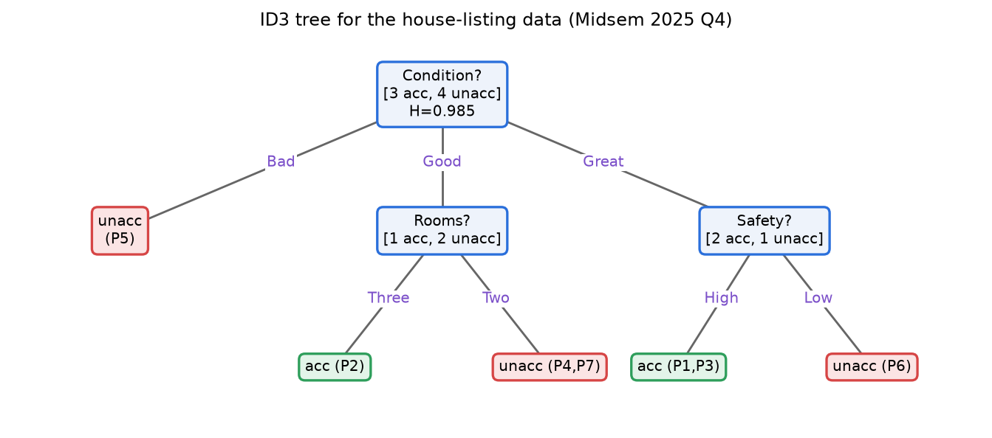
Final ID3 tree.
(c) P8 (High, Good, Three, Low): Condition = Good → Rooms = Three → acc. P9 (Low, Great, Two, Low): Condition = Great → Safety = Low → unacc.
(d) Use Gain Ratio (C4.5): GR = IG / SplitInfo, where SplitInfo = −Σ(|Dᵢ|/|D|)log₂(|Dᵢ|/|D|) penalises attributes that split data into many small partitions. (Also: CART's binary Gini splits, or pruning.) Check at the root: GR(Condition) = 0.198/1.449 = 0.137, GR(Safety) = 0.128/0.985 = 0.130, GR(Pricing) = GR(Rooms) = 0.020 → Condition still wins.
✅ Final answer
(a) 0.985 bits. (b) Condition at root; Good → split on Rooms (Three: acc, Two: unacc); Great → split on Safety (High: acc, Low: unacc); Bad: unacc. (c) P8 → acc, P9 → unacc. (d) Use Gain Ratio (C4.5) / split information normalisation.

⚠️ Edge cases & traps
- Ties at level 2 (Pricing vs Rooms both 0.252 in "Great") don't matter because Safety is clearly best — but if two IGs tie for the maximum, say which you pick (e.g., first in column order).
- The Bad branch has only ONE example — a classic "small pure partition"; it is exactly what part (d) is about.
- Only use the rows that reach a node when computing its entropies (a very common slip is re-using all 7 rows).
- P8's "Low" safety is never tested on its path — that's fine.

🔄 How the examiner can twist it
- Ask for the tree with Gini (CART, binary splits) instead.
- Add an "ID" attribute (unique per row): IG(ID) = 0.985 (maximum!) but SplitInfo = log₂7 = 2.807 → GR = 0.351 — show why IG alone is fooled.
- Ask for the training accuracy of the tree (100%) and whether it overfits.

✍️ Make your own new question
Remove P5 from the data and rebuild the root. Does Condition still win? (Now 3 acc : 3 unacc, H = 1; Condition: Great (2/1), Good (1/2) → H(Y|A) = 0.918 → IG = 0.082; Safety: High (2/1), Low (1/2) → IG = 0.082 — a tie! Pricing: High (1/1), Low (2/2) → 0; Rooms: Three (2/1), Two (1/2) → 0.082 → three-way tie; you must state a tie-break rule.)

📝 PYQ — Midsem Autumn 2025, Q5 [7]
Three 1-D points x = 1, 3, 5 with labels −, +, −. Weak learner = decision stump (choose c; x > c is one class, x ≤ c the other). Chosen stump: x > 2 → [+], x ≤ 2 → [−].
a) Initial weights? [1] b) How many different stumps are possible? [2] c) Which point(s) get increased weight after boosting? [1] d) Weights after boosting — show mathematically. [3]

🧠 How to think
Apply the AdaBoost formulas directly. For (b): a stump is defined by WHERE the threshold is (which gap) and WHICH SIDE is +.

Solution — step by step
(a) N = 3 → each weight = 1/3.
(b) Thresholds can lie in 4 places: c < 1, 1 < c < 3, 3 < c < 5, c > 5; each with 2 polarities (x > c is + or −) → 4 × 2 = 8 stumps. However, the two stumps with c < 1 predict "all +" or "all −", and so do the two with c > 5 — these 4 stumps give only 2 distinct classifiers → 6 distinct stumps (all +, all −, and 4 non-trivial ones with c in (1,3) or (3,5)).
(c) Stump predictions: x=1 → − (✔), x=3 → + (✔), x=5 → + (✗, true −). Only x = 5 is misclassified → its weight increases.
(d)
ε₁ = 1/3 , α₁ = ½ ln((1 − 1/3)/(1/3)) = ½ ln 2 = 0.3466
correct points: (1/3)·e^{−0.3466} = (1/3)(0.7071) = 0.2357 ; wrong point: (1/3)·e^{0.3466} = (1/3)(1.4142) = 0.4714
Z = 0.2357 + 0.2357 + 0.4714 = 0.9428 (= 2√(ε(1−ε)) = 2√(2/9) ✔)
new weights = 0.2357/0.9428 = 0.25 , 0.25 , 0.4714/0.9428 = 0.50
✅ Final answer
(a) 1/3 each. (b) 8 stumps (4 threshold positions × 2 orientations), of which 6 give distinct classifications. (c) x = 5. (d) α₁ = ½ln2 ≈ 0.347; new weights (x=1, x=3, x=5) = (0.25, 0.25, 0.50).

⚠️ Edge cases & traps
- Always normalise — un-normalised weights (0.236, 0.236, 0.471) lose marks.
- Check: the misclassified point now carries exactly half the total weight (0.5) — built-in sanity check.
- Counting stumps: state your convention (8 vs 6) with reasoning; marks go to the reasoning.

🔄 How the examiner can twist it
- Round 2: with weights (0.25, 0.25, 0.5), a best stump is "x > 4 → −, else +" (misclassifies only x = 1, ε = 0.25; it ties with "all −", which misclassifies only x = 3) → α₂ = ½ln3 = 0.549. Combined H(x) = sign(0.347h₁ + 0.549h₂): x=1 → −0.347 + 0.549 > 0 → + (still wrong!), x=3 → +, x=5 → −. The pattern −,+,− needs a third stump — ask "how many rounds are needed?"
- Ask for the exponential-loss bound: training error ≤ Z₁ = 0.943.
- Four points, or a stump with ε = 0.5 (α = 0 → learner ignored).

✍️ Make your own new question
Points x = 1, 2, 3, 4 with labels +, +, −, +. Stump "x ≤ 2.5 → +, else −". Find ε, α and new weights. (Wrong: x=4 → ε = 1/4, α = ½ln3 = 0.549; new weights: right ones 0.25·e^{−0.549}=0.144 each, wrong 0.25·e^{0.549}=0.433; Z = 0.866 → (1/6, 1/6, 1/6, 1/2).)

📝 PYQ — Midsem Autumn 2025, Q6 — Single-link dendrogram from a distance matrix [6]
Distance matrix for P1…P5: d(P1,P2) = 0.10, d(P1,P3) = 0.41, d(P1,P4) = 0.55, d(P1,P5) = 0.35, d(P2,P3) = 0.64, d(P2,P4) = 0.47, d(P2,P5) = 0.98, d(P3,P4) = 0.44, d(P3,P5) = 0.85, d(P4,P5) = 0.76.
(a) Perform single-link hierarchical clustering and draw the dendrogram. (b) How many clusters (and which) if the dendrogram is cut at 0.37 and at 0.41?

🧠 How to think
Single link: after every merge, the new row = minimum of the two old rows. Keep writing the reduced matrix — examiners give marks for it.

Solution — step by step
 | P1 | P2 | P3 | P4 | P5
P1 | 0 | 0.10 | 0.41 | 0.55 | 0.35
P2 | 0.10 | 0 | 0.64 | 0.47 | 0.98
P3 | 0.41 | 0.64 | 0 | 0.44 | 0.85
P4 | 0.55 | 0.47 | 0.44 | 0 | 0.76
P5 | 0.35 | 0.98 | 0.85 | 0.76 | 0

Merge 1: smallest = d(P1,P2) = 0.10 → {P1,P2} at height 0.10. Update: d({P1,P2},P3) = min(0.41, 0.64) = 0.41; d(·,P4) = min(0.55, 0.47) = 0.47; d(·,P5) = min(0.35, 0.98) = 0.35.
 | P12 | P3 | P4 | P5
P12 | 0 | 0.41 | 0.47 | 0.35
P3 | 0.41 | 0 | 0.44 | 0.85
P4 | 0.47 | 0.44 | 0 | 0.76
P5 | 0.35 | 0.85 | 0.76 | 0

Merge 2: smallest = 0.35 → {P1,P2,P5} at 0.35. Update: to P3 = min(0.41, 0.85) = 0.41; to P4 = min(0.47, 0.76) = 0.47.
 | P125 | P3 | P4
P125 | 0 | 0.41 | 0.47
P3 | 0.41 | 0 | 0.44
P4 | 0.47 | 0.44 | 0

Merge 3: smallest = 0.41 → {P1,P2,P5,P3} at 0.41. Update: to P4 = min(0.47, 0.44) = 0.44.
Merge 4: {P1,P2,P3,P5} + P4 at 0.44.
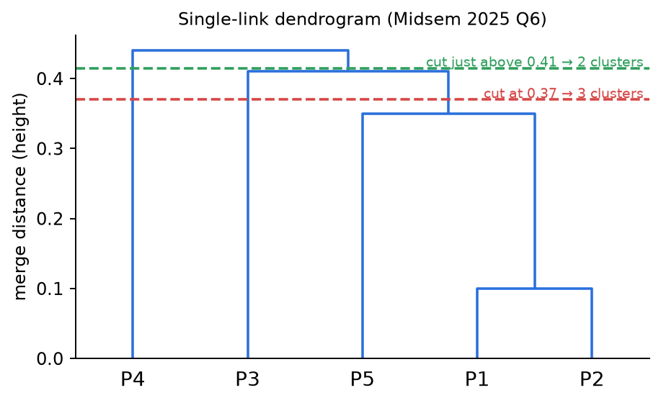
Figure 10.3 — Single-link dendrogram (merge heights 0.10, 0.35, 0.41, 0.44).
(b) Cut at 0.37: merges at 0.10 and 0.35 are done, 0.41 is not → 3 clusters: {P1,P2,P5}, {P3}, {P4}.
Cut at 0.41: the merge at exactly 0.41 is counted as done (convention "height ≤ cut") → 2 clusters: {P1,P2,P3,P5}, {P4}. (With the strict "< cut" convention it would still be 3 clusters — write your convention.)
✅ Final answer
(a) Merges: {P1,P2} @ 0.10 → {P1,P2,P5} @ 0.35 → {P1,P2,P5,P3} @ 0.41 → all @ 0.44.
(b) Cut 0.37 → 3 clusters {P1,P2,P5}, {P3}, {P4}. Cut 0.41 → 2 clusters {P1,P2,P3,P5}, {P4} (merges at height ≤ 0.41 included).

⚠️ Edge cases & traps
- Notice P3 joins at 0.41 through P1 (d(P1,P3) = 0.41) although d(P2,P3) = 0.64 — that is single link's "any one pair is enough" rule (chaining).
- P4 joins through P3 (0.44), not through P2 (0.47).
- Cutting exactly at a merge height is ambiguous — always state ≤ or <.
- The dendrogram y-axis must be the merge distance, not the step number.

🔄 How the examiner can twist it
- Complete link on the same matrix: {P1,P2} @ 0.10; then d(P12,P3) = max(0.41,0.64) = 0.64, d(P12,P4) = 0.55, d(P12,P5) = 0.98 → smallest is d(P3,P4) = 0.44 → {P3,P4}; then d(P12,P34) = max(0.64,0.55) = 0.64 → {P1,P2,P3,P4}; finally P5 at max(0.98, 0.85, 0.76) = 0.98. Very different tree!
- Ask "cut to get exactly 2 clusters" → any height in [0.41, 0.44).
- Ask average link.

✍️ Make your own new question
Same matrix, average link, first two merges? ({P1,P2} @ 0.10; new row: to P3 (0.41+0.64)/2 = 0.525, to P4 0.51, to P5 0.665 → smallest overall is d(P3,P4) = 0.44 → {P3,P4} @ 0.44.)

Class Test 2 (2025) — MCQ sheet
Autumn 2025 • 15 MCQs
📝 PYQ — Class Test 2 (2025) — MCQ Q1 to Q15 (in paper order) [15 × 1]
15 single-correct MCQs on SVD, PCA, CNN and neural networks (see each row for the question).

🧠 How to think
For each MCQ: recall the definition, eliminate options that contradict it, and for numeric ones compute quickly (CNN parameters = F·F·C_in + 1 per filter).

Solution — step by step
Q | Question (short) | Answer | Why
1 | SVD of an m×n real X | A X = UDVᵀ | U, V orthogonal; D diagonal with singular values
2 | Eigenvectors of the covariance matrix in PCA represent | B | directions of maximum variance
3 | Why centre the data before PCA | B | so the first PC passes through the origin (covariance measured about the mean)
4 | PCs are ordered by | B | decreasing eigenvalues
5 | Variance explained by first k PCs | B Σ_{i=1}^{k}λᵢ / Σ_{i=1}^{p}λᵢ | fraction of total variance
6 | Rank of A equals | B | number of non-zero singular values
7 | Geometric meaning of A = UΣVᵀ | A | rotation/reflection (Vᵀ), scaling (Σ), rotation/reflection (U)
8 | Main aim of a convolutional layer | B | extract spatial features
9 | Params in one 5×5×3 filter | C 76 | 5·5·3 weights + 1 bias
10 | Stride 1 → 2 | C | output feature map gets smaller (≈ halves)
11 | Why zero padding | B | to control the spatial size of the output
12 | 4 filters → output channels | B 4 | one channel per filter
13 | Feed-forward network | C | information flows only input → output (no cycles)
14 | Purpose of activation function | B | introduce non-linearity
15 | Backpropagation is used for | C | updating weights using the gradient of the loss

✅ Final answer
1-A, 2-B, 3-B, 4-B, 5-B, 6-B, 7-A, 8-B, 9-C, 10-C, 11-B, 12-B, 13-C, 14-B, 15-C

⚠️ Edge cases & traps
- Q9: never forget the +1 bias; the 32×32 input size does NOT affect parameter count.
- Q6: rank ≠ number of rows or of non-zero entries.

🔄 How the examiner can twist it
- Q9 with 10 filters → 760 parameters; with a 3×3×64 filter → 577 per filter.
- Q5 with numbers: λ = 5, 3, 2 → first PC explains 50%.

✍️ Make your own new question
How many parameters in a conv layer with 16 filters of size 3×3 on a 64×64×8 input? (16·(3·3·8 + 1) = 1,168.)

Class Test II — Autumn 2025
Section A • 15 questions × 2 marks
📝 PYQ — Class Test II (Autumn 2025) — Section A, Q1 to Q15 (in paper order) [15 × 2]
15 MCQs (2 marks each) on PCA, SVD, CNN and neural networks. Data for Q3–Q4: X = [[4, 2, 5, 1], [1, 3, 4, 0]] (points (4,1), (2,3), (5,4), (1,0)). Q10 figure: W₁×H₁×9 input → conv F = 8, S = 2, P = 2 → 63×63×16. Q12 figure: Network A = 100 → 100 units; Network B = 100 → 10 → 100.

🧠 How to think
Numeric ones: Q3/Q4 (compute the covariance and eigenvalues), Q10 (invert the output-size formula), Q12 (count parameters). The rest are definitions.

Solution — step by step
Q3/Q4 working: mean (3, 2); centred points (1,−1), (−1,1), (2,2), (−2,−2); covariance (÷4) = [[2.5, 1.5], [1.5, 2.5]] → eigenvalues 4 (direction (1,1)/√2) and 1 (direction (1,−1)/√2). PC1 explains 4/5 = 80% → unexplained = 20%.
Q10 working: (W₁ − 8 + 2·2)/2 + 1 = 63 ⇒ W₁ − 4 = 124 ⇒ W₁ = H₁ = 128; parameters = (8·8·9 + 1)·16 = 577·16 = 9,232.
Q12 working: A: 100·100 + 100 = 10,100 parameters; B: (100·10 + 10) + (10·100 + 100) = 2,110. B has a 10-unit bottleneck → A is more prone to overfitting; statement (II) is false.
Q | Question (short) | Answer | Why
1 | PCA twice (d → j → k) vs directly d → k | A equal sets | top-k PCs of the top-j projection are the top-k PCs
2 | Rigid rotation of all data before PCA | B eigenvalues unchanged | variance is rotation-invariant; PC directions rotate
3 | Best 1-D unit direction for X | B (1/√2, 1/√2) | eigenvector of the largest eigenvalue (4)
4 | % variance NOT explained by PC1 | D 20% | 1/(4+1)
5 | SVD C = UΣVᵀ, C is m×n | A | U is m×m, columns = eigenvectors of CCᵀ
6 | PCA primarily aims to | A | reduce features while preserving variance
7 | Before PCA it is important to | A | make features zero-mean
8 | CNN layer statements | B (I) and (II) | weights depend on input depth; #biases = #filters; stride/padding don't change #params
9 | 20 samples, high training loss → 10,000 samples? | B | high bias — more data does not help
10 | ⟨W₁, H₁, X⟩ | D ⟨128, 128, 9232⟩ | see working above
11 | Pooling layer statements | B (I) and (III) | no trainable params; reduces H, W, keeps depth
12 | Networks A vs B | D only (IV) | A (10,100 params) more prone to overfitting
13 | Learning y = 5x³ − 3x² + 20: INCORRECT statement | A | a non-linear function NEEDS non-linear activations
14 | Output [0.7, 0.2, 0.1], true class C₂ | C −log 0.2 | cross-entropy = −log(prob of true class)
15 | Receptive field depends on | B | filter size, stride, padding of all previous layers

✅ Final answer
1-A, 2-B, 3-B, 4-D, 5-A, 6-A, 7-A, 8-B, 9-B, 10-D, 11-B, 12-D, 13-A, 14-C, 15-B

⚠️ Edge cases & traps
- Q4 asks what is NOT explained (20%), not what is explained (80%).
- Q13 asks for the INCORRECT statement.
- Q10: padding is added on both sides → 2P.

🔄 How the examiner can twist it
- Q3 with a different X: always centre first, then eigen-decompose the 2×2 covariance (λ = a ± b for [[a, b], [b, a]]).
- Q10: ask for the output size given W₁ instead.

✍️ Make your own new question
Points (0,0), (2,2), (4,4), (2,−2): compute the first PC and the % variance it explains. (Mean (2,1); covariance [[2, 2], [2, 5]]; eigenvalues 6 and 1; PC1 = (1, 2)/√5 explains 6/7 ≈ 85.7%.)

End-Semester Examination — Autumn 2025 (25.11.2025)
AI20001 • 3 hrs • Full marks 60 • Answer all
📝 PYQ — End-sem Autumn 2025, Q1 — PCA objective and the variance identity [4]
(i) Show that vᵀSv = var(vᵀx), where S is the covariance matrix of the data.
Fill in: (ii) In PCA the vector v is constrained to be a ______ vector. (iii) vᵀx is the ______ of x onto v. (iv) The objective of PCA is to ______.

🧠 How to think
Write the variance of the scalar z = vᵀx from its definition, pull v out of the sum, and recognise the covariance matrix in the middle.

Solution — step by step
(i) Let z_{i} = vᵀx_{i}. The mean of z is z̄ = (1/N)Σ vᵀx_{i} = vᵀx̄.
var(vᵀx) = (1/N) Σ_{i} (vᵀx_{i} − vᵀx̄)² = (1/N) Σ_{i} (vᵀ(x_{i} − x̄))(x_{i} − x̄)ᵀv
= vᵀ [ (1/N) Σ_{i} (x_{i} − x̄)(x_{i} − x̄)ᵀ ] v = vᵀ S v ∎
(Key trick: a scalar squared, (vᵀa)², equals (vᵀa)(aᵀv).)
(ii) a unit (length-1) vector: vᵀv = ‖v‖² = 1.
(iii) the (scalar) projection of x onto v (its coordinate along v).
(iv) find a unit direction v along which the projected data has maximum variance (max vᵀSv s.t. vᵀv = 1 → Sv = λv, pick the largest λ).
✅ Final answer
(i) var(vᵀx) = (1/N)Σ(vᵀ(xᵢ − x̄))² = vᵀ[(1/N)Σ(xᵢ − x̄)(xᵢ − x̄)ᵀ]v = vᵀSv. (ii) unit vector. (iii) projection. (iv) maximise the variance of the projected data over unit directions v.

⚠️ Edge cases & traps
- Without the unit-length constraint the maximum is infinite (scale v up) — that is WHY (ii) is needed.
- vᵀx is the projection only when ‖v‖ = 1; in general it is ‖v‖ × projection.
- Equivalent objective: minimise the reconstruction error (mean squared distance from points to their projections) — both give the same PCs.

🔄 How the examiner can twist it
- "Hence show the maximum variance is the largest eigenvalue" → Lagrangian → Sv = λv → vᵀSv = λ.
- "Show the projections on two different PCs are uncorrelated": cov(v₁ᵀx, v₂ᵀx) = v₁ᵀSv₂ = λ₂v₁ᵀv₂ = 0.

✍️ Make your own new question
Show that var(aᵀx + b) = aᵀSa for any constant b. (The constant shifts the mean by b and cancels in (aᵀxᵢ + b) − (aᵀx̄ + b); the rest is the same derivation.)

📝 PYQ — End-sem Autumn 2025, Q2 — SVD of diagonal matrices [5]
Find the SVD of (a) A = [[3, 0], [0, 4]] and (b) B = [[3, 0], [0, −4]].

🧠 How to think
For a diagonal matrix, AᵀA is diagonal, so the eigenvectors are the standard basis vectors. Singular values must be sorted decreasing and non-negative; any minus sign goes into U. Build V first, then u_{i} = Av_{i}/σ_{i}.

Solution — step by step
(a) AᵀA = diag(9, 16) → eigenvalues 16 (vector (0, 1)) and 9 (vector (1, 0)) → σ₁ = 4, σ₂ = 3.
V = [v₁ v₂] = [[0, 1], [1, 0]] , Σ = diag(4, 3)
u₁ = Av₁/4 = (0, 4)/4 = (0, 1) , u₂ = Av₂/3 = (3, 0)/3 = (1, 0) ⇒ U = [[0, 1], [1, 0]]
Check: UΣ = [[0, 3], [4, 0]]; (UΣ)Vᵀ = [[0, 3], [4, 0]]·[[0, 1], [1, 0]] = [[3, 0], [0, 4]] = A ✓.
(b) BᵀB = diag(9, 16) again → same Σ = diag(4, 3) and same V = [[0, 1], [1, 0]].
u₁ = Bv₁/4 = (0, −4)/4 = (0, −1) , u₂ = Bv₂/3 = (3, 0)/3 = (1, 0) ⇒ U = [[0, 1], [−1, 0]]
Check: UΣ = [[0, 3], [−4, 0]]; (UΣ)Vᵀ = [[3, 0], [0, −4]] = B ✓.
✅ Final answer
(a) A = UΣVᵀ with U = [[0, 1], [1, 0]], Σ = diag(4, 3), V = [[0, 1], [1, 0]]. (b) B = UΣVᵀ with U = [[0, 1], [−1, 0]], Σ = diag(4, 3), V = [[0, 1], [1, 0]]. Singular values are never negative — the −4 appears as σ = 4 with the sign moved into U.

⚠️ Edge cases & traps
- If the order of singular values is not required, A = I · diag(3, 4) · I is also a valid SVD (A is already diagonal with positive entries). With the usual convention σ₁ ≥ σ₂, write the sorted version.
- For B, Σ = diag(3, −4) is WRONG — singular values cannot be negative.
- The sign could equally go into V: U = [[0, 1], [1, 0]], V = [[0, 1], [−1, 0]] also works. SVD is unique only up to such sign flips.
- Always compute u_{i} from Av_{i}/σ_{i}; picking U and V independently from AAᵀ and AᵀA can produce mismatched signs.

🔄 How the examiner can twist it
- Ask for the SVD of [[−2, 0], [0, −5]] → Σ = diag(5, 2), V = [[0, 1], [1, 0]], U = [[0, −1], [−1, 0]].
- Ask for rank and ‖A‖₂ (= σ₁ = 4) or the rank-1 approximation of A: 4 u₁v₁ᵀ = [[0, 0], [0, 4]].

✍️ Make your own new question
SVD of C = [[−5, 0], [0, 2]]? (CᵀC = diag(25, 4) → σ = 5, 2; v₁ = (1, 0), v₂ = (0, 1) → V = I; u₁ = Cv₁/5 = (−1, 0), u₂ = (0, 1) → U = [[−1, 0], [0, 1]], Σ = diag(5, 2).)

📝 PYQ — End-sem Autumn 2025, Q3 — A short SVD proof [3]
Let A = UΣVᵀ with singular values σ_{k} > 0, left singular vectors u_{k} and right singular vectors v_{k}, and u_{k} = Av_{k}/σ_{k}. Prove that Aᵀu_{k} = σ_{k}v_{k}.

🧠 How to think
Use the one fact you know about v_{k}: it is an eigenvector of AᵀA with eigenvalue σ_{k}². Substitute the definition of u_{k} and simplify.

Solution — step by step
AᵀA v_{k} = σ_{k}² v_{k} (v_{k} is an eigenvector of AᵀA, eigenvalue σ_{k}²)
Aᵀu_{k} = Aᵀ ( A v_{k} / σ_{k} ) = (AᵀA v_{k}) / σ_{k} = σ_{k}² v_{k} / σ_{k} = σ_{k} v_{k} ∎
Alternative (matrix form): Aᵀ = VΣᵀUᵀ ⇒ AᵀU = VΣᵀ; reading column k gives Aᵀu_{k} = σ_{k}v_{k}.
✅ Final answer
Aᵀu_{k} = Aᵀ(Av_{k}/σ_{k}) = (AᵀAv_{k})/σ_{k} = σ_{k}²v_{k}/σ_{k} = σ_{k}v_{k}.

⚠️ Edge cases & traps
- The division by σ_{k} needs σ_{k} ≠ 0 — for zero singular values u_{k} is chosen separately (any orthonormal completion).
- State WHY AᵀAv_{k} = σ_{k}²v_{k} (AᵀA = VΣᵀΣVᵀ) for full marks.

🔄 How the examiner can twist it
- Prove the companion: AAᵀu_{k} = σ_{k}²u_{k} (apply A to Aᵀu_{k} = σ_{k}v_{k}: AAᵀu_{k} = σ_{k}Av_{k} = σ_{k}²u_{k}).
- Prove the u_{k} are orthonormal: u_{i}ᵀu_{j} = v_{i}ᵀAᵀAv_{j}/(σ_{i}σ_{j}) = σ_{j}²v_{i}ᵀv_{j}/(σ_{i}σ_{j}) = δ_{ij}.

✍️ Make your own new question
Show that ‖Av_{k}‖ = σ_{k}. (‖Av_{k}‖² = v_{k}ᵀAᵀAv_{k} = σ_{k}²v_{k}ᵀv_{k} = σ_{k}².)

📝 PYQ — End-sem Autumn 2025, Q4 — Full SVD and rank-1 approximation [5]
A = [[3, 2, 2], [2, 3, −2]]. (a) Compute the (reduced) SVD of A. (b) Find the best rank-1 approximation A₁ and the approximation error in Frobenius norm.

🧠 How to think
A is 2 × 3, so AAᵀ is only 2 × 2 — find U and σ from it (easier), then v_{i} = Aᵀu_{i}/σ_{i} (from the proof in the previous question).

Solution — step by step
Step 1 — AAᵀ: row1·row1 = 9 + 4 + 4 = 17, row1·row2 = 6 + 6 − 4 = 8, row2·row2 = 17.
AAᵀ = [[17, 8], [8, 17]] ⇒ λ = 17 ± 8 = 25, 9 ⇒ σ₁ = 5, σ₂ = 3
Step 2 — equal diagonal → eigenvectors u₁ = (1, 1)/√2 (λ = 25), u₂ = (1, −1)/√2 (λ = 9).
Step 3 — right singular vectors:
v₁ = Aᵀu₁/5 = (1/(5√2)) (3 + 2, 2 + 3, 2 − 2) = (1/(5√2))(5, 5, 0) = (1, 1, 0)/√2
v₂ = Aᵀu₂/3 = (1/(3√2)) (3 − 2, 2 − 3, 2 + 2) = (1, −1, 4)/(3√2)
Check ‖v₂‖ = √(1 + 1 + 16)/(3√2) = √18/√18 = 1 ✓ and v₁·v₂ = (1 − 1 + 0)/6 = 0 ✓.
Step 4 — reduced SVD:
A = [[1/√2, 1/√2], [1/√2, −1/√2]] · [[5, 0], [0, 3]] · [[1/√2, 1/√2, 0], [1/(3√2), −1/(3√2), 4/(3√2)]]
(U 2 × 2, Σ 2 × 2, Vᵀ 2 × 3. For the full SVD add v₃ ⊥ v₁, v₂: v₃ = (2, −2, −1)/3 and a zero column in Σ.)
Step 5 — rank-1 approximation:
A₁ = σ₁ u₁ v₁ᵀ = 5 · (1/2) [[1, 1, 0], [1, 1, 0]] = [[2.5, 2.5, 0], [2.5, 2.5, 0]]
A − A₁ = [[0.5, −0.5, 2], [−0.5, 0.5, −2]] , ‖A − A₁‖_{F} = √(0.25 × 4 + 4 × 2) = √9 = 3 = σ₂
✅ Final answer
σ₁ = 5, σ₂ = 3; U = [(1,1)/√2, (1,−1)/√2]; V_{r} = [(1,1,0)/√2, (1,−1,4)/(3√2)]; A = U diag(5, 3) V_{r}ᵀ. Best rank-1 approximation A₁ = [[2.5, 2.5, 0], [2.5, 2.5, 0]] with Frobenius error 3 (= σ₂, as Eckart–Young predicts).

⚠️ Edge cases & traps
- Going through AᵀA (3 × 3) also works but needs a cubic: eigenvalues 25, 9, 0. Always pick the smaller Gram matrix.
- Do not choose v₂ independently from AᵀA — you might get the opposite sign; v_{i} = Aᵀu_{i}/σ_{i} keeps U and V consistent.
- The error of the rank-k approximation is √(sum of squares of the DISCARDED singular values), not the discarded values themselves (here only one: √(3²) = 3).
- rank(A) = 2 (two non-zero σ).

🔄 How the examiner can twist it
- Ask for the spectral (2-)norm error → σ₂ = 3 too.
- Ask for the fraction of "energy" kept: σ₁²/(σ₁² + σ₂²) = 25/34 = 73.5%.
- Ask for ‖A‖_{F}: √(9 + 4 + 4 + 4 + 9 + 4) = √34 = √(25 + 9) ✓.

✍️ Make your own new question
A = [[2, 2], [1, 1]]. SVD and rank? (AᵀA = [[5, 5], [5, 5]] → λ = 10, 0 → σ₁ = √10, rank 1; v₁ = (1, 1)/√2, u₁ = Av₁/√10 = (2, 1)/√5; A = √10 u₁v₁ᵀ exactly.)

📝 PYQ — End-sem Autumn 2025, Q5 — Equal eigenvalues [3]
The covariance matrix of a 2-D dataset has two equal eigenvalues. Is PCA useful for dimensionality reduction here? Explain, with an example.

🧠 How to think
Explained variance of each PC = λ / (λ + λ) = 50%. Also: if S = λI, then Sv = λv for EVERY v — there is no special direction.

Solution — step by step
- Each PC explains 50% of the variance → keeping 1 PC throws away half the information.
- S = λI (a circle-shaped cloud) → every unit vector is an eigenvector → the PCs are not unique; there is no preferred direction to project onto.
- Example: points (1, 0), (−1, 0), (0, 1), (0, −1). Mean = (0, 0); var(x1) = (1 + 1)/4 = 0.5, var(x2) = 0.5, cov = 0 → S = diag(0.5, 0.5). Projecting onto ANY direction gives variance 0.5.
✅ Final answer
No — with equal eigenvalues each PC explains 50%, so dropping one loses half the variance; moreover the data is isotropic (S ∝ I), there is no preferred direction and any direction is a PC. PCA gives no useful reduction. Example: (1, 0), (−1, 0), (0, 1), (0, −1) with S = diag(0.5, 0.5).

⚠️ Edge cases & traps
- Equal eigenvalues ≠ zero eigenvalues. Equal → no reduction; zero → free reduction (data lies in a lower-dimensional subspace).
- In d dimensions with ALL eigenvalues equal, keeping k PCs keeps only k/d of the variance.
- Standardised uncorrelated features give S = I → same situation.

🔄 How the examiner can twist it
- "Eigenvalues 5 and 5 and 0.01 in 3-D" → you CAN drop the third (99.9% kept) but PC1 and PC2 are not unique (any basis of that plane).
- Ask what the data cloud looks like: a circle/sphere (equal) vs an ellipse (different).

✍️ Make your own new question
Give 4 points in 2-D whose covariance has eigenvalues 2 and 0. (E.g. (1, 1), (−1, −1), (1, 1), (−1, −1): S = [[1, 1], [1, 1]] → λ = 2, 0; the data lies on the line x1 = x2 → reduce to 1-D with no loss.)

📝 PYQ — End-sem Autumn 2025, Q6 (a), (c) — ReLU before sigmoid; removing activations [3+2]
(a) A binary classifier (smiley = 1, non-smiley = 0) has output ŷ = σ(ReLU(z)), predicting "smiley" when ŷ ≥ 0.5. 37% of the test images are smileys. What accuracy will it get, whatever the weights? Explain. [3]
(c) What happens if all non-linear activation functions in a deep network are removed? [2]

🧠 How to think
(a) Look at the RANGE of each function: ReLU(z) ∈ [0, ∞) and σ is increasing, so the sigmoid only ever sees non-negative inputs. (c) Use the "product of matrices is a matrix" argument.

Solution — step by step
(a) ReLU(z) = max(0, z) ≥ 0 for every z.
σ is increasing ⇒ ŷ = σ(ReLU(z)) ≥ σ(0) = 1/(1 + e⁰) = 0.5
So ŷ ∈ [0.5, 1) for every image → the rule ŷ ≥ 0.5 always predicts "smiley".
A constant "smiley" classifier is correct exactly on the smileys → accuracy = 37% (all non-smileys are misclassified; recall for smileys = 100%, precision = 37%).
(c) Without non-linearities each layer is a = Wx + b, and
W_{L}( … (W₂(W₁x + b₁) + b₂) … ) = W′x + b′
The whole deep network collapses to one linear (affine) map — equivalent to linear / logistic regression. Extra depth adds no power; it can only draw linear decision boundaries, so it cannot learn XOR or any curved boundary.
✅ Final answer
(a) ŷ ≥ 0.5 always → always predicts smiley → accuracy = 37%. (c) The network becomes a single linear model (W′ = W_{L}…W₁); depth is useless and non-linear patterns (e.g., XOR) cannot be learned.

⚠️ Edge cases & traps
- Tie at exactly 0.5 (whenever z ≤ 0): with the rule "ŷ > 0.5 strictly", images with z ≤ 0 would be called non-smiley and accuracy would depend on the weights. State your threshold convention — the intended answer uses ≥ 0.5.
- Loss still decreases during training (σ can move between 0.5 and 1) but the classifier can never output < 0.5 — a design bug, not a training bug.
- Fix: remove the ReLU before the output (feed the raw logit z into σ).

🔄 How the examiner can twist it
- Change the proportion: 80% smileys → accuracy 80% (a useless model can look good on imbalanced data!).
- Swap roles: if smiley = 0 and non-smiley = 1, accuracy = 63%.
- Use tanh then sigmoid: tanh ∈ (−1, 1) → ŷ ∈ (0.269, 0.731) — no longer constant.

✍️ Make your own new question
A network outputs ŷ = σ(−ReLU(z)). What does it always predict and what is its accuracy if 30% of labels are 1? (−ReLU(z) ≤ 0 → ŷ ≤ 0.5 → with "≥ 0.5 → 1" it predicts 1 only when z ≤ 0 (ŷ = 0.5 exactly); with a strict "> 0.5" rule it always predicts 0 → accuracy 70%.)

📝 PYQ — End-sem Autumn 2025, Q6 (b) & Class Test II (Autumn 2025) MCQ [2]
A classifier trained on 50 samples converges with HIGH training error. A friend suggests training on 100,000 samples. Will it solve the issue? If not, give a solution. (MCQ version: 20 samples, SGD, training loss very high, then 10,000 samples — which is correct?)

🧠 How to think
High TRAINING error = the model cannot even fit the data it sees → high bias (underfitting). More data reduces variance, not bias.

Solution — step by step
More data helps when training error is low but test error is high (variance). Here training error itself is high, so the model is too simple (or under-trained).
Fixes: use a more complex / deeper / wider network, add better features, reduce regularisation, train longer or tune the learning rate, use a better optimiser, check for bugs/label noise.
✅ Final answer
No — the problem is high bias; more data won't reduce training error. Increase model capacity (more layers/neurons/features), reduce regularisation, train longer. MCQ answer: "Increasing training data size in general does not improve the performance as the model has high bias."

⚠️ Edge cases & traps
- If instead train error were low and test error high → then more data WOULD help (high variance).

🔄 How the examiner can twist it
- MCQ about Networks A (100→100 direct) vs B (100→10→100): A has 10,100 parameters, B has 2,110 → B (bottleneck) more prone to underfitting, A more prone to overfitting → "Only (IV) is true".

✍️ Make your own new question
Your model: train accuracy 99%, validation 70%. Diagnose and give three remedies.

📝 PYQ — End-sem Autumn 2025, Q6 (d) [1]
Univariate regression ŷ = w·x, w ∈ ℝ, x ∈ ℝ^{1×m}. Loss L = (1/m)‖ŷ − y‖². Derive ∂L/∂w. [1]

🧠 How to think
Vector version of the scalar chain rule. Write the norm as a sum.

Solution — step by step
L = (1/m) Σ_{i=1}^{m} (w x_{i} − y_{i})²
∂L/∂w = (1/m) Σ 2(w x_{i} − y_{i}) x_{i} = (2/m) Σ (ŷ_{i} − y_{i}) x_{i} = (2/m)(ŷ − y) x^{T}
✅ Final answer
∂L/∂w = (2/m)(ŷ − y)xᵀ = (2/m)Σ(wxᵢ − yᵢ)xᵢ. (Setting it to 0 gives w* = Σxᵢyᵢ / Σxᵢ².)

⚠️ Edge cases & traps
- Dimensions: (ŷ − y) is 1×m, xᵀ is m×1 → scalar ✔.

🔄 How the examiner can twist it
- Add a bias: also ask ∂L/∂b = (2/m)Σ(ŷᵢ − yᵢ).
- Ask for the Ridge version: add 2λw.

✍️ Make your own new question
Derive ∂L/∂w for L = (1/m)‖wx − y‖² + λw² and find the closed-form minimiser. (w = Σxᵢyᵢ / (Σxᵢ² + mλ).)*

📝 PYQ — End-sem Autumn 2025, Q6 (e) — Multi-class loss [2]
Classification into C classes (positive, negative, neutral). Which loss (show the expression)? Show that binary classification loss is a special case. m training examples. [1+1]

🧠 How to think
Softmax output + categorical cross-entropy. Then set C = 2.

Solution — step by step
L = −(1/m) Σ_{i=1}^{m} Σ_{c=1}^{C} y_{ic} log ŷ_{ic} , ŷ_{ic} = exp(z_{ic}) / Σ_{k} exp(z_{ik}) , y one-hot
For C = 2 put y_{i2} = 1 − y_{i1} = 1 − yᵢ and ŷ_{i2} = 1 − ŷᵢ:
L = −(1/m) Σ_{i} [ y_{i} log ŷ_{i} + (1 − y_{i}) log(1 − ŷ_{i}) ] = binary cross-entropy
✅ Final answer
Categorical cross-entropy with softmax; with C = 2 it reduces exactly to binary cross-entropy (log loss).

⚠️ Edge cases & traps
- Because y is one-hot, only the true-class term survives: loss of one sample = −log(ŷ of the true class).

🔄 How the examiner can twist it
- MCQ (Class Test II): output [0.7, 0.2, 0.1], true class C₂ → loss = −log 0.2 (not −0.2 log 0.2).

✍️ Make your own new question
Output probabilities [0.1, 0.6, 0.3], true class 2. Compute the CE loss in nats and bits. (−ln 0.6 = 0.511; −log₂ 0.6 = 0.737.)

📝 PYQ — End-sem Autumn 2025, Q7 — XOR network with threshold units, XNOR, sigmoid derivative [3+4+3]
Network: inputs i1, i2 → hidden h1, h2 → output o. Threshold activation f(z) = 1 if z > 0 else 0. Weights: i1→h1 = 1, i2→h1 = 1, bias→h1 = −1.5; i1→h2 = 1, i2→h2 = 1, bias→h2 = −0.5; h1→o = −1, h2→o = +1, bias→o = −0.5.
(a) Find the output for all four binary inputs; which function is it? [3] (b) Modify only the output-layer weights so the network computes XNOR [4]. (c) Prove σ′(z) = σ(z)(1 − σ(z)) and explain the vanishing-gradient problem [2+1].

🧠 How to think
Each threshold unit is a straight line. h1 fires only when BOTH inputs are 1 (sum > 1.5) → AND; h2 fires when AT LEAST ONE is 1 (sum > 0.5) → OR. The output "OR but not AND" = XOR. For XNOR, just flip the sign of every output weight.

Solution — step by step
(a) h1 = f(i1 + i2 − 1.5) = AND, h2 = f(i1 + i2 − 0.5) = OR, o = f(−0.5 − h1 + h2) (threshold assumed at the output too).
i1 | i2 | h1 (AND) | h2 (OR) | z_{o} = −0.5 − h1 + h2 | o
0 | 0 | 0 | 0 | −0.5 | 0
0 | 1 | 0 | 1 | +0.5 | 1
1 | 0 | 0 | 1 | +0.5 | 1
1 | 1 | 1 | 1 | −0.5 | 0

→ The network computes XOR.
(b) XNOR = NOT XOR. Negate the output unit: bias→o = +0.5, h1→o = +1, h2→o = −1 → z_{o} = 0.5 + h1 − h2.
i1 | i2 | h1 | h2 | z_{o} = 0.5 + h1 − h2 | o = XNOR
0 | 0 | 0 | 0 | +0.5 | 1
0 | 1 | 0 | 1 | −0.5 | 0
1 | 0 | 0 | 1 | −0.5 | 0
1 | 1 | 1 | 1 | +0.5 | 1

(c) σ(z) = (1 + e^{−z})⁻¹ ⇒ σ′(z) = e^{−z}/(1 + e^{−z})² = σ(z)·[e^{−z}/(1 + e^{−z})] = σ(z)(1 − σ(z)) (full steps in §12.3).
Vanishing gradient: σ′(z) ≤ 0.25 (maximum at z = 0, and ≈ 0 when |z| is large). Backprop multiplies one σ′ per layer, so after n layers the gradient reaching the first layers is ≤ 0.25^{n} × (weights) → it shrinks exponentially and early layers barely learn. ReLU (derivative 1 for z > 0) avoids this.
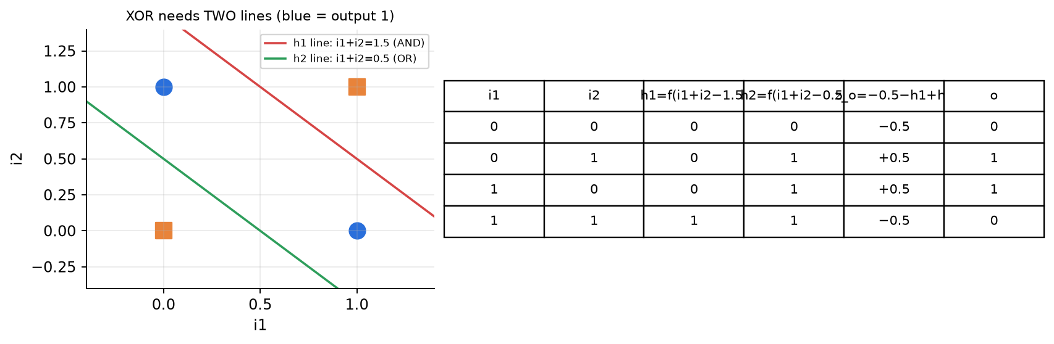
Figure 12.4 — XOR needs two lines: h1 (AND) and h2 (OR); output = OR and not AND.
✅ Final answer
(a) Truth table 0, 1, 1, 0 → XOR (h1 = AND, h2 = OR, o = OR AND NOT AND). (b) bias→o = +0.5, h1→o = +1, h2→o = −1 → outputs 1, 0, 0, 1 = XNOR. (c) σ′ = σ(1 − σ) ≤ 0.25 → product over layers vanishes.

⚠️ Edge cases & traps
- The question may not say what the output activation is — assume threshold and state it (with sigmoid the outputs would be σ(±0.5) = 0.62 / 0.38, rounded the same way).
- f(z) = 1 if z > 0: all z values here are ±0.5, never exactly 0, so the tie rule never matters — say so.
- In (b) "only output weights" — do NOT change the hidden layer. Alternative valid answers exist (e.g., bias 0.5, h1 +1, h2 −1 is the neatest; any weights with z > 0 for (0,0), (1,1) and z < 0 otherwise earn marks).
- A single perceptron can never do XOR/XNOR: the four points are not linearly separable.

🔄 How the examiner can twist it
- Ask for NAND or NOR with the same hidden units: NOR → o = f(0.5 − h2); NAND → o = f(0.5 − h1).
- Give weights and ask you to find the missing bias so that the net computes XOR.
- Ask for tanh′ = 1 − tanh² (max 1) and why tanh is better but still saturates.

✍️ Make your own new question
Keeping the same hidden units (h1 = AND, h2 = OR), choose output weights so the network computes NOR. Verify all four rows. (bias→o = +0.5, h1→o = 0, h2→o = −1: z = 0.5 − h2 → (0,0) +0.5 → 1; (0,1), (1,0), (1,1) −0.5 → 0.)

📝 PYQ — End-sem Autumn 2025, Q8 — Full CNN table + FC vs CNN [7 + 3]
Notation: CONV-K-N = N filters of size K×K (padding 0, stride 1); POOL-K = K×K max-pool with stride K; FC-N = fully-connected layer with N neurons.
(a) For the network INPUT 128×128×3 → CONV-9-32 → POOL-2 → CONV-5-64 → POOL-2 → CONV-5-64 → POOL-2 → FC-3, fill a table with the output size, number of weights and number of biases of each layer, and the total number of parameters. [7]
(b) An image is 1600×1200 RGB. (i) What is the size of the input layer of an FC network? [1] (ii) "A fully-connected network is always better than a CNN for images." True or false? Justify. [2]

🧠 How to think
Go layer by layer. Conv: O = W − K + 1 (P = 0, S = 1), weights = K·K·C_{in}·N, biases = N. Pool: halves H, W, zero params. FC: flatten then multiply by number of neurons.

Solution — step by step
Layer | Output size | Weights | Biases
INPUT | 128 × 128 × 3 | 0 | 0
CONV-9-32 | (128−9+1) = 120 → 120 × 120 × 32 | 9·9·3·32 = 7,776 | 32
POOL-2 | 60 × 60 × 32 | 0 | 0
CONV-5-64 | (60−5+1) = 56 → 56 × 56 × 64 | 5·5·32·64 = 51,200 | 64
POOL-2 | 28 × 28 × 64 | 0 | 0
CONV-5-64 | (28−5+1) = 24 → 24 × 24 × 64 | 5·5·64·64 = 102,400 | 64
POOL-2 | 12 × 12 × 64 | 0 | 0
FC-3 | 3 | 12·12·64·3 = 27,648 | 3

Total = 7,776 + 32 + 51,200 + 64 + 102,400 + 64 + 27,648 + 3 = 189,187
(b)(i) Input layer size = 1600 × 1200 × 3 = 5,760,000 neurons.
(b)(ii) FALSE. Even one hidden layer of just 1000 neurons would need 5,760,000 × 1000 = 5.76 billion weights. An FC net has no weight sharing and ignores spatial structure (neighbouring pixels), so it needs far more data, memory and compute and overfits easily; it must re-learn the same pattern at every position. A CNN uses small shared filters (local connectivity + weight sharing), exploits translation equivariance, and has orders of magnitude fewer parameters while generalising better.
✅ Final answer
(a) Sizes 120×120×32 → 60×60×32 → 56×56×64 → 28×28×64 → 24×24×64 → 12×12×64 → 3; weights 7,776 / 51,200 / 102,400 / 27,648; biases 32 / 64 / 64 / 3; total = 189,187 parameters.
(b) (i) 5,760,000 inputs. (ii) False — FC explodes in parameters, ignores spatial locality, has no weight sharing and overfits; CNNs are far more efficient for images.

⚠️ Edge cases & traps
- The second and third conv layers have filter depth = 32 and 64 (the previous layer's depth), NOT 3.
- The FC layer holds a big share of all parameters even here — always flatten carefully: 12·12·64 = 9,216 inputs.
- Pooling layers: write 0 explicitly in the table, don't leave blanks.
- "Always better" statements are almost always FALSE in ML exams — justify with numbers.

🔄 How the examiner can twist it
- Change padding to "same" → spatial size is kept by conv, only pools shrink it (128 → 64 → 32 → 16), FC weights = 16·16·64·3 = 49,152.
- Ask for the receptive field of one neuron after the second conv.
- Ask what happens to the parameter count if the input becomes 256×256×3 (conv params unchanged; only FC grows).

✍️ Make your own new question
INPUT 64×64×3 → CONV-5-16 → POOL-2 → FC-10. Table + total? (CONV: 60×60×16, weights 5·5·3·16 = 1,200, biases 16; POOL: 30×30×16; FC: weights 30·30·16·10 = 144,000, biases 10; total = 145,226.)

📝 PYQ — End-sem Autumn 2025, Q9 — RNN parameters, BatchNorm vs LayerNorm, Transformer parameter count [2 + 1 + 3 + 4]
(a) An RNN language model takes word vectors of dimension d, has hidden size d′ and vocabulary size v. How many parameters does it have? Does it depend on the sentence length T? [2]
(b) Why does a vanilla RNN struggle with long-range dependencies? [1]
(c) Why is Layer Normalisation preferred over Batch Normalisation in sequence models? Give an example. [3]
(d) A Transformer has 4 encoder layers and 4 decoder layers, model dimension d = 724 and vocabulary size 30,000. Estimate the total number of parameters, stating your assumptions. [4]

🧠 How to think
(a) List every weight matrix and bias with its shape. (b) Think "product of many numbers < 1". (c) BatchNorm needs statistics ACROSS samples at the same position — what if sentences have different lengths? (d) Count one MHA, one FFN, one LayerNorm, then assemble encoder/decoder layers.

Solution — step by step
(a)
Matrix | Shape | Count
W_{xh} (input → hidden) | d′ × d | d′d
W_{hh} (hidden → hidden) | d′ × d′ | d′²
b_{h} | d′ | d′
W_{hy} (hidden → output) | v × d′ | vd′
b_{y} | v | v
(Embedding, if learned) | v × d | vd

Total = d′d + d′² + d′ + v d′ + v (+ v d for a learned embedding)
It does not depend on T — the same weights are reused at every time step (weight sharing).
(b) In BPTT the gradient to an early step is a product of T Jacobians, each containing W_{h} and tanh′ (≤ 1). This product shrinks exponentially (vanishes) or blows up (explodes), so early words get almost no learning signal → the RNN cannot link words far apart.
(c) BatchNorm normalises each feature using the mean/variance across the batch at each position. In NLP: (1) sentences have different lengths and are padded — e.g. a batch with "I love ML" (3 tokens) and a 20-word sentence: at position 15 there is only ONE real token and the rest are pads, so the statistics are meaningless; (2) batches are often small → noisy estimates; (3) at inference we generate one token at a time (batch of 1, autoregressive) → mismatch with training statistics. LayerNorm normalises across the d features within each token, so it is independent of batch size and sequence length and behaves the same in training and testing.
(d) Assumptions: FFN inner size 4d = 2,896; all linear layers have biases; sinusoidal positional encoding (0 params); source embedding, target embedding and output projection share (tie) one matrix.
Component | Formula | Parameters
Embedding (shared) | v × d = 30,000 × 724 | 21,720,000
One MHA (W^{Q}, W^{K}, W^{V}, W^{O} + biases) | 4(d² + d) | 2,099,600
One FFN (d → 4d → d) | (d·4d + 4d) + (4d·d + d) = 8d² + 5d | 4,197,028
One LayerNorm (γ, β) | 2d | 1,448
Encoder layer | MHA + FFN + 2 LN | 6,299,524
4 encoder layers | × 4 | 25,198,096
Decoder layer | 2 MHA (self + cross) + FFN + 3 LN = 4,199,200 + 4,197,028 + 4,344 | 8,400,572
4 decoder layers | × 4 | 33,602,288
Total | 25,198,096 + 33,602,288 + 21,720,000 | 80,520,384 ≈ 80.5 M

Alternative assumption: separate source embedding, target embedding and output layer (with output bias 30,000): 58,800,384 + 3 × 21,720,000 + 30,000 = 123,990,384 ≈ 124 M.
✅ Final answer
(a) d′d + d′² + d′ + vd′ + v (+ vd embedding), independent of T. (b) Repeated multiplication by W_{h} and tanh′ in BPTT → vanishing/exploding gradients. (c) LayerNorm normalises within each token → works for variable lengths, padding, small batches and one-token-at-a-time inference; BatchNorm does not. (d) ≈ 80.5 M parameters with tied embeddings (≈ 124 M if all three embedding/output matrices are separate).

⚠️ Edge cases & traps
- In (d) there is no single "correct" number — marks are for clearly stated assumptions and correct per-block formulas.
- The number of heads does NOT change the MHA parameter count (the d×d matrices are just split among heads).
- Don't forget the decoder's cross-attention block and its third LayerNorm.
- d = 724 is not divisible by 8 heads (724/8 = 90.5) — fine for counting; mention it if heads are asked.

🔄 How the examiner can twist it
- Give the FFN inner size as 2048 instead of 4d: FFN = 2·d·2048 + 2048 + d.
- Ask for BERT-style (encoder only) or GPT-style (decoder only, no cross-attention) counts.
- Ask for LSTM params: 4 gates × (d′d + d′² + d′) = 4(d′d + d′² + d′).

✍️ Make your own new question
(i) RNN with d = 100, d′ = 50, v = 1000 (no embedding) — params? (5,000 + 2,500 + 50 + 50,000 + 1,000 = 58,550.) (ii) One Transformer encoder layer with d = 512? (MHA 4(512² + 512) = 1,050,624; FFN 8·512² + 5·512 = 2,099,712; 2 LN = 2,048 → 3,152,384.)

Class Test 1 (Group A) — 16 Feb 2026
Full marks 20
📝 PYQ — Class Test 1 (Group A), Q1 — Cost-sensitive linear classifier (loss matrix) [5]
8 points (from the plot): class −1: (2,4), (6,1), (8,3); class +1: (2,2), (5,6), (5,3), (8,2), (9,5).
Loss matrix: true +1 predicted −1 costs 1; true −1 predicted +1 costs 2; correct = 0. Find y = sign(aX1 + b) with a ∈ {1, −1}, b real, minimising the total loss. (The classifier is a line parallel to the X2-axis.) [5]

🧠 How to think
Only X1 matters: the rule is "X1 > t → +1" (a = 1, b = −t) or "X1 < t → +1" (a = −1, b = t). Only thresholds between distinct X1 values matter: X1 values are 2, 5, 6, 8, 9. Try every gap for both directions, count mistakes and weight them: FP (a −1 predicted +1) costs 2, FN costs 1.
List the X1 values with labels: X1=2: {−1, +1}; X1=5: {+1, +1}; X1=6: {−1}; X1=8: {−1, +1}; X1=9: {+1}.

Solution — step by step
Rule | Misclassified | Cost
a=+1, t<2 (all +1) | three −1 points (FP) | 3 × 2 = 6
a=+1, 2<t<5 | (6,1),(8,3) FP; (2,2) FN | 2+2+1 = 5
a=+1, 5<t<6 | (6,1),(8,3) FP; (2,2),(5,6),(5,3) FN | 4+3 = 7
a=+1, 6<t<8 | (8,3) FP; (2,2),(5,6),(5,3) FN | 2+3 = 5
a=+1, 8<t<9 | (2,2),(5,6),(5,3),(8,2) FN | 4
all −1 (t>9) | five +1 points (FN) | 5
a=−1, 2<t<5 | (2,4) FP; (5,6),(5,3),(8,2),(9,5) FN | 2+4 = 6
a=−1, 5<t<6 | (2,4) FP; (8,2),(9,5) FN | 2+2 = 4
a=−1, 6<t<8 | (2,4),(6,1) FP; (8,2),(9,5) FN | 4+2 = 6
a=−1, 8<t<9 | (2,4),(6,1),(8,3) FP; (9,5) FN | 6+1 = 7

Minimum cost = 4, achieved by two rules. Tie-break by the number of mistakes: a = −1, t ∈ (5, 6) makes 3 mistakes; a = +1, t ∈ (8, 9) makes 4.
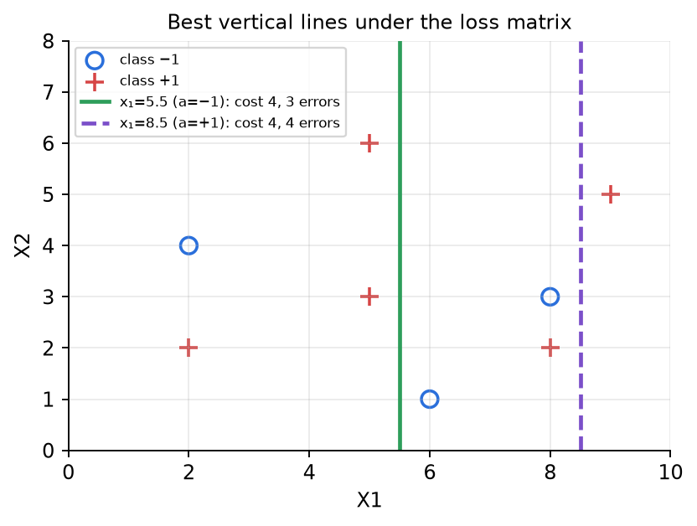
✅ Final answer
Best: y = sign(−X1 + 5.5) (a = −1, b = 5.5; any b in (5, 6) works) with total loss 4 (misclassifies (2,4), (8,2), (9,5)). Equally cheap alternative: y = sign(X1 − 8.5) (loss 4, but 4 mistakes).

⚠️ Edge cases & traps
- Points exactly on the line: choose b strictly between two X1 values so no point sits on the boundary.
- Read the loss matrix direction carefully: rows = TRUE, columns = PREDICTED. Swapping costs changes the answer.
- With equal costs (0-1 loss) the best would be 3 errors, a tie between a=−1, t∈(5,6) and a=+1, t∈(2,5) — the loss matrix exists to show how costs shift the decision.

🔄 How the examiner can twist it
- Make FP cost 5: then "all −1" (cost 5) competes, and a=+1, 8<t<9 (cost 4, no FP) becomes the unique best.
- Allow any line (not only vertical) → use perceptron/SVM thinking.
- Ask for the expected loss per point (4/8 = 0.5).

✍️ Make your own new question
Same points, but loss matrix: FN costs 3, FP costs 1. Find the best vertical classifier. (Try all thresholds; FNs are now expensive, so predicting +1 more often wins: e.g., a=+1, t<2 costs 3.)

📝 PYQ — Class Test 1 (Group A), Q2 [5]
Training set: (x₁=1, y₁=−7), (x₂=2, y₂=−9), (x₃=6, y₃=3). Fit a linear regression model by minimising squared error and predict for test point x₄ = 2. [5]

🧠 How to think
One feature → use the closed-form slope/intercept formulas (derived above). Compute means, then S_xy and S_xx.

Solution — step by step
x̄ = (1+2+6)/3 = 3 , ȳ = (−7 − 9 + 3)/3 = −13/3 = −4.333
i | xᵢ − x̄ | yᵢ − ȳ | (xᵢ − x̄)(yᵢ − ȳ) | (xᵢ − x̄)²
1 | −2 | −2.667 | 5.333 | 4
2 | −1 | −4.667 | 4.667 | 1
3 | 3 | 7.333 | 22.000 | 9
Σ |  |  | 32.000 | 14

θ₁ = S_{xy}/S_{xx} = 32/14 = 2.2857 , θ₀ = ȳ − θ₁x̄ = −4.333 − 2.2857 × 3 = −11.190
ŷ(2) = −11.190 + 2.2857 × 2 = −6.619
✅ Final answer
Model: ŷ = −11.19 + 2.286x. Prediction for x = 2: ŷ ≈ −6.62. (Self-check: residuals y − ŷ are +1.905 at x=1, −2.381 at x=2, +0.476 at x=6 → they sum to 0 ✔.)

⚠️ Edge cases & traps
- The test x=2 is also a training x, but the prediction is NOT y=−9: least squares fits the overall trend, not every point.
- The sum of residuals is always 0 when an intercept is included — a quick self-check.
- If asked "without intercept" (ŷ = θx): θ = Σxy/Σx² = (−7 − 18 + 18)/41 = −7/41 = −0.171.

🔄 How the examiner can twist it
- Ask for the gradient-descent route: start θ₀ = θ₁ = 0, η = 0.05, do one step.
- Ask for R²: SS_tot = Σ(y−ȳ)² = 7.11 + 21.78 + 53.78 = 82.67; SS_res = 1.90² + 2.38² + 0.48² = 9.52 → R² = 0.885.
- Add an outlier and ask how the line changes (least squares is sensitive to outliers).

✍️ Make your own new question
Fit ŷ = θ₀ + θ₁x to (0, 1), (1, 3), (2, 7), (3, 9) and predict x = 4. (x̄=1.5, ȳ=5, Sxy=14, Sxx=5 → θ₁=2.8, θ₀=0.8, ŷ(4)=12.0.)

📝 PYQ — Class Test 1 (Group A), Q3 — Decision stump with a continuous feature [10]
IDs 1–7: X1 = 1,1,1,1,2,2,2; X2 = 1.3, 0.4, 5.4, 3.7, 3.9, 1.8, 4.6; X3 = R,S,R,S,T,T,T; Y = A,A,B,B,A,A,B. Build a stump (one split) using the most discriminative feature by entropy; choose any suitable threshold for continuous features. Predict ID 8 (X1=2, X2=2, X3=S). [10]

🧠 How to think
A stump = tree of depth 1. Compare IG of X1 (binary), X3 (3 values) and the best threshold of X2. For X2, sort the values and test midpoints.

Solution — step by step
Root: 4 A, 3 B → H = 0.985.
X1: X1=1 → {A,A,B,B} H = 1; X1=2 → {A,A,B} H = 0.918 → H(Y|X1) = (4/7)(1) + (3/7)(0.918) = 0.965 → IG = 0.020.
X3: R → {A,B} 1; S → {A,B} 1; T → {A,A,B} 0.918 → H = (2/7) + (2/7) + (3/7)(0.918) = 0.965 → IG = 0.020.
X2 (continuous): sorted with labels: 0.4 A, 1.3 A, 1.8 A, 3.7 B, 3.9 A, 4.6 B, 5.4 B.
Threshold (midpoint) | Left (≤ t) | Right (> t) | IG
0.85 | A | A,A,B,A,B,B | 0.128
1.55 | A,A | A,B,A,B,B | 0.292
2.75 | A,A,A (H=0) | B,A,B,B (H=0.811) | 0.522
3.80 | A,A,A,B | A,B,B | 0.128
4.25 | A,A,A,B,A | B,B | 0.470
5.00 | A,A,A,B,A,B | B | 0.198

IG(X2 ≤ 2.75) = 0.985 − (4/7)(0.811) = 0.985 − 0.464 = 0.522
Best feature: X2 with threshold 2.75. Leaves: X2 ≤ 2.75 → A (pure); X2 > 2.75 → B (3 B, 1 A, majority B).
ID 8: X2 = 2 ≤ 2.75 → A.
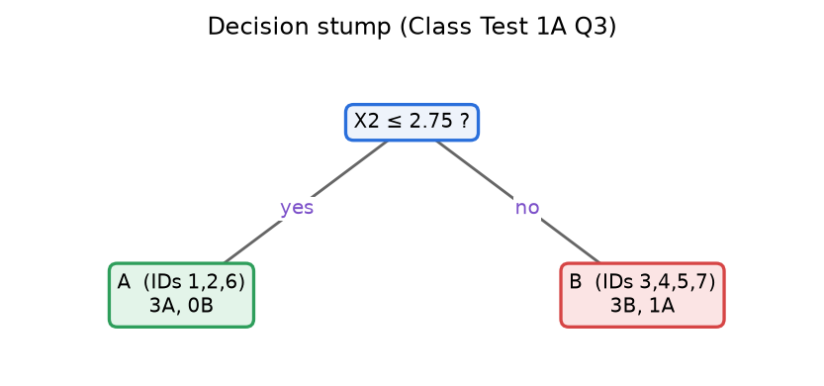
✅ Final answer
Stump: "if X2 ≤ 2.75 then A else B" (IG = 0.522, far above X1 and X3 at 0.020). Test point ID 8 → A.

⚠️ Edge cases & traps
- Only thresholds where the label changes need checking (between 1.8/3.7, 3.7/3.9, 3.9/4.6) — saves time; the others can never be optimal.
- Any threshold in (1.8, 3.7) gives the same split; 2.75 is the midpoint (safest choice).
- The question says "regression stump" but labels are classes → it is a classification (decision) stump; mention this.
- X1 and X3 tie at 0.020 — irrelevant since X2 wins.

🔄 How the examiner can twist it
- Ask for a depth-2 tree: the right branch {ID4 3.7 B, ID5 3.9 A, ID7 4.6 B, ID3 5.4 B} has H = 0.811. X2 ≤ 3.8 → IG 0.123; X2 ≤ 4.25 → IG 0.311; X1 (IDs 3,4 = B,B | IDs 5,7 = A,B) → IG 0.311; X3 → IG 0.311 → a 3-way tie you must break by a stated rule.
- Use Gini instead; use gain ratio (SplitInfo for X3 = 1.557 penalises the 3-way split).
- Put the test point at X2 = 2.75 exactly → define ≤ vs <.

✍️ Make your own new question
Values X = [1, 2, 3, 4, 5, 6] with labels [A, A, B, A, B, B]. Find the best threshold by IG. (Candidates 2.5: {A,A} | {B,A,B,B} → IG = 1 − (4/6)(0.811) = 0.459; 4.5: {A,A,B,A}|{B,B} → IG = 0.459; tie → state rule.)

Class Test 1 (Group B) — 16 Feb 2026
Full marks 20
📝 PYQ — Class Test 1 (Group B), Q1 — Perceptron [8]
Data: ID1 (1,1, −1), ID2 (2,1, −1), ID3 (1,3, −1), ID4 (5,4, +1), ID5 (2,5, +1), ID6 (3,4, +1). Is Y = sign(X1 − X2 + 2) suitable? If not, run the perceptron for one iteration (one pass over all 6 points), updating whenever needed. [8]

🧠 How to think
First test the given line on all points (that answers "is it suitable?"). Then run the perceptron rule with η = 1, w = (1, −1), b = 2, always using the latest w.

Solution — step by step
Checking the given classifier f = X1 − X2 + 2: ID1: 2 (→ +1, wrong); ID2: 3 (wrong); ID3: 0 (on the line → wrong); ID4: 3 ✔; ID5: −1 (wrong); ID6: 1 ✔. 4 of 6 wrong → not suitable.
Point (x, y) | f = wᵀx + b | y·f | Action | New w, b
ID1 (1,1), −1 | 1 − 1 + 2 = 2 | −2 | update: w − x, b − 1 | w = (0, −2), b = 1
ID2 (2,1), −1 | 0 − 2 + 1 = −1 | +1 | OK | —
ID3 (1,3), −1 | 0 − 6 + 1 = −5 | +5 | OK | —
ID4 (5,4), +1 | 0 − 8 + 1 = −7 | −7 | update: w + x, b + 1 | w = (5, 2), b = 2
ID5 (2,5), +1 | 10 + 10 + 2 = 22 | +22 | OK | —
ID6 (3,4), +1 | 15 + 8 + 2 = 25 | +25 | OK | —

After one pass: ŷ = sign(5X1 + 2X2 + 2). It still misclassifies ID1, ID2, ID3 (all give positive scores), so more passes are needed. The data IS linearly separable (e.g., X1 + X2 = 5.5 separates: negatives have X1+X2 ≤ 4, positives ≥ 7), so the perceptron is guaranteed to converge eventually.
✅ Final answer
Given classifier is NOT suitable (misclassifies ID1, ID2, ID3, ID5). After one perceptron pass: updates at ID1 and ID4 → w = (5, 2), b = 2, i.e. sign(5X1 + 2X2 + 2).

⚠️ Edge cases & traps
- A point exactly on the line (ID3 with f = 0) counts as a mistake — say this rule explicitly.
- Use the updated w immediately (ID2 is checked with w = (0, −2), not the original).
- Don't forget to update the bias b as well.
- The perceptron needs many passes here because the bias starts large and there is no normalisation — convergence speed depends on the margin (R/γ)².

🔄 How the examiner can twist it
- Change the order of points → different final line (perceptron is order-dependent).
- Use η = 0.5 → same decisions, weights halved.
- Ask for a second pass (updates at ID1, ID2, ID3, ID4 → w = (6, 1), b = 0).

✍️ Make your own new question
Data: (0,0,−1), (1,0,−1), (0,2,+1), (2,2,+1). Start w = (0,0), b = 0 and run the perceptron until convergence. (Pass 1: update at (0,0) [f=0] → w=(0,0), b=−1; (1,0) OK; (0,2) f=−1 → w=(0,2), b=0; (2,2) OK. Pass 2: (0,0) f=0 → update w=(0,2), b=−1; then all OK → sign(2X2 − 1).)

📝 PYQ — Class Test 1 (Group B), Q2 — KNN imputation [7]
10 labelled 2-D points; some have missing features or missing labels. Impute (estimate) the missing values using nearest neighbours. [7]
D1(4.8, −5.5, y=1), D2(5.1, −5.7, y=?), D3(−2.2, 1.8, y=2), D4(3.9, ?, y=1), D5(?, −5.0, y=1), D6(−2.2, 1.0, y=?), D7(0.3, ?, y=3), D8(?, −4.9, y=?), D9(−0.1, 0.2, y=3), D10(−0.5, −0.5, y=?)

🧠 How to think
There are two kinds of holes. (a) Missing label but full features → classic KNN classification using points whose label is known. (b) Missing feature → find neighbours using the features/label you DO know, then copy/average their value of the missing feature (KNN regression). Do the easiest ones first, then use them to fill harder ones (D8 misses two things).
Looking at the data: there are 3 groups — class 1 near (5, −5.5), class 2 near (−2.2, 1.5), class 3 near (0, 0).

Solution — step by step
Step 1 — missing labels (features complete): 1-NN on (X1, X2).
Point | Nearest labelled point | Distance | Imputed y
D2 (5.1, −5.7) | D1 (4.8, −5.5) | √(0.09+0.04) = 0.36 | 1
D6 (−2.2, 1.0) | D3 (−2.2, 1.8) [next: D9 = 2.25] | 0.80 | 2
D10 (−0.5, −0.5) | D9 (−0.1, 0.2) [next: D6 = 2.27, D3 = 2.86] | √(0.16+0.49) = 0.81 | 3

Step 2 — missing feature: use the known coordinate (and label) to find neighbours, then average their value (K = 2).
Point | Known info | Neighbours used (K=2) | Imputed value
D4 | X1 = 3.9, y = 1 | closest X1 among class-1 points with X2 known: D1 (|3.9−4.8| = 0.9), D2 (1.2) | X2 = (−5.5 − 5.7)/2 = −5.6
D5 | X2 = −5.0, y = 1 | closest X2 among points with X1 known: D1 (0.5), D2 (0.7) | X1 = (4.8 + 5.1)/2 = 4.95
D7 | X1 = 0.3, y = 3 | closest X1 with X2 known: D9 (0.4), D10 (0.8) — both class 3 | X2 = (0.2 − 0.5)/2 = −0.15

Step 3 — D8 (X1 and y both missing), X2 = −4.9. Closest by X2: D5 (0.1), D1 (0.6), D2 (0.8) — all in the class-1 group. X1 ≈ average of D1 and D2 = 4.95. Now D8 = (4.95, −4.9): its nearest full point is D5 (4.95, −5.0), distance 0.1 → y = 1.
✅ Final answer
D2 → y = 1, D6 → y = 2, D10 → y = 3, D4 → X2 ≈ −5.6, D5 → X1 ≈ 4.95, D7 → X2 ≈ −0.15, D8 → X1 ≈ 4.95 and y = 1. (Any K is fine if stated; 1-NN values: D4 → −5.5, D5 → 4.8, D7 → 0.2.)

⚠️ Edge cases & traps
- K matters for D10: with plain K = 3 the neighbours are D9 (3), D6 (2), D3 (2) → majority says 2! With 1-NN or distance-weighted K=3 (weights 1/d²: 1.54 for class 3 vs 0.32 for class 2) → 3. Always state K and justify (the class-3 point is 3× closer).
- Using an already-imputed value to impute another (D8 via D5) is allowed but say so — it can propagate errors.
- Do not use the label you are trying to impute, and do not use a point's own missing value.

🔄 How the examiner can twist it
- "Use mean imputation instead and compare": X2 mean of known values would ignore the class structure (≈ −2.3 for D4, clearly wrong).
- Ask for weighted KNN imputation, or for Manhattan distance.
- Give features on very different scales and ask whether to normalise first.

✍️ Make your own new question
Points: P1(1,1,A), P2(1.2,0.8,?), P3(5,5,B), P4(5.2,?,B), P5(?,1.1,A), P6(4.8,5.1,?). Impute all missing values with K=1 and K=2 and state which you trust more. (K=1: P2→A, P4 X2 from P3 or P6 = 5 or 5.1, P5 X1 from P1 = 1, P6 → B.)

📝 PYQ — Class Test 1 (Group B), Q3 — Cross-entropy loss [5]
Logistic regression with cross-entropy loss, W = [1, −1] (no bias). Data: ID1 (5, 3, y=1), ID2 (1, 4, 1), ID3 (−1, 7, 1), ID4 (1, −2, 0), ID5 (2, −3, 0), ID6 (−4, −1, 0). Compute the loss. [5]

🧠 How to think
For each row: z = Wᵀx → p = σ(z) = P(y=1) → per-sample loss = −[y ln p + (1−y) ln(1−p)] (i.e. −ln p if y = 1, −ln(1−p) if y = 0). Then sum (or average — state which).

Solution — step by step
ID | z = x₁ − x₂ | p = σ(z) | y | loss = −ln(p) or −ln(1−p)
1 | 5 − 3 = 2 | 0.8808 | 1 | −ln 0.8808 = 0.1269
2 | 1 − 4 = −3 | 0.0474 | 1 | −ln 0.0474 = 3.0486
3 | −1 − 7 = −8 | 0.000335 | 1 | −ln 0.000335 = 8.0003
4 | 1 + 2 = 3 | 0.9526 | 0 | −ln 0.0474 = 3.0486
5 | 2 + 3 = 5 | 0.9933 | 0 | −ln 0.0067 = 5.0067
6 | −4 + 1 = −3 | 0.0474 | 0 | −ln 0.9526 = 0.0486

Total = 19.28 , Mean = 19.28/6 = 3.213 (natural log)
✅ Final answer
Cross-entropy loss ≈ 19.28 (sum) or 3.21 (average per sample) with natural log. (With log₂: average 4.64.) The loss is large because W = [1, −1] points the wrong way — it gives low probability to most positive samples.

⚠️ Edge cases & traps
- State ln vs log₂ and sum vs mean.
- Use −ln(1−p) for y = 0 rows — the most common slip is using −ln p for every row.
- For large |z| compute carefully: σ(−8) = 1/(1+e⁸) = 1/2982 ≈ 0.000335.

🔄 How the examiner can twist it
- Ask for the gradient: ∇ = Σ(pᵢ − yᵢ)xᵢ = (0.8808−1)(5,3) + (0.0474−1)(1,4) + … → then do one GD step.
- Ask to compare with W = [−1, 1]: total loss = 2.127 + 0.049 + 0.0003 + 0.049 + 0.0067 + 3.049 = 5.28 → much better, so the sign of W was wrong.
- Add a bias b and ask for the loss at W = [1,−1], b = 1.

✍️ Make your own new question
Same data, W = [0.5, 0.5]. Compute each p and the mean cross-entropy loss. Which W (this one or [1,−1]) is better?

Mid-Spring Semester Examination — 2025-26 (26.02.2026)
AI20001 • 2 hrs • Full marks 30 • Answer any three
📝 PYQ — Midsem Spring 2026, Q1 A [3]
6 observations (X1, X2, X3 → Y): ID1 (1, 1, 3 → −0.5), ID2 (−1, 2, 0 → 3.2), ID3 (−3, 3, −1 → 3.7), ID4 (−1, 2, 5 → −1.6), ID5 (2, −1, 1 → 0.1), ID6 (0, −2, 2 → −6.8).
Two models: (i) Y = X1 + 2X2 − X3, (ii) Y = X1 + X2 − 2X3. Which do you prefer? [3]

🧠 How to think
"Prefer" = which fits the data better → compute predictions and a loss (SSE or MSE) for both. Lower loss wins. Show the table — that is where the marks are.

Solution — step by step
ID | Y | Model (i) ŷ | error y−ŷ | Model (ii) ŷ | error y−ŷ
1 | −0.5 | 1+2−3 = 0 | −0.5 | 1+1−6 = −4 | 3.5
2 | 3.2 | −1+4−0 = 3 | 0.2 | −1+2−0 = 1 | 2.2
3 | 3.7 | −3+6+1 = 4 | −0.3 | −3+3+2 = 2 | 1.7
4 | −1.6 | −1+4−5 = −2 | 0.4 | −1+2−10 = −9 | 7.4
5 | 0.1 | 2−2−1 = −1 | 1.1 | 2−1−2 = −1 | 1.1
6 | −6.8 | 0−4−2 = −6 | −0.8 | 0−2−4 = −6 | −0.8

SSE(i) = 0.25 + 0.04 + 0.09 + 0.16 + 1.21 + 0.64 = 2.39 (MSE = 0.398)
SSE(ii) = 12.25 + 4.84 + 2.89 + 54.76 + 1.21 + 0.64 = 76.59 (MSE = 12.77)
✅ Final answer
Prefer model (i) Y = X1 + 2X2 − X3: its squared-error loss (SSE 2.39) is about 32× smaller than model (ii) (SSE 76.59). Its errors are small and of mixed sign (unbiased-looking), while model (ii) is systematically too low.

⚠️ Edge cases & traps
- Use the SAME loss for both models. MAE also works (mean |e|: 0.55 vs 2.78) — same conclusion.
- Neither model has a bias term; the question in part B asks you to add one.
- For even more marks: mention the best least-squares fit (with bias) is ≈ 0.03 + 1.33X1 + 2.22X2 − 1.05X3 — close to model (i).

🔄 How the examiner can twist it
- Ask which model has lower MAE / max error.
- Give a model that fits most points perfectly but one point terribly — then SSE vs MAE may disagree (SSE is outlier-sensitive).

✍️ Make your own new question
Same data. Compare Y = 2X1 + X2 − X3 and Y = X1 + 2X2 − X3 − 0.5 using MSE. (Compute yourself — practise the table.)

📝 PYQ — Midsem Spring 2026, Q1 B [3]
With squared-error loss, explain how to find the optimal linear model Y = W·X by gradient descent (W includes the bias). Derive the update equation and show one round of update starting from the model chosen in Q1A. [3]

🧠 How to think
Three parts: (1) define loss, (2) derive gradient + update (use the derivation box above), (3) plug numbers for ONE full-batch step. The learning rate is not given → choose one and state it (η = 0.01).

Solution — step by step
Augment each x with 1 for the bias: X̃ = [1, X1, X2, X3], W = [b, w₁, w₂, w₃]. Start from model (i): W⁰ = [0, 1, 2, −1].
L(W) = (1/N) Σ (W^{T}x̃_{i} − y_{i})² ⇒ ∇L = (2/N) Σ (ŷ_{i} − y_{i}) x̃_{i} , W ← W − η∇L
Errors eᵢ = ŷᵢ − yᵢ (note the sign: prediction minus target) = [0.5, −0.2, 0.3, −0.4, −1.1, 0.8].
Component | Σ eᵢ·x̃ᵢⱼ | ∇ = (2/6)·Σ | new = old − 0.01·∇
b | 0.5−0.2+0.3−0.4−1.1+0.8 = −0.1 | −0.0333 | 0 + 0.00033 = 0.00033
w₁ (X1) | 0.5+0.2−0.9+0.4−2.2+0 = −2.0 | −0.6667 | 1 + 0.00667 = 1.00667
w₂ (X2) | 0.5−0.4+0.9−0.8+1.1−1.6 = −0.3 | −0.1000 | 2 + 0.001 = 2.00100
w₃ (X3) | 1.5+0−0.3−2.0−1.1+1.6 = −0.3 | −0.1000 | −1 + 0.001 = −0.99900

Check: MSE goes from 0.3983 → 0.3938 (it decreased, so the step is in the right direction).
✅ Final answer
Update rule W ← W − η(2/N)Σ(Wᵀx̃ᵢ − yᵢ)x̃ᵢ. After one step (η = 0.01): W¹ = [b, w₁, w₂, w₃] ≈ [0.0003, 1.0067, 2.0010, −0.9990], and the loss decreased from 0.398 to 0.394.

⚠️ Edge cases & traps
- Sign error is the #1 mistake: with e = ŷ − y you SUBTRACT the gradient. If you define e = y − ŷ the gradient is −(2/N)Σeᵢxᵢ.
- Don't forget the bias column of 1s.
- If η is too big (e.g., 0.5), the loss may increase — mention checking the loss.

🔄 How the examiner can twist it
- Ask for SGD instead (update after each row).
- Ask for 2 iterations, or ask to derive the gradient with L1 (absolute) loss: ∂/∂w = (1/N)Σ sign(ŷ−y)x.

✍️ Make your own new question
Start from model (ii) instead and do one step with η = 0.01. Does the loss drop more or less than above? Why? (More — the gradient is much bigger because the model is worse.)

📝 PYQ — Midsem Spring 2026, Q1 C — Logistic regression derivation [4]
Dataset {(X₁,Y₁), …, (X_N,Y_N)}, X ∈ ℝ^D, Y ∈ {0,1}. You want P(Y=1|X). Discuss how logistic regression is used and how its parameters are estimated from training data. Show necessary derivations. [4]

🧠 How to think
This is the MLE derivation box above, written as an answer. Structure: model → likelihood → log-likelihood → gradient → update rule → prediction.

Solution — step by step
1. Model. Assume the log-odds are linear: ln[P(Y=1|X)/(1−P(Y=1|X))] = wᵀX + b ⇒ P(Y=1|X) = σ(wᵀX + b) = 1/(1 + e^{−(wᵀX+b)}), P(Y=0|X) = 1 − σ(·).
2. Likelihood (samples independent): L(w,b) = Πᵢ σ(zᵢ)^{Yᵢ} (1 − σ(zᵢ))^{1−Yᵢ}, zᵢ = wᵀXᵢ + b.
3. Log-likelihood: ℓ = Σᵢ [Yᵢ ln σ(zᵢ) + (1−Yᵢ) ln(1−σ(zᵢ))]. Maximising ℓ ⇔ minimising cross-entropy J = −ℓ/N.
4. Gradient (using σ′ = σ(1−σ)): ∂ℓ/∂w = Σᵢ (Yᵢ − σ(zᵢ)) Xᵢ , ∂ℓ/∂b = Σᵢ (Yᵢ − σ(zᵢ)).
5. Update (no closed form → iterate): w ← w + η Σᵢ (Yᵢ − σ(zᵢ)) Xᵢ, b ← b + η Σᵢ (Yᵢ − σ(zᵢ)) — batch or stochastic (one sample at a time) until convergence.
6. Prediction: P(Y=1|X) = σ(wᵀX + b); predict 1 if ≥ 0.5 (i.e. wᵀX + b ≥ 0) → linear decision boundary. Total parameters: D + 1.
✅ Final answer
P(Y=1|X) = σ(wᵀX+b); parameters found by maximising the log-likelihood Σ[Y ln σ + (1−Y) ln(1−σ)] with gradient ascent: w ← w + ηΣ(Yᵢ − σ(wᵀXᵢ+b))Xᵢ.

⚠️ Edge cases & traps
- Say WHY log: product of many small numbers underflows, and log turns product into sum.
- Mention there is no closed-form solution (unlike linear regression) — examiners like this.
- Mention the loss is convex → GD finds the global optimum.

🔄 How the examiner can twist it
- "Why not use squared error for logistic regression?" → with a sigmoid, MSE becomes non-convex and gradients vanish when the prediction is confidently wrong.
- "Extend to K classes" → softmax + categorical cross-entropy.
- "Add L2 regularisation" → gradient gets an extra −λw term.

✍️ Make your own new question
Derive the gradient of the binary cross-entropy loss with an L2 penalty (λ/2)‖w‖² and write the SGD update.

📝 PYQ — Midsem Spring 2026, Q2 A — SVM from given α [3]
2D data with estimated Lagrange multipliers: ID1 (4, 3, +1, α=0), ID2 (2, 4, +1, α=0.5), ID3 (6, −2, +1, α=0.5), ID4 (−8, 1, −1, α=0), ID5 (1, −3, −1, α=1), ID6 (−1, −5, −1, α=0). What is the max-margin classifier and how does it satisfy the training constraints? [3]

🧠 How to think
Use w = Σαᵢyᵢxᵢ (only α > 0 rows: ID2, ID3, ID5 = support vectors), check Σαᵢyᵢ = 0, get b from the SVs, then verify yᵢ(wᵀxᵢ + b) ≥ 1 for all six points.

Solution — step by step
Σ α_{i}y_{i} = 0.5 + 0.5 − 1 = 0 ✔
w = 0.5(2, 4) + 0.5(6, −2) − 1·(1, −3) = (1, 2) + (3, −1) + (−1, 3) = (3, 4)
b from each SV (b = yₖ − wᵀxₖ): ID2: 1 − 22 = −21; ID3: 1 − 10 = −9; ID5: −1 − (3 − 12) = 8. They disagree → the given α's are only approximate; take the average b = (−21 − 9 + 8)/3 = −7.33.
Classifier: f(x) = sign(3x₁ + 4x₂ − 7.33).
ID | y | wᵀx + b | y(wᵀx + b) | ≥ 1 ?
1 (4,3) | +1 | 12 + 12 − 7.33 = 16.67 | 16.67 | ✔
2 (2,4) | +1 | 6 + 16 − 7.33 = 14.67 | 14.67 | ✔
3 (6,−2) | +1 | 18 − 8 − 7.33 = 2.67 | 2.67 | ✔
4 (−8,1) | −1 | −24 + 4 − 7.33 = −27.33 | 27.33 | ✔
5 (1,−3) | −1 | 3 − 12 − 7.33 = −16.33 | 16.33 | ✔
6 (−1,−5) | −1 | −3 − 20 − 7.33 = −30.33 | 30.33 | ✔

All six constraints yᵢ(wᵀxᵢ + b) ≥ 1 hold → every point is correctly classified and outside the margin. Other KKT conditions: αᵢ ≥ 0 ✔ and Σαᵢyᵢ = 0 ✔; points with α = 0 (IDs 1, 4, 6) do not influence w.
✅ Final answer
w = (3, 4), b ≈ −7.33 → ŷ = sign(3x₁ + 4x₂ − 7.33). It satisfies all training constraints yᵢ(wᵀxᵢ + b) ≥ 1 (smallest value 2.67 at ID3), with SVs = {ID2, ID3, ID5}. (Any b in [−9, 8] satisfies all constraints.)

⚠️ Edge cases & traps
- Examiner-level insight: at the true optimum, complementary slackness forces yₖ(wᵀxₖ + b) = 1 exactly for every SV; here the three SV values differ, so these α's are illustrative. The exact SVM (solved numerically) has the SAME support vectors {2, 3, 5} but w ≈ (0.353, 0.235), b ≈ −0.647. Writing this shows deep understanding.
- Never include α = 0 points in w.
- Don't forget the label yᵢ in w = Σαᵢyᵢxᵢ (ID5 contributes −(1, −3)).

🔄 How the examiner can twist it
- Ask for the margin: 2/‖w‖ = 2/5 = 0.4 (with this w).
- Ask to classify a new point, e.g., (0, 1): 0 + 4 − 7.33 < 0 → −1.
- Give α that violate Σαy = 0 and ask what is wrong.

✍️ Make your own new question
Given SVs x₁ = (1, 1, y=+1, α=0.25), x₂ = (−1, −1, y=−1, α=0.25), find w, b, check the constraints and classify (2, −1). (w = 0.25(1,1) + 0.25(1,1) = (0.5, 0.5); b = 1 − 1 = 0 from x₁ and −1 + 1 = 0 from x₂ (consistent ✔ — these α are exact); both SVs give y·f = 1; (2, −1) → f = 0.5 > 0 → +1.)

📝 PYQ — Midsem Spring 2026, Q2 B — Soft margin [2]
Write the soft-margin SVM formulation. For the dataset of Q2A, suggest another point for which the slack variable is non-zero. [2]

🧠 How to think
Slack ξᵢ = max(0, 1 − yᵢf(xᵢ)). Pick a point that is either inside the margin or on the wrong side of our classifier f(x) = 3x₁ + 4x₂ − 7.33.

Solution — step by step
min_{w,b,ξ} ½‖w‖² + C Σ_{i} ξ_{i} s.t. y_{i}(w^{T}x_{i} + b) ≥ 1 − ξ_{i} , ξ_{i} ≥ 0
Example 1 (misclassified): add (0, 0) with label +1: f = −7.33 → ξ = 1 − (+1)(−7.33) = 8.33 > 1.
Example 2 (inside the margin, correct side): add (1, 1.2) with label +1: f = 3 + 4.8 − 7.33 = 0.47 → ξ = 1 − 0.47 = 0.53 (0 < ξ < 1).
✅ Final answer
Soft margin: min ½‖w‖² + CΣξᵢ s.t. yᵢ(wᵀxᵢ + b) ≥ 1 − ξᵢ, ξᵢ ≥ 0. E.g., adding a positive point at (0, 0) gives ξ = 8.33 (misclassified); a positive point at (1, 1.2) gives ξ = 0.53 (margin violation).

⚠️ Edge cases & traps
- A point far on the correct side (e.g., (5, 5, +1)) has ξ = 0 — not a valid answer.
- State which classifier you use to compute ξ.

🔄 How the examiner can twist it
- Ask for the effect of C on that point: larger C → the optimiser tries harder to push it out (narrower margin).

✍️ Make your own new question
Suggest a NEGATIVE point with ξ between 0 and 1 for the same classifier. (We need 0 < y·f < 1 with y = −1, i.e. −1 < f < 0: e.g., (1, 1) with y = −1: f = 3 + 4 − 7.33 = −0.33 → y·f = 0.33 → ξ = 0.67 — correct side but inside the margin.)

📝 PYQ — Midsem Spring 2026, Q2 C [5]
2D dataset: Class A at (1,1), (2,2); Class B at (5,5), (6,6). Test point (3,3).
i) Compute Euclidean and Manhattan distances to all training points. [2] ii) Predict class for K = 1 and K = 3 using both metrics. [3]

🧠 How to think
Pure plug-and-play. Make ONE table with both distances, sort, vote. The hidden test is the tie at the 3rd neighbour — notice (1,1) and (5,5) are equally far from (3,3).

Solution — step by step
Training point | Class | Euclidean | Manhattan
(1,1) | A | √(4+4) = √8 = 2.83 | 2+2 = 4
(2,2) | A | √(1+1) = √2 = 1.41 | 1+1 = 2
(5,5) | B | √(4+4) = √8 = 2.83 | 2+2 = 4
(6,6) | B | √(9+9) = √18 = 4.24 | 3+3 = 6

K = 1: nearest is (2,2) under both metrics → Class A.
K = 3: sorted order (both metrics): (2,2) [A], then a tie between (1,1) [A] and (5,5) [B], then (6,6) [B]. The 3 nearest are exactly (2,2), (1,1), (5,5) → votes A, A, B → Class A.
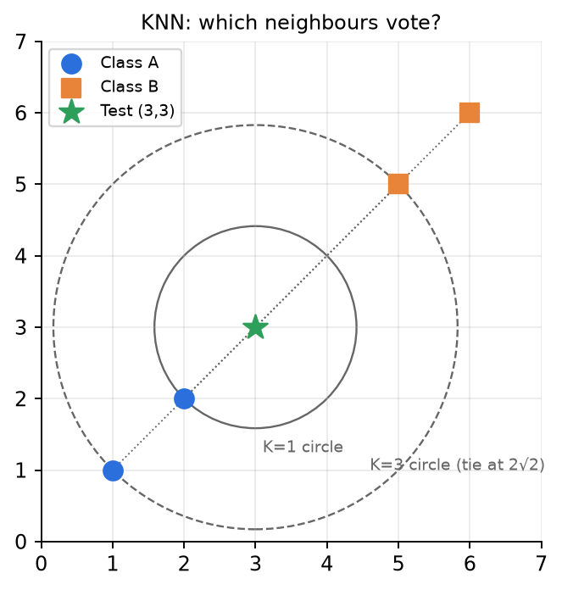
Figure 2.2 — K=1 circle catches only (2,2); K=3 circle hits (1,1) and (5,5) at the same distance.
✅ Final answer
K=1 → A (Euclidean) and A (Manhattan). K=3 → A (Euclidean) and A (Manhattan), with 2 votes A vs 1 vote B. Both metrics give the same ranking here because every difference vector is along the diagonal.

⚠️ Edge cases & traps
- Tie at the K-th distance: here the tie is harmless because the 2nd and 3rd neighbours are both included. If K were 2, you would have to break the tie (random, smaller index, or use distance-weighting) — say which rule you use.
- K = 4 would give a 2–2 tie → that is why odd K is preferred.
- Euclidean and Manhattan can give different neighbours when differences are not along a diagonal (e.g., (3,0) vs (2,2): Euclidean 3 vs 2.83, Manhattan 3 vs 4).

🔄 How the examiner can twist it
- Use weighted KNN with K=3 (w = 1/d²): A gets 1/2 + 1/8 = 0.625, B gets 1/8 = 0.125 → A.
- Ask for K = 4 → tie; ask for distance-weighted K = 4: A: 1/2+1/8 = 0.625; B: 1/8 + 1/18 = 0.18 → A.
- Move the test point to (4,4): now (5,5) is nearest (√2) and (2,2) is √8 → K=1 gives B; K=3 → (5,5) B, (6,6) B at √8 tie with (2,2) A → B wins. The answer flips just by moving the test point.
- Unscaled features: multiply the y-coordinate by 100 and ask what changes.

✍️ Make your own new question
Class A = {(0,0), (1,3)}, Class B = {(4,1), (3,4), (5,5)}. Test point (2,2). Find the class for K=1 and K=3 using Euclidean and Manhattan. (Euclidean: (1,3)=1.41, (0,0)=2.83, (4,1)=2.24, (3,4)=2.24 → K=1 A; K=3: A, B, B tie at 2.24 → B. Manhattan: (1,3)=2, (0,0)=4, (4,1)=3, (3,4)=3 → K=1 A, K=3 → A,B,B → B.)

📝 PYQ — Midsem Spring 2026, Q3 [10]
Samples (Feature A, Feature B → Label): 1 (Low, Hot, +), 2 (Low, Cold, −), 3 (High, Hot, +), 4 (High, Cold, +), 5 (Low, Hot, +), 6 (High, Cold, −).
A) Entropy of the full dataset [3]. B) Information gain for splitting on Feature A and Feature B [4]. C) Which feature is the root? Build the first level and explain the purity of the child nodes [3].

🧠 How to think
4 positives, 2 negatives → H(1:2) = 0.918 (from the table). For each feature, count +/− in each branch.

Solution — step by step
A) p(+) = 4/6, p(−) = 2/6:
H(S) = −(2/3)log₂(2/3) − (1/3)log₂(1/3) = 0.667(0.585) + 0.333(1.585) = 0.390 + 0.528 = 0.918 bits
B)
Feature | Branch | Samples | + / − | Entropy | Weight
A | Low | 1, 2, 5 | 2 / 1 | 0.918 | 3/6
A | High | 3, 4, 6 | 2 / 1 | 0.918 | 3/6
B | Hot | 1, 3, 5 | 3 / 0 | 0 | 3/6
B | Cold | 2, 4, 6 | 1 / 2 | 0.918 | 3/6

IG(A) = 0.918 − [½(0.918) + ½(0.918)] = 0.918 − 0.918 = 0
IG(B) = 0.918 − [½(0) + ½(0.918)] = 0.918 − 0.459 = 0.459 bits
C) Root = Feature B. Hot branch = {1, 3, 5}, all "+" → pure leaf (entropy 0) → predict "+". Cold branch = {2, 4, 6} = one "+" and two "−" → impure (entropy 0.918) → majority "−" (or split further on A: Cold & High → {4 +, 6 −} still mixed, Cold & Low → {2 −} pure).
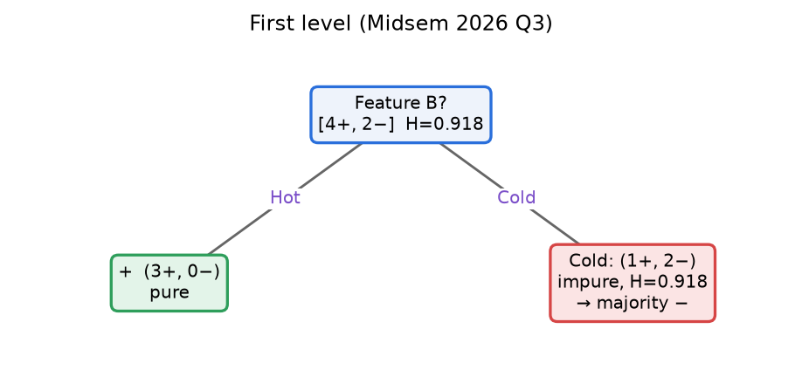
✅ Final answer
H = 0.918 bits; IG(A) = 0, IG(B) = 0.459 → root = B. Hot → pure "+"; Cold → impure (1+, 2−), H = 0.918.

⚠️ Edge cases & traps
- IG(A) = 0 exactly: A's branches have the same class ratio as the parent → no information.
- Even after splitting Cold on A, samples 4 and 6 have identical features but different labels → noisy/contradictory data: the tree can never be 100% pure; use a majority/probability leaf.
- Always write the formula before the numbers for method marks.

🔄 How the examiner can twist it
- Ask for Gini: Gini(root) = 1 − (4/6)² − (2/6)² = 0.444; B: Hot 0, Cold 0.444 → weighted 0.222 → Gini gain 0.222; A: gain 0 → same choice.
- Ask for gain ratio: SplitInfo(A) = SplitInfo(B) = 1 (3/3 split) → GR(B) = 0.459.
- Add a 7th sample to break the tie in the Cold branch.

✍️ Make your own new question
Add sample 7 (Low, Cold, +). Recompute H(S), IG(A), IG(B) and the root. (5+, 2−: H = 0.863; A: Low (3+,1−) 0.811, High (2+,1−) 0.918 → IG = 0.863 − 0.857 = 0.006; B: Hot (3+) 0, Cold (2+,2−) 1 → IG = 0.863 − 0.571 = 0.292 → root still B.)

📝 PYQ — Midsem Spring 2026, Q4 A — Parameter counting [4]
Naïve Bayes with 3 binary inputs X1, X2, X3 and binary output Y. (i) Minimum number of parameters to estimate? (ii) How many without the naïve assumption? [4]

🧠 How to think
Count free parameters: a distribution over k outcomes needs k − 1 numbers (they sum to 1).

Solution — step by step
(i) Naïve Bayes: prior P(Y=1): 1 parameter (P(Y=0) = 1 − P(Y=1)). For each feature and each class: P(Xᵢ = 1 | Y = y) → 3 features × 2 classes = 6. Total = 1 + 6 = 7.
(ii) Full Bayes (no independence): P(X1, X2, X3 | Y = y) is a distribution over 2³ = 8 combinations → 8 − 1 = 7 free parameters per class → 7 × 2 = 14, plus the prior 1. Total = 15.
General (d binary features, binary Y): NB = 2d + 1 , full joint = 2(2^{d} − 1) + 1
✅ Final answer
(i) 7 parameters: P(Y=1), and P(Xᵢ=1|Y=y) for i = 1..3, y ∈ {0,1}. (ii) 15 parameters (2·(2³ − 1) + 1).

⚠️ Edge cases & traps
- Don't count complementary probabilities (P(X=0|Y) = 1 − P(X=1|Y)) — "minimum" means free parameters.
- If the question counts ALL probabilities (not minimum): NB = 2 + 12 = 14; full = 2 + 16 = 18. State your interpretation.

🔄 How the examiner can twist it
- d = 30 features: NB = 61, full joint ≈ 2.1 × 10⁹ → why NB is practical.
- K classes and features with m values: NB = (K − 1) + K·d·(m − 1).

✍️ Make your own new question
Y has 3 classes; 4 features each with 3 possible values. Count NB parameters and full-joint parameters. (NB: 2 + 3·4·2 = 26. Full: 2 + 3·(3⁴ − 1) = 242.)

📝 PYQ — Midsem Spring 2026, Q4 B [3]
Regression data generated by a degree-3 polynomial with noise. Characterise the bias and variance (low/lowest/high/highest) w.r.t. the true model for: (i) linear regression, (ii) polynomial regression of degree 3, (iii) polynomial regression of degree 10. Use representative figures. [3]

🧠 How to think
Compare each model's flexibility with the truth (degree 3). Too rigid → bias; exactly right → lowest bias with modest variance; too flexible → fits noise → highest variance.

Solution — step by step
Model | Bias | Variance | Why
(i) Linear (degree 1) | Highest | Lowest | a line cannot bend like a cubic → systematic error on every sample; but all fitted lines look alike
(ii) Degree 3 | Lowest (≈ 0: matches the true family) | Low | right complexity; small wiggle from noise only
(iii) Degree 10 | Low | Highest | can bend through noise points; very different curves for different samples, wild at the edges

Draw these three sketches in the exam: many orange fits per panel (one per training sample) + the true blue curve.
✅ Final answer
Linear: highest bias, lowest variance (underfit). Degree 3: lowest bias, low variance (best — the sweet spot). Degree 10: low bias, highest variance (overfit). Expected test error is lowest for degree 3.

⚠️ Edge cases & traps
- Degree 10 has bias as low as degree 3 (it contains the cubic as a special case) — don't write "high bias" for it.
- Variance of degree 3 is "low", not zero — it still reacts to noise.
- Figures carry marks: always draw the true curve AND several fitted curves.

🔄 How the examiner can twist it
- "What happens to (iii) with 10× more data?" → variance drops, bias unchanged.
- "Add L2 regularisation to (iii)" → variance ↓, bias ↑ slightly.
- True data generated by a line — then degree 1 is best.

✍️ Make your own new question
True function is sin(x) with noise. Rank KNN with K = 1, K = 10, K = N by bias and variance. (K=1: lowest bias, highest variance; K=10: balanced; K=N: highest bias (predicts the mean), lowest variance.)

📝 PYQ — Midsem Spring 2026, Q4 C — AdaBoost explained [3]
When do we use AdaBoost? Mathematically explain the algorithm and describe step-wise how it solves the problem it is designed for. [3]

🧠 How to think
Write: problem it solves → algorithm with formulas → why it works (focus on hard examples, weighted vote, error bound).

Solution — step by step
When: when a simple, fast weak learner (e.g., a decision stump, slightly better than chance) is not accurate enough on its own and we want a strong classifier with low bias; binary classification with reasonably clean labels.
Algorithm (y ∈ {−1,+1}): 1) wᵢ = 1/N. 2) For t = 1…T: train hₜ minimising εₜ = Σᵢ wᵢ·I(hₜ(xᵢ) ≠ yᵢ); αₜ = ½ln((1−εₜ)/εₜ); wᵢ ← wᵢ·exp(−αₜyᵢhₜ(xᵢ))/Zₜ. 3) Output H(x) = sign(Σₜ αₜhₜ(x)).
How it solves the problem: each round re-weights data so misclassified points become more important → the next learner is forced to fix them; accurate learners get large αₜ in the final vote; the training error is bounded by Πₜ 2√(εₜ(1−εₜ)), which shrinks exponentially as long as each εₜ < ½. It is equivalent to greedy minimisation of the exponential loss Σᵢ exp(−yᵢF(xᵢ)).
✅ Final answer
AdaBoost combines weak learners sequentially: re-weight points (wrong ↑ by e^{α}, right ↓ by e^{−α}), weight each learner by α = ½ln((1−ε)/ε), final prediction sign(Σαₜhₜ(x)); used to turn weak, high-bias learners into a strong classifier.

⚠️ Edge cases & traps
- Mention its weakness: noisy labels/outliers get ever-increasing weight → overfitting to noise.

🔄 How the examiner can twist it
- Compare with bagging/Random Forest (parallel, reduces variance) — a common follow-up.

✍️ Make your own new question
Explain why a learner with ε = 0.6 is still useful to AdaBoost. (α = ½ln(0.4/0.6) < 0 → its predictions are flipped, making it a 40%-error learner.)

Class Test 2 (Group A) — 7 Apr 2026
Full marks 15
📝 PYQ — Class Test 2A, Q1 — Convolution with stride 2 + max-pooling [5]
An 8×8 image has rows: [23,24,2,47,46,49,50,48], [21,27,3,42,45,51,49,48], [3,7,49,48,47,1,2,5], [8,9,57,41,11,91,96,95], [1,2,63,38,12,86,89,91], [1,83,69,48,9,8,85,95], [5,77,74,63,15,12,8,3], [3,79,76,59,11,10,4,7].
Apply the filter [[1, 0], [0, 2]] with stride 2 (no padding, no bias). Then apply 2×2 max-pooling with stride 2. Give both outputs.

🧠 How to think
Output size = ⌊(8 − 2)/2⌋ + 1 = 4 → a 4×4 map. Stride 2 with a 2×2 filter means the windows are the non-overlapping 2×2 blocks of the image.
The filter keeps only the top-left value (×1) and the bottom-right value (×2) of each block: output = top-left + 2 × bottom-right. Then max-pool picks the biggest number in each 2×2 block of the 4×4 map.

Solution — step by step
Output size: O = ⌊(8 − 2 + 0)/2⌋ + 1 = 3 + 1 = 4 → 4×4.
Sample computations (block → top-left + 2·bottom-right):
Output cell | Image block (rows, cols) | Block values | Computation | Result
(1,1) | rows 1–2, cols 1–2 | [[23, 24], [21, 27]] | 23 + 2·27 | 77
(1,2) | rows 1–2, cols 3–4 | [[2, 47], [3, 42]] | 2 + 2·42 | 86
(2,1) | rows 3–4, cols 1–2 | [[3, 7], [8, 9]] | 3 + 2·9 | 21
(2,3) | rows 3–4, cols 5–6 | [[47, 1], [11, 91]] | 47 + 2·91 | 229
(3,4) | rows 5–6, cols 7–8 | [[89, 91], [85, 95]] | 89 + 2·95 | 279
(4,4) | rows 7–8, cols 7–8 | [[8, 3], [4, 7]] | 8 + 2·7 | 22

Full convolution output (4×4):
 | col 1 | col 2 | col 3 | col 4
row 1 | 77 | 86 | 148 | 146
row 2 | 21 | 131 | 229 | 192
row 3 | 167 | 159 | 28 | 279
row 4 | 163 | 192 | 35 | 22

Max-pooling 2×2, stride 2 (4×4 → 2×2):
max(77, 86, 21, 131) = 131 max(148, 146, 229, 192) = 229
max(167, 159, 163, 192) = 192 max(28, 279, 35, 22) = 279
✅ Final answer
Convolution output = [[77, 86, 148, 146], [21, 131, 229, 192], [167, 159, 28, 279], [163, 192, 35, 22]].
After 2×2 max-pool (stride 2): [[131, 229], [192, 279]].

⚠️ Edge cases & traps
- Stride 2 with a 2×2 filter: windows do NOT overlap. With stride 1 you would get a 7×7 map instead.
- The filter's zero entries still count as positions — only the top-left and bottom-right pixels contribute here.
- Deep-learning "convolution" does NOT flip the filter (it is cross-correlation). If the examiner explicitly says "true (flipped) convolution", the flipped filter is [[2, 0], [0, 1]] → output = 2·top-left + bottom-right.
- Pooling is done on the conv OUTPUT, not the original image.

🔄 How the examiner can twist it
- Ask for stride 1 → 7×7 output (e.g., first row first two cells: 23 + 2·27 = 77, 24 + 2·3 = 30).
- Ask for average-pooling instead of max-pooling.
- Add a bias b (every cell + b) or ReLU after subtracting a bias (negative values → 0).
- Ask for padding P = 1 → output ⌊(8 − 2 + 2)/2⌋ + 1 = 5×5.

✍️ Make your own new question
Apply 2×2 average-pooling (stride 2) to the 4×4 conv output above. (Answer: [[78.75, 178.75], [170.25, 91]] — e.g. (77 + 86 + 21 + 131)/4 = 315/4 = 78.75.)

📝 PYQ — Class Test 2 (Group A), Q2 — Single link on 1-D data [5]
Data: −2.3, −0.9, 0.1, 2.7, 3.2, 3.9, 4.5, 5.8, 6.9, 7.2. Perform agglomerative hierarchical clustering with single linkage and draw the dendrogram; mark the threshold (distance) at each level.

🧠 How to think
In 1-D single link, you never need the 10×10 matrix: sort the points, compute consecutive gaps, merge across gaps from smallest to largest (see derivation in 10.3).

Solution — step by step
Pair | −2.3 | −0.9 | −0.9 | 0.1 | 0.1 | 2.7 | 2.7 | 3.2 | 3.2 | 3.9 | 3.9 | 4.5 | 4.5 | 5.8 | 5.8 | 6.9 | 6.9 | 7.2
Gap | 1.4 | 1.0 | 2.6 | 0.5 | 0.7 | 0.6 | 1.3 | 1.1 | 0.3

Step | Height (threshold) | Merge | Clusters after merge
1 | 0.3 | 6.9 + 7.2 | 9
2 | 0.5 | 2.7 + 3.2 | 8
3 | 0.6 | 3.9 + 4.5 | 7
4 | 0.7 | {2.7, 3.2} + {3.9, 4.5} | 6
5 | 1.0 | −0.9 + 0.1 | 5
6 | 1.1 | 5.8 + {6.9, 7.2} | 4
7 | 1.3 | {2.7…4.5} + {5.8…7.2} | 3
8 | 1.4 | −2.3 + {−0.9, 0.1} | 2
9 | 2.6 | {−2.3, −0.9, 0.1} + {2.7 … 7.2} | 1

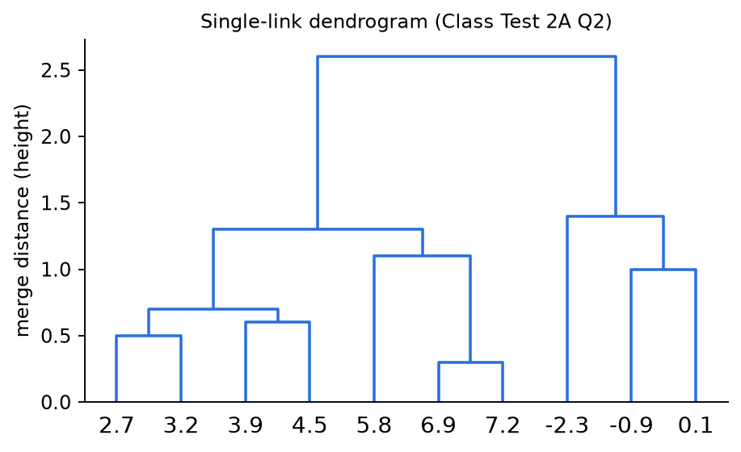
Figure 10.4 — Single-link dendrogram of the 1-D data; merge heights are the sorted gaps.
✅ Final answer
Merge heights (thresholds): 0.3, 0.5, 0.6, 0.7, 1.0, 1.1, 1.3, 1.4, 2.6. The top split (gap 2.6 between 0.1 and 2.7) gives 2 natural clusters {−2.3, −0.9, 0.1} and {2.7, …, 7.2} (any cut between 1.4 and 2.6). Cut between 1.3 and 1.4 → 3 clusters {−2.3}, {−0.9, 0.1}, {2.7 … 7.2}. Read other levels from the table.

⚠️ Edge cases & traps
- Step 4: the gap 3.2|3.9 = 0.7 joins two already-formed clusters — draw it as a join of two branches, not of single points.
- A cut at h with 1.1 < h < 1.3 gives 4 clusters: {−2.3}, {−0.9, 0.1}, {2.7…4.5}, {5.8, 6.9, 7.2}.
- The 1-D shortcut is only valid for single link. For complete link you must use the farthest pair (e.g. d({2.7,3.2},{3.9,4.5}) = 4.5 − 2.7 = 1.8).

🔄 How the examiner can twist it
- Ask for complete link on the same data (heights change; merge order may change).
- Ask "how many clusters at threshold 1.2?" → 4.
- Combine with CT2B: K-means with K = 2 on the same data gives the same 2 clusters as cutting at 2.0.

✍️ Make your own new question
Single link on 1, 3, 4, 9, 10, 15. (Gaps 2, 1, 5, 1, 5 → merges: 1 {3,4}; 1 {9,10}; 2 {1,3,4}; 5 {1,3,4}+{9,10} and 5 +15 (tie — both at height 5).)

📝 PYQ — Class Test 2 (Group A), Q3 [5]
Data (two features, six points): X1 = [−5, −3, −2, 1, 2, 5], X2 = [−3, −4, −1, 0, 3, 4].
A new orthonormal basis is proposed: W1 = [1/√2, 1/√2], W2 = [1/√2, −1/√2]. Check whether the dimension can be reduced using the principle of variance maximisation.

🧠 How to think
Project every point onto W1 and W2 (dot products), compute the variance along each new axis, and compare with the total variance. If one axis carries almost all the variance, drop the other.
Shortcut: √2 · z1 = x1 + x2 and √2 · z2 = x1 − x2, so work with integers first and divide by √2 at the end.

Solution — step by step
Step 1 — mean: x̄1 = (−5 − 3 − 2 + 1 + 2 + 5)/6 = −2/6 = −1/3, x̄2 = (−3 − 4 − 1 + 0 + 3 + 4)/6 = −1/6. So μ = (−1/3, −1/6).
Step 2 — projections z1 = W1ᵀx, z2 = W2ᵀx:
Point | (x1, x2) | x1 + x2 | z1 = (x1+x2)/√2 | x1 − x2 | z2 = (x1−x2)/√2
1 | (−5, −3) | −8 | −5.657 | −2 | −1.414
2 | (−3, −4) | −7 | −4.950 | 1 | 0.707
3 | (−2, −1) | −3 | −2.121 | −1 | −0.707
4 | (1, 0) | 1 | 0.707 | 1 | 0.707
5 | (2, 3) | 5 | 3.536 | −1 | −0.707
6 | (5, 4) | 9 | 6.364 | 1 | 0.707

Step 3 — variances (population, ÷6). For x1 + x2: mean = −3/6 = −0.5, mean of squares = (64 + 49 + 9 + 1 + 25 + 81)/6 = 229/6 = 38.167 → variance = 38.167 − 0.25 = 37.917 → divide by (√2)² = 2:
Var(z1) = 37.917 / 2 = 18.958
For x1 − x2: mean = −1/6, mean of squares = 9/6 = 1.5 → variance = 1.5 − 0.028 = 1.472 → ÷2:
Var(z2) = 1.472 / 2 = 0.736
Step 4 — total variance check: Var(x1) = 68/6 − 1/9 = 11.222, Var(x2) = 51/6 − 1/36 = 8.472 → total = 19.694 = 18.958 + 0.736 ✓ (an orthonormal rotation preserves total variance).
fraction kept by W1 = 18.958 / 19.694 = 0.963 = 96.3%
Step 5 — decide: W2 carries only 3.7% of the variance → drop W2 and represent each point by the single number z1.
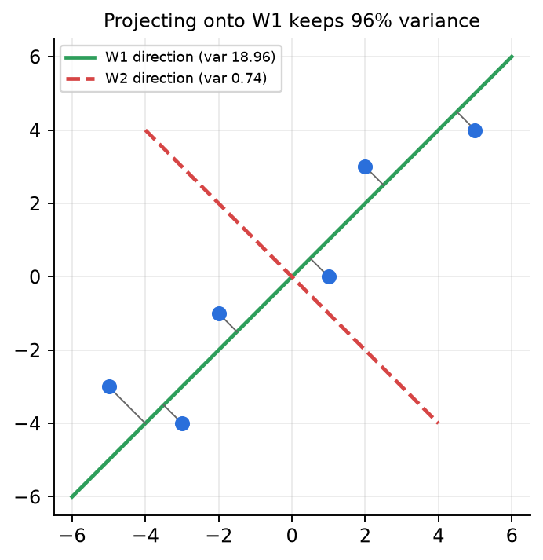
Figure 11.1 — The six points hug the W1 line (green); the spread along W2 (red, dashed) is tiny.
✅ Final answer
Yes, the data can be reduced from 2-D to 1-D: along W1 the variance is 18.958, along W2 only 0.736. W1 keeps 96.3% of the total variance (19.694), so keep z1 = (x1 + x2)/√2 and drop W2.

⚠️ Edge cases & traps
- Using sample variance (÷5) gives 22.75 and 0.883 — the ratio 96.3% is the same; just be consistent.
- W1 is not exactly PC1. The covariance is [[11.222, 9.111], [9.111, 8.472]] with eigenvalues 19.06 and 0.63; the true PC1 is at ≈ 40.7° instead of 45°. W1 is very close, so its variance 18.958 is just below the maximum 19.06. Nobody can beat λ₁.
- Centre before projecting if you want centred z-values; the variance is the same either way (subtracting a constant does not change variance).
- First check that the basis is orthonormal: W1·W2 = 1/2 − 1/2 = 0 and ‖W1‖ = ‖W2‖ = 1.

🔄 How the examiner can twist it
- "Find the true principal components" → eigen-decompose the covariance (λ = 19.06, 0.63).
- Give a non-orthonormal basis (e.g. [1, 1]) → you must normalise first or the variance is inflated by ‖w‖².
- Ask for the reconstruction of point 1 from z1 only: x̂ = μ + W1(z1 − W1ᵀμ).

✍️ Make your own new question
Points (2, 2), (−2, −2), (1, −1), (−1, 1). Variance along W1 and W2? (Mean 0. x1 + x2 = 4, −4, 0, 0 → Var(z1) = (16 + 16)/4/2 = 4; x1 − x2 = 0, 0, 2, −2 → Var(z2) = 8/4/2 = 1; W1 keeps 80%.)

Class Test 2 (Group B) — 7 Apr 2026
Full marks 15
📝 PYQ — Class Test 2 (Group B), Q1 — K-means on 1-D data, K = 2 [4]
Data: −2.3, −0.9, 0.1, 2.7, 3.2, 3.9, 4.5, 5.8, 6.9, 7.2. Run K-means with K = 2 taking the first two points (−2.3 and −0.9) as the initial centres. Show each iteration until convergence.

🧠 How to think
In 1-D, "nearest centre" = which side of the midpoint between the two centres a point lies. Compute the midpoint once per iteration instead of 20 distances.

Solution — step by step
Iteration 1: centres m₁ = −2.3, m₂ = −0.9; midpoint = −1.6. Only −2.3 is left of −1.6.
C₁ = {−2.3} ⇒ m₁ = −2.3 ; C₂ = {−0.9, 0.1, 2.7, 3.2, 3.9, 4.5, 5.8, 6.9, 7.2} ⇒ m₂ = 33.4 / 9 = 3.7111
Iteration 2: midpoint = (−2.3 + 3.7111)/2 = 0.7056.
x | d to m₁ = −2.3 | d to m₂ = 3.711 | Cluster
−0.9 | 1.4 | 4.611 | 1
0.1 | 2.4 | 3.611 | 1
2.7 | 5.0 | 1.011 | 2
3.2 … 7.2 | larger | smaller | 2

C₁ = {−2.3, −0.9, 0.1} ⇒ m₁ = −3.1/3 = −1.0333 ; C₂ = {2.7, 3.2, 3.9, 4.5, 5.8, 6.9, 7.2} ⇒ m₂ = 34.2/7 = 4.8857
Iteration 3: midpoint = (−1.0333 + 4.8857)/2 = 1.926 → 0.1 stays in C₁, 2.7 stays in C₂ → no change → converged.
✅ Final answer
Final clusters {−2.3, −0.9, 0.1} with centre −1.0333 and {2.7, 3.2, 3.9, 4.5, 5.8, 6.9, 7.2} with centre 4.8857 (converged at iteration 3).

⚠️ Edge cases & traps
- Bad initialisation (both centres at the far left) makes iteration 1 very unbalanced (1 vs 9) — K-means still recovers here, but it shows why K-means++ is used.
- Sum check: total of all 10 points = 31.1; 31.1 − (−2.3) = 33.4 ✔.
- Keep 4 decimals — these centres are re-used in the GMM question (CT2B Q2).

🔄 How the examiner can twist it
- Initial centres = last two points (6.9, 7.2) → mirror-image behaviour.
- K = 3 with initial centres −2.3, 3.2, 7.2.
- Ask for WCSS at convergence: C₁: 2.9067, C₂: 18.9886 → J = 21.895.

✍️ Make your own new question
Data 1, 2, 3, 10, 11, 12, 30, K = 2, initial centres 1 and 2. (It 1: {1} and {2,3,10,11,12,30} → 1, 11.33. It 2: {1,2,3} and {10,11,12,30} → 2, 15.75. It 3: no change. Note how the outlier 30 drags centre 2 to 15.75.)

📝 PYQ — Class Test 2 (Group B), Q2 — Initialise a GMM from K-means and compute responsibilities [4]
Using the two clusters obtained in Q1, initialise a 2-component 1-D GMM (mixing weights, means, variances) and compute the responsibility γ(z₁) of component 1 for every point.

🧠 How to think
Initialise: π = fraction of points in the cluster, μ = cluster mean, σ² = cluster variance. Then E-step: γ₁ = π₁N₁ / (π₁N₁ + π₂N₂) for each point. Do one point fully, then tabulate.

Solution — step by step
Initial parameters:
π₁ = 3/10 = 0.3 , μ₁ = −1.0333 , σ₁² = [(−1.2667)² + (0.1333)² + (1.1333)²]/3 = 2.9067/3 = 0.9689
π₂ = 7/10 = 0.7 , μ₂ = 4.8857 , σ₂² = 18.9886/7 = 2.7127
(Using the sample variance with n − 1 instead: σ₁² = 1.4533, σ₂² = 3.1648 — say which you use; below we use the population/MLE version that matches the M-step.)
Worked point x = 0.1:
N₁ = (1/√(2π·0.9689)) exp(−(0.1 + 1.0333)²/(2·0.9689)) = 0.4053 × e^{−0.6628} = 0.4053 × 0.5154 = 0.2089
π₁N₁ = 0.3 × 0.2089 = 0.06266
N₂ = (1/√(2π·2.7127)) exp(−(0.1 − 4.8857)²/(2·2.7127)) = 0.2422 × e^{−4.2215} = 0.2422 × 0.01468 = 0.003556
π₂N₂ = 0.7 × 0.003556 = 0.00249
γ(z₁) = 0.06266 / (0.06266 + 0.00249) = 0.9618 , γ(z₂) = 0.0382
x | −2.3 | −0.9 | 0.1 | 2.7 | 3.2 | 3.9 | 4.5 | 5.8 | 6.9 | 7.2
γ(z₁) | 0.9998 | 0.9971 | 0.9618 | 0.0013 | 0.0001 | ≈0 | ≈0 | ≈0 | ≈0 | ≈0
γ(z₂) | 0.0002 | 0.0029 | 0.0382 | 0.9987 | 0.9999 | ≈1 | ≈1 | ≈1 | ≈1 | ≈1

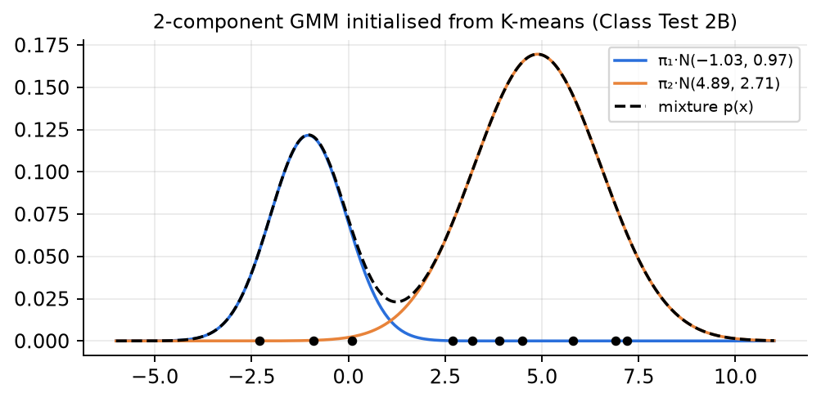
Figure 10.5 — The two weighted Gaussians π₁N₁ and π₂N₂ and the resulting responsibilities.
(Extra) one M-step with these γ: N₁ = Σγ₁ = 2.960 → μ₁ = −1.046, σ₁² = 0.972, π₁ = 0.296 — barely moves because the clusters are well separated.
✅ Final answer
π₁ = 0.3, μ₁ = −1.0333, σ₁² = 0.9689; π₂ = 0.7, μ₂ = 4.8857, σ₂² = 2.7127. γ(z₁) = 0.9998, 0.9971, 0.9618, 0.0013, 0.0001, and ≈ 0 for 3.9 … 7.2 (γ(z₂) = 1 − γ(z₁)). Point 0.1 is the most "uncertain" (96% / 4%).

⚠️ Edge cases & traps
- Forgetting π in the E-step (using only N₁ / (N₁ + N₂)) is the most common mistake.
- Use σ² inside the exponent and √(2πσ²) outside — do not mix σ and σ².
- Very small numbers: keep 3–4 significant figures, not decimal places, or γ will come out 0/0.
- Responsibilities of each point must sum to 1 across components (check!). They do NOT need to sum to 1 across points.

🔄 How the examiner can twist it
- Ask for the full M-step and the new log-likelihood.
- Give equal π (0.5, 0.5) → γ changes for borderline points only.
- Ask the hard labels (argmax γ) → identical to K-means clusters here.

✍️ Make your own new question
Same parameters, compute γ(z₁) for x = 1.0. (π₁N₁ = 0.3 × 0.4053 × e^{−(2.0333)²/1.9378} = 0.3 × 0.4053 × 0.1184 = 0.01440; π₂N₂ = 0.7 × 0.2422 × e^{−(3.8857)²/5.4254} = 0.7 × 0.2422 × 0.0619 = 0.01049 → γ(z₁) = 0.01440/0.02489 ≈ 0.58.)

📝 PYQ — Class Test 2 (Set B), Q3 — Forward + backward pass with f(x) = x²/10 [2+5]
Network: inputs X1, X2 → hidden layer 1 (Z11, Z12) → hidden layer 2 (Z21, Z22) → output Y. Weights: X1→Z11 = 1, X1→Z12 = −2, X2→Z11 = 2, X2→Z12 = −1; Z11→Z21 = 0, Z11→Z22 = 1, Z12→Z21 = 3, Z12→Z22 = 0; Z21→Y = 1, Z22→Y = −1. Every neuron (including Y) uses f(x) = x²/10; no biases.
A) Compute the output for input X = [3, 4] [2]. B) With target 60, perform one backpropagation step and give the updated weights [5].

🧠 How to think
Forward: for each neuron, in = Σ weight × (output of previous neuron), out = in²/10. Backward: f′(x) = x/5, so every δ = (incoming error) × (in/5). Choose L = ½(Y − t)² and a learning rate; because the activation squares values, the numbers get huge — pick a tiny η.

Solution — step by step
A) Forward pass
Neuron | Net input (in) | Output = in²/10 | f′(in) = in/5
Z11 | 1(3) + 2(4) = 11 | 12.1 | 2.2
Z12 | −2(3) − 1(4) = −10 | 10 | −2
Z21 | 0(12.1) + 3(10) = 30 | 90 | 6
Z22 | 1(12.1) + 0(10) = 12.1 | 14.641 | 2.42
Y | 1(90) − 1(14.641) = 75.359 | 567.898 | 15.072

B) Backward pass, loss L = ½(Y − 60)²:
∂L/∂Y = Y − t = 567.898 − 60 = 507.898
δ_{Y} = 507.898 × f′(75.359) = 507.898 × 15.072 = 7654.94
Neuron | Error signal δ = (Σ w·δ_{next}) × f′(in) | δ
Y | 507.898 × 15.072 | 7,654.94
Z21 | (1 × 7654.94) × 6 | 45,929.6
Z22 | (−1 × 7654.94) × 2.42 | −18,524.9
Z11 | (0 × 45,929.6 + 1 × (−18,524.9)) × 2.2 | −40,754.9
Z12 | (3 × 45,929.6 + 0 × (−18,524.9)) × (−2) = 137,788.8 × (−2) | −275,577.7

Gradients ∂L/∂w = δ(target neuron) × output(source neuron), then update w ← w − η·grad with η = 10⁻⁶:
Weight | Old w | Gradient | New w
Z21 → Y | 1 | 7654.94 × 90 = 688,944 | 1 − 0.689 = 0.311
Z22 → Y | −1 | 7654.94 × 14.641 = 112,076 | −1 − 0.112 = −1.112
Z11 → Z21 | 0 | 45,929.6 × 12.1 = 555,748 | −0.556
Z12 → Z21 | 3 | 45,929.6 × 10 = 459,296 | 2.541
Z11 → Z22 | 1 | −18,524.9 × 12.1 = −224,152 | 1.224
Z12 → Z22 | 0 | −18,524.9 × 10 = −185,249 | 0.185
X1 → Z11 | 1 | −40,754.9 × 3 = −122,265 | 1.122
X2 → Z11 | 2 | −40,754.9 × 4 = −163,020 | 2.163
X1 → Z12 | −2 | −275,577.7 × 3 = −826,733 | −1.173
X2 → Z12 | −1 | −275,577.7 × 4 = −1,102,311 | 0.102

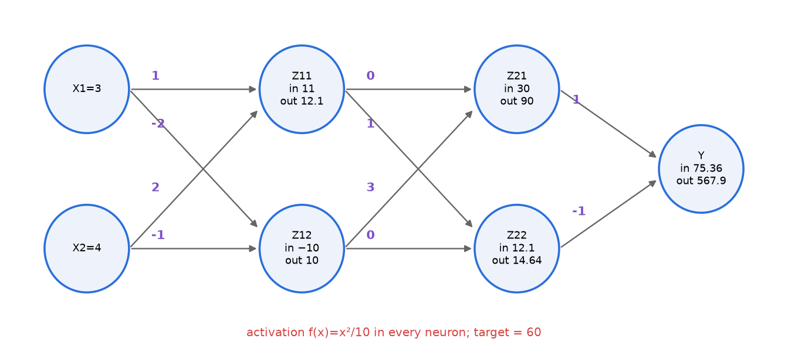
Figure 12.3 — CT-2B network with forward-pass values.
✅ Final answer
A) Y = 567.898 (hidden outputs 12.1, 10, 90, 14.641).
B) With L = ½(Y − 60)² and η = 10⁻⁶: W(Z21→Y, Z22→Y) = (0.311, −1.112); W(Z11→Z21, Z12→Z21, Z11→Z22, Z12→Z22) = (−0.556, 2.541, 1.224, 0.185); W(X1→Z11, X2→Z11, X1→Z12, X2→Z12) = (1.122, 2.163, −1.173, 0.102).

⚠️ Edge cases & traps
- State the loss convention. With L = (Y − t)² (no ½) every gradient doubles; with the ½ they are as above.
- x² activation explodes: gradients are ~10⁵–10⁶. With η = 0.01 or 0.1 the weights jump by thousands — the answer is "correct" arithmetically but training diverges. Say so and pick a small η; any η is acceptable if stated.
- f(−10) = +10 (squaring kills the sign) but f′(−10) = −2 — keep the sign of the derivative.
- A weight of 0 (Z11→Z21) still gets a non-zero gradient — it is not "absent", just currently zero.
- Use the old weights when back-propagating (e.g., 3 on Z12→Z21 when computing δ for Z12), then update everything together.

🔄 How the examiner can twist it
- Change the activation to ReLU or sigmoid (then δs are small and η = 0.1 is fine).
- Add biases (their gradient = δ of the neuron).
- Ask only for ∂L/∂w for one specific weight (e.g., X2→Z12) — trace the single chain: (Y − t)·f′(aY)·(1)·f′(a21)·(3)·f′(a12)·x₂.
- Ask for the new output after the update to check that the loss dropped.

✍️ Make your own new question
Same network, input X = [1, 1], target 0. Find Y and ∂L/∂w(Z21→Y). (a11 = 3 → Z11 = 0.9; a12 = −3 → Z12 = 0.9; a21 = 2.7 → Z21 = 0.729; a22 = 0.9 → Z22 = 0.081; aY = 0.648 → Y = 0.042; δY = 0.042 × 0.1296 = 0.00544; grad = 0.00544 × 0.729 = 0.00397.)

Class Test 2: SET 1 — Spring 2026
1 hr • Full marks 30 • Answer any three
📝 PYQ — Class Test 2 (Spring 2026), SET 1, Q1 — one K-means step, linkage definitions, single link [10]
(a) 1-D data {1, 2, 8, 9, 10}, K = 2, initial μ₁ = 1, μ₂ = 2. Perform ONE iteration of K-means (assignment + update). [5]
(b) Define single, complete and average linkage. [3]
(c) Points A = 1, B = 2, C = 6, D = 11. Perform single-link agglomerative clustering; give merge order and heights. [2]

🧠 How to think
(a) distance table + mean. (b) formulas + one-line meaning each. (c) 1-D → gaps 1, 4, 5.

Solution — step by step
(a)
x | |x − μ₁| (μ₁ = 1) | |x − μ₂| (μ₂ = 2) | Cluster
1 | 0 | 1 | 1
2 | 1 | 0 | 2
8 | 7 | 6 | 2
9 | 8 | 7 | 2
10 | 9 | 8 | 2

μ₁ = 1/1 = 1 , μ₂ = (2 + 8 + 9 + 10)/4 = 29/4 = 7.25
(b) For clusters A and B:
- Single link: d(A,B) = min_{a∈A, b∈B} d(a,b) — distance of the closest pair (tends to chain).
- Complete link: d(A,B) = max_{a∈A, b∈B} d(a,b) — distance of the farthest pair (compact clusters).
- Average link: d(A,B) = (1/(|A||B|)) Σ_{a∈A} Σ_{b∈B} d(a,b) — mean of all pairwise distances (compromise).
(c) Gaps: A–B = 1, B–C = 4, C–D = 5.
Step | Merge | Height
1 | A + B | 1
2 | {A,B} + C (min(|6−1|, |6−2|) = 4) | 4
3 | {A,B,C} + D (min distance = |11−6| = 5) | 5

✅ Final answer
(a) After one iteration: C₁ = {1}, C₂ = {2, 8, 9, 10}; μ₁ = 1, μ₂ = 7.25.
(b) Single = min pair distance; complete = max pair distance; average = mean pair distance.
(c) {A,B} @ 1 → {A,B,C} @ 4 → {A,B,C,D} @ 5.

⚠️ Edge cases & traps
- (a) asks for ONE iteration only — do not continue (though the next iteration would move 2 to C₁: {1,2} → 1.5 and {8,9,10} → 9, then converge).
- The poor initial centres (1 and 2 inside the same natural group) are exactly the K-means++ motivation.
- (c) complete link would give a tie at step 2: d({A,B},C) = 5 and d(C,D) = 5 — state a tie-break.

🔄 How the examiner can twist it
- "Perform K-means until convergence" → final {1, 2}, {8, 9, 10}; μ = 1.5, 9.
- (c) with complete or average link.
- Ask the WCSS before and after the iteration.

✍️ Make your own new question
{2, 4, 10, 12, 3, 20, 30, 11, 25}, K = 2, μ₁ = 3, μ₂ = 4. One iteration? (midpoint 3.5: {2, 3} → μ₁ = 2.5; {4, 10, 11, 12, 20, 25, 30} → μ₂ = 112/7 = 16.)

📝 PYQ — Class Test 2 (Spring 2026), SET 1, Q2 (a)/(b) — Hard vs soft clustering; EM for GMM
(a) Differentiate hard and soft clustering with an example. (b) Write the E-step and M-step of the EM algorithm for a Gaussian Mixture Model.

🧠 How to think
(a) compare in a table + example. (b) write formulas with symbol meanings; mention initialisation and stopping.

Solution — step by step
(a)
 | Hard clustering | Soft clustering
Membership | each point in exactly ONE cluster (0/1) | each point has a degree/probability for EVERY cluster (sums to 1)
Algorithms | K-means, hierarchical, DBSCAN | GMM (EM), fuzzy C-means
Border points | forced to one side | e.g. 55% / 45% — uncertainty is visible
Example | a customer is "budget" segment | a customer is 70% "budget", 30% "premium"

(b) Initialise π_{k}, μ_{k}, σ_{k}² (randomly or from K-means). Repeat:
E-step: γ_{ik} = π_{k} N(x_{i} | μ_{k}, σ_{k}²) / Σ_{j} π_{j} N(x_{i} | μ_{j}, σ_{j}²)
M-step: N_{k} = Σ_{i} γ_{ik} , μ_{k} = (1/N_{k}) Σ_{i} γ_{ik} x_{i} , σ_{k}² = (1/N_{k}) Σ_{i} γ_{ik}(x_{i} − μ_{k})² , π_{k} = N_{k}/N
Stop when the log-likelihood Σ_{i} ln Σ_{k} π_{k} N(x_{i} | μ_{k}, σ_{k}²) changes by less than a tolerance.
✅ Final answer
(a) Hard: one cluster per point (K-means). Soft: a probability for each cluster (GMM responsibilities). (b) E-step computes responsibilities γ_{ik} with the current parameters; M-step re-estimates π, μ, σ² as γ-weighted fractions, means and variances; iterate until the likelihood converges.

⚠️ Edge cases & traps
- E-step does NOT change parameters; M-step does NOT change γ — say this clearly.
- Mention the likelihood is monotonically non-decreasing but only a local maximum is guaranteed.
- Singularity: if a component sits on one point, σ² → 0 and likelihood → ∞ — fix with a small floor on variance.

🔄 How the examiner can twist it
- "Show that K-means is a special case of GMM-EM" → use the σ → 0 derivation in 10.4.
- "Why is EM needed?" → the log of a sum has no closed-form maximiser; the latent labels z make it easy if known.

✍️ Make your own new question
Write the M-step in d dimensions. (μ_{k} as before; Σ_{k} = (1/N_{k}) Σ_{i} γ_{ik}(x_{i} − μ_{k})(x_{i} − μ_{k})ᵀ; π_{k} = N_{k}/N.)

📝 PYQ — Class Test 2 (Set 1) Q2(c) and (Set 2) Q2(b) — Conv + pool sizes and params [5]
Set 1: Input 32×32×3. Conv layer with 6 filters of size 5×5, stride 1, padding 0, followed by 2×2 max-pooling with stride 2. Find the output size after each layer and the number of trainable parameters.
Set 2: Same network but input 24×24×3.

🧠 How to think
Use O = ⌊(W − F + 2P)/S⌋ + 1 for conv and pool. Each filter is 5×5×3 (depth = input channels). Pooling has no parameters.

Solution — step by step
Set 1:
Conv: O = (32 − 5 + 0)/1 + 1 = 28 ⇒ 28 × 28 × 6
Pool: O = (28 − 2)/2 + 1 = 14 ⇒ 14 × 14 × 6
Params = (5·5·3 + 1)·6 = 76·6 = 456 (450 weights + 6 biases)
Set 2:
Conv: O = (24 − 5)/1 + 1 = 20 ⇒ 20 × 20 × 6
Pool: O = (20 − 2)/2 + 1 = 10 ⇒ 10 × 10 × 6
Params = (5·5·3 + 1)·6 = 456 (same as Set 1!)
✅ Final answer
Set 1: conv → 28×28×6, pool → 14×14×6, params = 456. Set 2: conv → 20×20×6, pool → 10×10×6, params = 456.

⚠️ Edge cases & traps
- The parameter count is the SAME for both sets — it never depends on image size (weight sharing). This is the whole point of the question.
- Forgetting the depth 3 gives 5·5·6 + 6 = 156 — wrong.
- Forgetting biases gives 450 — lose a mark.
- Pooling keeps the depth (6), it only halves H and W.

🔄 How the examiner can twist it
- Add a second conv layer (e.g., 16 filters 5×5 on 14×14×6 → 10×10×16, params (5·5·6 + 1)·16 = 2,416) — this is LeNet-5.
- Use "same" padding (P = 2) → conv output stays 32×32×6.
- Ask for the number of multiplications: 28·28·6 outputs × 75 multiplications each = 352,800.

✍️ Make your own new question
Input 64×64×3, 10 filters of 3×3, stride 1, padding 1, then 2×2 max-pool stride 2. Sizes and params? (Conv: (64 − 3 + 2)/1 + 1 = 64 → 64×64×10; pool → 32×32×10; params (3·3·3 + 1)·10 = 280.)

📝 PYQ — Class Test 2 (Set 1), Q3 — PCA theory [10]
(a) State the objective of PCA and give two reasons why dimensionality reduction is useful. (b) Why should data be standardised before applying PCA? (c) List the four main steps of PCA.

🧠 How to think
Pure theory — write crisp points with one formula each. Examiners look for the keywords "maximum variance", "orthogonal", "eigenvector of covariance", "scale / units".

Solution — step by step
(a) Objective: find a new set of orthogonal directions (principal components) such that the projected data has maximum variance along the first, maximum remaining variance along the second, etc.: max vᵀSv s.t. vᵀv = 1 → Sv = λv. Equivalently, find the k-dimensional subspace with minimum reconstruction error.
Reasons to reduce dimensions (any two): (1) avoid the curse of dimensionality / overfitting; (2) faster training and less storage; (3) visualisation in 2-D/3-D; (4) removes noise and redundancy from correlated features.
(b) Standardise because PCA maximises variance and variance depends on units/scale. A feature measured in large units (e.g. income in rupees, variance ~10¹⁰) dominates a feature in small units (age in years) and PC1 just points along it, even if it is not more informative. Standardising (x − mean)/std gives every feature variance 1 so all features contribute fairly (PCA on the correlation matrix).
(c) Four steps:
- 1. Standardise / centre the data: x ← (x − μ)/σ (at least subtract μ).
- 2. Covariance matrix: S = (1/N) XᵀX.
- 3. Eigen-decomposition of S: eigenvalues λ and unit eigenvectors v; sort by decreasing λ.
- 4. Select top k eigenvectors (by explained variance) as W and project: z = Wᵀ(x − μ).
✅ Final answer
(a) Maximise the variance of the projected data using orthogonal directions (eigenvectors of the covariance matrix); reasons: fight curse of dimensionality/overfitting, speed/storage, visualisation, noise removal. (b) Variance is scale-dependent; large-unit features would dominate the PCs. (c) Standardise → covariance → eigen-decomposition (sort) → choose top k & project.

⚠️ Edge cases & traps
- Centring is ALWAYS needed; standardising is needed when units/scales differ. If all features already share a unit (e.g. pixel intensities) you may skip standardising.
- Don't write "PCA selects the most important features" — it creates new ones (extraction).

🔄 How the examiner can twist it
- "Give an example where PCA without standardisation fails" → height (cm) and weight (tonnes).
- "What is a scree plot?" → plot of eigenvalues (or % variance) vs component number; choose k at the elbow.

✍️ Make your own new question
Features: temperature in °C (variance 25) and pressure in Pa (variance 10⁶), uncorrelated. What is PC1 without and with standardisation? (Without: PC1 = pressure axis, explains ≈ 100%. With: S = I → both eigenvalues 1, no preferred direction.)

📝 PYQ — Class Test 2 (Set 1), Q4 — Perceptron, activation purpose, sigmoid vs ReLU [10]
(a) Draw a perceptron with two inputs and write its output equation. (b) What is the purpose of an activation function? Why must it be non-linear, and what happens if only linear activations are used? (c) Write the formulas and sketch sigmoid and ReLU. Give one advantage of ReLU over sigmoid. [10]

🧠 How to think
Pure theory — marks for a labelled diagram, the equation, the "collapse to linear" argument, and correct formulas + graph shapes. Use §12.1–12.3.

Solution — step by step
(a) Diagram: input nodes x₁, x₂ and a bias node "+1" → arrows labelled w₁, w₂, b → summation node Σ → activation box g → output ŷ.
z = w₁x₁ + w₂x₂ + b , ŷ = g(z) (perceptron: g = step → ŷ = 1 if z > 0 else 0)
The decision boundary w₁x₁ + w₂x₂ + b = 0 is a straight line in the (x₁, x₂) plane.
(b) Purpose: (i) introduce non-linearity so the network can model curved boundaries and complex functions; (ii) squash / gate the output into a useful range (probability for sigmoid, sparse positive values for ReLU); (iii) be differentiable so backprop can compute gradients.
Only linear activations: W₂(W₁x) = (W₂W₁)x → any depth collapses to ONE linear layer → only linear boundaries (cannot solve XOR), depth is wasted.
(c)
 | Sigmoid | ReLU
Formula | σ(z) = 1/(1 + e^{−z}) | max(0, z)
Derivative | σ(z)(1 − σ(z)), max 0.25 | 1 (z > 0), 0 (z < 0)
Range | (0, 1) | [0, ∞)
Graph | S-shaped, 0.5 at z = 0, flat at both ends | flat 0 for z < 0, straight line of slope 1 for z > 0
Use | binary output probability | hidden layers (default)

Advantage of ReLU: its gradient is 1 for every z > 0 → no saturation / vanishing gradient, so deep networks train much faster; it is also cheap (a comparison, no exponential) and gives sparse activations. (Drawback: dying ReLU for z < 0 → Leaky ReLU.)
✅ Final answer
(a) ŷ = g(w₁x₁ + w₂x₂ + b) with the labelled diagram. (b) Activations add non-linearity; with only linear ones the network collapses to a single linear map. (c) σ(z) = 1/(1 + e^{−z}), ReLU = max(0, z); ReLU avoids vanishing gradients for z > 0 and is cheap to compute.

⚠️ Edge cases & traps
- Draw the bias — many students forget it and lose a mark.
- Draw the sigmoid crossing 0.5 at z = 0, with asymptotes at 0 and 1; ReLU has a kink at 0 (not differentiable there — in practice use 0 or 1).
- "ReLU never has vanishing gradient" is wrong — its gradient is 0 for z < 0 (dying ReLU).

🔄 How the examiner can twist it
- Ask for tanh too (range (−1, 1), zero-centred).
- Ask which activation to use in the output layer for regression (linear), binary (sigmoid), multi-class (softmax).
- Ask why a step function cannot be trained with backprop (gradient 0 everywhere).

✍️ Make your own new question
Show that tanh(z) = 2σ(2z) − 1. (2σ(2z) − 1 = 2/(1 + e^{−2z}) − 1 = (1 − e^{−2z})/(1 + e^{−2z}); multiply top and bottom by e^{z} → (e^{z} − e^{−z})/(e^{z} + e^{−z}) = tanh z.)

Class Test 2: SET 2 — Spring 2026
1 hr • Full marks 30 • Answer any three
📝 PYQ — Class Test 2 (Spring 2026), SET 2, Q1 — Elbow method, K-means++, dendrogram [10]
(a) Explain the elbow method for choosing K with a sketch. [3] (b) How does K-means++ choose the initial centroids and why is it better than random initialisation? [3] (c) What is a dendrogram? How is it used to obtain clusters? [4]

🧠 How to think
Pure theory — write definition + formula + sketch + one advantage/limitation for each part.

Solution — step by step
(a) Elbow method: run K-means for K = 1…K_{max}; compute WCSS(K) = Σ_{k} Σ_{x∈Cₖ} ‖x − μ_{k}‖²; plot WCSS vs K. WCSS always decreases with K, steeply while K is below the true number of groups (splitting a real group gives a big gain) and slowly after it (just splitting real clusters). The K at the "bend" (elbow) is chosen.
Sketch for (a): elbow at K = 3.
Limitation: the elbow is sometimes not sharp → use silhouette score or the gap statistic.
(b) K-means++: (1) pick the first centre uniformly at random; (2) for each point compute D(x) = distance to the nearest chosen centre; (3) pick the next centre with probability D(x)² / Σ D(x′)²; (4) repeat until K centres; then run normal K-means.
Why better: centres are spread across the data, so it rarely puts two centres in one true cluster → fewer iterations, lower final WCSS, less variation between runs; provably O(log K)-competitive with the optimum in expectation. Being random (not "always farthest point") keeps it robust to outliers.
(c) Dendrogram: a tree diagram produced by hierarchical clustering. Leaves = individual points; each internal join = a merge of two clusters; the height of the join = the linkage distance at which they merged. To get clusters: draw a horizontal cut at height h (or choose the h that gives K vertical lines) — every subtree below the cut is one cluster. A large vertical gap between successive merges suggests a natural number of clusters.
✅ Final answer
(a) Plot WCSS vs K, choose K at the elbow. (b) D²-weighted sampling spreads initial centres → better, faster, more stable results. (c) Merge-history tree with heights = distances; cut horizontally to obtain clusters.

⚠️ Edge cases & traps
- Do not say "choose the K with minimum WCSS" — that is always K = N.
- K-means++ only changes the initialisation; the iterations afterwards are ordinary Lloyd steps.
- The order of leaves on the x-axis of a dendrogram is not meaningful; only heights are.

🔄 How the examiner can twist it
- Compute K-means++ probabilities for a small example (see new question).
- Ask to compare the elbow with silhouette.

✍️ Make your own new question
Points 0, 1, 5, 10. First K-means++ centre = 0. Probabilities of choosing each point as the second centre? (D² = 0, 1, 25, 100; sum 126 → P = 0, 0.008, 0.198, 0.794.)

📝 PYQ — Class Test 2 (Spring 2026), SET 2, Q2 (a) — Single link from a 4×4 matrix [5]
d(A,B) = 1, d(A,C) = 6, d(A,D) = 10, d(B,C) = 5, d(B,D) = 9, d(C,D) = 4. Perform single-link clustering and draw the dendrogram. [5]

🧠 How to think
Find the minimum, merge, update rows with MIN, repeat.

Solution — step by step
 | A | B | C | D
A | 0 | 1 | 6 | 10
B | 1 | 0 | 5 | 9
C | 6 | 5 | 0 | 4
D | 10 | 9 | 4 | 0

Merge 1: {A,B} at 1. Update: d(AB, C) = min(6, 5) = 5; d(AB, D) = min(10, 9) = 9.
 | AB | C | D
AB | 0 | 5 | 9
C | 5 | 0 | 4
D | 9 | 4 | 0

Merge 2: {C,D} at 4. Update: d(AB, CD) = min(5, 9) = min(6, 10, 5, 9) = 5.
Merge 3: {A,B,C,D} at 5.
Dendrogram: A and B join at height 1; C and D join at height 4; the two branches join at height 5.
✅ Final answer
Merges: {A,B} @ 1, {C,D} @ 4, {A,B,C,D} @ 5.

⚠️ Edge cases & traps
- After merge 1 the minimum is 4 (C–D), not 5 (AB–C) — do not keep merging into the first cluster automatically.
- The final height is the smallest of the 4 cross distances (B–C = 5).

🔄 How the examiner can twist it
- Complete link: {A,B} @ 1, {C,D} @ 4, final @ max(6, 10, 5, 9) = 10.
- Average link: final @ (6 + 10 + 5 + 9)/4 = 7.5.

✍️ Make your own new question
Change d(C,D) to 6. Single link? ({A,B} @ 1; then min(d(AB,C) = 5, d(AB,D) = 9, d(C,D) = 6) = 5 → {A,B,C} @ 5; then D @ min(9, 6) = 6.)

📝 PYQ — Class Test 2 (Spring 2026), SET 2, Q2 (b) — Conv + pool sizes and params [5]
Input 24 × 24 × 3. Conv layer: 6 filters, 5 × 5, stride 1, padding 0. Max-pool 2 × 2, stride 2. (a) Output size after conv [2] (b) after pooling [1] (c) total parameters in the conv layer [2].

🧠 How to think
Output size = ⌊(W − F + 2P)/S⌋ + 1; depth = number of filters. Pooling halves H and W and keeps depth. Parameters = (F·F·C_in + 1)·(number of filters).

Solution — step by step
Conv: (24 − 5 + 0)/1 + 1 = 20 ⇒ 20 × 20 × 6
Pool: (20 − 2)/2 + 1 = 10 ⇒ 10 × 10 × 6
Params = (5·5·3 + 1) × 6 = 76 × 6 = 456
✅ Final answer
(a) 20 × 20 × 6 (b) 10 × 10 × 6 (c) 456 parameters (450 weights + 6 biases).

⚠️ Edge cases & traps
- Parameters do not depend on the 24 × 24 input size — same 456 as Set 1 (32 × 32 input).
- Pooling has no parameters.

🔄 How the examiner can twist it
- Padding 2 → conv output 24 × 24 × 6; stride 2 → 10 × 10 × 6.
- Ask for number of activations after pooling: 600.

✍️ Make your own new question
Input 28 × 28 × 1, 8 filters 3 × 3, stride 1, padding 1, then 2 × 2 max-pool. Sizes and params? (28×28×8 → 14×14×8; params 8·(9+1) = 80.)

📝 PYQ — Class Test 2 (Set 2), Q3 — Eigenvalues, explained variance, extraction vs selection [10]
(a) What do the eigenvalues of the covariance matrix represent in PCA? (b) A dataset with 5 features has eigenvalues 4.5, 3.0, 1.5, 0.7, 0.3. Compute the explained variance ratio of each PC and the number of PCs needed to retain at least 80% of the variance. (c) True or False: "PCA is a feature selection method." Justify.

🧠 How to think
(a) Recall vᵀSv = λ. (b) Divide each eigenvalue by the total, then take the running sum. (c) Selection keeps original features; PCA makes new ones.

Solution — step by step
(a) Each eigenvalue λ_{k} is the variance of the data along the k-th principal component (the projected variance vᵀSv = λ). Geometrically, the data ellipsoid has axes along the eigenvectors with lengths ∝ √λ_{k}. Sum of eigenvalues = total variance; λ = 0 means no spread in that direction.
(b) Total = 4.5 + 3.0 + 1.5 + 0.7 + 0.3 = 10.
PC | λ | Explained ratio | Cumulative
1 | 4.5 | 45% | 45%
2 | 3.0 | 30% | 75%
3 | 1.5 | 15% | 90% ≥ 80%
4 | 0.7 | 7% | 97%
5 | 0.3 | 3% | 100%

2 PCs give only 75% < 80%, 3 PCs give 90% → k = 3.
(c) False. PCA is feature extraction: every PC is a linear combination of ALL original features (z = vᵀx), so no original feature is removed. Feature selection (filter/wrapper/embedded, e.g. forward selection) keeps a subset of the original features.
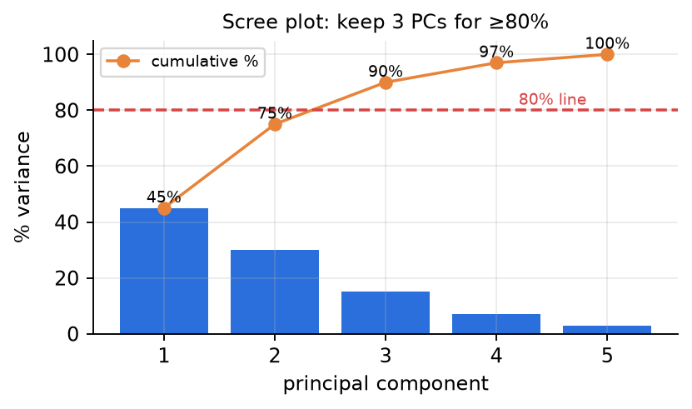
Figure 11.2 — Scree plot: bars = individual explained variance, line = cumulative; the 80% line is crossed at PC3.
✅ Final answer
(a) Variance of the data along each PC direction. (b) Ratios 45%, 30%, 15%, 7%, 3%; cumulative 45, 75, 90, 97, 100% → 3 PCs for ≥ 80%. (c) False — PCA builds new combined features (extraction), not a subset (selection).

⚠️ Edge cases & traps
- "At least 80%" → 75% is not enough; don't round up.
- If eigenvalues are not sorted in the question, sort them first.
- If the threshold were 90% exactly, 3 PCs (90%) still suffice because "at least" includes equality.

🔄 How the examiner can twist it
- Ask for 95% → 4 PCs (97%).
- Give the ratios and one eigenvalue and ask for the total variance (e.g. λ₁ = 4.5 is 45% → total 10).
- Ask for the reconstruction MSE when keeping 3 PCs → 0.7 + 0.3 = 1.0.

✍️ Make your own new question
Eigenvalues 6, 2, 1, 0.6, 0.4. How many PCs for ≥ 85%? (Total 10; cumulative 60, 80, 90% → 3 PCs.)

📝 PYQ — Class Test 2 (Set 2), Q4 — Neuron output and parameter counting [5+5]
(a) A neuron has inputs x₁ = 3, x₂ = −2, weights w₁ = 1, w₂ = 2 and bias b = −1. Compute its output with (i) ReLU and (ii) sigmoid activation. [5]
(b) A fully-connected network has 8 inputs, hidden layers of 10 and 6 neurons and 3 outputs (all with biases). How many trainable parameters? How does the count change if the second hidden layer is removed? [5]

🧠 How to think
(a) z first, then apply each g. (b) each layer contributes (n_{in} + 1) × n_{out}.

Solution — step by step
(a)
z = w₁x₁ + w₂x₂ + b = 1(3) + 2(−2) − 1 = 3 − 4 − 1 = −2
ReLU: max(0, −2) = 0
Sigmoid: σ(−2) = 1/(1 + e²) = 1/(1 + 7.389) = 1/8.389 ≈ 0.119
(b)
Layer | Weights n_{in} × n_{out} | Biases | Total
8 → 10 | 80 | 10 | 90
10 → 6 | 60 | 6 | 66
6 → 3 | 18 | 3 | 21
Sum | 158 | 19 | 177

Remove the 6-unit layer → 8 → 10 → 3: (8+1)·10 + (10+1)·3 = 90 + 33 = 123 parameters.
Change: 177 − 123 = 54 fewer parameters.
✅ Final answer
(a) z = −2 → ReLU output 0, sigmoid output ≈ 0.119. (b) 177 parameters; without the second hidden layer 123 (a decrease of 54).

⚠️ Edge cases & traps
- Don't forget biases: without them the count would be 80 + 60 + 18 = 158.
- The input layer has no parameters — it only holds x.
- σ(−2) uses e⁺² in the denominator: 1/(1 + e^{−z}) with z = −2.
- Removing a layer is not "subtract 66": the 10 → 3 layer is new (33 params) and both 66 and 21 disappear: −66 − 21 + 33 = −54.

🔄 How the examiner can twist it
- Ask for tanh(−2) = −0.964.
- Ask for parameters of a CNN layer instead (filters: (F·F·C_{in} + 1)·C_{out}).
- Ask how many multiplications one forward pass needs (= number of weights = 158).

✍️ Make your own new question
A network 784 → 128 → 64 → 10. Count parameters. (785·128 + 129·64 + 65·10 = 100,480 + 8,256 + 650 = 109,386.)

End-Spring Semester Examination — 2025-26 (28.04.2026)
AI20001 • 3 hrs • Full marks 50
📝 PYQ — End-sem Spring 2026, Q1 (a) and (b) — Perceptron & margin [6]
Points: ID1 (1, 4, +1), ID2 (−2, 1, +1), ID3 (−3, −7, −1), ID4 (−7, −5, −1). a) Starting from Y = sign(X1 − X2), use the perceptron to find a separating classifier. [3]
b) Adjust the features of one or two observations to increase the margin; show the perceptron converges faster from the same initialisation. [3]

🧠 How to think
(a) standard perceptron with w = (1, −1), b = 0. (b) Link to the convergence theorem: mistakes ≤ (R/γ)². A bigger gap between classes → fewer mistakes. The troublesome point is ID2 (−2, 1): it lies close to where the line wants to go. Move it further from the negatives.

Solution — step by step
(a) Pass 1:
Point | f = wᵀx + b | y·f | New w, b
ID1 (1,4), +1 | 1 − 4 + 0 = −3 | −3 ✗ | w = (2, 3), b = 1
ID2 (−2,1), +1 | −4 + 3 + 1 = 0 | 0 ✗ | w = (0, 4), b = 2
ID3 (−3,−7), −1 | 0 − 28 + 2 = −26 | 26 ✔ | —
ID4 (−7,−5), −1 | 0 − 20 + 2 = −18 | 18 ✔ | —

Pass 2: f = 18, 6, −26, −18 → all correct → converged after 2 updates: ŷ = sign(4X2 + 2), i.e. the line X2 = −0.5.
(b) Move ID2 from (−2, 1) to (−2, 4) (further from the negative class). Pass 1: ID1 wrong (f = −3) → w = (2, 3), b = 1; ID2: f = −4 + 12 + 1 = 9 ✔; ID3: −26 ✔; ID4: −28 ✔. Pass 2: no mistakes. Only 1 update instead of 2.
✅ Final answer
(a) Final classifier sign(4X2 + 2) (or equivalently sign(2X2 + 1)) after 2 updates. (b) Moving ID2 to (−2, 4) (bigger margin) → converges after only 1 update — consistent with the bound mistakes ≤ (R/γ)².

⚠️ Edge cases & traps
- A score of exactly 0 (ID2 in pass 1) is a mistake.
- In (b) you must keep the SAME initialisation and order — otherwise the comparison is unfair.
- Moving a point further away also increases R; the claim is about the ratio R/γ. Choosing a move that increases γ a lot (like ours) is safe.

🔄 How the examiner can twist it
- Ask to move a point to make the data NON-separable and describe what happens (perceptron never converges, cycles forever).
- Ask for the SVM line instead (max-margin) for the same points.

✍️ Make your own new question
Points (2,2,+1), (0,1,+1), (−1,−1,−1), (1,−2,−1); start w = (1,−1), b = 0. Run the perceptron. Then move (0,1) to (0,3) and compare the number of updates.

📝 PYQ — End-sem Spring 2026, Q1 (c) — RBF kernel SVM prediction [4]
Support vectors: (1, 4, +1, α=0.3), (−2, 1, +1, α=0.8), (6, −7, −1, α=0.5), (−7, −5, −1, α=0.6). RBF kernel K(x, x′) = exp(−‖x − x′‖²/2), b = 0. Classify the test point (2, 5). [4]

🧠 How to think
Kernel prediction: f(x) = Σ αᵢyᵢK(xᵢ, x) + b. Compute the squared distance from the test point to each SV → kernel value → weight by αᵢyᵢ → sum → sign.

Solution — step by step
SV | αᵢyᵢ | ‖xᵢ − x‖² | K = e^{−d²/2} | αᵢyᵢK
(1, 4) | +0.3 | 1 + 1 = 2 | e⁻¹ = 0.3679 | +0.1104
(−2, 1) | +0.8 | 16 + 16 = 32 | e⁻¹⁶ = 1.1 × 10⁻⁷ | +9.0 × 10⁻⁸
(6, −7) | −0.5 | 16 + 144 = 160 | e⁻⁸⁰ ≈ 1.8 × 10⁻³⁵ | ≈ 0
(−7, −5) | −0.6 | 81 + 100 = 181 | e^{−90.5} ≈ 5 × 10⁻⁴⁰ | ≈ 0

f(2, 5) = 0.1104 + 0.00000009 − 0 − 0 + 0 = 0.110 > 0
✅ Final answer
f(2, 5) ≈ 0.110 > 0 → class +1. The nearest support vector (1, 4) dominates because the RBF kernel decays exponentially with distance.

⚠️ Edge cases & traps
- The RBF kernel is a SIMILARITY: close points → K ≈ 1, far points → K ≈ 0. With γ = ½ points further than ~3 units barely matter.
- Check Σαᵢyᵢ = 0.3 + 0.8 − 0.5 − 0.6 = 0 ✔ (a quick sanity check examiners like).
- Use SQUARED distance in the exponent.

🔄 How the examiner can twist it
- Test point far from all SVs, e.g., (20, 20): all K ≈ 0 → f ≈ b = 0 → undecided; shows the role of b and γ.
- Change the kernel to linear: f = Σαᵢyᵢxᵢᵀx = 0.3(22) + 0.8(1) − 0.5(−23) − 0.6(−39) = 6.6 + 0.8 + 11.5 + 23.4 = 42.3 → +1.
- Change γ to 2 → K for (1,4) = e⁻⁴ = 0.018.

✍️ Make your own new question
Same SVs, test point (−4, −4). Compute f with the RBF kernel. (d² to (−7,−5) = 9 + 1 = 10 → K = e⁻⁵ = 0.0067 → −0.6 × 0.0067 = −0.0040; (−2,1): 4+25 = 29 → e^{−14.5} ≈ 5×10⁻⁷ → f ≈ −0.004 → class −1.)

📝 PYQ — End-sem Spring 2026, Q2 (a) — Gaussian Naïve Bayes posterior [5]
Observation X = [1, −1]. P(A) = 0.6. Class A: X1 ~ N(0, 1), X2 ~ N(0, 4). Class B: X1 ~ N(2, 8), X2 ~ N(−2, 8). Under Naïve Bayes, find P(A | X). [5]

🧠 How to think
Per class: multiply the two 1-D Gaussian pdfs (naïve assumption) and the prior; normalise. Careful: the second parameter is the VARIANCE σ², so use √(2πσ²).

Solution — step by step
N(x; μ, σ²) = (1/√(2πσ²)) · exp(−(x − μ)²/(2σ²))
Term | Computation | Value
P(X1=1 | A) | (1/√(2π)) e^{−1/2} = 0.3989 × 0.6065 | 0.2420
P(X2=−1 | A) | (1/√(8π)) e^{−1/8} = 0.1995 × 0.8825 | 0.1760
P(X1=1 | B) | (1/√(16π)) e^{−(1−2)²/16} = 0.1410 × 0.9394 | 0.1325
P(X2=−1 | B) | (1/√(16π)) e^{−(−1+2)²/16} = 0.1410 × 0.9394 | 0.1325

Score(A) = 0.6 × 0.2420 × 0.1760 = 0.02556
Score(B) = 0.4 × 0.1325 × 0.1325 = 0.00702
P(A | X) = 0.02556 / (0.02556 + 0.00702) = 0.784
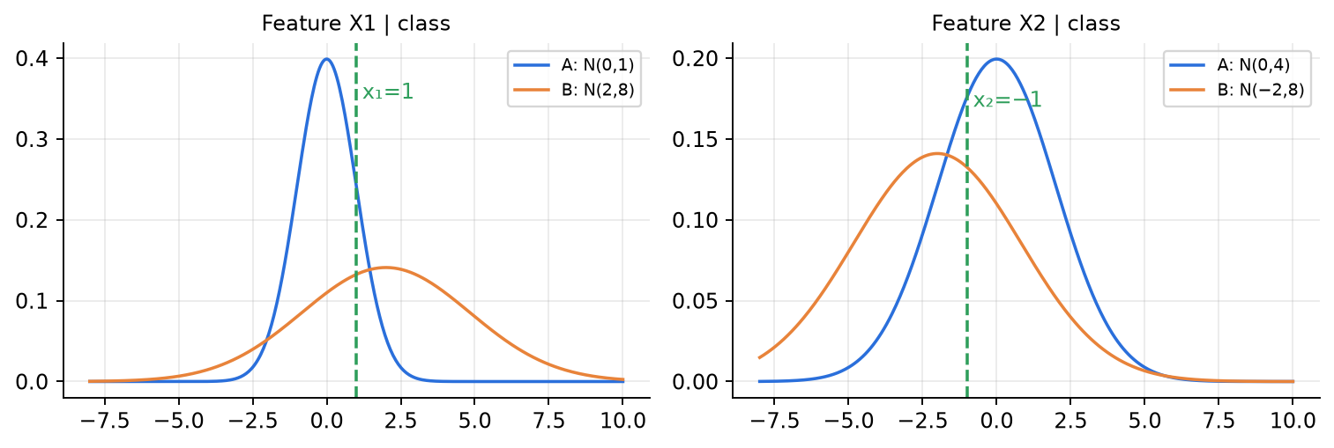
✅ Final answer
P(A | X) ≈ 0.78 (so P(B | X) ≈ 0.22) → classify as A.

⚠️ Edge cases & traps
- Using σ = 4 instead of σ² = 4 is the classic mistake (it changes the answer).
- Prior of B = 1 − 0.6 = 0.4.
- Keep 4 significant figures until the final division.

🔄 How the examiner can twist it
- Change the prior to 0.3: Score(A) = 0.01278, Score(B) = 0.01229 → P(A|X) = 0.51 — nearly a coin flip; shows how priors matter.
- Ask for the decision boundary along X1 only.
- Replace NB with a full covariance Gaussian (needs correlation).

✍️ Make your own new question
X = [0, 0], same distributions and prior. Compute P(A | X). (A: 0.6 × 0.3989 × 0.1995 = 0.04775; B: 0.4 × 0.1410e^{−0.25} × 0.1410e^{−0.25} = 0.4 × 0.1098 × 0.1098 = 0.00482 → P(A|X) = 0.908.)

📝 PYQ — End-sem Spring 2026, Q2 (b) — Gain Ratio [5]
D has 14 samples (9 P, 5 N). Attribute A splits D into D1 (4P, 0N), D2 (3P, 3N), D3 (2P, 2N). Attribute B splits D into D1 (6P, 2N), D2 (3P, 3N). (i) H(D) (ii) IG(A), IG(B) (iii) SplitInfo for A and B (iv) Which attribute is better by Gain Ratio? Use log₂. [5]

🧠 How to think
Classic C4.5 question. Use the entropy table: 9:5 → 0.940, 4:0 → 0, 3:3 → 1, 2:2 → 1, 6:2 → 0.811.

Solution — step by step
(i) H(D) = −(9/14)log₂(9/14) − (5/14)log₂(5/14) = 0.410 + 0.530 = 0.940
(ii) H(D|A) = (4/14)(0) + (6/14)(1) + (4/14)(1) = 0.714 ⇒ IG(A) = 0.940 − 0.714 = 0.226
H(D|B) = (8/14)(0.811) + (6/14)(1) = 0.464 + 0.429 = 0.892 ⇒ IG(B) = 0.940 − 0.892 = 0.048
(iii) SplitInfo(A) = −[(4/14)log₂(4/14) × 2 + (6/14)log₂(6/14)] = 0.516 × 2 + 0.524 = 1.557
SplitInfo(B) = −[(8/14)log₂(8/14) + (6/14)log₂(6/14)] = 0.461 + 0.524 = 0.985
(iv) GR(A) = 0.226/1.557 = 0.145 , GR(B) = 0.048/0.985 = 0.049
✅ Final answer
H(D) = 0.940; IG(A) = 0.226, IG(B) = 0.048; SplitInfo(A) = 1.557, SplitInfo(B) = 0.985; GR(A) = 0.145 > GR(B) = 0.049 → A is better (A also wins on plain IG; its pure branch D1 makes it informative even after the penalty for 3 branches).

⚠️ Edge cases & traps
- SplitInfo uses only branch SIZES (4, 6, 4), not class labels — don't mix them up.
- Gain ratio can over-favour attributes with very small SplitInfo (near-trivial splits); C4.5 therefore only considers attributes with at least average IG.

🔄 How the examiner can twist it
- Give an attribute C with 14 branches of 1 sample each: IG(C) = 0.940 (max!) but SplitInfo = log₂14 = 3.807 → GR = 0.247 — IG would pick C (useless), GR reduces its advantage.
- Ask for Gini of each split.

✍️ Make your own new question
Attribute C splits D into (5P,1N), (4P,4N). Compute IG, SplitInfo and GR, and rank A, B, C. (H(C) = (6/14)(0.650) + (8/14)(1) = 0.850 → IG = 0.090; SplitInfo = 0.985 → GR = 0.091 → A > C > B.)

📝 PYQ — End-sem Spring 2026, Q3 — When K-means fails, choosing K, single vs complete link [7]
(a) Give a situation where K-means will never give the desired clustering, and explain why. [2]
(b) How can you choose the number of clusters K? [3]
(c) Points A(1,1), B(2,2), C(5,5), D(6,5), E(7,6). Perform single-link and complete-link agglomerative clustering (Euclidean). Draw both dendrograms. How many clusters does each give if cut at h = 2?

🧠 How to think
(a) think of shapes that a mean + nearest-centre (straight-line boundary) rule cannot capture. (c) Build the 5×5 distance matrix once, then run both linkages side by side.

Solution — step by step
(a) Example: two concentric rings (a small circle inside a big ring), or two interleaving half-moons. The desired clusters are the rings, but K-means cuts the plane into Voronoi cells with straight boundaries around centroids; both ring centroids are almost at the same point (the centre), so it splits the data into left/right halves instead. Reasons: K-means assumes convex, spherical, equal-variance clusters, uses the mean as representative, and minimises squared distance to a centre — it cannot follow curved, non-convex shapes. Also fails with very different cluster sizes / densities (a big cluster is split while small ones are merged) and with outliers. (Use single-link, DBSCAN, spectral clustering or kernel K-means instead.)
(b) Elbow method (WCSS vs K, pick the bend); average silhouette score (pick max); gap statistic (compare with random reference data); BIC/AIC when using a GMM; domain knowledge / business need; stability of clusters across resamples.
(c) Distance matrix:
 | A | B | C | D | E
A | 0 | 1.414 | 5.657 | 6.403 | 7.810
B | 1.414 | 0 | 4.243 | 5.000 | 6.403
C | 5.657 | 4.243 | 0 | 1.000 | 2.236
D | 6.403 | 5.000 | 1.000 | 0 | 1.414
E | 7.810 | 6.403 | 2.236 | 1.414 | 0

Step | Single link (min) | Complete link (max)
1 | {C,D} @ 1.000 | {C,D} @ 1.000
2 | {A,B} @ 1.414 ; d(CD,E) = min(2.236, 1.414) = 1.414 | {A,B} @ 1.414 ; d(CD,E) = max(2.236, 1.414) = 2.236
3 | {C,D,E} @ 1.414 (tie with step 2) | {C,D,E} @ 2.236
4 | all @ min cross distance = d(B,C) = 4.243 | all @ max cross distance = d(A,E) = 7.810

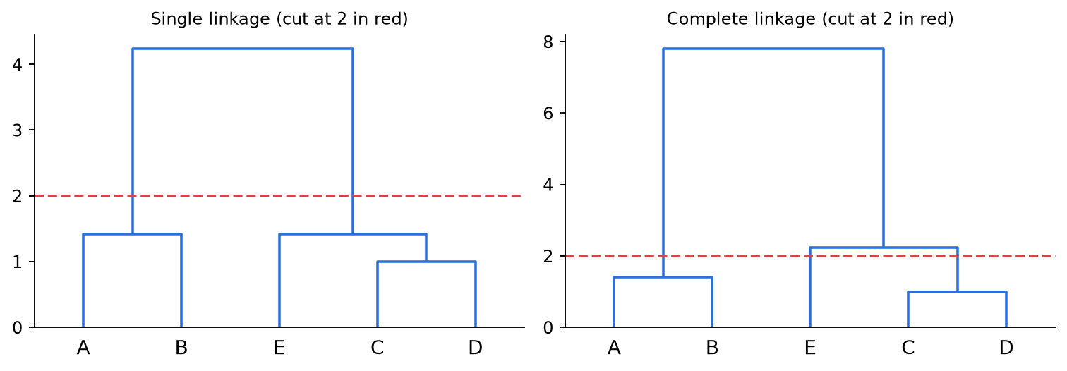
Figure 10.6 — Single link (left) vs complete link (right); dashed line = cut at h = 2.
Cut at h = 2: single link — merges at 1, 1.414, 1.414 done → 2 clusters {A,B}, {C,D,E}. Complete link — merges at 1 and 1.414 done, 2.236 not → 3 clusters {A,B}, {C,D}, {E}.
✅ Final answer
(a) e.g. concentric rings / two moons / very unequal sizes-densities — K-means gives convex Voronoi regions around means.
(b) Elbow, silhouette, gap statistic, BIC (GMM), domain knowledge.
(c) Same merge order in both: CD, AB, (CD)E, all. Heights single: 1, 1.414, 1.414, 4.243; complete: 1, 1.414, 2.236, 7.810. At h = 2: single → 2 clusters, complete → 3 clusters.

⚠️ Edge cases & traps
- In single link, steps 2 and 3 are both at 1.414 (a tie) — either order is fine, the dendrogram is the same.
- Complete-link heights are always ≥ single-link heights for the same merge.
- Compute distances to 3 decimals; √2 = 1.414, √5 = 2.236, √18 = 4.243, √32 = 5.657, √41 = 6.403, √61 = 7.810.

🔄 How the examiner can twist it
- Ask average link: d(CD,E) = (2.236 + 1.414)/2 = 1.825 → cut at 2 gives 2 clusters.
- Ask "which cut heights give the same number of clusters for both?" → h < 1.414 (5 or 4 clusters), 2.236 ≤ h < 4.243 (both 2), or h ≥ 7.810 (both 1).
- Ask K-means with K = 2 on the same points.

✍️ Make your own new question
Add F(10, 10). Where does it join in single link? (Nearest point is E: √(9 + 16) = 5 → F joins the whole cluster last at height 5, since 5 > 4.243.)

📝 PYQ — End-sem Spring 2026, Q4 (a) — PCA by hand in 3-D [5]
Three data points in ℝ³: x1 = (−1, 0, −1), x2 = (0, 1, 0), x3 = (1, −1, 1). Compute the covariance matrix, its eigenvalues, the first principal component and the 1-D projections of the three points. What fraction of variance does PC1 explain?

🧠 How to think
Check the mean first — here it is already (0, 0, 0), so no centring needed. Notice features 1 and 3 are identical → the covariance is singular (one eigenvalue is 0). Use the symmetry to guess the eigenvector shape (1, a, 1).

Solution — step by step
Step 1 — mean = ((−1 + 0 + 1)/3, (0 + 1 − 1)/3, (−1 + 0 + 1)/3) = (0, 0, 0) ✓.
Step 2 — covariance S = XᵀX / 3 (columns of X: c1 = (−1, 0, 1), c2 = (0, 1, −1), c3 = (−1, 0, 1)):
S = (1/3) [[2, −1, 2], [−1, 2, −1], [2, −1, 2]] = [[2/3, −1/3, 2/3], [−1/3, 2/3, −1/3], [2/3, −1/3, 2/3]]
Step 3 — characteristic polynomial det(S − sI) = s³ − (trace)s² + (sum of 2×2 principal minors)s − det:
- trace = 2/3 + 2/3 + 2/3 = 2
- minors: (4/9 − 1/9) + (4/9 − 4/9) + (4/9 − 1/9) = 1/3 + 0 + 1/3 = 2/3
- det = 0 (column 1 = column 3)
s³ − 2s² + (2/3)s = 0 ⇒ s (s² − 2s + 2/3) = 0
s = 0 , s = 1 ± √(1 − 2/3) = 1 ± 1/√3 ⇒ λ = 1.577, 0.423, 0
Step 4 — eigenvector for λ₁ = 1 + 1/√3. By symmetry (features 1 and 3 behave identically) try v = (1, a, 1):
- row 1 of Sv = λv: 2/3 − a/3 + 2/3 = λ ⇒ λ = (4 − a)/3
- row 2: −1/3 + 2a/3 − 1/3 = λa ⇒ (2a − 2)/3 = a(4 − a)/3
2a − 2 = 4a − a² ⇒ a² − 2a − 2 = 0 ⇒ a = 1 ± √3
λ = (4 − a)/3 = 1 + 1/√3 needs a = 1 − √3 = −0.732. So v ∝ (1, −0.732, 1); length = √(1 + 0.536 + 1) = 1.593:
v₁ = (0.628, −0.460, 0.628)
Step 5 — projections z = v₁ᵀx:
Point | Calculation | z (1-D)
x1 = (−1, 0, −1) | −0.628 + 0 − 0.628 | −1.256
x2 = (0, 1, 0) | 0 − 0.460 + 0 | −0.460
x3 = (1, −1, 1) | 0.628 + 0.460 + 0.628 | 1.716

Check: projections sum to 0 (data is centred) and their variance = (1.577 + 0.212 + 2.945)/3 = 1.578 ≈ λ₁ ✓.
Step 6 — explained variance = λ₁ / (λ₁ + λ₂ + λ₃) = 1.577 / 2 = 78.9%.
✅ Final answer
S = [[2/3, −1/3, 2/3], [−1/3, 2/3, −1/3], [2/3, −1/3, 2/3]]; eigenvalues 1.577, 0.423, 0; PC1 = (0.628, −0.460, 0.628) (∝ (1, 1 − √3, 1)); projections −1.256, −0.460, 1.716; PC1 explains 78.9% of the variance (PC1 + PC2 = 100%, since λ₃ = 0).

⚠️ Edge cases & traps
- Using ÷(N − 1) = ÷2 gives S twice as large with eigenvalues 2.366, 0.634, 0 — same eigenvectors, same 78.9%.
- The sign of v is arbitrary: (−0.628, 0.460, −0.628) is equally correct and flips the signs of all projections.
- λ₃ = 0 because feature 3 is an exact copy of feature 1 → the data lies in a 2-D plane; its eigenvector is (1, 0, −1)/√2.
- Don't forget to normalise v before projecting — otherwise the projections are scaled by 1.593.

🔄 How the examiner can twist it
- Ask for PC2 (λ = 1 − 1/√3, a = 1 + √3 → v ∝ (1, 2.732, 1) → (0.325, 0.888, 0.325)).
- Ask to reconstruct x2 from its 1-D code: x̂2 = −0.460 · v₁ = (−0.289, 0.212, −0.289).
- Ask for "how many PCs for 100%" → 2 (rank of the centred data).

✍️ Make your own new question
Points (2, 0), (−2, 0), (0, 1), (0, −1). Find the PCs and the explained variance. (Mean 0, S = diag(2, 0.5) → PC1 = (1, 0) with λ = 2 (80%), PC2 = (0, 1) with λ = 0.5 (20%).)

📝 PYQ — End-sem Spring 2026, Q4 (b) — Forward selection vs backward elimination [5]
Five features X1…X5; validation accuracy (%) of a classifier trained on each subset:
Singles: X1 60, X2 62, X3 65, X4 64, X5 63.
Pairs: {1,2} 66, {1,3} 68, {1,4} 67, {1,5} 66, {2,3} 69, {2,4} 68, {2,5} 67, {3,4} 70, {3,5} 69, {4,5} 68.
Triples: {1,2,3} 72, {1,2,4} 71, {1,2,5} 70, {1,3,4} 74, {1,3,5} 73, {1,4,5} 85, {2,3,4} 75, {2,3,5} 74, {2,4,5} 73, {3,4,5} 76.
Fours: {1,2,3,4} 77, {1,2,3,5} 81, {1,2,4,5} 79, {1,3,4,5} 79, {2,3,4,5} 78. All five: 80.
Select 3 features using (i) forward feature selection and (ii) backward feature elimination. Is either optimal? Explain.

🧠 How to think
Greedy search: at every step look ONLY at subsets that differ from the current one by one feature and take the best. FFS grows 0 → 1 → 2 → 3; BFE shrinks 5 → 4 → 3. Then scan all triples for the true optimum.

Solution — step by step
(i) Forward selection
Step | Candidates (accuracy) | Chosen
1 | X1 60, X2 62, X3 65, X4 64, X5 63 | {X3} — 65
2 | {3,1} 68, {3,2} 69, {3,4} 70, {3,5} 69 | {X3, X4} — 70
3 | {3,4,1} 74, {3,4,2} 75, {3,4,5} 76 | {X3, X4, X5} — 76

(ii) Backward elimination
Step | Remove → subset (accuracy) | Chosen
0 | start with all five | {1,2,3,4,5} — 80
1 | −X1 → {2,3,4,5} 78; −X2 → {1,3,4,5} 79; −X3 → {1,2,4,5} 79; −X4 → {1,2,3,5} 81; −X5 → {1,2,3,4} 77 | {X1, X2, X3, X5} — 81
2 | −X1 → {2,3,5} 74; −X2 → {1,3,5} 73; −X3 → {1,2,5} 70; −X5 → {1,2,3} 72 | {X2, X3, X5} — 74

(iii) Exhaustive check of all 10 triples: the best is {X1, X4, X5} = 85%.
Neither greedy method finds it. FFS chose X3 at step 1 (best single) and can never drop it; {1,4,5} does not contain X3. BFE removed X4 at step 1 (removing it gave 81%), so no later subset can contain X4.
✅ Final answer
FFS → {X3, X4, X5} (76%). BFE → {X2, X3, X5} (74%). The optimal triple is {X1, X4, X5} (85%) — both greedy methods miss it. Reason: X1, X4, X5 are weak individually (60, 64, 63) but strongly complementary together (feature interaction); greedy methods make locally best, irreversible choices and examine only a few of the 2⁵ − 1 = 31 subsets.

⚠️ Edge cases & traps
- In BFE step 2 you may only remove from {1,2,3,5} — do NOT look at {1,4,5} (X4 is already gone).
- FFS and BFE usually give different answers; both are heuristics.
- Note that removing X4 increased accuracy 80 → 81: more features is not always better (noise / redundancy / overfitting).
- Number of subsets checked: FFS 5 + 4 + 3 = 12; BFE 5 + 4 = 9; exhaustive C(5,3) = 10 triples (31 subsets overall).

🔄 How the examiner can twist it
- Ask for 2 features only: FFS → {X3, X4} (70); BFE → continue from {2,3,5}: remove X2 → {3,5} 69, remove X5 → {2,3} 69, remove X3 → {2,5} 67 → a tie between {X3, X5} and {X2, X3}; state your tie-break rule.
- Ask for "stop when accuracy stops improving": FFS would continue to 4 features ({3,4,5}+X1 = 79, +X2 = 78 → {1,3,4,5} 79) and then all five (80).
- Ask which family FFS/BFE belong to → wrapper methods.

✍️ Make your own new question
If {X2, X3, X4} had 77% instead of 75%, what would FFS pick? (Step 3 candidates from {3,4}: {1,3,4} 74, {2,3,4} 77, {3,4,5} 76 → {X2, X3, X4} with 77%; still not the optimum 85%.)

📝 PYQ — End-sem Spring 2026, Q5 — Soft clustering with GMM, responsibility of one point [5]
(a) Explain how a Gaussian Mixture Model performs soft clustering. [2]
(b) 1-D GMM with two components: component 1 μ₁ = 0, σ₁² = 1, π₁ = 0.5; component 2 μ₂ = 3, σ₂² = 2, π₂ = 0.5. Compute the responsibility γ(z₁) of component 1 for x = 1. [3]

🧠 How to think
(a) generative story + Bayes → responsibilities. (b) plug into N(x | μ, σ²), multiply by π, normalise.

Solution — step by step
(a) A GMM models p(x) = Σ π_{k} N(x | μ_{k}, σ_{k}²). Each point has a hidden label z. Instead of assigning x to one cluster, Bayes' rule gives the posterior γ(z_{k}) = P(z = k | x) = π_{k}N(x|μ_{k}, σ_{k}²)/Σ_{j} π_{j}N(x|μ_{j}, σ_{j}²) — a probability of membership in every cluster (they sum to 1). EM alternates computing these γ (E-step) and re-fitting π, μ, σ² with γ-weighted averages (M-step). Points between components get split memberships (e.g. 0.6 / 0.4) — that is soft clustering.
(b)
N₁ = N(1 | 0, 1) = (1/√(2π)) e^{−1/2} = 0.3989 × 0.6065 = 0.2420
N₂ = N(1 | 3, 2) = (1/√(4π)) e^{−(1−3)²/(2·2)} = 0.2821 × e⁻¹ = 0.2821 × 0.3679 = 0.1038
γ(z₁) = 0.5 × 0.2420 / (0.5 × 0.2420 + 0.5 × 0.1038) = 0.1210 / 0.1729 = 0.6998
✅ Final answer
(a) GMM gives each point a posterior probability (responsibility) for every component via Bayes' rule — soft membership. (b) γ(z₁) ≈ 0.70 (and γ(z₂) ≈ 0.30).

⚠️ Edge cases & traps
- σ₂² = 2 is the variance; the normaliser is √(2π·2) = √(4π), and the exponent denominator is 2σ² = 4.
- With equal π the π's cancel, but still write them.
- x = 1 is closer to μ₁ = 0 (distance 1) than to μ₂ = 3 (distance 2), so γ(z₁) > 0.5 makes sense — sanity-check your answer.

🔄 How the examiner can twist it
- Change π to (0.2, 0.8): γ(z₁) = 0.0484/(0.0484 + 0.0830) = 0.368 — the prior flips the decision.
- Ask for x = 1.5: γ(z₁) ≈ 0.446 (component 2's wider variance wins even though 1.5 is the midpoint).
- Ask for the updated μ₁ after one M-step for a small data set.

✍️ Make your own new question
Same GMM, x = 0 and x = 2. (x = 0: N₁ = 0.3989, N₂ = 0.2821e^{−2.25} = 0.0297 → γ₁ = 0.931. x = 2: N₁ = 0.0540, N₂ = 0.2821e^{−0.25} = 0.2197 → γ₁ = 0.197.)

📝 PYQ — End-sem Spring 2026, Q5 (c) — Backprop through softmax + cross-entropy [5]
Network: inputs X1, X2 → hidden units U1, U2 (w2 is the weight X1 → U1) → units V1, V2 (w1 is the weight U1 → V1) → softmax → outputs Y1, Y2. The loss is cross-entropy for 3-class classification. Derive ∂L/∂w1 and ∂L/∂w2. [5]

🧠 How to think
The text says 3 classes but the diagram has only 2 outputs → state an assumption and derive for general K outputs (then any K works). Chain: L → p (softmax) → v (logits) → w1 directly; for w2 go further: v → u1 → a_{U1} → w2. The key shortcut is ∂L/∂v_{k} = p_{k} − y_{k}.

Solution — step by step
Assumptions: u = g(a), a = W⁽¹⁾x (so a_{U1} = w2·x1 + W⁽¹⁾₁₂x2, u1 = g(a_{U1})); v = W⁽²⁾u are logits (v_{k} = Σ_{j} W⁽²⁾_{kj} u_{j}, with W⁽²⁾₁₁ = w1); p = softmax(v); L = −Σ_{k} y_{k} log p_{k}, y one-hot; K outputs (K = 2 in the figure, 3 in the text).
Step 1 — softmax Jacobian: ∂p_{j}/∂v_{k} = p_{j}(δ_{jk} − p_{k}) (quotient rule: p_{k}(1 − p_{k}) if j = k, −p_{j}p_{k} if j ≠ k).
Step 2 — gradient w.r.t. logits:
∂L/∂v_{k} = −Σ_{j} (y_{j}/p_{j}) p_{j}(δ_{jk} − p_{k}) = −y_{k} + p_{k} Σ_{j} y_{j} = p_{k} − y_{k}
Step 3 — w1 (U1 → V1): only v₁ depends on w1 and ∂v₁/∂w1 = u₁:
∂L/∂w1 = (∂L/∂v₁) (∂v₁/∂w1) = (p₁ − y₁) · u₁
Step 4 — w2 (X1 → U1): u₁ feeds EVERY logit v_{k} (through W⁽²⁾_{k1}), so sum over k:
∂L/∂u₁ = Σ_{k} (p_{k} − y_{k}) W⁽²⁾_{k1}
∂L/∂w2 = [Σ_{k=1}^{K} (p_{k} − y_{k}) W⁽²⁾_{k1}] · g′(a_{U1}) · x₁
For the 2-output figure: ∂L/∂w2 = [(p₁ − y₁)·w1 + (p₂ − y₂)·W⁽²⁾₂₁] · g′(a_{U1}) · x₁.
If V has its own activation h (v_{k} = h(c_{k}), c = W⁽²⁾u, softmax on v): multiply by h′: ∂L/∂w1 = (p₁ − y₁)·h′(c₁)·u₁ and ∂L/∂w2 = [Σ_{k}(p_{k} − y_{k}) h′(c_{k}) W⁽²⁾_{k1}]·g′(a_{U1})·x₁.
✅ Final answer
∂L/∂v_{k} = p_{k} − y_{k}; ∂L/∂w1 = (p₁ − y₁)·u₁; ∂L/∂w2 = [Σ_{k}(p_{k} − y_{k})·W⁽²⁾_{k1}]·g′(a_{U1})·x₁ (valid for any number K of outputs; if V has an activation h, include h′(c_{k}) in each term).

⚠️ Edge cases & traps
- Forgetting the sum over k in ∂L/∂u₁ is the most common mistake — u₁ influences every softmax output, not just V1.
- Don't write ∂L/∂v₁ = −y₁/p₁ and stop — the softmax couples all outputs; you must go through the full Jacobian (or quote p − y with its derivation).
- Mention the 3-class vs 2-output inconsistency explicitly; the general-K result covers both.
- If g = sigmoid, g′(a) = u₁(1 − u₁); if ReLU, g′ = 1 (a > 0) or 0.

🔄 How the examiner can twist it
- Give numbers: x = (1, 2), all weights 0.5, g = ReLU, y = (1, 0) → compute the gradients numerically.
- Ask for the bias gradient of V1: ∂L/∂b = p₁ − y₁.
- Replace softmax + CE with sigmoid + BCE on one output → same form ŷ − y.

✍️ Make your own new question
For a 3-class softmax with p = (0.7, 0.2, 0.1) and true class 2, find ∂L/∂v and the loss. (y = (0, 1, 0) → ∂L/∂v = (0.7, −0.8, 0.1); L = −ln 0.2 = 1.609.)

📝 PYQ — End-sem Spring 2026, Q6(a) — Output sizes with stride and padding [5]
Input 128×128×3. Conv1: 64 filters of 7×7, stride 2, padding 3. MaxPool: 3×3, stride 2, padding 0. Conv2: 128 filters of 5×5, stride 2, padding 0. Find the output size after each layer and the total number of activations at the output of Conv2.

🧠 How to think
Apply O = ⌊(W − F + 2P)/S⌋ + 1 three times. Watch the floor — it matters for the pool and Conv2.

Solution — step by step
Conv1: O = ⌊(128 − 7 + 2·3)/2⌋ + 1 = ⌊127/2⌋ + 1 = 63 + 1 = 64 ⇒ 64 × 64 × 64
MaxPool: O = ⌊(64 − 3 + 0)/2⌋ + 1 = ⌊61/2⌋ + 1 = 30 + 1 = 31 ⇒ 31 × 31 × 64
Conv2: O = ⌊(31 − 5 + 0)/2⌋ + 1 = 13 + 1 = 14 ⇒ 14 × 14 × 128
Activations = 14 × 14 × 128 = 25,088
Bonus (parameters): Conv1 = (7·7·3 + 1)·64 = 148·64 = 9,472; MaxPool = 0; Conv2 = (5·5·64 + 1)·128 = 1601·128 = 204,928.
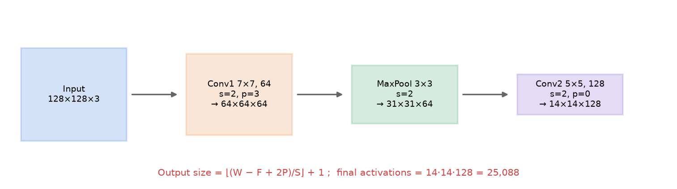
✅ Final answer
Conv1 → 64×64×64; MaxPool → 31×31×64; Conv2 → 14×14×128; total activations = 25,088.

⚠️ Edge cases & traps
- ⌊127/2⌋ = 63, not 63.5 — always floor before adding 1.
- The pool keeps depth 64; Conv2 depth = 128 (number of filters).
- Conv2 filters are 5×5×64 — use the pool's depth for the params.
- "Activations" = number of values in the output volume, not the number of parameters.

🔄 How the examiner can twist it
- Ask for the receptive field of one Conv2 output neuron on the input image.
- Change Conv1 padding to 0: ⌊121/2⌋ + 1 = 61 → pool ⌊58/2⌋ + 1 = 30 → Conv2 ⌊25/2⌋ + 1 = 13 → 13×13×128.
- Ask for the number of multiplications in Conv1: 64·64·64 outputs × 147 = 38,535,168.

✍️ Make your own new question
Input 224×224×3, conv with 96 filters of 11×11, stride 4, padding 2 (AlexNet). Output size and params? (⌊(224 − 11 + 4)/4⌋ + 1 = ⌊54.25⌋ + 1 = 55 → 55×55×96; params (11·11·3 + 1)·96 = 34,944.)

📝 PYQ — End-sem Spring 2026, Q6(b) — Multi-channel convolution by hand [5]
Input 5×5×3 with channels:
Channel 1: [1,2,0,1,2], [3,1,2,2,0], [0,1,3,1,1], [2,2,1,0,2], [1,0,2,1,3]
Channel 2: [0,1,2,1,0], [1,0,1,2,1], [2,1,0,1,2], [1,2,1,0,1], [0,1,2,1,0]
Channel 3: [1,0,1,2,1], [2,1,0,1,2], [1,2,1,0,1], [0,1,2,1,0], [1,0,1,2,1]
One filter of size 3×3×3: K1 = [[1,0,−1],[1,1,0],[0,−1,1]], K2 = [[0,1,0],[−1,1,1],[1,0,−1]], K3 = [[1,−1,0],[0,1,−1],[1,0,1]]. Stride 2, padding 0, bias 0. Compute the output feature map and apply ReLU.

🧠 How to think
Output size = ⌊(5 − 3)/2⌋ + 1 = 2 → 2×2×1 (one filter → one map). Windows start at rows/cols 0 and 2.
For each position: (window of ch1 ⊙ K1) + (window of ch2 ⊙ K2) + (window of ch3 ⊙ K3) + bias. Sum across channels!

Solution — step by step
Position (0,0), channel 1, fully: window = [[1,2,0],[3,1,2],[0,1,3]], K1 = [[1,0,−1],[1,1,0],[0,−1,1]]
1·1 + 2·0 + 0·(−1) + 3·1 + 1·1 + 2·0 + 0·0 + 1·(−1) + 3·1 = 1 + 0 + 0 + 3 + 1 + 0 + 0 − 1 + 3 = 7
Channel 2: window [[0,1,2],[1,0,1],[2,1,0]] ⊙ K2 = 0 + 1 + 0 − 1 + 0 + 1 + 2 + 0 + 0 = 3.
Channel 3: window [[1,0,1],[2,1,0],[1,2,1]] ⊙ K3 = 1 + 0 + 0 + 0 + 1 + 0 + 1 + 0 + 1 = 4.
Output position | Input rows / cols | Ch 1 | Ch 2 | Ch 3 | Sum (+ bias 0)
(0,0) | rows 0–2, cols 0–2 | 7 | 3 | 4 | 14
(0,1) | rows 0–2, cols 2–4 | 2 | 1 | 0 | 3
(1,0) | rows 2–4, cols 0–2 | 3 | 1 | 0 | 4
(1,1) | rows 2–4, cols 2–4 | 5 | 3 | 4 | 12

Example (0,1), channel 1: window [[0,1,2],[2,2,0],[3,1,1]] ⊙ K1 = 0 + 0 − 2 + 2 + 2 + 0 + 0 − 1 + 1 = 2.
ReLU = max(0, z): all four values are positive, so nothing changes.
✅ Final answer
Feature map = [[14, 3], [4, 12]] (2×2×1); after ReLU it is still [[14, 3], [4, 12]].

⚠️ Edge cases & traps
- One 3×3×3 filter → ONE output channel. Do NOT give three separate 2×2 maps as the answer — add them.
- With stride 2 the windows start at 0 and 2 (they overlap in the middle row/column).
- Signs: count the −1 entries carefully; most errors happen there.
- Params of this filter = 27 weights + 1 bias = 28.

🔄 How the examiner can twist it
- Use stride 1 → 3×3 output (9 windows).
- Add bias = −5 → [[9, −2], [−1, 7]] → ReLU → [[9, 0], [0, 7]].
- Add a second filter → output 2×2×2.
- Follow with 2×2 max-pool → single value 14.

✍️ Make your own new question
With stride 1, compute the channel-1 contribution at position (0,1). (Window [[2,0,1],[1,2,2],[1,3,1]] ⊙ K1 = 2 + 0 − 1 + 1 + 2 + 0 + 0 − 3 + 1 = 2.)

📝 PYQ — End-sem Spring 2026, Q7 — RNN equations, forward pass, seq2seq [4 + 4 + 2]
(a) Design an RNN that takes a sequence of 3-dimensional inputs x₁, …, x_{T}, keeps a 2-dimensional hidden state and produces ONE 1-dimensional output Y from the whole sequence. Write the equations, the shapes of all weights, and the expression of Y. [4]
(b) h(t) = tanh(W_{h}·h(t−1) + W_{x}·x(t)) with W_{h} = [[0.5, 0.1], [0.2, 0.4]], W_{x} = I (identity), h(0) = [0, 0], x(1) = [1, 0], x(2) = [0, 1]. Compute h(1) and h(2). [4]
(c) Explain sequence-to-sequence modelling with RNNs. [2]

🧠 How to think
(a) It is a many-to-one RNN: read all inputs, use only the last hidden state h_{T} for the output. Shapes follow from "output dim × input dim". (b) Plug in step by step; tanh is applied element-wise; tanh(0) = 0, tanh(1) = 0.7616.

Solution — step by step
(a)
h_{t} = tanh(W_{h} h_{t−1} + W_{x} x_{t} + b_{h}), t = 1, …, T, h₀ = 0
Y = g(w_{y}^{T} h_{T} + b_{y}), g = sigmoid (binary) or identity (regression)
Parameter | Shape | Role
W_{x} | 2 × 3 | input → hidden
W_{h} | 2 × 2 | hidden → hidden (memory)
b_{h} | 2 × 1 | hidden bias
w_{y} | 2 × 1 | hidden → output
b_{y} | 1 × 1 | output bias

Unrolled: Y = g( w_{y}^{T} tanh( W_{h} tanh( W_{h}(…) + W_{x}x_{T−1} + b_{h}) + W_{x}x_{T} + b_{h}) + b_{y} ). Total params = 6 + 4 + 2 + 2 + 1 = 15, the same for any T.
(b) Step 1:
a(1) = W_{h}·[0, 0] + [1, 0] = [1, 0] ⇒ h(1) = [tanh 1, tanh 0] = [0.7616, 0]
Step 2:
W_{h}·h(1) = [0.5·0.7616 + 0.1·0, 0.2·0.7616 + 0.4·0] = [0.3808, 0.1523]
a(2) = [0.3808, 0.1523] + [0, 1] = [0.3808, 1.1523]
h(2) = [tanh 0.3808, tanh 1.1523] = [0.3634, 0.8185]
(c) Seq2seq = encoder–decoder. The encoder RNN reads the input sequence (e.g., an English sentence) token by token and its final hidden state becomes a fixed-size context vector. The decoder RNN is initialised with this context and generates the output sequence (e.g., the Hindi translation) one token at a time, each step conditioned on the context and the previously generated token, until <EOS>. Input and output lengths can differ. Training uses teacher forcing; attention over all encoder states fixes the bottleneck for long sentences. (A synced many-to-many RNN, one output per input, is used for tagging tasks.)
✅ Final answer
(a) h_{t} = tanh(W_{h}h_{t−1} + W_{x}x_{t} + b_{h}), W_{x} 2×3, W_{h} 2×2, b_{h} 2×1; Y = g(w_{y}^{T}h_{T} + b_{y}), w_{y} 2×1 — a many-to-one RNN. (b) h(1) = [0.7616, 0], h(2) = [0.3634, 0.8185]. (c) Encoder compresses the input into a context vector; decoder generates the output sequence step by step from it.

⚠️ Edge cases & traps
- W_{x} is 2×3 (hidden × input), NOT 3×2 — check with a matrix-vector product: (2×3)(3×1) = 2×1.
- Only h_{T} feeds the output in many-to-one; don't add an output at every step.
- Calculator in radians mode for tanh (tanh 1 = 0.7616).
- W_{h}·h(1) is a matrix-vector product: row 1 · h(1) and row 2 · h(1).

🔄 How the examiner can twist it
- Swap the order of the inputs (x(1) = [0, 1], x(2) = [1, 0]) — the answer changes, showing the RNN is order-sensitive.
- Add a bias or use ReLU instead of tanh.
- Ask for Y = σ(w_{y}^{T}h(2)) with a given w_{y}.
- Ask how many parameters an LSTM version would have: 4 × (2·3 + 2·2 + 2) = 48 (+ output 3).

✍️ Make your own new question
Repeat (b) with x(1) = [0, 1] and x(2) = [1, 0]. (h(1) = [0, 0.7616]; a(2) = [0.1·0.7616 + 1, 0.4·0.7616] = [1.0762, 0.3046] → h(2) = [0.7918, 0.2956].)

