**NAME:MUKUL KUMAR**

**REG NO: 23MCA1072**

**Exercise-6**

Design a queue system for a play area in a mall. The webpage of the play area must have a textbox to enter the name of the child entering the play area. On clicking the button enter the name must be displayed in webpage in a

tag. Add some names. Then create another button "exit" that deletes the top most name. Perform the above using DOM.

CODE:

<!DOCTYPE html>

<html lang="en">

<head>

<meta charset="UTF-8">

<meta name="viewport" content="width=device-width, initial-scale=1.0">

<title>Play Area Queue</title>

</head>

<body style="background-color: #f0b660;">

<center>

<h1>Play Area Queue</h1>

<input type="text" id="childName" placeholder="Enter child's name">

<button onclick="enterQueue()">Enter</button>

<button onclick="exitQueue()">Exit</button>

<h3>Queue:</h3>

<ul id="queueList"></ul>

<script>

const queue = [];

function enterQueue() {

const childName = document.getElementById('childName').value;

if (childName) {

queue.push(childName);

displayQueue();

document.getElementById('childName').value = '';

}

}

function exitQueue() {

if (queue.length > 0) {

queue.shift();

displayQueue();

}

}

function displayQueue() {

const queueList = document.getElementById('queueList');

queueList.innerHTML = ''; // Clear the previous list

for (let i = 0; i < queue.length; i++) {

const listItem = document.createElement('li');

listItem.textContent = queue[i];

queueList.appendChild(listItem);

}

}

</script>

</center>

</body>

</html>

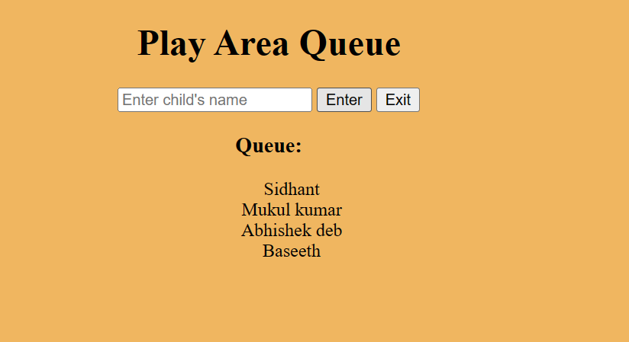**OUTPUT:**