Web Application Penetration Testing Report
Target: Damn Vulnerable Web Application (DVWA)
Prepared by: Mukul Kumar
Role: Aspiring SOC Analyst / VAPT Analyst
GitHub: mukulkumar-labs
Confidential — For Educational / Portfolio Purposes Only

1. Executive Summary
This report presents the results of a black-box web application penetration test conducted against Damn Vulnerable Web Application (DVWA), a deliberately vulnerable PHP/MySQL application used for security training. The objective was to identify, exploit, and document common web application vulnerabilities mapped to the OWASP Top 10, and to demonstrate the real-world impact of each finding through proof-of-concept exploitation.
A total of 10 distinct vulnerability classes were tested and confirmed, including SQL Injection, Cross-Site Scripting (all three variants), CSRF, Command Injection, Unrestricted File Upload, Local File Inclusion, weak authentication controls, and security misconfigurations. Several findings were chained together to demonstrate realistic attacker workflows — for example, credentials extracted via SQL Injection were cracked and independently confirmed through a brute-force attack against the login form.
Overall risk posture: CRITICAL. Multiple vulnerabilities allow complete compromise of user data and remote code execution on the underlying server. Findings and remediation guidance are detailed in Section 5.

2. Scope & Methodology
Target Application: DVWA (Damn Vulnerable Web Application), deployed via Docker
Testing Type: Black-box, manual web application penetration testing
Security Levels Tested: Low (primary exploitation), High (hardening comparison)
Testing Environment: Kali Linux (attacker), Docker container (target), isolated local network — no external systems affected

Tools Used
- Burp Suite (Proxy, Intruder, Repeater) — request interception and automated attacks
- Gobuster — directory and file enumeration
- John the Ripper — offline password hash cracking
- Firefox (Kali) — manual testing and payload delivery

Methodology
Testing followed a structured approach: reconnaissance and mapping, followed by vulnerability identification and exploitation for each OWASP Top 10 category, followed by a hardening comparison between DVWA's Low and High security levels. All testing was performed in an isolated lab environment against an intentionally vulnerable application; no production systems or third-party assets were involved.

3. Reconnaissance
The application was crawled using Burp Suite's site map to enumerate all available modules and endpoints. A directory brute-force scan was also performed using Gobuster to identify hidden paths.
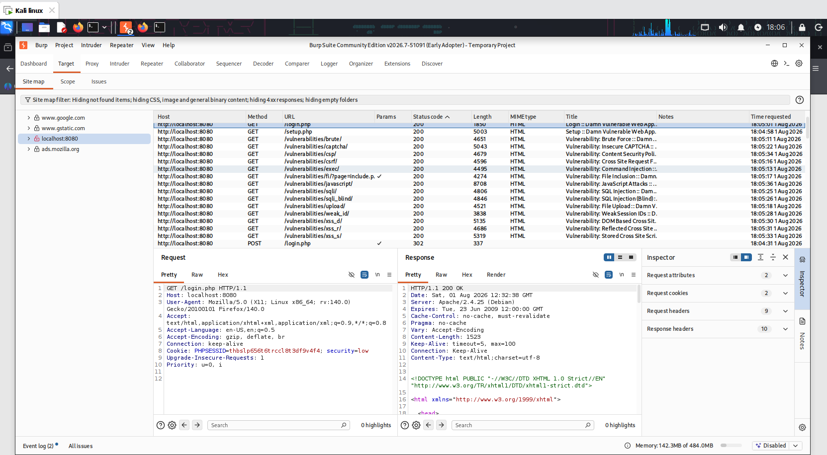
Figure 3.1 — Burp Suite Site Map showing all discovered DVWA modules and endpoints
The scan confirmed a /config/ directory was reachable but properly restricted — no sensitive file or source disclosure was observed, indicating this particular path was hardened correctly despite being discoverable.

4. Detailed Findings

4.1 SQL Injection
Severity: Critical | CVSS (approx): 9.8
The SQL Injection module's User ID input was found to be directly concatenated into a backend SQL query without sanitization, allowing arbitrary query manipulation.

Steps to Reproduce
- Submitted a single quote (') — triggered a raw MariaDB syntax error, confirming the injection point.
- Submitted 1' OR '1'='1 — bypassed the intended WHERE clause and returned all user records instead of one.
- Submitted 1' UNION SELECT user, password FROM users -- - — extracted usernames and password hashes directly from the users table.
- Cracked the extracted admin password hash (5f4dcc3b5aa765d61d8327deb882cf99) using John the Ripper against the rockyou wordlist, recovering the plaintext password 'password' in under a second.
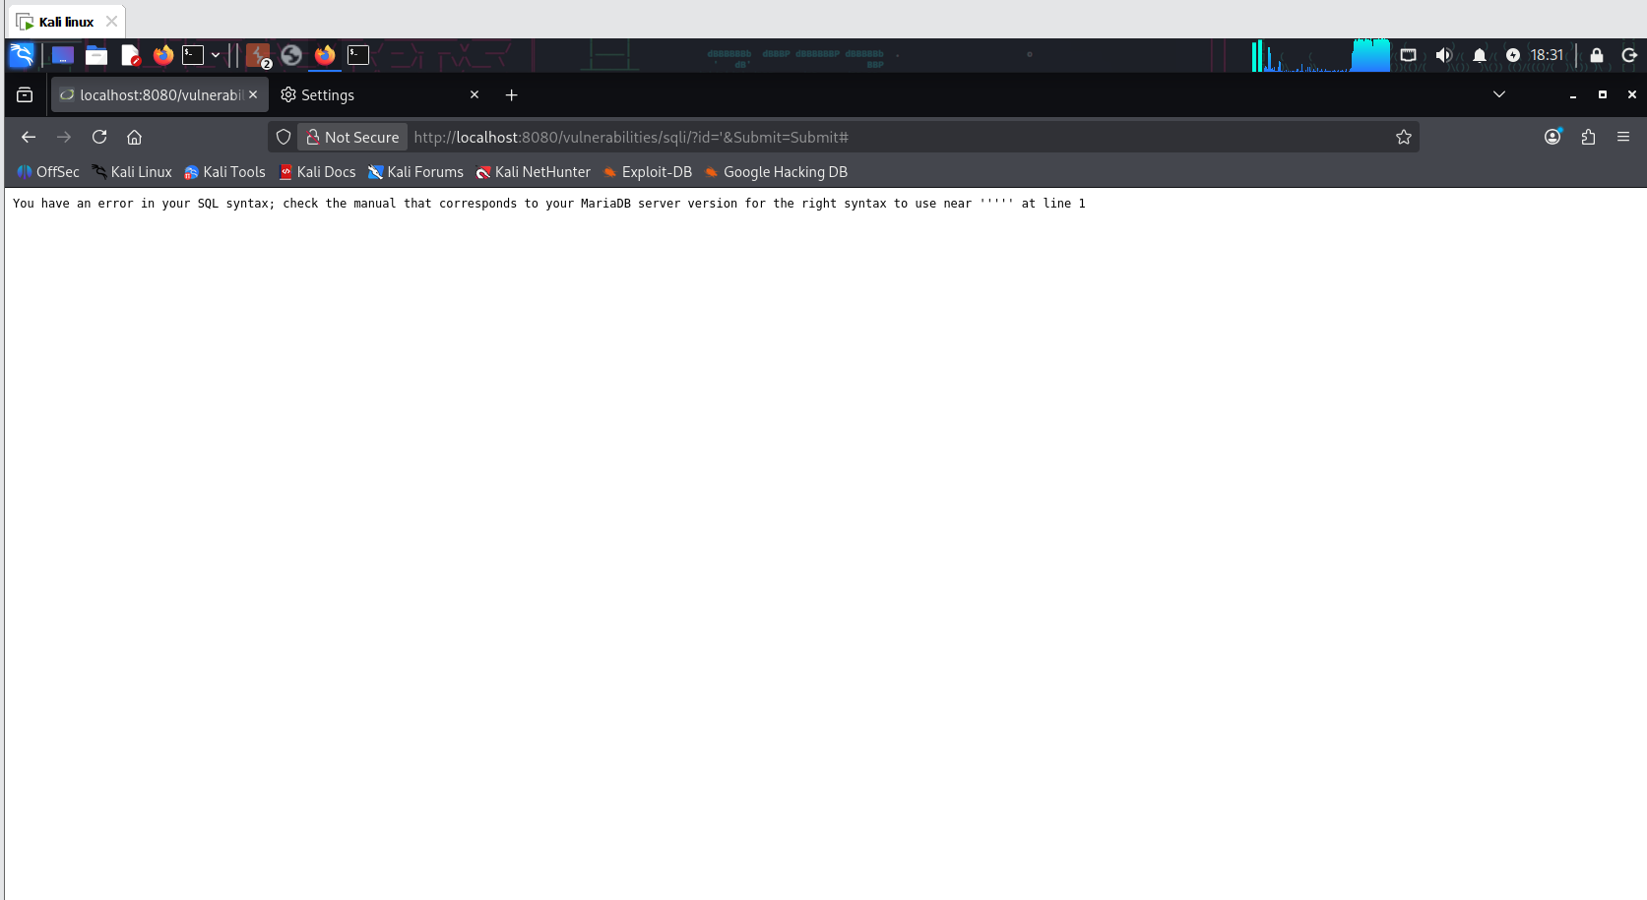
Figure 4.1a — SQL syntax error confirming the injection point
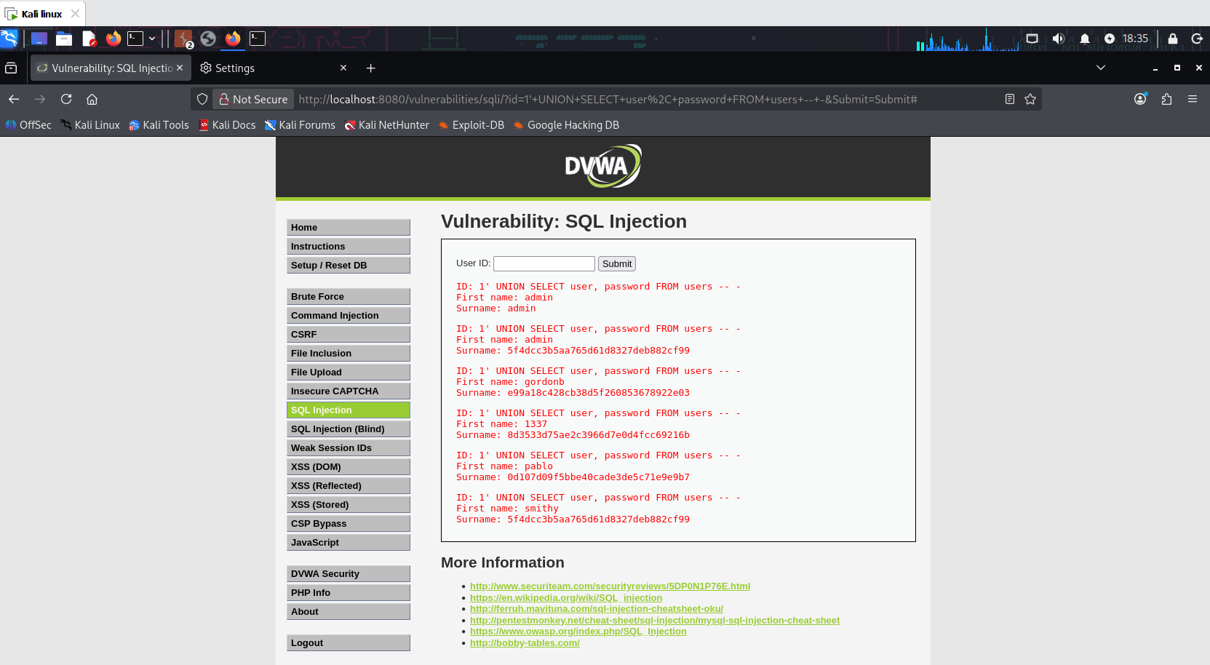
Figure 4.1b — UNION-based injection extracting usernames and password hashes
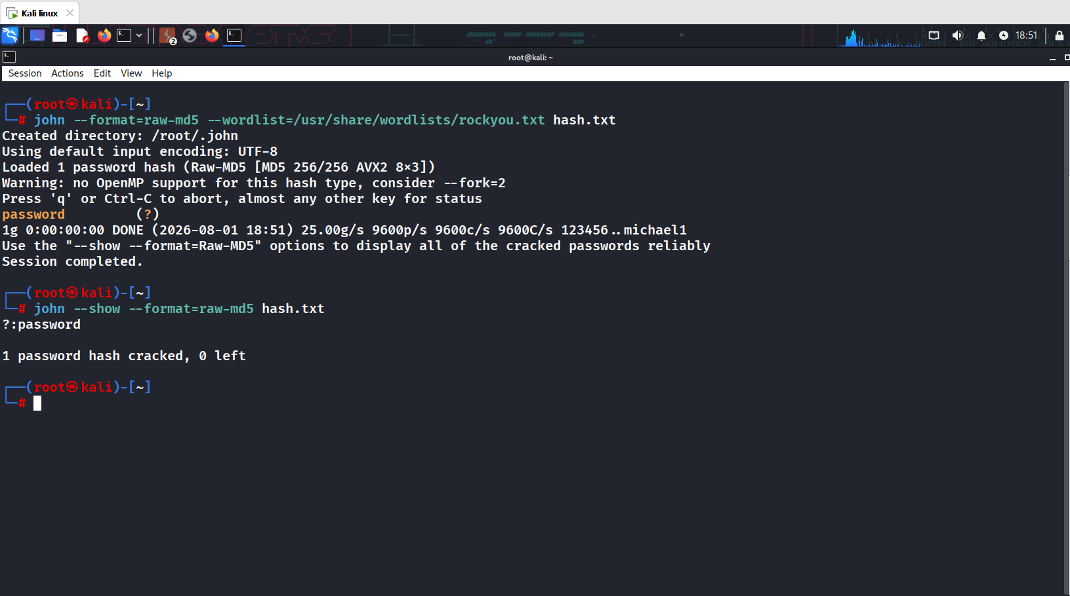
Figure 4.1c — John the Ripper cracking the admin password hash to plaintext 'password'
Impact: Complete compromise of the application's user database, including credential theft, and full account takeover of the admin account.

Remediation
- Use parameterized queries / prepared statements for all database access.
- Apply the principle of least privilege to the database account used by the application.
- Enforce a strong password policy to reduce the impact of any credential exposure.

4.2 Brute Force / Weak Authentication Controls
Severity: High | CVSS (approx): 8.1
The login form imposed no rate limiting or account lockout, allowing unlimited automated login attempts. Credentials were also transmitted via the GET method, exposing them in browser history and server logs.

Steps to Reproduce
- Captured a login request in Burp Suite and sent it to Intruder.
- Marked the password parameter as the payload position, keeping the username fixed to 'admin'.
- Ran a Sniper attack with a small custom password list.
- Identified the correct password by its distinct response length (4740 bytes vs ~4702-4703 for failed attempts) — the payload 'password' was confirmed valid, matching the password recovered independently via SQL Injection + hash cracking.
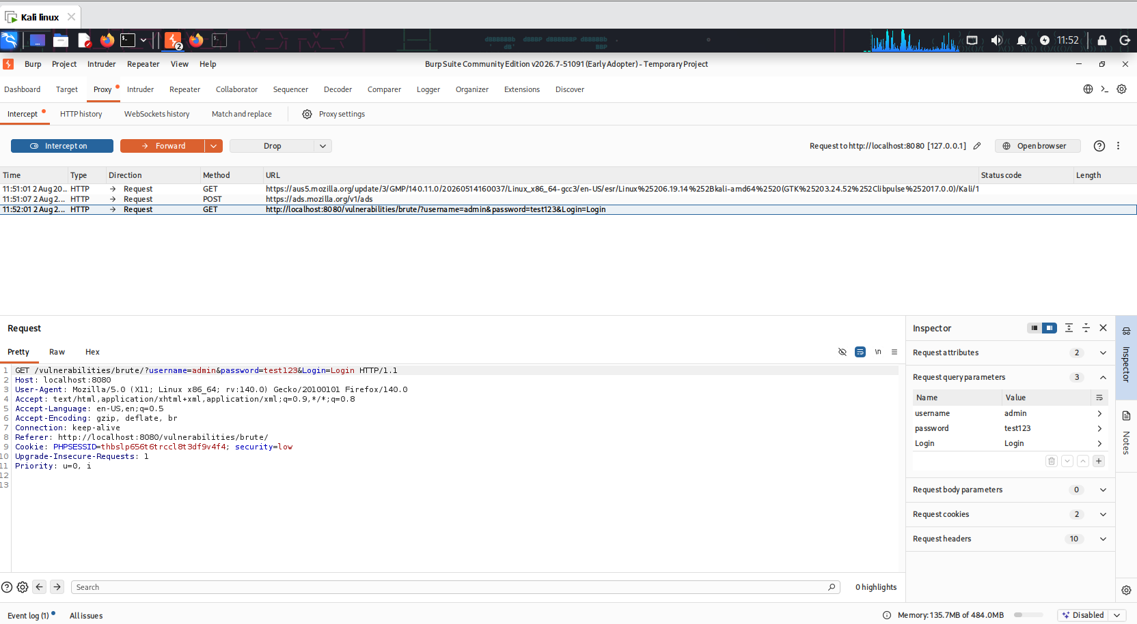
Figure 4.2a — Captured login request showing credentials sent via GET parameters
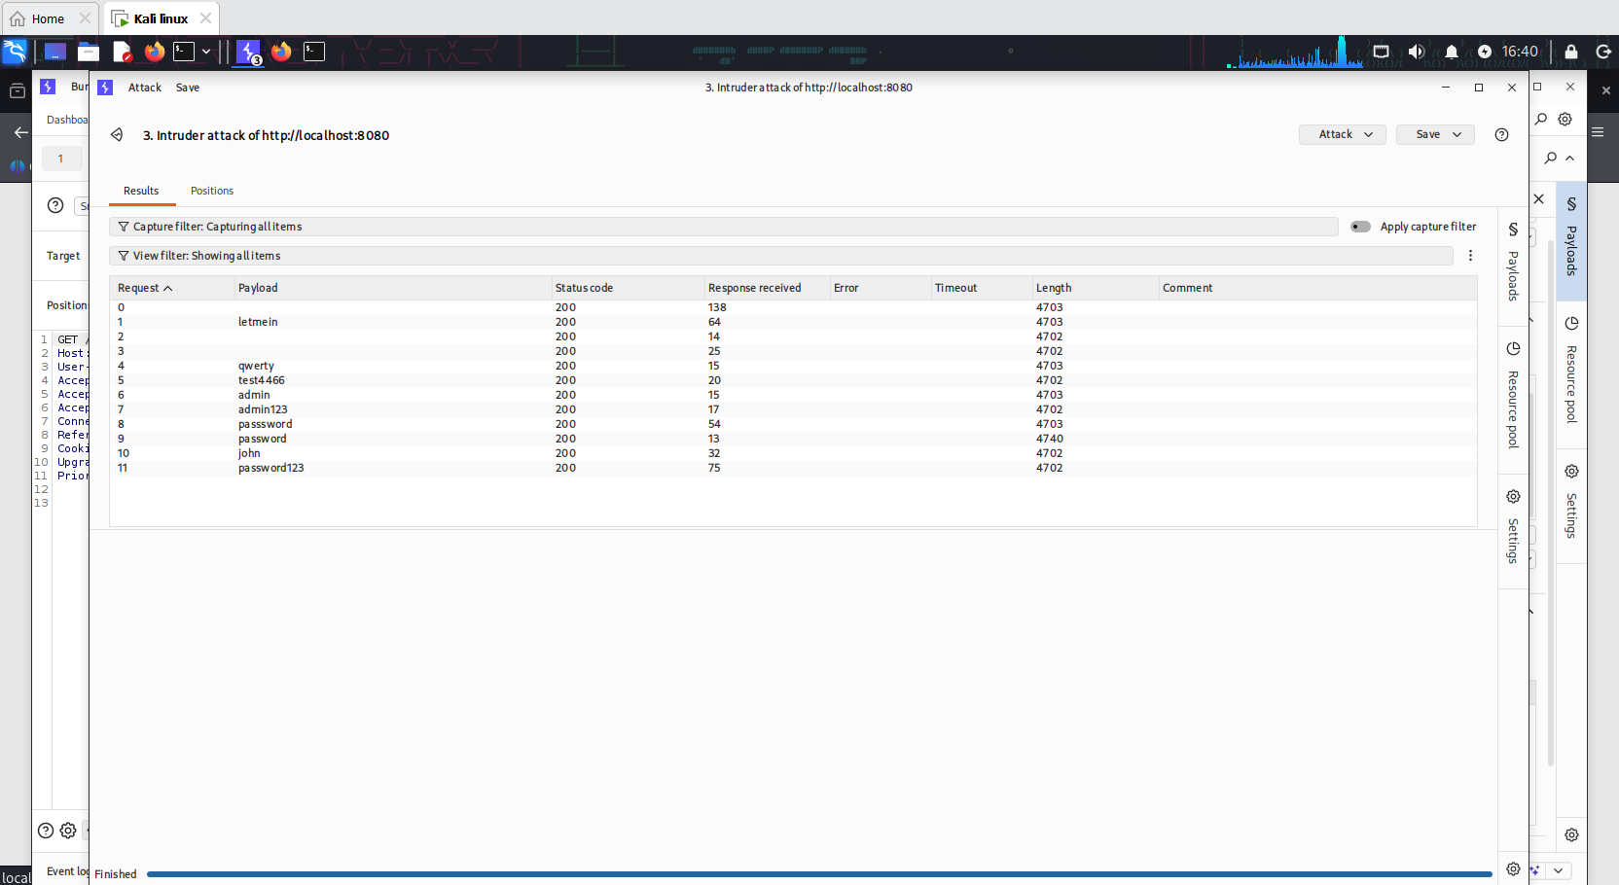
Figure 4.2b — Burp Intruder results; the 'password' row shows an anomalous response length, indicating success
Impact: An attacker can brute-force valid credentials without restriction, and the same weak password was independently confirmed via two separate attack paths — demonstrating a systemic weak-password issue.

Remediation
- Implement account lockout / rate limiting after a small number of failed attempts.
- Enforce strong password complexity requirements.
- Use POST requests for credential submission, never GET.
- Consider CAPTCHA or MFA for additional protection.

4.3 Cross-Site Scripting — Reflected
Severity: High | CVSS (approx): 6.1
User input from the 'name' parameter was reflected back into the page HTML without encoding, allowing arbitrary script execution in the victim's browser.

Steps to Reproduce
- Submitted the payload <script>alert('XSS')</script> into the name field.
- The payload executed immediately, and was also visible reflected directly in the URL — confirming the reflected nature of the vulnerability.
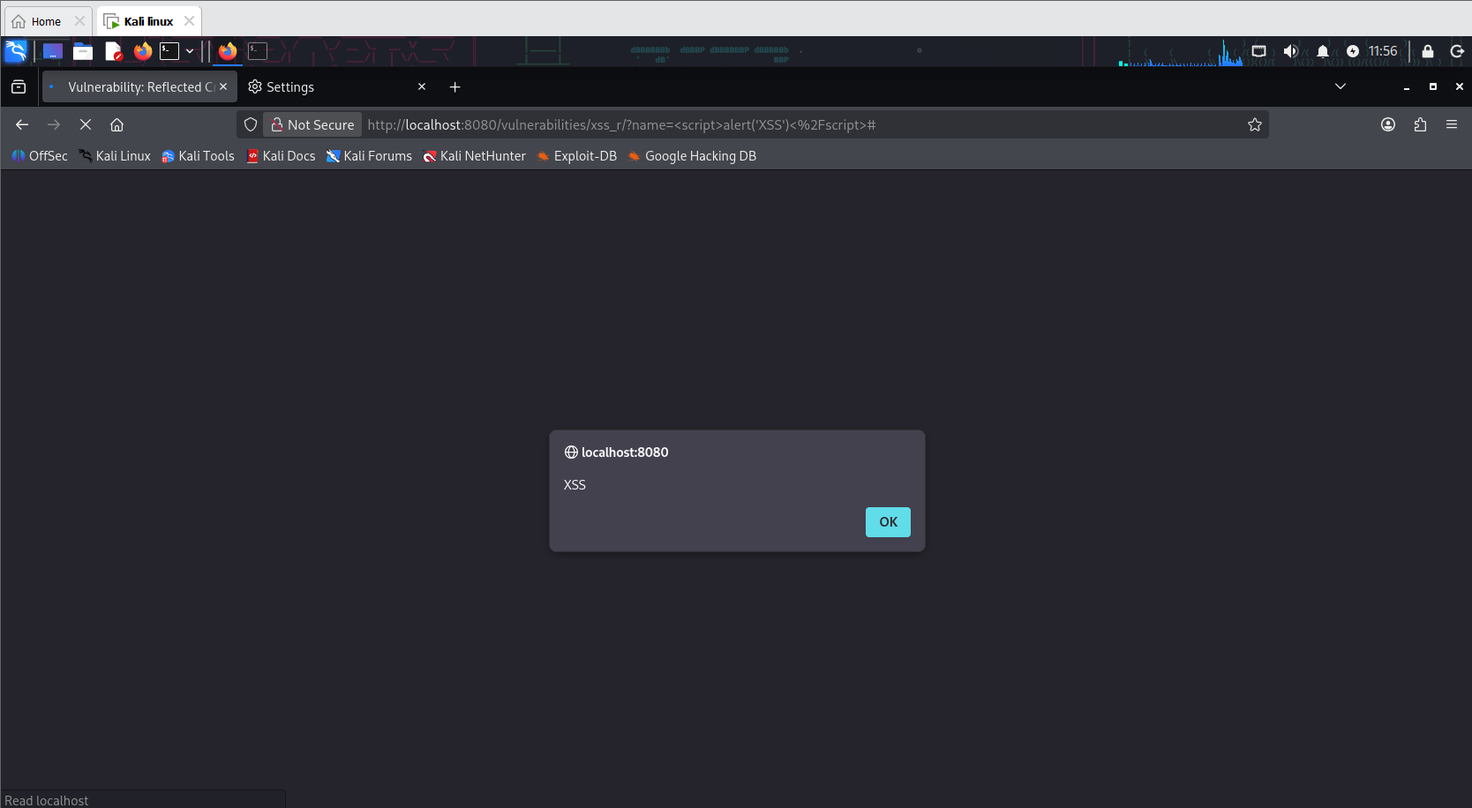
Figure 4.3 — JavaScript payload executing via the reflected 'name' parameter
Impact: An attacker could craft a malicious link that executes arbitrary JavaScript in a victim's session — enabling session hijacking, credential theft, or defacement.

Remediation
- HTML-encode all user-supplied output before rendering.
- Apply a Content Security Policy (CSP) to restrict inline script execution.

4.4 Cross-Site Scripting — Stored
Severity: High | CVSS (approx): 8.8
The guestbook 'Message' field stored user input without sanitization, allowing a persistent XSS payload that executes for every visitor of the page.

Steps to Reproduce
- Submitted <script>alert('Stored XSS')</script> into the guestbook message field.
- The payload executed immediately upon submission.
- Reloaded the page with empty form fields — the alert fired again, confirming the payload was persisted server-side rather than merely reflected.
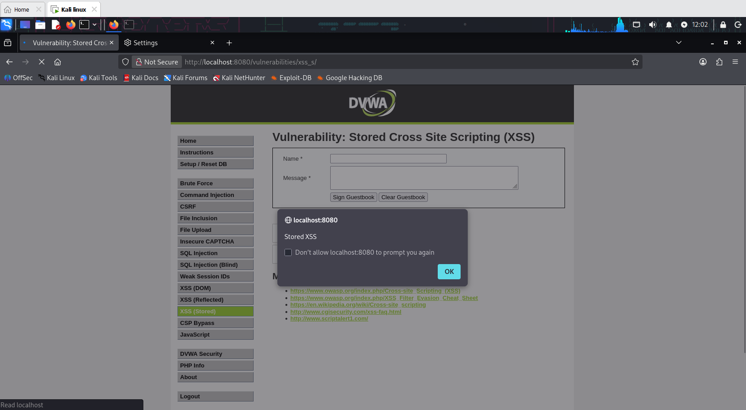
Figure 4.4 — Payload re-executing on page reload, confirming persistence in the database
Impact: Significantly more dangerous than reflected XSS — every user who views the guestbook is affected without needing to click a crafted link, enabling mass session hijacking or worm-like propagation.

Remediation
- Sanitize and HTML-encode all stored user input on output.
- Apply input validation and a strict CSP.

4.5 Cross-Site Scripting — DOM-based
Severity: High | CVSS (approx): 6.1
The 'default' URL parameter was read and rendered directly into the page by client-side JavaScript, without any server-side involvement, allowing script injection purely on the client.

Steps to Reproduce
- Modified the URL to: ?default=<script>alert('DOM XSS')</script>
- The client-side JavaScript rendered the payload directly into the DOM, triggering execution.
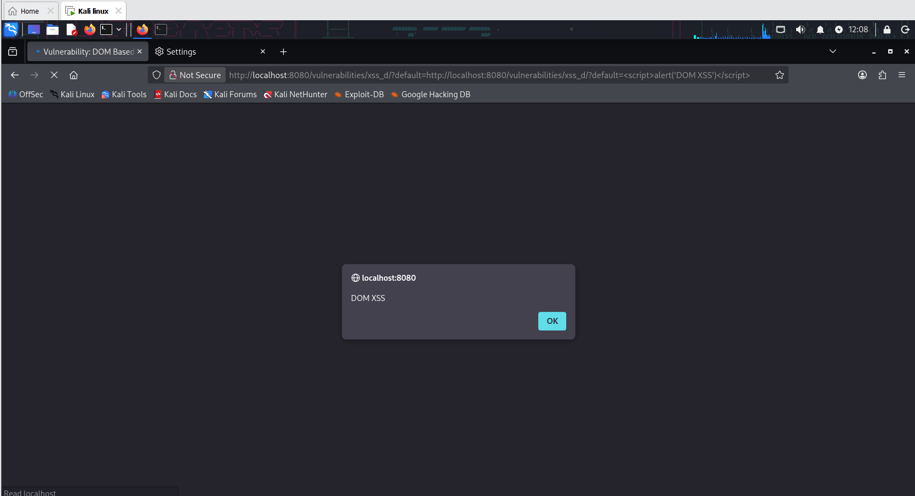
Figure 4.5 — DOM-based XSS payload executing via client-side URL parameter handling
Impact: Demonstrates that server-side output encoding alone is insufficient — client-side JavaScript must also treat URL-derived data as untrusted.

Remediation
- Avoid directly writing untrusted data into the DOM (innerHTML, document.write, etc.).
- Use safe DOM APIs (textContent) or a framework that auto-escapes output.

4.6 Cross-Site Request Forgery (CSRF)
Severity: High | CVSS (approx): 8.0
The password change function accepted state-changing GET requests without any anti-CSRF token, session-bound validation, or re-authentication step.

Steps to Reproduce
- Captured the legitimate password-change request in Burp Suite to identify its structure.
- Created a standalone malicious HTML page containing an auto-submitting form targeting the same endpoint with attacker-chosen password values.
- Opened the malicious page in a browser tab while an authenticated DVWA session was active — the form auto-submitted on page load.
- The application confirmed 'Password Changed', and the new credentials (admin / hacked123) were successfully used to log in — without the victim ever interacting with DVWA's own form.
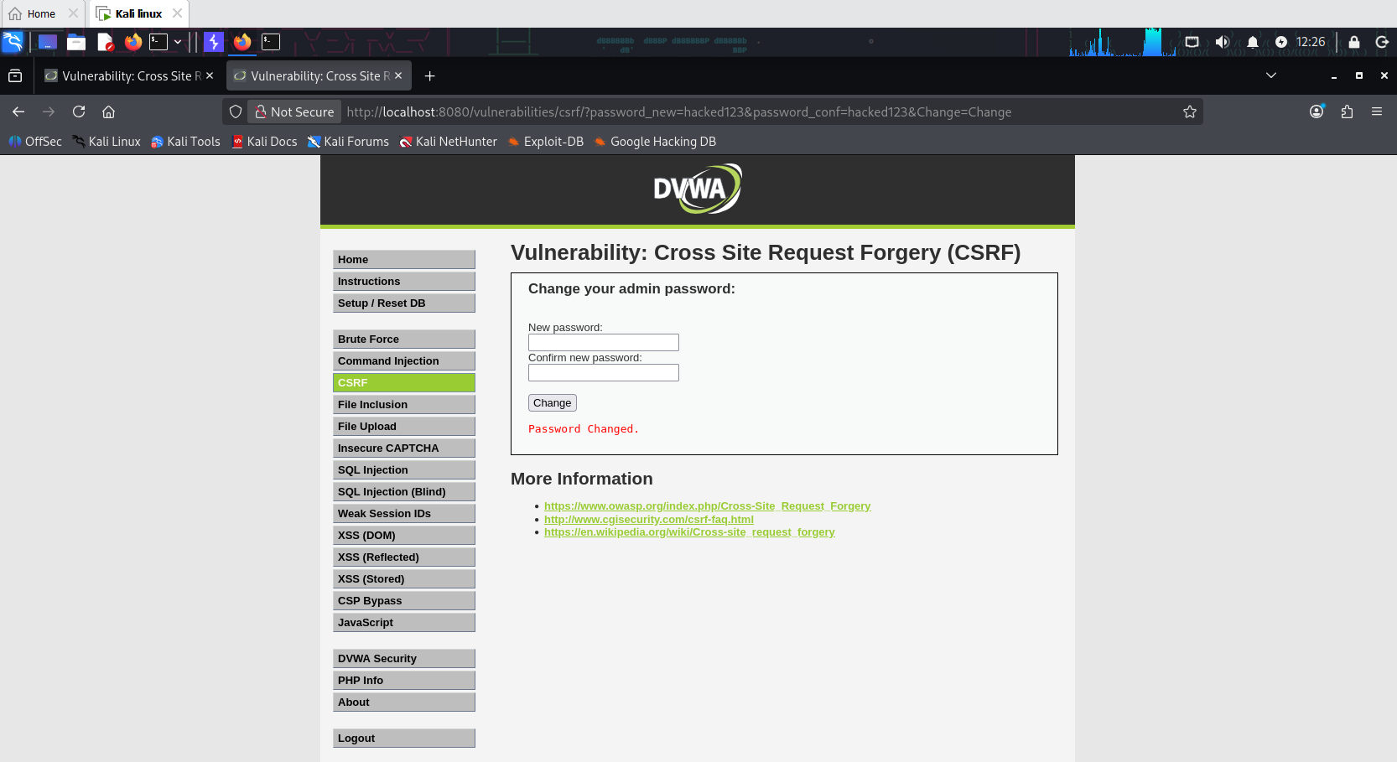
Figure 4.6a — Password successfully changed via the forged cross-site request
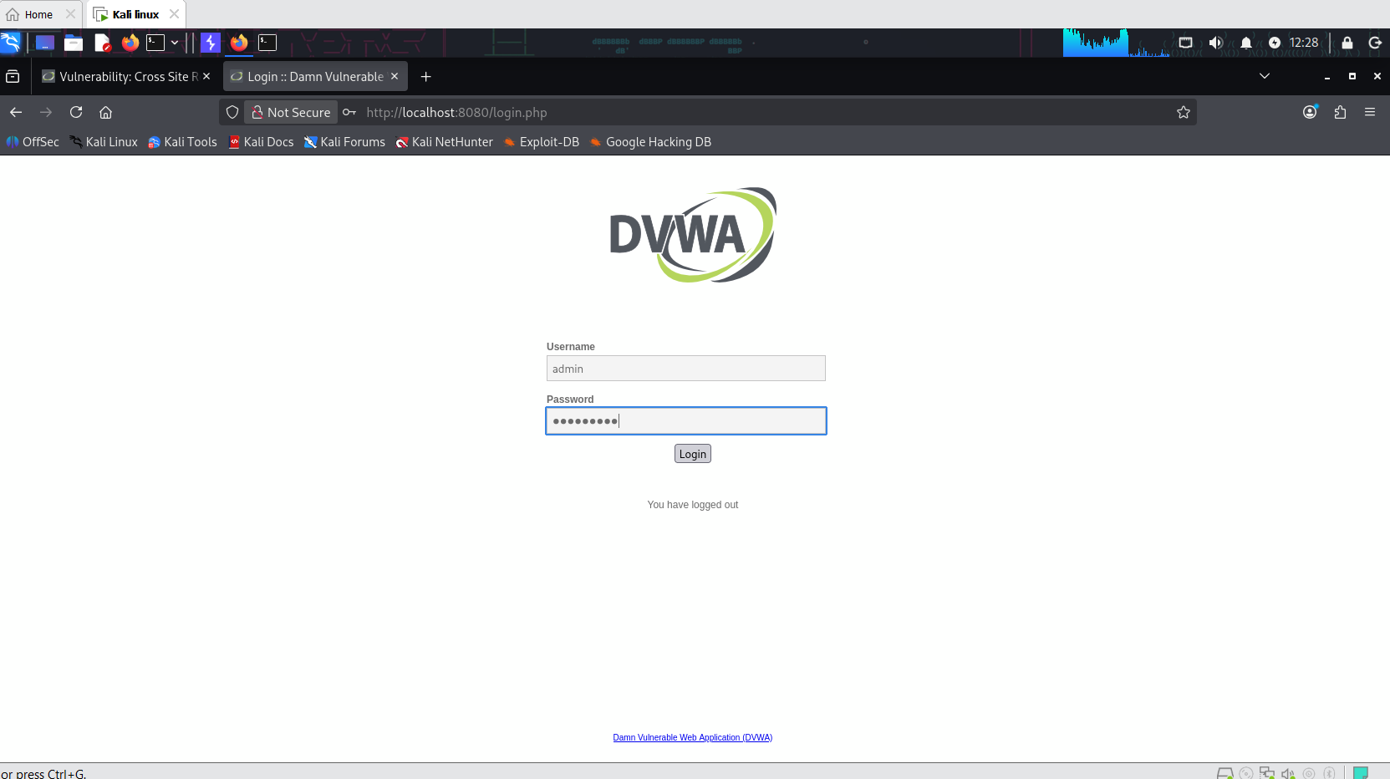
Figure 4.6b — Successful login using the attacker-set password, confirming full exploitation
Impact: An attacker can silently change a victim's password (or perform any other state-changing action) simply by getting them to visit a malicious page, leading to full account takeover.

Remediation
- Implement per-session, unpredictable anti-CSRF tokens on all state-changing requests.
- Require state-changing actions to use POST, never GET.
- Validate the Origin/Referer header as a defense-in-depth measure.

4.7 Command Injection
Severity: Critical | CVSS (approx): 9.8
The 'ping' utility's IP address input was passed directly to a shell command without sanitization, allowing arbitrary OS command execution via shell metacharacters.

Steps to Reproduce
- Submitted 127.0.0.1 && whoami — the ping executed normally, followed by the output of the injected whoami command (www-data).
- Submitted 127.0.0.1 && cat /etc/passwd — the full contents of the system's user account database were disclosed.
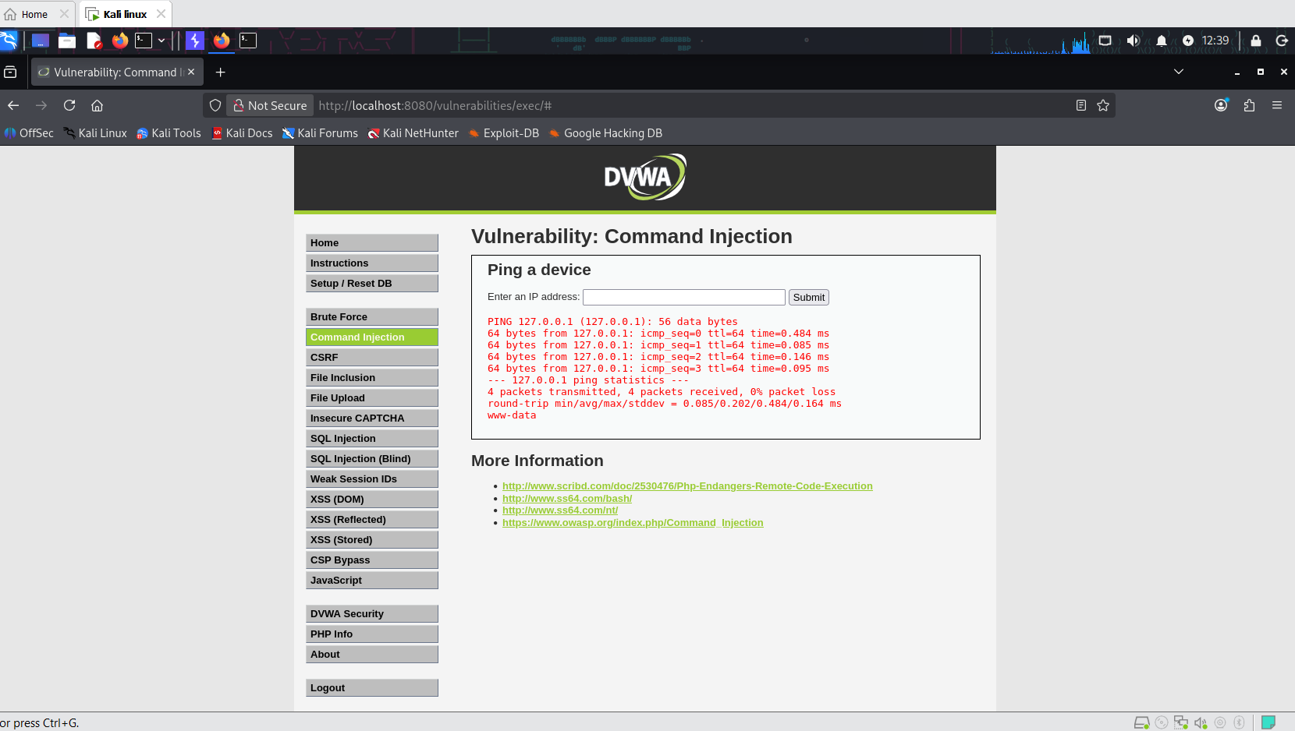
Figure 4.7a — Injected 'whoami' command executing, confirming OS command injection
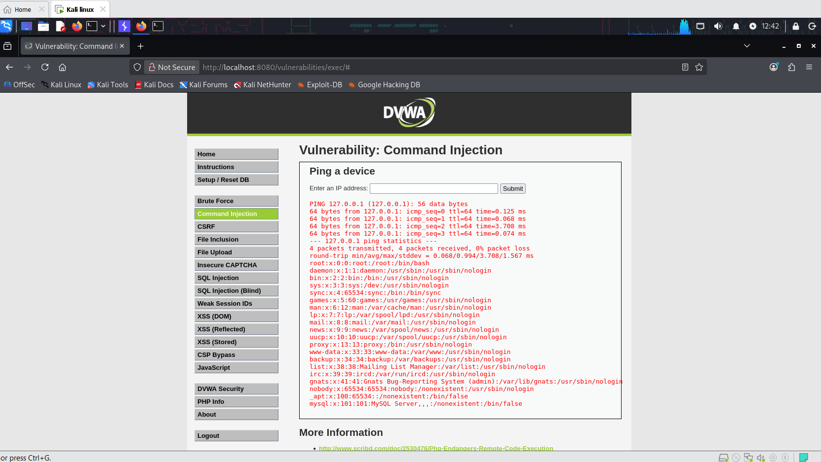
Figure 4.7b — Full /etc/passwd contents disclosed via command chaining
Impact: Full remote code execution as the web server user (www-data), enabling further system compromise, lateral movement, or data exfiltration.

Remediation
- Never pass user input to a shell command; use safe APIs that avoid shell interpretation entirely.
- If shell execution is unavoidable, strictly whitelist allowed input (e.g., valid IPv4 format only).

4.8 Unrestricted File Upload
Severity: Critical | CVSS (approx): 9.8
The file upload feature accepted PHP files without validating file type, content, or extension, allowing a web shell to be uploaded and executed on the server.

Steps to Reproduce
- Created a minimal PHP web shell: <?php system($_GET['cmd']); ?>
- Uploaded the file via the File Upload module; the application confirmed successful upload and revealed the storage path.
- Accessed the uploaded file directly with a cmd parameter (?cmd=whoami) — the server executed the command and returned www-data.
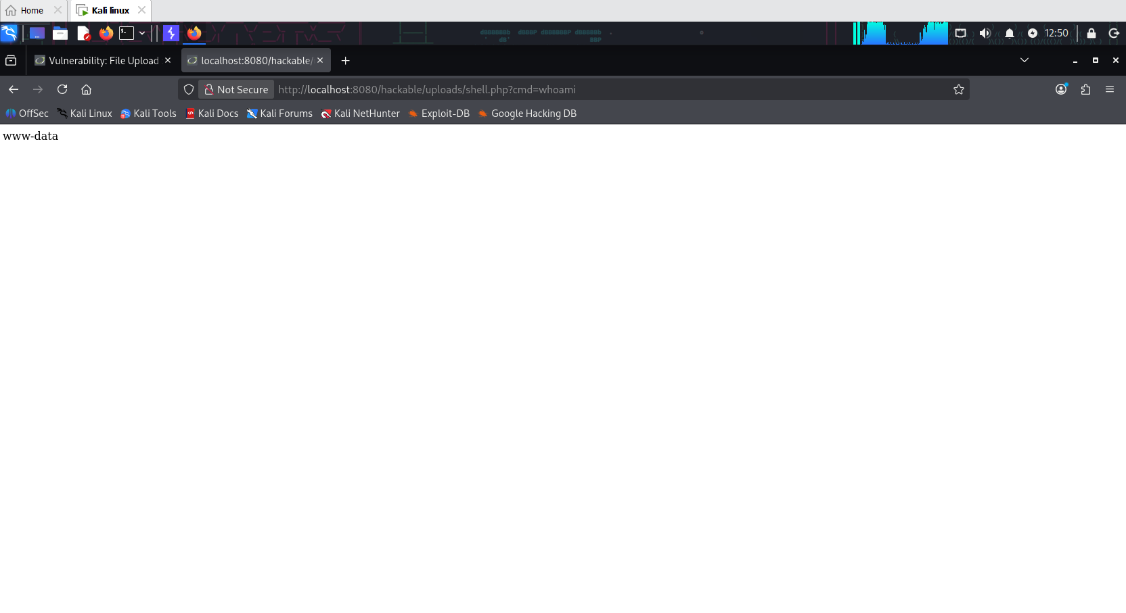
Figure 4.8 — Uploaded web shell executing an arbitrary OS command on the server
Impact: Full remote code execution on the server — the most severe class of finding in this assessment, equivalent to complete server compromise.

Remediation
- Validate file type by content (magic bytes), not just extension or MIME type.
- Store uploaded files outside the web root, or disable script execution in the upload directory.
- Rename uploaded files and restrict allowed extensions to a strict whitelist.

4.9 Local File Inclusion (LFI)
Severity: High | CVSS (approx): 7.5
The 'page' parameter used to include content files was not validated, allowing path traversal sequences to include arbitrary files from the local filesystem.

Steps to Reproduce
- Modified the URL to ?page=../../../../etc/passwd — the full contents of /etc/passwd were rendered directly on the page.
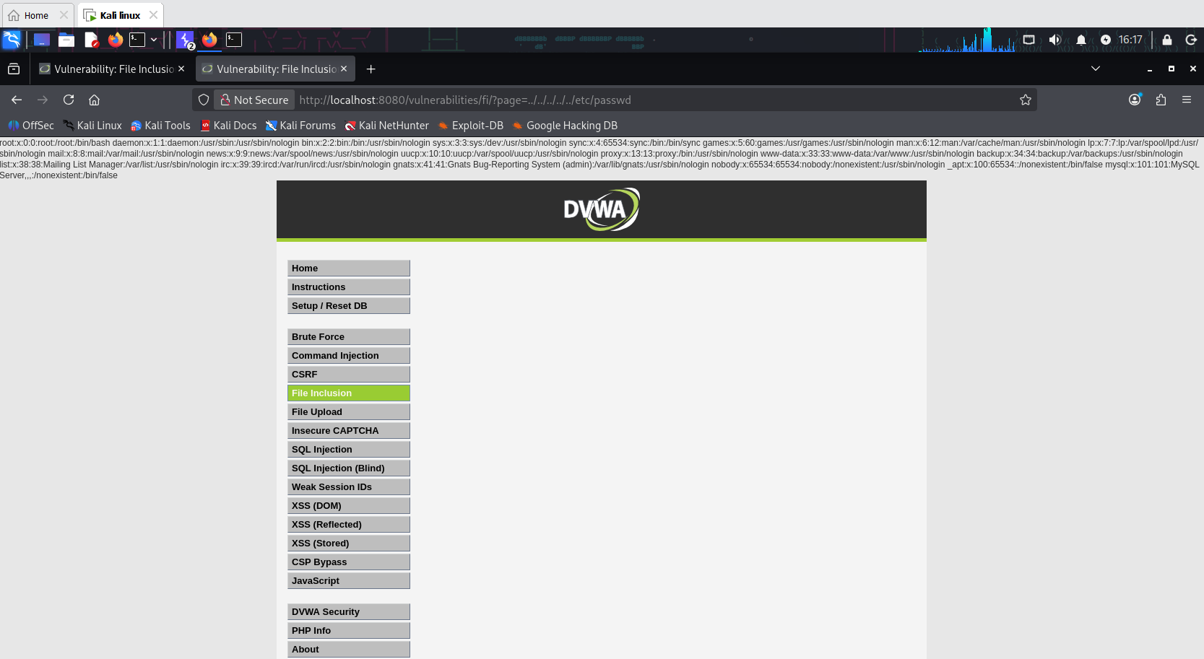
Figure 4.9 — /etc/passwd contents disclosed via path traversal in the 'page' parameter
Impact: Sensitive system file disclosure, and potential remote code execution if combined with the file upload vulnerability (by including an uploaded web shell through this parameter).

Remediation
- Avoid using user input to construct file system paths.
- Use a strict whitelist of allowed page/file values instead of dynamic path construction.

4.10 Security Misconfiguration / Hardening Gaps
Severity: Medium | CVSS (approx): 5.3
DVWA's security level was raised from Low to High to evaluate whether basic hardening mitigated the identified vulnerabilities.

Observations
- XSS (Reflected): the script payload was stripped/sanitized at the High level — the application returned only 'Hello >' with no execution. Mitigation was effective.
- SQL Injection: the same 1' OR '1'='1 payload still returned valid data at the High level. The underlying query remained vulnerable; only DVWA's 'Impossible' level fully remediates this class of issue.
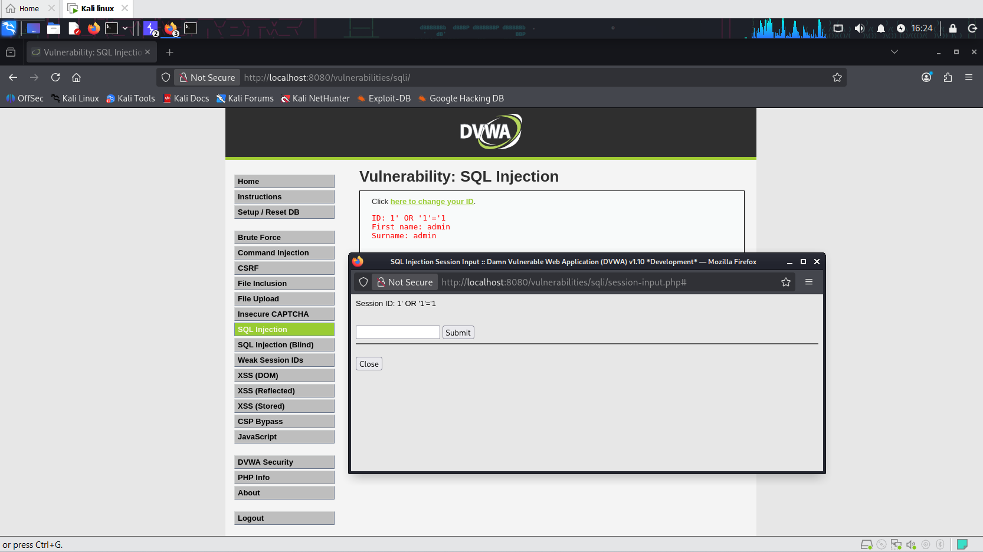
Figure 4.10a — SQL Injection payload still succeeding at the High security level
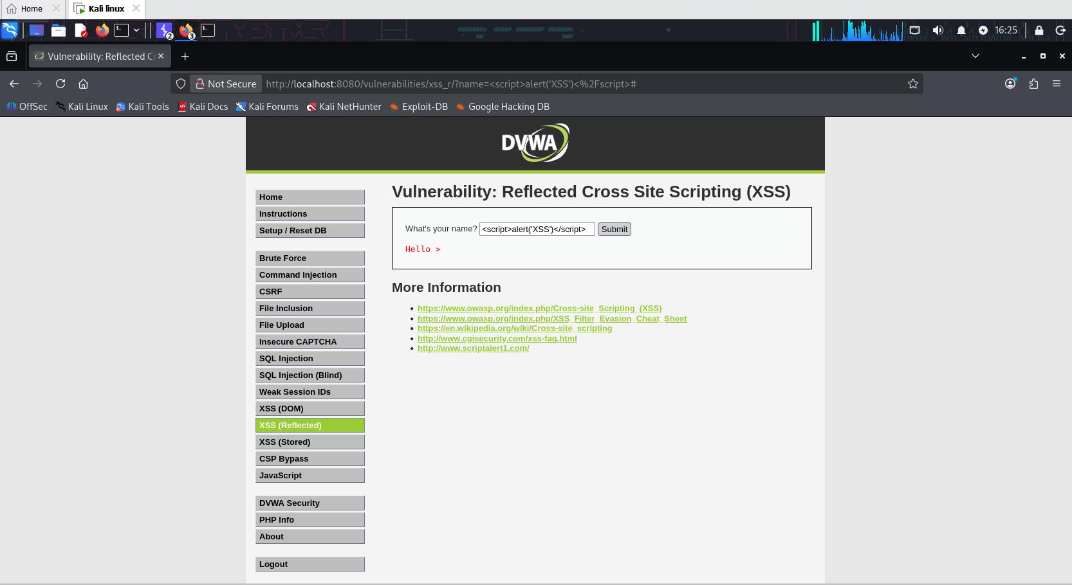
Figure 4.10b — XSS payload sanitized and blocked at the High security level
Impact: Demonstrates that security hardening is inconsistent across an application — some controls (XSS filtering) were meaningfully improved, while others (SQL Injection defenses) remained ineffective at the 'High' configuration level. This highlights the risk of assuming a single hardening pass secures an entire application.

Remediation
- Apply consistent, defense-in-depth controls (parameterized queries, output encoding, WAF rules) across every input, rather than relying on a single configuration tier.
- Validate hardening changes against every vulnerability class, not just the most visible ones.

5. Remediation Summary (Prioritized)
- Priority 1 — Critical: Rewrite all database queries to use parameterized statements (fixes SQL Injection); eliminate direct shell command construction from user input (fixes Command Injection); enforce strict file-type validation and move uploads outside the web root (fixes File Upload).
- Priority 2 — High: Implement anti-CSRF tokens on all state-changing requests; add account lockout / rate limiting to authentication; encode all output to prevent XSS (reflected, stored, and DOM); whitelist file inclusion paths.
- Priority 3 — Medium: Review and standardize security hardening across all modules, ensuring consistent defense-in-depth rather than partial mitigation.

6. Conclusion
This assessment confirmed 10 distinct, exploitable vulnerabilities within DVWA, several of which were successfully chained to demonstrate realistic end-to-end attack scenarios — most notably, credential compromise via SQL Injection and hash cracking, independently reconfirmed through brute-force attack, and full remote code execution achieved via both Command Injection and File Upload. The findings collectively represent a Critical overall risk. Remediation should be prioritized according to Section 5, with particular urgency on injection-class vulnerabilities and file upload handling.

Appendix A — Tools & References
- Burp Suite Community/Professional Edition — https://portswigger.net/burp
- Gobuster — https://github.com/OJ/gobuster
- John the Ripper — https://www.openwall.com/john/
- OWASP Top 10 — https://owasp.org/www-project-top-ten/

