07/08/2019
Project Report for First Week
- What is FIFO?
FIFO is an acronym for first in, first out. A method for organizing and manipulating a data buffer, where the oldest (first) entry, or 'head' of the queue, is processed first. It is analogous to processing a queue with first-come, first-served (FCFS) behavior, where the people leave the queue in the order in which they arrive.
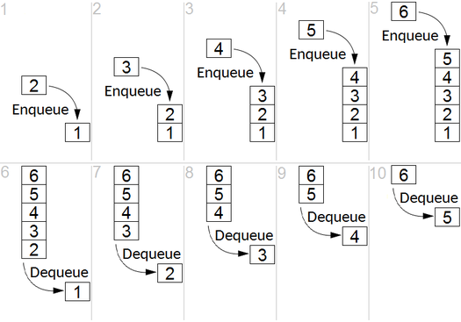
FIFOs are commonly used in electronic circuits for buffering and flow control between hardware and software.
In its hardware form, a FIFO primarily consists of a set of read and write pointers, storage and control logic. Storage may be static random-access memory (SRAM), flip-flops, latches or any other suitable form of storage. For FIFOs of non-trivial size, a dual-port SRAM is usually used, where one port is dedicated to writing and the other to reading.
The first known FIFO implemented in electronics was done by Peter Alfke in 1969 at Fairchild Semiconductors. Peter Alfke was later a director at Xilinx.
- Why FIFO is required and what is multiple clock domain design? What are the applications?
- What is Synchronous FIFO?
A synchronous FIFO is a FIFO where the same clock is used for both reading and writing.
- What is Asynchronous FIFO?
An asynchronous FIFO refers to a FIFO design where data values are written to a FIFO buffer from one clock domain and the data values are read from the same FIFO buffer from another clock domain, where the two clock domains are asynchronous to each other. Asynchronous FIFOs are used to safely pass data from one clock domain to another clock domain. An asynchronous FIFO uses different clocks for reading and writing. Asynchronous FIFOs introduce metastability issues. A common implementation of an asynchronous FIFO uses a Gray code (or any unit distance code) for the read and write pointers to ensure reliable flag generation. One further note concerning flag generation is that one must necessarily use pointer arithmetic to generate flags for asynchronous FIFO implementations.
- How it performs read and write?
A FIFO is first in first out memory. Data being shifted in one end and shifted out the other, with the amount of data in the FIFO being allowed to grow up to some maximum limit.
However, actually shifting data around in memory is costly to do in hardware. A better way is to use a memory more normally but make it look like a circular buffer by manipulation of the next address to write to and read from. These addresses live in separate registers and are often called the read pointer and the write pointer.
Here is a illustration of the state for a simple FIFO using a 8-word memory:
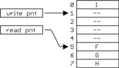
The next incoming word will be written to the empty word at address 1 (the value of the write pointer), then the write pointer incremented to 2. The next read request will fetch the word at 5 (the value of the read pointer), then the read pointer is incremented by 1. In this example, the addresses are automatically circular if the pointers are 3 bits wide. Adding 1 to 7 yields 0 in 3-bit unsigned math.
Complete FIFO systems need ways to identify the full and empty conditions. There are various schemes for this. A separate register could be used to keep track of how many words are in the FIFO.
A useful scheme for a firmware implementation is to compare the read and write pointers. If both pointers equal then FIFO is empty and write one behind read (after wrapping) is FIFO full.

- Can I imagine the write and read pointers and logic?

- How many pins? Functionality of pins?
There can be 6 pins
- Write clock: It is given to write control logic.
- Read clock: To drive read control logic.
- Reset: To perform reset operation. On reset, read and write pointer will initialize to zero.
- Input data: Feed input data to memory
- Output data: Access data from memory.
- Flags: To indicate status of memory.
e.g. full, empty, almost full, almost empty, etc.

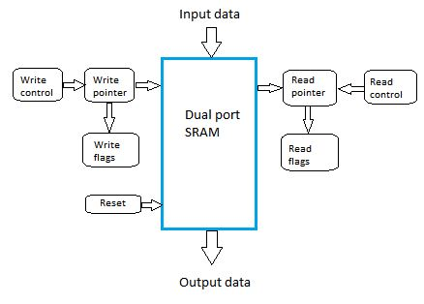
- Can I sketch the top level diagram?

- Now do I know the basics and can I extract specifications?
Now we know the basics of FIFO and extracted the specifications by considering a write frequency as fix and according to that we can extract FIFO size, R/W frequency based on which depth of FIFO is calculated.
- FIFO Size: 1 K bytes
- Input Data Pins: 8
- Output Data Pins: 8
- Write Pointer Pins: 10
- Read Pointer Pins: 10
- Flag Pins: 6 (EMPTY, FULL, HALF FULL / EMPTY, ALMOST FULL, ALMOST EMPTY)
- Reset: 1
- Write Clock (100MHz)
- Read Clock (33MHz)

- Can I define scope of project work?

