# Problem Statement 1: Home Decoration

Description:

“Home Décor”, an interior decoration company wants to automate its process of kitchen interior cost calculation. Implement the below class diagram to achieve the same.

## Class Diagram:

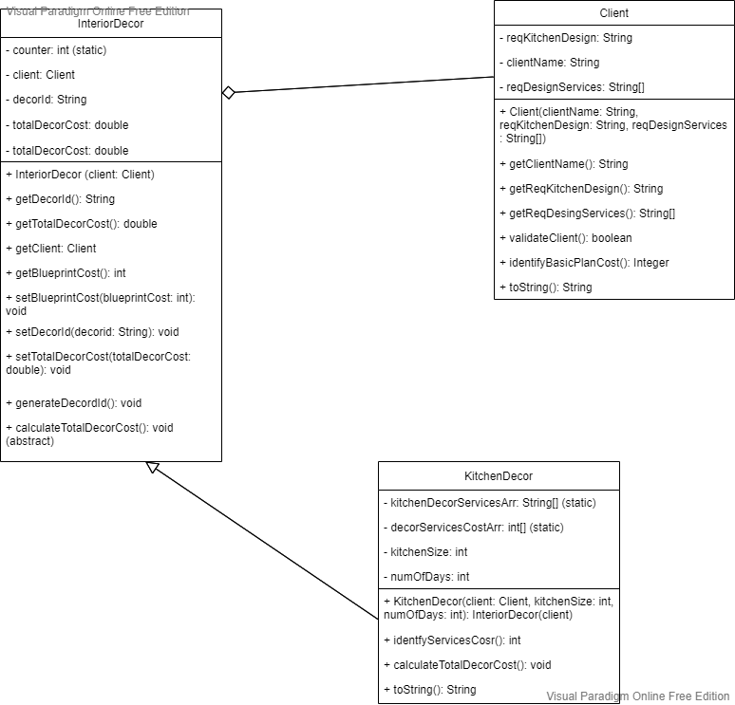

## Client Class:

### identifyBasicPlanCost():

* This method identifies and returns the ***basicPlanCost(Integer)*** based on ***reqKitchenDesign***
* The ***basicPlantCost*** is calculated based on the below-given table:

|  |  |
| --- | --- |
| ***reqKitchenDesign*** | ***basicPlanCost*** |
| “Modular” | 1500 |
| “Italian” | 2500 |
| “Rustic” | 1200 |
| Other Values | 0 |

#### Example:

if the ***reqKitchenDesing*** is “Rustic”, then ***basicPlanCost*** would be 1200 currency.

## InteriorDecor Class:

### generateDecordId():

* This method auto-generates and set the ***decorId (String)***
* This ***decorId*** would be the first two characters of ***reqKitchenDesign*** of the ***Client*** class is uppercase followed by auto-generated value starting from 1001
* The auto-generated value must be incremented by 1 for the subsequent ***decorId***
* Use static variable counter appropriately to implement the auto-generation logic

#### Example:

The first ***decorId*** would be “RU1001” if the ***reqKitchenDesign*** is “Rustic”, the second ***decordId*** would be “MO1002” if the ***reqKitchenDesign*** is “Modular” and so on.

## KitchenDecor Class:

### kitchenDecorServicesArr:

* This is a static array(String[]) containing ***kitchenDecorService(String)*** as its elements
* The initial values of the ***kitchenDecorServicesArr*** are given below:

|  |  |
| --- | --- |
| ***kitchenDecorServicesArr*** | {“Flooring”,”Lighting”,”Cabinet”} |

### decorServicesCostArr:

* This is a static array(int[]) containing ***basicServicesCost(int)*** as its elements
* This array has one-to-one correspondence with ***kitchenDecorServicesArr***
* The initial values of the ***decorServicesCostArr*** are given below:

|  |  |
| --- | --- |
| ***decorServicesCostArr*** | {450,200,2000} |

### identifyServicesCost():

* This method calculates and returns the ***decorServicesCost(int)*** based on the logic below:
* For each ***reqService(String)*** in the ***reqDesignServices(String[])*** of Client class.
  + If the ***reqService*** is an element of the ***kitchenDecorServicesArr***, identify the corresponding ***basicServicesCost(int)*** from the ***decorServicesCostArr***
* If none of the elements of ***reqDesignServices*** are present in the ***kitchenDecorServicesArr*** or if ***reqDesignServices*** is null, then ***decorServicesCost*** would be -1
* Return ***decorServicesCost***

#### Assumption:

* The value of ***reqDesignServices*** would be either null or an array with at least one String element
* The ***reqDesignServices*** would not contain duplicate elements (even in case-insensitive format)

#### Example:

If the ***reqDesignServices*** is (“Flooring”. “Cabinet”, “Plumbing”), then the ***decorServicesCost*** would be 2450 currency.

### calculateTotalDecorCost():

* This method generates the ***decorId(String)***, calculates and sets the ***totalDecorCost(double)*** based on the logic below:
* Invoke the ***identifyServicesCost()*** method to obtain the ***decorServicesCost(int)***
* Invoke the ***validateClient()*** method of the ***Client*** class.
* If the ***decorServicesCost*** is not -1 and the above method returns true and ***numOfDays*** is more than 0,
  + Invoke the ***identifyBasicPlanCost()*** method of Client class to identify ***basicPlanCost(int)***
  + If the ***basicPlanCost*** is not 0,
    - Check if the ***reqDesignServices*** contains “Flooring” as one of its elements
    - If so,
      * Update the identified ***decorServicesCost*** by deducting the initial “Flooring” ***basicServiceCost(int)***
      * Add product of individual ***basicServicesCost*** of “Flooring” and the ***kitchenSize***(***int***, would be in measure of square feet) to ***decorServicesCost***
      * Set the value of ***blueprintCost(int)*** as 75 currency for every square feet of ***kitchenSize*** in total
* Otherwise, ***blueprintCost*** would be set to 2500 currency.
* Identify the ***decorServicesCost*** for total ***numOfDays*** as ***totalDecorServicesCost(int)***
* Obtain the ***totalCost(double)*** as a sum of ***totalDecorServicesCost***, ***basicPlanCost*** and ***blueprintCost***
* If the ***totalCost*** greater than or equal to 200000 currency, update the ***totalCost*** by applying a discount of 5%
* Set the value of ***totalDecorCost*** with the above calculated ***totalCost***
* Generate the ***decorId*** by invoking ***generateDecorId()*** method of ***InteriorDecor*** class
* Otherwise, set ***totalDecorCost*** to -1, 0 and ***decorId*** to “NA” in upper case.
* Otherwise, set ***totalDecorCost*** to -1, 0 and ***decorId*** to “NA” in upper case

#### Example:

If the ***clientName*** is ‘Kevin:, ***reqKitchenDesign*** is “Rustic”, ***reqDesignServices*** is {“Flooring”, ”Cabinet”, “Plumbing”}, ***kitchenSize*** is 100 square feet and ***numOfDays*** is 5, then the ***decorId*** would be “RU1001” (assuming the first ***decorId***), and ***totalDecorCost*** would be 23515.0 currency.