**Heliware Plugin**

Heliware plugin exports QGIS data directly onto the Heliware for further analysis and free 3D map creation purposed after signing free account on Heliware. Its also provide vector data quality control feature for QGIS.

**Documentation**

The Heliware integrates with QGIS through the Heliware QGIS plugin. The plugin enable to export of vector layer map from QGIS into Heliware layer for more analysis and further visualization. The Heliware Plugin is design as simple and easy to use.

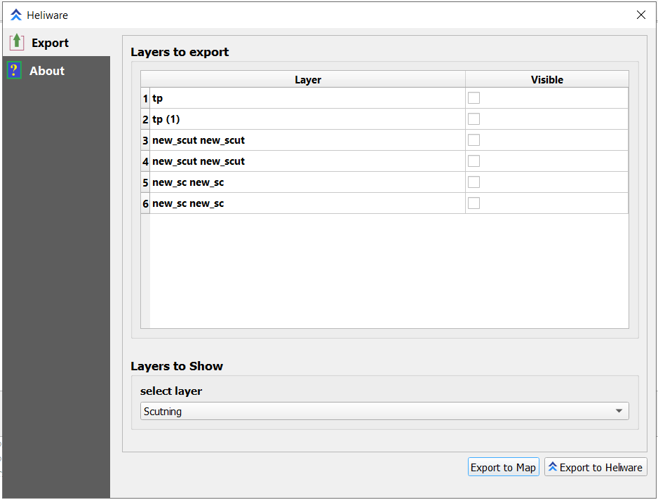

**UI of Heliware Plugin**

Heliware Plugin has two Windows first one is Export and second one is about.

Export sub divided into two parts first one is Layer to Export to show all export layer from QGIS and here make selection as per requirement, Next step is to select layer in which output of selected layer required to shows on QGIS.

**Heliware Plugin functionality**

The following section explain the functionality of Plugin. Before start working on Heliware Plugin, add datasets for data file in QGIS.

**Layers to Export**

All the layer will exported into Plugin, user can select layer multiple layers as a input layers.

**Layers to show**

We have three visualization layer option to shows on QGIS, User must need to select at least one layer from “Layers to Export” as a input layer and then select visualization layer from Layers to show. Following are the visualization layer and there functionality:

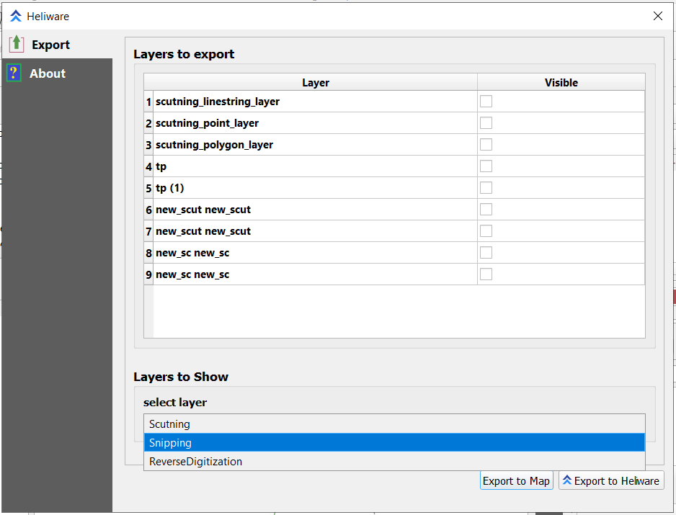

**Three Different types of layers**

* **Scutning :** Scutning show similar area cover by more then one geometry or geometry type weather geometry type will be point, linestring or polygon. Scutning support LineString and Polygon geometry type.

Example: As shown in image, after applying Scutning we have similar portion from

input layer, for polygon the similar area shown in red color and input is in yellow color and for linestring output scutning shows in blue color and input in gray color.

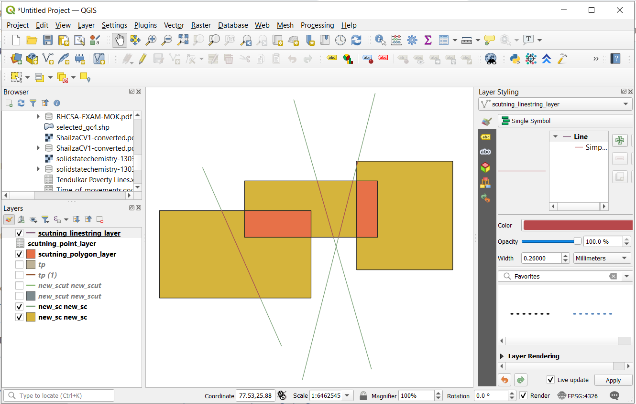

**Scutning layer output with input layer**

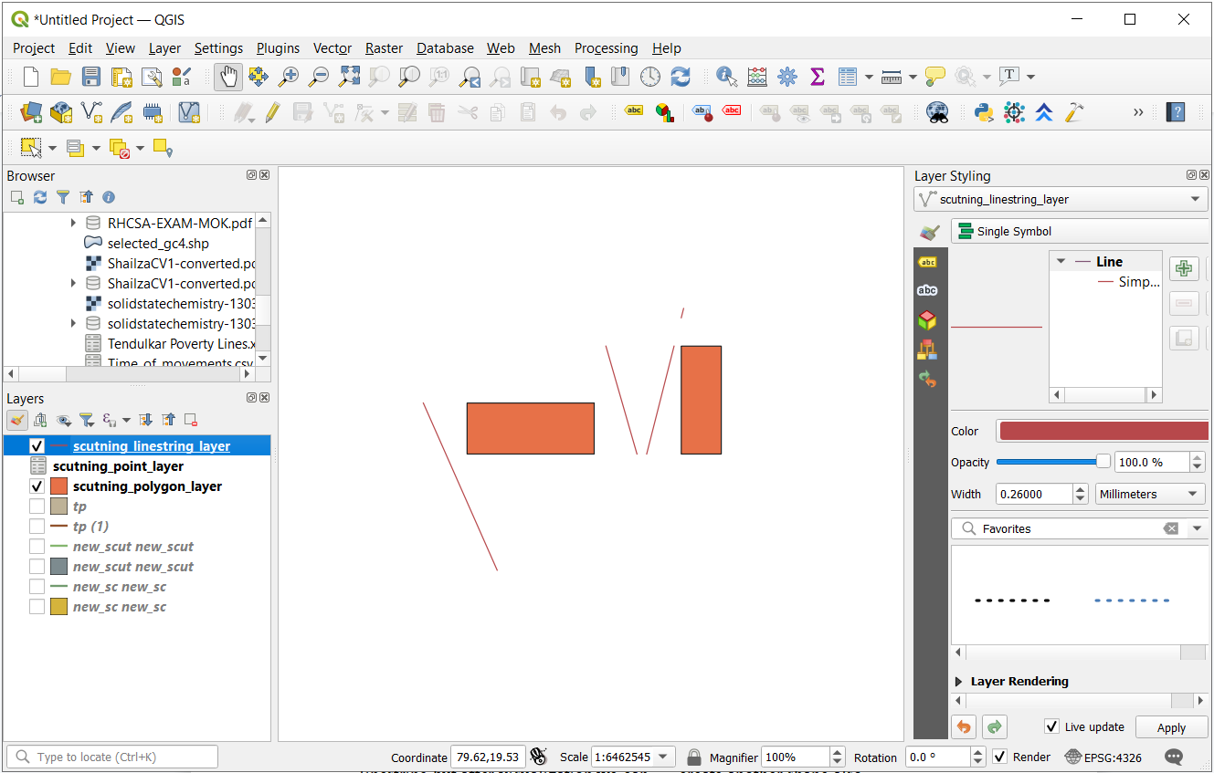

**Scutning layer output**

* **Snipping:** Snipping perform an functionality to analysis layer and create another geometry by slicing coordinates. Snipping support geometry type LineString or polygon. Means snipping work on one geometry type at a time either it will be linestring or polygon.

Example: Geometry type Linestring are selected in plugin where Linestring look as first image, this layer create open shape with linestring but after visualization we can create another shape also.

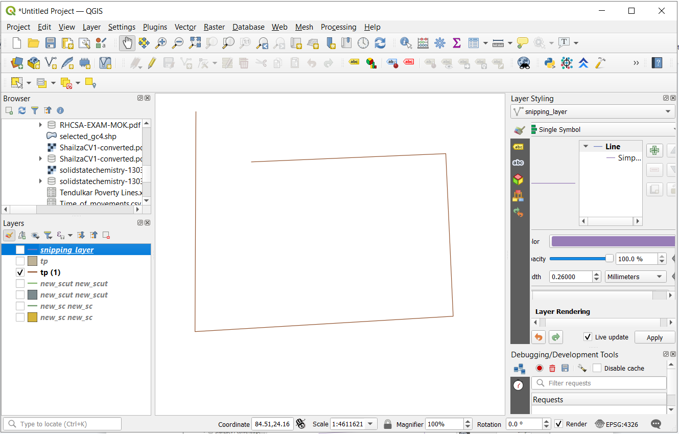

**Snipping input layer**

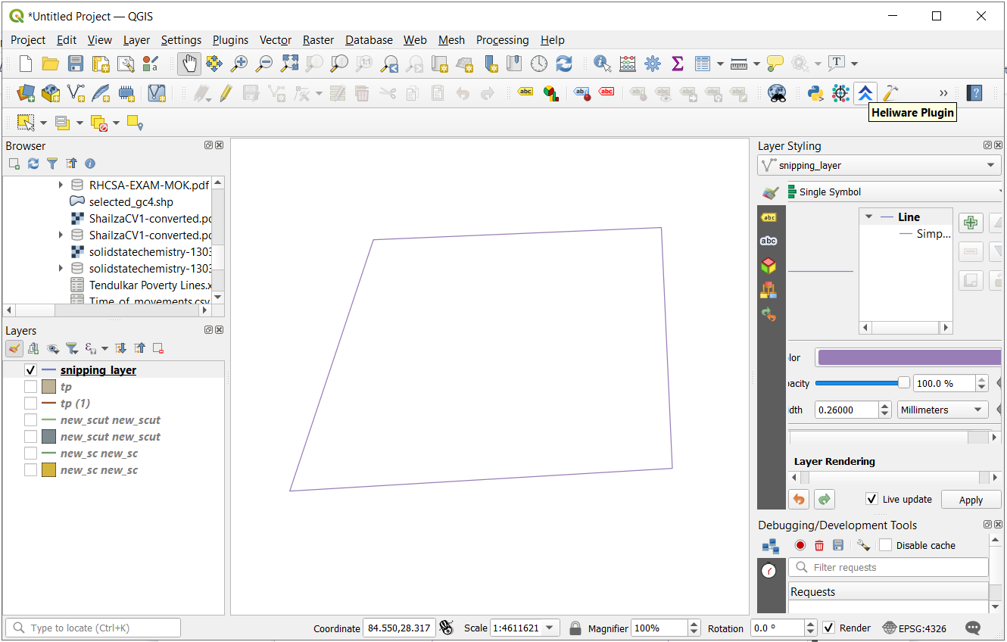

**Snipping output layer**

As shown in above image After performing snipping there is one close shape different from previous input layer. Snipping work on both Linestring and polygon

* **ReverseDigitization:** Reverse Digitization differentiate between two geometry. Find out area of geometry except from similar area of both the geometry or find out area of geometry except from intersection of two geometry. Reverse Digitization support geometry type LineString and polygon.

Example: There are two layer both are polygon geometry with same shape but polygon of “BOUNDARY2” layer is smaller then polygon of “BOUNDARY1” layer. In below image both the geometry are in one frame where intersection area is complete polygon of layer “BOUNDARY2”, but in reverse digitization we found area of geometry apart from intersection of geometries

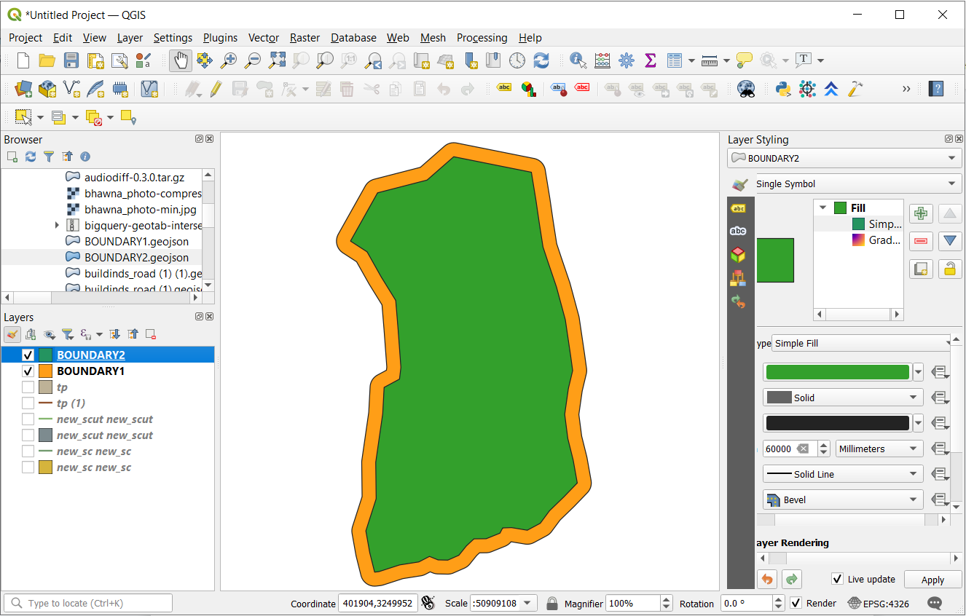

**Reverse Digitization input layer**

After performing Reverse Digitization we have a out layer as shown in below image.

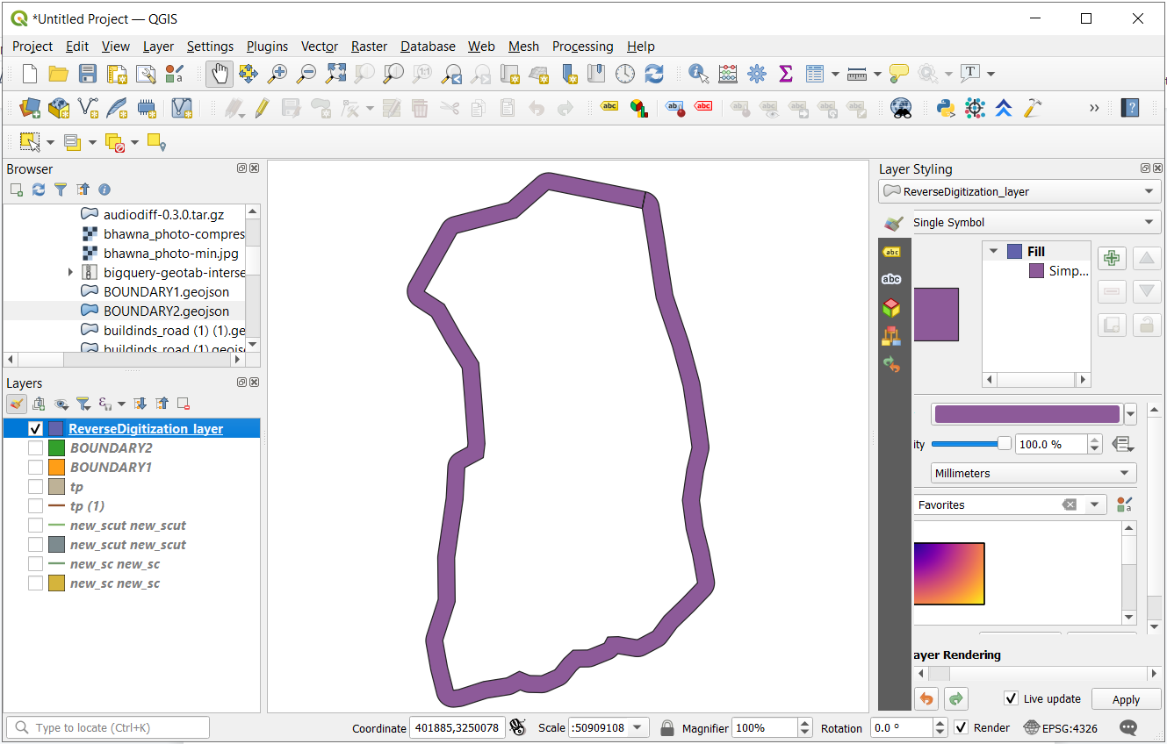

**Reverse Digitization output layer**

**Export to Map**

Export to Map button shows the output in QGIS. By clicked Export to Map one more new output layer will generate which contain only final output coordinates. For example Snipping was selected then one output layer of name Snipping will generate. In below image “tp(1)” is input layer and “snapping_layer” is new generated output layer after clicked Export to Map button.

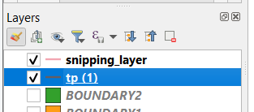

**Export to Heliware**

By Export to Heliware user will navigate to Heliware Application where user can use more Heliware Visualization feature.