[Project Title]
Attribute-Level Sentiment Analysis of Amazon Electronics Reviews for Product Management
Final Project Report
[Team Members]
[Course Code]
[Professor]
[Date]
Table of Contents
1. Executive Summary 1
2. Introduction and Business Problem 2
2.1 Background and Context 2
2.2 Problem Statement 2
2.3 Motivation and Importance 2
2.4 Objectives and Research Questions 3
2.5 Scope and Expected Outcomes 3
2.6 Business Use Cases and Beneficiaries 3
3. Literature Review and Analytical Background 4
3.1 From Review Mining to Aspect-Based Sentiment Analysis 4
3.2 Pretrained Transformers for ABSA 4
3.3 Word Embeddings for Attribute Matching 5
3.4 Reviews, Ratings and Business Value 5
3.5 Statistical Background 5
3.6 Gaps and Chosen Direction 6
4. Data Description and Preparation 6
4.1 Data Source 6
4.2 Dataset Overview 7
4.3 Data Quality Assessment and Cleaning 8
4.4 Transformation, Feature Engineering and Integration 9
5. Methodology and System Architecture 9
5.1 Analytical Framework and Workflow 9
5.2 Attribute Detection 10
5.3 Aspect-Level Sentiment Scoring 10
5.4 Aggregation 11
5.5 Statistical Model, Selection and Evaluation 11
5.6 System Architecture and Technologies 12
5.7 Efficiency, Scalability and Reproducibility 13
5.8 Implementation Challenges 13
6. Results and Analysis 14
6.1 Pipeline Coverage 14
6.2 Which Attributes Customers Discuss and Criticise (RQ1) 14
6.3 Attribute Sentiment and Star Ratings 15
6.4 Subcategory Regressions (RQ2) 16
6.5 Robustness: Multicollinearity Check 18
6.6 Product Score Card (RQ3) 18
6.7 Expected and Unexpected Findings 19
7. Discussion and Business Implications 19
7.1 Answers to the Research Questions 19
7.2 Implications for Decision-Making 20
7.3 Comparison with the Literature 20
7.4 Organisational, Ethical and Operational Considerations 20
7.5 Supported Conclusions versus Potential Benefits 21
8. Limitations and Future Improvements 21
9. Conclusion and Recommendations 22
10. References 23
Appendix A: Data Dictionary 25
Appendix B: Data Preparation Rules 26
Appendix C: Technical Implementation 27
Appendix D: Additional Results 28
Appendix E: Model Evaluation 30
Appendix F: Expanded Architecture and Pipeline 33
Appendix G: Attribute Dictionary by Subcategory 34

1. Executive Summary
A star rating tells an e-commerce product manager how satisfied customers are, but not why. Thousands of free-text reviews contain that explanation, yet no team can read them all, and a product's average rating hides which features customers praise or criticise. This project builds a reproducible pipeline that turns review text into attribute-level evidence that a product manager can act on.
We analysed 30,740 Amazon Electronics reviews of 17,452 products in 22 subcategories, drawn from the Amazon Reviews 2023 dataset [1]. The pipeline, written in R, splits reviews into 84,342 sentences. It detects the product attributes each sentence mentions using a subcategory-specific dictionary of 60 attributes, expanded with fastText word embeddings [2], [3]. It then scores the sentiment towards each detected attribute with a pretrained DeBERTa-v3 aspect-based sentiment model [4], [5], called from R through reticulate. The results are aggregated into review × attribute and product × attribute tables. Finally, one ordinary least squares (OLS) regression per subcategory relates the star rating to each attribute’s sentiment score and coverage.
The system detected at least one attribute in 72.8% of sentences and 85.9% of reviews (68,013 attribute mentions, 71.1% positive). Connectivity, compatibility and battery are the most criticised high-volume attributes, and noise is the only frequently mentioned attribute with net-negative sentiment. Mean ratings fall from 4.60 to 3.85 stars as reviews discuss more attributes (zero to seven). In the two best subcategory models, attribute features explain about 55% of rating variance (adjusted R² 0.558 for cables and 0.551 for peripherals). Fit and charging sentiment carry the largest coefficients for cables, while build quality dominates peripherals. Holding sentiment constant, writing more about an attribute is associated with lower ratings, which suggests that dissatisfied customers elaborate. No pair of predictors is correlated above |r| = 0.70.
Recommendations: (1) use the product × attribute score card to find defects that averages hide, for example a security camera with 36 of 45 connectivity mentions negative; (2) prioritise improvements by subcategory, not catalogue-wide; (3) validate the attribute and sentiment labels on a human-annotated sample before using the outputs for operational decisions; and (4) extend the analysis with ordinal models and the full catalogue.

2. Introduction and Business Problem

2.1 Background and Context
Online marketplaces rely on customer reviews to signal product quality. Reviews influence purchase decisions, and negative reviews influence them more strongly than positive ones [6]. For a product manager, reviews are also a free and continuous stream of feedback about specific product features. Research has shown that feature-level opinions extracted from review text carry economic information beyond the star rating [7]. In practice, however, most retail dashboards still summarise this feedback as an average rating and a review count.

2.2 Problem Statement
A single star rating cannot tell a product manager which attributes, such as battery life, fit, connectivity or build quality, drive satisfaction or dissatisfaction. The volume of reviews makes manual reading impractical. The attributes that matter also differ by product type: sound matters for headphones, fit for phone cases, and charging for cables. The business problem is therefore to extract attribute-level sentiment from review text at scale and quantify how it relates to star ratings, separately for each product subcategory.

2.3 Motivation and Importance
Knowing which attribute is responsible for low ratings lets a team target engineering fixes, supplier quality checks, listing content and customer-service scripts at the actual cause. Ratings on Amazon are strongly skewed towards five stars [8], so averages compress differences between products and hide minority complaints. Attribute-level evidence gives a sharper signal. It matters to product managers, category managers and quality-assurance teams, and indirectly to shoppers, who benefit from better products and more informative listings.

2.4 Objectives and Research Questions
The project builds an end-to-end, R-based pipeline that measures attribute-level sentiment in electronics reviews and explains star ratings with it. It addresses three research questions:
- RQ1. Which attributes do customers discuss most, and which attract the most negative sentiment?
- RQ2. How much of the variation in star ratings do attribute sentiment and attribute coverage explain, and which attributes matter most within a subcategory?
- RQ3. Can the outputs be packaged into a product-level view that helps a product manager find and prioritise attribute problems?

2.5 Scope and Expected Outcomes
The scope is a sample of 30,740 English-language reviews from the Electronics category, grouped into 22 subcategories. Attributes are limited to a curated dictionary of 60 attributes, six to eight per subcategory. Sentiment comes from a pretrained model and is not fine-tuned. Regressions are explanatory, not causal or predictive. The expected outcomes are (a) a sentence-level table of detected attributes and sentiment scores, (b) review × attribute and product × attribute tables, and (c) subcategory regression results that rank attributes by their association with ratings.

2.6 Business Use Cases and Beneficiaries
- Product managers: a per-product score card that shows which attributes generate negative reviews, for defect triage and roadmap prioritisation.
- Category managers: subcategory-level drivers of ratings, for supplier selection and assortment decisions.
- Marketing and listing teams: attributes that customers praise, to highlight in product copy.
- Customer service: recurring attribute complaints, for proactive FAQs and troubleshooting guides.

3. Literature Review and Analytical Background

3.1 From Review Mining to Aspect-Based Sentiment Analysis
Hu and Liu [9] framed review mining as three steps: extracting the product features that customers comment on, deciding whether each opinion is positive or negative, and summarising the results by feature. This idea became aspect-based sentiment analysis (ABSA). The SemEval ABSA shared tasks [10], [11] standardised it into subtasks such as aspect-term extraction, aspect-category detection and aspect-level polarity classification, with benchmark datasets in the restaurant and laptop domains. A recent survey [12] shows that the field has moved from lexicon and rule-based methods to neural and pretrained-language-model approaches.

3.2 Pretrained Transformers for ABSA
BERT [13] introduced bidirectional transformer pre-training followed by task-specific fine-tuning. Sun et al. [14] showed that ABSA works well as a sentence-pair task, in which the aspect is supplied as an auxiliary input alongside the sentence. DeBERTa [15] improved on BERT with disentangled attention, and DeBERTa-v3 [4] added ELECTRA-style pre-training. Pretrained checkpoints are distributed through the Hugging Face Transformers library [16]. The model used here, sy12ssss/absa-deberta-v3, is a DeBERTa-v3-base model fine-tuned on SemEval restaurant and laptop data. Its model card reports 82.1% accuracy on a held-out test set [5]. Most public ABSA models are trained on these two domains, so applying them to other electronics subcategories involves domain shift.

3.3 Word Embeddings for Attribute Matching
Dictionary matching misses synonyms and misspellings. Distributional word embeddings address this by placing words with similar meanings close together in vector space. GloVe [17] learns vectors from global co-occurrence counts. fastText [2] represents each word as a bag of character n-grams, so it can build vectors for rare, misspelled or unseen words. The Common Crawl fastText vectors [3] provide 300-dimensional English embeddings trained on web text, which is closer to informal review language than curated corpora.

3.4 Reviews, Ratings and Business Value
Archak et al. [7] used text mining of Amazon reviews to show that individual product features carry measurable pricing power, which supports moving beyond star ratings. Chevalier and Mayzlin [6] found that one-star reviews have a larger effect on sales than five-star reviews. This matches the broader negativity bias in psychology, which finds that bad information is processed more thoroughly than good [18]. Mudambi and Schuff [19] showed that review depth affects perceived helpfulness, so how much a reviewer writes is itself informative. Hu et al. [8] documented the J-shaped distribution of online ratings, caused by purchase and under-reporting biases. As a result, rating data are dominated by five-star reviews, and averages should be interpreted with care.

3.5 Statistical Background
OLS estimates the linear association between a continuous outcome and a set of predictors. Its coefficients can be read individually only when the predictors are not strongly collinear. A widely used rule of thumb, supported by simulation evidence, is that pairwise correlations above |r| = 0.7 signal collinearity that seriously distorts estimates [20]. Star ratings are ordinal, so ordered (cumulative logit) models [21] are the theoretically preferred alternative. OLS remains common because its coefficients are directly interpretable in rating points.

3.6 Gaps and Chosen Direction
ABSA research mostly optimises classification accuracy on benchmark datasets and rarely links aspect sentiment to business outcomes. Econometric studies that do make this link typically cover only a few product types. Few works combine (a) subcategory-specific attribute vocabularies, (b) a pretrained aspect-sentiment model and (c) a separate explanatory model for each product type. This project combines these three elements. It uses fastText for robust attribute detection, an aspect-conditioned DeBERTa-v3 classifier for sentiment, and per-subcategory regression for interpretation, all within the course constraint of an R-based pipeline.

4. Data Description and Preparation

4.1 Data Source
The data come from Amazon Reviews 2023, released by the McAuley Lab at UC San Diego [1]. It contains more than 570 million reviews across 33 categories. We used the Electronics category. Each record combines review fields (rating, title, text, helpful votes, verified purchase) with product metadata (average rating and number of ratings). Our working file contains 30,740 reviews. [TO CONFIRM: sampling procedure used to draw the 30,740 reviews and the review time period covered.] Each review was assigned one of 22 product subcategories (for example cables, headphones, protection, security) using AI-assisted (large-language-model) categorisation of the product.

4.2 Dataset Overview
Table 1. Dataset overview
Item | Value
Reviews / products | 30,740 reviews of 17,452 products (median 1 review per product; maximum 659)
Subcategories | 22 (largest: protection 6,007; smallest: specialized 84)
Fields | asin, rating, title, text, helpful_vote, verified_purchase, metadata_average_rating, metadata_rating_number, subcategory
Target variable | rating (1–5 stars)
Rating distribution | 1★ 2,818 · 2★ 1,155 · 3★ 1,612 · 4★ 3,227 · 5★ 21,928 (71.3% five-star)
Verified purchases | 96.4%
Review length (title + text) | median 19 words, mean 33, maximum 1,447
Attribute dictionary | 1,529 rows (subcategory, attribute, term); 60 distinct attributes; 6–8 per subcategory
Source: Amazon Reviews 2023, Electronics sample (n = 30,740 reviews); project pipeline v2 outputs.
Ratings follow the J-shape typical of online reviews [8] (Figure 1). Seven in ten reviews give five stars, so dissatisfied customers are a minority whose feedback is easily lost in an average. Subcategory sizes vary by a factor of more than 70 (Figure 2), which matters for the reliability of the subcategory models.
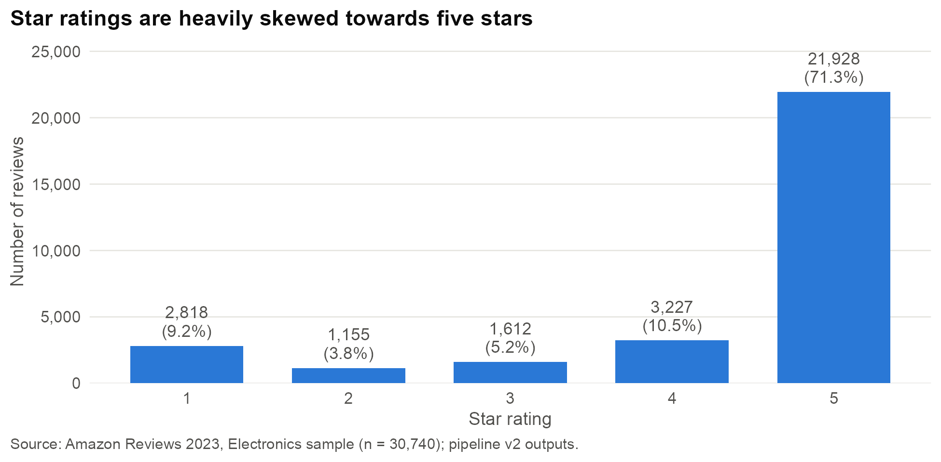
Figure 1. Distribution of star ratings in the review sample
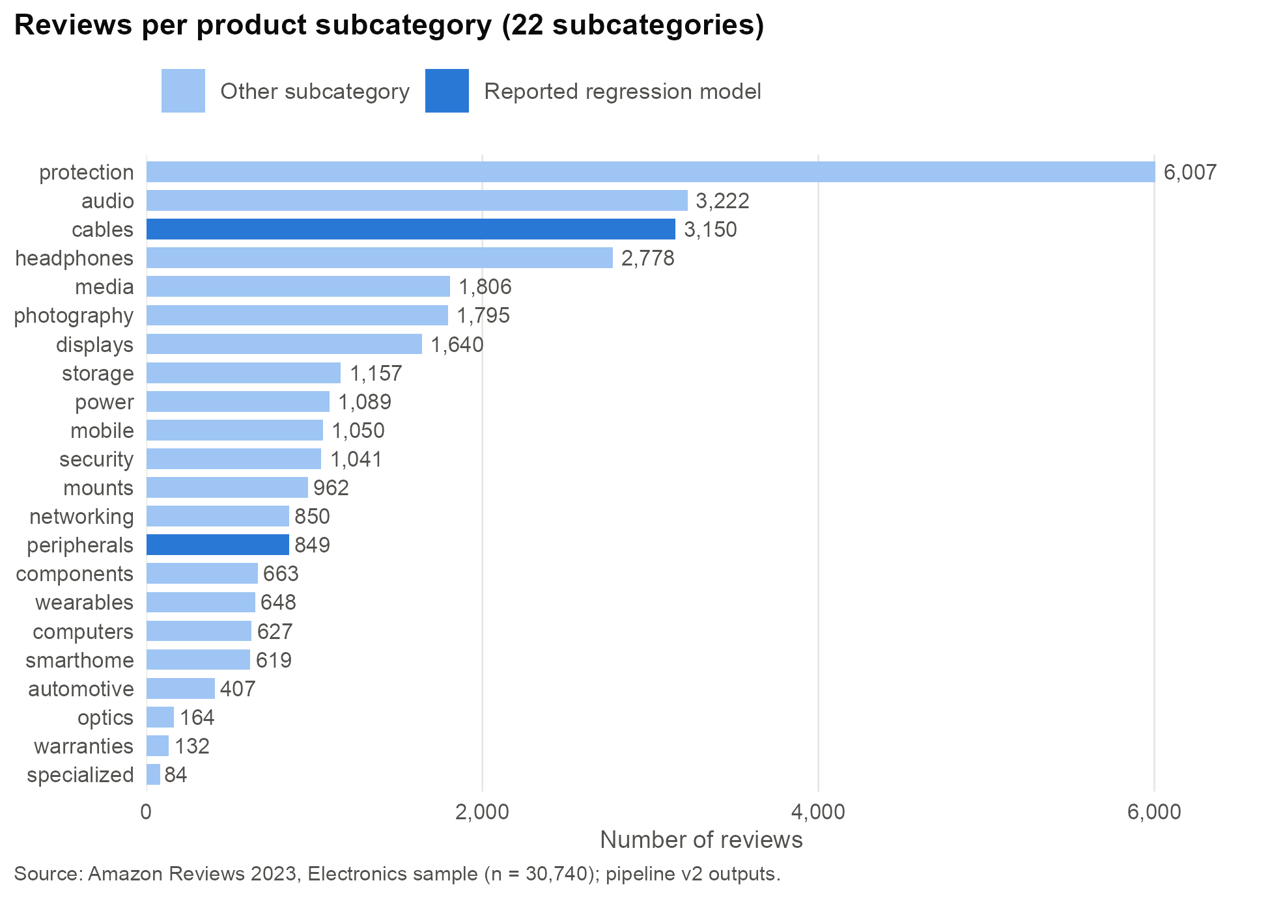
Figure 2. Number of reviews per product subcategory (darker bars: subcategories reported in Section 6)

4.3 Data Quality Assessment and Cleaning
- Missing values: 3 reviews had no text and 6 had no title. Missing parts were replaced with empty strings before concatenation, so a review is still analysed if either part exists.
- Encoding and markup: invalid UTF-8 bytes were removed (iconv), HTML tags were stripped and whitespace was normalised. Two reviews produced no sentence after cleaning, leaving 30,738 for analysis.
- Duplicates: 356 rows repeat the same product, title, text and rating, and 2,601 texts occur more than once. Most are short generic reviews such as “Good” (159 times) or “Great product” (111). They were kept because they can be genuine independent reviews, and they rarely contain attributes.
- Outliers: review length is highly skewed (99th percentile 215 words). Long reviews were kept. The transformer input is bounded by the three-sentence window and 256-token truncation.
- Sparsity: most products have a single review in the sample, so product-level score cards are reliable only for products with many reviews.

4.4 Transformation, Feature Engineering and Integration
Each review’s title and text were concatenated, because titles carry concentrated sentiment (for example “So easy to use”). Reviews were then split into 84,342 sentences (mean 2.7 per review) with the tokenizers package [22]. The attribute dictionary was joined by subcategory, so each review is matched only against the attributes defined for its product type. Three features were engineered for every review × attribute pair: attribute score (mean sentence sentiment, −1 to +1), attribute count (number of sentences mentioning the attribute) and attribute coverage (count divided by the review’s total sentences). The data were reshaped from a wide sentence table (one column per attribute) to a long review × attribute table (218,397 rows) and a product × attribute table (124,110 rows). Appendices A, B and G give the data dictionary, cleaning rules and attribute dictionary.

5. Methodology and System Architecture

5.1 Analytical Framework and Workflow
The methodology has two layers (Figure 3). The measurement layer turns unstructured text into structured attribute-level sentiment (steps 1–5). The explanation layer uses those measurements to describe products (step 6a) and to explain star ratings (step 6b). Keeping the layers separate lets either one be improved, for example by swapping in a better sentiment model, without changing the other.
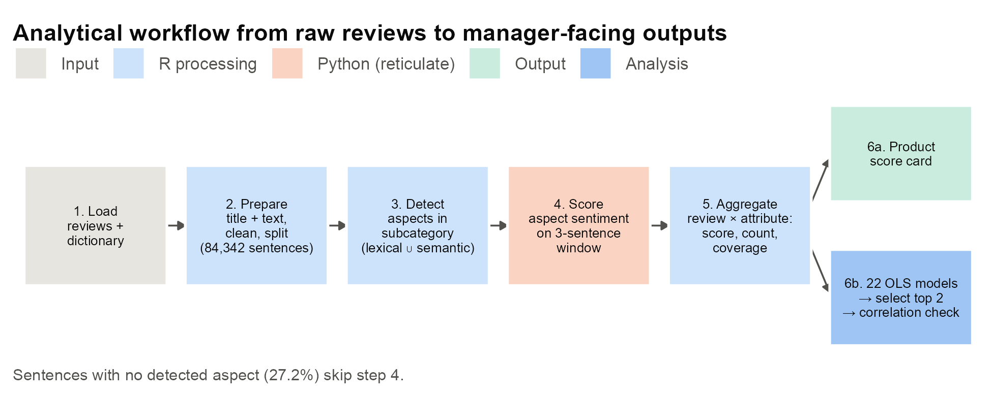
Figure 3. Analytical workflow from raw reviews to manager-facing outputs

5.2 Attribute Detection
Attribute detection is restricted to the attributes of the review’s subcategory and combines two methods. Lexical matching generates all n-grams of a sentence up to the length of the longest dictionary phrase, drops stop-word unigrams, and looks for exact matches with attribute names and terms. Semantic matching embeds each remaining word with the 300-dimensional Common Crawl fastText model [3], using the fastTextR interface [23]. Each word is compared by cosine similarity with every dictionary term of the subcategory. Before matching, the dictionary was expanded with each attribute’s 70 nearest fastText neighbours, keeping those with similarity ≥ 0.59. A word is assigned to its best attribute only if the similarity is at least 0.30 and exceeds the second-best attribute by at least 0.05. This competitive margin prevents ambiguous words from being forced onto an attribute. Generic words (good, great, product, works) are excluded. A sentence’s attribute set is the union of both methods. We chose fastText over GloVe [17] because its subword model [2] handles the misspellings and product jargon common in reviews.

5.3 Aspect-Level Sentiment Scoring
Each sentence is scored together with its neighbours: the context window is the previous, current and next sentence of the same review. This keeps pronoun references and contrast (“It barely lasts until lunch”) without splitting clauses. Detection runs on the current sentence, and sentiment is scored on the window. For each (window, attribute) pair, the pretrained DeBERTa-v3 classifier [4], [5] receives the attribute and the window as a sentence pair [14], truncated to 256 tokens. It returns probabilities for negative, neutral and positive. The sentiment score is defined as
score = P(positive) − P(negative), score ∈ [−1, +1]
so a neutral or uncertain prediction lies near zero. The model is used for inference only, under the course rule that Python may run only pretrained transformer models. It is loaded once, run without gradient tracking, and called from R through reticulate [24] and the Transformers library [16].

5.4 Aggregation
Sentence scores are aggregated per review × attribute (mean score, count, coverage) and then per product × attribute (mean sentiment and the number of positive, neutral and negative reviews). Only attributes that belong to the review’s subcategory are kept.

5.5 Statistical Model, Selection and Evaluation
For each subcategory s, star rating is regressed on the sentiment score S and coverage C of every dictionary attribute a of that subcategory:
ratingᵢ = β₀ + Σₐ βₐ Sᵢₐ + Σₐ γₐ Cᵢₐ + εᵢ
An attribute that a review does not mention takes S = 0 (neutral) and C = 0. Every dictionary attribute is included, even if it was rarely detected. βₐ measures the rating difference associated with moving from neutral to fully positive sentiment on attribute a. γₐ measures the association with devoting the whole review to a, holding sentiment fixed. Models are evaluated with R², adjusted R² (which penalises the 12–16 predictors), the overall F-test, and t-tests on each coefficient at α = 0.05. All 22 subcategory models were fitted. The two reported models were chosen by averaging each model’s rank on adjusted R² and its rank on the share of predictors significant at p < 0.05. This rule balances explanatory power against the number of reliable attribute effects, and it avoids choosing a small subcategory whose high R² rests on few significant terms. Multicollinearity was checked with pairwise Pearson correlations of all predictors against the |r| = 0.7 threshold [20]. OLS assumes linearity and constant error variance. Because the outcome is ordinal and skewed, coefficients are read as average associations, not causal effects. An ordered logit model [21] is the planned robustness check.

5.6 System Architecture and Technologies
Figure 4 shows the technical infrastructure behind the methodology. The pipeline runs in R [25], with dplyr and tidyr for data handling, tokenizers for sentence splitting, fastTextR for embeddings, lm for modelling and ggplot2 [26] for figures. Python is used only inside the sentiment step, through reticulate. Data are stored as CSV files at each stage, and embeddings are cached as RDS files. Table 2 lists the components.
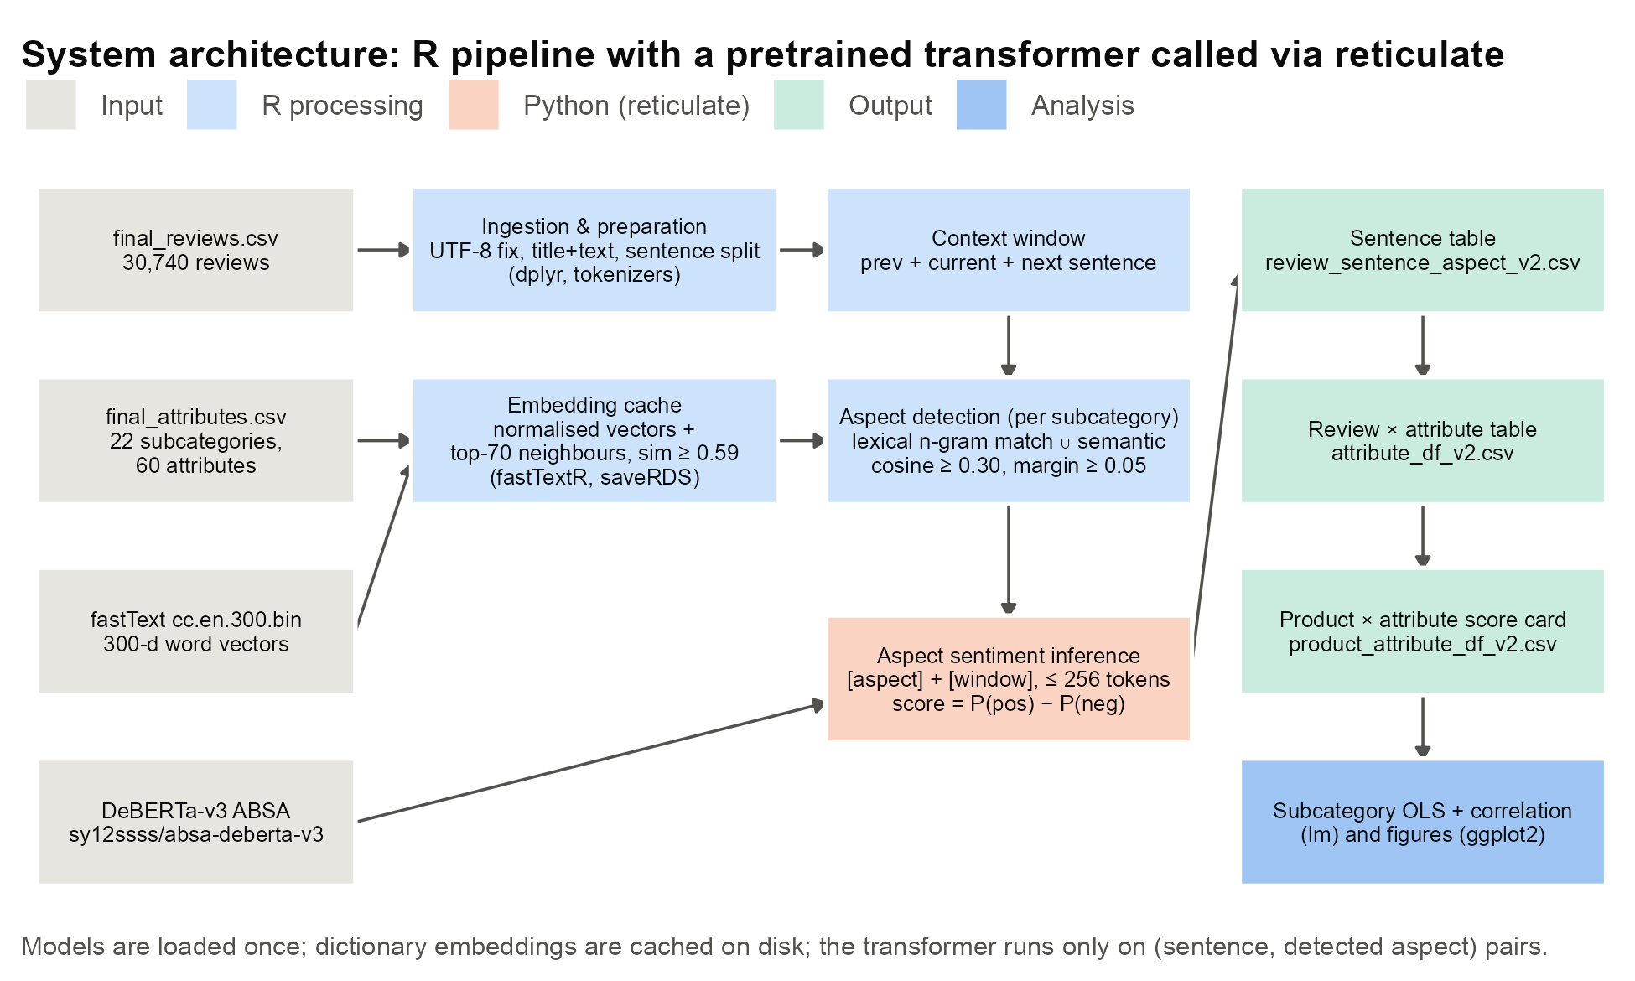
Figure 4. System architecture: R pipeline with a pretrained transformer called through reticulate
Table 2. Pipeline components and technologies
Layer | Role | Technology / file
Configuration | Model IDs, paths, stop-lists, feature flags | R – constants.R
Ingestion | Load reviews and attribute dictionary | R – setup.R
Preparation | Clean, concatenate, count and split sentences | dplyr, tokenizers – utils.R
Attribute detection | Lexical n-gram match; fastText cosine + margin | fastTextR – text_processing.R, semantic_matching.R
Sentiment | Aspect-conditioned DeBERTa-v3 inference | Python via reticulate – bert_sentiments.R
Aggregation | Sentence → review → product tables | dplyr, tidyr – utils.R, main.R
Analysis | 22 OLS models, selection, correlation check | lm – subcategory_regression.R
Visualisation | Report figures | ggplot2 – report_figures.R
Source: project repository.

5.7 Efficiency, Scalability and Reproducibility
Four design choices keep the pipeline tractable. (1) Compute once and reuse: the fastText model (about 7 GB) and the transformer are loaded once. Dictionary and neighbour embeddings are L2-normalised and cached to disk, so similarity reduces to a single matrix multiplication. (2) Search-space pruning: each sentence is compared with the 6–8 attributes of its subcategory instead of all 60, which reduces both false positives and model calls. (3) Selective inference: the transformer runs only on (sentence, detected attribute) pairs. The 27.2% of sentences with no attribute are skipped entirely. (4) Tidy intermediate tables make every stage auditable and joinable. All thresholds and model identifiers are fixed in configuration (Appendix C), and inference is deterministic, so the same inputs reproduce the same outputs. The main constraint is runtime, which is dominated by sequential, one-pair-at-a-time transformer calls on a CPU. Batching inputs, using a GPU, and processing subcategories in parallel are the most direct ways to scale to the full catalogue.

5.8 Implementation Challenges
The main challenges were (a) bridging R and Python, solved by isolating Python in a virtual environment and exposing one scoring function to R; (b) memory pressure from the large embedding model, solved by caching sub-matrices per subcategory; (c) ambiguous words matching several attributes, solved by the competitive margin rule; and (d) pronoun-heavy sentences, solved by the context window.

6. Results and Analysis

6.1 Pipeline Coverage
Table 3. Pipeline output volumes
Stage | Count
Reviews analysed | 30,738
Sentences | 84,342
Sentences with ≥ 1 attribute | 61,422 (72.8%)
Reviews with ≥ 1 attribute | 26,405 (85.9%)
Review × attribute mentions | 68,013 (71.1% positive, 28.9% negative)
Product × attribute rows | 124,110 (17,451 products)
Source: Amazon Reviews 2023, Electronics sample (n = 30,740 reviews); project pipeline v2 outputs.
The pipeline found at least one attribute in most reviews (Table 3), so the dictionary-plus-embedding approach covers the vocabulary customers actually use. Sentiment scores are strongly bimodal (median 0.97, mean 0.40): the model is usually confident, and neutral predictions are rare. A typical mention spans one sentence. More detail is in Appendix D.

6.2 Which Attributes Customers Discuss and Criticise (RQ1)
Build quality, durability, fit and sound are the most discussed attributes (Figure 5). The share of negative mentions identifies the pain points. Connectivity (40% negative), display (40%), controls (37%), compatibility (35%) and battery (34%) are criticised far more often than comfort (12%) or design (20%). Among smaller attributes, noise is the only one with a net-negative mean score (−0.15, 58% negative), followed by motion detection, warranty claims, cost and heat. These concentrate in components, security cameras and warranties. For a product manager, they are the attributes where improvements are most likely to change customer sentiment.
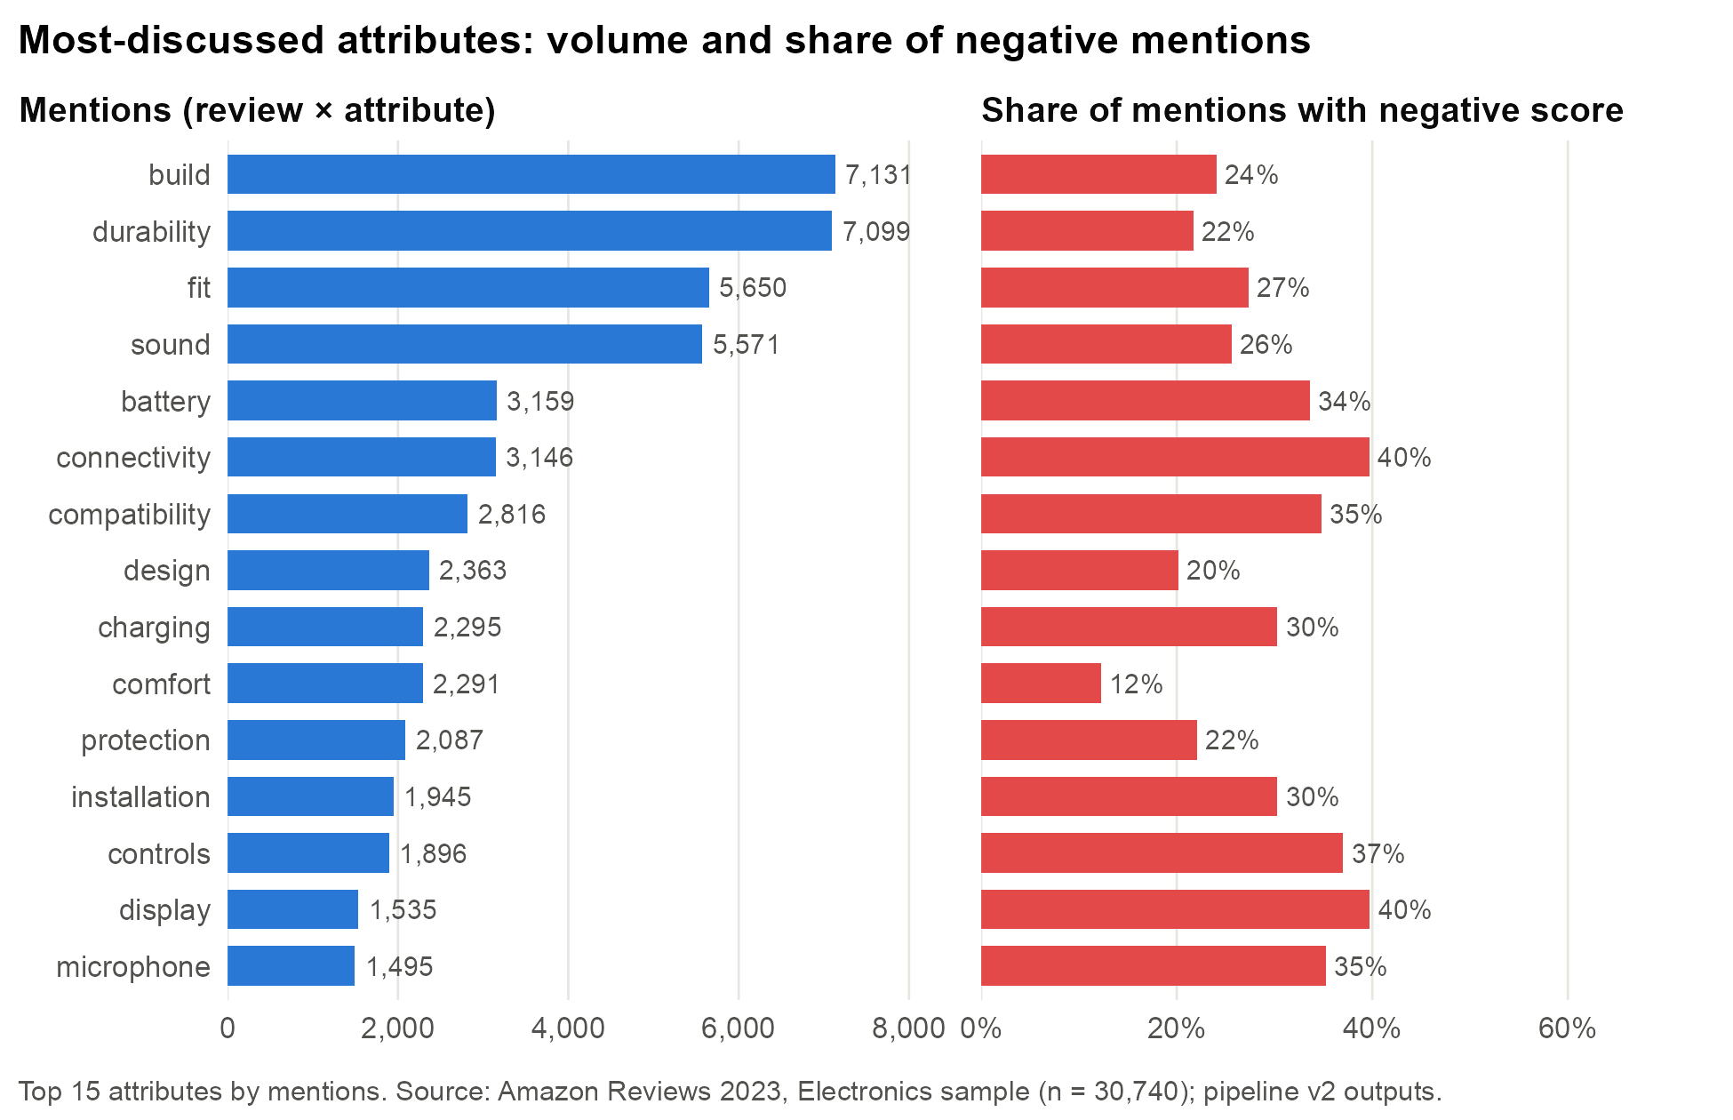
Figure 5. Mention volume and share of negative mentions for the 15 most-discussed attributes

6.3 Attribute Sentiment and Star Ratings
Two descriptive patterns link the text measures to ratings. First, mean rating falls steadily as a review discusses more attributes, from 4.60 stars with none to 3.85 with seven (Figure 6). Satisfied customers write briefly (“Works great”), while unhappy customers explain in detail, consistent with negativity bias [18]. Second, the review’s mean attribute sentiment tracks the rating closely (Figure 7). Among very negative reviews, 46% give one star and only 8% give five, whereas 91% of very positive reviews give five stars. This agreement supports the validity of the sentiment scores, which were produced without access to the ratings.
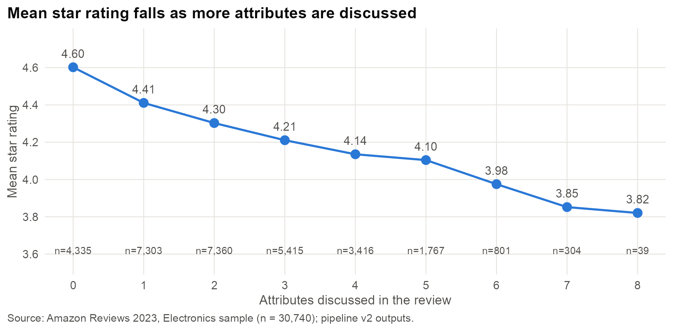
Figure 6. Mean star rating by number of attributes discussed in the review
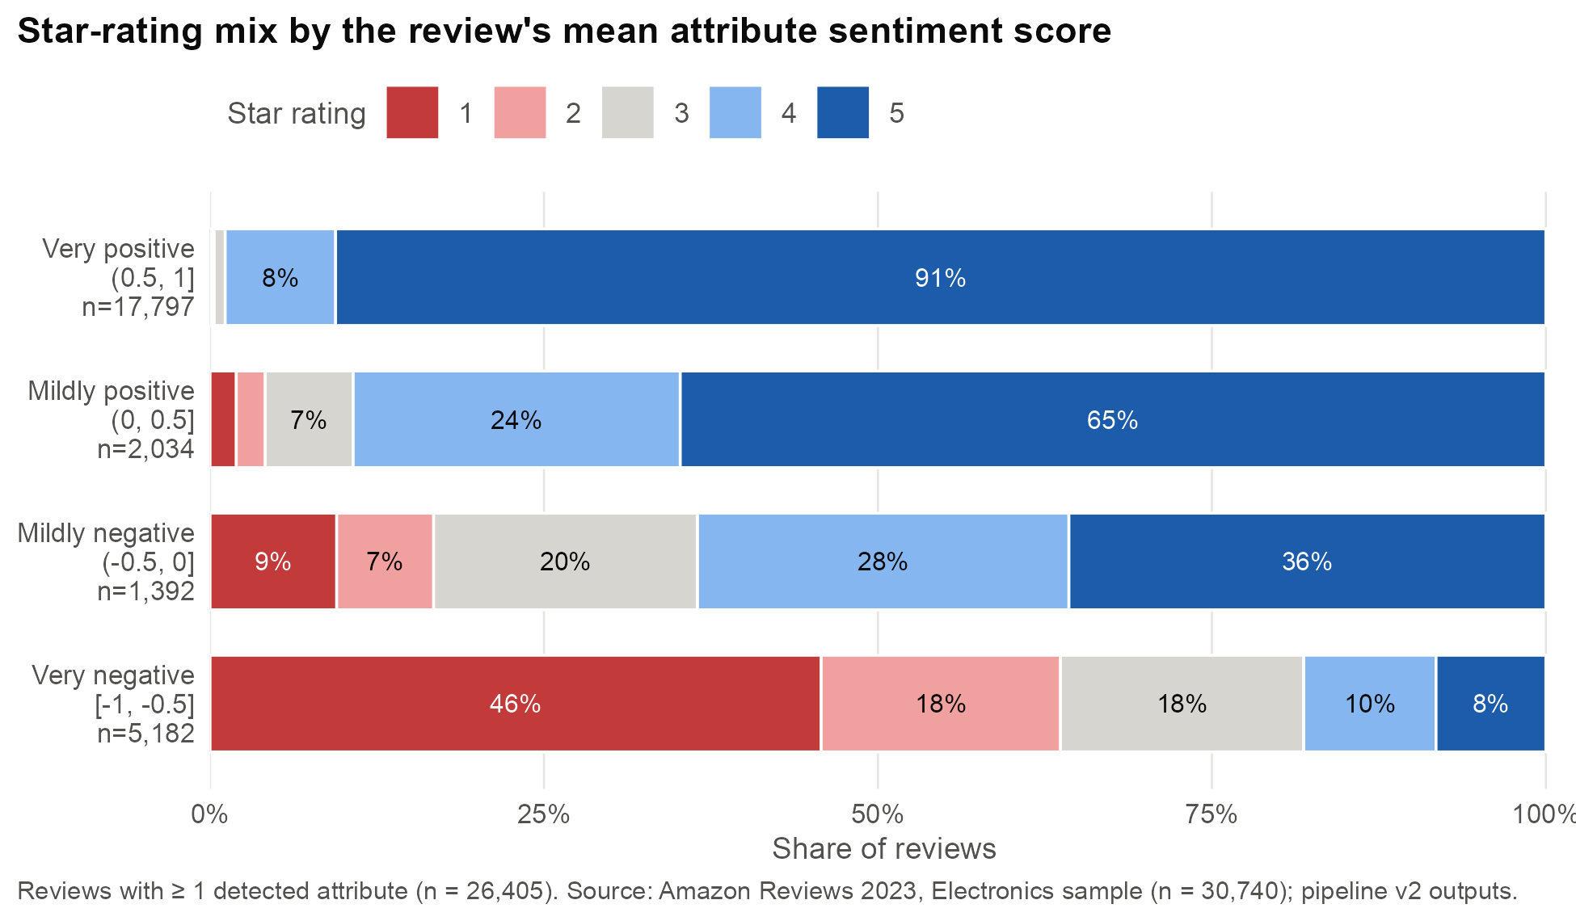
Figure 7. Star-rating mix by the review’s mean attribute sentiment score

6.4 Subcategory Regressions (RQ2)
Across the 22 subcategory models, adjusted R² ranges from 0.35 (storage) to 0.61 (computers). Cables and peripherals rank best on the combined selection rule (Table 4; the full ranking is in Appendix E). Computers has the highest adjusted R² but only 5 of 14 significant predictors, and specialized (n = 84) only 2 of 12, which shows why fit alone was not used for selection.
Table 4. Fit statistics of the two selected subcategory models (OLS, dependent variable: star rating)
Subcategory | n | Predictors | Significant | Adj. R² | F | p (F)
Cables | 3,149 | 14 | 11 | 0.558 | 284.3 | < 0.001
Peripherals | 849 | 14 | 10 | 0.551 | 75.2 | < 0.001
Significant = predictors with p < 0.05. Source: output/subcategory_regression_top2_v2.txt.
Cables (Figure 8). All seven sentiment coefficients are positive and significant. Fit (β = 0.73) and charging (0.67) dominate: moving from neutral to fully positive on either is associated with about 0.7 additional stars. Length (0.26) and durability (0.22) come next, followed by speed, compatibility and connectivity (0.13–0.18). The coverage coefficients for charging (−0.59), fit (−0.51) and length (−0.34) are negative. For the same sentiment, reviews that dwell on these attributes give lower ratings. Durability coverage is the exception (+0.11): customers praise long-lasting cables at length.
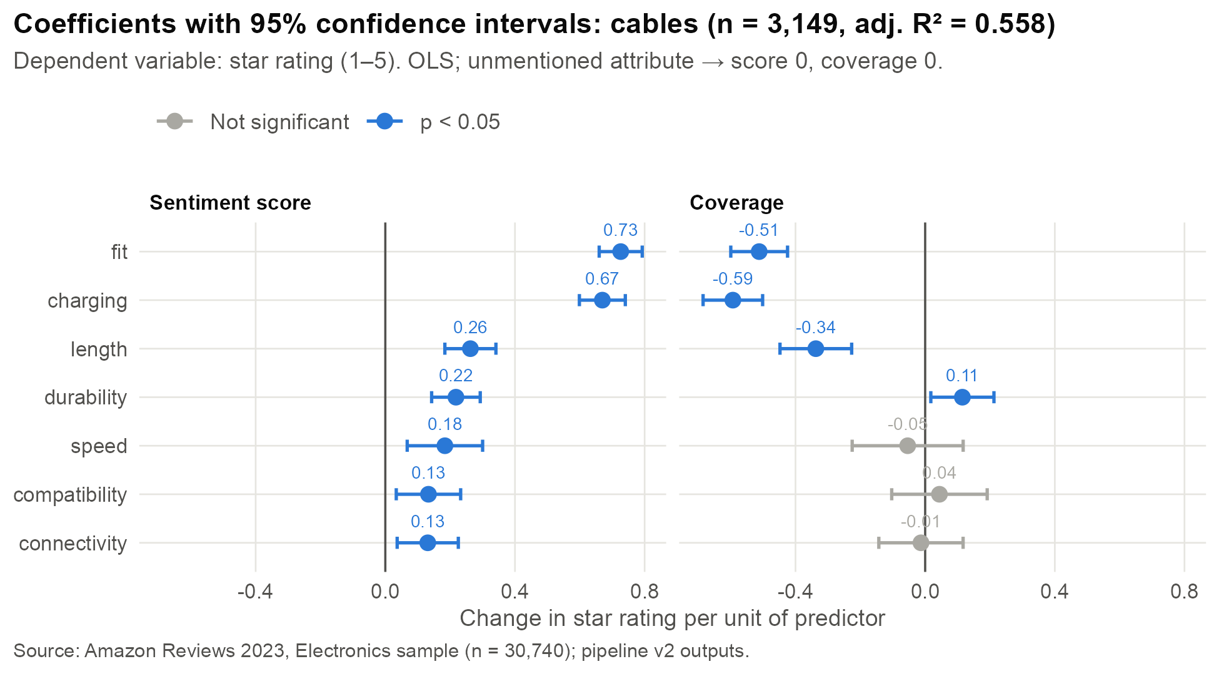
Figure 8. Cables: OLS coefficients with 95% confidence intervals (n = 3,149)
Peripherals (Figure 9). Build quality has the largest effect in either model (β = 1.10), with a strongly negative coverage term (−0.94). Performance (0.36), battery (0.24), controls (0.23), compatibility (0.22) and connectivity (0.22) follow. Comfort sentiment is not significant, but comfort coverage is positive (+0.36). The two comfort measures are the most correlated pair in the model (r = 0.68), so their joint reading is that customers who talk about comfort usually praise it.
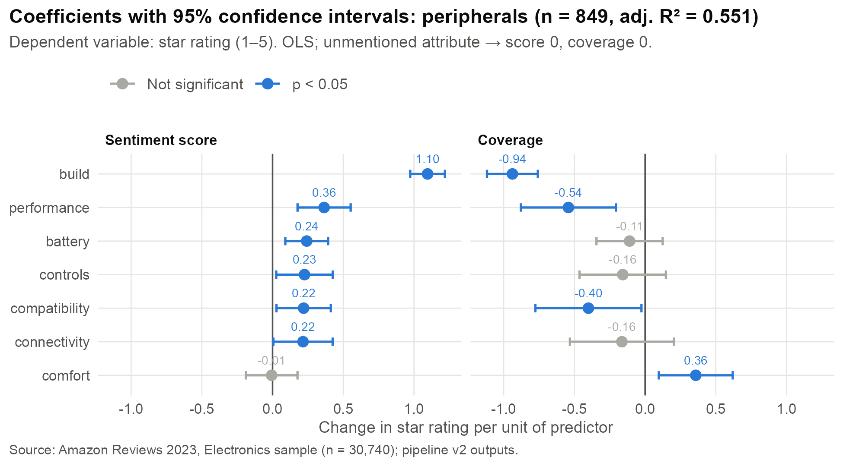
Figure 9. Peripherals: OLS coefficients with 95% confidence intervals (n = 849)

6.5 Robustness: Multicollinearity Check
The highest absolute pairwise correlation among the 14 predictors is 0.53 for cables (charging score vs fit score) and 0.68 for peripherals (comfort score vs comfort coverage). Both are below the 0.7 threshold [20], so the coefficients can be interpreted individually (full matrices in Appendix E). Both models are also highly significant overall. Their residual standard errors (0.91 stars) show that about half of the rating variation remains unexplained by attribute text.

6.6 Product Score Card (RQ3)
Figure 10 shows the product × attribute output for one security camera with 106 reviews in the sample. Its connectivity problem is clear: 36 of 45 reviews that mention connectivity are negative (mean −0.63). Reliability (26 of 34 negative) and alerts (24 of 37) follow. A star average condenses all of this into one number. The score card tells the product manager where to look first.
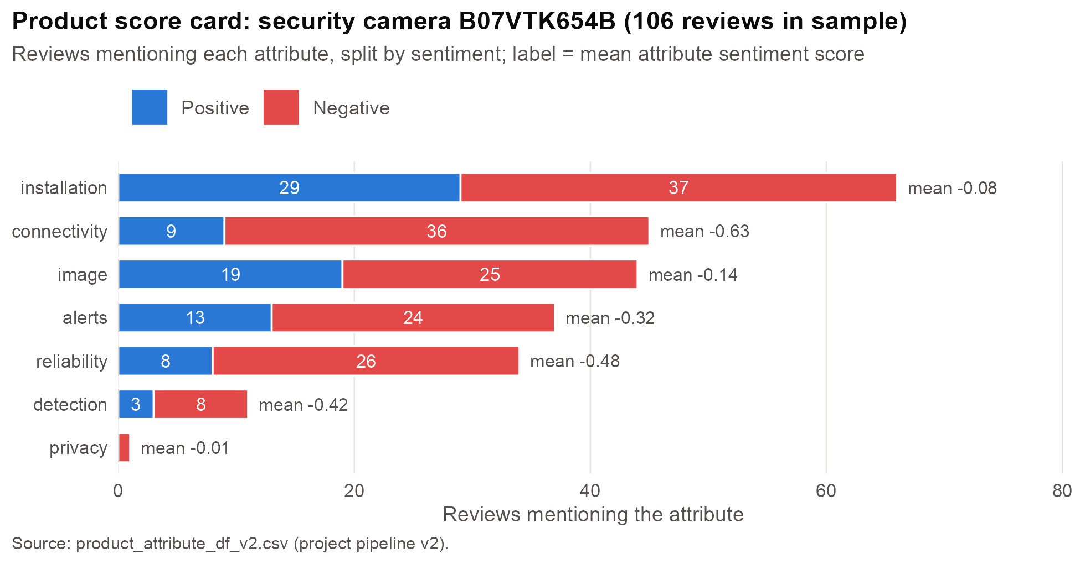
Figure 10. Product score card for security camera B07VTK654B

6.7 Expected and Unexpected Findings
As expected, every significant sentiment coefficient is positive, and drivers differ by subcategory. The unexpected result is the consistently negative coverage effect, which reverses only for attributes customers tend to praise at length (durability, comfort). This pattern matches the descriptive decline in ratings as more attributes are discussed. It suggests that elaboration, not only polarity, carries information about dissatisfaction.

7. Discussion and Business Implications

7.1 Answers to the Research Questions
RQ1: customers mostly discuss build, durability, fit and sound. Connectivity, compatibility, battery and display draw the highest shares of negative mentions, and noise, detection and warranty claims are net-negative. RQ2: attribute sentiment and coverage explain about 55% of rating variance in the best subcategories. The leading drivers are subcategory-specific: fit and charging for cables, build quality for peripherals. RQ3: the product score card turns these measures into a concrete, product-level diagnosis.

7.2 Implications for Decision-Making
- Prioritisation: the regression coefficients give each subcategory a ranked list of attributes associated with ratings. For cables, connector fit and charging performance are the first quality targets. For peripherals, build quality is.
- Monitoring and risk management: the score card can be refreshed as new reviews arrive and flag products whose negative share on an attribute rises, giving early warning of supplier or firmware problems.
- Customer experience: recurring complaints, such as compatibility in cables and setup in networking, can drive listing clarifications and support content that prevent returns.
- Revenue: negative reviews weigh more heavily on sales than positive ones [6], so fixing the attributes behind one-star reviews is likely to have an outsized commercial return. This benefit is inferred from the literature and was not tested here.

7.3 Comparison with the Literature
Our results agree with prior work that review text explains outcomes beyond the star rating [7]. The negative coverage effect is consistent with negativity bias [18] and with evidence that review depth is informative [19]. The five-star dominance of the data reflects the J-shaped distribution reported by Hu et al. [8]. Unlike benchmark-focused ABSA studies [12], this project evaluates aspect sentiment by its explanatory value for ratings, which is closer to what a business user needs.

7.4 Organisational, Ethical and Operational Considerations
Turning these findings into value requires (a) a validated labelling sample to establish accuracy, (b) a regular data refresh and an owner for the score card, (c) dictionary maintenance as products and vocabulary change, and (d) agreement on action thresholds. Ethically, the analysis uses public reviews without personal identifiers. Outputs should be reported at product and attribute level, never used to profile individual reviewers. Automated labels should support decisions, not make them without review.

7.5 Supported Conclusions versus Potential Benefits
The data directly support the descriptive patterns, the statistical associations within the two reported subcategories, and the product-level diagnoses. They do not establish that improving an attribute will raise ratings or sales. That would require causal designs such as before-and-after product changes or A/B tests of listing content.

8. Limitations and Future Improvements
Table 5 lists the main limitations, how each affects interpretation, and a realistic improvement, ordered by priority.
Table 5. Limitations, their effect on the findings, and prioritised improvements
Limitation | Effect on interpretation | Improvement
1. No human-labelled validation of attribute detection or sentiment | Accuracy is unknown; errors attenuate or bias coefficients | Annotate a stratified sample; report precision, recall and accuracy
2. Sentiment model trained on restaurant and laptop reviews only [5] | Domain shift may lower accuracy for other electronics | Fine-tune or calibrate on labelled electronics data
3. Rating skew (71% five-star) and ordinal outcome modelled with OLS | Linear effects are approximations; few negative examples | Ordered logit [21] as robustness check; class-balanced analysis
4. Heuristic thresholds (0.59, 0.30, 0.05) | Results may be sensitive to the chosen values | Tune on labelled data; sensitivity analysis
5. Score and coverage are coupled (both 0 when unmentioned) | Coefficients must be read jointly | Add mention indicators or interaction terms
6. Broad attributes such as “build” absorb general praise | Large build coefficient partly reflects overall sentiment | Refine dictionary; separate general from specific quality terms
7. Overlapping context windows; no de-duplication | Repeated evidence counts several times | De-duplicate windows or weight by distance
8. Small subcategories (84–164 reviews) | Unstable coefficients | Larger samples; pool similar subcategories
9. Single sample; AI-assigned subcategories | Generalisability and possible misclassification | Full-catalogue run; audit subcategory labels
10. Sequential CPU inference | Runtime limits scale | Batched or GPU inference; parallel by subcategory
Priority reflects impact on the validity of business decisions.
Generalisability. The results describe one Electronics sample and should not be assumed to hold for other categories, marketplaces or time periods without re-estimation. Privacy and fairness. Reviews are public, but outputs should remain aggregated. Text models can perform unevenly across writing styles or non-native English, which validation should check. Future work should, in order, validate labels, fine-tune the sentiment model on electronics data, add ordered-logit and sensitivity analyses, enrich the models with price, delivery and seller variables, and move to batched inference to process the full catalogue.

9. Conclusion and Recommendations
Product managers need to know why customers rate products as they do, and star ratings alone cannot tell them. This project built an R pipeline that detects attributes in 84,342 review sentences, scores attribute-level sentiment with a pretrained DeBERTa-v3 model, and relates the results to ratings for each subcategory. The objectives were met: the system covers 86% of reviews, identifies attribute-specific pain points, explains about 55% of rating variance in the best subcategories with interpretable, non-collinear predictors, and produces product score cards that expose problems hidden by averages. The main contribution is to connect aspect-level text analytics with subcategory-specific explanatory models in a form a business user can act on.
Prioritised recommendations:
- Validate first: label a stratified sample of about 1,000 sentence–attribute pairs to measure detection and sentiment accuracy before operational use.
- Pilot the score card in two subcategories (cables and peripherals), with clear thresholds for flagging attributes, for example more than 50% negative mentions with at least 20 mentions.
- Target the top drivers: prioritise connector fit and charging for cables, and build quality for peripherals, and track whether attribute sentiment improves after changes.
- Strengthen the models with ordered logit, threshold sensitivity analysis, and price and seller covariates.
- Scale up with batched or GPU inference to cover the full catalogue, and refresh results monthly.

10. References
[1] Y. Hou, J. Li, Z. He, A. Yan, X. Chen, and J. McAuley, “Bridging language and items for retrieval and recommendation,” arXiv:2403.03952, 2024. [Online]. Available: https://amazon-reviews-2023.github.io/
[2] P. Bojanowski, E. Grave, A. Joulin, and T. Mikolov, “Enriching word vectors with subword information,” Transactions of the Association for Computational Linguistics, vol. 5, pp. 135–146, 2017, doi: 10.1162/tacl_a_00051.
[3] E. Grave, P. Bojanowski, P. Gupta, A. Joulin, and T. Mikolov, “Learning word vectors for 157 languages,” in Proc. 11th Int. Conf. Language Resources and Evaluation (LREC 2018), Miyazaki, Japan, 2018.
[4] P. He, J. Gao, and W. Chen, “DeBERTaV3: Improving DeBERTa using ELECTRA-style pre-training with gradient-disentangled embedding sharing,” in Proc. Int. Conf. Learning Representations (ICLR), 2023.
[5] sy12ssss, “absa-deberta-v3,” Hugging Face model card. [Online]. Available: https://huggingface.co/sy12ssss/absa-deberta-v3 (accessed Oct. 22, 2026).
[6] J. A. Chevalier and D. Mayzlin, “The effect of word of mouth on sales: Online book reviews,” Journal of Marketing Research, vol. 43, no. 3, pp. 345–354, 2006.
[7] N. Archak, A. Ghose, and P. G. Ipeirotis, “Deriving the pricing power of product features by mining consumer reviews,” Management Science, vol. 57, no. 8, pp. 1485–1509, 2011, doi: 10.1287/mnsc.1110.1370.
[8] N. Hu, J. Zhang, and P. A. Pavlou, “Overcoming the J-shaped distribution of product reviews,” Communications of the ACM, vol. 52, no. 10, pp. 144–147, 2009.
[9] M. Hu and B. Liu, “Mining and summarizing customer reviews,” in Proc. 10th ACM SIGKDD Int. Conf. Knowledge Discovery and Data Mining (KDD), Seattle, WA, USA, 2004, pp. 168–177.
[10] M. Pontiki, D. Galanis, J. Pavlopoulos, H. Papageorgiou, I. Androutsopoulos, and S. Manandhar, “SemEval-2014 Task 4: Aspect based sentiment analysis,” in Proc. 8th Int. Workshop on Semantic Evaluation (SemEval 2014), Dublin, Ireland, 2014, pp. 27–35, doi: 10.3115/v1/S14-2004.
[11] M. Pontiki et al., “SemEval-2016 Task 5: Aspect based sentiment analysis,” in Proc. 10th Int. Workshop on Semantic Evaluation (SemEval-2016), San Diego, CA, USA, 2016, pp. 19–30, doi: 10.18653/v1/S16-1002.
[12] W. Zhang, X. Li, Y. Deng, L. Bing, and W. Lam, “A survey on aspect-based sentiment analysis: Tasks, methods, and challenges,” IEEE Transactions on Knowledge and Data Engineering, vol. 35, no. 11, pp. 11019–11038, 2023, doi: 10.1109/TKDE.2022.3230975.
[13] J. Devlin, M.-W. Chang, K. Lee, and K. Toutanova, “BERT: Pre-training of deep bidirectional transformers for language understanding,” in Proc. 2019 Conf. North American Chapter of the Association for Computational Linguistics: Human Language Technologies (NAACL-HLT), Minneapolis, MN, USA, 2019, pp. 4171–4186, doi: 10.18653/v1/N19-1423.
[14] C. Sun, L. Huang, and X. Qiu, “Utilizing BERT for aspect-based sentiment analysis via constructing auxiliary sentence,” in Proc. 2019 Conf. NAACL-HLT, Minneapolis, MN, USA, 2019, pp. 380–385, doi: 10.18653/v1/N19-1035.
[15] P. He, X. Liu, J. Gao, and W. Chen, “DeBERTa: Decoding-enhanced BERT with disentangled attention,” in Proc. Int. Conf. Learning Representations (ICLR), 2021.
[16] T. Wolf et al., “Transformers: State-of-the-art natural language processing,” in Proc. 2020 Conf. Empirical Methods in Natural Language Processing: System Demonstrations, 2020, pp. 38–45, doi: 10.18653/v1/2020.emnlp-demos.6.
[17] J. Pennington, R. Socher, and C. D. Manning, “GloVe: Global vectors for word representation,” in Proc. 2014 Conf. Empirical Methods in Natural Language Processing (EMNLP), Doha, Qatar, 2014, pp. 1532–1543, doi: 10.3115/v1/D14-1162.
[18] R. F. Baumeister, E. Bratslavsky, C. Finkenauer, and K. D. Vohs, “Bad is stronger than good,” Review of General Psychology, vol. 5, no. 4, pp. 323–370, 2001, doi: 10.1037/1089-2680.5.4.323.
[19] S. M. Mudambi and D. Schuff, “What makes a helpful online review? A study of customer reviews on Amazon.com,” MIS Quarterly, vol. 34, no. 1, pp. 185–200, 2010.
[20] C. F. Dormann et al., “Collinearity: A review of methods to deal with it and a simulation study evaluating their performance,” Ecography, vol. 36, no. 1, pp. 27–46, 2013, doi: 10.1111/j.1600-0587.2012.07348.x.
[21] P. McCullagh, “Regression models for ordinal data,” Journal of the Royal Statistical Society: Series B, vol. 42, no. 2, pp. 109–142, 1980.
[22] L. A. Mullen, K. Benoit, O. Keyes, D. Selivanov, and J. Arnold, “Fast, consistent tokenization of natural language text,” Journal of Open Source Software, vol. 3, no. 23, p. 655, 2018, doi: 10.21105/joss.00655.
[23] F. Schwendinger and E. Hvitfeldt, fastTextR: An Interface to the ‘fastText’ Library, R package version 2.1.1, 2026, doi: 10.32614/CRAN.package.fastTextR.
[24] T. Kalinowski, K. Ushey, J. Allaire, and Y. Tang, reticulate: Interface to ‘Python’, R package version 1.47.0, 2026, doi: 10.32614/CRAN.package.reticulate.
[25] R Core Team, R: A Language and Environment for Statistical Computing, version 4.6.1. Vienna, Austria: R Foundation for Statistical Computing, 2026. [Online]. Available: https://www.R-project.org/
[26] H. Wickham, ggplot2: Elegant Graphics for Data Analysis. New York, NY, USA: Springer-Verlag, 2016.

Appendix A: Data Dictionary
Table 6. Input review fields (datasets/final_reviews.csv)
Field | Type | Description
asin | text | Amazon product identifier
rating | integer | Star rating 1–5 (dependent variable)
title | text | Review title
text | text | Review body
helpful_vote | integer | Helpful votes (median 0, mean 0.53, max 506)
verified_purchase | logical | Verified purchase flag (96.4% TRUE)
metadata_average_rating | numeric | Product’s average rating in Amazon metadata (median 4.5)
metadata_rating_number | integer | Product’s total number of ratings in metadata (median 4,004)
subcategory | text | One of 22 AI-assigned product subcategories

Table 7. Pipeline output tables
File | Grain | Key fields
review_sentence_aspect_v2.csv | sentence (84,342) | review_id, subcategory, asin, sentence, one score column per attribute (NA if not detected)
attribute_df_v2.csv | review × attribute (218,397) | review_id, asin, subcategory, attribute, attribute_score, attribute_count, attribute_coverage
product_attribute_df_v2.csv | product × attribute (124,110) | product_asin, total_product_reviews, subcategory, attribute, sentiment, total_attribute_reviews, positive/neutral/negative_reviews

Appendix B: Data Preparation Rules
- Assign review_id = row number; concatenate title and text (missing parts replaced by an empty string).
- Remove invalid UTF-8 bytes (iconv, sub = “”); count sentences per review (total_sentence_count).
- Split into sentences with tokenizers::tokenize_sentences; keep sentence order.
- Per sentence: strip HTML tags, collapse whitespace, trim.
- Build a three-sentence window (previous + current + next) within the same review.
- Lexical candidates: n-grams of length 1 to the longest dictionary phrase; drop stop-word unigrams.
- Semantic candidates: non-stop-words excluding the generic list (product, item, thing, good, great, excellent, nice, bad, terrible, awful, amazing, works, working, job, bought, purchased, buy, ask, recommend, reasonable).
- Keep only attributes defined for the review’s subcategory when pivoting to the review × attribute table.
- Regression input: attributes not mentioned in a review take score 0 and coverage 0.

Appendix C: Technical Implementation
Table 8. Configuration and hyperparameters
Setting | Value
Sentiment model | sy12ssss/absa-deberta-v3 (DeBERTa-v3-base fine-tuned for ABSA)
Model input | tokenizer(aspect, window), truncation at 256 tokens, inference with torch.no_grad()
Label order | 0 = negative, 1 = neutral, 2 = positive; score = P(pos) − P(neg)
Embeddings | fastText cc.en.300.bin (Common Crawl, 300 dimensions)
Neighbour expansion | 70 nearest neighbours per attribute; keep cosine ≥ 0.59
Semantic match rule | best cosine ≥ 0.30 and margin over second-best ≥ 0.05
Context window | previous + current + next sentence (same review)
Regression | lm(rating ~ .) per subcategory; α = 0.05; top 2 by mean rank of adj. R² and significant share
Software | R 4.6.1; dplyr, tidyr, tokenizers 0.3.0, fastTextR 2.1.1, reticulate 1.47.0, ggplot2 4.0.3; Python venv with torch and transformers

Excerpt 1. Aspect sentiment score (models/bert_sentiments.R)
inputs = bert$tokenizer(aspect, sentence, return_tensors = "pt",
truncation = TRUE, max_length = 256L)
outputs = bert$model(input_ids = inputs$input_ids,
attention_mask = inputs$attention_mask)
probabilities = bert$torch$softmax(outputs$logits, dim = -1L)
sentiment_score = positive - negative
Excerpt 2. Model selection (processing/subcategory_regression.R)
data.frame(subcategory = names(models),
adj_r2 = sapply(models, function(m) summary(m)$adj.r.squared),
significant_share = sapply(models, function(m) {
p_values = summary(m)$coefficients[-1, 4]
sum(p_values < SIGNIFICANCE_LEVEL) / (length(coef(m)) - 1)})) %>%
mutate(selection_score = (rank(-adj_r2) + rank(-significant_share)) / 2) %>%
arrange(selection_score, desc(adj_r2))
Figures are reproduced by processing/report_figures.R, which reads only the v2 outputs and sources processing/subcategory_regression.R so that the reported models are identical.

Appendix D: Additional Results
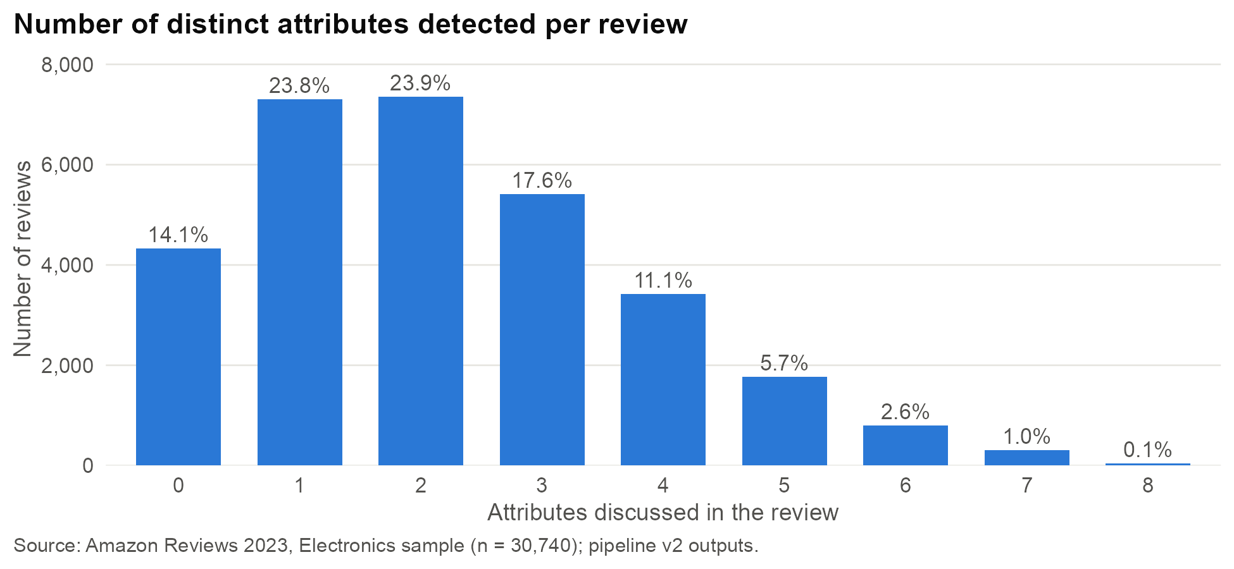
Figure 11. Number of distinct attributes detected per review
Table 9. Mentions, mean sentiment score and share of negative mentions for all 60 attributes
Attribute | Mentions | Mean | % neg. | Attribute | Mentions | Mean | % neg.
build | 7,131 | 0.48 | 24.1 | bass | 361 | 0.43 | 26.6
durability | 7,099 | 0.55 | 21.7 | storage | 360 | 0.38 | 30.6
fit | 5,650 | 0.44 | 27.3 | keyboard | 354 | 0.34 | 29.1
sound | 5,571 | 0.47 | 25.6 | cooling | 333 | 0.37 | 30.0
battery | 3,159 | 0.30 | 33.6 | motion | 315 | 0.38 | 29.5
connectivity | 3,146 | 0.18 | 39.7 | alerts | 270 | 0.03 | 47.8
compatibility | 2,816 | 0.28 | 34.8 | software | 251 | 0.09 | 43.4
design | 2,363 | 0.58 | 20.2 | ports | 223 | 0.32 | 27.4
charging | 2,295 | 0.37 | 30.3 | security | 220 | 0.36 | 28.6
comfort | 2,291 | 0.74 | 12.3 | camera | 218 | 0.26 | 35.8
protection | 2,087 | 0.53 | 22.1 | power | 217 | 0.26 | 36.9
installation | 1,945 | 0.36 | 30.3 | features | 202 | 0.48 | 24.3
controls | 1,896 | 0.22 | 37.0 | lowlight | 195 | 0.17 | 40.0
display | 1,535 | 0.16 | 39.7 | accessibility | 192 | 0.17 | 38.5
microphone | 1,495 | 0.28 | 35.3 | detection | 164 | -0.08 | 53.7
image | 1,461 | 0.37 | 29.6 | adjustability | 152 | 0.34 | 30.9
noise | 1,303 | -0.15 | 58.0 | automation | 151 | 0.51 | 22.5
setup | 1,012 | 0.33 | 31.4 | heat | 134 | 0.01 | 52.2
speed | 1,012 | 0.45 | 26.4 | coverage | 129 | 0.25 | 35.7
reliability | 973 | 0.29 | 34.8 | privacy | 88 | 0.57 | 20.5
length | 949 | 0.22 | 37.8 | portability | 74 | 0.79 | 10.8
focus | 879 | 0.36 | 29.9 | replacement | 70 | 0.05 | 50.0
capacity | 864 | 0.38 | 29.6 | claims | 69 | -0.07 | 53.6
playback | 733 | 0.40 | 29.5 | safety | 67 | 0.22 | 35.8
quality | 677 | 0.57 | 20.7 | magnification | 66 | 0.47 | 25.8
performance | 639 | 0.42 | 27.5 | cost | 52 | -0.07 | 51.9
volume | 613 | 0.49 | 23.3 | service | 36 | 0.10 | 44.4
video | 516 | 0.41 | 26.7 | functionality | 26 | 0.03 | 46.2
stability | 497 | 0.30 | 34.0 | usability | 26 | 0.33 | 34.6
accuracy | 368 | 0.39 | 29.3 | clarity | 23 | 0.44 | 26.1
Source: Amazon Reviews 2023, Electronics sample (n = 30,740 reviews); project pipeline v2 outputs.

Appendix E: Model Evaluation
Table 10. All 22 subcategory models ranked by the selection rule (mean of rank on adjusted R² and rank on share of significant predictors)
Rank | Subcategory | n | Predictors | Significant | R² | Adj. R² | Score
1 | cables | 3,149 | 14 | 11 | 0.559 | 0.557 | 3.00
2 | peripherals | 849 | 14 | 10 | 0.558 | 0.551 | 5.00
3 | optics | 164 | 12 | 8 | 0.553 | 0.518 | 7.50
4 | headphones | 2,778 | 16 | 10 | 0.550 | 0.547 | 8.00
5 | protection | 6,006 | 14 | 10 | 0.496 | 0.495 | 8.50
6 | photography | 1,795 | 16 | 12 | 0.496 | 0.491 | 8.50
7 | power | 1,089 | 14 | 9 | 0.517 | 0.510 | 9.25
8 | warranties | 132 | 12 | 6 | 0.611 | 0.572 | 9.75
9 | media | 1,806 | 14 | 12 | 0.402 | 0.397 | 10.50
10 | computers | 627 | 14 | 5 | 0.615 | 0.606 | 10.75
11 | mounts | 962 | 12 | 7 | 0.506 | 0.500 | 11.00
12 | security | 1,041 | 14 | 10 | 0.485 | 0.478 | 11.00
13 | mobile | 1,050 | 14 | 8 | 0.520 | 0.514 | 11.25
14 | specialized | 84 | 12 | 2 | 0.644 | 0.583 | 12.00
15 | displays | 1,640 | 14 | 6 | 0.536 | 0.532 | 12.75
16 | wearables | 648 | 14 | 8 | 0.504 | 0.493 | 13.25
17 | storage | 1,157 | 14 | 9 | 0.356 | 0.348 | 15.25
18 | audio | 3,222 | 14 | 7 | 0.483 | 0.480 | 16.25
19 | networking | 850 | 14 | 8 | 0.458 | 0.449 | 16.25
20 | smarthome | 619 | 14 | 8 | 0.408 | 0.395 | 17.25
21 | automotive | 407 | 14 | 5 | 0.504 | 0.486 | 17.75
22 | components | 663 | 14 | 6 | 0.486 | 0.475 | 18.25
Lower score is better. Source: models fitted by processing/subcategory_regression.R on attribute_df_v2.csv.
Full R output of the two selected models.
Order of output: cables, then peripherals.

Call:
lm(formula = rating ~ ., data = data_wide)

Residuals:
Min 1Q Median 3Q Max
-3.9436 -0.4040 0.1746 0.5079 3.9585

Coefficients:
Estimate Std. Error t value Pr(>|t|)
(Intercept) 4.28922 0.03010 142.518 < 2e-16 ***
charging_attribute_score 0.66957 0.03614 18.529 < 2e-16 ***
compatibility_attribute_score 0.13310 0.05066 2.627 0.00865 **
connectivity_attribute_score 0.13090 0.04811 2.721 0.00655 **
durability_attribute_score 0.21786 0.03823 5.699 1.32e-08 ***
fit_attribute_score 0.72621 0.03385 21.455 < 2e-16 ***
length_attribute_score 0.26245 0.04017 6.534 7.45e-11 ***
speed_attribute_score 0.18388 0.05933 3.099 0.00196 **
charging_attribute_coverage -0.59327 0.04684 -12.667 < 2e-16 ***
compatibility_attribute_coverage 0.04408 0.07512 0.587 0.55737
connectivity_attribute_coverage -0.01297 0.06631 -0.196 0.84500
durability_attribute_coverage 0.11482 0.04967 2.312 0.02085 *
fit_attribute_coverage -0.51212 0.04467 -11.466 < 2e-16 ***
length_attribute_coverage -0.33731 0.05639 -5.981 2.46e-09 ***
speed_attribute_coverage -0.05397 0.08732 -0.618 0.53654
---
Signif. codes: 0 '***' 0.001 '**' 0.01 '*' 0.05 '.' 0.1 ' ' 1

Residual standard error: 0.9071 on 3134 degrees of freedom
Multiple R-squared: 0.5595, Adjusted R-squared: 0.5575
F-statistic: 284.3 on 14 and 3134 DF, p-value: < 2.2e-16

Call:
lm(formula = rating ~ ., data = data_wide)

Residuals:
Min 1Q Median 3Q Max
-3.7972 -0.3577 0.1356 0.6137 3.6416

Coefficients:
Estimate Std. Error t value Pr(>|t|)
(Intercept) 4.240255 0.056983 74.413 < 2e-16 ***
battery_attribute_score 0.241536 0.077116 3.132 0.00180 **
build_attribute_score 1.096079 0.062567 17.519 < 2e-16 ***
comfort_attribute_score -0.006283 0.093068 -0.068 0.94620
compatibility_attribute_score 0.219725 0.097876 2.245 0.02503 *
connectivity_attribute_score 0.215307 0.106712 2.018 0.04395 *
controls_attribute_score 0.225637 0.101750 2.218 0.02685 *
performance_attribute_score 0.364460 0.095681 3.809 0.00015 ***
battery_attribute_coverage -0.109632 0.119262 -0.919 0.35823
build_attribute_coverage -0.938037 0.091592 -10.241 < 2e-16 ***
comfort_attribute_coverage 0.358322 0.133153 2.691 0.00727 **
compatibility_attribute_coverage -0.400717 0.191059 -2.097 0.03626 *
connectivity_attribute_coverage -0.163969 0.187307 -0.875 0.38161
controls_attribute_coverage -0.158214 0.155609 -1.017 0.30957
performance_attribute_coverage -0.542052 0.171092 -3.168 0.00159 **
---
Signif. codes: 0 '***' 0.001 '**' 0.01 '*' 0.05 '.' 0.1 ' ' 1

Residual standard error: 0.9132 on 834 degrees of freedom
Multiple R-squared: 0.558, Adjusted R-squared: 0.5506
F-statistic: 75.2 on 14 and 834 DF, p-value: < 2.2e-16

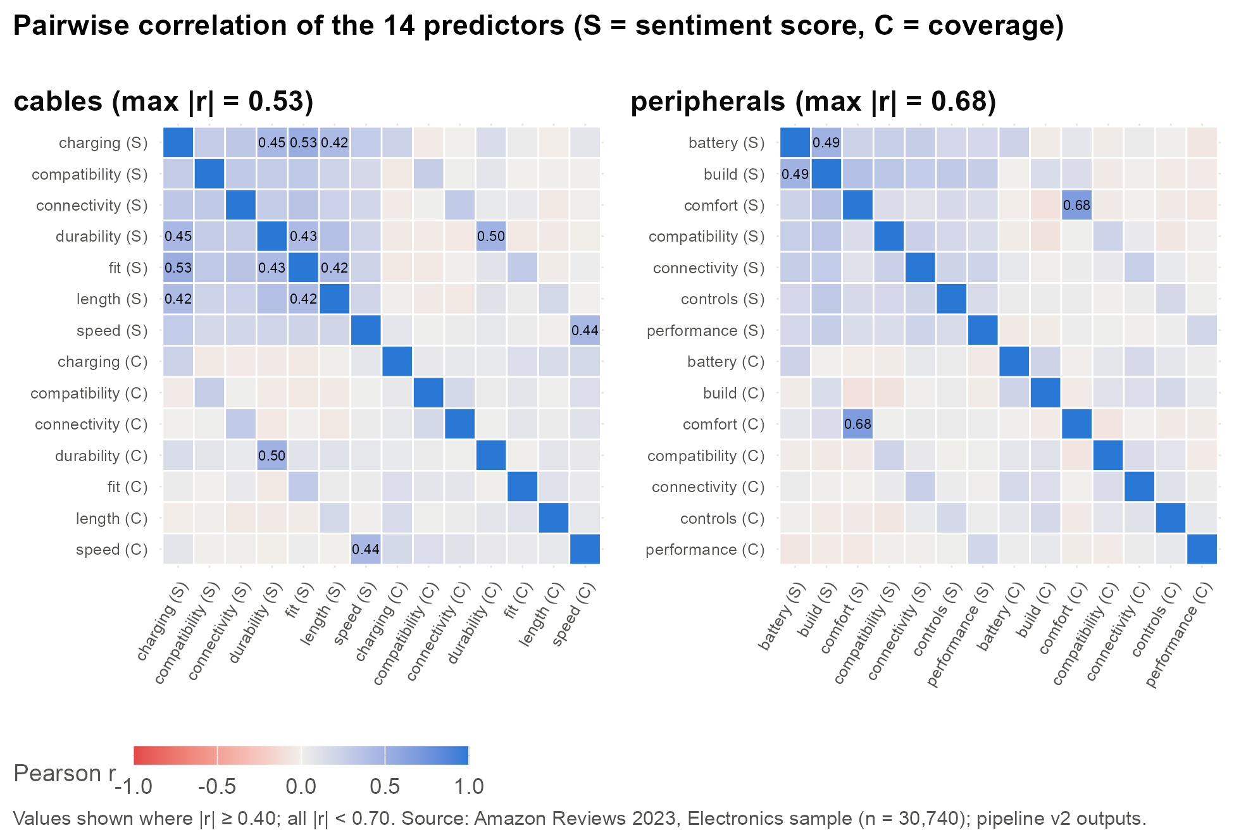
Figure 12. Pairwise correlation of the 14 predictors in each selected model
Table 11. Pairwise Pearson correlations of predictors: cables (S = sentiment score, C = coverage)
 | charging S | compat S | connect S | durab S | fit S | length S | speed S | charging C | compat C | connect C | durab C | fit C | length C | speed C
charging S | 1.00 | 0.29 | 0.32 | 0.45 | 0.53 | 0.42 | 0.29 | 0.23 | -0.03 | 0.00 | 0.15 | 0.03 | -0.02 | 0.08
compat S | 0.29 | 1.00 | 0.30 | 0.29 | 0.31 | 0.22 | 0.18 | -0.05 | 0.27 | 0.02 | 0.08 | -0.00 | -0.01 | -0.01
connect S | 0.32 | 0.30 | 1.00 | 0.29 | 0.35 | 0.24 | 0.20 | -0.03 | 0.01 | 0.30 | 0.05 | 0.04 | -0.05 | 0.01
durab S | 0.45 | 0.29 | 0.29 | 1.00 | 0.43 | 0.39 | 0.21 | -0.04 | -0.03 | -0.05 | 0.50 | -0.05 | -0.04 | -0.01
fit S | 0.53 | 0.31 | 0.35 | 0.43 | 1.00 | 0.42 | 0.22 | -0.05 | -0.05 | 0.01 | 0.10 | 0.30 | -0.03 | 0.02
length S | 0.42 | 0.22 | 0.24 | 0.39 | 0.42 | 1.00 | 0.21 | -0.01 | -0.04 | -0.05 | 0.10 | 0.04 | 0.18 | -0.00
speed S | 0.29 | 0.18 | 0.20 | 0.21 | 0.22 | 0.21 | 1.00 | 0.07 | 0.01 | 0.03 | 0.06 | 0.03 | 0.01 | 0.44
charging C | 0.23 | -0.05 | -0.03 | -0.04 | -0.05 | -0.01 | 0.07 | 1.00 | 0.05 | 0.06 | 0.05 | 0.13 | 0.17 | 0.18
compat C | -0.03 | 0.27 | 0.01 | -0.03 | -0.05 | -0.04 | 0.01 | 0.05 | 1.00 | 0.18 | 0.04 | 0.08 | 0.02 | 0.14
connect C | 0.00 | 0.02 | 0.30 | -0.05 | 0.01 | -0.05 | 0.03 | 0.06 | 0.18 | 1.00 | 0.02 | 0.08 | 0.03 | 0.10
durab C | 0.15 | 0.08 | 0.05 | 0.50 | 0.10 | 0.10 | 0.06 | 0.05 | 0.04 | 0.02 | 1.00 | -0.01 | 0.08 | 0.05
fit C | 0.03 | -0.00 | 0.04 | -0.05 | 0.30 | 0.04 | 0.03 | 0.13 | 0.08 | 0.08 | -0.01 | 1.00 | 0.11 | 0.05
length C | -0.02 | -0.01 | -0.05 | -0.04 | -0.03 | 0.18 | 0.01 | 0.17 | 0.02 | 0.03 | 0.08 | 0.11 | 1.00 | 0.07
speed C | 0.08 | -0.01 | 0.01 | -0.01 | 0.02 | -0.00 | 0.44 | 0.18 | 0.14 | 0.10 | 0.05 | 0.05 | 0.07 | 1.00
Source: output/subcategory_regression_top2_v2.txt.
Table 12. Pairwise Pearson correlations of predictors: peripherals (S = sentiment score, C = coverage)
 | battery S | build S | comfort S | compat S | connect S | controls S | perf S | battery C | build C | comfort C | compat C | connect C | controls C | perf C
battery S | 1.00 | 0.49 | 0.23 | 0.26 | 0.27 | 0.19 | 0.19 | 0.23 | -0.03 | 0.07 | -0.02 | 0.04 | 0.01 | -0.06
build S | 0.49 | 1.00 | 0.38 | 0.33 | 0.29 | 0.30 | 0.26 | 0.00 | 0.15 | 0.14 | -0.04 | 0.00 | -0.03 | -0.03
comfort S | 0.23 | 0.38 | 1.00 | 0.14 | 0.11 | 0.17 | 0.15 | -0.02 | -0.09 | 0.68 | -0.04 | 0.00 | -0.04 | -0.05
compat S | 0.26 | 0.33 | 0.14 | 1.00 | 0.24 | 0.19 | 0.15 | -0.03 | -0.08 | 0.01 | 0.23 | 0.05 | -0.06 | -0.01
connect S | 0.27 | 0.29 | 0.11 | 0.24 | 1.00 | 0.21 | 0.22 | 0.06 | 0.01 | 0.03 | 0.05 | 0.26 | 0.05 | -0.01
controls S | 0.19 | 0.30 | 0.17 | 0.19 | 0.21 | 1.00 | 0.16 | 0.04 | 0.04 | 0.04 | -0.01 | 0.03 | 0.18 | 0.02
perf S | 0.19 | 0.26 | 0.15 | 0.15 | 0.22 | 0.16 | 1.00 | -0.04 | -0.02 | 0.03 | 0.02 | 0.02 | 0.03 | 0.20
battery C | 0.23 | 0.00 | -0.02 | -0.03 | 0.06 | 0.04 | -0.04 | 1.00 | 0.22 | -0.01 | 0.07 | 0.17 | 0.07 | 0.03
build C | -0.03 | 0.15 | -0.09 | -0.08 | 0.01 | 0.04 | -0.02 | 0.22 | 1.00 | -0.03 | 0.11 | 0.13 | 0.18 | 0.06
comfort C | 0.07 | 0.14 | 0.68 | 0.01 | 0.03 | 0.04 | 0.03 | -0.01 | -0.03 | 1.00 | -0.07 | -0.00 | -0.04 | -0.02
compat C | -0.02 | -0.04 | -0.04 | 0.23 | 0.05 | -0.01 | 0.02 | 0.07 | 0.11 | -0.07 | 1.00 | 0.14 | 0.08 | -0.03
connect C | 0.04 | 0.00 | 0.00 | 0.05 | 0.26 | 0.03 | 0.02 | 0.17 | 0.13 | -0.00 | 0.14 | 1.00 | 0.10 | 0.03
controls C | 0.01 | -0.03 | -0.04 | -0.06 | 0.05 | 0.18 | 0.03 | 0.07 | 0.18 | -0.04 | 0.08 | 0.10 | 1.00 | 0.06
perf C | -0.06 | -0.03 | -0.05 | -0.01 | -0.01 | 0.02 | 0.20 | 0.03 | 0.06 | -0.02 | -0.03 | 0.03 | 0.06 | 1.00
Source: output/subcategory_regression_top2_v2.txt.

Appendix F: Expanded Architecture and Pipeline
Table 13. Data flow by stage
Stage | Input → output | Rows
1 Ingest | final_reviews.csv → review_df | 30,740
2 Sentence split | review_df → sentence table | 84,342 sentences (30,738 reviews)
3 Embedding cache | dictionary + neighbours → RDS caches | 60 attributes; per-subcategory sub-matrices
4 Detection + sentiment | sentence table → review_sentence_aspect_v2 | 84,342 × 60 attribute columns
5 Review aggregation | → attribute_df_v2 | 218,397
6 Product aggregation | → product_attribute_df_v2 | 124,110
7 Modelling | attribute_df_v2 + ratings → 22 lm models | top 2 written to text output

Computational requirements. R 4.6 with the packages in Appendix C; a Python virtual environment (absa-env) with torch and transformers; the fastText binary cc.en.300.bin (about 7 GB on disk) in ./embeddings; and enough RAM to hold the fastText model. Embedding caches are written once to ./embeddings as RDS files and reused on later runs. A full run logs progress to output/log_dump.txt.

Appendix G: Attribute Dictionary by Subcategory
Table 14. Attributes per subcategory with number of dictionary terms and one example term per attribute
Subcategory | Terms | Attributes (example term)
audio | 70 | bass: bass response; battery: portable speaker battery; build: speaker build quality; connectivity: bluetooth pairing; controls: volume knob; sound: speaker sound quality; volume: maximum volume
automotive | 70 | accuracy: gps accuracy; compatibility: vehicle compatibility; connectivity: bluetooth connection; display: navigation screen; installation: vehicle installation; reliability: gps signal loss; sound: car audio quality
cables | 70 | charging: charging through cable; compatibility: device compatibility; connectivity: stable connection; durability: cable fraying; fit: secure connector fit; length: cable length; speed: data transfer speed
components | 70 | build: component durability; compatibility: motherboard compatibility; cooling: cpu temperature; installation: component installation; noise: fan noise; performance: processing speed; power: power consumption
computers | 70 | battery: laptop battery life; build: laptop build quality; connectivity: wifi connectivity; cooling: fan noise; display: screen quality; keyboard: keyboard feel; performance: system speed
displays | 70 | build: screen build quality; connectivity: hdmi connectivity; controls: remote control; display: picture quality; motion: motion blur; setup: initial setup; sound: built in speakers
headphones | 89 | battery: battery life; comfort: ear cushion comfort; connectivity: bluetooth connection; controls: volume controls; durability: headphone durability; microphone: microphone quality; noise: active noise cancellation; sound: sound quality
media | 70 | compatibility: file format support; connectivity: hdmi output; controls: remote control; playback: media playback; quality: recording quality; reliability: player freezes; storage: recording capacity
mobile | 70 | battery: battery life; build: device build quality; camera: camera quality; connectivity: cellular signal; display: screen brightness; performance: phone responsiveness; software: operating system
mounts | 60 | adjustability: height adjustment; build: metal construction; capacity: weight capacity; compatibility: vesa compatibility; installation: mount installation; stability: mount stability
networking | 70 | compatibility: modem compatibility; coverage: wifi range; ports: ethernet ports; security: network security; setup: router setup; speed: wifi speed; stability: connection drops
optics | 60 | accuracy: measurement accuracy; build: instrument build quality; clarity: optical clarity; focus: focus adjustment; magnification: magnification power; usability: easy to operate
peripherals | 70 | battery: wireless mouse battery; build: keycap durability; comfort: ergonomic design; compatibility: windows compatibility; connectivity: wireless receiver; controls: programmable buttons; performance: mouse tracking
photography | 80 | battery: camera battery life; build: camera build quality; compatibility: lens compatibility; controls: camera controls; focus: autofocus performance; image: image quality; lowlight: low light photography; video: video recording quality
power | 70 | capacity: battery capacity; charging: charging speed; compatibility: device compatibility; portability: compact charger; ports: usb charging ports; reliability: consistent power output; safety: overheating charger
protection | 70 | accessibility: port cutouts; capacity: storage compartments; comfort: comfortable to carry; design: case design; durability: case durability; fit: snug fit; protection: drop protection
security | 70 | alerts: push notifications; connectivity: camera wifi connection; detection: motion detection; image: camera image quality; installation: camera installation; privacy: data privacy; reliability: camera reliability
smarthome | 70 | automation: automation routines; compatibility: alexa compatibility; connectivity: wifi connection; controls: voice commands; installation: smart device setup; power: energy monitoring; reliability: automation reliability
specialized | 60 | build: build quality; compatibility: equipment compatibility; controls: control buttons; functionality: intended function; installation: installation process; performance: operating performance
storage | 70 | capacity: storage capacity; compatibility: device compatibility; durability: drive durability; heat: drive overheating; portability: compact storage; reliability: data corruption; speed: read speed
warranties | 60 | claims: claim process; cost: plan price; coverage: warranty coverage; replacement: product replacement; service: customer service; speed: claim turnaround
wearables | 70 | accuracy: heart rate accuracy; battery: watch battery life; comfort: wrist comfort; connectivity: phone pairing; display: screen brightness; durability: water resistance; features: activity tracking
Source: datasets/final_attributes.csv (1,529 rows).

