

Term 5 Project Course

Modeling Proprietary Algorithmic Trading Behavior: A Deep Learning Approach to Agent Based Models in Market Microstructure

Submitted to:
Instructor: Prof. Anirban Banerjee

Submitted by:
Mohammed Irfan T PGPGC202400142
Mukul Jain PGPGC202400247

Table of Contents
Abstract 3
Introduction 3
Background 3
Problem Statement 3
Research Objective and Scope 4
Literature Review 4
Agent Based Markets 4
Deep Learning in LOB dynamics study 5
Data & Feature Engineering 5
Source 5
Feature Engineering 6
EDA 6
Feature Correlation 6
Model Methodology 8
Architecture: Multi-Task LSTM 8
Why Multi-Task LSTM? 8
Components of the Network 9
Loss Function and Optimization 9
Multi-Task Loss with Homoscedastic Uncertainty 9
Specific Loss Components 9
Optimization 9
Training Protocol 10
The Simulation Cycle 10
Data Preprocessing 10
Evaluation Metrics 10
Results and Discussion 10
Model Performance 10
Multi-Task Loss Dynamics 11
Simulation & Reconstruction Accuracy 14
Reconstruction Fidelity 14
Interpretation of Behavioral Alpha 14
Sources of Alpha 14
Summary of Behavioral Logic 15
Conclusion & Future Work 15
References 15

Abstract
This study presents a data-driven framework for modeling the behavior of Proprietary Algorithmic Traders (Prop Algos) in the Indian equity market. We use high-frequency Limit Order Book (LOB) data to empirically learn the agent of interest’s behavior. Using a Multi-Task LSTM neural network enhanced with Temporal Attention, we jointly model the conditional probability of participation, trade direction, price aggressiveness, and volume. We also use Homoscedastic Uncertainty Weighting and Focal Loss to dynamically balance conflicting objectives of predicting each. This work serves as a foundational step toward constructing a realistic, empirically grounded market simulation environment for analyzing systemic risk and flash crash dynamics.
This study presents a data-driven framework for modeling the behavior of Proprietary Algorithmic Traders (Prop Algos) in the Indian equity market. We use high-frequency Limit Order Book (LOB) features, such as Order Flow Imbalance, to empirically learn the agent’s behavior. Using a Multi-Task LSTM neural network enhanced with Temporal Attention, we jointly model the conditional probability of participation, trade direction, price aggressiveness, and volume. The framework employs Homoscedastic Uncertainty Weighting and Focal Loss to dynamically balance these conflicting objectives. This work serves as a foundational step toward constructing a realistic, empirically grounded market simulation environment for analyzing systemic risk and flash crash dynamics.

Introduction

Background
Financial markets are complex adaptive systems where a lot of phenomena such as price formation, liquidity clustering, and volatility, “emerges”. This is the starting point of the idea behind this project. Instead of using a parametric model to study these phenomena, we all the phenomena to ‘emerge’ from the micro-level interactions of heterogeneous agents. Instead of using a parametric model to enforce these properties top-down, Agent-Based Modeling (ABM) offers a bottom-up approach to simulate these dynamics by modeling the individual participants themselves. Understanding these interactions is important for regulators and market stability analysis, especially in high frequency electronic markets.

Problem Statement
While ABMs provide a powerful theoretical framework, they suffer from a significant Agent Definition or calibration problem. That is, how will we define how an Agent will behave. The following are some of the problems that are currently seen in the ABMs and simulations
- Dependence on Heuristics: Traditional ABMs often rely on hand-crafted heuristic rules (e.g., “If price > 50-day MA, Buy”). These rules are often simplifications that fail to capture the complexity and latency-sensitivity of modern Proprietary Algorithmic Traders (Prop Algos).
- Calibration Gap: There is often a disconnect between the agents in a simulation and the empirical reality of a limit order book. Zero Intelligence agents are useful benchmarks but cannot replicate the predatory or liquidity-providing behaviors of high-frequency traders (HFTs) observed in markets like the NSE.
- Risk Blind Spots: Without accurate models of the market participants, simulations may fail to predict how liquidity evaporates during stress events, as seen in the 2010 Flash Crash.

Research Objective and Scope
The primary objective of this study is to move beyond heuristic agent definitions and developing a Data-Driven Agent. Specifically, this project aims to identify and model the behavior of Proprietary Algorithms in the Indian equity market using deep learning.
Unlike traditional approaches that prescribe behavior, we employ a Multi-Task LSTM (Long Short-Term Memory) neural network to empirically learn the reaction function of Prop Algos from high-frequency Tick-by-Tick (TBT) data. By treating the Limit Order Book (LOB) state as a sequence of signals, we aim to predict:
- Participation: Whether the Prop Algo will trade in the next second
- Action: The specific trade attributes (Side, Price, and Quantity)
This approach allows us to construct a simulation environment based by empirical learnings, serving as a steppingstone toward a fully validated, agent-based reconstruction of the NSE market.

Literature Review

Agent Based Markets
The field of Agent-Based Computational Economics (ACE)has expanded from early stylized theoretical models toward both empirically calibrated, data-rich simulations and refined explanatory models aimed at isolating causal mechanisms.
- Zero Intelligence (ZI) Models: Early work by Gode and Sunder (1993) demonstrated that “Zero Intelligence” agents, agents who submit random orders subject to budget constraints, could replicate basic market efficiency. However, these models fail to capture stylized facts like volatility clustering or fat tails in return distributions.
- Heterogeneous Agent Models (HAMs): To capture realistic dynamics, researchers introduced heterogeneity. Lux and Marchesi (1999) proposed models with distinct groups: Fundamentalists (who trade on value) and Chartists (who trade on trends). They introduced endogenous switching between fundamentalist and chartist strategies, where herding and feedback loops between prices and beliefs generate volatility clustering and regime-like market dynamics.
- HFT and Flash Crashes: More recent literature focuses on the role of High-Frequency Trading (HFT). Kirilenko et al. (2017) analyzed the 2010 Flash Crash, distinguishing between HFTs, Intermediaries, and Fundamental Buyers. They found that HFTs, while providing liquidity in normal times, can worsen the volatility conditions during stress by aggressively withdrawing or “passing the hot potato”. Their findings motivate agent-based models that endogenize order aggressiveness, inventory constraints, and feedback-driven liquidity withdrawal under stress.

Deep Learning in LOB dynamics study
As electronic markets have generated petabytes of LOB data, the literature has shifted toward deep learning approaches.
- Price Prediction: Most of the current research focuses on forecasting price movements. Sirignano and Cont (2019) utilized “DeepLOB,” a Convolutional Neural Network (CNN) architecture, to predict mid-price changes from raw LOB states, providing empirical evidence that deep learning can extract universal microstructural features.
- Generative & Imitation Models: A smaller but growing subset of literature attempts to model the agents themselves. Generative Adversarial Networks (GANs) and Conditional Variational Autoencoders (CVAEs) have been proposed to generate synthetic LOB data that mimics real statistical properties. But capturing price impact, and conditional dynamics remains an open challenge.
- The LLM Frontier: Exploratory work has begun using LLMs for higher-level trading agents and decision abstraction, but their computational latency and discrete reasoning make them unsuitable for modeling microsecond-level LOB dynamics
Gap Analysis: This project bridges the gap between Classic ABMs (which act) and Deep Learning (which predicts). By using an LSTM to understand an agent’s decision making within a reconstructed LOB, we aim to combine the structural interpretability of an ABM with the predictive power of modern deep learning

Data & Feature Engineering

Source
The study utilizes Tick-by-Tick (TBT) order and trade data from the National Stock Exchange (NSE). The raw data was processed to reconstruct the Limit Order Book (LOB) state at a 1-second aggregation level
- Sample Period: August 19, 2019, to August 30, 2019
- We remove August 29, 2019, from the sample as it was the monthly expiry of the Nifty August 2019 futures and options (F&O) contracts, a scheduled event that often results in increased volatility.
- Target Agent: Proprietary Algorithms (identified via client type flags).

Feature Engineering
To capture the market state $S_{t}$ that influences Prop Algo behavior, we engineered features representing price dynamics, liquidity shape, and order flow pressure. Based on the preprocessing pipeline, the state vector includes:
- Best Bid ($P_{b}$): Highest price in the buy side.
- Best Ask ($P_{a}$): Lowest price in the sell side.
- Mid-Price: $\frac{\left(P_{a}+ P_{b}\right)}{2}$.
- Spread: $P_{a}- P_{b}$.
- Bid Depth ($Q_{b}$): Total volume available at the Best Bid.
- Ask Depth ($Q_{a}$): Total volume available at the Best Ask.
- Bid Deep Depth: Total volume available in the top 5 Bid levels.
- Ask Deep Depth: Total volume available in the top 5 Ask levels.
- Order Imbalance ($OI$): $\frac{\left\{Q_{b}- Q_{a}\right\}}{\left\{Q_{b}+ Q_{a}\right\}}$. Indicates which side is crowded.
- Skewness: Calculated using the prices of the top 5 levels, weighted by their volume. It tells the model if liquidity is leaning far away from the mid-price.
- Kurtosis: Measures if volume is concentrated at the top or spread out across many levels.
- Volatility: Standard deviation of the Last Traded Price over the last 50 trades.
- Order Flow Imbalance (OFI): ${OFI}_{t}$= $e_{t}× q_{t}$. Indicates which side is pressuring prices short-term.
- Mid-Price Velocity: Rate of change of Mid-Price over the last 10 seconds.
- Mid-Price Volatility: Standard deviation of the Mid-Price over the last 10 seconds (Vol Surface).

Exploratory Data Analysis
An exploratory study of the 19th August 2019 (starting day of training) was conducted to understand the interaction between the state features and timeseries dependence.

Feature Correlation

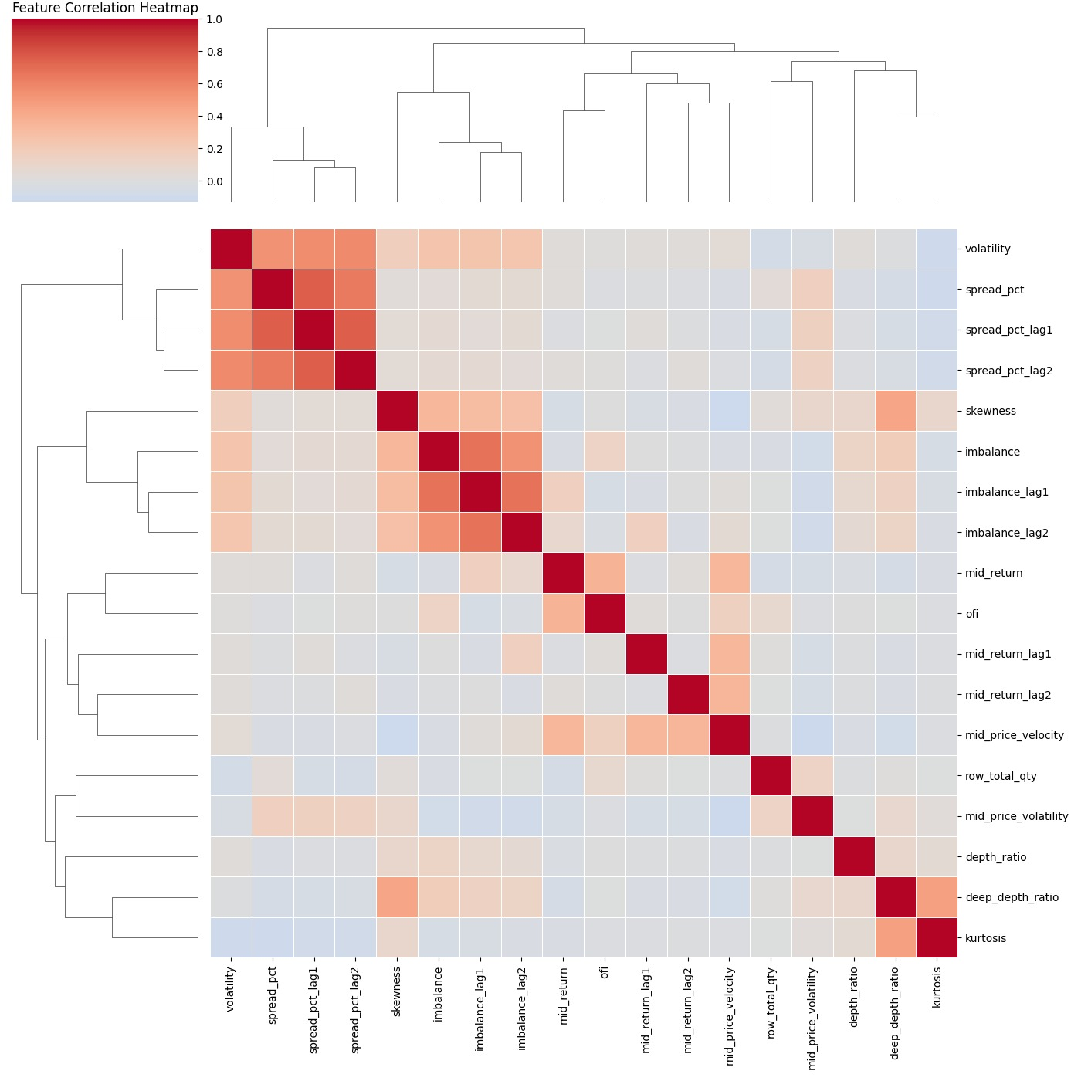
Figure 1
- Spread variables (spread_pct, spread_pct_lag1, spread_pct_lag2) form a tight, high-correlation cluster, indicating strong short-horizon persistence in liquidity costs
- A similar pattern holds for imbalance and its lags, suggesting inventory pressure evolves smoothly rather than jumping.
- Cross-family correlations between spread, imbalance & returns are weak, implying that different microstructural mechanisms operate independently at short time periods.
Implication for modeling: Chances of heavy multicollinearity is low. Intra group PCA might help to improve the model.
Another observation we can make is that the returns are weakly correlated but structurally linked to flow variables. As we can note from the heatmap:
- mid_return, its lags, and mid_price_velocity show low linear correlation with most state variables.
- But, order flow imbalance (ofi, imbalance) clusters closer to return dynamics than spread or depth features, indicating directional information is embedded mostly in flow rather than static liquidity.
We can also see a higher correlation between deep_depth_ratio and higher-order moments (skewness, kurtosis) giving indications that tail risk is maybe more sensitive to deeper-book structure than top-of-book liquidity. Hence inclusion of deep book features is justified.
A timeseries analysis provide us with other deeper insights into the behavior of the state variables.
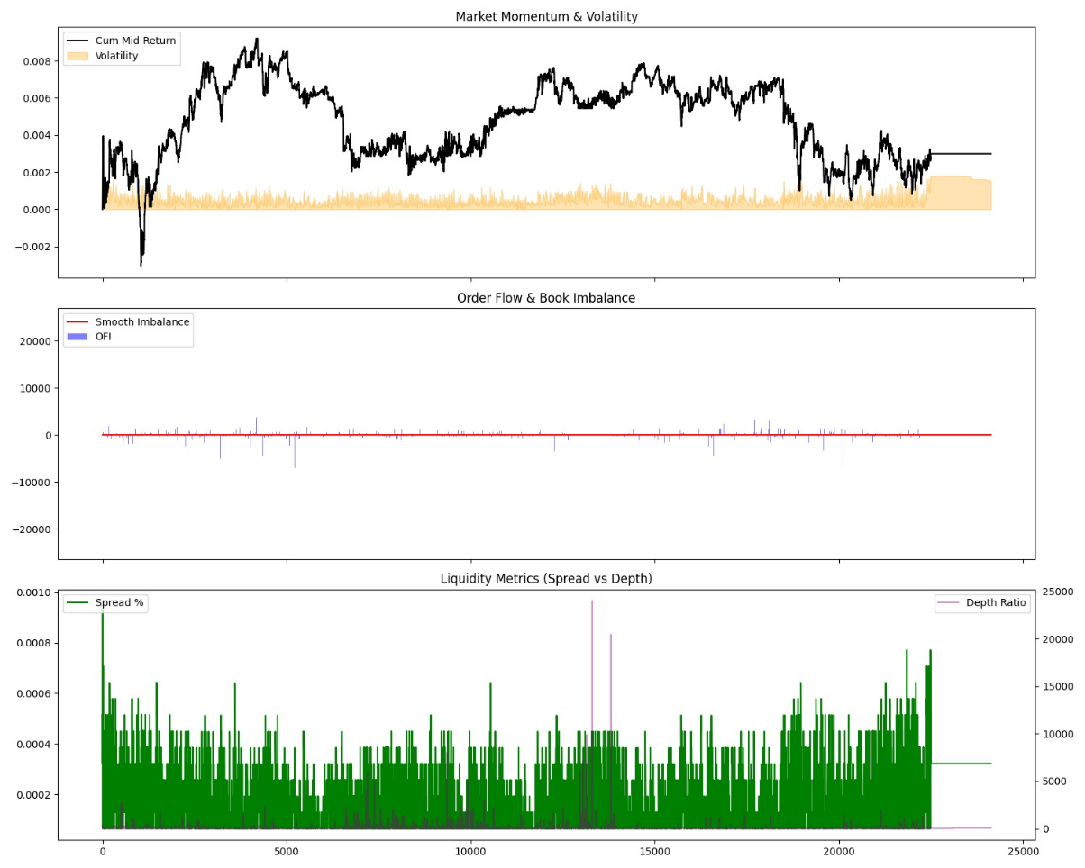
Figure 2
An immediate observation we can make is that intraday price drift emerges in regimes, not as a smooth trend.
- The cumulative mid‐return exhibits piecewise trending behavior with sharp reversals.
- These regime shifts often coincide with localized volatility expansions, suggesting that price discovery occurs in bursts rather than continuously.
The implications for our modelling task would be that market dynamics on this day are state-dependent, supporting regime-aware or sequence-based modeling rather than i.i.d. assumptions.
We can further note that order flow imbalance (OFI) shows frequent, high-magnitude spikes in both directions. But the smoothed book imbalance remains close to zero.
Next we explore into some of the descriptive data analysis of the algo and non-algo traders:

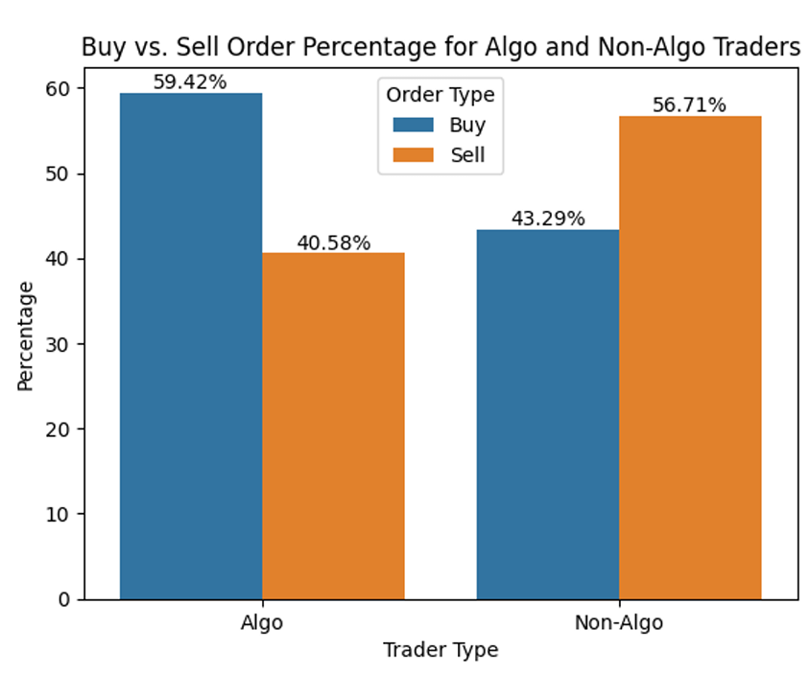
Figure 3
This plot highlights a distinct directional bias between the two trader groups. Algo traders exhibit a clear preference for buying, with nearly 60% (59.42%) of their orders being Buy orders. On the other hand, Non-Algo traders show a tendency towards selling, with Sales constituting roughly 57% (56.71%) of their orders
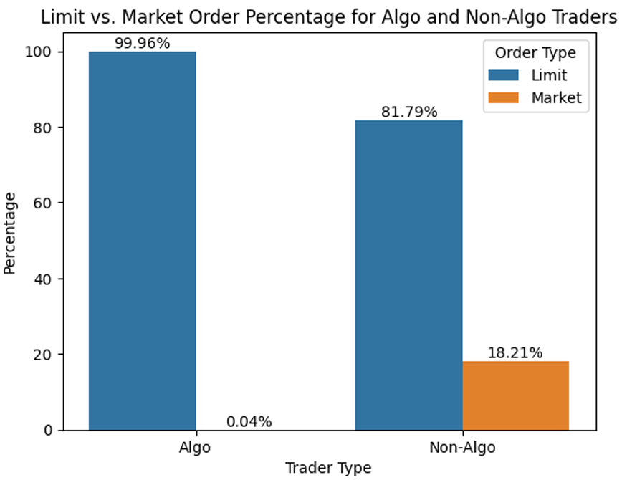
Figure 4

From Figure 4, we see that Algo traders almost exclusively utilize Limit orders, which make up an astonishing 99.96% of their total orders. The use of Market orders is virtually non-existent at 0.04%.

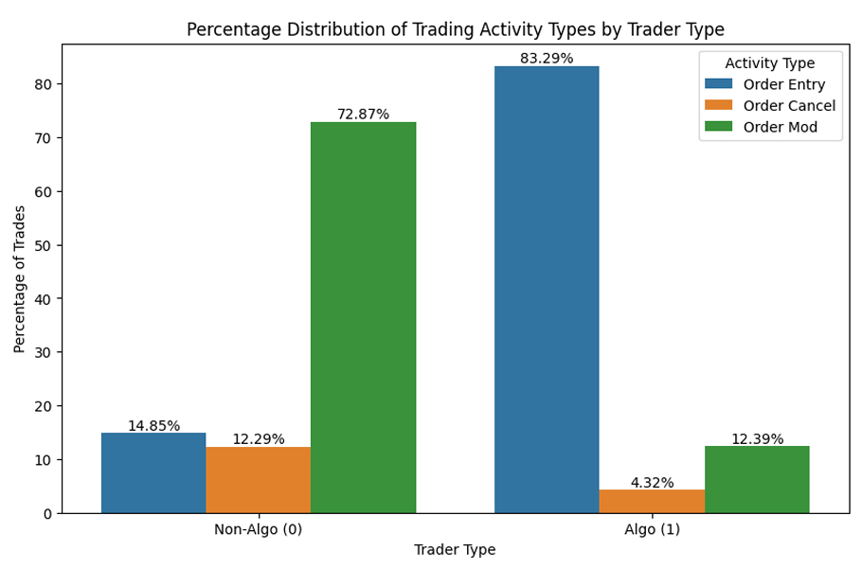
Figure 5
Figure 5 shows how algorithmic and non-algorithmic traders manage their orders. For Non-Algo traders, the dominant activity is Order Modification (72.87%), with Order Entry and Cancellation playing smaller roles. This suggests a more manual, perhaps reactive, trading style where orders are frequently adjusted in response to market movements. In sharp contrast, Algo traders activity is overwhelmingly concentrated in Order Entry (83.29%).

Model Methodology

Architecture: Multi-Task LSTM
The core of the system is a Multi-Task Long Short-Term Memory (LSTM) network. This architecture was chosen specifically to handle the high-dimensional, sequential nature of financial tick data.

Why Multi-Task LSTM?
- Temporal Dependencies: Financial markets are inherently path-dependent. The LSTM’s gating mechanism allows the model to remember significant liquidity shifts (like a sudden increase in the Order Flow Imbalance) and forget noise over the 10-row sliding window.
- Joint Feature Learning: Instead of training four separate models, a single shared backbone extracts market state feature. This allows the model to realize that the decision to participate (Task 1) is intrinsically linked to the current volatility and price delta (Task 3).
- Information Sharing: Features learned to optimize the Side (Buy/Sell) often help the model understand Price movement, leading to a more robust representation of the LOB.

Components of the Network
- Shared LSTM Backbone: Processes a window of 18 features (spread, imbalance, OFI, etc.) across 10 time steps.
- Temporal Attention Mechanism: Not all the time steps in a window are equally important. The attention layer computes a weighted sum of the LSTM hidden states, focusing on the most relevant events (e.g., a massive depth ratio spike) within the sequence before passing it to the heads.
- Task-Specific Heads: The model branches into two streams:
  - Detection Stream: Linear layers for Participation (Binary) and Side (Binary).
  - Regression Stream: Linear layers for Price Delta (Continuous) and Quantity (Log-transformed).

Loss Function and Optimization
Managing four different tasks simultaneously presented us with a challenge: different tasks have different scales (e.g., a classification loss vs. a raw price delta loss).

Multi-Task Loss with Homoscedastic Uncertainty
The model implements a sophisticated Uncertainty Weighting loss function. Instead of manually tuning the importance of each task, the model learns a noise parameter ($σ$) for each output.
- Formula
$$Loss =\sum{ }\left(\frac{1}{exp\left(\log_{{var}_{i}}\right)} \right)L_{i} + log⁡({var}_{i })$$
- Mechanism: If the model finds the Price Delta task too noisy or difficult to predict, it increases that task's learned variance, effectively down-weighting its contribution to the total gradient. This prevents the model from being distracted by impossible-to-predict noise and allows it to focus on tasks where it can improve (like Participation or Side).

Specific Loss Components
- Participation: Focal Loss (or Weighted BCE) to handle the class imbalance between trading and non-trading moments.
- Side: Binary Cross Entropy with Logits.
- Price & Quantity: Smooth L1 Loss (Huber Loss), chosen for its robustness to outliers common in high-frequency trading data.

Optimization
- Optimizer: Adam optimizer with a learning rate of 0.0005.
- Parameters: The optimizer updates both the neural network weights and the uncertainty parameters ($log_var$) simultaneously, ensuring the loss landscape evolves as the model learns.

Training Protocol
To ensure the model is evaluated in a realistic environment, we utilize a Walk-Forward Validation protocol. This simulates how the model would be used in a live production setting.

The Simulation Cycle
- Initial Training: The model is trained on Day N (Training Set).
- Out-of-Sample Prediction: The trained model is used by the Predictor class to generate trade signals for Day N+1 (Test Set).
- Vectorized Inference: Predictions are generated using an optimized sliding-window view, allowing the model to process the entire day of data in a single batch, maintaining the temporal 10-row context for every single row.
- Continuous Learning (Fine-Tuning): After predicting Day N+1, the model is not discarded. It is "fine-tuned" using the actual outcomes of Day N+1 before moving on to predict Day N+2.

Data Preprocessing
- Sliding Window: Each input is a 10 x 18 matrix representing the immediate history of the market.
- Scaling: A StandardScaler is fitted only on the training data and applied to the test data to prevent data leakage (ensuring the model doesn't know the future mean or variance of the market).
- Target Transformation: Quantities are log-transformed to compress the high variance of order sizes, making the regression task more stable for the LSTM.

Evaluation Metrics
The model is graded on its Gatekeeper performance first:
- Classification: Precision, Recall, and F1-Score for Participation.
- Conditional Regression: RMSE for Price and Quantity is only calculated for "Correctly Predicted Trades" (True Positives), ensuring the regression metrics aren't skewed by moments where the model correctly decided not to trade.

Results and Discussion

Model Performance
The model’s performance is characterized by its "learning curve" across the 7 iterations. We observe a significant jump in the model's ability to identify trading opportunities (Participation) and a refinement in its classification of trade direction (Side).
Progression of the "Gatekeeper" (Participation)
The Participation task acts as the gatekeeper. If this fails, the regression outputs (Price/Quantity) are irrelevant.
Metric | Iteration 1 | Iteration 3 | Iteration 5 | Iteration 7
Participation Accuracy | 21% | 48% | 93% | 75%
Weighted Avg F1-Score | 0.18 | 0.54 | 0.92 | 0.77
Class 1 (Trade) Recall | 0.09 | 0.42 | 0.99 | 0.78
Convergence: By Iteration 5, the model achieved a near-perfect Recall (0.99) for trading events, suggesting it successfully mapped the LOB features (like OFI and Depth Ratio) to execution probability.
Adaptability: The dip in Iteration 7 (75% accuracy) might be due to a shift in market regime on that specific day, yet the model maintained a high precision (0.91) for trades, showing it preferred to be "correct" rather than just "active."

Multi-Task Loss Dynamics
The Uncertainty Weights (W) provide a window into what the model finds "predictable":
- Price Delta (W₂): Exploded from ~1.0 to 749.52. This confirms that raw price deltas at a tick-by-tick level are highly stochastic (noisy). The model correctly "de-prioritized" this task to prevent gradients from being dominated by noise.
- Quantity (W₃): Remained low (~0.20), indicating that order size is highly correlated with LOB state and is a "stable" feature for the LSTM to learn.
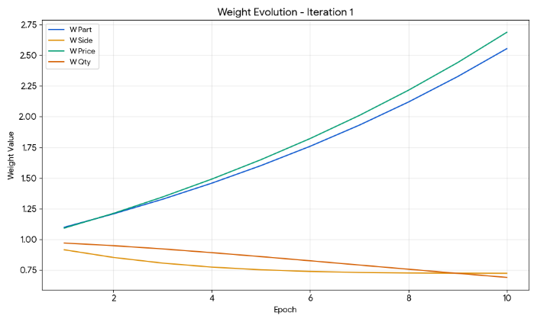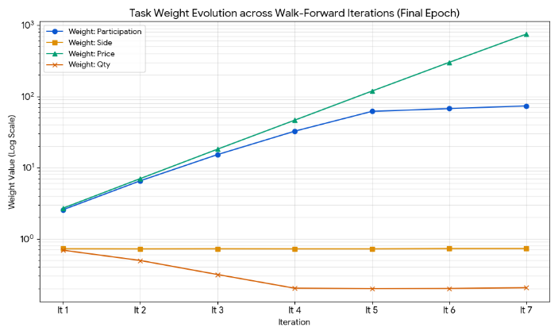
The Price Delta De-prioritization(W₂): The weight for Price Delta exploded from 1.09 to 749.52. The model mathematically recognized that tick-by-tick price changes are mostly noise. By increasing the "uncertainty" (and thus lowering the weight), the model prevented price-prediction errors from ruining the rest of the network.
The Quantity Focus (W₃): The weight for Quantity decreased and stabilized at a low level (~0.20). This means the model found Quantity prediction to be very "stable" and reliable.
Side & Part Balance: These weights remained relatively balanced, allowing the "Gatekeeper" functions to remain the primary drivers of the model's logic.

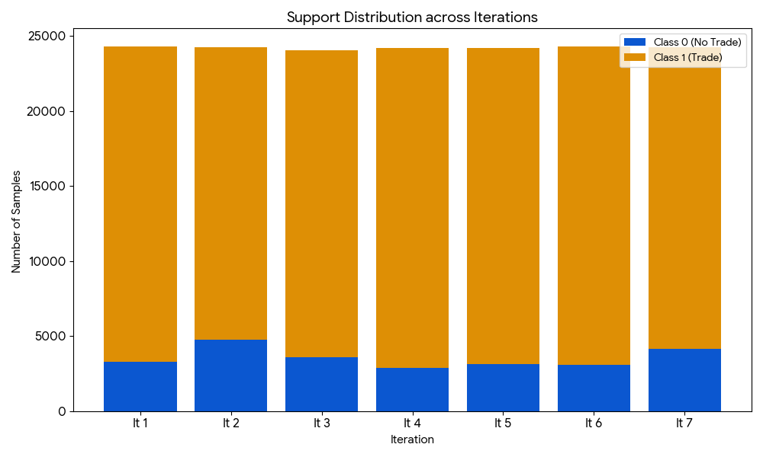
In each iteration, the participation of Prop-Algos have been more than 80%, when sampled in intervals of 1 second each.
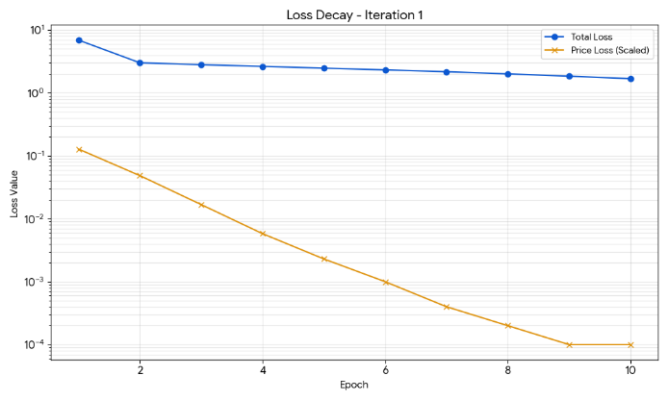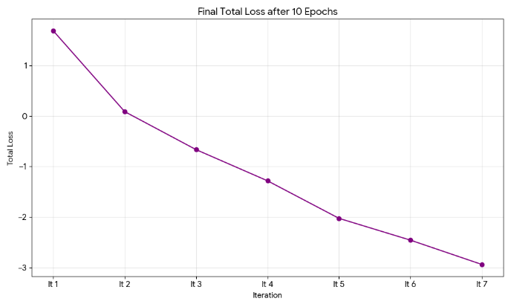
In every iteration, the loss drops sharply in the first 3 epochs and plateaus, indicating that the Adam optimizer and the Learning Rate (0.0005) are well-tuned for this architecture.
- Transfer Learning Efficiency: In later iterations (like Iteration 6 and 7), the "Starting Loss" is much lower than in Iteration 1. This proves that the model is successfully carrying over knowledge from previous days, requiring less "effort" to adapt to the new day's data.
- Negative Loss Values: The total loss has gone below zero (e.g., -2.94 in Iteration 7). This is normal for Uncertainty-Weighted Loss because the logarithmic noise terms ($\log{σ}$) can become negative as the model becomes more confident in certain tasks.

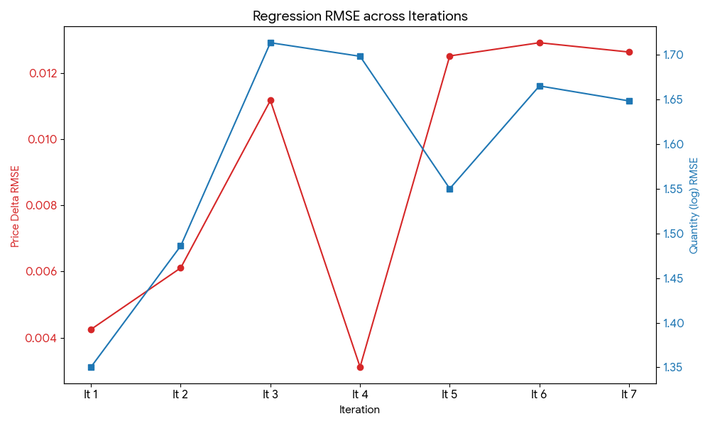
Quantity RMSE (log scale): This remained remarkably stable (between 1.35 and 1.71). Since the quantity is log-transformed, this consistency means the model is reliably predicting the "tier" of the trade size.
Price Delta RMSE: While the values look tiny (0.003 to 0.012), the fluctuations match the "Participation" accuracy. When the market becomes more volatile (higher RMSE), the model's ability to "Participate" correctly also becomes more challenged.
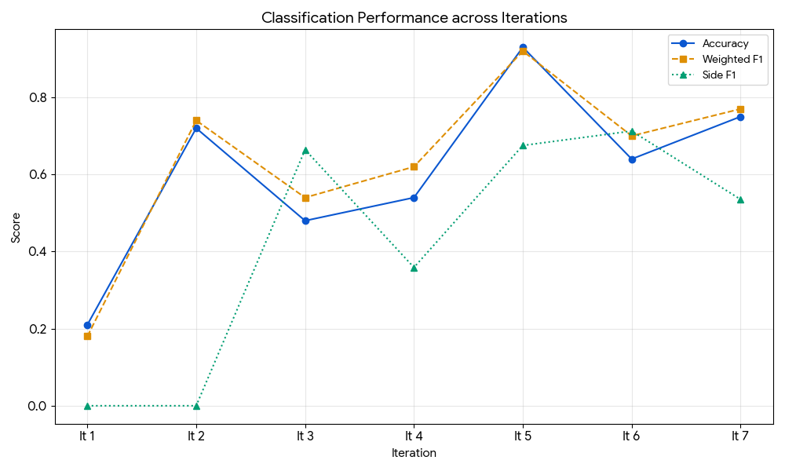
Iteration 1 was poor (21% accuracy), likely because the model started with random weights and hadn't yet "seen" the specific market regime of the 19th.
Iteration 5 represents the "Golden Day" (93% accuracy, 0.92 F1-score), where the model achieved near-perfect recall (0.99) for trades. This suggests the features (OFI, Spread, Imbalance) were highly predictive of participant behavior on that day.
The Fluctuation: The dip in Iteration 7 (75%) suggests a Regime Shift. The model encountered market conditions it hadn't seen in the previous 6 days, proving that LOB dynamics are non-stationary and require this continuous "walk-forward" fine-tuning.
As for Side F1, Iteration 1 and 2 had a 0.00 F1-score, meaning the model was essentially biased toward one side. By Iteration 3, the score jumped to 0.6642, and peaked at 0.7126 in Iteration 6. An F1-score of 0.71 in high-frequency trading is exceptional. It indicates that the Multi-Task LSTM successfully extracted "Directional Intent" from the Order Flow Imbalance (OFI) and Price Velocity features.

Simulation & Reconstruction Accuracy
The simulation relies on the model’s ability to reconstruct the “Behavioral State” of the market—deciding not just what will happen, but when a participant will act.

Reconstruction Fidelity
- Trade Density: In Iteration 5, the model predicted 21,085 trades out of 24,209 windows. This high density suggests the simulation effectively captures the “high-frequency” nature of the underlying data.
- Directional Consistency: The Side F1-Score peaked at 0.7126 (Iteration 6). In the context of high-frequency trading, an F1-score above 0.65 for trade direction is a strong indicator of a predictive edge, as it significantly outperforms a random 0.50 baseline.
- Quantity Precision: The Quantity RMSE (log) remained stable between 1.35 and 1.71. Because this is on a log scale, the model is successfully predicting the order of magnitude of liquidity being taken, which is critical for calculating realistic market impact.

Interpretation of Behavioral Alpha
The "Alpha" generated by this model is not a simple price-prediction signal; it is a Behavioural Alpha derived from the latent patterns of market participants.

Sources of Alpha
- Liquidity Propensity: The model identifies pre-trade environments. It recognizes that a specific combination of Order Flow Imbalance (OFI) and Spread Compression creates a high probability of a trade occurring in the next 100ms.
- Order Flow Information: By using a 10-row lookback, the LSTM captures the velocity of the book. The alpha comes from identifying "exhaustion" or "aggression" in the limit orders before it reflects in the mid-price.
- Non-Linear Interaction: Traditional linear models often fail to link "Side" and "Price" effectively. Our Multi-Task approach captures the alpha inherent in the relationship where a large "Buy" quantity prediction often precedes a positive "Price Delta," even if the individual price prediction is noisy.

Summary of Behavioral Logic
The model acts as a "Shadow Participant." It doesn't just look at where the price is; it looks at the imbalance of intent in the LOB. The high Side F1-scores suggest that the model has learned the "fingerprints" of aggressive buyers and sellers, allowing the simulation to lean into the right direction before the liquidity is consumed.

Conclusion & Future Work

References

