Step 1:
A. How to configure Django package.
go to :
File>settings>project>Project Interpreter>Click +>Search Django>Install Package.
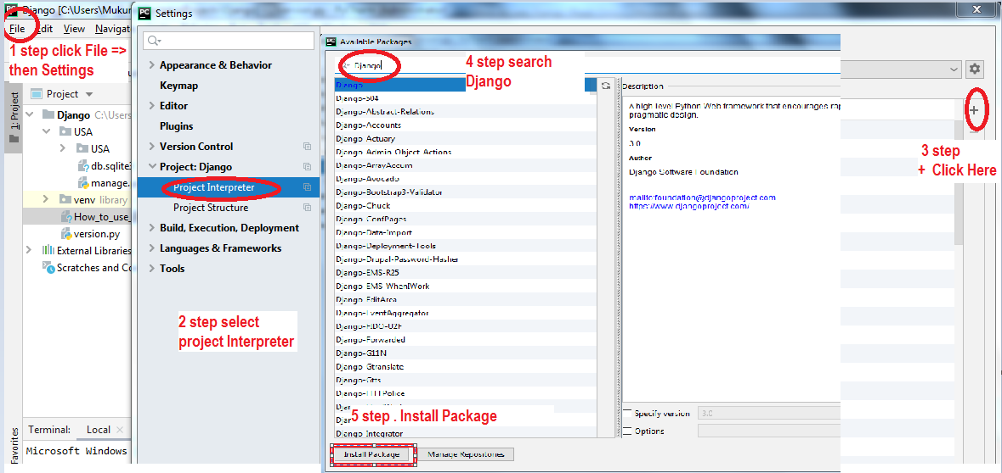
Done.
B. how to create Django website.
go to terminal :=>
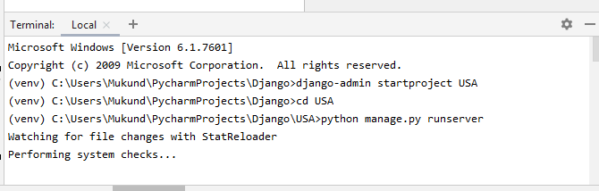
Microsoft Windows [Version 6.1.7601]
Copyright (c) 2009 Microsoft Corporation. All rights reserved.
(venv) C:\Users\Mukund\PycharmProjects\Django>django-admin startproject My_website_name
(venv) C:\Users\Mukund\PycharmProjects\Django>cd My_website_name
(venv) C:\Users\Mukund\PycharmProjects\Django\USA>python manage.py runserver
Starting development server at http://127.0.0.1:8000/

C. How to Check Django Website.
http://127.0.0.1:8000/
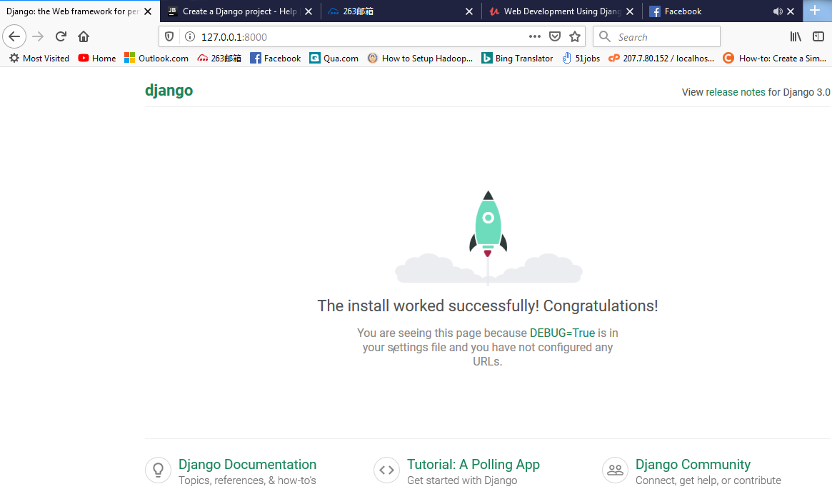

Step 2:
2. How to create or migrate existing database.
(venv) C:\Users\Mukund\PycharmProjects\Django\USA>python manage.py migrate
Operations to perform:
Apply all migrations: admin, auth, contenttypes, sessions
Running migrations:
Applying contenttypes.0001_initial... OK
Applying auth.0001_initial... OK
Applying admin.0001_initial... OK
Applying admin.0002_logentry_remove_auto_add... OK
Applying admin.0003_logentry_add_action_flag_choices... OK
Applying contenttypes.0002_remove_content_type_name... OK
Applying auth.0002_alter_permission_name_max_length... OK
Applying auth.0003_alter_user_email_max_length... OK
Applying auth.0004_alter_user_username_opts... OK
Applying auth.0005_alter_user_last_login_null... OK
Applying auth.0006_require_contenttypes_0002... OK
Applying auth.0007_alter_validators_add_error_messages... OK
Applying auth.0008_alter_user_username_max_length... OK
Applying auth.0009_alter_user_last_name_max_length... OK
Applying auth.0010_alter_group_name_max_length... OK
Applying auth.0011_update_proxy_permissions... OK
Applying sessions.0001_initial... OK
Run server
(venv) C:\Users\Mukund\PycharmProjects\Django\USA>python manage.py runserver
Watching for file changes with StatReloader
Performing system checks...

System check identified no issues (0 silenced).
December 17, 2019 - 14:22:53
Django version 3.0, using settings 'USA.settings'
Starting development server at http://127.0.0.1:8000/
Quit the server with CTRL-BREAK.
Step 3:
http://127.0.0.1:8000/admin
2. How to create or super User means admin user and password.
go to terminal
(venv) C:\Users\Mukund\PycharmProjects\Django\USA>python manage.py createsuperuser
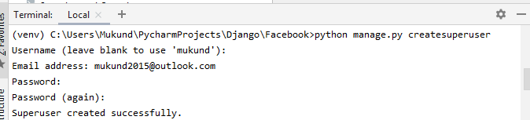
Step 3:
1. How to log in admin and create users.
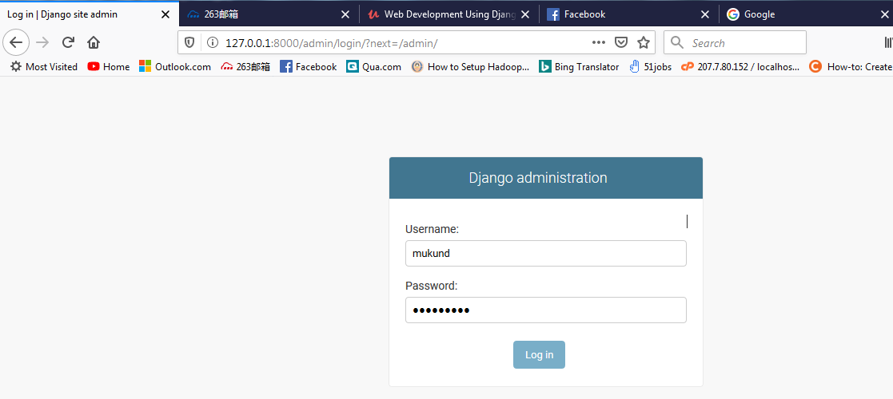
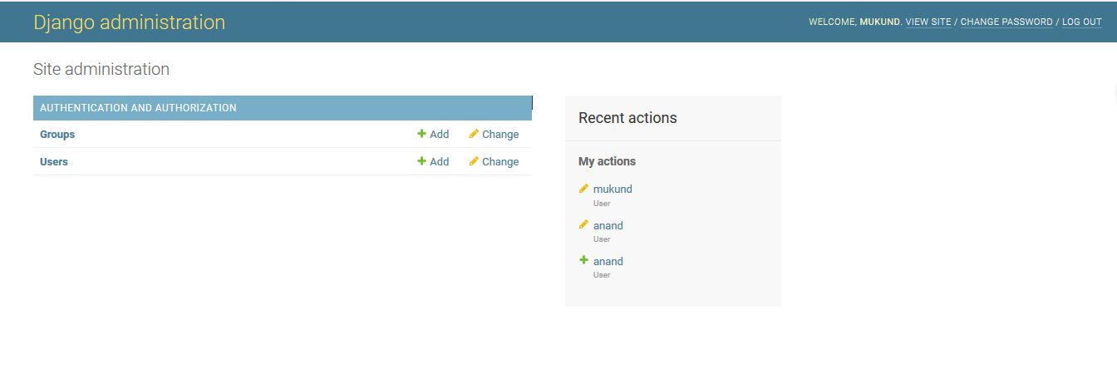

How to create one website:
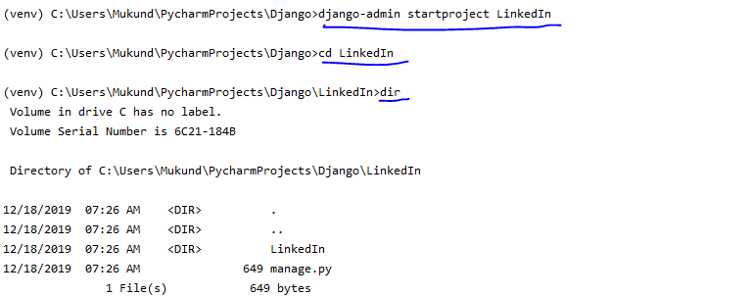
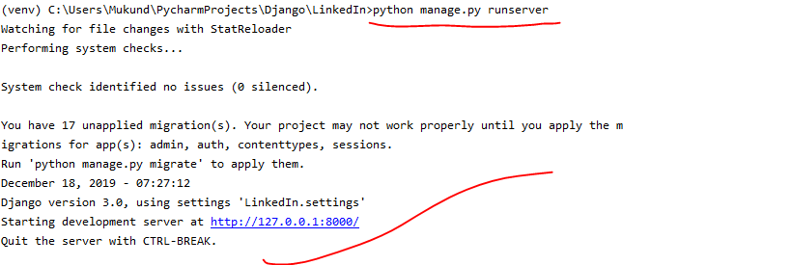
go to browser
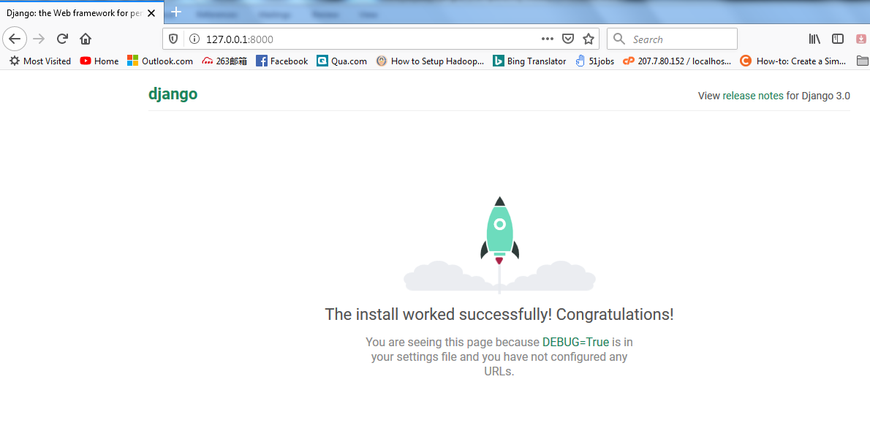

How to create Database in sqllite3 & super user admin.
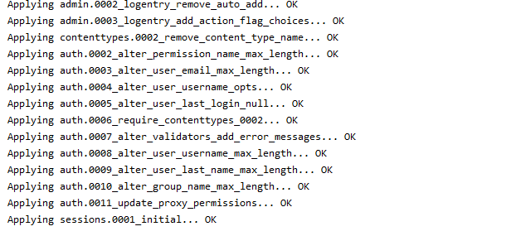
now create user for admin Login
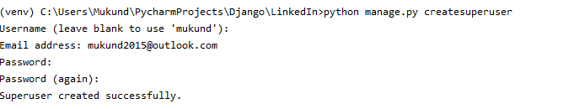
now start server
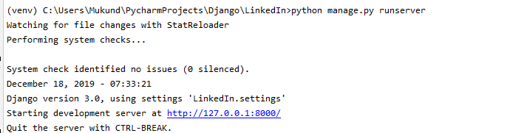
Login admin
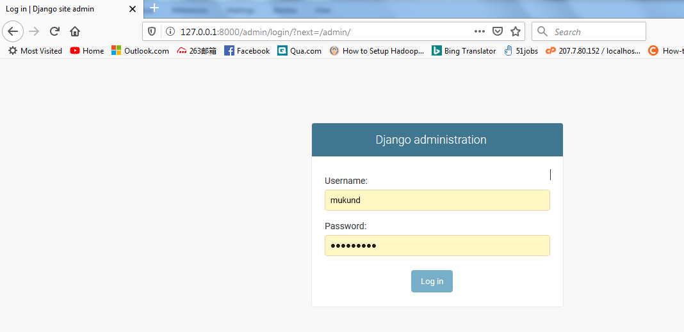
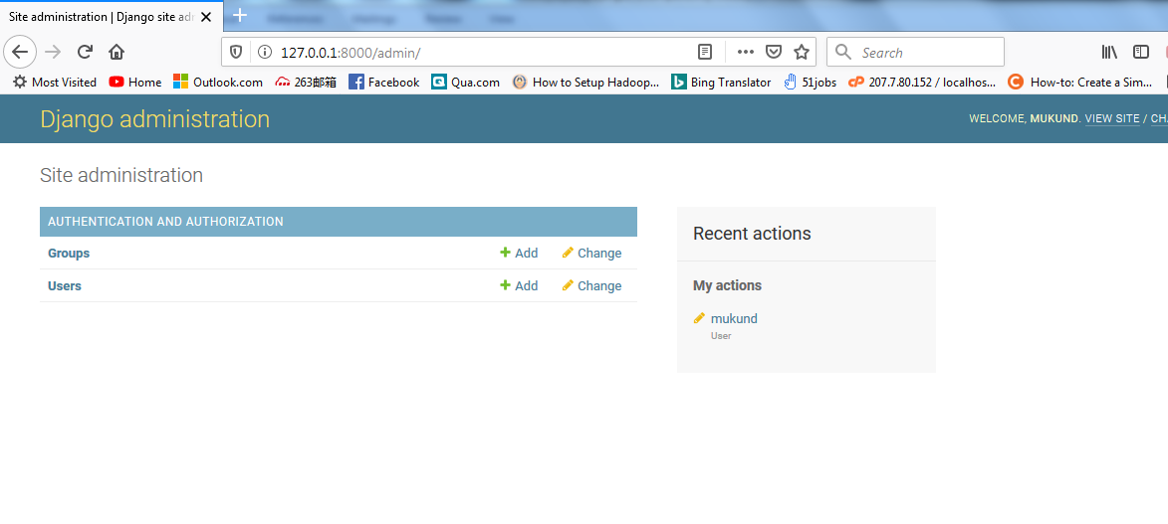

step 2.how to create other apps under this project
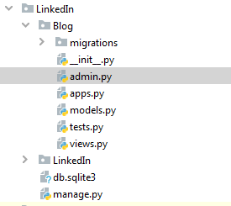
Understand Flow of the Django Projects
Step 1 :- How to Refer any URL from Main Project(Refer Blog to Main URLS.py)
Urls.py
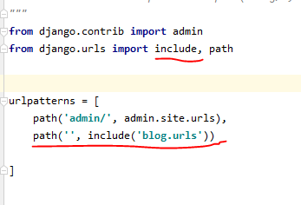
Step 2 :- create one Blank urls.py file under blog directory
I:- urls.py
from django.urls import path
from . import views
urlpatterns = [
path('home/',views.home),
path('about/',views.about),
path('Contact/',views.Contact)
]
II:- views.py
from django.shortcuts import render
# Create your views here.
from django.http import HttpResponse
def home(request):
return HttpResponse("Hello, Mukund Biradar Welcome to USA.")
def about(request):
return HttpResponse("Shaurya Biradar Washington DC.")
def Contact(request):
return HttpResponse("My Contact Number is :- 123456666")
Out Put
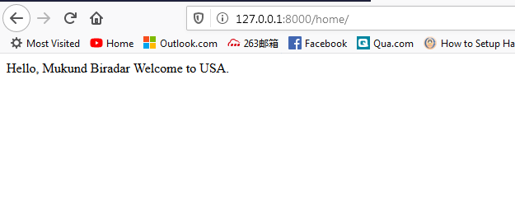
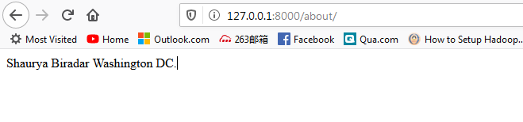
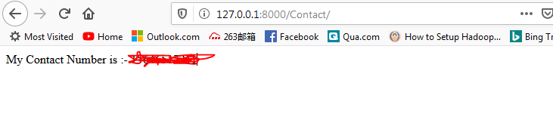
Url======> Views
URL is reference and view use to display Functions.

============End=========End==================================

How to create website ,Super user & database in 5 Minutes.
Demo:- Facebook (Website creation)
step 1: create Django project Name or Directory
(venv) C:\Users\Mukund\PycharmProjects\Facebook>django-admin startproject Facebook
(venv) C:\Users\Mukund\PycharmProjects\Facebook>python manage.py runserver
C:\Users\Mukund\AppData\Local\Programs\Python\Python37-32\python.exe: can't open file 'manage.py': [Errno 2] No such file or directory
step 2: Enter created Directory
(venv) C:\Users\Mukund\PycharmProjects\Facebook>cd Facebook
(venv) C:\Users\Mukund\PycharmProjects\Facebook\Facebook>python manage.py runserver
(Server started)
You have 17 unapplied migration(s). Your project may not work properly until you apply the migrations for app(s): admin, auth, content types, sessions.
Run 'python manage.py migrate' to apply them. // How to create database using migrate command
Go to browser and check site is working or not
Starting development server at http://127.0.0.1:8000/
Quit the server with CTRL-BREAK.
step 3: Create database for existing project.
(venv) C:\Users\Mukund\PycharmProjects\Facebook\Facebook>python manage.py migrate
Operations to perform:
Apply all migrations: admin, auth, contenttypes, sessions
Running migrations:
step 4: Create admin user to login to admin panel.
(venv) C:\Users\Mukund\PycharmProjects\Facebook\Facebook>python manage.py createsuperuser
Username (leave blank to use 'mukund'):
Email address: Mukund@mukund.com
Password:
Password (again):
The password is too similar to the username.
Bypass password validation and create user anyway? [y/N]: N
Password:
Password (again):
Superuser created successfully.
step 5: Start server
(venv) C:\Users\Mukund\PycharmProjects\Facebook\Facebook>python manage.py runserver
Starting development server at http://127.0.0.1:8000/
++++++++++++++++++++++++++++++++++++++++++++++
Step 5: how to create other directory to store html pages & directory wise Images.
> python manage.py startapp blog
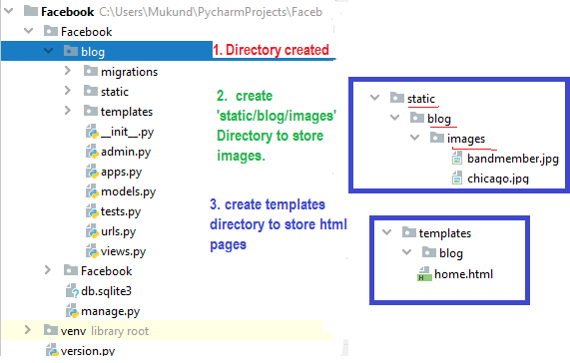

step1 : settings.py(main file)
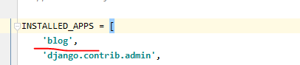
step 2: urls.py
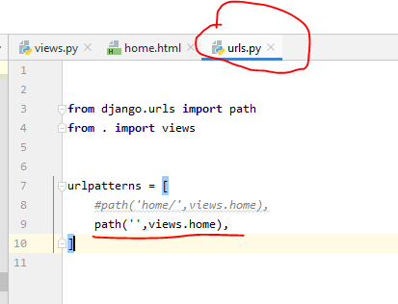
step 3: view.py
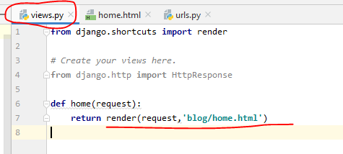
step 4 :- how to display images.
Note:- write these below code in your html page.

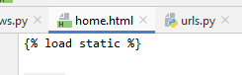
{% static 'blog/images/architect.jpg' %}
{% static 'blog/images/house1.jpg' %}
{% static 'blog/images/house2.jpg' %}
{% static 'blog/images/house3.jpg' %}
{% static 'blog/images/hourse4.jpg' %}
{% static 'blog/images/persion1.jpg' %}
{% static 'blog/images/persion2.jpg' %}
{% static 'blog/images/persion3.jpg' %}
{% static 'blog/images/persion4.jpg' %}

