**Project Documentation: Hospital Management System**

**OBJECTIVE:**

To develop a Java-based Hospital Management System using JDBC and MySQL that allows adding/viewing patients and doctors, and booking appointments.

**TECHNOLOGIES USED:**

* Language: Java
* Database: MySQL
* Database Connectivity: JDBC
* IDE: Eclipse
* Version Control: Git + GitHub

**PROJECT STRUCTURE:**

**JDBCDemo/**

**├── src/**

**│ ├── model/**

**│ │ ├── Doctor.java**

**│ │ └── Patient.java**

**│ └── ui/**

**│ └── HospitalManagementSystem.java**

**├── README.md**

**├── Documentation/**

**└── HospitalManagementSystem_Documentation.docx**

**MODULES/ FEATURES:**

1. Add Patient
2. View Patients
3. View Doctors
4. Book Appointment
5. Exit

**USER ROLES:**

1. Receptionist: Add/View Patients, View Doctors, Book Appointments
2. Admin: Add Doctors (from MySQL)

**CLASS DESIGN:**

1. Patient:

Attributes:

* Id
* Name
* Age
* Gender

Methods:

* addPatient()
* viewPatients()
* getPatientByID()

1. Doctor:

Attributes:

* Id
* Name
* Specialization

Methods:

* viewDoctors()
* getDoctorByID()

1. Book Appointment:

Attributes:

* Patient_id
* Doctor_id
* Appointment_date

Methods:

* bookAppointment()
* checkDoctorAvailability()

1. Main class:

* Contains main() method and menu-driven interactions

**SAMPLE TEST CASES**

|  |  |  |
| --- | --- | --- |
| **Feature** | **Input** | **Expected Output** |
| Add Patient | Name: Sai, Age: 30, Gender: Male | Patient added successfully |
| View Doctors | - | |  | | --- | |  |  |  | | --- | | List of doctors | |
| View Patients | - | List of patients |
| Book Appointment | PatientID: 2, DoctorID: 1, Date: 2025-08-05 | Appointment Booked |

**HOW TO RUN:**

1. Install MySQL and create a “hospital” database with relevant tables.
2. Update database credentials in “HospitalManagementSystem.java”.
3. Open project in your IDE(Eclipse).
4. Compile and run “HospitalManagementSystem.java”.
5. Use the console menu to operate the system.

**FUTURE ENHANCEMENTS:**

* GUI using JavaFX/Swing
* Role-based login system
* Email/SMS appointment notifications
* Doctor availability scheduling system
* Prescription module + Billing system
* Rest API and Frontend integration

**AUTHOR:**

Name: Mothku Mukunda Sai

Contact: [mukundasaimothku@gmail.com](mailto:mukundasaimothku@gmail.com)

GitHub: https://github.com/mukunda6/Hosptial-Management-System

**SYSTEM ARCHITECTURE DIAGRAM:**

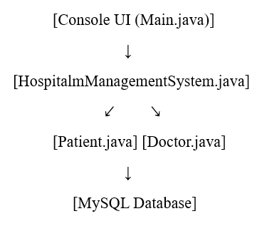

**SAMPLE SCREENSHOTS:**

Screenshot showing the menu-driven interface in console output:

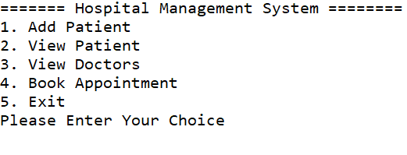

The system takes user input and performs operations based on the selected menu item.