Birla Institute of Technology & Science, Pilani
Work Integrated Learning Programmes Division
Second Semester 2024-2025

Comprehensive Test
(EC 3- Regular)

Course No. : CS ZG524/ES ZG524/MEL ZG524 ( Merged)
Course Title : Real Time Operating Systems
Nature of Exam : Open Book
Weightage : 40%
No. of Pages = 02

No. of Questions = 06
Duration : 2 Hours 30 Minutes
Date of Exam : 25.05.2025 ( 1 PM )

Note to Students:

- Please follow all the Instructions to Candidates given on the cover page of the answer book.
- All parts of a question should be answered consecutively. Each answer should start from a fresh page.
- Assumptions made if any, should be stated clearly at the beginning of your answer.

Q.1 | A system of periodic tasks is scheduled and executed according to a cyclic schedule. For each system, choose an appropriate frame size. Preemptions are allowed, but the number of preemption should be kept small. The 3 tasks are T1, T2 and T3 with (P, e) = (6, 3), (10, 2), and (12, 3) respectively | 8 Marks
Q.2 | Consider three tasks (T1, T2, T3) with the following priorities and resource needs: T1: Priority 1 (highest), T2: Priority 2, T3: Priority 3 (lowest), and there are 2 resources Shaded , S1 and Black, S2  The scenario is T1 needs S1 and S2 each for 2 time slots in the same order; T2 needs S2 for 2 time slots ; T3 needs S1 for 2 time slots.  T1 , T2 and T3 are released at 4, 2 and 0 respectively and execution times are 6, 4 and 4 respectively  Explain Priority Inheritance Protocol with neat and necessary diagrams for the above example | 8 Marks
Q.3 | Explain with an example how Priority Ceiling Protocol avoids Deadlock. Provide necessary diagrams for the same. | 6 Marks
Q.4 | Explain Weibull distribution with necessary graphs and mathematical equations. What will be the probability of a magnetic disk failing before 400 hours if the disk is exposed to corrosive gas. The value of γ and α is 300 and 0.5 | 6 Marks
Q.5 | List the various applications of IoT in home automation. City Corporation and Water Supply Board wants to develop smart electricity and water reading meters using IoT. Explain with necessary block diagram various components and elaborate on how human resource can be significantly reduced | 6 Marks
Q. 6 | Consider 8 Jobs [ J1, ….J8]. All the jobs are released at 0 except J5 which is released at 3. Figure shows the precedence graph and execution time for each of the Jobs. Schedule the jobs using priority driven scheduling using (a) Preemptive (b) Non Preemptive  Assume that two processors are available for execution of the Jobs  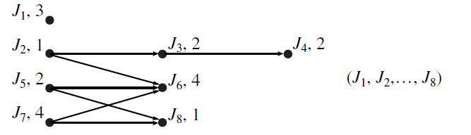 | 6 Marks

