Software Requirements Specification

“Forensic Management System”

# Introduction

Forensic science deals with criminal and civil laws. Forensic

scientists are involve in collection, preservation and scientific

evidence analysis related to criminal or civil prosecution. sharp and

gradual increase in number of cases for investigation needs

systematic maintenance of information and records. For

maintenance of information and records, it’s important to have

efficient system to organize and store data in crime bureau.

Best utilization of available resources- timely and quickly,

accurate information is very vital and important.

For this purpose, **“Forensic management system (FMS)”** software was developed.

## Purpose

The proposed system will be able to reduce the paper trail required in the process. Digital files will make the sharing and appending of case files extremely easy. Since access to the system is required to view a case file it becomes very simple to track and regulate access to the case files. Documents from different laboratories regarding analyses can be securely and instantly sent via the internet. This system will augment the crime solving and record keeping abilities of a modern police force.

## Intended Audience and Reading Suggestions

The FMS will be useful for the developers and the end users.

## References

**Websites:**

# Overall Description

## Product Perspective

FMS saves time as it allows to store the case investigation information anytime, anywhere. Also all the authority members can retrieve that information.

## Product Functions

**Context Level DFD:**

This diagram represents what are the bounders and scope of “**FMS”** project. It describes the main objective of the system and its entities involved.

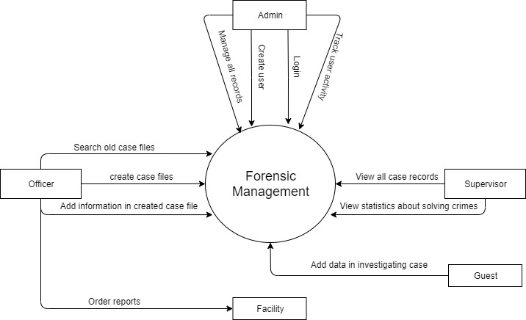

**2.3 User Classes and Characteristics**

The users of the system are the officers and users. All users have a basic technical know how to use internet.

## 2.4Operating Environment

The Software will operate on computer having internet connectivity

* **Hardware Requirement**
* Processor – Dual Core or Above
* RAM 1GB or Higher.
* Hard Disk with 2GB or Higher capacity.
* **Software Requirement**
* Windows 7 and above.
* Apache Tomcat Web Server .
* Back End: SQL Server 2017.

# System Features

The system features here will be described based on functional hierarchy.

**The features that are available to the Admin are:**

* The admin can create user profiles and will be able to track user activity.
* Any attempts to breach the security of the system will automatically lock out the system and notify the admin.

**The features available to the Supervisor are:**

* The supervisor module is reserved for the higher officials in the police department.
* They will be able to view current and past case files and statistics about solving crimes.

**The features available to the Officer are**:

* The officer module will be able to create case files and can add information in the same.
* They will be able to search old case files and order reports from different facilities

**The features available to the Facility are**:

* This module is for facilities such as laboratories and other departments such as the Department of Motor Vehicles to log reports requested by investigating officers.

**The features available to the Guest are**:

* The guest profile can be created for officers from other departments who are collaborating on the investigation.
* They will be able to add data about the case they are investigating but will not be able to access historical case files.
* Any request for access to old case files will be routed to the profile of Officers they are working with and will have to be approved by them.

# Other Nonfunctional Requirements

## Performance Requirements

* The response time should be fast i.e. the data should be retrieved fast.
* Secured-The system must be secured from any sort of threat.
* Maintainable-The system must be maintainable for latest updates.
* Throughput-It should be able to handle multiple users at a time.

## Safety Requirements

**Proper backup should be there to recover from any type of loss like system failure, other cybercrime.**

## Security Requirements

**The usage of FMS should be restricted to only registered members of System. So, proper majors and licensing agreements should be made for the same.**

## Software Quality Attributes

**The software should be adaptable, available, correct, flexible, portable, robust, testable, and Interoperable.**

## Business Rules

All the rules for the design and development of the software will be under the jurisdiction.