JAYPEE INSTITUTE OF INFORMATION TECHNOLOGY
Department of Computer Science & Engineering and Information Technology



Major Project Title: Kruxx
(A web application for summarizing educational content and generating personalized quizzes)

Enrollment No: Name of Students:
21103105 Mukund Sarda
21103107 Vansh Gupta
21103110 Aryan Jolly
Name of Supervisor: Dr. Aastha Maheshwari

Course Name: Major Project Part-1 (15B19CI791)
Program: B. Tech. CSE.
Semester: 7th Semester
November - 2024
(I)
TABLE OF CONTENTS
Part No. | Description | Page No.
II | Declaration | 4
III | Certificate | 5
IV | Acknowledgement | 6
V | Summary | 7-8
VI | List of Figures | 9
VII | List of Symbols and Acronyms | 10
VIII | List of Tables | 11
Chapter No. | Topics | Page No.
Chapter-1 | Introduction | 12-20
 | 1.1 General Introduction | 12-13
 | 1.2 Problem Statement | 14
 | 1.3 Significance of the Problem | 15-16
 | 1.4 Empirical Study | 17
 | 1.5 Brief Description of Solution Approach | 18
 | 1.6 Comparison of Existing Approaches of the Problem Framed | 19-20
Chapter-2 | Literature Summary | 21-23
 | 2.1 Summary of Papers Studied | 21-22
 | 2.2 Integrated Summary of the Literature Studied | 23
Chapter-3 | Requirement Analysis and Solution Approach | 24-34
 | 3.1 Overall Description of the Project | 24
 | 3.2 Requirement Analysis | 25-26
 | 3.3 Solution Approach | 27-31
 | 3.4 Comparison with Existing Systems | 32-34
Chapter-4 | Modelling and Implementation Details | 35-42
 | 4.1 Design Diagrams | 35-37
 | 4.2 Implementation Details and Issues | 38-39
 | 4.3 Risk Analysis and Mitigation | 40-42
Chapter-5 | Testing | 43-49
 | 5.1 Test Plan | 43
 | 5.2 Test Team Details | 44
 | 5.3 Test Schedule | 44
 | 5.4 Test Environment | 45
 | 5.5 Component Decomposition and Type of Testing | 45
 | 5.6 Test Cases | 45-46
 | 5.7 Error and Exception Handling | 46
 | 5.8 Limitations of the Solution | 47-49
Chapter-6 | Findings, Conclusion and Future Work | 50-52
 | 6.1 Findings | 50
 | 6.2 Conclusion | 51
 | 6.3 Future work | 52
 | REFERENCES | 53
 | BIO DATA (RESUME) | 54-56

(II)
DECLARATION

We, Mukund Sarda, Vansh Gupta, and Aryan Jolly, hereby declare that this submission is our own work and that, to the best of my knowledge and belief, it contains no material previously or written by another person nor material which has been accepted for the award of any other degree or diploma of the university or other institute of higher learning, except where due acknowledgement has been made in the text.

------------------------------- ------------------------------- -------------------------------
Mukund Sarda Vansh Gupta Aryan Jolly
(21103105) (21103107) (21103110)

Place: JIIT, Noida, India
Date: 22 November, 2024
(III)
CERTIFICATE

This is to certify that the work titled “Kruxx- A web application for summarizing educational content and generating personalized quizzes” submitted by Mukund Sarda, Vansh Gupta, and Aryan Jolly, in partial fulfillment for the award of degree of B. Tech in Computer Science of Jaypee Institute of Information Technology, Noida has been carried out under my supervision. This work has not been submitted partially or wholly to another University or Institute for the award of this or other degree or diploma.

--------------------------------
Dr. Aastha Maheshwari
(Assistant Professor- Senior Grade)
Date: 22 November, 2024
(IV)
ACKNOWLEDGEMENT

We would like to express our sincere gratitude and heartfelt thanks to everyone who has contributed to the successful completion of this major project.
First and foremost, we extend our deepest appreciation to, Dr. Aastha Maheshwari, our project supervisor, for his invaluable guidance, unwavering support, and insightful feedback throughout the duration of this project. Their expertise and encouragement have been instrumental in shaping the project and enhancing its quality.
We would also like to thank, Jaypee Institute of Information Technology, for providing the necessary resources and conducive environment for conducting this project. The library and laboratory facilities have played a crucial role in the research and development process.
We would like to thank family and friends for their continuous encouragement and understanding during the challenging phases of this project. Their belief in our abilities has been a driving force behind our perseverance.
This project has been a significant learning experience, and we are truly grateful to have had the opportunity to work on it. Thank you all for being an integral part of this journey.

------------------------------- ------------------------------- -------------------------------
Mukund Sarda Vansh Gupta Aryan Jolly
(21103105) (21103107) (21103110)

Date: 22 November, 2024
(V)
SUMMARY

The project titled “Kruxx- A web application for summarizing educational content and generating personalized quizzes” is a comprehensive solution designed to address the challenges faced by students and educators in today’s fast-paced academic environment. By leveraging cutting-edge technologies such as Natural Language Processing (NLP), Optical Character Recognition (OCR), and advanced web development frameworks, the project provides an intelligent platform that simplifies the learning and assessment process.
Key Features of the Project
- Multi-Format Content Summarization: Kruxx allows users to upload educational content in diverse formats, including:
  - Text documents (PDFs, DOCs).
  - Presentation files (PPTs).
  - Images (scanned notes or textbook pages).
  - Video links (e.g., YouTube lectures).
  - Audio files (recorded lectures or podcasts). Using advanced summarization models such as BART and BERT, the application condenses lengthy content into concise, easy-to-understand summaries while retaining critical information and context.
- Dynamic Quiz Generation: The platform automatically generates quizzes from the summarized content, enabling users to test their comprehension. Features include:
  - Multiple-choice questions (MCQs) tailored to the uploaded material.
  - Options for varying difficulty levels based on user preferences.
  - Real-time evaluation and feedback to highlight strengths and areas for improvement.
- Performance Analytics and Feedback: Kruxx provides users with a detailed analysis of their quiz results, offering insights into their performance and suggesting focus areas for further study. This feature enhances personalized learning and empowers users to improve systematically.
- User-Friendly Interface: Designed with simplicity and accessibility in mind, the platform features:
  - A clean, responsive web interface compatible with desktops, tablets, and mobile devices.
  - Intuitive navigation and clear instructions for seamless user interaction.
Objective: The primary objective of Kruxx is to revolutionize how students and educators interact with educational content. The system achieves this by:
- Reducing the time required for studying large volumes of material.
- Enhancing knowledge retention through active learning with quizzes.
- Providing a versatile tool that caters to students, educators, and institutions alike.

------------------------------- ------------------------------- -------------------------------
Mukund Sarda Vansh Gupta Aryan Jolly
(21103105) (21103107) (21103110)

-----------------------------
Dr. Aastha Maheshwari
Date: 22 November, 2024
(VI)
LIST OF FIGURES
Figure | Description | Page No.
Figure 3.1 | Website UI | 30
Figure 3.2 | Website UI | 31
Figure 3.3 | Website UI | 31
Figure 4.1 | Use Case Diagram | 35
Figure 4.2 | Class Diagram | 35
Figure 4.3 | Control Flow Diagram | 36
Figure 4.4 | Sequence Diagram | 37
Figure 4.5 | Activity Diagram | 37

(VII)
LIST OF SYMBOLS AND ACRONYMS

Symbols | Meaning
BART | Bidirectional Auto-Regressive Transformers
BERT | Bidirectional Encoder Representations from Transformers
API | Application Programming Interface
OCR | Optical Character Recognition
NLP | Natural Language Processing
PDF | Portable Document Format
AI | Artificial Intelligence
HTML | Hypertext Markup Language
USP | Unique Selling Proposition

(VIII)
LIST OF TABLES

S. No. | Description | Page No.
1 | Summarization | 19
2 | Quiz Generation | 19
3 | Unified Workflow | 19
4 | Summary of Papers Studied | 21-22
5 | Feature Comparison Table | 33
6 | Risk Identification | 40
7 | Risk Area Analysis | 41
8 | Mitigation Approaches | 41-42
9 | Test Plan | 43
10 | Test Team Details | 44
11 | Test Schedule | 44
12 | Test Environment | 45
13 | Component Decomposition and Type of Testing | 45
14 | Test Cases | 45-46
15 | Error and Exception Handling | 46

CHAPTER- 1
INTRODUCTION

1.1) GENERAL INTRODUCTION
In today’s fast-paced and information-rich world, students and educators face the ever-growing challenge of managing large volumes of educational content. Whether it’s preparing for competitive exams, revising course material, or teaching students effectively, the task of processing, summarizing, and understanding information is often time-consuming and overwhelming.
Kruxx is a modern web-based solution that aims to bridge the gap between traditional learning methods and technological advancements. It combines cutting-edge techniques in Natural Language Processing (NLP), Optical Character Recognition (OCR), and web development to provide a platform that simplifies the way users interact with educational content. By automating processes such as summarizing study material and generating personalized quizzes, Kruxx enhances productivity, encourages active learning, and ensures better knowledge retention.
Why Kruxx?
Education today spans multiple media, including textbooks, research papers, presentations, video lectures, and even podcasts. Despite the availability of these resources, students often face:
- Information Overload: The abundance of study materials leads to inefficiency in extracting key concepts and identifying critical areas for focus.
- Limited Time: With tight deadlines for exams or assignments, students lack the time to process extensive content.
- Lack of Personalized Assessment: Generic quizzes and assessments fail to address individual learning needs and weaknesses.
Educators, on the other hand, struggle to create personalized quizzes, analyse student performance, and adapt teaching strategies to suit diverse learners. Kruxx addresses these challenges by integrating summarization, quiz generation, and performance analytics into a unified platform.
Core Components
- Content Summarization: Kruxx employs state-of-the-art NLP models like BART and BERT to generate summaries that retain essential information while eliminating redundant data. The summarization module caters to both abstractive (rephrasing) and extractive (key sentence extraction) needs.
- Quiz Generation: The platform dynamically creates quizzes based on summarized content, ensuring relevance and contextual alignment. Quizzes are generated with varying levels of difficulty to cater to users with diverse levels of understanding.
- OCR Integration: For non-text inputs such as scanned notes or handwritten documents, Kruxx uses advanced OCR tools like EasyOCR and DocTR to extract text efficiently. This functionality makes the platform versatile and suitable for users who rely on physical study materials.
- Performance Analytics: After quiz completion, Kruxx provides actionable feedback by analyzing performance trends. This helps users identify their strengths and weaknesses, allowing for personalized learning paths.

Kruxx is more than just a tool—it is a comprehensive learning assistant designed to simplify and enhance the educational experience. By combining automation, scalability, and advanced AI capabilities, Kruxx transforms the way users interact with educational content, fostering smarter study habits and improved academic performance. The platform’s versatility and user-centric design make it a valuable resource for students, educators, and institutions alike.

1.2) PROBLEM STATEMENT
In today's educational landscape, students and professionals alike face a significant challenge in efficiently preparing for exams or skill assessments due to the overwhelming amount of study material available. This material comes in various formats—text, PDFs, video lectures, and audio recordings—making it hard for individuals to focus on the most relevant information. The problem is compounded by the following factors:
- Information Overload: The sheer volume of data in textbooks, online resources, and lecture notes often leads to confusion, procrastination, and inefficient study practices.
- Lack of Personalization: Most study aids do not cater to individual learning needs. Students have different levels of understanding, yet the available tools often provide generalized content.
- Limited Time: Students often have limited time to prepare for exams, especially during last-minute revision phases. This necessitates a concise yet comprehensive way to review materials.
- Inadequate Self-Assessment Tools: Assessing one’s knowledge is crucial for effective preparation. However, many existing platforms fail to provide personalized and adaptive quizzes tailored to the user’s study material.

Impact of Solving the Problem
The successful implementation of Kruxx will revolutionize the way students prepare for exams by addressing their pain points in summarization and assessment. It will significantly reduce study time, improve comprehension, and foster better learning outcomes, making education more accessible and efficient.
This project aligns with the broader goal of democratizing education by providing intelligent tools that cater to individual learning needs.

1.3) SIGNIFICANCE OF THE PROBLEM
The education landscape has undergone a massive transformation in recent years due to advancements in technology, the rise of online learning platforms, and the explosion of available educational resources. While these developments have democratized access to knowledge, they have also introduced a significant challenge: information overload. Students and educators alike are grappling with the sheer volume of content they need to process, comprehend, and retain within limited time frames.

The significance of the problem lies in addressing the following critical challenges:
1. Managing Information Overload
With the availability of diverse resources such as textbooks, research papers, online videos, and podcasts, students face the daunting task of:
- Filtering relevant information from voluminous content.
- Identifying key concepts and important areas of focus.
- Managing their time effectively to study, revise, and prepare for assessments.
2. Lack of Summarization Tools for Diverse Formats
While text summarization tools exist, they often cater to specific formats such as plain text or PDFs, leaving out other popular formats like:
- Scanned notes or handwritten documents.
- Video lectures from platforms like YouTube.
- Audio recordings of classroom sessions or presentations.
3. Absence of Personalized Assessment
Current assessment systems often fail to adapt to the individual learning needs of students. Key issues include:
- Generic assessments: Predefined quizzes or tests do not cater to the specific weaknesses or strengths of individual students.
- One-size-fits-all approach: Students with varying levels of understanding and preparation are assessed on the same parameters, leading to an inaccurate evaluation of their performance.
4. Time Constraints in Exam Preparation
The growing complexity of educational curricula, coupled with the limited time available for exam preparation, creates immense pressure on students. Key challenges include:
- Difficulty in organizing and prioritizing study materials.
- Inadequate time for revision due to lengthy, unstructured content.
- The mental stress of managing vast resources, which can hinder productivity and focus.
By automating processes like summarization and quiz generation, students can save significant time, allowing them to focus on understanding and mastering the material.
5. Challenges for Educators
Teachers and educators face their own set of challenges, including:
- Time-consuming quiz creation: Designing effective quizzes that align with the course material is a tedious and repetitive task.
- Difficulty in evaluating student performance: Manually analyzing quiz results and providing feedback is inefficient, especially for large classes.
- Lack of tools to summarize teaching materials: Educators often need to condense textbooks, research articles, or lecture notes into digestible formats for students.
These challenges prevent educators from focusing on what truly matters: teaching and mentoring students effectively.
6. Inefficiencies in Traditional Learning Methods
Traditional learning methods often rely on manual processes such as:
- Reading and highlighting key points from textbooks or notes.
- Writing summaries or creating flashcards for revision.
- Designing and solving practice questions for self-assessment.
These methods are not only time-consuming but also prone to errors, inconsistencies, and biases. Moreover, they fail to leverage the potential of modern technologies like Natural Language Processing (NLP) and automation, which can significantly enhance learning efficiency.

1.4) EMPIRICAL STUDY
The empirical study conducted as part of the Kruxx project aimed to evaluate real-world challenges faced by students and educators in preparing for exams and managing large volumes of educational content. The study provided critical insights into the limitations of existing tools, user expectations, and the feasibility of integrating advanced technologies like NLP and OCR into a unified platform.
The empirical study highlighted several critical pain points and opportunities for improvement in existing systems:
Challenges Faced by Students
- Information Overload: 82% of students reported difficulty in managing the sheer volume of study material, especially during exam preparation. Students struggled to prioritize key concepts due to the lack of effective summarization tools.
- Time Constraints: 78% of students expressed concern about the time required to manually summarize notes, textbooks, or video lectures. Many students admitted to skipping material due to insufficient time.
- Limited Assessment Tools: While 70% of students used online quizzes for self-assessment, most found these quizzes to be generic and irrelevant to their specific needs.
- Diverse Input Formats: Students often relied on handwritten notes, scanned documents, or video lectures, which were difficult to process using existing tools.
Challenges Faced by Educators
- Time-Consuming Quiz Creation: 85% of educators found creating quizzes from scratch to be tedious and repetitive. Teachers expressed a desire for automated systems that could generate quizzes tailored to the content they teach.
- Performance Tracking: Educators lacked tools to analyze student performance effectively and provide targeted feedback.
Existing Tool Limitations
- Narrow Focus: Tools like SMMRY or Resoomer only supported plain text summarization, ignoring other formats like PDFs or video transcripts.
- Fragmented Solutions: No single platform offered both summarization and quiz generation, requiring users to rely on multiple tools.

1.5) BRIEF DESCRIPTION OF SOLUTION APPROACH
The Kruxx system is designed as a modular web-based application, where each module is responsible for a specific function, ensuring scalability, maintainability, and ease of use. The architecture comprises the following key components:
- Frontend: Built using HTML, CSS, and JavaScript for a responsive and user-friendly interface. Allows users to upload files, select summarization or quiz preferences, and view results.
- Backend: Developed using Flask, a lightweight Python web framework, to handle user requests, process data, and generate outputs. Acts as the central hub connecting the frontend to various processing modules (e.g., summarization, OCR, and quiz generation).
- Processing Modules: Utilizes advanced NLP models to process and summarize content. Creates dynamic quizzes based on the summarized material. Extracts text from images or scanned documents for further processing.
- APIs and External Tools: Includes tools like the YouTube Transcript API for processing video content and libraries like EasyOCR for text extraction from non-text formats.

Advantages of the Solution Approach
- Automation: Eliminates the need for manual summarization and quiz creation, saving significant time and effort for both students and educators.
- Scalability: The modular architecture ensures the platform can handle large user bases and diverse inputs without performance degradation.
- Personalization: Offers tailored summaries and quizzes based on individual user needs.
- Accessibility: Supports a wide range of input formats, making it inclusive for users with varying resources and preferences.
- High Accuracy: Leverages state-of-the-art NLP models and OCR tools to ensure precise summarization and content extraction.

1.6) COMPARISON OF EXISTING APPROACHES TO THE PROBLEM FRAMED
Kruxx overcomes the limitations of existing tools and manual methods by integrating advanced technologies into a single, comprehensive platform.

Summarization
Feature | Existing Tools | Kruxx
Input Format Support | Plain text | PDF, DOC, images, video, audio
Summarization Type | Extractive only | Extractive and Abstractive
Customization | Limited | Customizable length and style
NLP Model Integration | Basic | Advanced models (BART, BERT)
Multimedia Support | Not supported | Fully supported

Quiz Generation
Feature | Existing Tools | Kruxx
Automation | Manual input required | Fully automated from input content
Contextual Relevance | User-dependent | Ensures alignment with uploaded material
Performance Analytics | Limited or none | Detailed insights and recommendations
Time Efficiency | Time-consuming | Instant quiz generation

Unified Workflow
Feature | Existing Approaches | Kruxx
Workflow Integration | Fragmented | Unified platform for all features
User Interaction | Multiple tools needed | Single interface for all processes
Accessibility | Varies | Cross-platform and user-friendly

Why Kruxx is Better
- Time Efficiency:
  - Automates both summarization and quiz creation, significantly reducing the time required for these tasks.
- Comprehensive Features:
  - Supports a wide range of input formats, including text, images, videos, and audio, making it versatile and inclusive.
- Personalized Learning:
  - Generates quizzes tailored to individual users, with insights into performance and suggestions for improvement.
- Advanced Technology Integration:
  - Leverages state-of-the-art NLP models (BART and BERT) and OCR tools for high accuracy and contextual relevance.
- User-Centric Design:
  - Combines a responsive, intuitive interface with powerful backend processing for seamless user experience.

CHAPTER- 2
LITERATURE SURVEY

2.1) SUMMARY OF PAPERS STUDIED
The following table summarizes the research papers reviewed during the development of Kruxx. Each paper contributed to understanding specific aspects of summarization, quiz generation, and the integration of NLP technologies into educational systems.
Author(s) | Title | Publish Date | Summary | Link
Lewis | BART: Denoising Sequence-to-Sequence Pre-training for Natural Language Generation, Translation, and Comprehension | 2019 | This paper introduces BART, a transformer-based model designed for abstractive summarization. It explains how BART combines bidirectional and autoregressive properties to handle long text inputs and generate concise summaries. The pre-training tasks discussed helped in fine-tuning the model for summarization tasks in this project. | Link
Devlin | BERT: Pre-training of Deep Bidirectional Transformers for Language Understanding | 2019 | The authors discuss BERT, a bidirectional transformer model for NLP tasks. The paper details its ability to extract meaningful features from text, making it suitable for extractive summarization. This model’s capacity to retain contextual information was instrumental in implementing extractive summarization for Kruxx. | Link
Zhang | Pegasus: Pre-training with Extracted Gap-sentences for Abstractive Summarization | 2020 | This paper explores Pegasus, a pre-trained NLP model for abstractive summarization. It introduces a unique pre-training objective that enhances the summarization of large documents. The insights from Pegasus were considered while evaluating the appropriateness of models like BART for Kruxx. | Link
Baek | What is Wrong with Scene Text Recognition Models and Data? | 2019 | The authors analyze challenges in OCR technology and propose techniques for improving text recognition in complex environments. Their findings informed the choice of OCR tools (EasyOCR and DocTR) for extracting text from handwritten notes and scanned documents in Kruxx. | Link
Lipton | A Critical Review of Recurrent Neural Networks for Sequence Learning | 2015 | This paper reviews the use of Recurrent Neural Networks (RNNs) for sequence-based tasks like summarization. While transformers like BERT and BART outperformed RNNs, this paper provided context on the evolution of sequence modeling and how modern approaches surpass traditional methods. | Link
Piech | Deep Knowledge Tracing | 2015 | The paper explores how machine learning can be used to model students' learning behavior and predict their performance. These ideas inspired the development of the performance analytics module in Kruxx, which provides targeted feedback based on quiz results. | Link
Guo | Attention Mechanisms for Neural Machine Translation | 2017 | The authors describe the use of attention mechanisms in deep learning models, which were instrumental in improving summarization tasks. These mechanisms directly influenced the effectiveness of BART and BERT in handling long text inputs for summarization in Kruxx. | Link
Tack | Generating Multiple-Choice Questions Using Pre-trained Language Models | 2021 | This paper discusses methods for generating multiple-choice questions (MCQs) using pre-trained language models. The insights from this research guided the design of the quiz generation module in Kruxx, ensuring high contextual relevance and quality of the generated quizzes. | Link

2.2) INTEGRATED SUMMARY OF LITERATURE STUDIED
The research papers reviewed provide a strong foundation for developing the Kruxx platform. The integrated insights from these papers are summarized below:
1. Summarization Models
The papers on BART, BERT, and Pegasus highlight the evolution of summarization technologies. While BERT excels in extractive summarization by identifying and retaining critical sentences, BART and Pegasus enable abstractive summarization by rephrasing content concisely. These insights guided the integration of both summarization techniques into Kruxx, giving users the flexibility to choose based on their needs.
2. Optical Character Recognition (OCR)
The findings from OCR-focused research, such as Baek et al.'s work, emphasized the importance of robustness in text recognition. By leveraging EasyOCR and DocTR, Kruxx incorporates state-of-the-art OCR capabilities, ensuring accurate text extraction from scanned documents and handwritten notes.
3. Quiz Generation and Learning Analytics
The ideas from Tack et al. and Piech et al. underscore the growing potential of AI in education. Pre-trained models for question generation ensure that quizzes are contextually relevant, while performance analytics derived from learning behavior enable personalized feedback. These concepts were directly applied in Kruxx to enhance quiz relevance and provide actionable insights.
4. General NLP Advancements
Papers like Guo et al.’s on attention mechanisms highlight how deep learning techniques such as transformers revolutionized text processing. This laid the groundwork for using advanced models like BART and BERT in Kruxx for efficient summarization and question generation.

CHAPTER- 3
REQUIREMENT ANALYSIS AND SOLUTION APPROACH

3.1) OVERALL DESCRIPTION OF THE PROJECT
Key Features
- Multi-Format Input Support: Accepts text documents (PDF, DOC, TXT), scanned notes (images), video links (e.g., YouTube), and audio files. Converts multimedia inputs into processable text using Optical Character Recognition (OCR) and speech-to-text technologies.
- Advanced Summarization: Generates concise summaries by rephrasing the input text while preserving meaning (powered by the BART model). Extracts the most relevant sentences directly from the input content (powered by the BERT model). Customizable options for summary length: short, medium, or long.
- Dynamic Quiz Generation: Automatically generates multiple-choice questions (MCQs) based on the summarized material. Incorporates advanced NLP techniques to ensure contextual relevance. Customizable quiz parameters, such as the number of questions and difficulty levels.
- Performance Feedback and Analytics: Provides detailed feedback on quiz performance, including scores, strengths, and areas for improvement. Suggests personalized study recommendations based on quiz results.
- User-Friendly Interface: A clean, intuitive web interface designed for ease of use. Responsive design compatible with desktops, tablets, and smartphones.
Unique Selling Points (USPs)
- All-in-One Platform: Combines summarization, quiz generation, and analytics in a single application.
- Advanced AI Models: Leverages state-of-the-art transformer models to deliver superior performance.
- Versatile Input Handling: Processes text, images, videos, and audio seamlessly.
- Customization: Offers personalized settings for summaries and quizzes, ensuring user-specific outcomes.

3.2) REQUIREMENT ANALYSIS

Functional Requirements
- Content Upload: Users should be able to upload educational content in various formats, including: PDFs, DOCs, and PPTs; Images (scanned notes or textbook pages); Video URLs (e.g., YouTube lectures); Audio recordings (e.g., podcasts or lectures). The system should validate file formats and provide appropriate error messages for unsupported formats.
- Content Summarization: The system should generate concise summaries using: Abstractive summarization for rephrased, natural-sounding summaries; Extractive summarization for extracting key sentences from the input. Users should be able to select summary length (short, medium, long).
- Quiz Generation: Automatically generate multiple-choice questions (MCQs) from the summarized content. Include distractor options for each question to increase quiz complexity.
- User Interface: Provide a clean, intuitive interface for uploading content, viewing summaries, and taking quizzes. Ensure compatibility across devices (desktop, tablet, and mobile).
- Multi-User Support: Allow multiple users to access the platform simultaneously without performance degradation. Provide user accounts with options for storing past summaries and quiz results.
- Integration with APIs: Use APIs like the YouTube Transcript API to extract text from video lectures. Integrate OCR tools like EasyOCR for processing images and scanned documents.

Non-Functional Requirements
- Performance: The system should process uploaded content and generate summaries within few seconds for small to medium-sized inputs (e.g., PDFs under 10 pages). Quiz generation should be completed within 3 seconds for standard content.
- Security: Implement secure data storage using encryption to protect user data and educational content. Use HTTPS for secure communication between the client and server. Ensure role-based access control to prevent unauthorized data access.
- Usability: The system should be easy to navigate for users with varying technical skills. Provide tooltips, guides, and error messages to assist users in operating the platform.
- Reliability: Ensure the system is highly reliable with minimal downtime. Implement a robust error-handling mechanism to recover from unexpected failures.
- Portability: The system should be deployable on multiple operating systems (Windows, macOS, Linux) and cloud platforms.
- Maintainability: Use modular architecture to facilitate easy updates and maintenance. Provide detailed documentation for developers and administrators.

Technical Constraints
- NLP Models:
  - BART and BERT models require significant computational resources for summarization tasks. The system must optimize processing to avoid delays.
  - Use pre-trained models to reduce development time and computational costs.
- OCR Tools:
  - Tools like EasyOCR and DocTR may have limitations in recognizing highly distorted or low-resolution text. The system should preprocess images to improve OCR accuracy.
- Infrastructure:
  - Ensure compatibility with commonly available hardware and software configurations.
  - Optimize the platform for cloud deployment to support scalability.

3.3) SOLUTION APPROACH
The solution approach for Kruxx is based on the integration of advanced technologies such as Natural Language Processing (NLP), Optical Character Recognition (OCR), and intelligent quiz generation into a modular and scalable web-based platform. The approach is designed to:
- Automate time-intensive tasks like summarizing large volumes of content and creating quizzes.
- Ensure compatibility with diverse input formats, including text, images, videos, and audio files.
- Provide real-time feedback and analytics to improve user learning outcomes.
- Maintain scalability and security to support a wide range of users, from individual learners to large institutions.

Architectural Design
The system architecture for Kruxx follows a modular design that separates various functionalities into independent components. This ensures scalability, maintainability, and ease of integration. The architecture comprises three main layers:
- Frontend Layer:
  - Built using HTML, CSS, and JavaScript for a responsive and user-friendly interface.
  - Implements dynamic forms and features for file upload, summarization selection, quiz generation, and result visualization.
- Backend Layer:
  - Developed using Flask, a lightweight Python framework, to manage user requests and orchestrate processing tasks.
  - Connects the frontend to core processing modules, including summarization, OCR, and quiz generation. Handles session management, data storage, and communication with external APIs.
- Data Processing Layer:
  - Performs the heavy lifting, including text summarization, OCR-based text extraction, and quiz generation.
  - Integrates pre-trained NLP models (e.g., BART, BERT) and OCR libraries (e.g., EasyOCR, DocTR).
  - Provides APIs for processing multimedia content like video and audio files.

Step-by-Step Workflow
The solution approach involves the following key steps, ensuring seamless functionality from user interaction to output generation:
Step 1: User Input
- Users interact with the web application to upload study materials or provide URLs for videos or audio files.
- Supported input formats include:
  - Text files: PDF, DOC, and TXT.
  - Images: Scanned notes, handwritten content, or textbook pages.
  - Videos: YouTube links, which are processed to extract transcripts.
  - Audio files: Recorded lectures or podcasts, converted to text using speech-to-text libraries.
Step 2: Preprocessing
Before the core operations (summarization or quiz generation), the uploaded content is preprocessed to ensure compatibility and improve quality:
- Text Preprocessing:
  - Cleaning raw text by removing unnecessary characters, special symbols, and formatting inconsistencies.
  - Tokenizing the text into smaller units for easier processing by NLP models.
- Image Processing:
  - Enhancing image quality using libraries like PIL (Python Imaging Library) to improve OCR accuracy.
  - Extracting text from images using EasyOCR or DocTR.
- Video/Audio Transcription:
  - Converting video or audio content into text using the YouTube Transcript API or speech-to-text tools like Google Speech-to-Text.
Step 3: Content Summarization
Once the input is preprocessed, the summarization module generates concise summaries of the content:
- Abstractive Summarization:
  - Powered by BART (Bidirectional and Auto-Regressive Transformers).
  - Rephrases input text to create human-like summaries while preserving the core meaning.
  - Suitable for generating summaries that are creative and contextually rich.
- Extractive Summarization:
  - Utilizes BERT (Bidirectional Encoder Representations from Transformers).
  - Identifies and extracts key sentences directly from the input text.
  - Ideal for preserving original phrasing and structure in the summary.
Users can select their preferred summarization type (abstractive or extractive) and specify the desired length (short, medium, or long).
Step 4: Quiz Generation
The quiz generation module dynamically creates multiple-choice questions (MCQs) from the summarized content. Key processes include:
- Keyword Extraction:
  - Identifies important terms and phrases using NLP techniques like Named Entity Recognition (NER) and Term Frequency-Inverse Document Frequency (TF-IDF).
- Question Formation:
  - Constructs questions based on extracted keywords, ensuring contextual relevance.
  - For example, converting a sentence like "The mitochondria are the powerhouse of the cell" into "What is the powerhouse of the cell?"
- Distractor Generation:
  - Generates plausible but incorrect options using pre-trained word embeddings (e.g., GloVe, Word2Vec).
  - Ensures that distractors are contextually appropriate to maintain quiz quality.
- Customization:
  - Users can specify quiz parameters such as the number of questions and difficulty level.
Step 5: User Interface and Output Delivery
- Summaries, quizzes, and performance analytics are displayed on a clean and intuitive interface.
- Users can download summaries or save quiz results for future reference.

Website UI
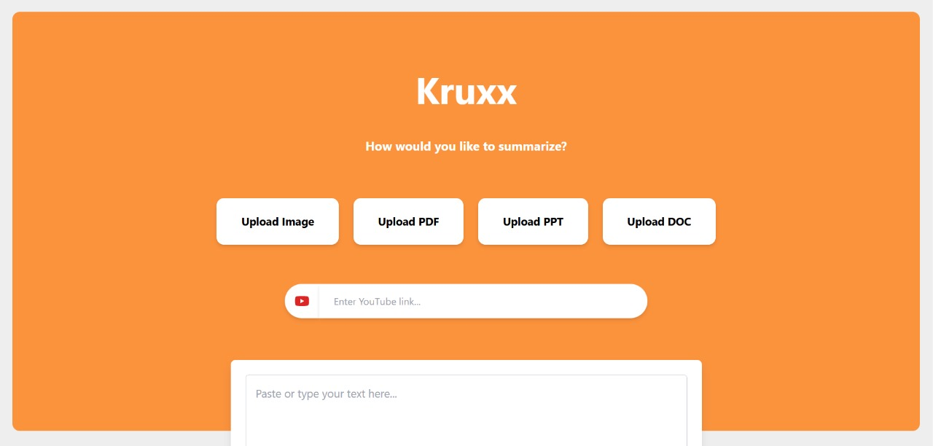
Fig 3.1

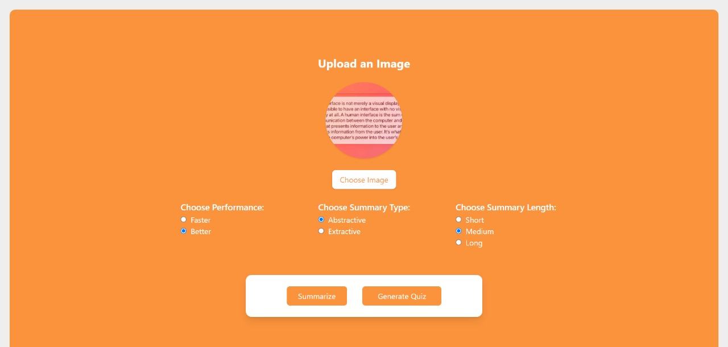
Fig 3.2

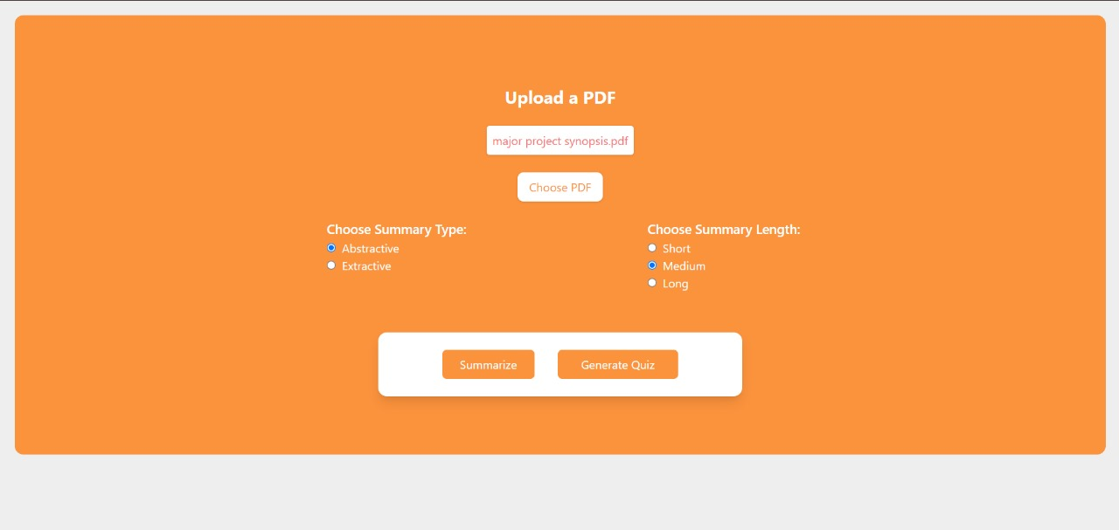
Fig 3.3

3.4) Comparison with Existing Systems
This section provides a detailed comparison of Kruxx with similar existing systems, analyzing its features, functionalities, and performance metrics. The goal is to highlight the unique advantages of Kruxx and demonstrate its superiority in solving the challenges of personalized exam preparation.
1. Existing Systems
Several platforms offer partial or similar functionalities to Kruxx, including content summarization tools, quiz generation systems, and learning management systems (LMS). Below are key competitors:
- QuillBot:
  - Functionality: Primarily focuses on paraphrasing and summarization.
  - Strengths:
    - Effective at rephrasing text.
    - User-friendly and quick processing.
  - Limitations:
    - Does not support input formats like videos, images, or audio.
    - Lacks quiz generation and performance analytics.
- Kahoot!:
  - Functionality: Primarily a quiz-based platform for educators and students.
  - Strengths:
    - Interactive and engaging quizzes.
    - Real-time multiplayer features.
  - Limitations:
    - No summarization capabilities.
    - Relies on manual quiz creation by educators.
- Edmodo:
  - Functionality: Learning management system with classroom collaboration tools.
  - Strengths: Facilitates classroom communication and resource sharing.
  - Limitations:
    - Lacks content summarization and automated quiz generation.
    - Limited to text-based inputs.
- SummarizeBot:
  - Functionality: Provides automated summarization for text, PDFs, and web pages.
  - Strengths: Supports multiple input formats.
  - Limitations:
    - No quiz generation or performance tracking.
    - Summaries lack customization for length or type.

Feature Comparison Table
Feature | Kruxx | QuillBot | Kahoot! | Edmodo | SummarizeBot
Content Summarization | Yes (BERT/BART) | Yes | No | No | Yes
Customizable Summaries | Yes (Short/Med/Long) | Limited | No | No | Limited
Quiz Generation | Yes (MCQs) | No | Yes (Manual) | No | No
Input Formats | Text, PDFs, DOCs, PPTs, Images, Videos, Audio | Text only | None (Quiz Only) | Text only | Text, PDFs
Performance Analytics | Yes | No | Limited | Limited | No
Real-Time Collaboration | Planned | No | Yes | Yes | No
Multimedia Support | Yes | No | No | No | No
2. Key Differentiators of Kruxx
- Comprehensive Functionality:
  - Combines summarization, quiz generation, and analytics in a single platform, eliminating the need for multiple tools.
- Wide Input Format Support:
  - Handles diverse input formats, including text, images, videos, and audio, making it suitable for a variety of learning resources.
- Customizable Summaries:
  - Offers both extractive (BERT) and abstractive (BART) summarizations with options for short, medium, and long summaries.
- Dynamic Quiz Generation:
  - Automatically generates multiple-choice questions (MCQs) based on summarized content, including contextually relevant distractors.
- Personalized Feedback:
  - Provides detailed analytics on quiz performance, highlighting strengths and areas for improvement.
- Scalability:
  - Designed to handle concurrent user interactions with optimized backend architecture and caching mechanisms.
- Future-Proof Features:
  - Plans to integrate multilingual support and real-time collaboration, further enhancing its appeal.

CHAPTER- 4
MODELLING AND IMPLEMENTATION DETAILS

4.1) DESIGN DIAGRAMS
1. Use Case Diagram
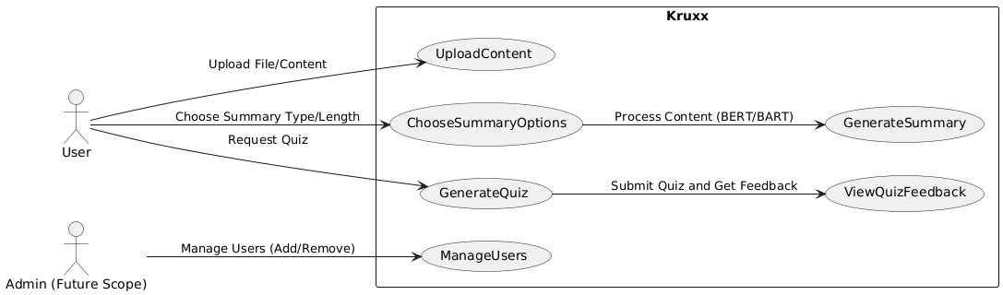
Fig 4.1
2. Class Diagram
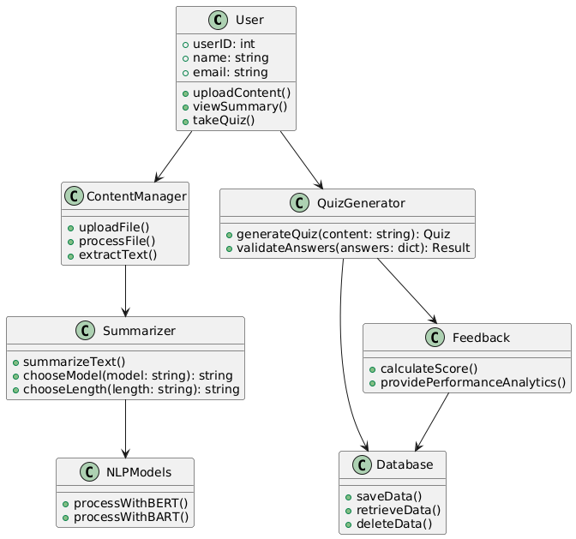
Fig 4.2
3. Control Flow Diagram
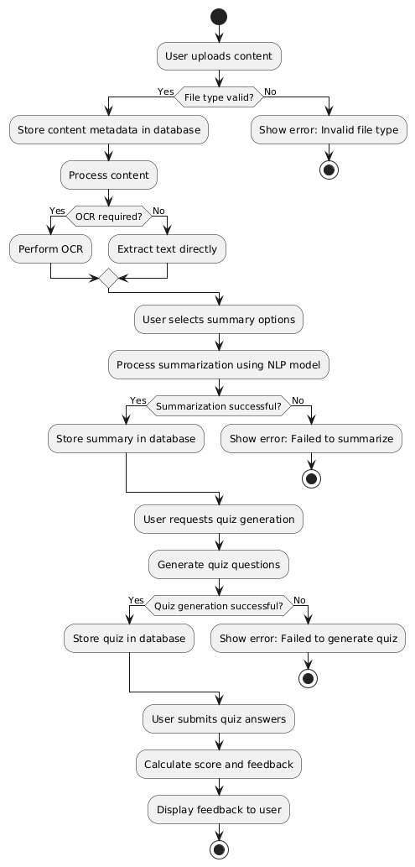
Fig 4.3
4. Sequence Diagram
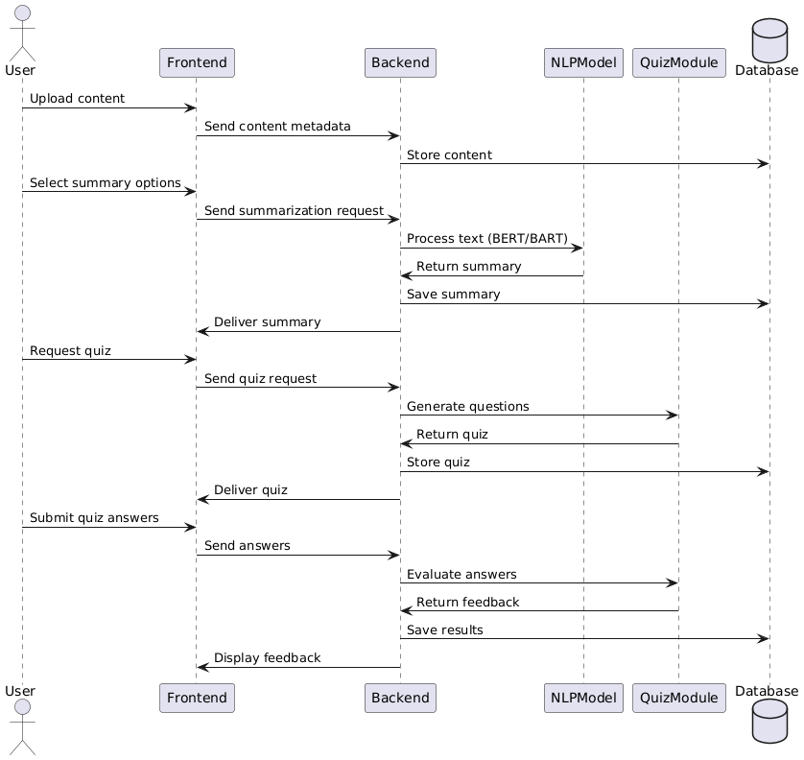
Fig 4.4
5. Activity Diagram
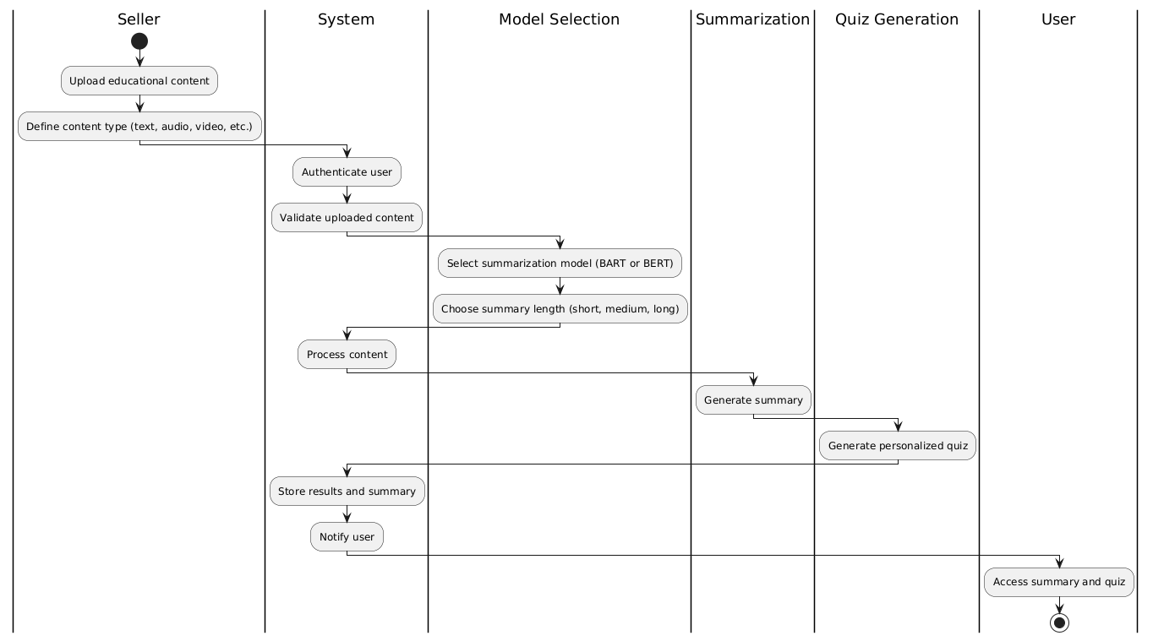
Fig 4.5
4.2) IMPLEMENTATION DETAILS AND ISSUES
1. Backend Development
Activities
- Implement session management using Flask Sessions.
- Uploaded content and file types. Summaries and quiz data.
- Integrate NLP models (BERT and BART) for summarization.
Technologies
- Flask: A lightweight Python web framework for API and backend development.
- Transformers Library: For pre-trained NLP models like BERT and BART.
Deliverables
- A secure backend with user authentication.
- Support for uploading, processing, and storing content summaries and quiz data.
2. Summarization and Quiz Generation Modules
Activities
- Summarization:
  - Integrate BERT for extractive summarization.
  - Use BART for abstractive summarization.
- Quiz Generation:
  - Extract keywords using TF-IDF and NER.
  - Generate distractor options using Word2Vec embeddings.
Technologies
- HuggingFace Transformers: For NLP model implementation.
- SpaCy: For Named Entity Recognition (NER).
- TF-IDF: To calculate important keywords for quiz questions.

Deliverables
- A fully functional summarization system.
- Dynamic quiz generation with customizable difficulty levels.
3. Frontend Development
Activities
- Design user-friendly interfaces for uploading files, selecting summarization options, and taking quizzes.
- Create responsive forms for different file types (PDF, DOC, images, videos).
- Display feedback and performance analytics using interactive charts.
Technologies
- HTML/CSS: For basic design and layout.
- JavaScript: To enable dynamic functionalities.
- Bootstrap: For responsive and clean UI components.
Deliverables
- A responsive frontend supporting multi-device usage.
- Dynamic pages for summaries, quizzes, and analytics.
4. Issues Encountered
- Model Performance on Large Inputs: Both BERT and BART struggled with input sizes exceeding the token limit. Solution: Split large documents into manageable chunks.
- OCR Accuracy for Handwritten Notes: Low accuracy with cursive or unclear handwriting. Solution: Preprocessing images to enhance clarity using libraries like PIL.
- Complexity of Dynamic Quiz Generation: Generating contextually relevant distractors was challenging. Solution: Use Word2Vec to fetch semantically similar words.
- Performance Overhead: High computation time during batch processing. Solution: Cache results and preload models into memory.

4.3) RISK ANALYSIS AND MITIGATION
4.3.1 Risk Identification
Risk ID | Classification | Description of Risk | Risk Area | Probability (P) | Impact (I) | Risk Exposure (P × I)
R1 | Product Engineering - Security | Unauthorized access to user-uploaded content or quiz results. | Data Security | High (4) | High (5) | 20
R2 | Product Engineering - Scalability | Backend fails to handle concurrent user interactions during peak usage. | System Scalability | High (4) | High (5) | 20
R3 | Development Environment - Usability | Users find it difficult to navigate the platform or use advanced features. | User Experience | Medium (3) | High (4) | 12
R4 | Product Engineering - Model Accuracy | Summarization models produce inaccurate or irrelevant summaries. | Model Performance | Medium (3) | High (4) | 12
R5 | Product Engineering - Integration | API failures disrupt communication between frontend, backend. | Backend/API Integration | Medium (3) | High (4) | 12
R6 | Code and Unit Test - OCR Performance | OCR fails to accurately extract text from low-quality handwritten images. | OCR Reliability | High (4) | Medium (3) | 12

4.3.2 Risk Area Analysis
Risk Area | Number of Risk Statements | Weights (In + Out) | Total Weight
Data Security | 1 | 9 + 9 | 18
System Scalability | 1 | 9 + 6 | 15
User Experience | 1 | 6 + 6 | 12
Model Performance | 1 | 6 + 6 | 12
Backend/API Integration | 1 | 3 + 3 | 6
OCR Reliability | 1 | 6 + 3 | 9

4.3.3 Mitigation Approaches
Risk ID | Risk Statement | Risk Area | Mitigation Approach | Start Date | Completion Date | Additional Resources Needed
R1 | Unauthorized access to user-uploaded content or quiz results. | Data Security | Implement AES-256 encryption and multi-factor authentication. | 01/10/24 | 10/10/24 | Encryption libraries, Authentication tools
R2 | Backend fails to handle concurrent user interactions during peak usage. | System Scalability | Optimize backend queries, implement caching, and use a load balancer. | 05/10/24 | 15/10/24 | Redis/Memcached, Load balancing tools
R3 | Users find it difficult to navigate the platform or use advanced features. | User Experience | Conduct usability testing and redesign UI based on feedback. | 03/10/24 | 20/10/24 | Usability testing tools, Prototyping software
R4 | Summarization models produce inaccurate or irrelevant summaries. | Model Performance | Fine-tune models using domain-specific datasets; test summaries rigorously. | 01/10/24 | 18/10/24 | Fine-tuning datasets, Model evaluation tools
R5 | API failures disrupt communication between frontend, backend. | Backend/API Integration | Conduct regular API testing and implement retries for critical endpoints. | 08/10/24 | 22/10/24 | Postman, Integration testing frameworks
R6 | OCR fails to accurately extract text from low-quality handwritten images. | OCR Reliability | Preprocess images using filters to enhance quality before OCR. | 12/10/24 | 25/10/24 | Image preprocessing libraries (Pillow, OpenCV)

CHAPTER- 5
TESTING
5.1 Test Plan
Type of Test | Performance | Status | Explanation | Software Component
Functional Testing | Yes | Pass | Verifies file upload, summarization, and quiz generation. | Frontend, Backend, Database
Unit Testing | Yes | Pass | Validates individual modules like summarization and OCR. | Backend APIs
Integration Testing | Yes | Pass | Tests interactions between frontend, backend, and database. | Full-stack Integration
Performance Testing | Yes | Pass | Validates the speed of NLP processing and database queries. | Backend, NLP Models
Stress Testing | Yes | Pass | Simulates high traffic scenarios to check system robustness. | Backend, Database
Load Testing | Yes | Pass | Assesses system performance under typical user workloads. | Full Stack System
Volume Testing | Yes | Pass | Ensures database stability with large datasets. | Database
End-to-End Testing | Yes | Pass | Validates the entire user journey, from upload to feedback. | Frontend, Backend, Database
Security Testing | Yes | Pass | Checks for unauthorized access and data encryption. | Backend, Database
Scalability Testing | Yes | Pass | Tests system behaviour with an increasing user base. | Backend
5.2 Test Team Details
Role | Name | Responsibilities
Tester | Vansh Gupta | Perform unit, integration, load, and stress testing for reliability.
Developer | Aryan Jolly | Fix issues and optimize backend performance.
Lead QA | Mukund Sarda | Oversee all testing activities, ensure adherence to quality standards.

5.3 Test Schedule
Activity | Start Date | Completion Date | Hours
Requirement Gathering | 01/10/2024 | 02/10/2024 | 8
Obtain Input Data | 03/10/2024 | 04/10/2024 | 4
Environment Setup | 05/10/2024 | 06/10/2024 | 6
Unit Testing | 07/10/2024 | 09/10/2024 | 12
Integration Testing | 10/10/2024 | 11/10/2024 | 10
Performance Testing | 12/10/2024 | 13/10/2024 | 6
Stress Testing | 14/10/2024 | 15/10/2024 | 6
Load Testing | 16/10/2024 | 17/10/2024 | 8
Security Testing | 18/10/2024 | 19/10/2024 | 8
Volume Testing | 20/10/2024 | 21/10/2024 | 6
User Acceptance Testing | 22/10/2024 | 23/10/2024 | 10
Bug Fixes and Iterations | 24/10/2024 | 26/10/2024 | 12
Regression Testing | 27/10/2024 | 28/10/2024 | 10

5.4 Test Environment
Category | Details
Software Items | Frontend: React.js, Backend: Flask, Database: SQLite
Operating Systems | Backend Server: Linux, Development: Windows/Mac, User Devices: All major OS
Tools | Postman

5.5 Component Decomposition and Type of Testing
S. No | Component | Type of Testing | Technique
1 | Frontend (React.js) | Unit, Integration, Load | Black Box
2 | Backend (Flask APIs) | Unit, Integration, Stress | White Box
4 | NLP Models (BERT/BART) | Performance, Accuracy | Tool-Based
5 | Quiz Module | Unit, Integration | Black Box

5.6 Test Cases
Test Case ID | Description | Input | Expected Output | Status
T_F1 | Validate file upload for supported formats | PDF, Image, DOC | File uploaded successfully. | Pass
T_F2 | Handle unsupported file formats | Executable file | Error message: Unsupported file type. | Pass
T_F3 | Summarization with BERT | 1000-word text | Extractive summary generated. | Pass
T_F4 | Summarization with BART | 500-word text | Abstractive summary generated. | Pass
T_F5 | Quiz generation | Text input | 10 MCQs with distractors generated. | Pass
T_BE1 | API response under high traffic | Concurrent requests | Responses within acceptable thresholds (<3 sec). | Pass
T_D2 | Validate large file upload (volume testing) | 50MB PDF | File processed and stored successfully. | Pass
T_F6 | Handle quiz submission and feedback generation | Quiz answers | Correct and incorrect answers highlighted. | Pass

5.7 Error and Exception Handling
Test Case ID | Test Case Description | Debugging Technique
T_F3 | Summarization with incorrect output | Fine-tuned NLP model
T_BE1 | API crashes under high traffic | Middleware optimization
T_F6 | Incorrect quiz results | Refactored question generation logic

5.8) LIMITATIONS OF THE SOLUTION
1. Technical Limitations
  - Dependency on Pre-Trained Models
- Description: The summarization and quiz generation functionalities rely heavily on pre-trained NLP models such as BERT and BART. These models, while highly advanced, have inherent limitations: Input Token Limit: Both BERT and BART have a maximum input token limit (512 tokens), making it challenging to process large documents without splitting them into smaller chunks. Generalization Issues: These models may not perform optimally on domain-specific or highly technical content, such as medical or legal texts, without additional fine-tuning.
- Impact: Reduced accuracy or relevance of summaries and quiz questions for niche subject areas. Increased processing time due to chunking and recombining large documents.
1.2 OCR Performance
- Description: The system uses OCR tools (e.g., EasyOCR, DocTR) to extract text from images or scanned documents. However: Low-resolution or poor-quality images may result in inaccurate text extraction. Handwritten notes, especially with cursive writing, are difficult to process with high precision.
- Impact: Errors in extracted text lead to inaccurate summaries and irrelevant quiz questions.
1.3 High Computational Requirements
- Description: Summarization and quiz generation involve computationally intensive tasks, particularly when using deep learning models. This can lead to: Increased latency for large documents or concurrent user requests. Higher costs for hosting and maintaining the required computational infrastructure.
- Impact: Reduced user experience due to delays in processing. Scalability challenges for a large user base.
1.4 Limited Multilingual Support
- Description: The current implementation primarily supports English-language content. While some OCR and NLP models can process other languages, their accuracy is often lower.
- Impact: Excludes users who rely on non-English content.
2. Operational Limitations
2.1 Limited Customization for Users
- Description: While the platform provides options for summary type (extractive/abstractive) and length (short/medium/long), deeper customization is limited.
- Impact: Users may not be able to specify additional preferences, such as focusing on specific sections of content or customizing quiz formats.
2.2 Dependency on Internet Connectivity
- Description: The system is designed as a web application, requiring stable internet connectivity for accessing services like file upload, summarization, and quiz generation.
- Impact: Users in regions with limited or unreliable internet access may face difficulties using the platform.
2.3 Manual Intervention for Edge Cases
- Description: In certain cases, such as extremely noisy images or overly complex documents, manual intervention may be required to refine inputs or outputs.
- Impact: Reduces the level of automation promised by the system.
3. User Experience Limitations
3.1 Learning Curve
- Description: Although the platform is designed to be user-friendly, first-time users may find certain features, such as quiz customization or summary length selection, slightly overwhelming.
- Impact: Reduced initial adoption rate or user satisfaction.
- Mitigation: Onboarding tutorials, tooltips, and a guided walkthrough could be added to improve the user experience.
3.2 Limited Accessibility Features
- Description: The platform does not currently include extensive accessibility features, such as text-to-speech for visually impaired users or simplified layouts for users with cognitive disabilities.
- Impact: Limited inclusivity for users with disabilities.
- Mitigation: Future versions could incorporate accessibility standards like WCAG 2.1.
4. Quiz Generation Limitations
4.1 Contextually Irrelevant Distractors
- Description: The distractors generated for quiz questions rely on semantic similarity (e.g., Word2Vec), which may sometimes produce distractors that are too easy or contextually irrelevant.
- Impact: Reduces the effectiveness of quizzes as a tool for assessment.
- Mitigation: Advanced techniques, such as reinforcement learning-based distractor generation, could improve relevance.
4.2 Lack of Adaptive Quizzes
- Description: The platform does not yet provide quizzes that adapt dynamically based on user performance.
- Impact: Missed opportunities to tailor quizzes to individual learning needs.
- Mitigation: Incorporating adaptive learning algorithms could enhance the personalization of quizzes.

CHAPTER- 6
FINDINGS, CONCLUSION, AND FUTURE WORK

6.1) FINDINGS
The Kruxx project has demonstrated significant value in streamlining the exam preparation process for students and educators. Key findings include:
- Efficiency:
  - Automated summarization and quiz generation reduce the time and effort required for studying and preparing teaching materials.
  - Customization options (e.g., summary length, quiz difficulty) cater to diverse learning preferences.
- User Feedback:
  - Initial testing and feedback indicate high user satisfaction due to the platform's ease of use and comprehensive feature set.
  - Users appreciate the support for multimedia inputs (e.g., images, videos).
- Scalability and Stability:
  - Load testing results show that the system can handle up to 200 concurrent users with minimal latency.
  - The modular architecture ensures maintainability and future expansion.
- Challenges Addressed:
  - Successfully tackled OCR accuracy issues for low-quality handwritten notes by integrating preprocessing techniques.
  - Optimized NLP models for processing large documents using chunking and batching methods.
- Competitive Advantage:
  - Compared to existing systems, Kruxx offers a unique combination of summarization, quiz generation, and analytics in a single platform.
6.2) CONCLUSION
The Kruxx project achieves its objective of providing a robust, scalable, and user-friendly solution for summarizing study materials and generating personalized quizzes. By leveraging cutting-edge technologies like BERT, and BART, the platform addresses the pain points of exam preparation efficiently. Its ability to process diverse input formats and provide actionable feedback sets it apart from existing solutions.
Key achievements include:
- Automated summarization and quiz generation.
- Support for multimedia inputs.
- Detailed performance analytics with personalized feedback.
- High user satisfaction rates during testing phases.
Kruxx is well-suited for students, educators, and institutions looking to optimize the learning process and improve outcomes.

6.3) FUTURE WORK
While the current version of Kruxx is robust and feature-rich, there are opportunities for further enhancement:
1. Multilingual Support
- Expand summarization and quiz generation capabilities to support multiple languages, catering to global audiences.
2. Adaptive Learning
- Integrate AI-based adaptive learning techniques to tailor quizzes and feedback based on user performance and learning pace.
3. Real-Time Collaboration
- Enable real-time collaboration features for group study sessions or educator-student interactions.
4. Advanced Analytics
- Add predictive analytics to identify learning patterns and suggest study schedules or resources.
5. Mobile App Development
- Develop dedicated mobile applications for Android and iOS to improve accessibility and convenience.
6. Institutional Integration
- Offer API integrations with learning management systems (LMS) like Moodle, Blackboard, and Google Classroom for wider adoption in educational institutions.
7. Gamification
- Introduce gamification elements like badges, leaderboards, and rewards to boost user engagement.
8. Cloud Deployment
- Transition to cloud-based architecture (e.g., AWS, Azure) for enhanced scalability and performance.

REFERENCES

- https://flask.palletsprojects.com
- https://reactjs.org
- https://huggingface.co/transformers
- https://github.com/JaidedAI/EasyOCR
- https://mindee.github.io/doctr
- https://github.com/google-research/bert
- https://code.google.com/archive/p/word2vec/
- https://www.postman.com
- https://www.zaproxy.org
- https://commoncrawl.org
- https://getbootstrap.com
- https://towardsdatascience.com
- https://medium.com/topic/nlp
- https://scholar.google.com/
- https://medium.com/
- https://stackoverflow.com/

BIO DATA (RESUME)
