FinalProject.R

Mukund Kathait

2019-10-20

rm(list=ls())  
library(rio)  
library(car)

## Loading required package: carData

library(rio)  
library(moments)  
library(corrplot)

## corrplot 0.84 loaded

## Loading required package: carData  
#PreProcessing  
  
#1 Reading in CSV Data  
  
cab_trips=read.csv(file="6304 Regression Project Data.csv", header=TRUE, sep=",")  
  
colnames(cab_trips)=tolower(make.names(colnames(cab_trips)))  
attach(cab_trips)  
  
#2  
  
set.seed(27683820)  
  
my.cabInfo =cab_trips[sample(1:nrow(cab_trips),100,replace=FALSE),]  
  
summary(my.cabInfo)

## taxi_id trip_seconds trip_miles fare   
## Min. : 4 Min. : 0 Min. : 0.00 Min. : 3.250   
## 1st Qu.:1767 1st Qu.: 240 1st Qu.: 0.00 1st Qu.: 5.750   
## Median :4364 Median : 480 Median : 0.95 Median : 8.025   
## Mean :4173 Mean : 681 Mean : 7.22 Mean :13.504   
## 3rd Qu.:6354 3rd Qu.: 855 3rd Qu.: 3.00 3rd Qu.:15.062   
## Max. :8696 Max. :4680 Max. :450.00 Max. :56.000   
## tips tolls extras trip_total   
## Min. : 0.00 Min. :0 Min. :0.000 Min. : 3.250   
## 1st Qu.: 0.00 1st Qu.:0 1st Qu.:0.000 1st Qu.: 6.250   
## Median : 0.00 Median :0 Median :0.000 Median : 9.125   
## Mean : 1.66 Mean :0 Mean :0.705 Mean :15.869   
## 3rd Qu.: 2.00 3rd Qu.:0 3rd Qu.:1.000 3rd Qu.:18.863   
## Max. :10.15 Max. :0 Max. :6.000 Max. :60.900   
## payment_type  
## Cash :50   
## Credit Card:50   
## Other : 0   
##   
##   
##

attach(my.cabInfo)

## The following objects are masked from cab_trips:  
##   
## extras, fare, payment_type, taxi_id, tips, tolls, trip_miles,  
## trip_seconds, trip_total

#3  
#There are a few records wherein trip_seconds is 0 and trip_fair is some positive value.  
#This is a case of INCORRECT DATA or missing value, since if the trip_seconds are 0,   
#ideally there shouldn't be any fare. So cleaning those values  
  
my.cabInfo = subset(my.cabInfo, my.cabInfo$trip_seconds > 0 ,select = c("taxi_id","trip_seconds","trip_miles","fare","tips","extras","trip_total","payment_type"))  
  
#Also there are few instances wherein the trip_miles is 0 but trip fair is again some positive value.  
#This is also a case of missing or Incorrect Data, since if the miles covered is 0,  
#then the fare should also be 0  
  
sample_cabdata = subset(my.cabInfo, my.cabInfo$trip_miles > 0,select = c("taxi_id","trip_seconds","trip_miles","fare","tips","extras","trip_total","payment_type"))  
  
#Finally after removing incorrect entries, we are left with 73 observations  
  
summary(sample_cabdata)

## taxi_id trip_seconds trip_miles fare   
## Min. : 4 Min. : 60.0 Min. : 0.100 Min. : 3.75   
## 1st Qu.:1488 1st Qu.: 360.0 1st Qu.: 0.800 1st Qu.: 6.25   
## Median :4362 Median : 540.0 Median : 1.600 Median : 8.75   
## Mean :4033 Mean : 765.2 Mean : 9.889 Mean :13.55   
## 3rd Qu.:6207 3rd Qu.: 960.0 3rd Qu.: 4.400 3rd Qu.:15.00   
## Max. :8696 Max. :4680.0 Max. :450.000 Max. :56.00   
## tips extras trip_total payment_type  
## Min. : 0.000 Min. :0.0000 Min. : 4.45 Cash :34   
## 1st Qu.: 0.000 1st Qu.:0.0000 1st Qu.: 7.50 Credit Card:39   
## Median : 1.000 Median :0.0000 Median : 9.75 Other : 0   
## Mean : 1.895 Mean :0.7603 Mean :16.21   
## 3rd Qu.: 2.500 3rd Qu.:1.0000 3rd Qu.:18.75   
## Max. :10.150 Max. :5.0000 Max. :60.90

#ANALYSIS  
  
#1  
  
d1 <- density(sample_cabdata$trip_seconds)  
plot(d1, main="Total Time of Trip in Seconds", xlab="Time in Seconds")  
polygon(d1, col="green", border="red")

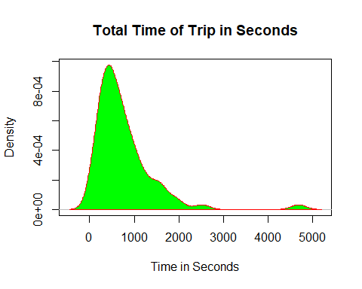

#From the density plot we can say that most of the records lie between 60-2000 seconds  
#and some lie in the vicinity of 4800 seconds  
  
boxplot(sample_cabdata$trip_seconds,col="red",main="Boxplot for trip_seconds",xlab = "Time in Seconds")

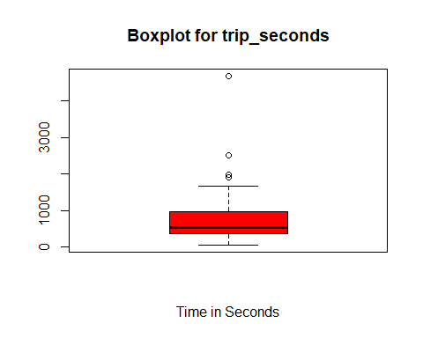

min(sample_cabdata$trip_seconds)

## [1] 60

max(sample_cabdata$trip_seconds)

## [1] 4680

median(sample_cabdata$trip_seconds)

## [1] 540

skewness(sample_cabdata$trip_seconds)

## [1] 3.053151

summary(sample_cabdata$trip_seconds)

## Min. 1st Qu. Median Mean 3rd Qu. Max.   
## 60.0 360.0 540.0 765.2 960.0 4680.0

#As we can see in the box plot for seconds  
#the minimum is at 60 seconds and the maximum value(which is an outlier) is 4680 seconds  
#the median is 540 seconds and we have 4 outliers  
#From the skewness we can see that the plot is right skewed with high skewness  
  
########################  
  
d2 <- density(sample_cabdata$trip_miles)  
plot(d2, main="Boxplot for Total Trip in Miles", xlab = 'Total Trip Miles')  
polygon(d2, col="green", border="red",xlab = "Miles Travelled")

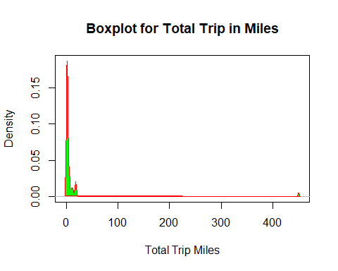

#From the density plot we can see that most of the values are between 0.1 and 9.889  
#and a few values are scattered between 0.100 to somewhere around 10  
  
boxplot(sample_cabdata$trip_miles,col="red",main="Boxplot for trip_miles",xlab = "Total Miles Travelled")

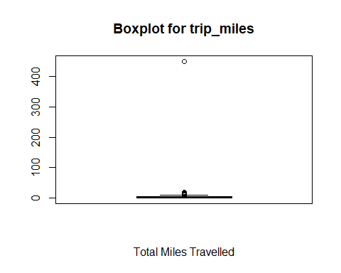

min(sample_cabdata$trip_miles)

## [1] 0.1

max(sample_cabdata$trip_miles)

## [1] 450

median(sample_cabdata$trip_miles)

## [1] 1.6

skewness(sample_cabdata$trip_miles)

## [1] 8.258317

summary(sample_cabdata$trip_miles)

## Min. 1st Qu. Median Mean 3rd Qu. Max.   
## 0.100 0.800 1.600 9.889 4.400 450.000

#For the trip_miles boxplot,  
#the minimum value is 0.1 mile and the maxmium value(which is an outlier) is 450 miles  
#and the median is 1.6 miles. As shown in the boxplot, we have multiple outliers  
#around 6-7  
#The skewness for trip_miles is 8.25 which indicates that it is highly skewed to the right  
  
###########################################  
d3 <- density(sample_cabdata$fare)  
plot(d3, main="Total Fare of the Trip",xlab = "Total Fare")  
polygon(d3, col="green", border="red")

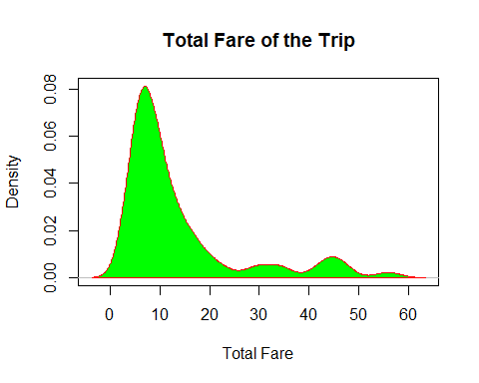

boxplot(sample_cabdata$fare,col="red",main="Boxplot for Fare",xlab = "Total Fare")

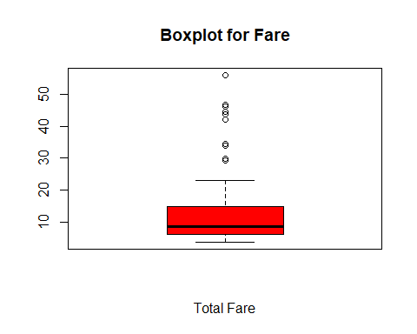

#From the density plot we can see that most values are between 3.75 to 20 and some are scattered from 20 to 60  
  
min(sample_cabdata$fare)

## [1] 3.75

max(sample_cabdata$fare)

## [1] 56

median(sample_cabdata$fare)

## [1] 8.75

skewness(sample_cabdata$fare)

## [1] 1.9303

summary(sample_cabdata$fare)

## Min. 1st Qu. Median Mean 3rd Qu. Max.   
## 3.75 6.25 8.75 13.55 15.00 56.00

#For the fare boxplot,  
#the minimum value is 3.75 and the maxmium value(which is an outlier) is 56  
#and the median is 8.75. As shown in the boxplot, we have multiple outliers  
#around 10  
#The skewness for fare is 1.9303 which indicated that it is skewed to the right  
  
###########################################  
  
d4 <- density(sample_cabdata$tips)  
plot(d4, main="Tip for the Trip",xlab = "Tips")  
polygon(d4, col="green", border="red")

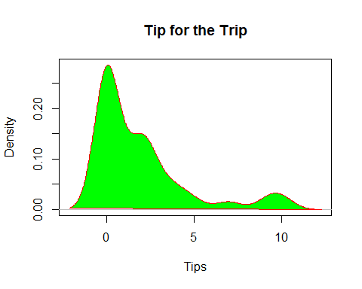

#From the density plot we can see that most of the values are between 0 to 5 and a few are between 5 to 10  
  
boxplot(sample_cabdata$tips,col="red",main="Boxplot for Tips", xlab = "Tips")

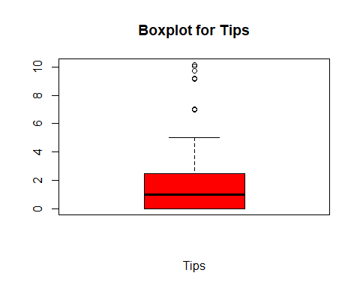

min(sample_cabdata$tips)

## [1] 0

max(sample_cabdata$tips)

## [1] 10.15

median(sample_cabdata$tips)

## [1] 1

skewness(sample_cabdata$tips)

## [1] 1.75484

summary(sample_cabdata$tips)

## Min. 1st Qu. Median Mean 3rd Qu. Max.   
## 0.000 0.000 1.000 1.895 2.500 10.150

#For the tips boxplot,  
#the minimum value(and the 1st quartile which overlap) is 0 and the maxmium value(which is an outlier) is 10.15  
#and the median is 1. As shown in the boxplot, we have multiple outliers  
#around 7  
#The skewness for tips is 1.75484, which is high and from the plot we can say that it is right skewed  
###########################################  
  
d5 <- density(sample_cabdata$extras)  
plot(d5, main="Extra Incidentals of Trip",xlab = "Extras")  
polygon(d5, col="green", border="red")

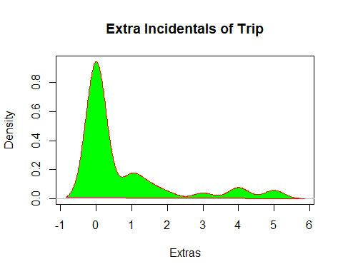

#From the plot we can see that most of the values are between 0 to 1 and rest are scattered beyond 2 till 6  
  
boxplot(sample_cabdata$extras,col="red",main="Boxplot for Extras",xlab = "Extras")

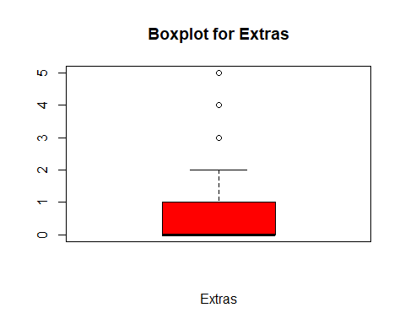

min(sample_cabdata$extras)

## [1] 0

max(sample_cabdata$extras)

## [1] 5

median(sample_cabdata$extras)

## [1] 0

skewness(sample_cabdata$extras)

## [1] 1.912984

summary(sample_cabdata$extras)

## Min. 1st Qu. Median Mean 3rd Qu. Max.   
## 0.0000 0.0000 0.0000 0.7603 1.0000 5.0000

#For the extras boxplot,  
#the minimum value(and the 1st quartile and also the median which overlap) is 0 and the maxmium   
#value(which is an outlier) is 5 #and the median is 0. As shown in the boxplot, we have multiple outliers  
#around 3  
#The skewness for extras is 1.912984, and from the plot we can say that it is right skewed  
  
###########################################  
  
d6 <- density(sample_cabdata$trip_total)  
plot(d6, main="Final Amount of Trip",xlab = "Trip Total Amount")  
polygon(d6, col="green", border="red")

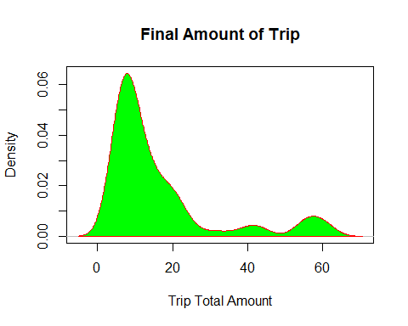

#From the density plot, we can say that most of the values are between 4.45 to 20 while few other points  
#are from 20 to 60.90  
  
boxplot(sample_cabdata$trip_total,col="red",main="Boxplot for Total Amount",xlab = "Trip Total Amount ")

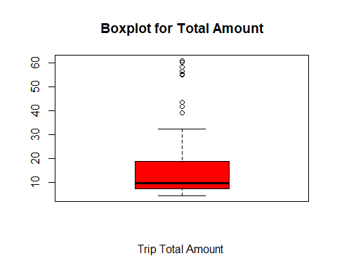

min(sample_cabdata$trip_total)

## [1] 4.45

max(sample_cabdata$trip_total)

## [1] 60.9

median(sample_cabdata$trip_total)

## [1] 9.75

skewness(sample_cabdata$trip_total)

## [1] 1.894067

summary(sample_cabdata$trip_total)

## Min. 1st Qu. Median Mean 3rd Qu. Max.   
## 4.45 7.50 9.75 16.21 18.75 60.90

#For the trip_total boxplot,  
#the minimum value is 4.45 and the maxmium value(which is an outlier) is 60.9  
#and the median is 9.75. As shown in the boxplot, we have multiple outliers  
#around 9  
#The skewness for trips_total is 1.894067 and from the plot we can see that the plot is right skewed  
  
###########################################  
  
#2  
  
table(sample_cabdata$payment_type)

##   
## Cash Credit Card Other   
## 34 39 0

#The table method when used on payment_type, returns the total count of "CASH",  
#"CREDIT CARD" and "OTHER" payments   
  
  
#3  
  
sample_data_correlation = cor(sample_cabdata[sapply(sample_cabdata, is.numeric)])  
sample_data_correlation

## taxi_id trip_seconds trip_miles fare tips  
## taxi_id 1.000000000 0.04186455 0.01519282 0.05853383 -0.07969568  
## trip_seconds 0.041864550 1.00000000 0.09974792 0.88164974 0.45709667  
## trip_miles 0.015192823 0.09974792 1.00000000 0.08116272 -0.02385927  
## fare 0.058533825 0.88164974 0.08116272 1.00000000 0.69735729  
## tips -0.079695676 0.45709667 -0.02385927 0.69735729 1.00000000  
## extras 0.007082741 0.43519439 0.11554362 0.61932816 0.59780069  
## trip_total 0.033265127 0.83061058 0.07160004 0.98608652 0.79576276  
## extras trip_total  
## taxi_id 0.007082741 0.03326513  
## trip_seconds 0.435194385 0.83061058  
## trip_miles 0.115543624 0.07160004  
## fare 0.619328161 0.98608652  
## tips 0.597800694 0.79576276  
## extras 1.000000000 0.69804512  
## trip_total 0.698045117 1.00000000

#The sample_data_correlation matrix shows the matrix of correlation.  
#It measure the linear relation and strength between two variables  
#For example the cor between trip_seconds and trip_miles is 0.0997. It is a positive number  
#it mean that if trip_seconds increases, trip_miles also increases.  
#Another example as per the cor, the relation between tips and trip_miles is negative,  
#it means as the trip_miles increases the tips decreases or vice versa  
#The best correlation is between fare and trip_miles  
  
#In order to aid in better understanding of correlation, I have also shown a visual plot  
corrplot(sample_data_correlation, method = "number",title = "visualization of a correlation matrix")

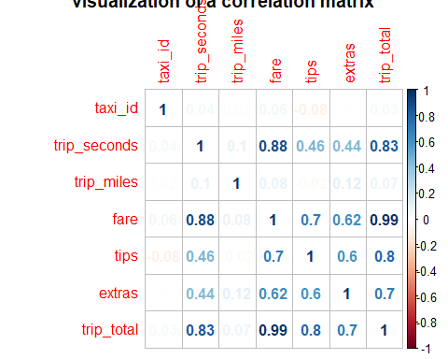

#4  
  
lm_sample_cab = lm(formula = fare ~ trip_seconds + trip_miles + payment_type, data = sample_cabdata)  
confint(lm_sample_cab, level = 0.95)

## 2.5 % 97.5 %  
## (Intercept) -2.10607443 2.50346298  
## trip_seconds 0.01325227 0.01718661  
## trip_miles -0.02324120 0.02733108  
## payment_typeCredit Card 0.49333928 5.81493280

summary(lm_sample_cab)

##   
## Call:  
## lm(formula = fare ~ trip_seconds + trip_miles + payment_type,   
## data = sample_cabdata)  
##   
## Residuals:  
## Min 1Q Median 3Q Max   
## -15.4619 -2.8452 -0.7579 1.3970 18.5555   
##   
## Coefficients:  
## Estimate Std. Error t value Pr(>|t|)   
## (Intercept) 0.1986943 1.1553041 0.172 0.8640   
## trip_seconds 0.0152194 0.0009861 15.434 <2e-16 ***  
## trip_miles 0.0020449 0.0126751 0.161 0.8723   
## payment_typeCredit Card 3.1541360 1.3337692 2.365 0.0209 *   
## ---  
## Signif. codes: 0 '***' 0.001 '**' 0.01 '*' 0.05 '.' 0.1 ' ' 1  
##   
## Residual standard error: 5.572 on 69 degrees of freedom  
## Multiple R-squared: 0.794, Adjusted R-squared: 0.7851   
## F-statistic: 88.68 on 3 and 69 DF, p-value: < 2.2e-16

plot(sample_cabdata$fare,lm_sample_cab$fitted.values,pch=19,main="Actual v/s Fitted values",  
 xlab = "fare", ylab = "Fitted Values")  
abline(0,1,col="red",lwd=3)

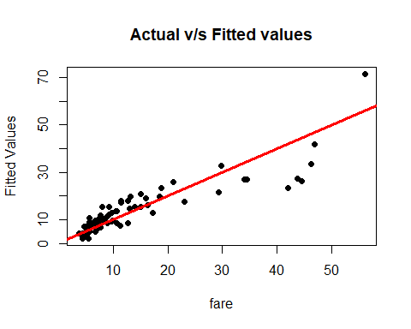

#This linear model was built using fare as the dependent variable and trip_seconds, trip_miles, and payment_type  
#as dependent variables. Keeping the confience interval at 95%, we get the values, the confidence interval values  
#for (Intercept) -2.10607443 to 2.50346298,   
#for trip_seconds 0.01325227 to 0.01718661,  
#for trip_miles -0.02324120 to 0.02733108 and   
#for payment_type 0.49333928 to 5.81493280  
#The equation for fare would be  
#fare = 0.198694 + 0.0152194 * trip_seconds + 0.0020449 * trip_miles + 3.154136 * payment_type  
#for every change in trip_seconds, the fare changes by 0.0152194, and its p value is significantly small (<2e-16),   
#hence we reject the null hypothesis  
#for every change in trip_miles, the fare changes by 0.0020449, but its p value is significantly large(0.8723),   
#hence we fail to reject the null hypothesis since there is not enough evidence  
#for every change in payment, the fare changes by 3.154136, and its p value is significantly small (0.0209),   
#hence we reject the null hypothesis   
#for the intercept, if the miles and seconds travelled is 0, and payment is also 0, then the total fare  
#should be 0.198694, which doesnt make any sense. Also its pvalue is significantly lare (0.8640),  
#hence we fail to reject the null hypothesis since there is not enough evidence  
#Also the value for R-sq is 0.794 and Adj R-sq is 0.7851 which tells us the percentage that the three independent  
#variables describe the dependent one.  
  
#By looking at the plot we can see that the points are clustered at the start, with few outliers  
#  
#################################################  
  
  
#5  
  
#Creating squared variables to use for generating linear model  
sample_cabdata$miles_sq = 0  
  
sample_cabdata$miles_sq = sample_cabdata$trip_miles^2  
  
sample_cabdata$trip_seconds_sq = 0  
  
sample_cabdata$trip_seconds_sq = sample_cabdata$trip_seconds^2  
  
############  
lm_sample_cab = lm(formula = fare ~ trip_seconds + trip_miles + payment_type, data = sample_cabdata)  
summary(lm_sample_cab)

##   
## Call:  
## lm(formula = fare ~ trip_seconds + trip_miles + payment_type,   
## data = sample_cabdata)  
##   
## Residuals:  
## Min 1Q Median 3Q Max   
## -15.4619 -2.8452 -0.7579 1.3970 18.5555   
##   
## Coefficients:  
## Estimate Std. Error t value Pr(>|t|)   
## (Intercept) 0.1986943 1.1553041 0.172 0.8640   
## trip_seconds 0.0152194 0.0009861 15.434 <2e-16 ***  
## trip_miles 0.0020449 0.0126751 0.161 0.8723   
## payment_typeCredit Card 3.1541360 1.3337692 2.365 0.0209 *   
## ---  
## Signif. codes: 0 '***' 0.001 '**' 0.01 '*' 0.05 '.' 0.1 ' ' 1  
##   
## Residual standard error: 5.572 on 69 degrees of freedom  
## Multiple R-squared: 0.794, Adjusted R-squared: 0.7851   
## F-statistic: 88.68 on 3 and 69 DF, p-value: < 2.2e-16

plot(sample_cabdata$fare,lm_sample_cab$fitted.values,pch=19,main="Actual v/s Fitted values",  
 xlab = "fare", ylab = "Fitted Values")  
abline(0,1,col="red",lwd=3)



#This is the standard linear model considering all the dependent variables(as explained in question number 4),  
#the equation for line here is  
#fare = 0.198694 + 0.0152194 * trip_seconds + 0.0020449 * trip_miles + 3.154136 * payment_type

#Removing Payment  
  
lm_sample_cab_no_payment = lm(formula = fare ~ trip_seconds + trip_miles, data = sample_cabdata)  
summary(lm_sample_cab_no_payment)

##   
## Call:  
## lm(formula = fare ~ trip_seconds + trip_miles, data = sample_cabdata)  
##   
## Residuals:  
## Min 1Q Median 3Q Max   
## -18.6691 -2.5465 -0.7999 1.0105 19.7727   
##   
## Coefficients:  
## Estimate Std. Error t value Pr(>|t|)   
## (Intercept) 1.616472 1.019451 1.586 0.117   
## trip_seconds 0.015615 0.001003 15.567 <2e-16 ***  
## trip_miles -0.001569 0.012989 -0.121 0.904   
## ---  
## Signif. codes: 0 '***' 0.001 '**' 0.01 '*' 0.05 '.' 0.1 ' ' 1  
##   
## Residual standard error: 5.752 on 70 degrees of freedom  
## Multiple R-squared: 0.7774, Adjusted R-squared: 0.771   
## F-statistic: 122.2 on 2 and 70 DF, p-value: < 2.2e-16

plot(sample_cabdata$fare,lm_sample_cab_no_payment$fitted.values,pch=19,main="Actual v/s Fitted values",  
 xlab = "fare", ylab = "Fitted Values")  
abline(0,1,col="red",lwd=3)

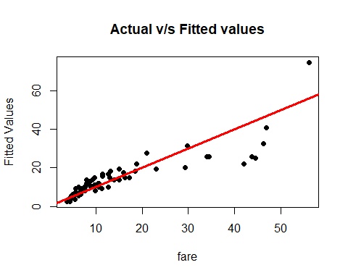

#Here we remove the payment record and build a linear model using only trip_seconds and trip_miles  
#the equation of line is 1.616472 + 0.015615 * trip_seconds - 0.001569 * miles  
#For intercept the value is 1.616472. Its p value is 0.117 which is significantly large. It means if we change  
#the trip_seconds and trip_miles to 0, the fare would be 1.61647 which isn't correct. Hence judging for the p value,  
#we fail to reject the null hypothesis for the intercept  
#In case of trip_seconds, if the value for trip_seconds changes, the fare also changes by 0.015615. Its p value  
#is 2e-16 which is significanlty small and hence we reject the null hypothesis  
#In case of trip_miles, if the value for trip_miles changes, the fare also changes by 0.001569. Its p value  
#is 0.904 which is significanlty large and hence we fail to reject the null hypothesis, due to lack of evidence  
#The value of R-sq is 0.7774 and for adj R-sq is 0.771 which is a good indicator for how the independent  
#variables describe the dependent variable  
  
##################################################  
  
lm_sample_cab_no_miles = lm(formula = fare ~ trip_seconds + payment_type, data = sample_cabdata)  
summary(lm_sample_cab_no_miles)

##   
## Call:  
## lm(formula = fare ~ trip_seconds + payment_type, data = sample_cabdata)  
##   
## Residuals:  
## Min 1Q Median 3Q Max   
## -15.5333 -2.8542 -0.7538 1.3744 18.5390   
##   
## Coefficients:  
## Estimate Std. Error t value Pr(>|t|)   
## (Intercept) 0.2184070 1.1408045 0.191 0.8487   
## trip_seconds 0.0152382 0.0009723 15.672 <2e-16 ***  
## payment_typeCredit Card 3.1281896 1.3147943 2.379 0.0201 *   
## ---  
## Signif. codes: 0 '***' 0.001 '**' 0.01 '*' 0.05 '.' 0.1 ' ' 1  
##   
## Residual standard error: 5.533 on 70 degrees of freedom  
## Multiple R-squared: 0.794, Adjusted R-squared: 0.7881   
## F-statistic: 134.9 on 2 and 70 DF, p-value: < 2.2e-16

plot(sample_cabdata$fare,lm_sample_cab_no_miles$fitted.values,pch=19,main="Actual v/s Fitted values",  
 xlab = "fare", ylab = "Fitted Values")  
abline(0,1,col="red",lwd=3)

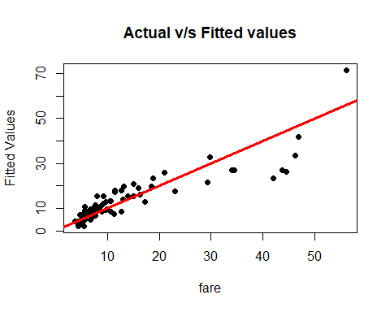

#If we do not consider the trip_miles, the equation for line that is obtained is  
#fare = 0.2184070 + 0.0152382 * trip_seconds + 3.1281896 * payment_type  
# If trip_seconds changes, the value for fare changes by 0.0152382. Its pvalue is less than 2e-16, which is  
#significantly small. Hence we reject null hypothesis  
#If changes payment_type, the value for fare changes by 3.1281896. Its p value is 0.0201, which is significantly  
#small. Hence we rejet null hypothesis  
#For intercept, if both trip_seconds and payment_type is 0, the fare would be 0.2184070, which is not correct.  
#Its p value is 0.8487, which is significantly large, hence we fail to reject the null hypothesis.  
#The value for R-sq is 0.794 and for adj R is 0.7881, it tells how the independent variables describle the dependent one  
##########################################  
  
#NOT A GOOD FIT  
lm_sample_cab_no_seconds = lm(formula = fare ~ trip_miles + payment_type, data = sample_cabdata)  
summary(lm_sample_cab_no_seconds)

##   
## Call:  
## lm(formula = fare ~ trip_miles + payment_type, data = sample_cabdata)  
##   
## Residuals:  
## Min 1Q Median 3Q Max   
## -12.656 -5.969 -2.789 -0.046 45.807   
##   
## Coefficients:  
## Estimate Std. Error t value Pr(>|t|)   
## (Intercept) 9.74846 2.04394 4.769 9.75e-06 ***  
## trip_miles 0.02514 0.02637 0.953 0.3436   
## payment_typeCredit Card 6.65033 2.75359 2.415 0.0183 *   
## ---  
## Signif. codes: 0 '***' 0.001 '**' 0.01 '*' 0.05 '.' 0.1 ' ' 1  
##   
## Residual standard error: 11.67 on 70 degrees of freedom  
## Multiple R-squared: 0.083, Adjusted R-squared: 0.0568   
## F-statistic: 3.168 on 2 and 70 DF, p-value: 0.04819

plot(sample_cabdata$fare,lm_sample_cab_no_seconds$fitted.values,pch=19,main="Actual v/s Fitted values",  
 xlab = "fare", ylab = "Fitted Values")  
abline(0,1,col="red",lwd=3)

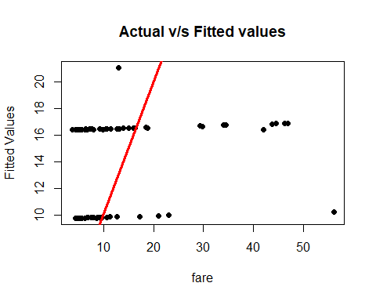

#This is not a good fit since R-sq = 0.083 and Adj R-sq = 0.0568  
  
##########################################  
  
lm_sample_cab_only_seconds = lm(formula = fare ~ trip_seconds , data = sample_cabdata)  
summary(lm_sample_cab_only_seconds)

##   
## Call:  
## lm(formula = fare ~ trip_seconds, data = sample_cabdata)  
##   
## Residuals:  
## Min 1Q Median 3Q Max   
## -18.6341 -2.5360 -0.7912 1.0174 19.7933   
##   
## Coefficients:  
## Estimate Std. Error t value Pr(>|t|)   
## (Intercept) 1.6102035 1.0110400 1.593 0.116   
## trip_seconds 0.0156034 0.0009912 15.742 <2e-16 ***  
## ---  
## Signif. codes: 0 '***' 0.001 '**' 0.01 '*' 0.05 '.' 0.1 ' ' 1  
##   
## Residual standard error: 5.712 on 71 degrees of freedom  
## Multiple R-squared: 0.7773, Adjusted R-squared: 0.7742   
## F-statistic: 247.8 on 1 and 71 DF, p-value: < 2.2e-16

plot(sample_cabdata$fare,lm_sample_cab_only_seconds$fitted.values,pch=19,main="Actual v/s Fitted values",  
 xlab = "fare", ylab = "Fitted Values")  
abline(0,1,col="red",lwd=3)

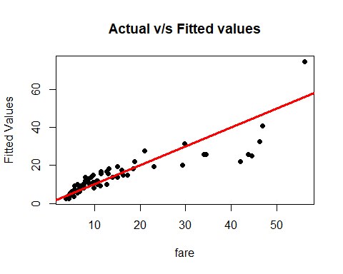

#Here we are only considering trip_second for the Linear Model. The equation for fare becomes  
# Fare = 1.6102035 + trip_seconds * 0.0156034. It mean when the trip_seconds changes, the fare changes by  
#0.0156034. The p value for fair is,less than 2e-16 which is significantly small, hence we reject the null hypothesis.  
#The intercepts value is 1.6102035, and its pvalue is 0.116 which is significantly large, hence we fail  
#to reject Null Hypothesis since we dont have enough evidence.  
  
#########################################  
#NOT GOOD  
lm_sample_cab_only_binpayment = lm(formula = fare ~ payment_type, data = sample_cabdata)  
summary(lm_sample_cab_only_binpayment)

##   
## Call:  
## lm(formula = fare ~ payment_type, data = sample_cabdata)  
##   
## Residuals:  
## Min 1Q Median 3Q Max   
## -12.772 -5.772 -3.141 0.609 45.859   
##   
## Coefficients:  
## Estimate Std. Error t value Pr(>|t|)   
## (Intercept) 10.141 2.001 5.069 3.06e-06 ***  
## payment_typeCredit Card 6.381 2.737 2.331 0.0226 *   
## ---  
## Signif. codes: 0 '***' 0.001 '**' 0.01 '*' 0.05 '.' 0.1 ' ' 1  
##   
## Residual standard error: 11.67 on 71 degrees of freedom  
## Multiple R-squared: 0.07109, Adjusted R-squared: 0.05801   
## F-statistic: 5.434 on 1 and 71 DF, p-value: 0.0226

plot(sample_cabdata$fare,lm_sample_cab_only_binpayment$fitted.values,pch=19,main="Actual v/s Fitted values",  
 xlab = "fare", ylab = "Fitted Values")  
abline(0,1,col="red",lwd=3)

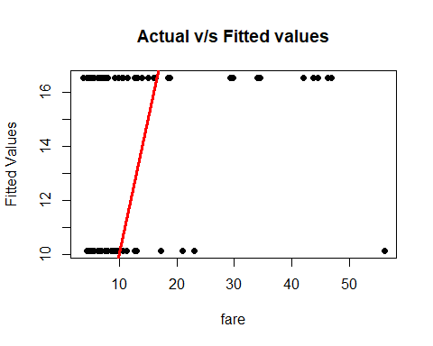

#SAME VALUE FOR BOTH  
  
#NOT GOOD  
  
lm_sample_cab_only_payment = lm(formula = fare ~ payment_type, data = sample_cabdata)  
summary(lm_sample_cab_only_payment)

##   
## Call:  
## lm(formula = fare ~ payment_type, data = sample_cabdata)  
##   
## Residuals:  
## Min 1Q Median 3Q Max   
## -12.772 -5.772 -3.141 0.609 45.859   
##   
## Coefficients:  
## Estimate Std. Error t value Pr(>|t|)   
## (Intercept) 10.141 2.001 5.069 3.06e-06 ***  
## payment_typeCredit Card 6.381 2.737 2.331 0.0226 *   
## ---  
## Signif. codes: 0 '***' 0.001 '**' 0.01 '*' 0.05 '.' 0.1 ' ' 1  
##   
## Residual standard error: 11.67 on 71 degrees of freedom  
## Multiple R-squared: 0.07109, Adjusted R-squared: 0.05801   
## F-statistic: 5.434 on 1 and 71 DF, p-value: 0.0226

plot(sample_cabdata$fare,lm_sample_cab_only_payment$fitted.values,pch=19,main="Actual v/s Fitted values",  
 xlab = "fare", ylab = "Fitted Values")  
abline(0,1,col="red",lwd=3)



#All the values are the same if we consider, bin_payment or payment, hence we consider payment only  
#Also the R-sq = 0.07109 and the Adj. R-sq = 0.05801, hence this model is not a good fit

#BAD FIT  
lm_sample_cab_only_miles = lm(formula = fare ~ trip_miles , data = sample_cabdata)  
summary(lm_sample_cab_only_miles)

##   
## Call:  
## lm(formula = fare ~ trip_miles, data = sample_cabdata)  
##   
## Residuals:  
## Min 1Q Median 3Q Max   
## -9.622 -7.622 -4.718 1.545 42.305   
##   
## Coefficients:  
## Estimate Std. Error t value Pr(>|t|)   
## (Intercept) 13.36607 1.43725 9.300 6.57e-14 ***  
## trip_miles 0.01860 0.02711 0.686 0.495   
## ---  
## Signif. codes: 0 '***' 0.001 '**' 0.01 '*' 0.05 '.' 0.1 ' ' 1  
##   
## Residual standard error: 12.06 on 71 degrees of freedom  
## Multiple R-squared: 0.006587, Adjusted R-squared: -0.007404   
## F-statistic: 0.4708 on 1 and 71 DF, p-value: 0.4949

plot(sample_cabdata$fare,lm_sample_cab_only_miles$fitted.values,pch=19,main="Actual v/s Fitted values",  
 xlab = "fare", ylab = "Fitted Values")  
abline(0,1,col="red",lwd=3)

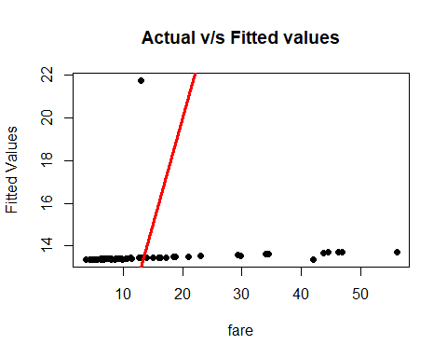

#This is a bad fit  
#Also the R-sq = 0.006587 and Adj. R-sq = -0.007404  
  
################################################  
  
lm_sample_cab_only_miles_sq = lm(formula = fare ~ trip_miles + miles_sq , data = sample_cabdata)  
summary(lm_sample_cab_only_miles_sq)

##   
## Call:  
## lm(formula = fare ~ trip_miles + miles_sq, data = sample_cabdata)  
##   
## Residuals:  
## Min 1Q Median 3Q Max   
## -2.958 -1.258 -0.873 -0.181 34.867   
##   
## Coefficients:  
## Estimate Std. Error t value Pr(>|t|)   
## (Intercept) 4.7551053 0.6821874 6.97 1.41e-09 ***  
## trip_miles 2.3833269 0.1144416 20.83 < 2e-16 ***  
## miles_sq -0.0052553 0.0002533 -20.75 < 2e-16 ***  
## ---  
## Signif. codes: 0 '***' 0.001 '**' 0.01 '*' 0.05 '.' 0.1 ' ' 1  
##   
## Residual standard error: 4.544 on 70 degrees of freedom  
## Multiple R-squared: 0.861, Adjusted R-squared: 0.8571   
## F-statistic: 216.9 on 2 and 70 DF, p-value: < 2.2e-16

plot(sample_cabdata$fare,lm_sample_cab_only_miles_sq$fitted.values,pch=19,main="Actual v/s Fitted values",  
 xlab = "fare", ylab = "Fitted Values")  
abline(0,1,col="red",lwd=3)

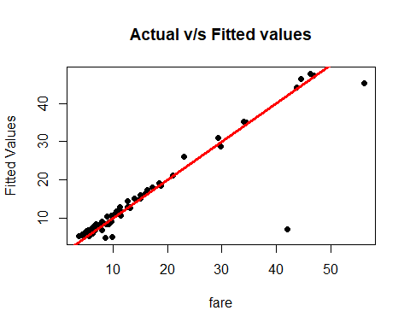

#Here we are considering only the trip_miles and its squared value stored in miles_sq.   
#The equation for fare would be: fare = 4.7551053 + 2.3833269 * trip_miles - 0.0052553 * miles_sq  
#If trip_miles changes, the value for fare changes by 2.3833269. The p value for trip_miles is <2e-16, which  
#is significantly less, hence we can reject the Null Hypothesis.   
#If miles_sq changes, the value for fare changes by -0.0052553. The p value for miles_sq is < 2e-16, which  
#is significantly less, hence we can reject the Null Hypothesis.   
#For Intercept, the pvalue is 1.41e-09, hence we reject the Null Hypothesis  
#The R-sq = 0.861 and Adj R-sq = 0.8571  
##########################################  
  
#NOT GOOD AFER SQUARE  
lm_sample_cab_only_seconds_sq =lm(formula = fare ~ trip_seconds + trip_seconds_sq , data = sample_cabdata)  
summary(lm_sample_cab_only_seconds_sq)

##   
## Call:  
## lm(formula = fare ~ trip_seconds + trip_seconds_sq, data = sample_cabdata)  
##   
## Residuals:  
## Min 1Q Median 3Q Max   
## -10.2011 -3.1689 -0.0702 1.9242 16.8935   
##   
## Coefficients:  
## Estimate Std. Error t value Pr(>|t|)   
## (Intercept) -2.227e+00 1.266e+00 -1.759 0.083 .   
## trip_seconds 2.367e-02 2.064e-03 11.469 < 2e-16 ***  
## trip_seconds_sq -2.249e-06 5.193e-07 -4.330 4.88e-05 ***  
## ---  
## Signif. codes: 0 '***' 0.001 '**' 0.01 '*' 0.05 '.' 0.1 ' ' 1  
##   
## Residual standard error: 5.109 on 70 degrees of freedom  
## Multiple R-squared: 0.8243, Adjusted R-squared: 0.8193   
## F-statistic: 164.3 on 2 and 70 DF, p-value: < 2.2e-16

plot(sample_cabdata$fare,lm_sample_cab_only_seconds_sq$fitted.values,pch=19,main="Actual v/s Fitted values",  
 xlab = "fare", ylab = "Fitted Values")  
abline(0,1,col="red",lwd=3)

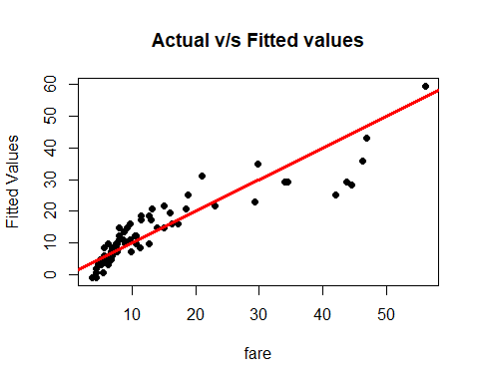

#Here we are considering only trip_seconds and trip_seconds_sq for building the linear model.  
#The equation for fare would be  
# fare = -2.227e+00 + 2.367e-02 * trip_seconds + -2.249e-06 * trip_seconds_sq  
  
#The p value for trip_seconds, trip_seconds_sq and Intercept is < 2e-16, 4.88e-05 and 0.083, which are   
#significantly small, hence we reject the Null Hypothesis  
#The R-sq = 0.8243 and Adj R-sq = 0..8193  
#######################################################################   
  
lm_sample_cab_no_payment_time_sq = lm(fare ~ trip_seconds+trip_seconds_sq + trip_miles, data = sample_cabdata)  
summary(lm_sample_cab_no_payment_time_sq)

##   
## Call:  
## lm(formula = fare ~ trip_seconds + trip_seconds_sq + trip_miles,   
## data = sample_cabdata)  
##   
## Residuals:  
## Min 1Q Median 3Q Max   
## -10.3071 -2.9109 -0.0966 1.9169 16.7726   
##   
## Coefficients:  
## Estimate Std. Error t value Pr(>|t|)   
## (Intercept) -2.249e+00 1.273e+00 -1.766 0.0818 .   
## trip_seconds 2.382e-02 2.092e-03 11.387 < 2e-16 ***  
## trip_seconds_sq -2.276e-06 5.243e-07 -4.341 4.75e-05 ***  
## trip_miles -6.444e-03 1.165e-02 -0.553 0.5819   
## ---  
## Signif. codes: 0 '***' 0.001 '**' 0.01 '*' 0.05 '.' 0.1 ' ' 1  
##   
## Residual standard error: 5.135 on 69 degrees of freedom  
## Multiple R-squared: 0.8251, Adjusted R-squared: 0.8175   
## F-statistic: 108.5 on 3 and 69 DF, p-value: < 2.2e-16

plot(sample_cabdata$fare,lm_sample_cab_no_payment_time_sq$fitted.values,pch=19,main="Actual v/s Fitted values",  
 xlab = "fare", ylab = "Fitted Values")  
abline(0,1,col="red",lwd=3)

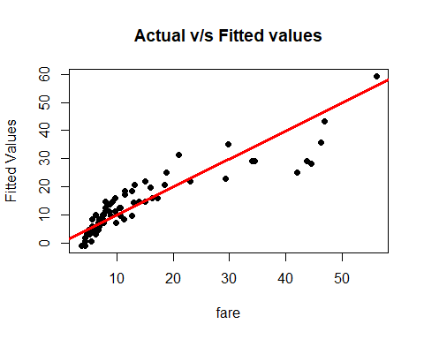

#Here we consider trip_seconds, trip_seconds_sq, trip_miles for building the linear model.  
#The equation for fare becomes :  
# fare = -2.249e+00 + 2.382e-02 * trip_seconds - 2.276e-06 * trip_seconds_sq - 6.444e-03 * trip_miles  
#If trip_seconds, trip_seconds_sq or trip_miles change, the fare changes by 2.382e-02 and 2.276e-06 and   
#6.444e-03 respictively  
#The p value of intercept is 0.0818, which is a bit high and hence we fail to reject the Null Hypothesis due to lack of evidence   
#for trips_seconds is <2e-16,hence we reject the null hypothesis,  
#for trip_seconds_sq is 4.75e-05 hence we reject the null hypothesis,and for trip_miles is 0.5819,  
#which is significantly high,  
#hence we fail to reject the null hypothesis  
#The R-sq = 0.8251 and Adj R-sq = 0.8175  
###############################################################################  
  
#FINAL BEST MODEL  
lm_sample_cab_no_payment_miles_sq = lm(fare ~ trip_seconds + trip_miles + miles_sq, data = sample_cabdata)  
summary(lm_sample_cab_no_payment_miles_sq)

##   
## Call:  
## lm(formula = fare ~ trip_seconds + trip_miles + miles_sq, data = sample_cabdata)  
##   
## Residuals:  
## Min 1Q Median 3Q Max   
## -4.3709 -1.0388 -0.4466 -0.0264 29.1699   
##   
## Coefficients:  
## Estimate Std. Error t value Pr(>|t|)   
## (Intercept) 2.6668736 0.6824707 3.908 0.000215 ***  
## trip_seconds 0.0064833 0.0011628 5.575 4.46e-07 ***  
## trip_miles 1.6087559 0.1687012 9.536 3.18e-14 ***  
## miles_sq -0.0035525 0.0003717 -9.558 2.91e-14 ***  
## ---  
## Signif. codes: 0 '***' 0.001 '**' 0.01 '*' 0.05 '.' 0.1 ' ' 1  
##   
## Residual standard error: 3.801 on 69 degrees of freedom  
## Multiple R-squared: 0.9042, Adjusted R-squared: 0.9   
## F-statistic: 217.1 on 3 and 69 DF, p-value: < 2.2e-16

plot(sample_cabdata$fare,lm_sample_cab_no_payment_miles_sq$fitted.values,pch=19,main="Actual v/s Fitted values",  
 xlab = "fare", ylab = "Fitted Values")  
abline(0,1,col="red",lwd=3)

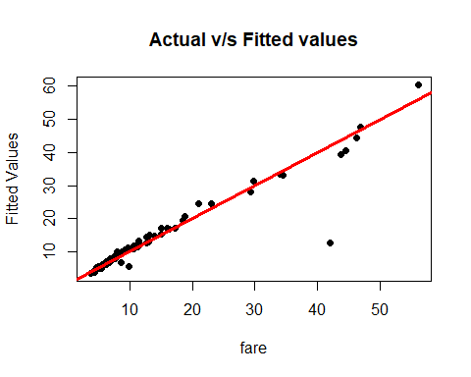

#Here we consider trip_seconds, trip_miles and miles_sq for building the linear model.  
#The equation for fare:  
#fare = 2.6668736 + 0.0064833 * trip_seconds + 1.6087559 * trip_miles - 0.0035525 * miles_sq  
#Here for all the variables, we get a pvalue such that we can reject the Null Hypothesis in every case.  
#For Intercept, the pvalue is 0.000215, for trip_seconds, the pvalue is 4.46e-07, for trip_miles, the pvalue is 3.18e-14  
#and for miles_sq, the pvalue is 2.91e-14 which are all less than 0.05. We can reject the Null Hypothesis  
#The R-sq = 0.9042 and Adj R-sq = 0.9  
##########################################################################################  
  
#GOOD MODEL  
  
lm_sample_cab_sum_sq = lm(fare ~ trip_seconds + trip_seconds_sq + trip_miles + miles_sq, data = sample_cabdata)  
summary(lm_sample_cab_sum_sq)

##   
## Call:  
## lm(formula = fare ~ trip_seconds + trip_seconds_sq + trip_miles +   
## miles_sq, data = sample_cabdata)  
##   
## Residuals:  
## Min 1Q Median 3Q Max   
## -5.1134 -1.1913 -0.1622 0.4412 27.2845   
##   
## Coefficients:  
## Estimate Std. Error t value Pr(>|t|)   
## (Intercept) 1.264e+00 1.029e+00 1.229 0.2234   
## trip_seconds 1.010e-02 2.315e-03 4.364 4.44e-05 ***  
## trip_seconds_sq -7.686e-07 4.273e-07 -1.799 0.0765 .   
## trip_miles 1.458e+00 1.861e-01 7.833 4.41e-11 ***  
## miles_sq -3.223e-03 4.092e-04 -7.876 3.68e-11 ***  
## ---  
## Signif. codes: 0 '***' 0.001 '**' 0.01 '*' 0.05 '.' 0.1 ' ' 1  
##   
## Residual standard error: 3.74 on 68 degrees of freedom  
## Multiple R-squared: 0.9085, Adjusted R-squared: 0.9032   
## F-statistic: 168.9 on 4 and 68 DF, p-value: < 2.2e-16

plot(sample_cabdata$fare,lm_sample_cab_sum_sq$fitted.values,pch=19,main="Actual v/s Fitted values",  
 xlab = "fare", ylab = "Fitted Values")  
abline(0,1,col="red",lwd=3)

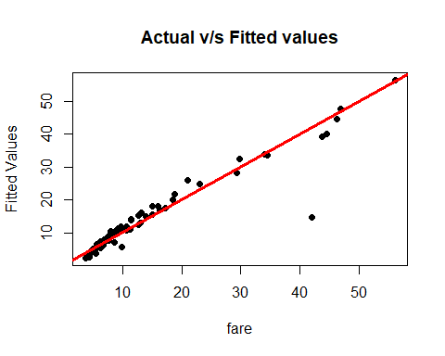

#Here we are using trip_seconds, trip_seconds_sq, trip_miles and miles_sq for building the linear model.  
#The equation for fare would be  
#fare = 1.264e+00 + 1.010e-02 * trip_seconds - 7.686e-07 * trip_seconds_sq + 1.458e+00 * trip_miles - 3.223e-03 * miles_sq  
#the p value for Intercept is significantly large 0.2234, hence we fail to reject Null Hypothesis, due to  
#lack of evidence  
#and p value for trip_seconds_sq is 0.0765,   
#Hence we reject the Null Hypothesis in this case due to lack of evidence  
#The R-sq value is 0.9085 and Adj R-sq is 0.9032  
  
########################################################################################################  
  
lm_sample_cab_sum_sq_payment = lm(fare ~ trip_seconds + trip_seconds_sq + trip_miles + miles_sq + payment_type, data = sample_cabdata)  
summary(lm_sample_cab_sum_sq_payment)

##   
## Call:  
## lm(formula = fare ~ trip_seconds + trip_seconds_sq + trip_miles +   
## miles_sq + payment_type, data = sample_cabdata)  
##   
## Residuals:  
## Min 1Q Median 3Q Max   
## -4.3203 -1.2769 -0.4029 0.6885 26.9733   
##   
## Coefficients:  
## Estimate Std. Error t value Pr(>|t|)   
## (Intercept) 1.018e+00 1.056e+00 0.964 0.33869   
## trip_seconds 9.634e-03 2.358e-03 4.086 0.00012 ***  
## trip_seconds_sq -6.481e-07 4.427e-07 -1.464 0.14786   
## trip_miles 1.443e+00 1.865e-01 7.739 7.11e-11 ***  
## miles_sq -3.188e-03 4.103e-04 -7.770 6.26e-11 ***  
## payment_typeCredit Card 9.817e-01 9.498e-01 1.034 0.30505   
## ---  
## Signif. codes: 0 '***' 0.001 '**' 0.01 '*' 0.05 '.' 0.1 ' ' 1  
##   
## Residual standard error: 3.739 on 67 degrees of freedom  
## Multiple R-squared: 0.91, Adjusted R-squared: 0.9033   
## F-statistic: 135.5 on 5 and 67 DF, p-value: < 2.2e-16

plot(sample_cabdata$fare,lm_sample_cab_sum_sq_payment$fitted.values,pch=19,main="Actual v/s Fitted values",  
 xlab = "fare", ylab = "Fitted Values")  
abline(0,1,col="red",lwd=3)

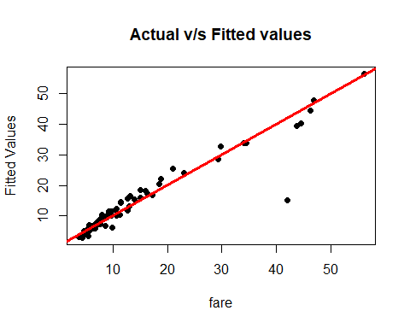

#Here we are considering trip_seconds, trip_seconds_sq, trip_miles, miles_sq and payment_type for building the  
#linear model. The equation for fare would be:  
#fare = 1.018e+00 + 9.634e-03 * trip_seconds -6.481e-07 * trip_seconds_sq + 1.443e+00 * trip_miles - 3.188e-03 * miles_sq + 9.817e-01 * payment_type  
#the p value for intercept, trip_seconds_sq and payment_type is significantly high 0.33869, 0.14786 and 0.30505, hence we reject the  
#Null Hypothesis.  
#Also the R-sq value is 0.91 and Adj R-sq value is 0.9033  
#The p value of trip_seconds,trip_seconds_sq and payment_type is significantly large  
#Hence we reject the Null Hypothesis due to lack of evidence  
#For the rest, the p value is significanlty small  
  
#For interactions we do the following  
  
lm_sample_cab_intercations = lm(formula = fare ~ trip_seconds + trip_miles + payment_type + trip_seconds:trip_miles, data = sample_cabdata)  
summary(lm_sample_cab_intercations)

##   
## Call:  
## lm(formula = fare ~ trip_seconds + trip_miles + payment_type +   
## trip_seconds:trip_miles, data = sample_cabdata)  
##   
## Residuals:  
## Min 1Q Median 3Q Max   
## -13.3780 -2.8159 -0.8525 1.7625 18.3650   
##   
## Coefficients:  
## Estimate Std. Error t value Pr(>|t|)   
## (Intercept) -0.6398421 1.5518904 -0.412 0.6814   
## trip_seconds 0.0168970 0.0022907 7.376 2.97e-10 ***  
## trip_miles 0.1225686 0.1490112 0.823 0.4136   
## payment_typeCredit Card 2.8994642 1.3733886 2.111 0.0384 *   
## trip_seconds:trip_miles -0.0001356 0.0001670 -0.812 0.4198   
## ---  
## Signif. codes: 0 '***' 0.001 '**' 0.01 '*' 0.05 '.' 0.1 ' ' 1  
##   
## Residual standard error: 5.586 on 68 degrees of freedom  
## Multiple R-squared: 0.796, Adjusted R-squared: 0.784   
## F-statistic: 66.34 on 4 and 68 DF, p-value: < 2.2e-16

plot(sample_cabdata$fare,lm_sample_cab_intercations$fitted.values,pch=19,main="Actual v/s Fitted values",  
 xlab = "fare", ylab = "Fitted Values")  
abline(0,1,col="red",lwd=3)

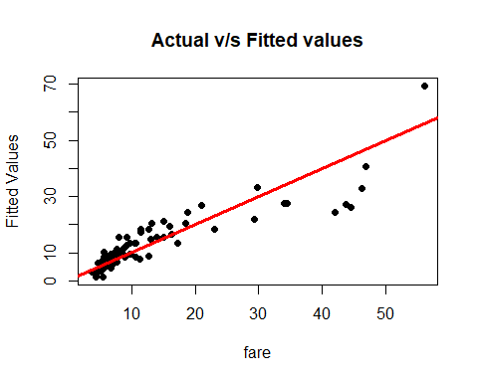

#Here we consider the interaction of trip_seconds and trip_miles,  
#the equation for fare becomes  
#fare = -0.6399 + trip_seconds * 0.016 + trip_miles * 0.1225 + payment_type 2.899 - trip_seconds:trip_miles * 0.0001356  
# the fare changes  
  
  
lm_sample_cab_intercations_sq = lm(formula = fare ~ trip_seconds + trip_miles + payment_type + trip_seconds:trip_miles + trip_seconds_sq,data = sample_cabdata)  
summary(lm_sample_cab_intercations_sq)

##   
## Call:  
## lm(formula = fare ~ trip_seconds + trip_miles + payment_type +   
## trip_seconds:trip_miles + trip_seconds_sq, data = sample_cabdata)  
##   
## Residuals:  
## Min 1Q Median 3Q Max   
## -8.682 -2.167 -0.383 1.458 22.297   
##   
## Coefficients:  
## Estimate Std. Error t value Pr(>|t|)   
## (Intercept) -6.009e-02 1.226e+00 -0.049 0.961   
## trip_seconds 2.157e-02 1.941e-03 11.112 < 2e-16 ***  
## trip_miles -1.121e+00 2.237e-01 -5.009 4.23e-06 ***  
## payment_typeCredit Card 1.001e+00 1.120e+00 0.894 0.375   
## trip_seconds_sq -5.868e-06 8.990e-07 -6.528 1.05e-08 ***  
## trip_seconds:trip_miles 1.243e-03 2.488e-04 4.996 4.45e-06 ***  
## ---  
## Signif. codes: 0 '***' 0.001 '**' 0.01 '*' 0.05 '.' 0.1 ' ' 1  
##   
## Residual standard error: 4.4 on 67 degrees of freedom  
## Multiple R-squared: 0.8753, Adjusted R-squared: 0.866   
## F-statistic: 94.08 on 5 and 67 DF, p-value: < 2.2e-16

plot(sample_cabdata$fare,lm_sample_cab_intercations_sq$fitted.values,pch=19,main="Actual v/s Fitted values",  
 xlab = "fare", ylab = "Fitted Values")  
abline(0,1,col="red",lwd=3)

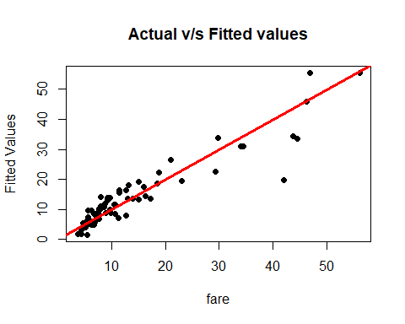

#Here we also consider trip_seconds_sq bu no miles_sq.  
#The equation for fare would be  
#Fare = -6.009e-02 + 2.157e-02 * trip_seconds - 1.121e+00 * trip_miles + 1.001e+00 * payment_type + 1.243e-03 * trip_seconds:trip_miles -5.868e-06 * trip_seconds_sq  
#The p value of Intercept and payment_type is significanlty large 0.961 and 0.375 respictively.  
#Hence we fail to reject the Null Hypothesis. For rest the pvalue is well below the acceptable limit of 0.05  
#The value for R-sq is 0.8753 and Adj R-sq is 0.866  
  
  
#6  
  
#LINE ASSUMPTIOMS  
  
#Linearity  
  
plot(sample_cabdata$fare,lm_sample_cab_no_payment_miles_sq$fitted.values,pch=19,main="Actual v/s Fitted values",  
 xlab = "fare", ylab = "Fitted Values")  
abline(0,1,col="red",lwd=3)



#The "Actual v/s Fitted values" plot shows the points clustered near the lower tail  
#There are few outliers in the plot as well. Hence the plot is linear  
  
  
#Normality  
  
qqnorm(lm_sample_cab_no_payment_miles_sq$residuals,pch=19,main="P&O Normality Plot")  
qqline(lm_sample_cab_no_payment_miles_sq$residuals,col="green",lwd=3)

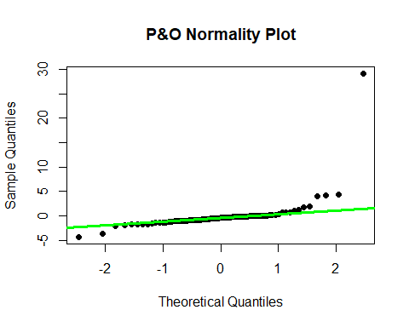

#The "P&O Normality Plot" plot shows that the points are normal in nature except some points  
#which are towards the upper tail i.e. increased residuals  
#There are some outliers in the plot as well but the plot shows the points are normal in nature.  
  
#Equality of Variance  
plot(lm_sample_cab_no_payment_miles_sq$fitted.values,lm_sample_cab_no_payment_miles_sq$residuals,pch=19,main="P&O Residuals",  
 xlab = "Fitted Values",ylab="Residuals")  
abline(0,0,col="orange",lwd=3)

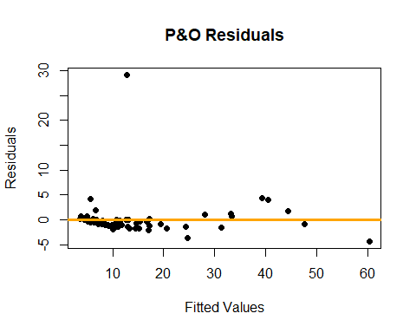

#The "P&O Residuals" plot shows that the residuals are not equivalent to variance .  
#There are many outliers in the plot as well.  
#Hence we can say that the outliers do not affect the accuracy of the model  
  
#7  
  
#Since there are a lot of outliers in the plot we check for leverage.  
#We expell the points with high leverage   
  
leverage=hat(model.matrix(lm_sample_cab_no_payment_miles_sq))  
plot(leverage,pch=19)  
abline(3*mean(leverage),0,col="green",lwd=3)

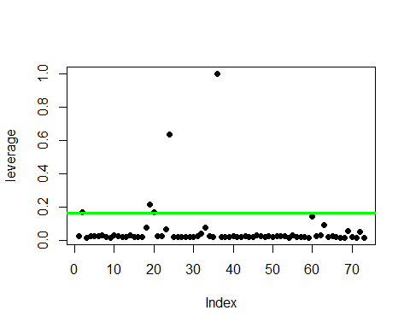

#from the plot we can see there are around 4 - 5 points which can be considered as outliers.  
#by using Which function, returns the indices of the logical object when it is TRUE.  
  
leverage_points = which(leverage>3*mean(leverage))  
  
leverage_points

## [1] 2 19 20 24 36

#There are 5 outliers, the points are '2, 19, 20, 24, 36' are out of the leverage level  
#here are the details of the points which are inappropriate for the model.  
  
sample_cabdata[2,]

## taxi_id trip_seconds trip_miles fare tips extras trip_total  
## 1052446 1685 1980 18.8 46.25 10.05 4 60.3  
## payment_type miles_sq trip_seconds_sq  
## 1052446 Credit Card 353.44 3920400

sample_cabdata[19,]

## taxi_id trip_seconds trip_miles fare tips extras trip_total  
## 1490807 2235 1500 18.2 44.5 9.7 4 58.2  
## payment_type miles_sq trip_seconds_sq  
## 1490807 Credit Card 331.24 2250000

sample_cabdata[20,]

## taxi_id trip_seconds trip_miles fare tips extras trip_total  
## 1581222 7065 1560 17.2 43.75 9.15 2 54.9  
## payment_type miles_sq trip_seconds_sq  
## 1581222 Credit Card 295.84 2433600

sample_cabdata[24,]

## taxi_id trip_seconds trip_miles fare tips extras trip_total  
## 658621 5056 4680 17.7 56 0 0.5 56.5  
## payment_type miles_sq trip_seconds_sq  
## 658621 Cash 313.29 21902400

sample_cabdata[36,]

## taxi_id trip_seconds trip_miles fare tips extras trip_total  
## 318619 4362 900 450 13.05 0 1.5 14.55  
## payment_type miles_sq trip_seconds_sq  
## 318619 Cash 202500 810000

#Here we remove the inappropriate points and build a new model using the new dataset  
  
final_regression = sample_cabdata[-c(leverage_points),]  
summary(final_regression)

## taxi_id trip_seconds trip_miles fare   
## Min. : 4 Min. : 60.0 Min. : 0.100 Min. : 3.750   
## 1st Qu.:1439 1st Qu.: 300.0 1st Qu.: 0.800 1st Qu.: 5.750   
## Median :4357 Median : 540.0 Median : 1.550 Median : 8.025   
## Mean :4030 Mean : 665.3 Mean : 2.941 Mean :11.553   
## 3rd Qu.:6235 3rd Qu.: 840.0 3rd Qu.: 3.500 3rd Qu.:12.875   
## Max. :8696 Max. :2520.0 Max. :18.600 Max. :46.750   
## tips extras trip_total payment_type  
## Min. : 0.000 Min. :0.0000 Min. : 4.450 Cash :32   
## 1st Qu.: 0.000 1st Qu.:0.0000 1st Qu.: 6.938 Credit Card:36   
## Median : 1.000 Median :0.0000 Median : 9.500 Other : 0   
## Mean : 1.610 Mean :0.6397 Mean :13.802   
## 3rd Qu.: 2.038 3rd Qu.:1.0000 3rd Qu.:16.387   
## Max. :10.150 Max. :5.0000 Max. :60.900   
## miles_sq trip_seconds_sq   
## Min. : 0.010 Min. : 3600   
## 1st Qu.: 0.640 1st Qu.: 90000   
## Median : 2.405 Median : 291600   
## Mean : 21.120 Mean : 656471   
## 3rd Qu.: 12.250 3rd Qu.: 705600   
## Max. :345.960 Max. :6350400

#Rerunning the models using the new data afer removing the outliers  
  
reg_without_outliers = lm(fare ~ trip_seconds + trip_miles + miles_sq , data = sample_cabdata)  
  
summary(reg_without_outliers)

##   
## Call:  
## lm(formula = fare ~ trip_seconds + trip_miles + miles_sq, data = sample_cabdata)  
##   
## Residuals:  
## Min 1Q Median 3Q Max   
## -4.3709 -1.0388 -0.4466 -0.0264 29.1699   
##   
## Coefficients:  
## Estimate Std. Error t value Pr(>|t|)   
## (Intercept) 2.6668736 0.6824707 3.908 0.000215 ***  
## trip_seconds 0.0064833 0.0011628 5.575 4.46e-07 ***  
## trip_miles 1.6087559 0.1687012 9.536 3.18e-14 ***  
## miles_sq -0.0035525 0.0003717 -9.558 2.91e-14 ***  
## ---  
## Signif. codes: 0 '***' 0.001 '**' 0.01 '*' 0.05 '.' 0.1 ' ' 1  
##   
## Residual standard error: 3.801 on 69 degrees of freedom  
## Multiple R-squared: 0.9042, Adjusted R-squared: 0.9   
## F-statistic: 217.1 on 3 and 69 DF, p-value: < 2.2e-16

plot(sample_cabdata$fare,reg_without_outliers$fitted.values,pch=19,main="Actual v/s Fitted values",  
 xlab = "fare", ylab = "Fitted Values")  
abline(0,1,col="red",lwd=3)



#As we can see we get the same values after removing the outliers even for R-sq = 0.9042 and Adj R-sq = 0.9,   
#i.e. both the models are quite similar  
  
#The equation for fare would be  
# fare = 2.6668736 + trip_seconds * 0.0064833 + trip_miles * 1.6087559 - miles_sq * 0.0035525   
  
#All the p values are significantly low hence we reject the null hypothesis  
  
#8  
  
#Adding +5 to my U number 27683820 to set the new seed  
set.seed(27683825)  
  
my.testCabInfo = cab_trips[sample(1:nrow(cab_trips),100, replace = FALSE),]  
#There are some records wherein the trip seconds and trip_miles are zero, but the fare is still some  
#positive number. Hence cleaning up such records  
  
test_cabModel = subset(my.testCabInfo, trip_seconds > 0 & trip_miles > 0, -c(tolls,taxi_id))

#Checking is there is any NA value in the model  
sum(is.na(test_cabModel))

## [1] 0

test_cabModel$trip_miles_sq = test_cabModel$trip_miles ^ 2  
attach(test_cabModel)

## The following objects are masked from my.cabInfo:  
##   
## extras, fare, payment_type, tips, trip_miles, trip_seconds,  
## trip_total

## The following objects are masked from cab_trips:  
##   
## extras, fare, payment_type, tips, trip_miles, trip_seconds,  
## trip_total

##########################################  
  
test_cabModel_lm = lm(fare ~ trip_seconds + trip_miles + trip_miles_sq, data = test_cabModel)  
summary(test_cabModel_lm)

##   
## Call:  
## lm(formula = fare ~ trip_seconds + trip_miles + trip_miles_sq,   
## data = test_cabModel)  
##   
## Residuals:  
## Min 1Q Median 3Q Max   
## -5.7936 -1.4374 -0.7492 0.4917 15.0242   
##   
## Coefficients:  
## Estimate Std. Error t value Pr(>|t|)   
## (Intercept) 3.1029464 0.6050318 5.129 2.37e-06 ***  
## trip_seconds 0.0080489 0.0007806 10.311 7.98e-16 ***  
## trip_miles 1.1125162 0.1853898 6.001 7.22e-08 ***  
## trip_miles_sq 0.0173281 0.0056223 3.082 0.00291 **   
## ---  
## Signif. codes: 0 '***' 0.001 '**' 0.01 '*' 0.05 '.' 0.1 ' ' 1  
##   
## Residual standard error: 3.25 on 72 degrees of freedom  
## Multiple R-squared: 0.9539, Adjusted R-squared: 0.952   
## F-statistic: 496.7 on 3 and 72 DF, p-value: < 2.2e-16

plot(test_cabModel$fare,test_cabModel_lm$fitted.values,pch=19,main="Actual v/s Fitted values",  
 xlab = "fare", ylab = "Fitted Values")  
abline(0,1,col="cyan",lwd=3)

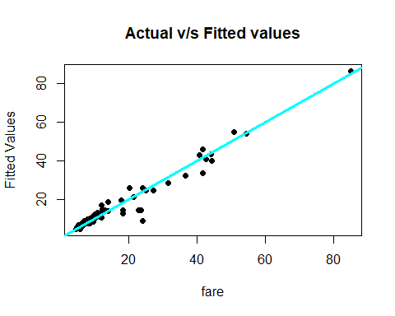

#Using the best model from question 6 on the new dataset, we get a R-sq = 0.9539 and Adj R-sq = 0.952.  
#The value for Intercept is 3.1029464 and its p value is 2.37e-06  
#The value for trip_seconds is 0.0080489 and its p value is 7.98e-16  
#The value for trip_miles is 1.1125162 and its p value is 7.22e-08  
#The value for trip_miles_sq is 0.0173281 and its p value is 0.00291   
#Hence in all the cases, we Reject the Null Hypothesis.  
#The equation for fare would be  
# fare = 3.1029464 + 0.0080489 * trip_seconds + 1.1125162 * trip_miles + 0.0173281 * trip_miles_sq

#If trip_seconds changes, fare changes by 0.0080489,

#If trip_miles changes, fare changes by 1.1125162,

#If trip_seconds changes, fare changes by 0.0173281