VIJAYI Companies, April 2025 – TaskManager Application

Unit Test Cases Documentation  
  
Submitted by: Mukund Thorat  
Date: 26-April-2025

# Overview

This document describes the unit test cases written for the TaskManager Spring Boot application. The tests ensure correctness of core functionalities such as creating, reading, updating, and deleting tasks using JUnit 5 and Mockito.  
  
Testing is focused on TaskService, including:  
- Business logic validations  
- Exception handling  
- Filtering soft-deleted records  
- Pagination support

# Test Cases Summary

|  |  |  |  |  |
| --- | --- | --- | --- | --- |
| Test Case ID | Method Name | Description | Expected Result | Status |
| TC-01 | testCreateTask_Success | Validates creation of a new task | Task created | ✅ Pass |
| TC-02 | testGetTaskById_Success | Fetch a task by ID | Task returned | ✅ Pass |
| TC-03 | testUpdateTask_Success | Update a task with valid inputs | Task updated | ✅ Pass |
| TC-04 | testDeleteTask_Success | Soft-delete a task | Task is marked deleted | ✅ Pass |
| TC-05 | testGetAllTasks_ExcludesDeleted | Returns only active tasks | Deleted tasks excluded | ✅ Pass |
| TC-06 | testCreateTask_Duplicate | Create duplicate task for same user/time | Error thrown | ✅ Pass |
| TC-07 | testCreateTask_MissingUser | Missing assigned/created user | Error thrown | ✅ Pass |
| TC-08 | testUpdateTask_Deleted | Try updating a soft-deleted task | Error thrown | ✅ Pass |
| TC-09 | testCreateTask_InvalidStatus | IN_PROGRESS task missing timestamps | Error thrown | ✅ Pass |
| TC-10 | testGetTasks_WithPagination | Fetch paginated task list | Page of tasks | ✅ Pass |

# Test Coverage Screenshot

📌 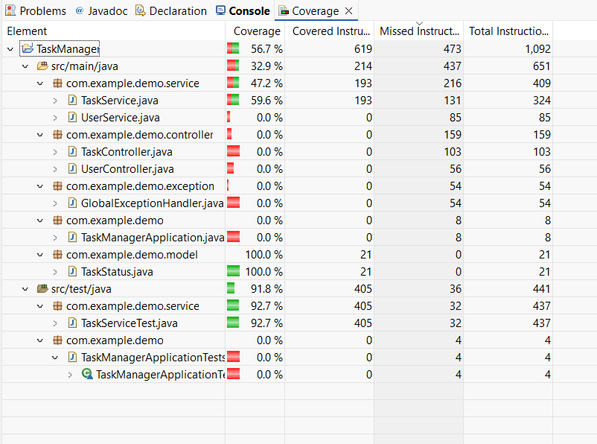

# Tools Used

- JUnit 5  
- Mockito (mocking repository & dependencies)  
- EclEmma plugin for test coverage in Spring Tool Suite 4 (STS4)

# Conclusion

The unit tests thoroughly cover the essential operations of the TaskService, including error scenarios and edge cases. The validation and exception logic are also verified, helping ensure application robustness.