**Mukund Kumar Upadhyay**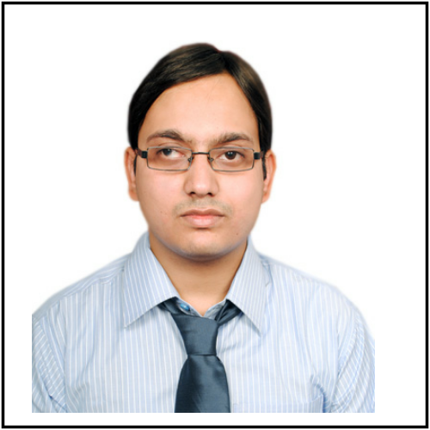

Phone: 7756876755

Mailto: [mukundkumar.upadhyay@tcs.com](mailto:mukundkumar.upadhyay@tcs.com)

__________________________________________________________________________________________

**Objective**

To excel in my field through hard work, research, skills and perseverance and serve the organization with the best of my abilities.

**Overview**

* **Five years** of experience in the areas of **software developing and programming**.
* Experience in developing web based, client/server, distributed architecture applications using **Core Java and J2EE, HTML, SPRING, HIBERNATE, XML technologies**.
* Adept in end to end development of software products from requirement analysis to designing, coding, testing, documentation and maintenance.
* Experience in developing application using **SPRING (DI, JDBC, MVC)**.
* Having knowledge of **Angular JS and C# Dot Net**.
* Also having knowledge of scripting with Perl and shell.
* Good communication and interpersonal skills with abilities in resolving complex software issues.

**Technical Skills**

|  |  |
| --- | --- |
| TECHNOLOGIES WORKED ON | Core Java, Spring, Hibernate, Web services, AngularJS, Sybase, Perl, Unix Shell, Dot Net |
| LANGUAGES WORKED ON | Java, HTML, SQL, Perl, C# |
| DEVELOPMENT TOOLS | Eclipse IDE, DBArtisan, Perforce, GIT, SourceTree, Autosys, Train, BatchMon, JIRA, Putty, Visual Studio |
| OPERATING SYSTEMS | Linux, Windows |
| DATABASES WORKED ON | Sybase12.5, Sybase 15, Microsoft SQL Server 2008 |

**Key Roles and Projects**

**Role: Developer**

**Duration: (18/12/2017 till date)**

|  |  |
| --- | --- |
| Client | Morgan Stanley |
| Employer | Tata Consultancy Services |
| Project Name | CLAdmin CIS-Deco project |
| Project Details | This project involved the decommissioning of CIS dependencies from CLAdmin application and developing the Java application and Jobs to provide similar functionality.  As a part of this project, we developed application to read messages from message queues and update the database tables accordingly. Also we developed jobs using Shell/Perl. |
| Responsibility | Coding, Testing, Bug fixing, maintaining and configuration management. |
| Technologies | Java, Spring, SOAP services, Shell and Perl scripting and Sybase database |
| Tools | Visual studio, Eclipse IDE, DB Artisan, Perforce, GIT, windeploy, Putty, Batchmon, JIRA |

**Role: Developer**

**Duration: (05/07/2017 to 15/12/2017)**

|  |  |
| --- | --- |
| Client | Morgan Stanley |
| Employer | Tata Consultancy Services |
| Project Name | LEXI NEA Enhancements |
| Project Details | This project involved the development of enhanced UI and functionality of LEXI NEA application  As a part of this project, we enhanced NEA to capture the Firm’s new General Ledger and additional information systematically to reduce operational risk and FTE effort. The existing LEC approvers can take ownership for the data and approvals which can also be obtained systematically via NEA.  NEA is web based application that has been developed usingC#, .NET framework. The services have been written in Java. |
| Responsibility | Coding, Testing, Bug fixing, maintaining and configuration management. |
| Technologies | Java, Web services, C# dot net, Shell and Perl scripting and Sybase database |
| Tools | Visual studio, Eclipse IDE, DB Artisan, Perforce, GIT, windeploy, Putty, Batchmon, JIRA |

**Role: Developer**

**Duration: (01/08/2013 to 15/06/2014) and (05/01/2016 to 30/06/2017)**

|  |  |
| --- | --- |
| Client | Morgan Stanley |
| Employer | Tata Consultancy Services |
| Project Name | EDG Docs Development |
| Project Details | This project involved the development and maintenance of “GDS” and “DocPoint”application.  Global Document System (GDS) is an application used to provide document storage and management functionality. This primarily holds scanned images of regulatory client documentation. For this it uses a complex rules engine to track legal regulations worldwide and ensures firms compliance with applicable laws.  DocPoint is windows based application that has been developed usingC#, .NET framework. This application keeps track of all the contracts that are associated with the parties and Firm. |
| Responsibility | Coding, Testing, Bug fixing, maintaining and configuration management. |
| Technologies | Java, JSP, Servlet, Spring, Hibernate, C# dot net, Shell and Perl scripting and Sybase database |
| Tools | Eclipse IDE, DB Artisan, Perforce, GIT, Putty, Batchmon, JIRA |

**Role: Developer**

**Duration: (16/06/2014 to 02/06/2016)**

|  |  |
| --- | --- |
| Client | Morgan Stanley |
| Employer | Tata Consultancy Services |
| Project Name | HR Data Security Project |
| Project Details | This project contains analysis and implementation of data security in HR IT space |
| Responsibility | Data analysis, Requirement analysis, Coding, Testing, Bug fixing and configuration management. |
| Technologies | Perl, Shell scripting, NFS, Autosys, Sybase |
| Tools | DB Artisan, Perforce, Batchmon, Putty |

**Achievements**

* **Received client appreciation for good quality work** while working for EDG Docs Developmentand HRIT projects
* **Received five times “On The Spot”** award for good quality work.
* Completed **Campus Connect Life Skills Program** conducted by Infosys.
* Won first prize in **Skit Competition** held in TCS.
* Won runner-up trophy in **Gargee Memorial Cricket Tournament** in college.

**Educational Qualification**

|  |  |  |
| --- | --- | --- |
| Qualification | University/Board | Percentage/CGPA |
| B.E. | WBUT | 8.09 (CGPA) |
| H.S.C. | CBSE | 73.5 |
| S.S.C. | CBSE | 81.8 |

**Personal Details**

|  |  |
| --- | --- |
| **Name** | Mukund Kumar Upadhyay |
| **Date Of Birth** | 26th August 1991 |
| **Permanent Address** | Near new kali mandir, Nunudih, P.O.-Patherdih, Dhanbad, Jharkhand - 828119 |
| **Present Address** | Flat no 402, Parmar Mayank Society, Vishal Nagar, Pimple Nilakh, Pune - 411027 |
| **Capabilities** | Problem-solving skills, Hard work. |
| **Gender** | Male |
| **Marital Status** | Married |
| **Hobbies** | Singing, Playing guitar, Playing computer games, Cricket |
| **Phone No** | 7756876755 |