Car Dealership Management System (CDMS)
WebTech — Assignment 4
MUKUNZI Jonathan — 27132
GitHub repository: https://github.com/mukunzijonathan/car-dealership
Video walkthrough (Google Vids): <<INSERT GOOGLE VIDS VIDEO LINK HERE>>
Figma UI/UX file: <<INSERT FIGMA LINK HERE>>

1. What this phase delivers
Assignment 4 moves CDMS from the JSF prototype (Car + Customer) to a Spring Boot RESTful API with three entities, business-logic validation, a designed and implemented desktop UI, and Postman tests. The domain model from Assignment 3 is unchanged; this phase implements Car, Customer and Employee.

2. UI/UX design

2.1 Design intent
The interface is modelled on a Kigali showroom at dusk rather than a generic SaaS dashboard: charcoal wood sidebar, cream paper surfaces, copper action buttons, forest and terracotta status chips. Display type is a serif (Fraunces); UI type is Outfit. Currency is RWF. Sample people are Rwandan.

2.2 How the Figma frames are produced (Google Stitch)
The teacher asked to see Figma. Google Stitch generates the desktop frames; those frames are then pasted into Figma. The ready-to-paste prompt and the exact export steps live in docs/STITCH-FIGMA.md. Short version:
- Open https://stitch.withgoogle.com → New project → Desktop.
- Paste the prompt from .stitch/next-prompt.md (always include the DESIGN SYSTEM block from .stitch/DESIGN.md).
- Generate the eight screens: dashboard, inventory, car form, customers, customer form, staff, staff form, validation error.
- Select the screens → Export → Figma → Convert → paste into a Figma file named CDMS Assignment 4 UI.
- Share the Figma file and put the link in the placeholder on the title page.
Optional Cursor command once Stitch MCP is signed in: npx plugins add google-labs-code/stitch-skills --scope workspace --target cursor

2.3 Implemented UI
The same design is implemented as a static SPA served by Spring Boot at http://localhost:8080/. It talks to the REST API for full CRUD on the three entities. Screens: Dashboard, Inventory, Customers, Staff, plus create/edit forms that surface Bean Validation (400) and business-rule (422) messages.

3. Entities chosen for CRUD
Three entities from the class diagram: Car, Customer and Employee. Customer and Employee inherit identity and contact data from the abstract Person mapped superclass.
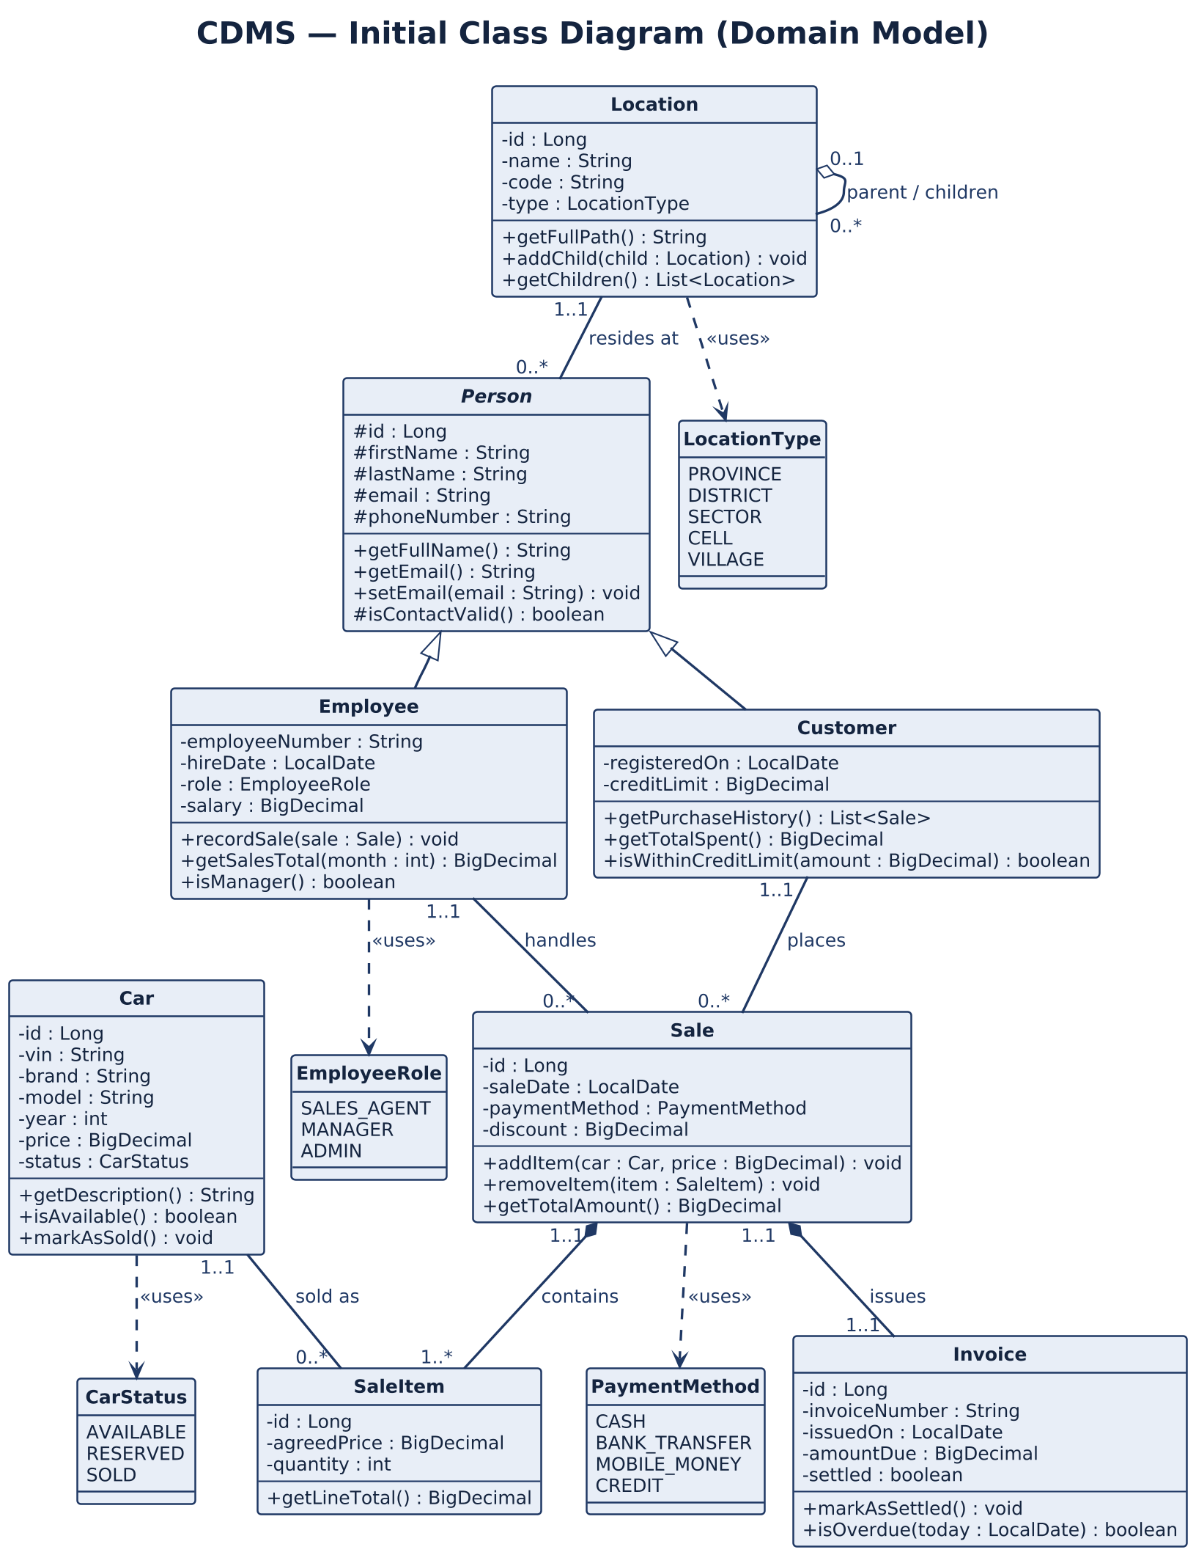
Figure 1 — Domain class diagram (Assignment 3, still the source of truth).

4. REST API
Method | Path | Meaning | Success
GET | /api/cars | List cars | 200
GET | /api/cars/{id} | Get one car | 200 / 404
POST | /api/cars | Create car | 201
PUT | /api/cars/{id} | Update car | 200
DELETE | /api/cars/{id} | Delete car | 204
GET | /api/customers | List customers | 200
GET | /api/customers/{id} | Get one customer | 200 / 404
POST | /api/customers | Create customer | 201
PUT | /api/customers/{id} | Update customer | 200
DELETE | /api/customers/{id} | Delete customer | 204
GET | /api/employees | List employees | 200
GET | /api/employees/{id} | Get one employee | 200 / 404
POST | /api/employees | Create employee | 201
PUT | /api/employees/{id} | Update employee | 200
DELETE | /api/employees/{id} | Delete employee | 204

5. Business-logic validation
Two layers: Bean Validation on the request DTO (@Valid → HTTP 400 with field errors) and service-layer BusinessRuleException → HTTP 422.
- Car — VIN must be unique and 17 characters (no I/O/Q).
- Car — year cannot be later than next calendar year.
- Car — a SOLD car cannot be deleted.
- Car — a SOLD car cannot be moved back to AVAILABLE or RESERVED.
- Customer — email unique; cannot reuse an employee email.
- Customer — credit limit cannot be negative.
- Employee — email and EMP-0001 number unique.
- Employee — hire date cannot be in the future.
- Employee — MANAGER and ADMIN salary at least RWF 500,000.
- Employee — the last ADMIN cannot be deleted or demoted.

6. Postman
Import postman/CDMS-Assignment4.postman_collection.json. The collection includes the happy-path CRUD calls and the business-rule failures (duplicate VIN, invalid email, delete last ADMIN, manager salary too low). Base URL: http://localhost:8080

7. How to run
JDK 17+, Maven 3.8+. H2 is the default so a demo does not need PostgreSQL.
cd cdms-api
mvn spring-boot:run
UI: http://localhost:8080/ API: http://localhost:8080/api/cars. For PostgreSQL: SPRING_PROFILES_ACTIVE=postgres DB_USER=postgres DB_PASSWORD=… mvn spring-boot:run

8. Links
- GitHub: https://github.com/mukunzijonathan/car-dealership
- Video (5–10 min, Google Vids, screen + camera): <<INSERT GOOGLE VIDS VIDEO LINK HERE>>
- Figma: <<INSERT FIGMA LINK HERE>>
The video should walk through the UI, then Postman CRUD on Car, Customer and Employee, and at least one business-rule rejection per entity.

