1. Use filter, to choose objects from array of objects whose city:”Bangalore”.
2. Create a directive and use it in your view.
3. Create a service and use one service in another service
4. Create a service and use it in controller.
5. Create a service using all the different options to create service
6. Create a custom filter to toggle the case of given input
7. Create multiple modules and make one module dependent on another module
8. Create Navigation menu as shown below. Show the chosen option as shown below.

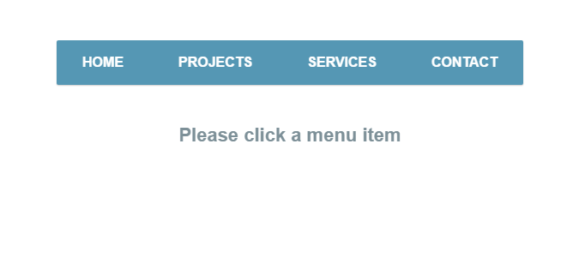

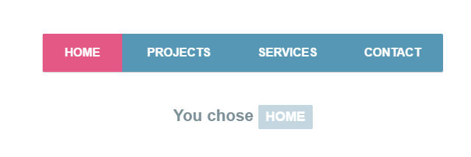

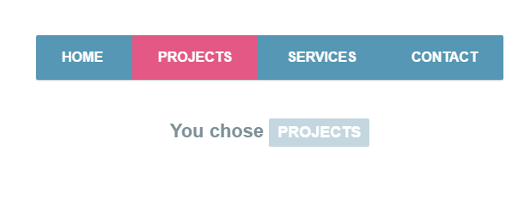

1. Create a ToDo List. Give option to add items to the ToDo List and show the list of items.
2. Create form to collect the feedback and display the feedback
3. Using Routing and ng-view, create a simple SPA
4. Create a button and display the number of times, the button is clicked