A OOP Course Project Report on
“Online Quiz Management System”
SUBMITTED IN PARTIAL FULFILLMENT OF THE REQUIREMENTS FOR THE DEGREE OF
BACHELOR OF TECHNOLOGY IN
Computer Science Engineering - Artificial
Intelligence

OF
VISHWAKARMA INSTITUTE OF TECHNOLOGY

Savitribai Phule Pune University

Yashraj Nagargoje ( 12414910 )
Raghav Mulay (12413749)
Mustafa Nazir (124112525)
Parth Naik (12412077)
UNDER THE GUIDANCE OF
Prof. Roshni V.Pawar


DEPARTMENT OF ARTIFICIAL INTELLIGENCE
BANSILAL RAMNATH AGARWAL CHARITABLE TRUST’S
VISHWAKARMA INSTITUTE OF TECHNOLOGY
(An Autonomous Institute affiliated to Savitribai Phule Pune University)
2025 - 2026

BANSILAL RAMNATH AGARWAL CHARITABLE TRUST’S

VISHWAKARMA INSTITUTE OF TECHNOLOGY
(An Autonomous Institute affiliated to Savitribai Phule Pune University)

PUNE – 411037


CERTIFICATE

This is to certify that the Course Project titled “Online Quiz Management System” submitted by Yashraj Nagargoje (12414910) Raghav Muley (12412144) Mustafa Nazir (124112525) Parth Naik (12412077) is in partial fulfillment for the award of Degree of Bachelor of Technology in Department Of Artificial Intelligence of Vishwakarma Institute of Technology, Savitribai Phule Pune University. This project report is a record of bonafide work carried out by him under my guidance during the academic year 2024-25.

Guide HOD, CSE(AI)
Prof. Roshni V.Pawar Prof. Nilesh Sable

Place: VIT, Pune
Date: 13-10-2025

Bansilal Ramnath Agarwal Charitable Trust’s

Vishwakarma Institute of Technology, Pune-37
Department of Artificial Intelligence

PROJECT SYNOPSIS

Group No :
Members: 4
Roll No. | G.R.No. | Name of Student | Contact No. | Email ID
26 | 12412601 | Raghav Mulay | 8551021662 | raghav.mulay24@vit.edu
29 | 12412144 | Mustafa Nazir | 8767821081 | abbasali.mustafa24@vit.edu
31 | 12414910 | Yashraj Nagargoje | 8180906898 | yashraj.nagargoje24@vit.edu
32 | 12412077 | Parth Naik | 9028603262 | parth.naik24@vit.edu

Academic Year : 2025-2026
Project Title : Online Quiz Management System
Project Area : C++ Programming, User Authentication, Management, Console Application
Internal Guide : Prof. Roshni V.Pawar

Signature of Internal Guide

ACKNOWLEDGEMENT

We extend our sincere gratitude to Prof. Roshai V.Pawar for his invaluable guidance and constant encouragement throughout the development of our project. His support has been instrumental in the successful completion of this work.

We also express our appreciation to Vishwakarma Institute of Technology, Pune, for providing us with the necessary facilities and an excellent learning environment.

A special thanks to our team members for their dedication and cooperation, as well as to our families and friends for their unwavering support
INTRODUCTION

The Online Quiz Management System is a console-based application developed in C++ that demonstrates the core principles of Object-Oriented Programming (OOP) such as classes, inheritance, polymorphism, and file handling.

The project is designed to automate and simplify the process of conducting quizzes in an educational setting by providing separate interfaces for students and administrators.

In this system, the admin can log in securely and perform various management operations such as adding and viewing quiz questions, as well as viewing the results of students. The student module allows users to register, log in, attempt quizzes, and view their previous results.

Each student’s quiz performance is recorded with timestamps and stored in external files, ensuring persistence of data even after the program terminates.

The project provides a simple and interactive command-line interface for both admin and student roles while focusing on efficient file-based storage instead of databases. This project effectively demonstrates practical implementation of OOP principles and real-world use of file handling, encapsulation, and data abstraction.

Codes of main modules used in project

This project is implemented in C++ using an object-oriented approach. The code is modularized into several header and source files, each representing a key component of the Online Quiz Management System. Below is a description of each module along with its role in the system:

- Main.cpp — Main Driver Program

Description:
This is the starting point of the program. It initializes the system by creating Admin and Student objects and provides a menu for the user to log in either as an Admin or a Student.
It handles user navigation between different roles and manages the overall control flow of the application.

Code:

#include <iostream>
#include "Admin.h"
#include "Student.h"
using namespace std;

int main() {
Admin admin("admin", "1234");
int choice;

while (true) {
cout << "\n==== Online Quiz Management System ====\n";
cout << "1. Admin Login\n";
cout << "2. Student Login\n";
cout << "3. Student Registration\n";
cout << "4. Exit\n";
cout << "Enter your choice: ";
cin >> choice;

switch (choice) {
case 1:
admin.login();
break;
case 2: {
Student student;
student.login();
break;
}
case 3: {
Student student;
student.registerStudent();
break;
}
case 4:
cout << "\nThank you for using the Quiz System!\n";
return 0;
default:
cout << "Invalid choice! Please try again.\n";
}
}

return 0;
}

Key Functions:
- Displays the main system menu (Admin / Student / Exit).
- Calls appropriate login methods from Admin and Student classes.
- Maintains the program flow and ensures clean termination.

- User.h — Base Class for Users

Description:

User.h defines a base class named User, representing common attributes and behaviors of both Admins and Students.
This class uses inheritance and polymorphism to ensure code reusability.

Code:

#ifndef USER_H
#define USER_H

#include <iostream>
#include <string>
using namespace std;

class User {
protected:
string username;
string password;
public:
User(string uname = "", string pass = "") : username(uname), password(pass) {}
virtual void login() = 0; // Pure virtual
};

#endif

Key Functions:

- Stores shared data members like username and password.
- Defines a pure virtual function login(), enforcing that derived classes implement their own login mechanism.
- Serves as the foundation for all user-related operations.

- Admin.h — Administrator Module

Description:

The Admin class inherits from User and manages administrative operations such as question creation, viewing all questions, and checking student quiz results.
It handles file input/output (I/O) operations to store and retrieve quiz data.

Code:

#ifndef ADMIN_H
#define ADMIN_H

#include "User.h"
#include "Quiz.h"
#include <iostream>
using namespace std;

class Admin : public User {
public:
Admin(string uname = "admin", string pass = "1234") : User(uname, pass) {}

void login() override {
string u, p;
cout << "\n[Admin Login]\n";
cout << "Enter Username: ";
cin >> u;
cout << "Enter Password: ";
cin >> p;

if (u == username && p == password) {
cout << "\nLogin Successful!\n";
menu();
} else {
cout << "\nInvalid Credentials!\n";
}
}

void menu() {
int choice;
Quiz quiz;
quiz.loadQuestions();

do {
cout << "\n--- Admin Menu ---\n";
cout << "1. Add Question\n";
cout << "2. Edit Question\n";
cout << "3. Delete Question\n";
cout << "4. View Questions\n";
cout << "5. Shuffle Questions\n";
cout << "6. View Student Results\n";
cout << "7. Logout\n";
cout << "Enter choice: ";
cin >> choice;
cin.ignore();

switch (choice) {
case 1:
quiz.addQuestion();
break;
case 2:
quiz.editQuestion();
break;
case 3:
quiz.deleteQuestion();
break;
case 4:
quiz.displayAll();
break;
case 5:
quiz.shuffleQuestions();
cout << "\nQuestions shuffled successfully!\n";
break;
case 6:
viewResults();
break;
case 7:
cout << "Logging out...\n";
break;
default:
cout << "Invalid choice!\n";
}

} while (choice != 7);
}

void viewResults() {
ifstream file("results.txt");
if (!file) {
cout << "\nNo results found.\n";
return;
}

cout << "\n--- Student Quiz Results ---\n";
string line;
while (getline(file, line)) {
cout << line << endl;
}

file.close();
}
};

#endif

Key Functions:

- Admin Login: Validates credentials before granting access to admin features.
- Add Question: Allows admin to enter new questions with four options and correct answer, saving them to questions.txt.
- View Questions: Displays all stored questions for review.
- View Results: Reads and displays student scores and quiz attempts from results.txt.
- Ensures proper use of file handling (reading/writing text files).

- Student.h — Student Module

Description:

The Student class handles all student-side functionalities, such as logging in, attempting quizzes, and viewing results.
It interacts directly with the Quiz class to manage quiz sessions.

Code:

#ifndef STUDENT_H
#define STUDENT_H

#include "User.h"
#include "Quiz.h"
#include <iostream>
#include <fstream>
#include <ctime>
#include <iomanip>
using namespace std;

class Student : public User {
public:
Student(string uname = "", string pass = "") : User(uname, pass) {}

void registerStudent() {
cout << "\n[Student Registration]\n";
cout << "Enter new username: ";
cin >> username;
cout << "Enter password: ";
cin >> password;

ofstream file("students.txt", ios::app);
if (!file) {
cout << "Error opening student file.\n";
return;
}
file << username << " " << password << endl;
file.close();

cout << "\nRegistration successful! You can now log in.\n";
}

void login() override {
cout << "\n[Student Login]\n";
cout << "Enter username: ";
cin >> username;
cout << "Enter password: ";
cin >> password;

ifstream file("students.txt");
if (!file) {
cout << "No registered students found. Please register first.\n";
return;
}

string u, p;
bool found = false;
while (file >> u >> p) {
if (u == username && p == password) {
found = true;
break;
}
}
file.close();

if (found) {
cout << "\nLogin successful!\n";
studentMenu();
} else {
cout << "\nInvalid credentials. Try again or register first.\n";
}
}

void studentMenu() {
int choice;
Quiz quiz;
quiz.loadQuestions();

do {
cout << "\n--- Student Menu ---\n";
cout << "1. Attempt Quiz\n";
cout << "2. View Results\n";
cout << "3. Logout\n";
cout << "Enter choice: ";
cin >> choice;

if (choice == 1)
attemptQuiz(quiz);
else if (choice == 2)
viewResults();
else if (choice == 3)
cout << "Logging out...\n";
else
cout << "Invalid choice! Try again.\n";

} while (choice != 3);
}

void attemptQuiz(Quiz& quiz) {
int total = quiz.getQuestionCount();
if (total == 0) {
cout << "No questions available.\n";
return;
}

cout << "\nStarting Quiz...\n";
int score = 0;
char ans;
for (int i = 0; i < total; i++) {
Question q = quiz.getQuestion(i);
cout << "\nQ" << i + 1 << ": " << q.text << endl;
for (int j = 0; j < 4; j++)
cout << " " << char('A' + j) << ") " << q.options[j] << endl;

cout << "Enter your answer (A/B/C/D): ";
cin >> ans;
ans = toupper(ans);
if (ans == q.correctOption)
score++;
}

time_t now = time(0);
tm* ltm = localtime(&now);
ofstream result("results.txt", ios::app);
result << left << setw(15) << username
<< " scored " << setw(5) << score << "/" << total
<< " Date: " << 1900 + ltm->tm_year << "-" << 1 + ltm->tm_mon << "-" << ltm->tm_mday
<< " Time: " << setw(2) << setfill('0') << ltm->tm_hour << ":"
<< setw(2) << ltm->tm_min << ":" << setw(2) << ltm->tm_sec
<< setfill(' ') << endl;
result.close();

cout << "\nQuiz Completed! Your Score: " << score << "/" << total << endl;
}

void viewResults() {
ifstream file("results.txt");
if (!file) {
cout << "\nNo results available.\n";
return;
}

cout << "\n--- Student Quiz Results ---\n";
cout << left << setw(15) << "Student" << setw(15) << "Score" << setw(15) << "Date" << setw(10) << "Time" << endl;
cout << string(60, '-') << endl;

string line;
while (getline(file, line)) {
if (line.find(username) != string::npos)
cout << line << endl;
}

file.close();
}
};

#endif

Key Functions:

- Student Login: Authenticates existing student credentials.
- Attempt Quiz: Fetches quiz questions from file and presents them to the student.
- Scoring: Calculates total marks based on correct answers.
- Result Storage: Stores student name, score, date, and time into results.txt.
- Implements encapsulation by hiding internal data like score and quiz logic.

- Quiz.h — Quiz Management Module

Description:

The Quiz class manages the structure and behavior of the quiz. It holds a list of questions and provides functionalities for loading, displaying, and evaluating quizzes.
A nested Question structure/class represents individual quiz questions.

Code:

#ifndef QUIZ_H
#define QUIZ_H

#include <iostream>
#include <vector>
#include <string>
#include <fstream>
#include <algorithm>
#include <ctime>
#include <random>
using namespace std;

struct Question {
string text;
string options[4];
char correctOption;
};

class Quiz {
private:
vector<Question> questions;

public:
void loadQuestions() {
ifstream file("questions.txt");
if (!file) {
cout << "No questions file found!\n";
return;
}
questions.clear();
string line;
while (getline(file, line)) {
if (line.empty()) continue;
Question q;
q.text = line;
for (int i = 0; i < 4; i++)
getline(file, q.options[i]);
file >> q.correctOption;
q.correctOption = toupper(q.correctOption);
file.ignore();
getline(file, line); // read separator ---
questions.push_back(q);
}
file.close();
}

void saveQuestions() {
ofstream file("questions.txt");
if (!file) {
cout << "Error saving questions!\n";
return;
}
for (auto &q : questions) {
file << q.text << endl;
for (int i = 0; i < 4; i++)
file << q.options[i] << endl;
file << q.correctOption << endl;
file << "---" << endl;
}
file.close();
}

void displayAll() const {
if (questions.empty()) {
cout << "\nNo questions available.\n";
return;
}
for (size_t i = 0; i < questions.size(); i++) {
cout << "\nQ" << i + 1 << ": " << questions[i].text << endl;
for (int j = 0; j < 4; j++)
cout << char('A' + j) << ". " << questions[i].options[j] << endl;
cout << "Correct Answer: " << questions[i].correctOption << endl;
}
}

void addQuestion() {
Question q;
cin.ignore();
cout << "\nEnter Question: ";
getline(cin, q.text);
for (int i = 0; i < 4; i++) {
cout << "Enter Option " << char('A' + i) << ": ";
getline(cin, q.options[i]);
}
cout << "Enter Correct Option (A-D): ";
cin >> q.correctOption;
q.correctOption = toupper(q.correctOption);
questions.push_back(q);
saveQuestions();
cout << "\nQuestion added successfully!\n";
}

void editQuestion() {
if (questions.empty()) {
cout << "No questions to edit.\n";
return;
}
displayAll();
cout << "\nEnter question number to edit: ";
int qno;
cin >> qno;
if (qno < 1 || qno > (int)questions.size()) {
cout << "Invalid question number!\n";
return;
}
Question &q = questions[qno - 1];
cin.ignore();
cout << "Editing Question " << qno << ":\n";
cout << "Current: " << q.text << "\nEnter new (or press Enter to keep same): ";
string newText;
getline(cin, newText);
if (!newText.empty()) q.text = newText;
for (int i = 0; i < 4; i++) {
cout << "Option " << char('A' + i) << " [" << q.options[i] << "]: ";
string newOpt;
getline(cin, newOpt);
if (!newOpt.empty()) q.options[i] = newOpt;
}
cout << "Correct Option [" << q.correctOption << "]: ";
string temp;
getline(cin, temp);
if (!temp.empty()) {
char newCorrect = toupper(temp[0]);
if (newCorrect >= 'A' && newCorrect <= 'D')
q.correctOption = newCorrect;
}
saveQuestions();
cout << "Question updated successfully!\n";
}

void deleteQuestion() {
if (questions.empty()) {
cout << "No questions to delete.\n";
return;
}
displayAll();
cout << "\nEnter question number to delete: ";
int qno;
cin >> qno;
if (qno < 1 || qno > (int)questions.size()) {
cout << "Invalid question number!\n";
return;
}
questions.erase(questions.begin() + (qno - 1));
saveQuestions();
cout << "Question deleted successfully!\n";
}

void shuffleQuestions() {
random_device rd;
mt19937 g(rd());
shuffle(questions.begin(), questions.end(), g);
}

void takeQuiz() {
if (questions.empty()) {
cout << "No questions available!\n";
return;
}
shuffleQuestions();
int score = 0;
char ans;
for (size_t i = 0; i < questions.size(); i++) {
cout << "\nQ" << i + 1 << ": " << questions[i].text << endl;
for (int j = 0; j < 4; j++)
cout << char('A' + j) << ". " << questions[i].options[j] << endl;
cout << "Enter your answer (A-D): ";
cin >> ans;
ans = toupper(ans);
if (ans == questions[i].correctOption)
score++;
}
cout << "\nFinal Score: " << score << "/" << questions.size() << "\n";
}

int getQuestionCount() const { return questions.size(); }
Question getQuestion(int index) const {
if (index >= 0 && index < (int)questions.size())
return questions[index];
return Question();
}
};

#endif

Key Functions:

- Load Questions: Reads questions from questions.txt and stores them in a vector.
- Shuffle Questions: Randomly shuffles question order using std::shuffle.
- Display and Conduct Quiz: Displays one question at a time and collects student responses.
- Score Calculation: Compares answers and returns total score to Student class.
- Uses file handling and STL (Standard Template Library) features like vectors.

- Overall Project Features

- Implements OOP concepts: Inheritance, Polymorphism, Encapsulation, and Abstraction.
- Uses file handling for persistent storage of questions and results.
- Provides modular structure, ensuring code clarity and maintainability.
- Supports both Admin and Student roles with distinct functionalities.
- Designed using menu-driven navigation for easy user interaction.

Screenshots of Results

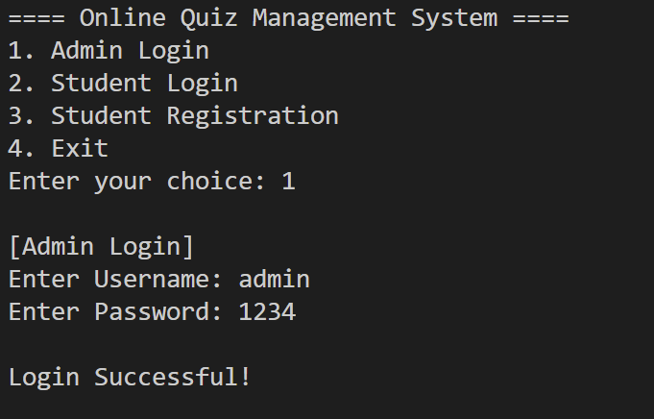

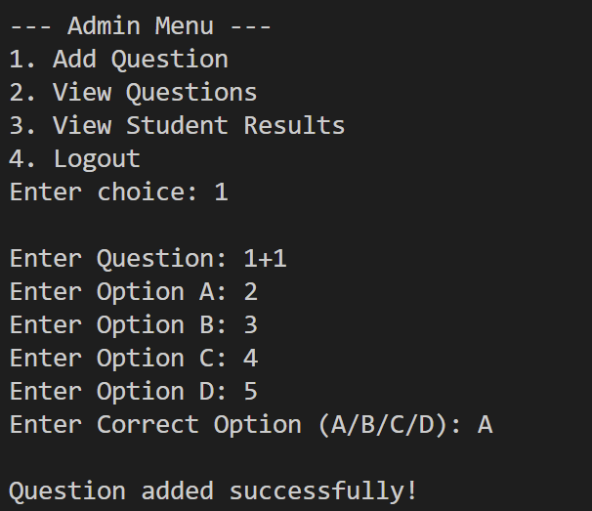

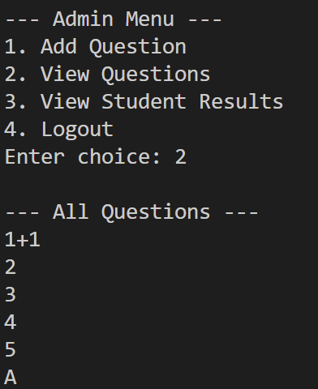

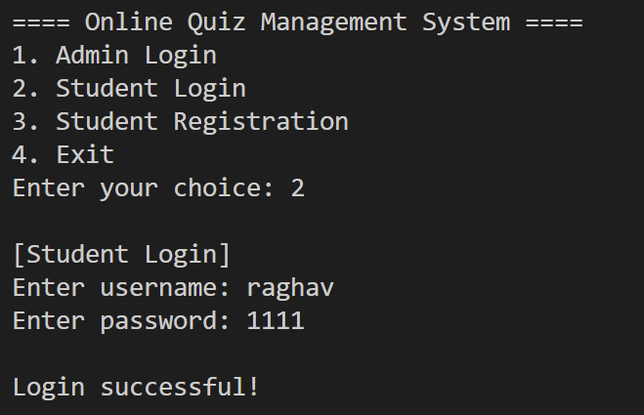

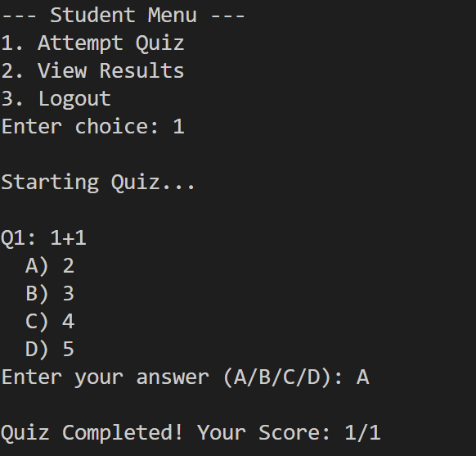

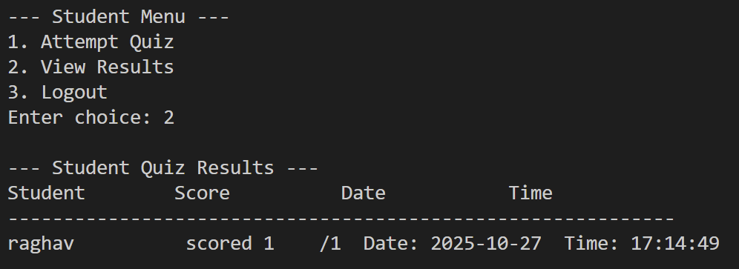

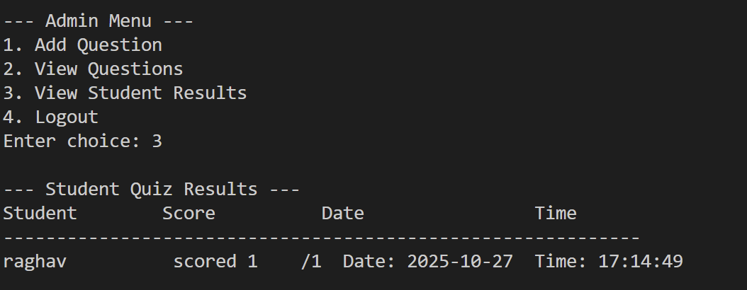

CONCLUSION

The Online Quiz Management System serves as an effective demonstration of Object-Oriented Programming (OOP) principles implemented in C++. Throughout the development of this project, several key OOP concepts such as encapsulation, inheritance, polymorphism, abstraction, and file handling were applied to create a modular and scalable system. The project provides two major user roles — Admin and Student — each with distinct functionalities. The Admin can add and view quiz questions, as well as review student performance, while the Student can log in, attempt quizzes, and receive instant feedback on results.

The use of file handling ensures persistent data storage, allowing quiz questions and student results to be maintained even after the program terminates, eliminating the need for a dedicated database. The project architecture promotes code reusability and maintainability by separating functionality into independent classes such as User, Admin, Student, and Quiz.

Developing this system enhanced understanding of real-world problem-solving using programming concepts, especially the importance of structured design and clear class hierarchies. It also demonstrated how C++ can be used beyond theoretical applications to build practical, user-interactive systems. Overall, the Online Quiz Management System is a successful representation of how OOP can be used to design efficient, secure, and user-friendly software systems for educational and assessment purposes.

REFERANCES

- GeeksforGeeks. Object-Oriented Programming in C++. Available at: https://www.geeksforgeeks.org/object-oriented-programming-in-cpp/

- W3Schools. C++ File Handling Tutorial. Available at: https://www.w3schools.com/cpp/cpp_files.asp

- TutorialsPoint. C++ Classes and Objects. Available at: https://www.tutorialspoint.com/cplusplus/cpp_classes_objects.htm

- Programiz. C++ Inheritance and Polymorphism. Available at: https://www.programiz.com/cpp-programming/inheritance

- Microsoft Learn. C++ Input and Output (I/O) Streams. Available at: https://learn.microsoft.com/en-us/cpp/standard-library/input-output

