RESEARCH REPORT
Student Performance Prediction
Using Machine Learning
A Machine Learning Regression Study Using the UCI Student Performance Dataset
Prepared by
Mule Mohan Reddy
B.Tech – Computer Science and Engineering
IIIT Sri City
Academic Research / Machine Learning Project

Executive Summary
This report presents a machine learning-based approach for predicting students’ final mathematics grades using the UCI Student Performance dataset. The project follows a complete workflow covering data loading, inspection, exploratory data analysis, preprocessing, model training, evaluation, comparison, feature-importance analysis, and model saving.
Two regression models were evaluated: Linear Regression and Random Forest Regression. On the 80:20 train-test split used in the project, Linear Regression obtained an MAE of 1.647, RMSE of 2.378, and R² of 0.724. Random Forest obtained an MAE of 1.165, RMSE of 1.949, and R² of 0.815. Within this particular experiment, Random Forest produced lower prediction errors and a higher R² value.
An important methodological limitation is that G1 and G2, which represent earlier academic grades, were included as input features for predicting G3, the final grade. Therefore, the present study should be interpreted as final-grade prediction using previous academic performance and student characteristics, rather than as an early-warning prediction system.

Table of Contents
- 1. Introduction
- 2. Problem Statement
- 3. Objectives
- 4. Dataset Description
- 5. Data Understanding and Inspection
- 6. Exploratory Data Analysis
- 7. Data Preprocessing
- 8. Categorical Variable Encoding
- 9. Train-Test Split
- 10. Machine Learning Models
- 11. Evaluation Metrics
- 12. Results
- 13. Model Comparison
- 14. Actual vs Predicted Analysis
- 15. Feature Importance
- 16. Model Saving and Reusability
- 17. Discussion
- 18. Limitations
- 19. Future Scope
- 20. Conclusion
- 21. References
- Appendix A. Project Structure

1. Introduction
Academic performance is an important indicator of a student’s progress and educational development. Student achievement can be associated with multiple academic, demographic, social, and behavioral factors. Machine learning provides a way to analyze these factors together and build predictive models that estimate a student’s final academic outcome.
This project applies machine learning techniques to the UCI Student Performance dataset. The objective is to predict the final mathematics grade (G3) using student-related and academic information. Two regression approaches, Linear Regression and Random Forest Regression, are implemented and evaluated using MAE, RMSE, and R².

2. Problem Statement
The project investigates whether machine learning models can use student characteristics and previous academic information to predict a student’s final mathematics grade.
Research question:
Can machine learning models use student characteristics and previous academic performance to predict the final mathematics grade (G3)?

3. Objectives
The main objectives of this project are:
- Understand the structure and characteristics of the student-performance dataset.
- Perform exploratory data analysis to examine the target and selected relationships.
- Prepare categorical and numerical data for machine learning.
- Develop a Linear Regression baseline model.
- Develop a Random Forest Regression model.
- Evaluate both models using MAE, RMSE, and R².
- Compare the models using the same test set.
- Analyze Random Forest feature importance.
- Save the trained model and prediction outputs for reuse.

4. Dataset Description
The project uses the Student Performance dataset from the UCI Machine Learning Repository. The repository describes it as a multivariate dataset concerning student achievement in secondary education. It contains separate data for Mathematics and Portuguese language courses. This project uses the Mathematics file, student-mat.csv.
Dataset Property | Value
Dataset | UCI Student Performance
File used | student-mat.csv
Records | 395 students
Columns | 33
Target | G3 – Final Grade
Grade scale | 0–20
Task | Regression
The dataset includes demographic, social, school-related, and academic attributes. Important grade variables are G1 (first-period grade), G2 (second-period grade), and G3 (final grade).

5. Data Understanding and Inspection
The CSV file uses a semicolon delimiter, so it was loaded with sep=';'. The dataset was then inspected using shape, column names, missing-value counts, data types, and descriptive statistics. The loaded dataset had 395 rows and 33 columns. The missing-value inspection did not identify missing values requiring imputation.
The core loading operation was:
df = pd.read_csv("dataset/student-mat.csv", sep=";")

6. Exploratory Data Analysis

6.1 Final Grade Distribution
A histogram was created to inspect the distribution of final grades (G3). The resulting figure is stored as final_grade_distribution.png in the visualizations folder.
Figure 1. Distribution of Final Grades (G3)
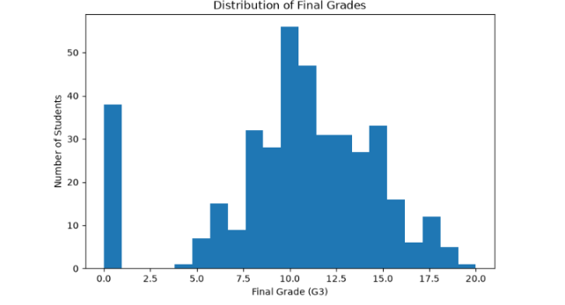

6.2 Absences and Final Grade
A scatter plot of absences against G3 was created to examine the pattern between attendance and final grade. This visualization is descriptive and does not establish causation.
Figure 2. Absences vs Final Grade
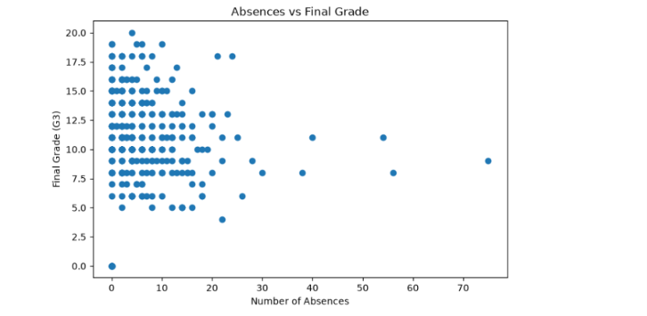

6.3 Study Time and Final Grade
A boxplot was used to compare final-grade distributions across study-time categories.
Figure 3. Study Time vs Final Grade
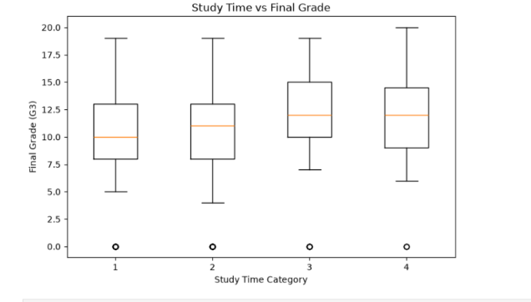

6.4 G2 and Final Grade
A scatter plot was generated to examine the relationship between the second-period grade (G2) and the final grade (G3).
Figure 4. G2 vs Final Grade
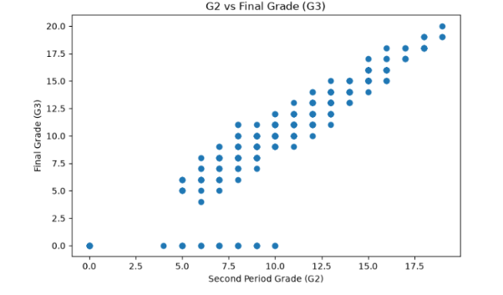

6.5 Correlation Analysis
A correlation matrix was calculated for numerical variables and visualized as a heatmap. The correlation values with G3 were also sorted to identify numerical variables with stronger linear associations with the target. Correlation is treated as an exploratory measure and not as evidence of causation.
Figure 5. Correlation Heatmap
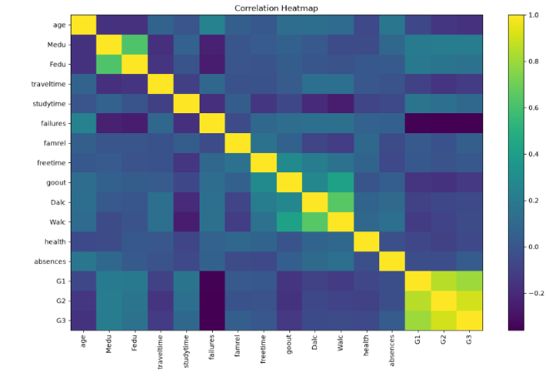

7. Data Preprocessing
The target variable G3 was separated from the input features. The initial feature matrix contained 395 rows and 32 columns, while the target contained 395 values.
Categorical and numerical columns were identified using Pandas data-type selection. Categorical variables were then transformed using one-hot encoding with drop_first=True.

8. Categorical Variable Encoding
Before encoding, the feature matrix had shape (395, 32). After one-hot encoding, it had shape (395, 41). This transformation converted categorical information into numerical features suitable for the regression models.

9. Train-Test Split
The encoded dataset was divided into an 80% training set and a 20% testing set using train_test_split with random_state=42.
Subset | Shape
Training features | (316, 41)
Testing features | (79, 41)
Training target | (316,)
Testing target | (79,)

10. Machine Learning Models

10.1 Linear Regression
Linear Regression was used as a baseline model. It provides a simple reference against which the more flexible Random Forest model can be evaluated.

10.2 Random Forest Regression
Random Forest Regression was implemented with 100 trees and random_state=42. The model was selected for comparison because it can represent nonlinear relationships and feature interactions that a simple linear model may not capture.

11. Evaluation Metrics

11.1 Mean Absolute Error (MAE)
MAE measures the average absolute difference between actual and predicted values. Lower values indicate smaller average prediction errors.

11.2 Root Mean Squared Error (RMSE)
RMSE measures prediction error while giving greater weight to larger errors. Lower values indicate smaller errors under this metric.

11.3 R² Score
R² measures the proportion of variation in the target explained by the model on the evaluation data. Higher values indicate more explained variation.

12. Results
The actual results obtained from the experiment are:
Model | MAE | RMSE | R²
Linear Regression | 1.647 | 2.378 | 0.724
Random Forest | 1.165 | 1.949 | 0.815
Linear Regression achieved MAE=1.6467, RMSE=2.3784, and R²=0.7241. Random Forest achieved MAE=1.1646, RMSE=1.9488, and R²=0.8148.

13. Model Comparison
Within the particular train-test experiment, Random Forest produced lower MAE and RMSE and a higher R² than Linear Regression. Therefore, Random Forest was selected as the final model for this experiment. This comparison should not be interpreted as evidence that Random Forest will always outperform Linear Regression on every student-performance dataset.
Figure 6. R² Model Comparison
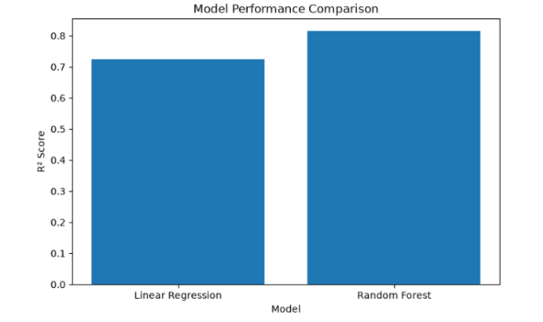

14. Actual vs Predicted Analysis
Actual-versus-predicted plots were generated for both models. The diagonal reference line represents perfect prediction. Points closer to the line indicate predictions closer to the observed final grades.
Figure 7. Linear Regression: Actual vs Predicted
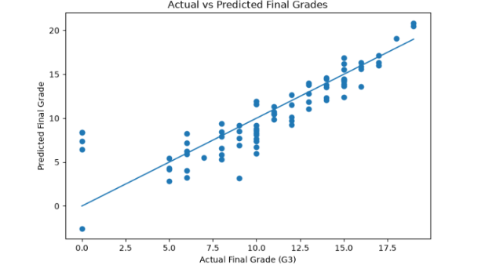

Figure 8. Random Forest: Actual vs Predicted
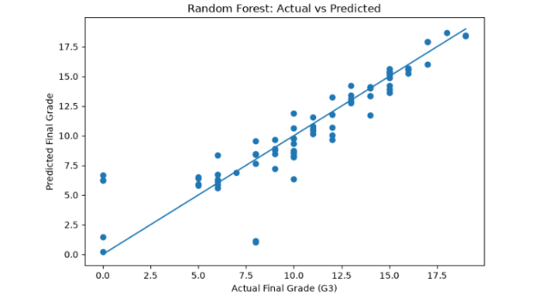

15. Feature Importance
Feature importance values were extracted from the Random Forest model and sorted to identify the most influential predictive features within the model. These values describe predictive importance, not causal importance.
Figure 9. Top 10 Random Forest Features
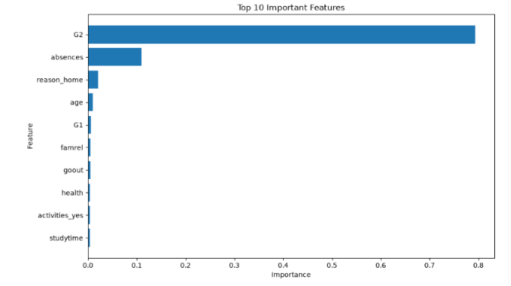

16. Model Saving and Reusability
The selected model was saved as student_performance_model.pkl using Joblib. The saved model was loaded again and successfully generated predictions: [8.32, 11.78, 6.50, 9.76, 8.80]. This confirms that the trained model can be serialized and restored for later prediction use.
Prediction outputs were also saved in prediction_results.csv and the model comparison was saved in model_comparison.csv.

17. Discussion
The experiment demonstrates that machine learning can model relationships between student characteristics, previous academic performance, and final mathematics grades. Random Forest performed better than the Linear Regression baseline under the current test-set evaluation.
A key interpretation issue is the inclusion of G1 and G2. These variables represent earlier academic grades and are directly related to the final grade G3. Consequently, the current model should be understood as predicting G3 when previous grades are available. It should not be presented as a prediction made before earlier academic assessments.

18. Limitations
- The Mathematics dataset contains 395 students, so the sample is relatively limited.
- The data concerns students from two Portuguese schools and may not directly represent other educational populations.
- G1 and G2 are included as input features, which makes the current task different from early-warning prediction.
- The reported performance is based on one 80:20 train-test split with random_state=42.
- Predictive relationships do not establish causal relationships.
- Performance on this dataset does not guarantee the same performance on new populations or institutions.

19. Future Scope
- Run a separate early-prediction experiment excluding G1 and G2.
- Use k-fold cross-validation for a more robust performance estimate.
- Perform hyperparameter tuning for Random Forest.
- Evaluate additional algorithms such as Gradient Boosting, Support Vector Regression, and Decision Tree Regression.
- Evaluate the approach using larger and more diverse student datasets.
- Develop a simple application interface for authorized users to generate predictions.

20. Conclusion
This project developed a complete machine learning workflow for predicting final mathematics grades using the UCI Student Performance dataset. The workflow included data loading, inspection, exploratory analysis, preprocessing, categorical encoding, train-test splitting, model training, evaluation, feature-importance analysis, and model saving.
Linear Regression achieved an MAE of 1.647, RMSE of 2.378, and R² of 0.724, while Random Forest achieved an MAE of 1.165, RMSE of 1.949, and R² of 0.815. Within this experiment, Random Forest therefore showed lower observed prediction errors and higher explained variation.
The findings support the use of machine learning for modeling final-grade outcomes, while also highlighting the importance of clearly defining the prediction setting. Since G1 and G2 were used as predictors, the present study represents final-grade prediction using previous academic performance and student characteristics. Future work can evaluate an early-prediction setting by excluding G1 and G2.

21. References
- Cortez, P. (2008). Student Performance Dataset. UCI Machine Learning Repository. DOI: 10.24432/C5TG7T.
- Cortez, P., & Silva, A. M. G. (2008). Using Data Mining to Predict Secondary School Student Performance. Proceedings of the 5th Annual Future Business Technology Conference.
- UCI Machine Learning Repository. Student Performance — Dataset Documentation and Variable Information.
- Pedregosa, F., et al. (2011). Scikit-learn: Machine Learning in Python. Journal of Machine Learning Research, 12, 2825–2830.
- McKinney, W. (2010). Data Structures for Statistical Computing in Python. Proceedings of the 9th Python in Science Conference.

Appendix A. Project Structure
Student_Performance_Prediction/
│
├── dataset/
│ └── student-mat.csv
│
├── visualizations/
│ ├── final_grade_distribution.png
│ ├── absences_vs_final_grade.png
│ ├── study_time_vs_final_grade.png
│ ├── g2_vs_final_grade.png
│ ├── correlation_heatmap.png
│ ├── actual_vs_predicted.png
│ ├── random_forest_actual_vs_predicted.png
│ ├── model_comparison_r2.png
│ └── top_10_feature_importance.png
│
├── report/
├── presentation/
├── prediction_results.csv
├── model_comparison.csv
├── student_performance_model.pkl
└── Student_Performance_Prediction.ipynb

Note: Figures in this report were inserted from the completed notebook outputs provided for the project. The numerical results correspond to the reported experiment.

