MINI PROJECT – 1
TITLE
Student Result Processing System
Problem Statement
Develop a Python application to manage student marks, calculate percentage, assign grades, and generate academic performance reports.
Algorithm
- Start
- Enter student name and roll number.
- Enter marks of five subjects.
- Calculate total marks.
- Calculate percentage using:
Percentage = Total Marks / 5
- Find highest and lowest marks.
- Assign grade based on percentage:
  - A+ : Percentage ≥ 90
  - A : Percentage ≥ 80
  - B : Percentage ≥ 70
  - C : Percentage ≥ 60
  - D : Percentage ≥ 50
  - F : Percentage < 50
- Display student report.
- Stop.
Python Source Code
print("STUDENT RESULT PROCESSING SYSTEM")

name = input("Enter Student Name: ")
roll_no = input("Enter Roll Number: ")

m1 = float(input("Enter Marks in Subject 1: "))
m2 = float(input("Enter Marks in Subject 2: "))
m3 = float(input("Enter Marks in Subject 3: "))
m4 = float(input("Enter Marks in Subject 4: "))
m5 = float(input("Enter Marks in Subject 5: "))

total = m1 + m2 + m3 + m4 + m5
percentage = total / 5

highest = max(m1, m2, m3, m4, m5)
lowest = min(m1, m2, m3, m4, m5)

if percentage >= 90:
grade = "A+"
elif percentage >= 80:
grade = "A"
elif percentage >= 70:
grade = "B"
elif percentage >= 60:
grade = "C"
elif percentage >= 50:
grade = "D"
else:
grade = "F"

print("\n----- STUDENT REPORT -----")
print("Student Name :", name)
print("Roll Number :", roll_no)
print("Total Marks :", total)
print("Percentage :", percentage)
print("Highest Marks:", highest)
print("Lowest Marks :", lowest)
print("Grade :", grade)
Sample Input
Enter Student Name: Keerthi
Enter Roll Number: 101
Enter Marks in Subject 1: 90
Enter Marks in Subject 2: 85
Enter Marks in Subject 3: 88
Enter Marks in Subject 4: 80
Enter Marks in Subject 5: 92
Sample Output
----- STUDENT REPORT -----
Student Name : Keerthi
Roll Number : 101
Total Marks : 435.0
Percentage : 87.0
Highest Marks: 92.0
Lowest Marks : 80.0
Grade : A
OUTPUT SCREENSHOT:
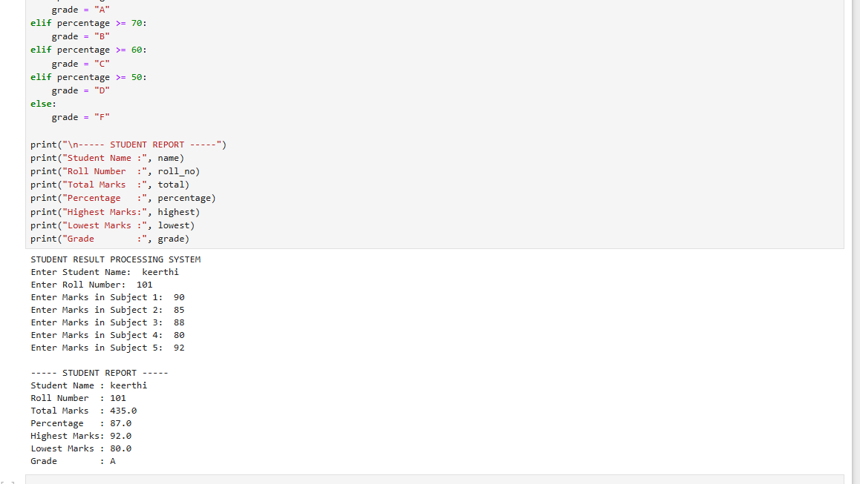
FLOW CHART:
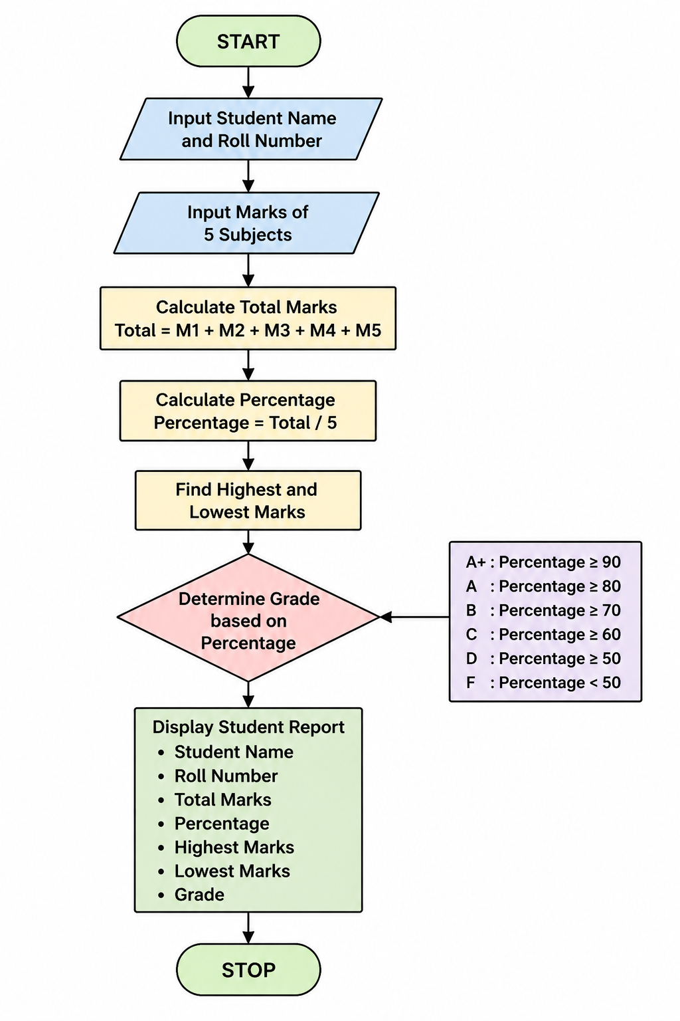
README
Project Name
Student Result Processing System
Description
The Student Result Processing System is a Python-based application that accepts student details and subject marks, calculates total marks and percentage, determines grades, and generates a performance report.
Features
- Student information management
- Marks calculation
- Percentage calculation
- Grade assignment
- Highest and lowest marks identification
- Academic report generation
Tools Used
- Jupyter Notebook / VS Code
Outcome
The project successfully processes student marks and generates an academic performance report.

MINI PROJECT – 2
TITLE
Personal Finance Manager
Problem Statement
Develop a Python application to track income, expenses, savings, and monthly financial performance.
Algorithm
- Start
- Enter monthly income.
- Enter house rent expense.
- Enter food expense.
- Enter transport expense.
- Enter other expenses.
- Calculate total expenses.
- Calculate savings.
- Calculate savings percentage.
- Display financial report.
- Stop.
Python Source Code
print("PERSONAL FINANCE MANAGER")

income = float(input("Enter Monthly Income: "))

rent = float(input("Enter House Rent Expense: "))
food = float(input("Enter Food Expense: "))
transport = float(input("Enter Transport Expense: "))
other = float(input("Enter Other Expenses: "))

total_expenses = rent + food + transport + other

savings = income - total_expenses

savings_percentage = (savings / income) * 100

print("\n----- FINANCIAL REPORT -----")
print("Monthly Income :", income)
print("Total Expenses :", total_expenses)
print("Total Savings :", savings)
print("Savings Percentage :", round(savings_percentage, 2), "%")
Sample Input
Enter Monthly Income: 50000
Enter House Rent Expense: 10000
Enter Food Expense: 8000
Enter Transport Expense: 3000
Enter Other Expenses: 4000
Sample Output
----- FINANCIAL REPORT -----
Monthly Income : 50000.0
Total Expenses : 25000.0
Total Savings : 25000.0
Savings Percentage : 50.0 %
OUTPUT SCREENSHOT:
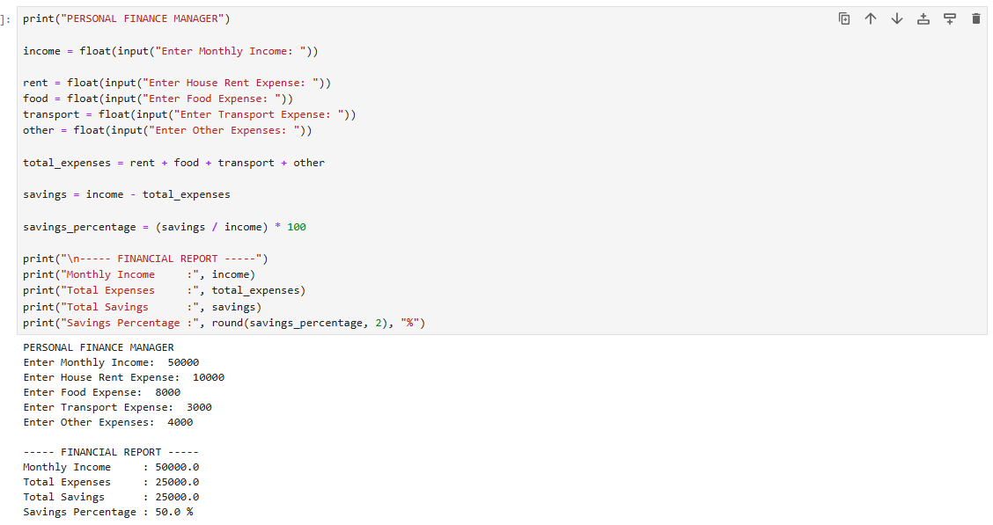
FLOW CHART:
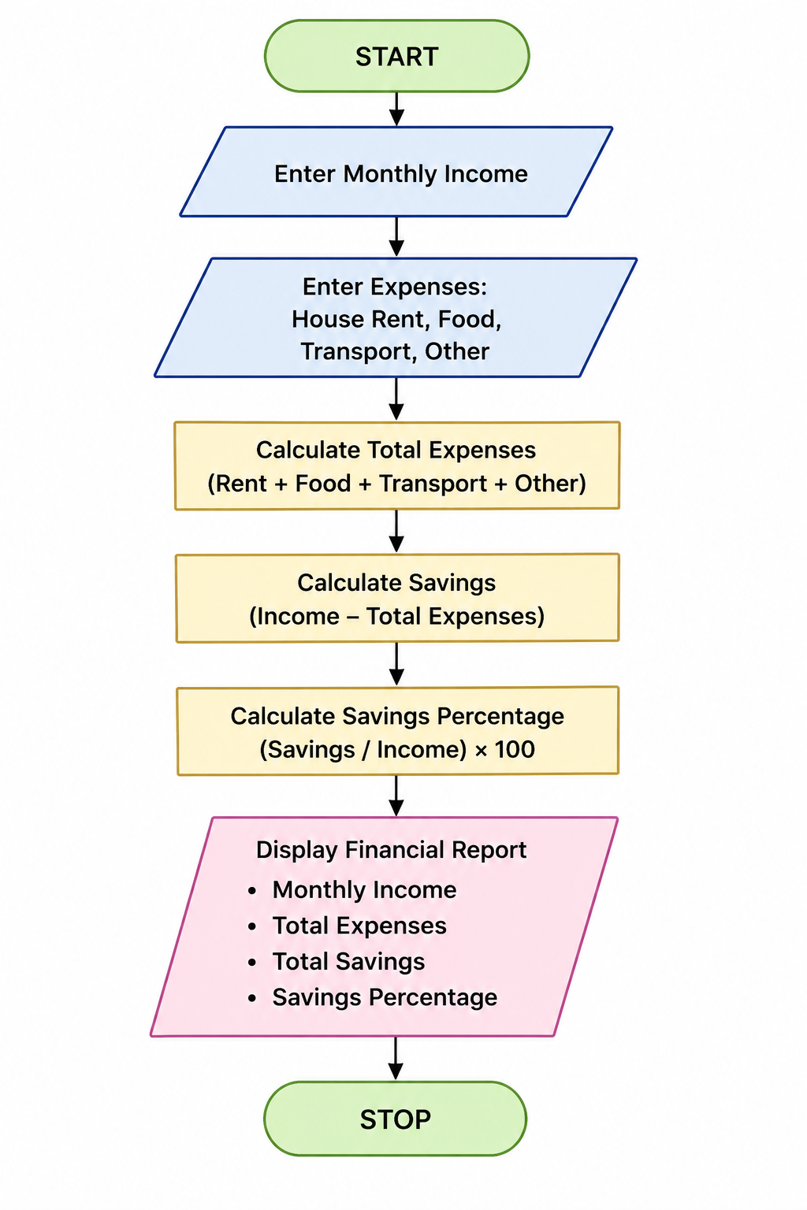
README
Project Name
Personal Finance Manager
Description
The Personal Finance Manager is a Python application used to track monthly income, expenses, and savings. It helps users understand their financial status and savings performance.
Features
- Income tracking
- Expense tracking
- Savings calculation
- Savings percentage calculation
- Monthly financial report generation
Tools Used
- Jupyter Notebook / VS Code
Outcome
The project successfully calculates monthly expenses, savings, and financial performance.

