**Docker important points to be considered…**

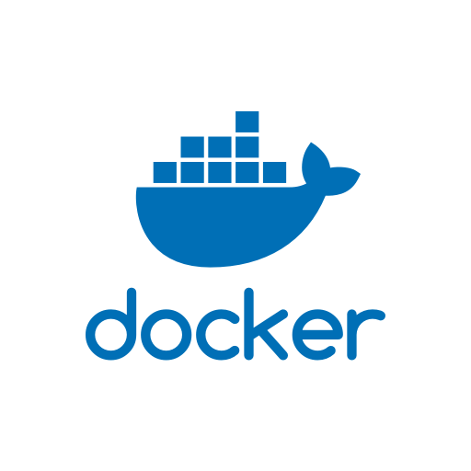

[This Photo](https://c43s4rs.blogspot.com/2018/05/) by Unknown Author is licensed under [CC BY-NC](https://creativecommons.org/licenses/by-nc/3.0/)

* Port mapping (-p) is defined only at container creation time, you **cannot** **change** port mapping of an existing container after it's created.
* Once the container is created, even if it's stopped, you **cannot update its port mapping**.
* Anything after the image name is passed as a command to that container.  
  (docker run -p6000:6379 -d redis --name redis_container) -Incorrect  
  (docker run -d -p 6000:6379 --name redis_container redis) -Correct