**CONNECT IBM MQ USING CLINET CHANNEL TABLE**

# Connect IBM MQ Using CCDT

**We have to follow the below steps**

1. To create CCDT we have to open the cmd with administrative privileges.

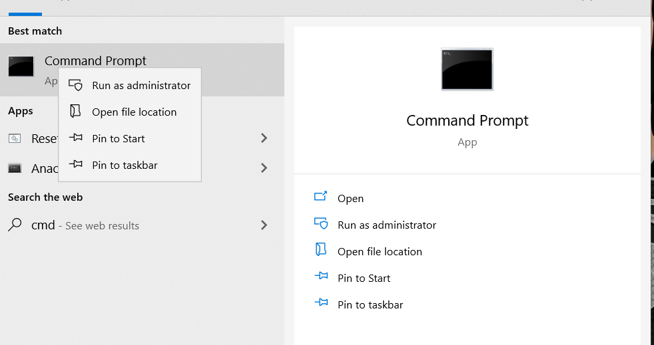

2. Change the path in cmd to ibm mq  installed path

***cd C:\Program Files\IBM\MQ***

***cd bin***

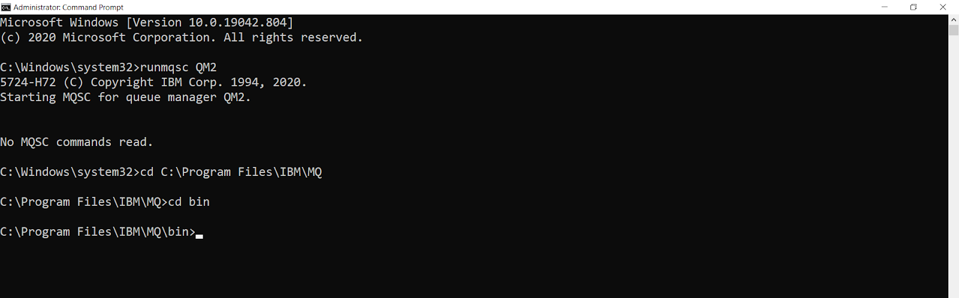

3. Running the queue manager using following command

***runmqsc <queuemanager_name>***

Example :

***runmqsc QM1***

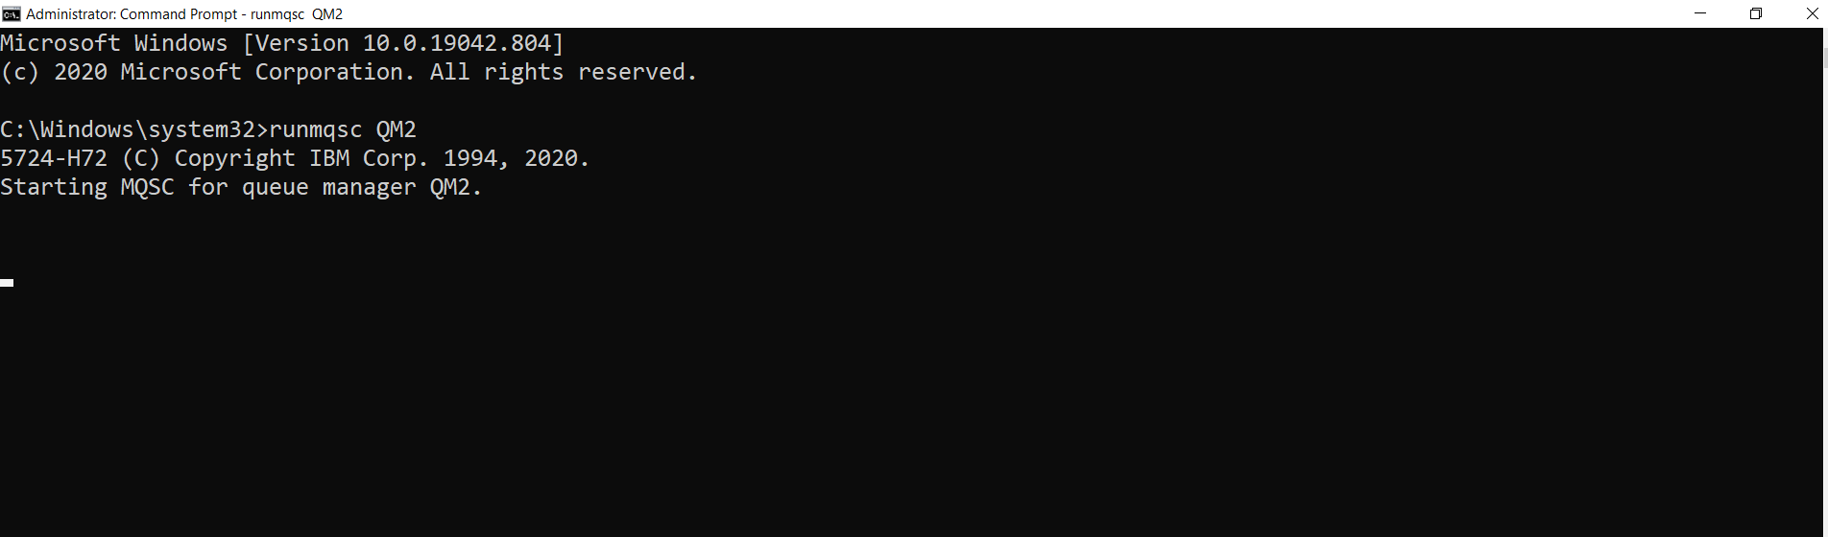

**4.**  Creation of CCDT using following command

***DEFINE CHANNEL(<channel_name>) CHLTYPE(<channel_type>) CONNAME(<websphere MQ_server_IP_addess>) QMNAME(<queue_manager_name>)***

**Example**

***DEFINE CHANNEL(Q1CHL) CHLTYPE(CLTCONN) CONNAME(’10.1.200.71(1414)’) QMNAME(QM2) REPLACE***

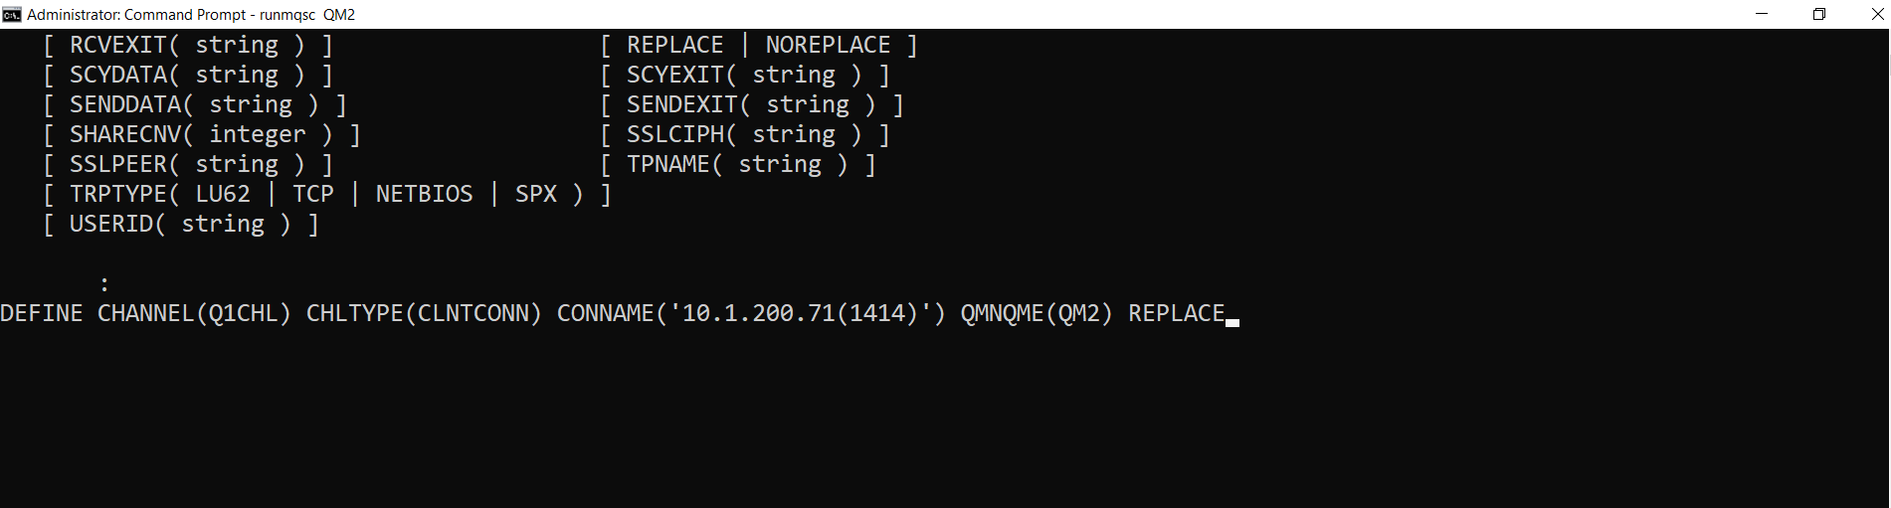

5. After Creating the channel we can see the following files in MQ folder

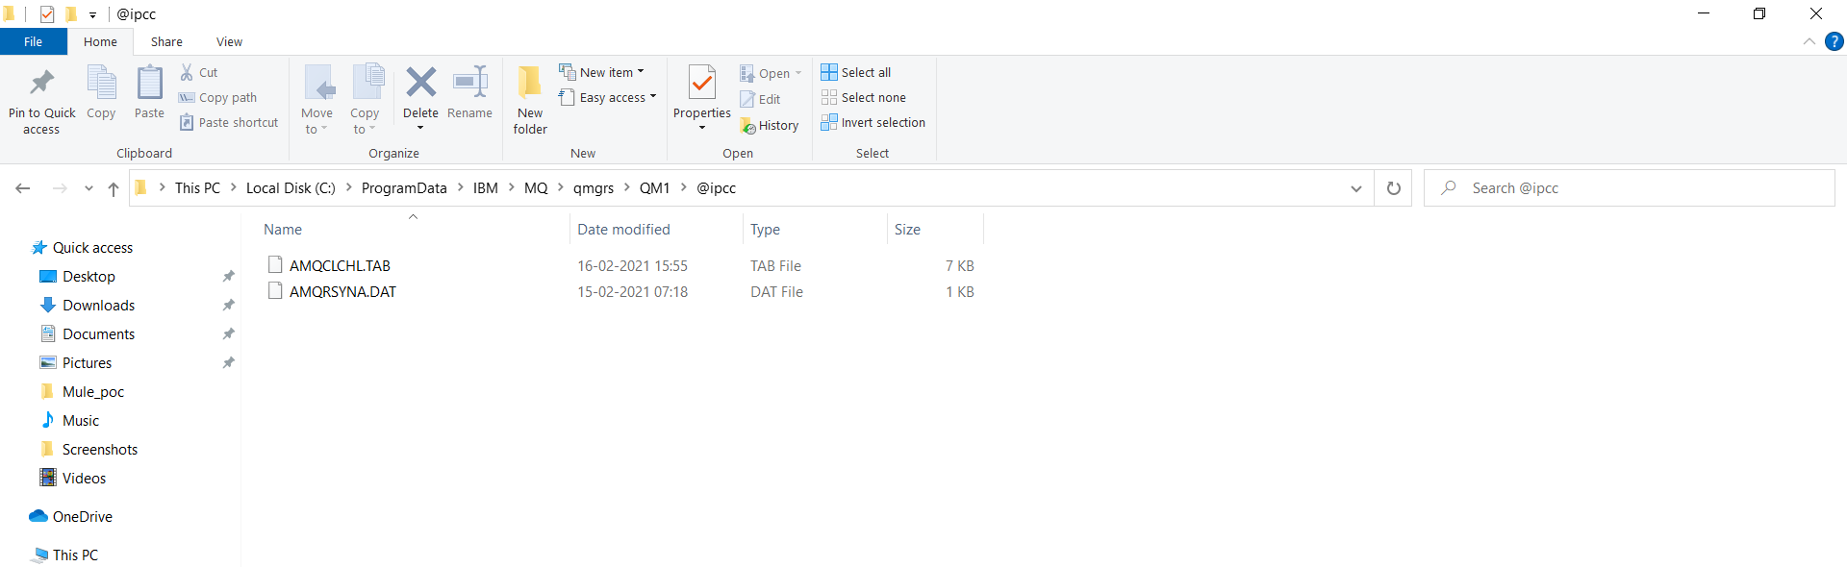

**6. We can see the channels in IBM explorer under channels folder.**

