**MQv9.0 Installation**

Ref:<https://www.ibm.com/support/knowledgecenter/en/SSFKSJ_9.0.0/com.ibm.mq.ins.doc/q008640_.htm>

Steps to install:

1.Create a folder under /opt/IBM as shown below.

**mkdir -p /opt/IBM/MQ9/**



2.Copy the mq installable files to the created location.



3.Once file is copied then change the user and group names for the files.

**[root@rhmwiibdv1 MQ9]# ls -tlr**

**total 549856**

**-rw-r--r--. 1 root root 563050791 Aug 10 10:00 IBM_MQ_9.0.0.0_LINUX_X86-64.tar.gz**

**[root@rhmwiibdv1 MQ9]# chown iibadmin:iibadmin IBM_MQ_9.0.0.0_LINUX_X86-64.tar.gz**

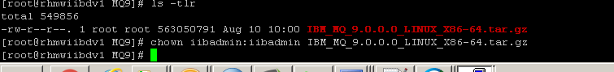

**4.**Unzip the tar file.

**tar -zxvf IBM_MQ_9.0.0.0_LINUX_X86-64.tar.gz**

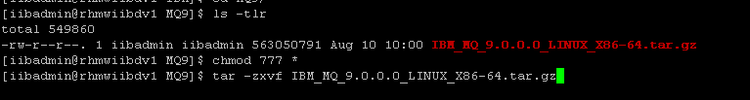

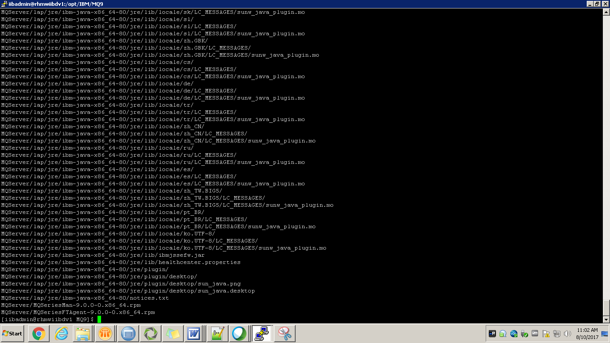

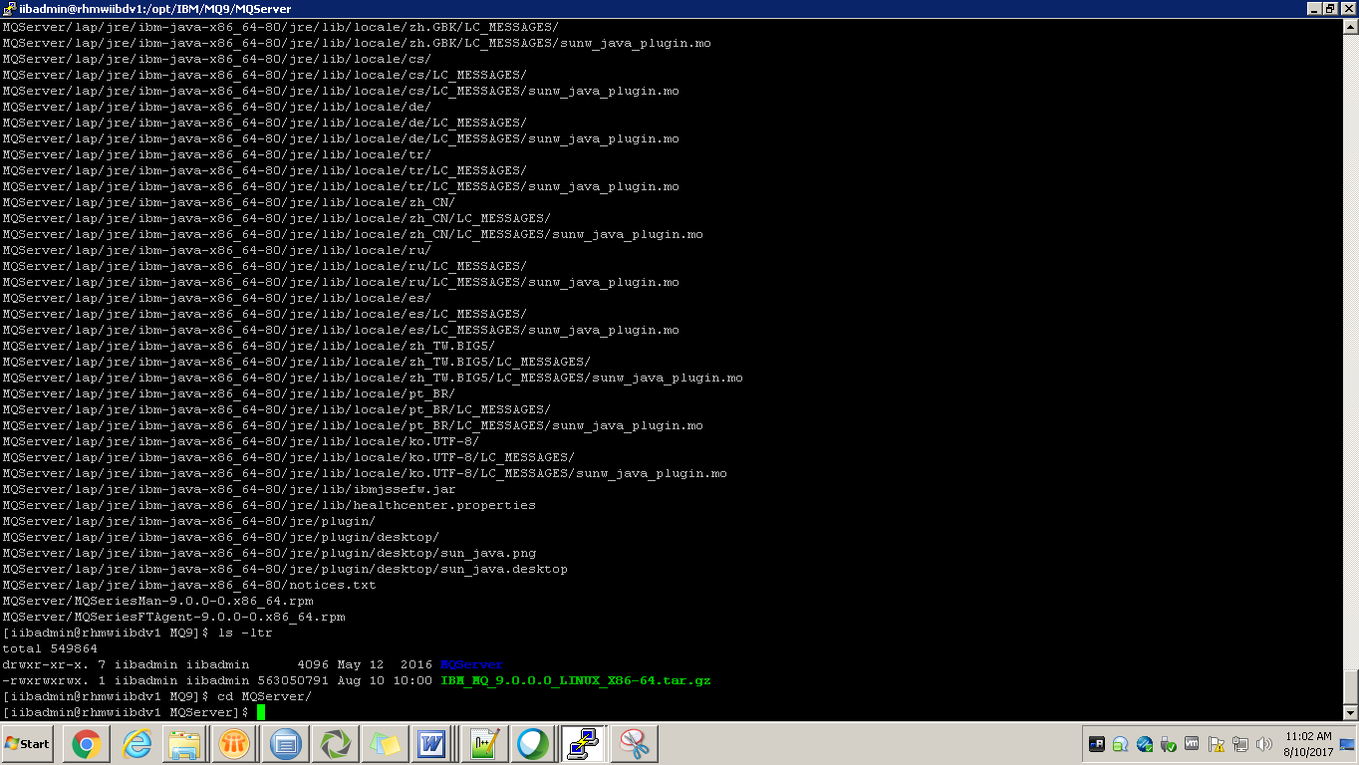

Under MQServer folder you will find these files.

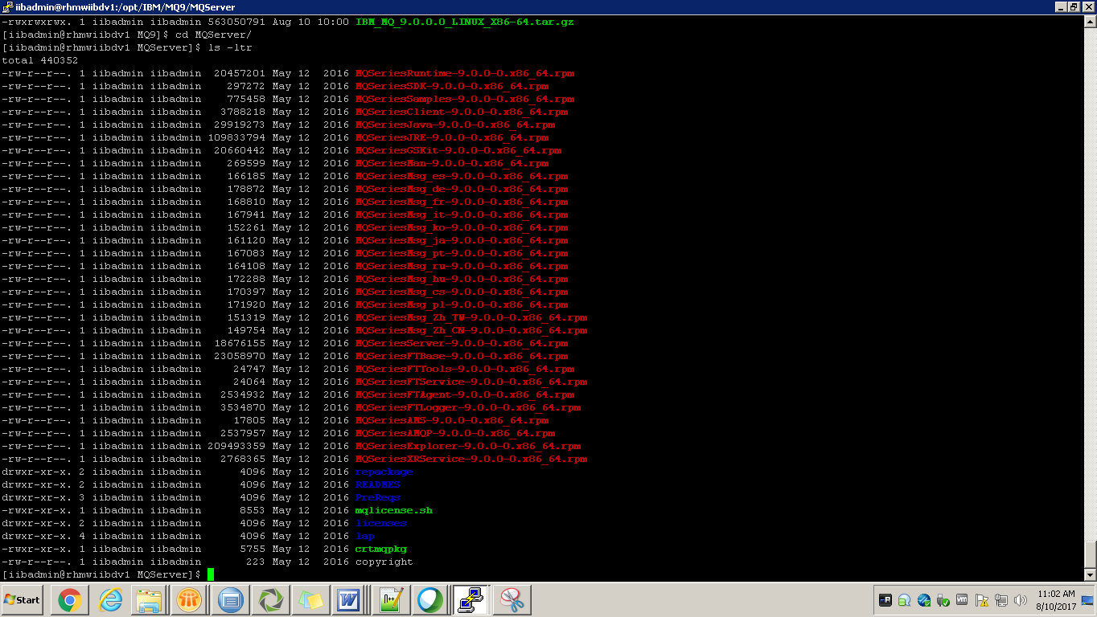



**5.**Accept the license using the following command. Please login as root in order to execute this

command.

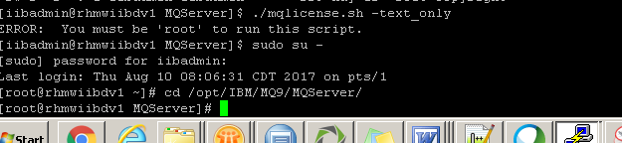

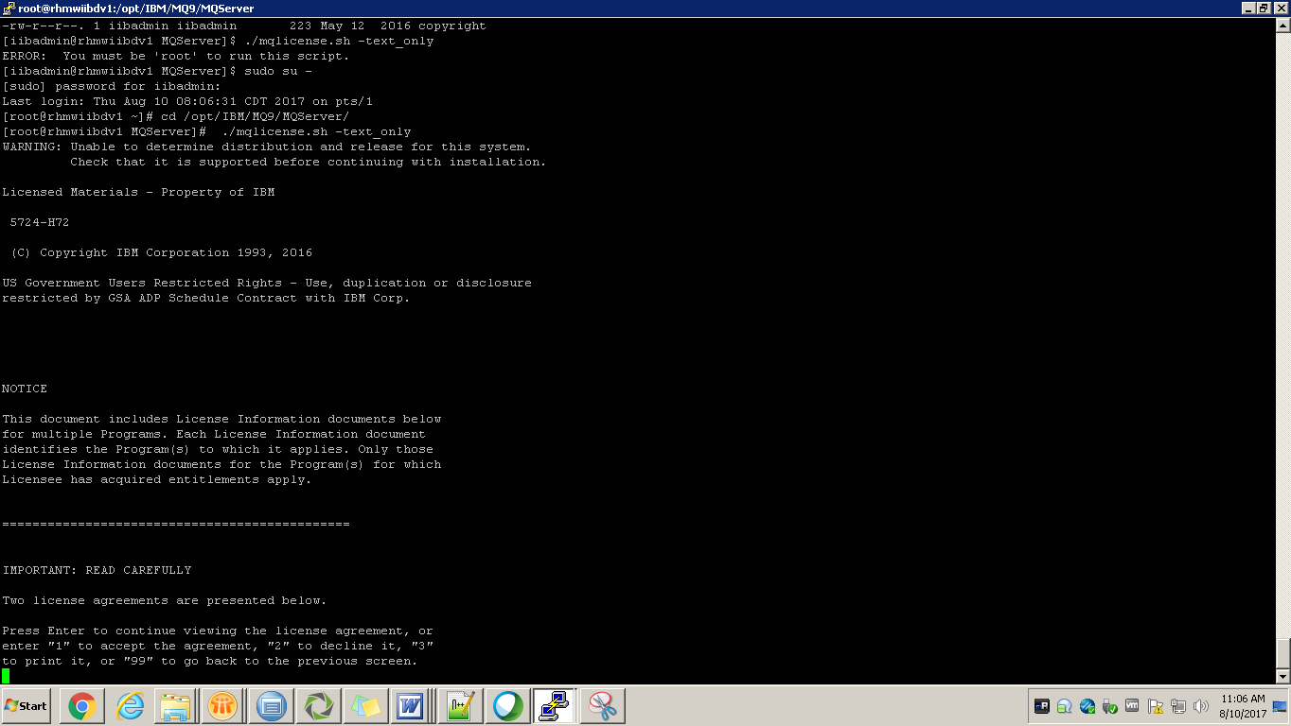

Accept the license by giving input 1.

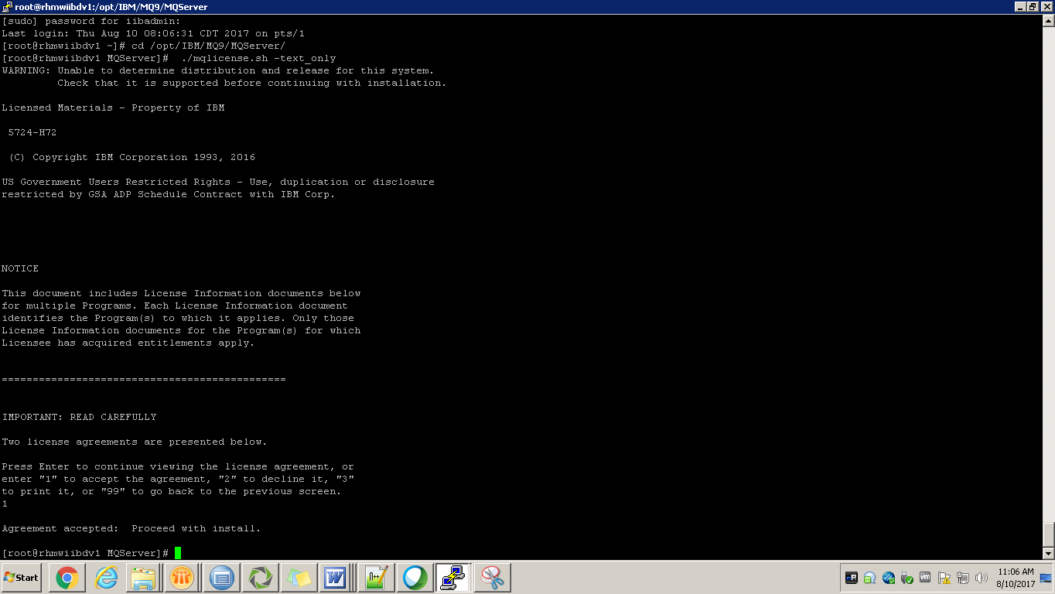

**6.**Now create the packages for the installation using below command.

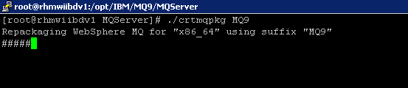

Packages are created in the below location.

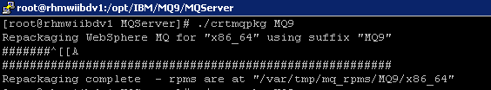

List of packages created will be listed as

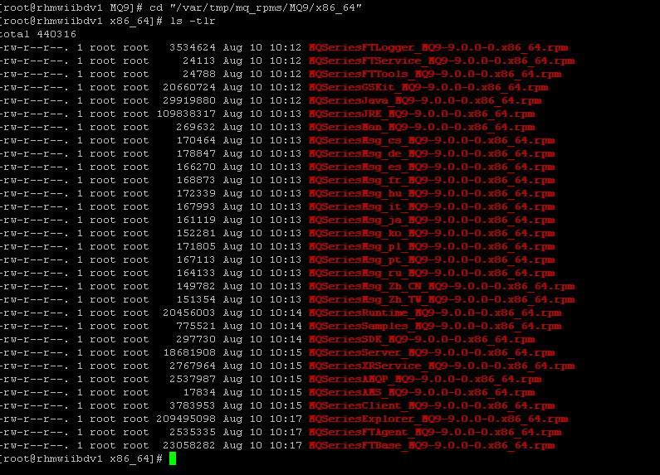

* MQSeriesRuntime
* MQSeriesJRE
* MQSeriesJava
* MQSeriesServer
* MQSeriesWeb
* MQSeriesFTBase
* MQSeriesFTAgent
* MQSeriesFTService
* MQSeriesFTLogger
* MQSeriesFTTools
* [V9.0.0.0 Jun 2016]MQSeriesAMQP
* MQSeriesAMS
* MQSeriesXRService
* MQSeriesExplorer
* MQSeriesGSKit
* MQSeriesClient
* MQSeriesMan
* MQSeriesMsg
* MQSeriesSamples
* MQSeriesSDK
* [V9.0.2 Mar 2017]MQSeriesSFBridge

**7.**We need to install in the above order. For now we installing only 2 which are required for

runtime.

Using this command we will install the packages.

rpm --prefix /opt/IBM/MQ9/ -ivh <package>

just install the MQSeriesRuntime and server as shown in the below screen.



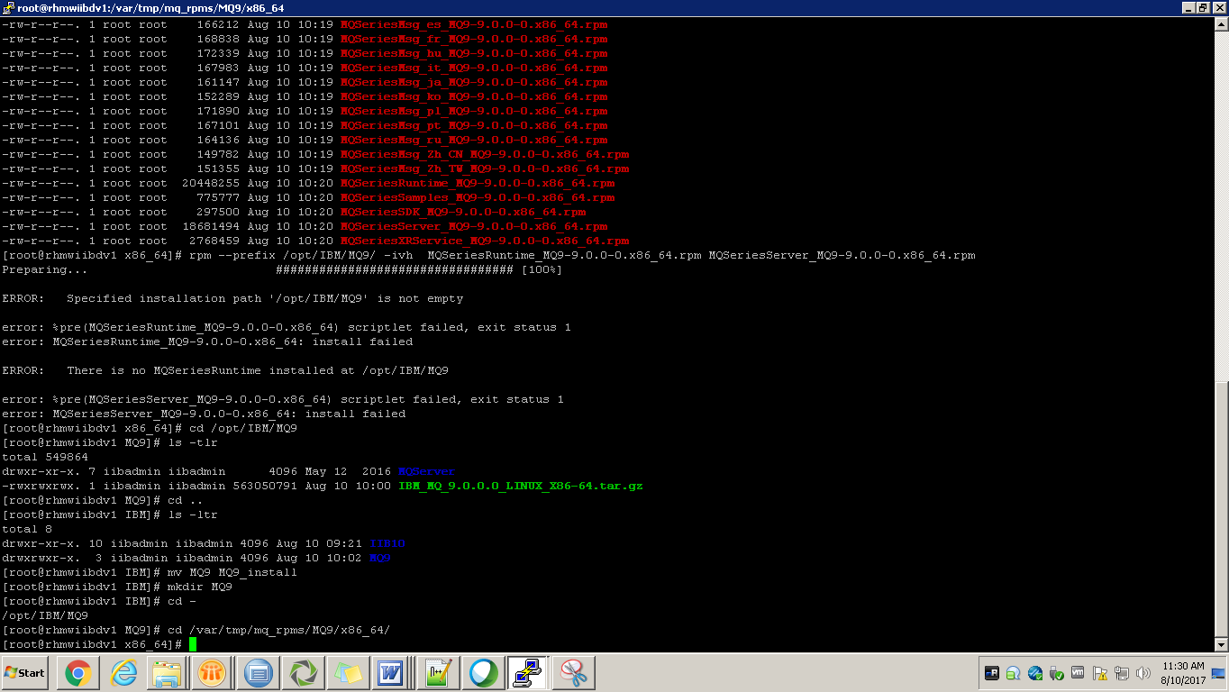

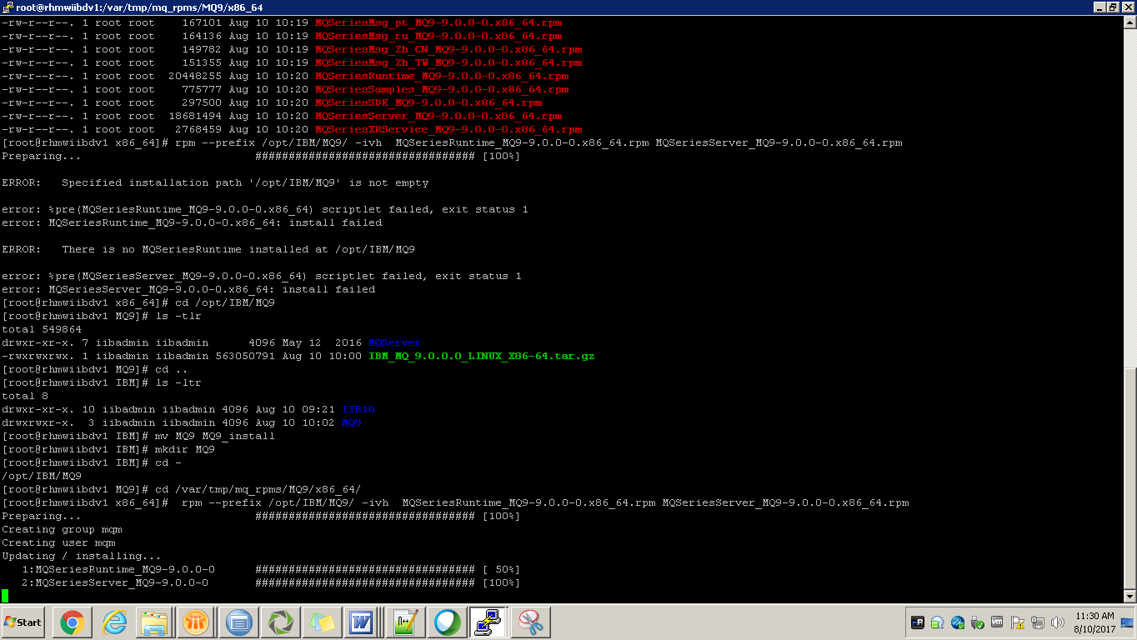

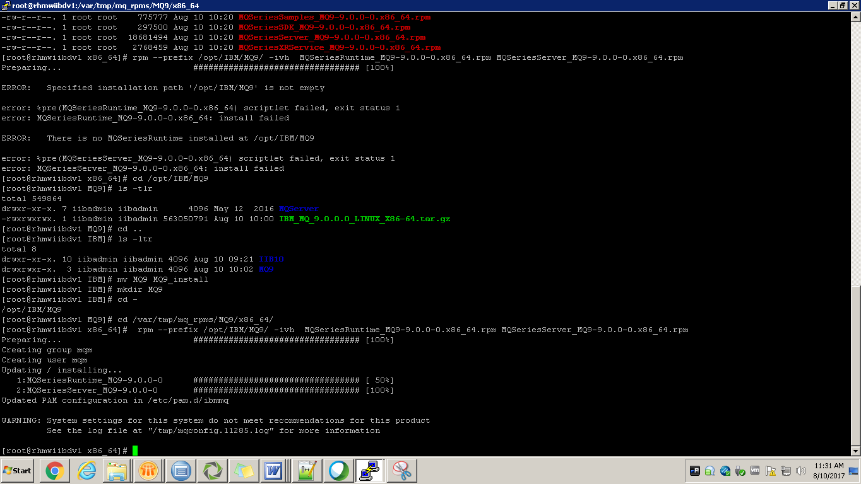

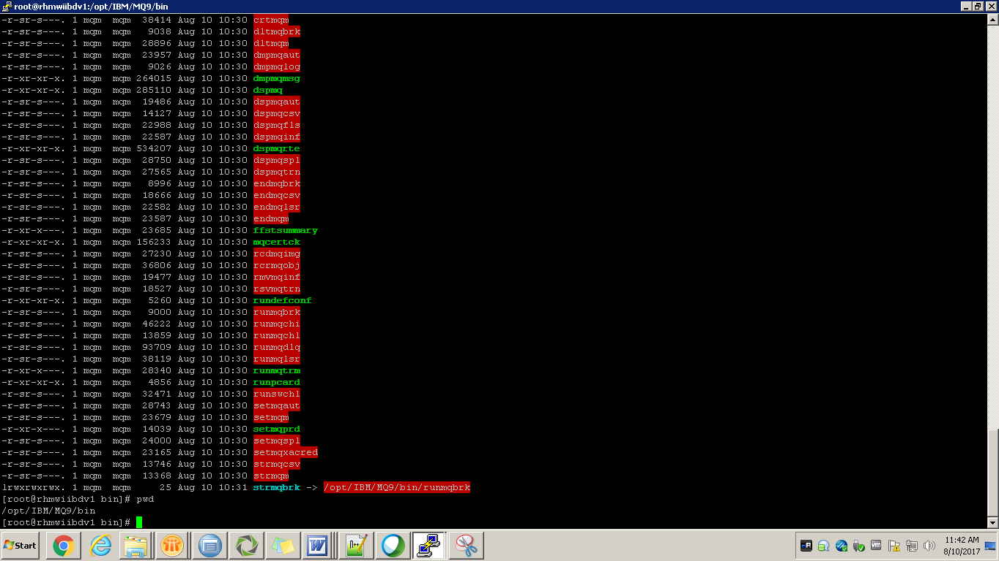

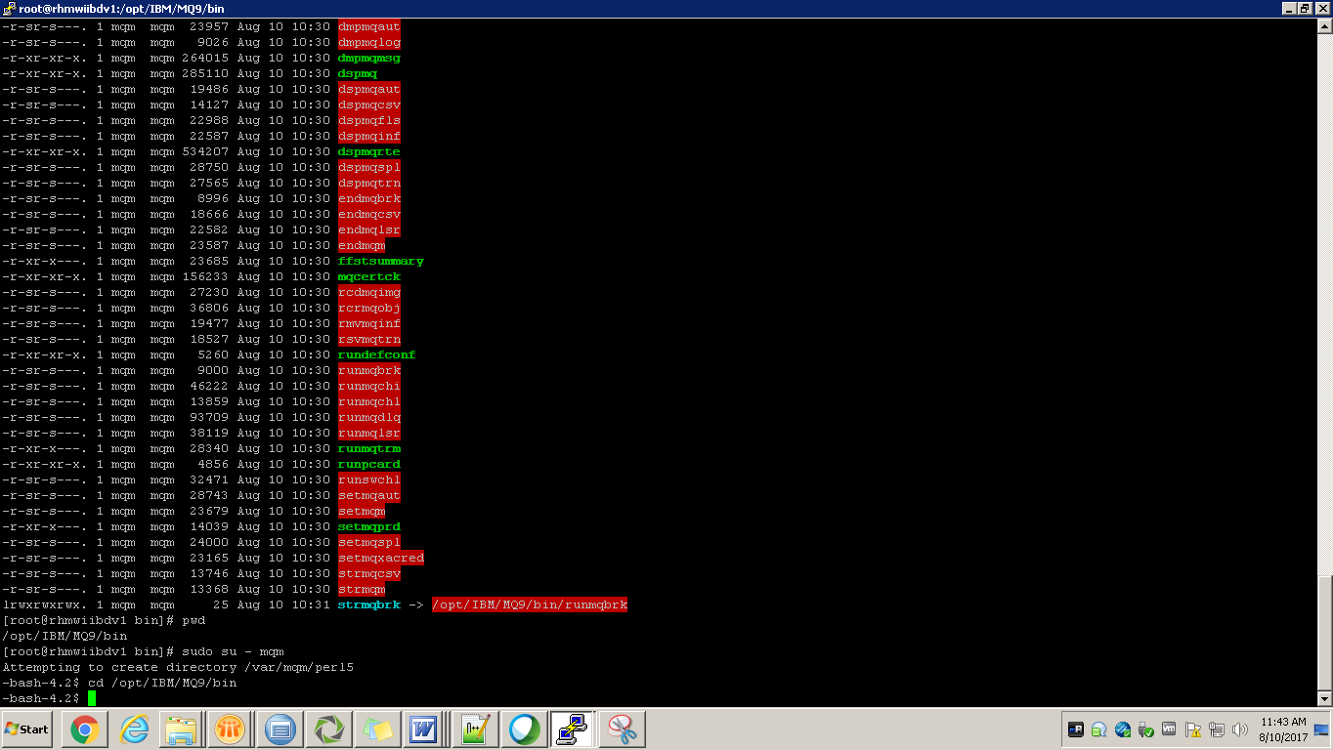

**8**.Switch to mqm user and go to /opt/IBM/MQ9/bin dir and execute the dspmqver to get the

version info.

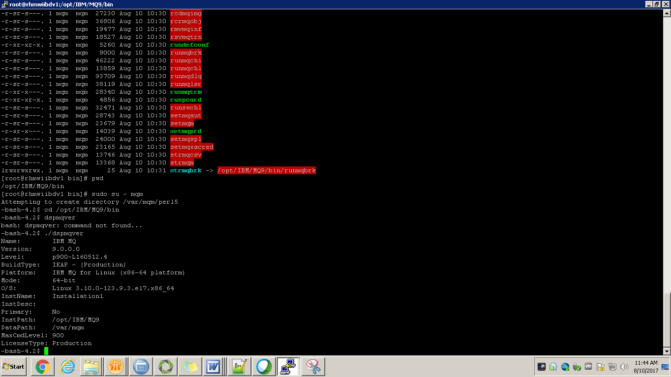

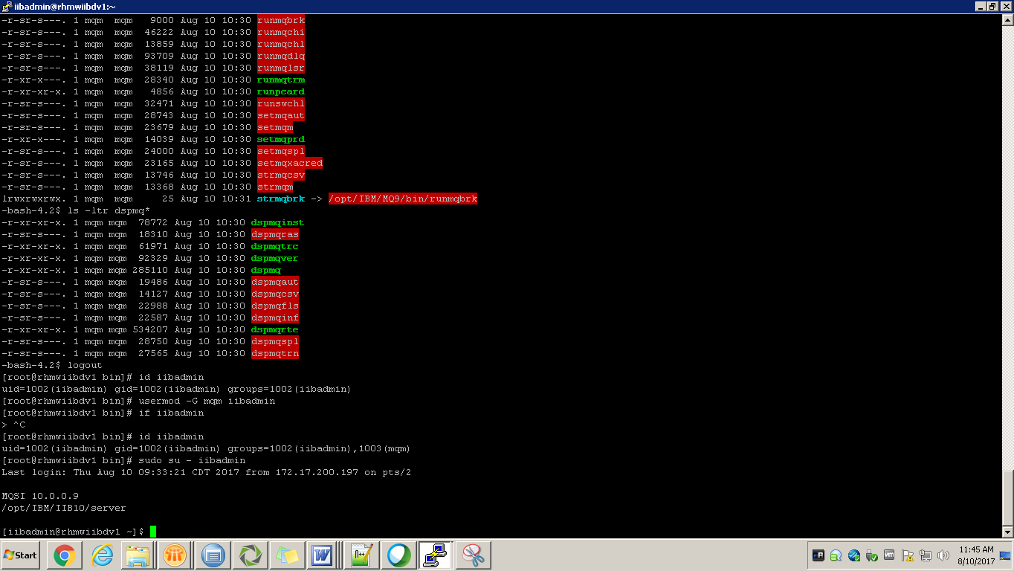

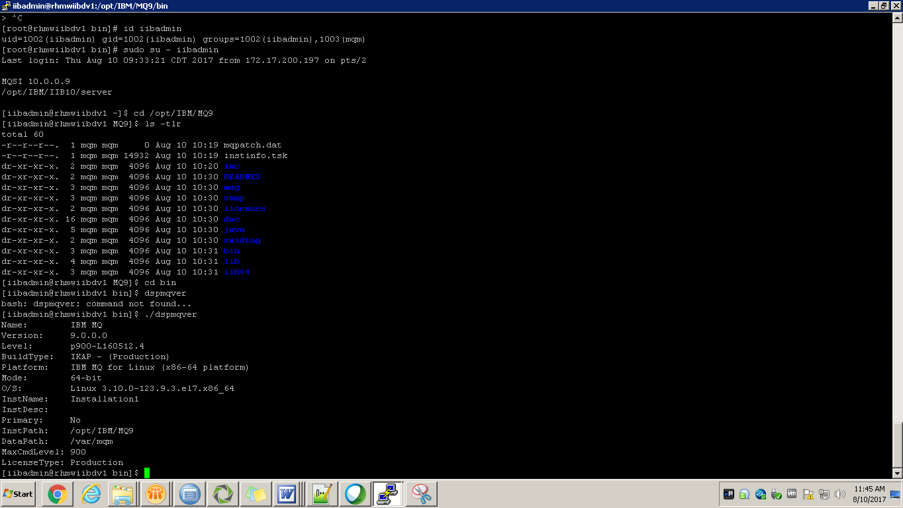

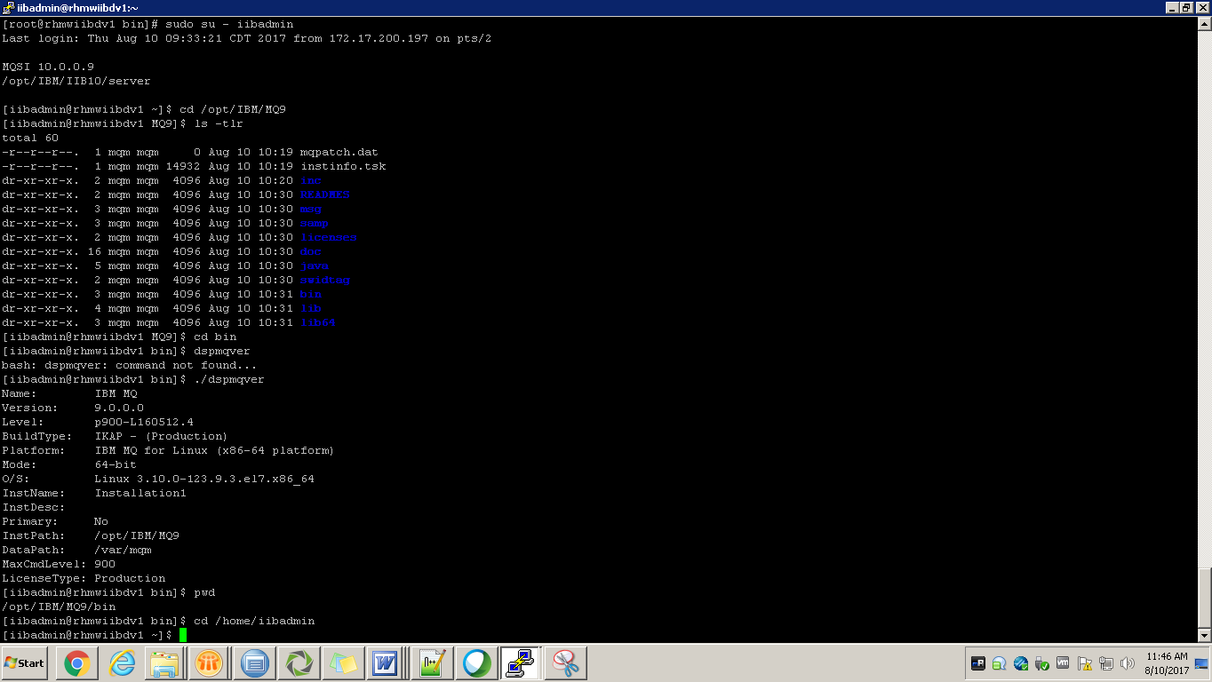

**9.**Now add MQ bin path to the bashrc file, in order to get all mq commands through out the user.

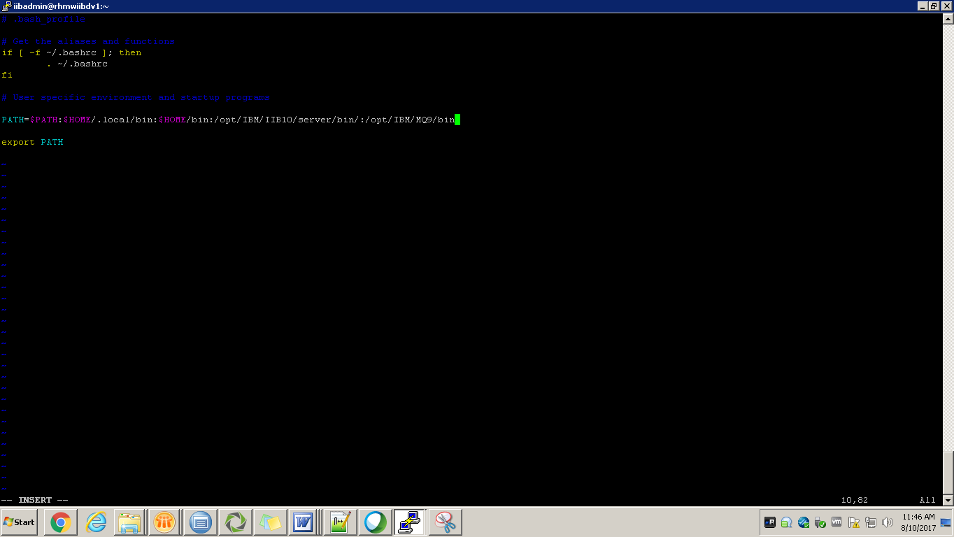

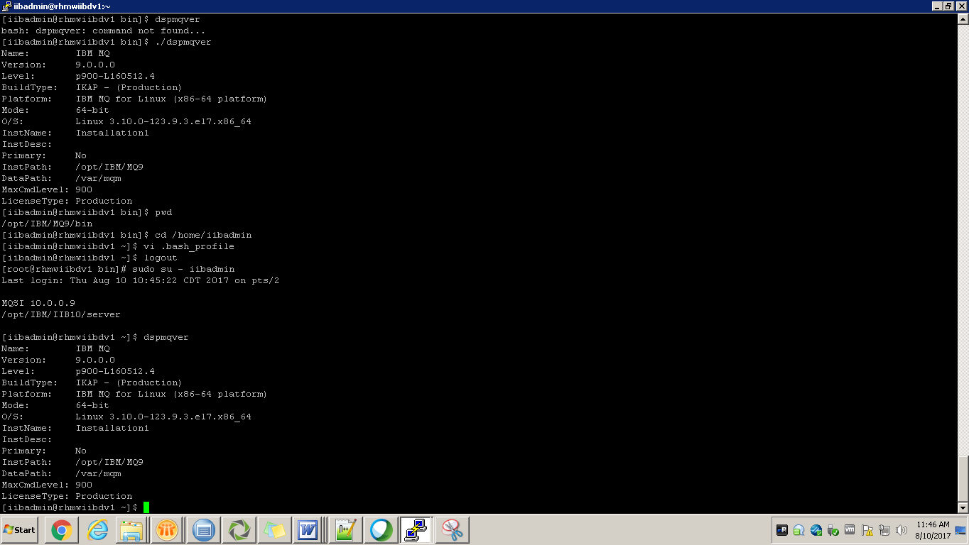

**10.Some Important points:**



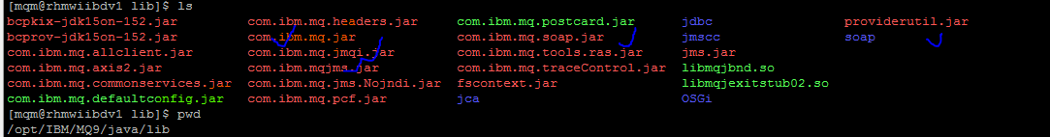



**END.**