**Recommendations for Big Mountain Resort based on your findings**

**1.**

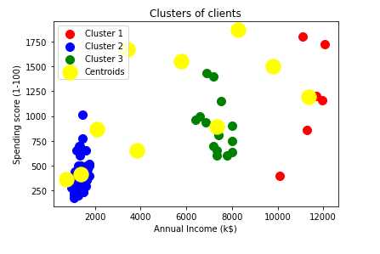

**From the above clusters, we found that there more clients with annual income less than 2k.Inorder to increase tickets sales, we can provide a promo code for people with group charges for these people.**

**2.**

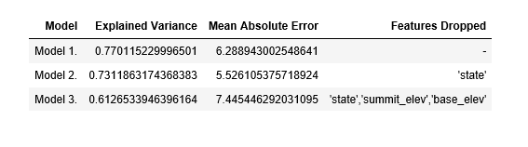

**After performing modeling with different machine learning algorithm, we found that model two i.e. RandomForestregressor performs well in prediction of weekend prices we can use the model the prices in future.**