A
Mini Project Report On
“Explainability Audit of Plant Disease Classifiers: Quantifying Background Shortcut Learning with Grad-CAM and a Background-Suppression Training Strategy”
Submitted
in partial fulfillment of the requirements for the degree of

Bachelor of Technology
in

CSE(AIML) Engineering
By

Mr. Amogh Narendra Mulik (PRN: 2417022)

Under the Guidance of
Prof. Ashvini Sandip Patil


Department of CSE(AIML) Engineering
K. E. Society’s

Rajarambapu Institute of Technology, Rajaramnagar
(An Empowered Autonomous Institute, Affiliated to Shivaji University, Kolhapur)
2026-27

Explainability Audit of Plant Disease Classifiers: Quantifying Background Shortcut Learning with Grad-CAM and a Background-Suppression Training Strategy
Abstract: Deep learning models for plant disease classification report accuracies above 99% on the PlantVillage dataset, yet they fail on photographs taken in real fields. A likely cause is shortcut learning: because PlantVillage leaves were photographed on plain backgrounds under controlled conditions, a network can separate classes using the background instead of the diseased tissue. This project audits three deep learning architectures, ResNet-50, EfficientNet-B0 and the vision transformer ViT-S/16, trained for 30 epochs on the ten-class PlantVillage tomato subset (18,155 images). Grad-CAM heatmaps are converted into a Lesion Focus Score (LFS), the share of attention that falls on the leaf, and background reliance is tested directly with background-only and Mixed-Rand (background-swapped) test images. A training strategy, BG-Suppress, is then proposed; it combines random background replacement with an attention-alignment loss that penalises Grad-CAM attention outside the leaf. All baselines reached 99.2–99.9% test accuracy but classified 22–28% of images correctly from the background alone (chance: 10%) and lost up to 13.8 points when backgrounds were swapped; ViT-S/16 was the most background-reliant (LFS 0.602). BG-Suppress raised LFS to 0.98–0.99 for all three models and cut the background-swap loss to 0.3 points or less, at a cost of at most 0.37 points of test accuracy. On 744 real-field PlantDoc images, accuracy remained 25–29%, showing that removing background shortcuts is necessary but not sufficient for field-ready plant disease diagnosis.
Keywords: Plant disease classification, explainable AI, Grad-CAM, shortcut learning, ResNet-50, EfficientNet-B0, vision transformer, domain shift.
1. Introduction
1.1 Background
Plant diseases cause large crop losses every year, and many farmers have no quick access to a plant pathologist. Image-based diagnosis with deep learning promises a phone-based alternative. Since the release of the PlantVillage dataset [1], convolutional neural networks (CNNs) have repeatedly reported near-perfect accuracy on it: Mohanty et al. [2] reached 99.35% on 54,306 images, and later comparative studies reported similar figures [3], [4]. These numbers do not carry over to the field. When PlantVillage-trained models are tested on internet-sourced field images from PlantDoc [5], accuracy has been reported to fall from 99.77% to 28.57% for MobileNetV2 [6].
A probable reason is shortcut learning [7]: a network learns any feature that correlates with the label, whether or not it is related to the disease. PlantVillage photographs each detached leaf on a plain background under controlled light, and capture conditions differ between classes. Noyan [8] trained a classifier on only eight background pixels per image and still obtained 49.0% accuracy against a chance level of 2.6%.
1.2 Problem Statement
Explainability Audit of Plant Disease Models: use Grad-CAM to show whether plant disease classifiers look at the lesion or at the background (shortcut learning), and propose a background-suppression training strategy that makes the models focus on the leaf.
1.3 Research Gap
• Grad-CAM in plant disease papers is mostly qualitative: a few heatmaps are shown, but attention is not measured.
• No plant disease study uses counterfactual background tests to prove, rather than suggest, shortcut reliance.
• Attention-constraining training has not been evaluated on multi-class PlantVillage together with a real-field test.
• Architecture comparisons report accuracy only, not whether CNNs and vision transformers differ in background reliance.
1.4 Objectives
1. Train and compare three deep learning architectures (ResNet-50, EfficientNet-B0 and ViT-S/16) on PlantVillage tomato for 30 epochs each.
2. Measure where each model looks with a Grad-CAM-based Lesion Focus Score (LFS).
3. Prove or disprove background shortcut learning with background-only and Mixed-Rand counterfactual test sets.
4. Propose and evaluate BG-Suppress, a background-suppression training strategy.
5. Test every model on real-field PlantDoc images that were never used for training.
2. Literature Review / Related Work
2.1 Deep Learning on PlantVillage
Hughes and Salathé [1] released PlantVillage as an open repository of leaf images. Mohanty et al. [2] trained AlexNet and GoogLeNet on its 54,306 images (14 crops, 26 diseases) and reported 99.35% held-out accuracy. Ferentinos [3] and Too et al. [4] compared several CNN families and fine-tuning strategies and again reported near-perfect accuracy. All of these evaluated models only on images captured under the same laboratory conditions.
2.2 Dataset Bias and the Laboratory-to-Field Gap
Singh et al. [5] built PlantDoc, 2,598 internet images with natural backgrounds, and showed that training on it raised field accuracy by up to 31%. Noyan [8] demonstrated capture bias in PlantVillage with the eight-pixel experiment. Ahmad et al. [11] reached 81.6% cross-dataset accuracy on corn only when backgrounds were removed or laboratory and field images were combined. Ho-Lam and Nguyen [6] measured the PlantVillage-to-PlantDoc collapse for three CNNs and used Grad-CAM to show that most attention fell off the leaf in field images, but stopped at diagnosis.
2.3 Explainability for Plant Disease Models
Grad-CAM [9] weights the feature maps of a layer by the averaged gradients of the class score and is the most widely used explanation in this domain; Gökten et al. [12] compared Grad-CAM maps across ConvNeXt-Tiny, MobileNetV2 and VGG16. Amara et al. [13], [14] applied concept-based explanations to PlantVillage models and found background and lighting concepts among the most influential for weak classes. Wang et al. [15] introduced the energy-based pointing game, which this project adapts from bounding boxes to leaf masks. Lee et al. [16] also noted that CNNs can attend to irrelevant background regions.
2.4 Shortcut Learning and Attention-Constraining Training
Geirhos et al. [7] framed shortcut learning as decision rules that work on benchmarks but fail under realistic shifts. Xiao et al. [10] showed that ImageNet models classify above chance from backgrounds alone. On the corrective side, Ross et al. [17] penalised input gradients in regions marked irrelevant, Li et al. [18] made attention maps trainable, Heo et al. [19] combined explanation regularisation with robustness on a binary leaf dataset, and Ferdi [20] showed that background-removed images used as augmentation help apple-leaf classification.
Table 1: Summary of related work and comparison with this project
Study | Method / model | Dataset | Key result | Limitation for this problem
Mohanty et al. [2] | AlexNet, GoogLeNet | PlantVillage | 99.35% held-out accuracy | Laboratory-only evaluation
Singh et al. [5] | VGG16, InceptionV3 | PlantDoc | Field data raise accuracy by up to 31% | Small dataset; no attention analysis
Noyan [8] | Classifier on 8 background pixels | PlantVillage | 49.0% vs. 2.6% chance | Shows bias; no deep-model fix
Ahmad et al. [11] | Five CNNs incl. DenseNet169 | Five corn datasets | 81.6% cross-dataset accuracy | No explainability
Amara et al. [14] | InceptionV3 + concept extraction | PlantVillage | Background concepts in weak classes | No mitigation
Ho-Lam & Nguyen [6] | TinyCNN, MobileNetV2, ResNet18 | PlantVillage → PlantDoc | 99.77% → 28.57% (MobileNetV2) | Diagnosis only; no fix
Xiao et al. [10] | ResNet family | ImageNet-9 | Backgrounds alone classify | General vision, not agriculture
Ross et al. [17] | Input-gradient penalty | Toy and text data | Better generalisation under shift | Not tested on plant images
Heo et al. [19] | Explanation-guided training | Binary leaf-spot data | Beats standard training | Binary task; not PlantVillage
This project | ResNet-50, EfficientNet-B0, ViT-S/16 + BG-Suppress | PlantVillage tomato → PlantDoc | LFS 0.98–0.99; shortcut gap ≤ 0.3 pts | Measured fix across three architectures with a field test

Novelty of this project. Unlike earlier work, this project (i) measures attention with a number (LFS) instead of showing a few heatmaps, (ii) proves background reliance with counterfactual tests, (iii) proposes and evaluates a fix, BG-Suppress, and (iv) compares a CNN, a lightweight CNN and a vision transformer under one protocol, including a real-field test.
3. Methodology / Materials & Methods
3.1 System Architecture
Figure 1 shows the overall pipeline. Leaf images and their masks are prepared once; each of the three architectures is trained in two modes, standard (baseline) and BG-Suppress; and every trained model is evaluated with the same four tests: laboratory test accuracy, Grad-CAM LFS, the two counterfactual shortcut tests and the PlantDoc field test.
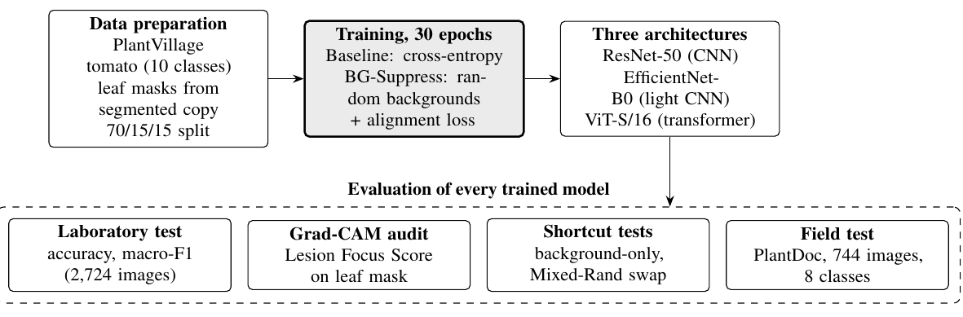
Figure 1: System architecture of the explainability audit. PlantDoc images are never used for training; the shaded box is the proposed training strategy.
3.2 Datasets
PlantVillage tomato (training and laboratory test). The ten tomato classes of the public PlantVillage release were used. The release contains a colour and a segmented version of every image; a binary leaf mask M was obtained from the segmented copy by thresholding, morphological closing, hole filling (so dark lesions stay inside the leaf) and keeping the largest connected component. Images were resized to 256×256. After pairing images with masks, 18,155 images remained, split 70/15/15 with class stratification (seed 42) into 12,708 training, 2,723 validation and 2,724 test images (Table 2).
PlantDoc tomato (field test only). Tomato images from the cropped PlantDoc release [5] were mapped to PlantVillage labels and used only for testing. Target Spot has no PlantDoc counterpart and the spider-mite folder holds only two images, so both were excluded, leaving 744 field images in eight classes. Uniform chance on this set is 12.5% and the majority class (Septoria, 151 images) is 20.3%.
Table 2: Number of images per class
Class | Train | Validation | Test | PlantDoc (field)
Bacterial spot | 1,489 | 319 | 319 | 110
Early blight | 699 | 150 | 150 | 88
Late blight | 1,336 | 286 | 287 | 111
Leaf mold | 666 | 143 | 143 | 91
Septoria leaf spot | 1,238 | 265 | 266 | 151
Spider mites | 1,173 | 251 | 251 | –
Target spot | 983 | 211 | 210 | –
Yellow leaf curl virus | 3,749 | 803 | 804 | 76
Mosaic virus | 261 | 56 | 56 | 54
Healthy | 1,114 | 239 | 238 | 63
Total | 12,708 | 2,723 | 2,724 | 744

3.3 Deep Learning Models Compared
Three architectures from different design families were selected (Table 3). All start from ImageNet weights from the timm library, with the classifier replaced by a ten-class head.
• ResNet-50 [21] stacks bottleneck residual blocks with identity skip connections, which allow very deep networks to train; it is the most common backbone in plant disease studies.
• EfficientNet-B0 [22] uses mobile inverted-bottleneck blocks with squeeze-and-excitation and scales depth, width and resolution together; with about 5.3M parameters it suits mobile deployment.
• ViT-S/16 [23] splits the image into 16×16 patches and processes the 196 patch tokens with self-attention, giving every layer a global view of the image.
Table 3: The three deep learning architectures compared
Model | Family | Parameters | Pretrained weights (timm) | Grad-CAM layer | Learning rate
ResNet-50 | Residual CNN | 25.6M | resnet50.a1_in1k | Last residual stage | 2×10⁻⁴
EfficientNet-B0 | Compound-scaled CNN | 5.3M | efficientnet_b0.ra_in1k | Final 1×1 conv head | 2×10⁻⁴
ViT-S/16 | Vision transformer | 22M | vit_small_patch16_224.augreg | Last block (14×14 tokens) | 1×10⁻⁴

3.4 Grad-CAM and the Lesion Focus Score
For an input x and class c with score yᴄ, Grad-CAM [9] weights the feature maps Fₖ of a chosen layer by their averaged gradients and keeps the positive part:
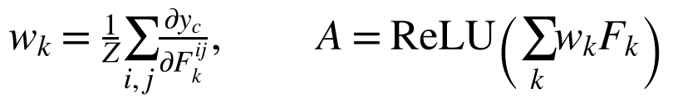 (1)
For ViT-S/16 the 196 patch tokens are reshaped into a 14×14 map first. The map is upsampled to 224×224, min–max normalised to Â and compared with the leaf mask M:
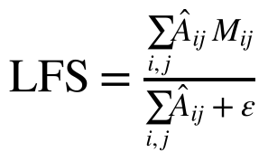 (2)
A model that attends only to the leaf scores 1.0, and a spatially uniform map scores the leaf's area fraction, 0.517 on this test set. LFS is computed for the predicted class and averaged over the 2,724 test images.
3.5 Counterfactual Shortcut Tests
Every test image is also evaluated in two modified forms that do not depend on any explanation method (Eq. 3):
(3)
• Background-only (x_bg): the leaf pixels are removed so only the background remains. Accuracy above the 10% chance level shows that the background alone carries label information.
• Mixed-Rand (x_mix): following Xiao et al. [10], each leaf is pasted onto the background b_d of a test image from a different class. The drop from original to Mixed-Rand accuracy is the shortcut gap.
3.6 Proposed BG-Suppress Training Strategy
BG-Suppress has two parts applied together. Background randomisation: with probability p = 0.8, each training image is recomposed onto a random background B (solid colours, gradients, smoothed noise, earth- or foliage-coloured noise), after the same geometric augmentation is applied to the image and its mask:
(4)
Attention-alignment loss: for the true class, Grad-CAM is computed during training with the channel weights detached (stop-gradient, sg), so no second-order gradients are needed. The mask is average-pooled to the feature size (M̃) and the share of attention outside the leaf is penalised:
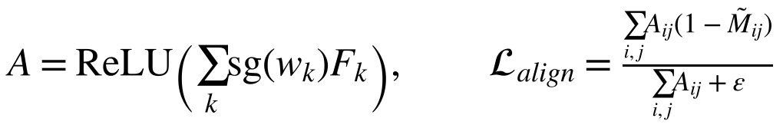 (5)
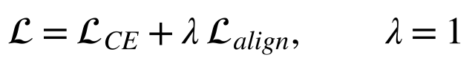 (6)
In the baseline mode the same pipeline is used with p = 0 and λ = 0. One BG-Suppress training step is:
1. Apply the same random crop, flip and rotation to each image and its mask; apply colour jitter to the image.
2. With probability 0.8, replace the background: x ← M⊙x + (1−M)⊙B.
3. Forward pass under bfloat16 autocast; store the target-layer features F.
4. Compute cross-entropy loss with label smoothing 0.1.
5. Compute detached Grad-CAM weights, the map A and the pooled mask M̃; compute L_align.
6. Update the model with AdamW on L_CE + λL_align; clip the gradient norm at 1.0.
3.7 Experimental Setup
All six runs (three architectures × two training modes) used identical settings apart from the training mode and the learning rate of ViT-S/16 (Table 4). Training ran on a laptop with an Intel Core 7 240H processor, 16 GB RAM and an NVIDIA GeForce RTX 5060 Laptop GPU (8 GB), using Python 3.12, PyTorch 2.11 with CUDA 12.8 [24] and timm. The checkpoint with the highest validation macro-F1 was kept for testing. One epoch took 57–152 s depending on the model.
Table 4: Training hyperparameters (identical for all runs)
Setting | Value
Input size | 224×224 (images stored at 256×256)
Epochs / batch size | 30 / 32
Optimiser | AdamW [25], weight decay 0.05; LR 2×10⁻⁴ (CNNs), 1×10⁻⁴ (ViT)
Schedule | 2 warm-up epochs, then cosine decay
Loss | Cross-entropy, label smoothing 0.1 (+ λL_align, λ = 1, for BG-Suppress)
Augmentation | Random resized crop (0.7–1.0), horizontal flip, ±15° rotation, colour jitter 0.2
Precision | Mixed precision (bfloat16); gradient clipping at norm 1.0
Model selection / seed | Best validation macro-F1 / 42
Evaluation metrics | Accuracy (95% bootstrap CI), macro-F1, LFS, background-only accuracy, shortcut gap, PlantDoc accuracy and macro-F1

4. Results & Discussion
4.1 Training Behaviour
Figure 2 shows validation accuracy and training loss per epoch. All models passed 99% validation accuracy within about 10–15 epochs and then levelled off, so 30 epochs were sufficient. The ResNet-50 baseline became numerically unstable at epoch 14 (loss became NaN); its best checkpoint, from epoch 9, is the one evaluated. All BG-Suppress runs trained stably for 30 epochs.
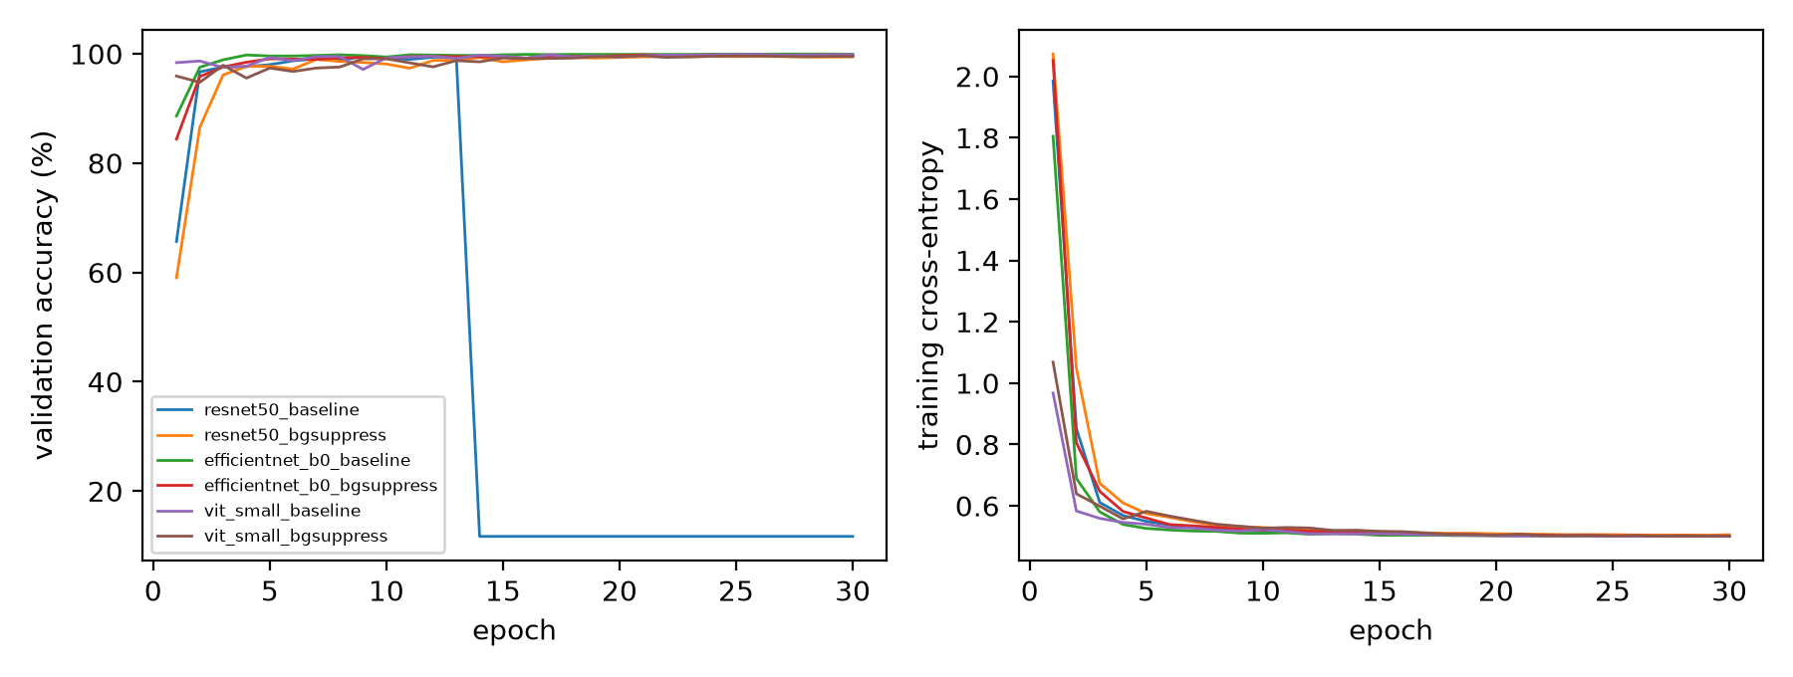
Figure 2: Validation accuracy (left) and training cross-entropy (right) for the six runs
4.2 Laboratory Classification Performance
Table 5 reports performance on the 2,724 test images. All six models exceeded 99.1% accuracy. BG-Suppress changed accuracy by only −0.04 to −0.37 points, and every BG-Suppress confidence interval overlaps that of its baseline.
Table 5: Laboratory test performance on PlantVillage tomato (2,724 images)
Model | Training | Accuracy (%) | 95% CI | Macro-F1 (%) | Best epoch
ResNet-50 | Baseline | 99.23 | 98.86–99.52 | 98.99 | 9
ResNet-50 | BG-Suppress | 99.19 | 98.83–99.52 | 98.94 | 24
EfficientNet-B0 | Baseline | 99.82 | 99.63–99.96 | 99.78 | 27
EfficientNet-B0 | BG-Suppress | 99.60 | 99.34–99.82 | 99.50 | 21
ViT-S/16 | Baseline | 99.85 | 99.67–99.96 | 99.84 | 26
ViT-S/16 | BG-Suppress | 99.49 | 99.19–99.74 | 99.46 | 21

4.3 Attention Audit and Shortcut Tests
Table 6 and Figure 3 show that all three baselines rely on the background despite their near-perfect accuracy. With the leaf removed they still classified 22.2–27.9% of images correctly, two to three times the 10% chance level, and swapping backgrounds cost up to 13.8 points. ViT-S/16 was the most background-reliant: its LFS of 0.602 is close to the 0.517 of a uniform map. BG-Suppress moved every measure in the intended direction: LFS rose to 0.981–0.994, the shortcut gap fell to 0.3 points or less, and background-only accuracy fell sharply (ViT-S/16: 27.9% → 6.0%).
Table 6: Attention and counterfactual shortcut tests (laboratory test set)
Model | Training | LFS ↑ | Background-only acc. (%) ↓ | Mixed-Rand acc. (%) | Shortcut gap (pts) ↓
ResNet-50 | Baseline | 0.905 | 22.21 | 95.96 | 3.27
ResNet-50 | BG-Suppress | 0.994 | 13.55 | 99.12 | 0.07
EfficientNet-B0 | Baseline | 0.839 | 24.05 | 87.52 | 12.30
EfficientNet-B0 | BG-Suppress | 0.985 | 12.52 | 99.30 | 0.29
ViT-S/16 | Baseline | 0.602 | 27.86 | 86.05 | 13.80
ViT-S/16 | BG-Suppress | 0.981 | 5.98 | 99.19 | 0.29
Reference | Uniform map / chance | 0.517 | 10.00 | – | –

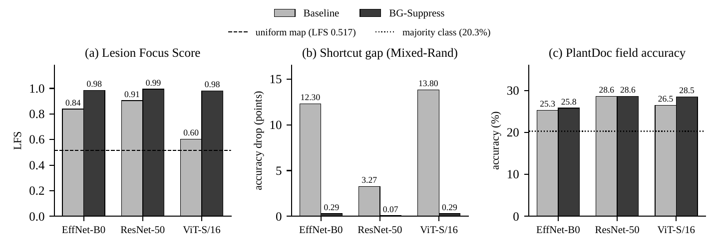
Figure 3: Baseline vs. BG-Suppress. (a) Lesion Focus Score; (b) shortcut gap; (c) PlantDoc field accuracy
4.4 Qualitative Grad-CAM Comparison
Figure 4 shows Grad-CAM maps for the same six test images under every model. The baseline CNNs place their peak on the leaf but spread attention onto the background; the ViT-S/16 baseline often highlights background regions and image corners. After BG-Suppress, the CNN maps contract onto the leaf and the ViT-S/16 maps follow the leaf outline.
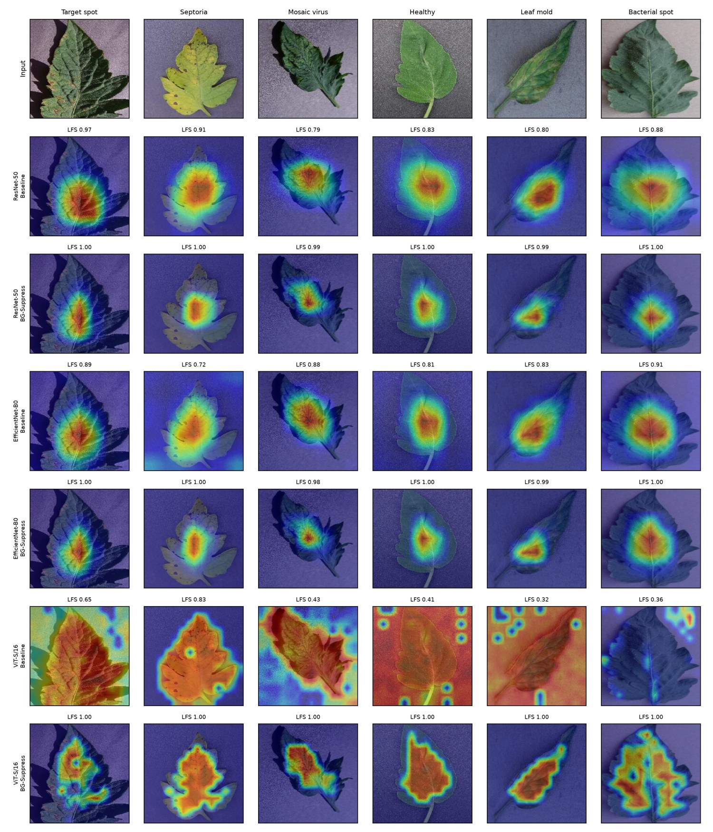
Figure 4: Grad-CAM maps for six test images (top row). Rows alternate baseline and BG-Suppress for ResNet-50, EfficientNet-B0 and ViT-S/16; the number above each map is its LFS.
4.5 Field Test on PlantDoc
On 744 PlantDoc field images (Table 7), every model fell to 25–29% accuracy, only modestly above the 20.3% majority-class baseline. BG-Suppress raised field macro-F1 for all three models (by 1.0–3.3 points) and raised ViT-S/16 accuracy from 26.5% to 28.5%, but the confidence intervals overlap, so this is not a significant gain. Most field images were predicted as Early or Late blight; field photos also differ in scale, viewpoint, lighting, number of leaves and image quality, so removing background reliance addresses only one of several shifts.
Table 7: Field performance on PlantDoc tomato (744 images, 8 classes)
Model | Training | Accuracy (%) | 95% CI | Macro-F1 (%)
ResNet-50 | Baseline | 28.63 | 25.54–31.86 | 19.24
ResNet-50 | BG-Suppress | 28.63 | 25.27–31.99 | 20.22
EfficientNet-B0 | Baseline | 25.27 | 22.31–28.23 | 16.10
EfficientNet-B0 | BG-Suppress | 25.81 | 22.72–29.17 | 19.41
ViT-S/16 | Baseline | 26.48 | 23.39–29.70 | 18.68
ViT-S/16 | BG-Suppress | 28.50 | 25.27–31.86 | 20.83
Reference | Majority class / chance | 20.30 / 12.50 | – | –

4.6 Comparison of the Three Architectures
Table 8: Summary comparison of the three deep learning architectures
Criterion | ResNet-50 | EfficientNet-B0 | ViT-S/16
Parameters | 25.6M | 5.3M (smallest) | 22M
Lab accuracy, baseline / BG-Suppress | 99.23 / 99.19% | 99.82 / 99.60% | 99.85 / 99.49%
LFS, baseline → BG-Suppress | 0.905 → 0.994 | 0.839 → 0.985 | 0.602 → 0.981
Shortcut gap, baseline → BG-Suppress | 3.27 → 0.07 pts | 12.30 → 0.29 pts | 13.80 → 0.29 pts
Field accuracy, baseline → BG-Suppress | 28.6 → 28.6% | 25.3 → 25.8% | 26.5 → 28.5%
Training stability | Baseline diverged at epoch 14 | Stable | Stable
Observation | Least background-reliant baseline; best field accuracy | Best accuracy per parameter; lowest field accuracy | Most background-reliant baseline; largest gain from BG-Suppress

In the laboratory the three architectures are practically indistinguishable, so accuracy alone would not separate them; the audit does. ViT-S/16, the most accurate baseline, was also the most background-reliant, so global self-attention did not protect against the shortcut. ResNet-50 was the least background-reliant baseline, and EfficientNet-B0 matched the larger models with about one fifth of ResNet-50's parameters.
4.7 Comparison with Existing Work
The laboratory accuracies (99.2–99.9%) agree with earlier PlantVillage studies [2]–[4], and the field accuracies (25–29%) agree with the collapse reported by Ho-Lam and Nguyen [6] (28.57% for MobileNetV2). Where earlier work showed background attention only qualitatively [6], [12], this project measures it with LFS, proves it with counterfactual tests in the style of Xiao et al. [10], and removes it with BG-Suppress.
4.8 Limitations
• Each configuration was trained with a single seed (42), so small differences, including the field changes, should be confirmed with repeated runs.
• LFS measures attention on the whole leaf, not on the lesion itself, because PlantVillage provides leaf masks but not lesion masks.
• The ablation separating background randomisation from the alignment loss was not completed.
• The field test uses 744 internet images, which approximate but do not fully represent systematic field acquisition.
5. Conclusion and Future Work
This project audited three deep learning architectures for tomato leaf disease classification. Models with 99.2–99.9% laboratory accuracy were shown, with an attention metric and two counterfactual tests, to rely measurably on image backgrounds, with the vision transformer the most affected. The proposed BG-Suppress strategy, which combines background randomisation with a detached Grad-CAM alignment loss, raised the Lesion Focus Score to 0.98–0.99 and reduced the background-swap accuracy loss to 0.3 points or less for all three models, while laboratory accuracy changed by at most 0.37 points. Field accuracy on PlantDoc stayed between 25% and 29%, so background suppression is necessary but not sufficient for field-ready models.
Future work:
• Repeat all experiments with three or more seeds and complete the ablation study.
• Localise attention to lesions instead of whole leaves using lesion-level annotations.
• Combine BG-Suppress with field-image fine-tuning, real soil and foliage backgrounds, and stronger field-style augmentation.
• Apply domain adaptation using unlabelled field images, and test stronger pretrained backbones.
6. References
[1] D. P. Hughes and M. Salathé, "An open access repository of images on plant health to enable the development of mobile disease diagnostics," arXiv:1511.08060, 2015.
[2] S. P. Mohanty, D. P. Hughes, and M. Salathé, "Using deep learning for image-based plant disease detection," Front. Plant Sci., vol. 7, p. 1419, 2016.
[3] K. P. Ferentinos, "Deep learning models for plant disease detection and diagnosis," Comput. Electron. Agric., vol. 145, pp. 311–318, 2018.
[4] E. C. Too, L. Yujian, S. Njuki, and L. Yingchun, "A comparative study of fine-tuning deep learning models for plant disease identification," Comput. Electron. Agric., vol. 161, pp. 272–279, 2019.
[5] D. Singh, N. Jain, P. Jain, P. Kayal, S. Kumawat, and N. Batra, "PlantDoc: A dataset for visual plant disease detection," in Proc. CoDS-COMAD, 2020, pp. 249–253.
[6] N.-B. Ho-Lam and T.-A. Nguyen, "TinyCNN: A 193K-parameter network for on-device plant disease detection, with a cross-dataset robustness diagnosis," arXiv:2609.20290, 2026.
[7] R. Geirhos et al., "Shortcut learning in deep neural networks," Nature Mach. Intell., vol. 2, no. 11, pp. 665–673, 2020.
[8] M. A. Noyan, "Uncovering bias in the PlantVillage dataset," arXiv:2206.04374, 2022.
[9] R. R. Selvaraju, M. Cogswell, A. Das, R. Vedantam, D. Parikh, and D. Batra, "Grad-CAM: Visual explanations from deep networks via gradient-based localization," in Proc. IEEE ICCV, 2017, pp. 618–626.
[10] K. Xiao, L. Engstrom, A. Ilyas, and A. Madry, "Noise or signal: The role of image backgrounds in object recognition," in Proc. ICLR, 2021.
[11] A. Ahmad, A. El Gamal, and D. Saraswat, "Toward generalization of deep learning-based plant disease identification under controlled and field conditions," IEEE Access, vol. 11, 2023.
[12] A. Gökten, E. Tekeli, and H. B. Dönmez, "Explainable deep learning for plant leaf diseases: A comparative study of Grad CAM," J. Agric. Sci. (Tarım Bilimleri Dergisi), 2026.
[13] J. Amara, B. König-Ries, and S. Samuel, "Concept explainability for plant diseases classification," in Proc. VISAPP, 2023.
[14] J. Amara, B. König-Ries, and S. Samuel, "Explainability of deep learning-based plant disease classifiers through automated concept identification," arXiv:2412.07408, 2024.
[15] H. Wang et al., "Score-CAM: Score-weighted visual explanations for convolutional neural networks," in Proc. IEEE/CVF CVPR Workshops, 2020.
[16] S. H. Lee, H. Goëau, P. Bonnet, and A. Joly, "Attention-based recurrent neural network for plant disease classification," Front. Plant Sci., vol. 11, 601250, 2020.
[17] A. S. Ross, M. C. Hughes, and F. Doshi-Velez, "Right for the right reasons: Training differentiable models by constraining their explanations," in Proc. IJCAI, 2017, pp. 2662–2670.
[18] K. Li, Z. Wu, K.-C. Peng, J. Ernst, and Y. Fu, "Tell me where to look: Guided attention inference network," in Proc. IEEE CVPR, 2018, pp. 9215–9223.
[19] J. Heo, V. Piratla, M. Wicker, and A. Weller, "Use perturbations when learning from explanations," arXiv:2303.06419, 2023.
[20] Y. Ferdi, "Data augmentation through background removal for apple leaf disease classification using the MobileNetV2 model," arXiv:2412.01854, 2024.
[21] K. He, X. Zhang, S. Ren, and J. Sun, "Deep residual learning for image recognition," in Proc. IEEE CVPR, 2016, pp. 770–778.
[22] M. Tan and Q. Le, "EfficientNet: Rethinking model scaling for convolutional neural networks," in Proc. ICML, 2019, pp. 6105–6114.
[23] A. Dosovitskiy et al., "An image is worth 16x16 words: Transformers for image recognition at scale," in Proc. ICLR, 2021.
[24] A. Paszke et al., "PyTorch: An imperative style, high-performance deep learning library," in Adv. Neural Inf. Process. Syst., vol. 32, 2019.
[25] I. Loshchilov and F. Hutter, "Decoupled weight decay regularization," in Proc. ICLR, 2019.

