**Task 2:** Analyze a Phishing Email Sample

A **phishing attack** is a type of cybercrime where attackers impersonate legitimate institutions or individuals to trick people into revealing sensitive information. This information can include:

* **Usernames and passwords**
* **Credit card numbers**
* **Social Security numbers**
* **Bank account details**
* **Personal identification information**

**How Phishing Works**

Phishing typically happens through:

1. **Email:** The most common method. The attacker sends an email that looks like it’s from a trusted source (e.g., a bank, government agency, or a well-known company).
2. **Fake websites:** The email often contains a link to a fraudulent website that mimics a real one, prompting the victim to enter their details.
3. **Text messages (SMS phishing or "smishing")**
4. **Phone calls (voice phishing or "vishing")**
5. **Social media messages or fake profiles**

**Email phishing:**

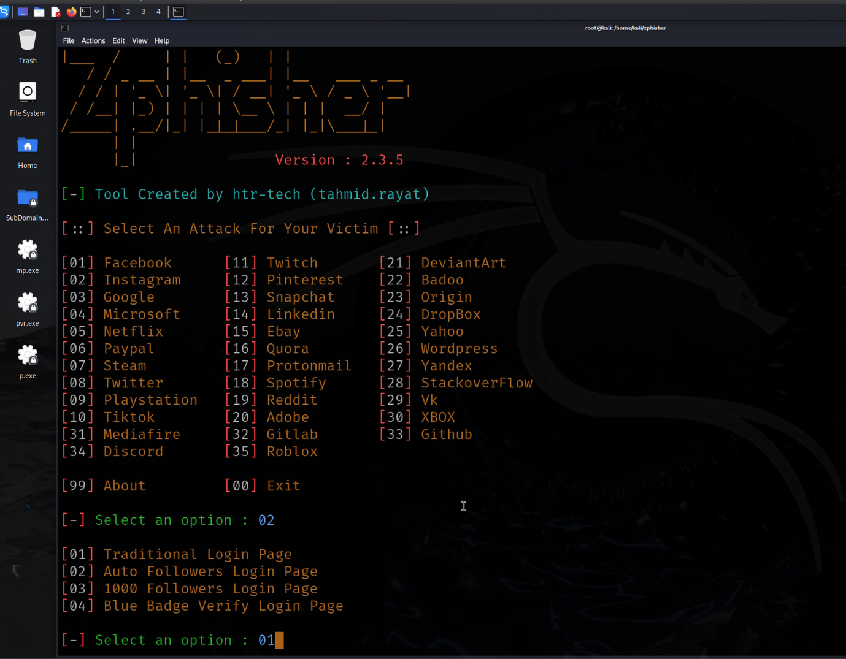

This is how the real website looks like:



