

Nkozi Tours
Group C
─
Members
NDAGIRE CROWIE _ 2025-B201-13111
MUHUMA FREDRICK _2025-B291-13181
MULIRA TENDO MUKISA _ 2025-B291-10549
KISITU VIANNEY _ 2025-B291-13664
ZZIWA VINCENT _ 2025-B201-13832
AGABA KAGUMYA KAKURU _ 2025-B071-13144

Topic and Purpose
Our topic is Tourism.
Nkozi Tours is a tour planner that enables tourists to book tours to see gorillas in Uganda, beach tours in Kenya and climb Mount Kilimanjaro in Tanzania. Nkozi Tours also provides access to accommodation facilities at partner hotels in East Africa and various means of transportation, boasting a variety of vehicle privileges.

Description of each page and its functionality
- Home page
This page provides a quick review of some of the many services provided by Nkozi Tours. It also contains a selection of some of the reviews made by our customers, as well as an FAQ section.
- About us - Vian
This page basically informs the user what Nkozi Tours is all about, identifies the co-creators and states its mission and why you have to choose us over all the available Tours and travel companies. Once a site user clicks on it from the home page, they are redirected to it for such information.
- Services - Agaba
This page shows a short description of the services that our tourism board offers, such as the destinations visited, the accommodations available and the transport the customers will use. This page is directly linked to the checkout page, where customers pick their payment package.

- Signup and login - Crowie
This page is about creating an account on our website, where we have a sign-in page and when you click on create account it takes you to the sign-up page, where a person's details are filled in. This page helps tourists open accounts with our company for easy access to the services provided.
- Blogs - Fredrick
This page displays the different activities done by the different tourists who have booked and gone on our trips. The page also displays the comments by some of the tourists who visited our destinations.
- Check Out - Mulira
The checkout page is a section that enables customers to select a service and a payment method before making a payment. It features various payment methods and payment options.
- Contact and help - Vincent
The page has a contact form that enables users to get in touch with our support Team. It also has an FAQ section for frequently asked questions. Users can enter their email, name and also select the category of the query they ask, before providing details of the query. The FAQ section has some questions and answers that the users can ask about the website.

Summary of Technologies used
- HTML
98.5% of our website is made up of basic HTML code.
- Bootstrap
Almost all elements on the website rely on locally hosted Bootstrap CSS styles, with minor customisations to the default colour themes using a custom Sass file.
- Vue.js
Our Checkout page uses Vue.js to selectively display content in the checkout and payment sections.
- Animate On Scroll (AOS)
Our entire website uses the AOS JavaScript library to animate the elements on the screen.

Screenshots of each page
HOME
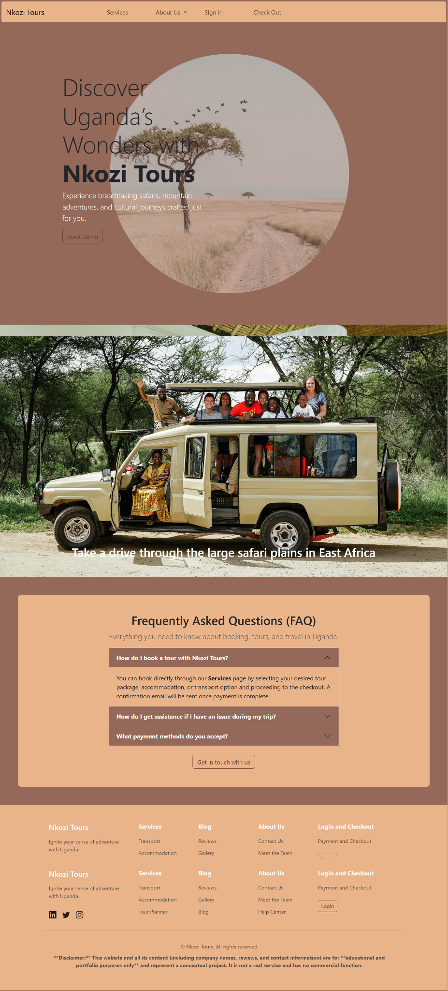

SERVICES
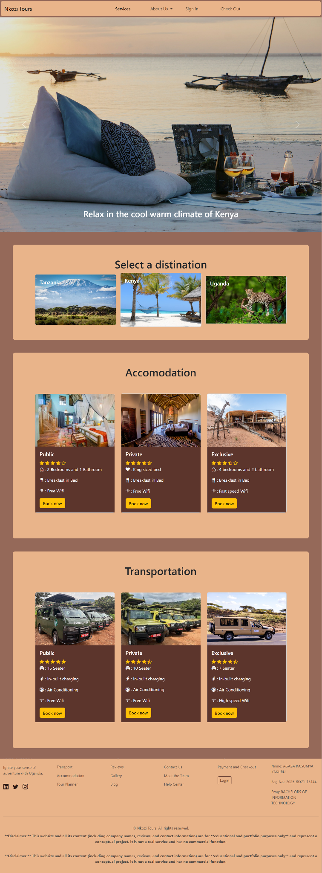
BLOG
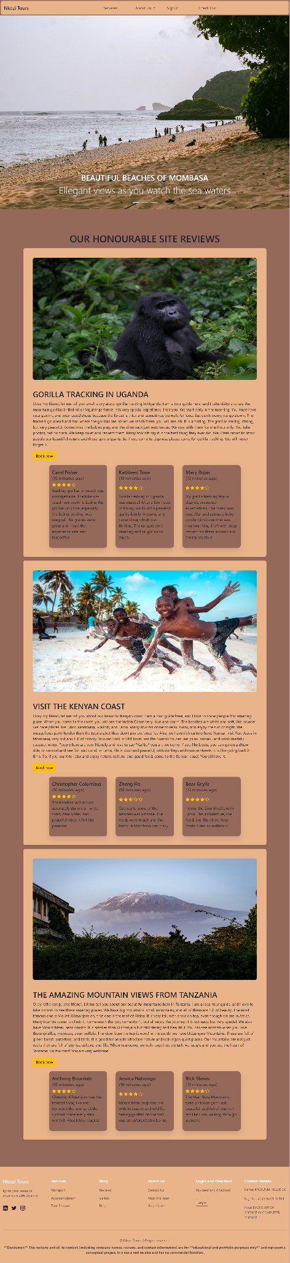
ABOUT US
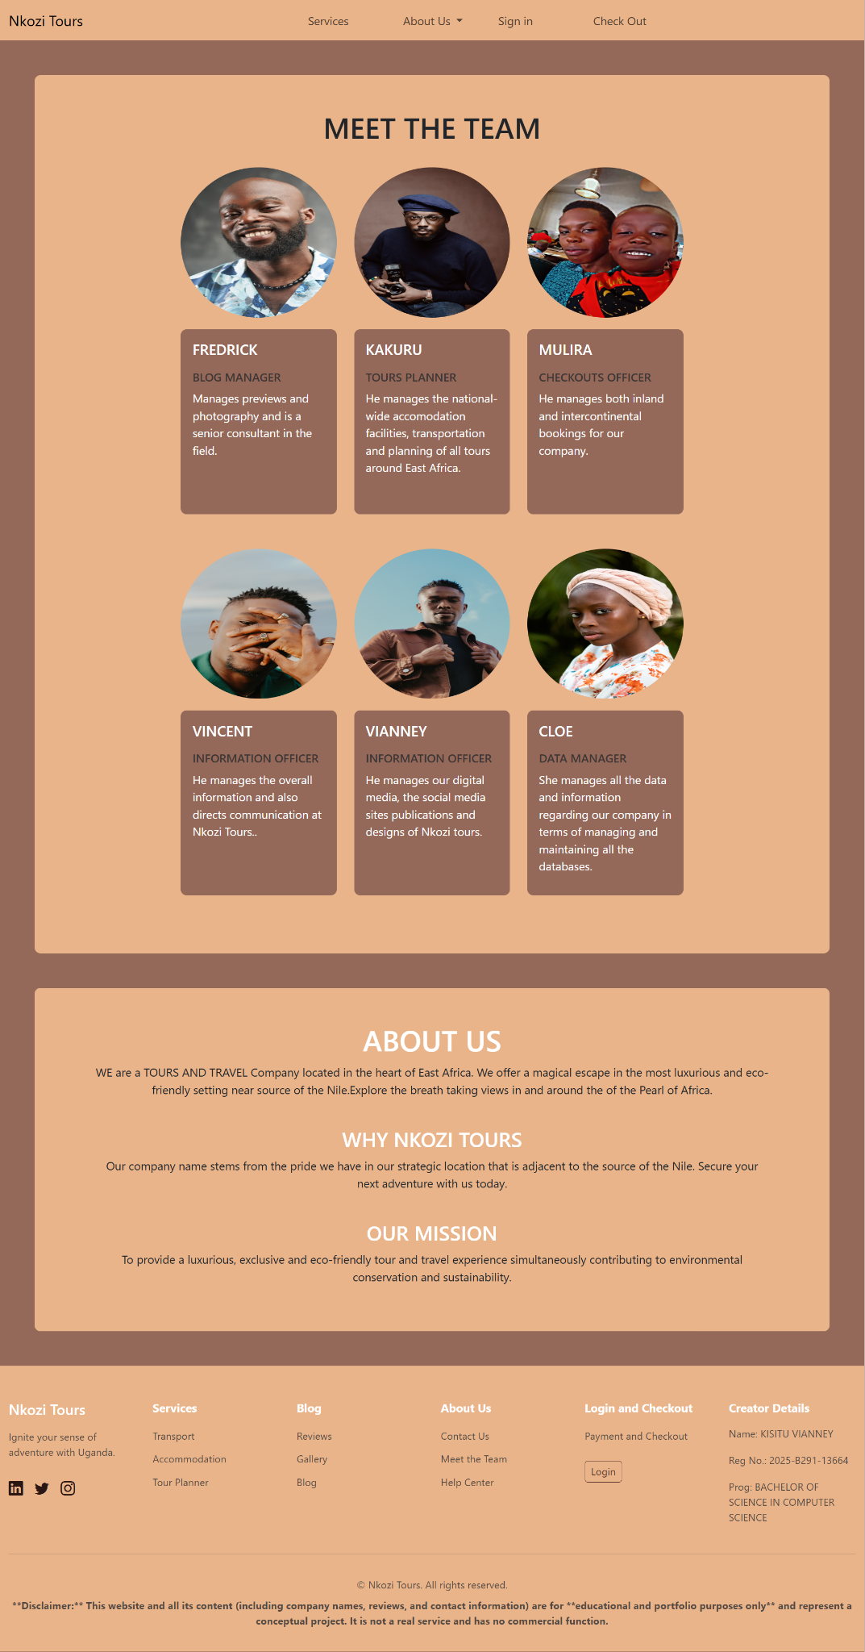
CONTACT AND HELP
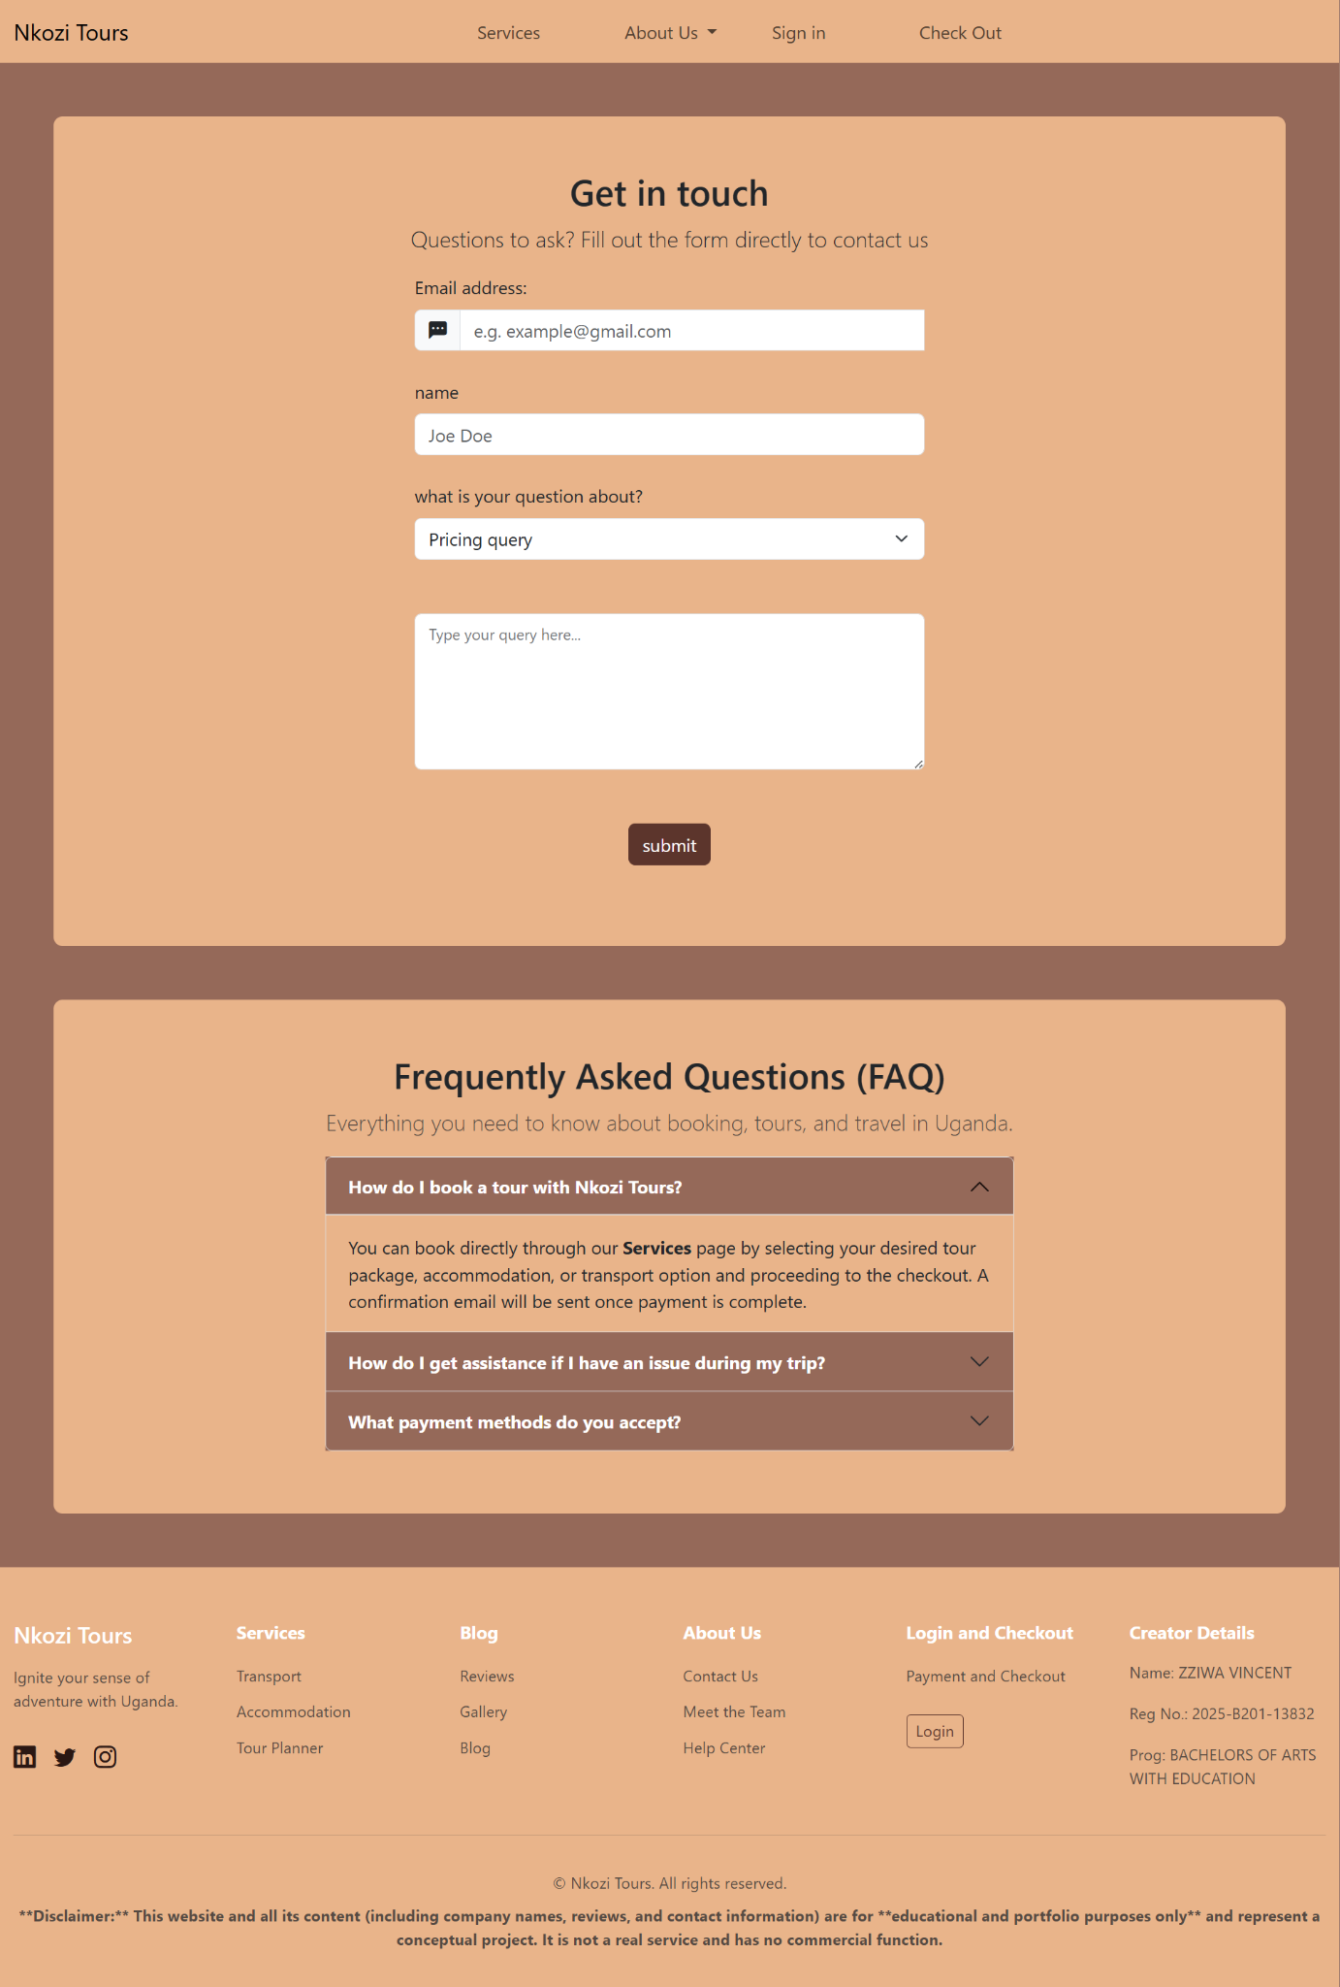

LOGIN
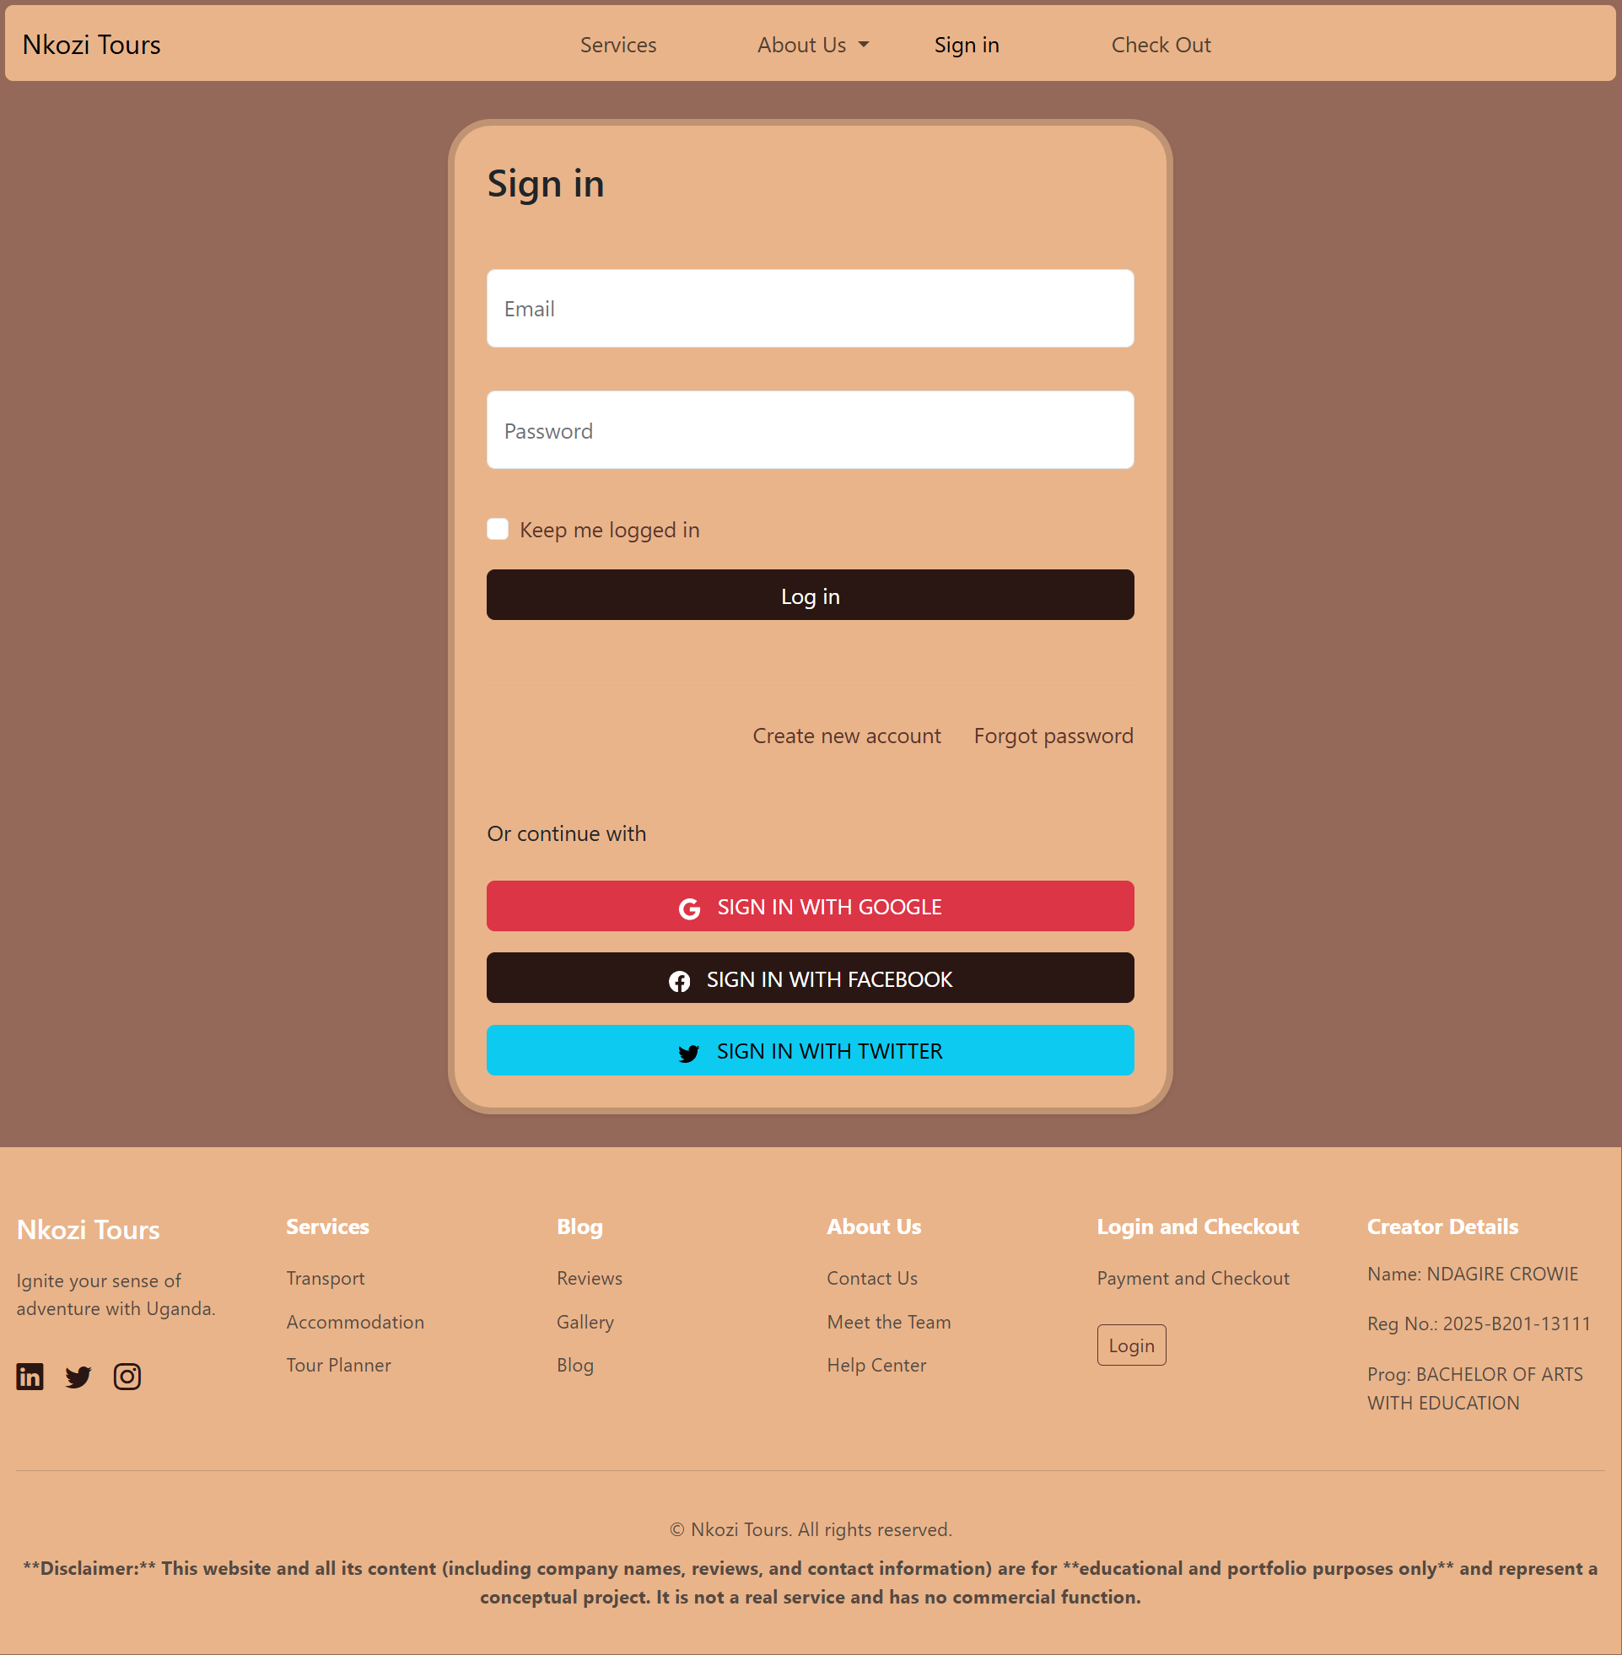
SIGN UP
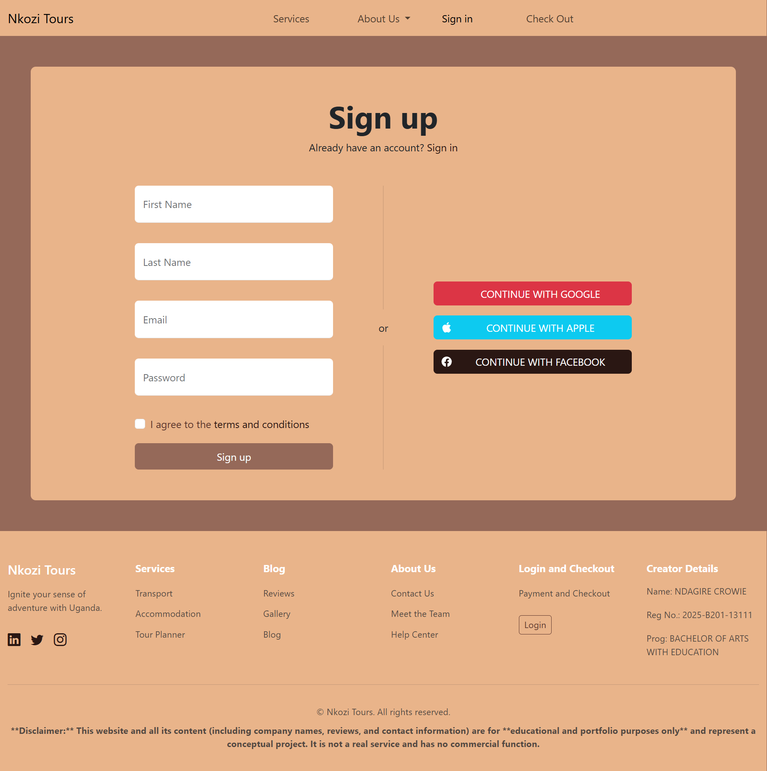

CHECK OUT
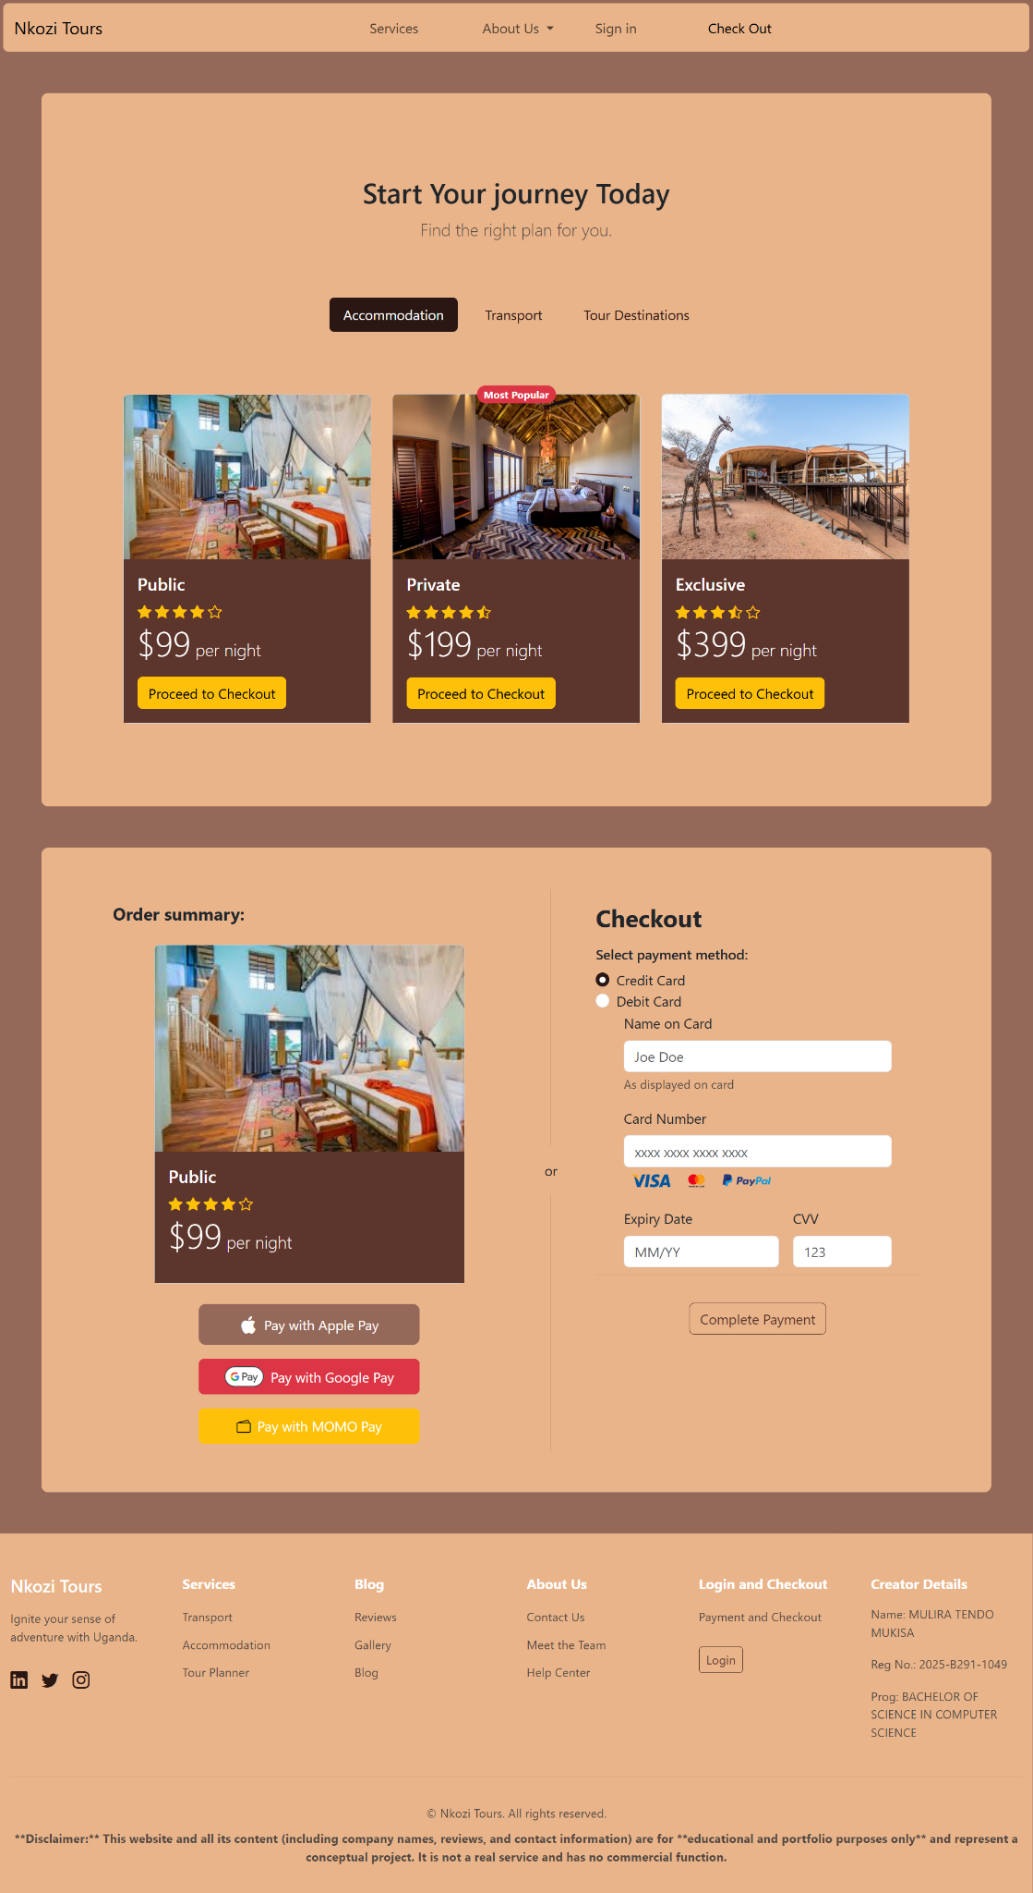

Challenges faced and lessons learned

Challenges faced
- Merging our branches into the main branch.
- Learning how to add APIs.
- Uploading work to GitHub.
- Using some bootstrap features.
- Learning how to use git bash when pushing the work.

Lessons learned
- Collaborating on git hub.
- How to work with git branches
- How to upload work on git hub using git bash
- How to use some of the Bootstrap features

Website Layout

Home
Carrousel
Links and page review
- About Us - Vian
Dev info
About project
- Services - Agaba
Tour Planner
Accomodation
Transport
- Signup & Login - Crowie
Form
Help
Login
Username
Password
Sign up
First and Last name
Email
Password and confirm
- Blog - Fredrick
Reviews
Image gallery
- Checkout - Mulira
Pricing
Payment and Checkout
- Contact & Help - Vincent
Contact Info
Contact form
FAQ

