PART 1: FUNCTIONS

Q1: Write a Dart function named welcomeMessage that prints a welcome message for the school system.

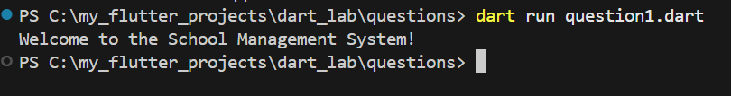

Q2: Write a function named createStudent that uses named parameters (name and age) and prints the student details.

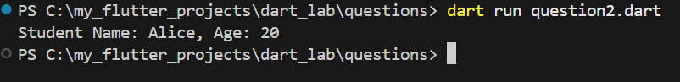

Q3: Write a function named createTeacher with one required parameter name and one optional parameter subject. If subject is not provided, print Subject not assigned.
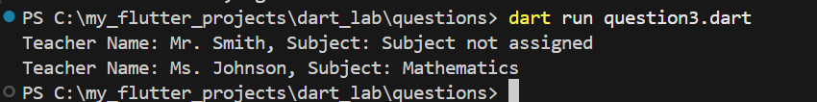

PART 2: CONSTRUCTORS AND CLASSES

Q4: Create a class named Student with name and age, and a constructor to initialize these values.

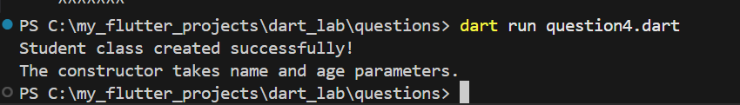

Q5: Create an object of Student and print the student's name and age.

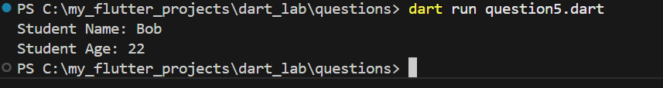

PART 3: INHERITANCE

Q6: Create a class Person with a variable name and a function introduce() that prints the name.

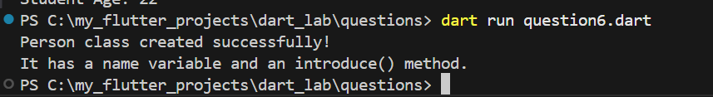

Q7: Make Student inherit from Person and call introduce() from a Student object.

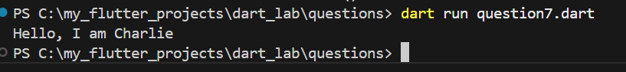

PART 4: INTERFACES

Q8: Create an abstract class Registrable with function registerCourse(String courseName).

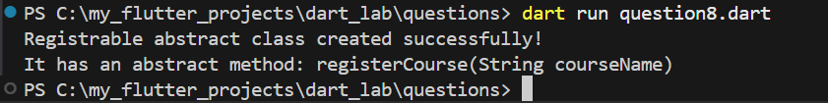

Q9: Make Student implement Registrable and implement registerCourse to print the student name and course.
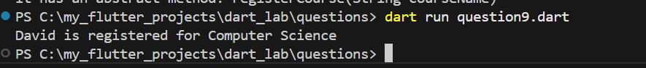

PART 5: MIXINS

Q10: Create a mixin AttendanceMixin that stores an attendance counter and has a function markAttendance() to increase attendance.
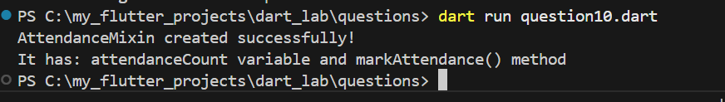

Q11: Apply AttendanceMixin to Student. Mark attendance 3 times and print the attendance.
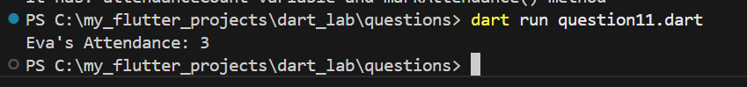

PART 6: COLLECTIONS

Q12: Create a List storing multiple Student objects. Add 3 students.
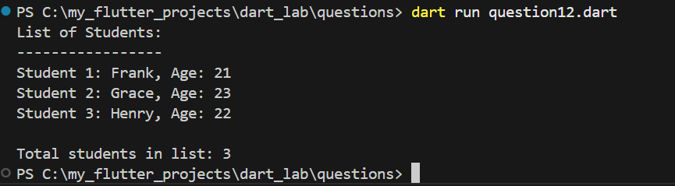

Q13: Create a Map where the key is student ID and value is a Student. Print all student names.
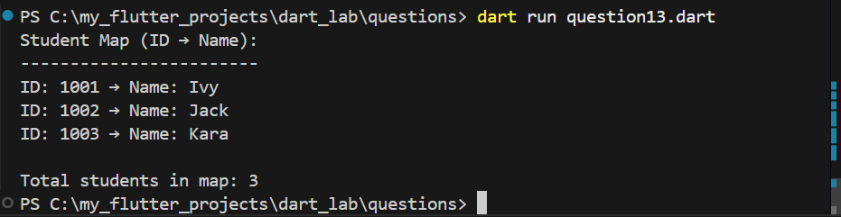

PART 7: ANONYMOUS AND ARROW FUNCTIONS

Q14: Use an anonymous function to print all student names from the list.

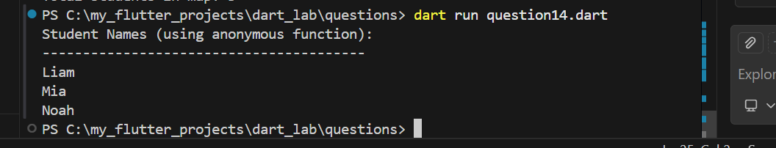

Q15: Write an arrow function that takes a student name and prints a greeting message.

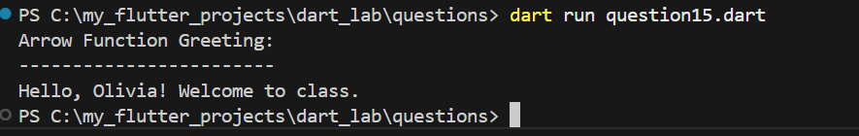

PART 8: ASYNCHRONOUS PROGRAMMING

Q16: Write an async function loadStudents() that waits 2 seconds and returns the list of students.
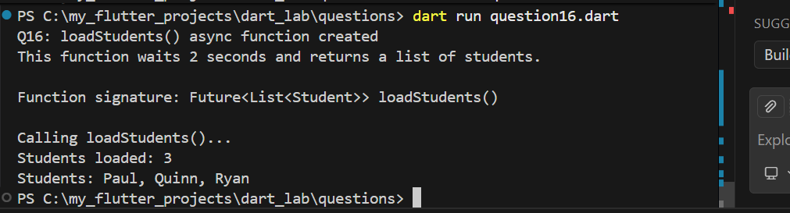

Q17: In main(), call loadStudents(), use await, and print the number of students loaded.

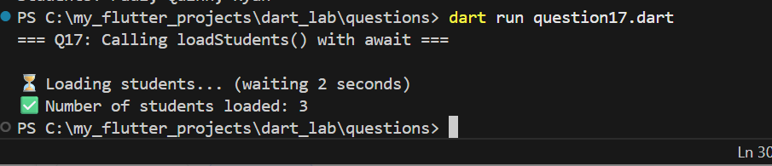
PART 9: INTEGRATION CHALLENGE

Q19: Create a new mixin NotificationMixin that prints a message when a student is registered to a course. Apply it to Student.
