Table of Contents

PREDICT
One Word, Two Roads, and the Ocean Behind Both
Expanded Field Edition
with deep technical notes on how I build AI and how I use AI
SURYA
Expanded Edition
PREDICT: One Word, Two Roads, and the Ocean Behind Both — Expanded Field Edition
Copyright © 2026 by Surya. All rights reserved.
No part of this publication may be reproduced, distributed, or transmitted in any form without prior written permission of the author, except brief quotations in critical reviews.
This is a work of creative nonfiction reflecting the author's personal recollections, learning process, and technical understanding at the time of writing. Every formula, mechanism, and workflow described here is written the way I actually worked through it — first person, in the order I actually learned it — so this book doubles as a field manual for building AI systems and a field manual for using them.
For everyone still standing at the base of the mountain, wondering whether to climb.
CONTENTS
Prologue — The Night I Stopped Sleeping Right
PART ONE — The Ladder: How I Learned to Build It
I. The Lie of Simplicity
II. The Word Underneath Everything
III. The Ladder — How Prediction Learned to Walk (with the full prehistory: Markov, Shannon’s n-grams, Turing, Dartmouth, the Perceptron, symbolic AI, and both AI winters)
III½. What Actually Happens Inside the Sentence
PART TWO — The Road: How I Learned to Use It, and Do the Magic
IV. The Other Side of the Coin
IV½. Three Things Nobody Told Me Early Enough
V. The Evolution of Using AI
V½. Building the Business Analyst — My Break-Even Calculator, Rung by Rung
VI. Two Roads, One Traveler
VI½. The Toolkit I Actually Reach For
VII. The Craft of the Prompt
VII½. The Tool Ecosystem — MCP and the Wiring Between Model and World
VIII. Evaluation and Deployment — Where Most Projects Actually Die
VIII½. Open Weights, Closed Weights, and Running a Model on My Own Machine
Epilogue — The Ocean I Fell Into
About the Author
PROLOGUE
The Night I Stopped Sleeping Right
I am the kind of person who cannot just use something. I have to open it — take the back off, look at the wiring, ask why the current flows the way it flows. Give me a phone and I don't care about the camera, I care about the chip. Give me a market and I don't care about the price, I care about the crowd of minds that produced it. This isn't a hobby. It's closer to a compulsion.
So when something finally pulled at me harder than anything else ever had, I noticed. It didn't feel like curiosity anymore. It felt like gravity — like standing at the base of a mountain that every other mountain seemed to lean toward. AI. Not the headlines, not the hype reels, not the LinkedIn posts calling every prompt a "breakthrough." I mean what happened when I sat alone at 2 a.m. with a blinking cursor and a stubborn need to understand the machinery underneath the magic trick.
This book is part history, part confession, part field notes from someone still, right now, in the middle of building his way through it.
There are two sides to this story, and I've written them as two roads rather than a pile of chapters, because that's really what they are. Part One is the ladder — how prediction became a machine, rung by rung, for seventy years, and I climb every rung slowly enough this time to actually show you the mechanism inside each one: the formula, the failure mode it fixed, and the intuition that finally made it click for me. Part Two is the road — how I, and people like me without a research lab or a warehouse of GPUs, actually use that machine to build real things, employee by employee, tool by tool. Both roads run on the same single word. I promise you'll see it by the end, and I promise that by the end you'll have enough of both — the theory under the hood and the wiring diagram for actually building something — to stop being a tourist in either world.
PART ONE
The Ladder
How Prediction Learned to Walk — and How I Learned to Build With It
I
The Lie of Simplicity
The first thing I learned about AI is that the word itself is a lie — not a malicious one, just a lazy one. "AI" sounds like a single subject, something you study for a weekend and check off a list. It isn't. It's an ocean, and the moment you put a toe in, you find provinces: machine learning a continent, deep learning a mountain range inside it, reinforcement learning and computer vision and NLP each a lifetime of its own. Pull one thread — gradient descent, say — and it unravels into calculus, linear algebra, probability, the physics of how information moves through numbers.
I kept asking the same annoying question that has haunted me in every domain I've entered: why is this thing eating every other field alive? Medicine, trading, art, law, a documentary editor's bay, a farmer's irrigation schedule. What mechanism lets one technology metastasize across all of human effort at once?
When I actually mapped the field instead of just admiring it from outside, I found it breaks into a handful of honest provinces, and knowing the map stopped me from confusing one province's tools for another's:
- Supervised learning — I already have labeled examples (input, correct output) and I'm teaching a function to reproduce that mapping on new inputs it hasn't seen. Almost everything in Part One's ladder lives here.
- Unsupervised learning — I have data but no labels, and I'm asking the system to find structure on its own: clusters, compressed representations, anomalies that don't fit the pattern.
- Self-supervised learning — the trick that quietly built the entire large-language-model era. I manufacture the label from the data itself — hide the next word and ask the model to predict it — so I get supervised-learning's power without paying a human to label anything.
- Reinforcement learning — no fixed correct answer at all, just a reward signal from acting in an environment, and the system has to discover, through trial and consequence, which sequence of actions accumulates the most reward over time.
I went down the rabbit hole for real — long nights, the kind where the sky outside changes color without your permission. And at the bottom I found something that didn't feel like a fact. It felt like a key. The thing that rules all of it isn't a machine, an algorithm, or some emergent magic hiding in silicon. It's one word.
PREDICT.
Once I had that key, the whole intimidating taxonomy stopped being a wall of unrelated acronyms and turned into variations on a single question: given what I've already seen, what comes next, and how confident am I? A spam filter predicts a label. A translation model predicts a sequence of tokens in another language. A recommendation engine predicts which item you'd click. A self-driving car's perception stack predicts where every other object in the scene will be a half-second from now. Different inputs, different outputs, identical skeleton.
II
The Word Underneath Everything
One word is running the most talked-about technology in human history. Not intelligence. Not consciousness. Not even learning, really — learning is just the process by which a system gets better at this one core act. Every large language model, every fraud detector, every recommendation feed, every self-driving car's perception stack is, underneath the branding, a machine guessing what comes next given what came before.
A language model doesn't know language — it predicts the next token, at a speed no human could sustain, until the predictions start looking like thought. A trading algorithm doesn't understand the market — it predicts the next tick from the shape of the ticks before it. A vision model doesn't see a cat — it predicts the label most consistent with the pixels. Peel back any AI system enough times and you land on the same floor: a probability distribution over what happens next, sharpened by data.
But it stopped being a fact about computers the moment I zoomed out. Because it isn't just AI — it's everything. This entire biological world runs on the same loop: sense the environment, predict what's about to happen, act to survive the prediction, then compare the outcome against the prediction to update the next guess. A gazelle that predicts the lion's angle of approach half a second sooner, lives. A trader who predicts the crowd's next move a moment before the crowd does, profits. Your amygdala fires before you consciously register fear because it already predicted the threat. Your dopamine system doesn't reward the treat — it rewards the accuracy of the prediction that led to it, which is why a surprise reward spikes harder than an expected one. Neuroscience even has a name: reward prediction error.
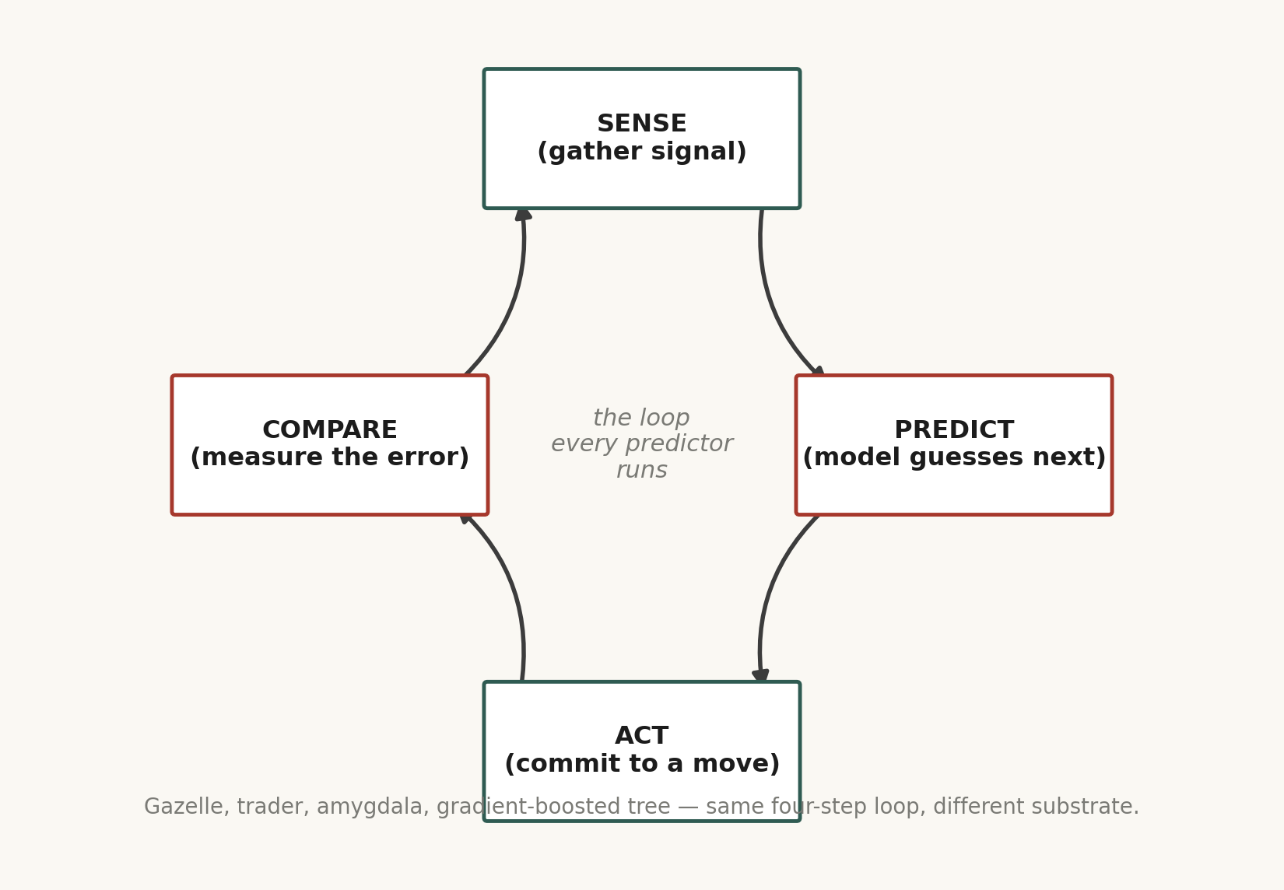
Sense, predict, act, compare — nature ran this loop for a billion years before anyone called it machine learning.
Karl Friston's free energy principle pushes this further than I was ready for the first time I read it: that everything a living brain does — perceiving, moving, even attention — can be described as minimizing the gap between what it predicted and what it actually sensed. Not maximizing pleasure. Minimizing surprise. I don't bring this up to claim AI and brains are the same thing — the substrates are worlds apart — but it means the word I found at the bottom of the AI rabbit hole isn't a coincidence of engineering. It might be closer to the operating principle of any system, biological or artificial, that has to survive inside an environment it can't fully control.
Why prediction beats memorization
The deeper I dug, the clearer it became that pure memorization is a dead end for any system that has to face a world it hasn't fully seen yet. A lookup table only ever answers questions it was already asked. Prediction, by contrast, is a compression trick — a model that has genuinely learned the structure behind data can answer questions it was never explicitly given, because it has captured the rule generating the examples, not just the examples. This is exactly why a language model trained only to predict the next token starts to look like it can reason, summarize, translate, and code: those are all downstream consequences of having compressed an enormous chunk of human-written structure into a predictive rule.
So in that oldest game there is, who survives? Not the strongest — strength is expensive and slow. Not even the smartest, if smart just means holding more facts. The one who predicts fastest, and adjusts quickest when the prediction is wrong. That's the whole game, stripped to its skeleton. And AI is that same principle wearing a different coat — linear algebra and silicon instead of blood and instinct.
III
The Ladder — How Prediction Learned to Walk
The ambition started humble: predicting something small and linear, like a house price from its square footage. But the problems kept getting harder, and stubbornly, step by step, we kept solving them. That slow climb became a ladder. Most people who talk about AI never actually climbed it — they teleported to the top and started narrating. So here it is, rung by rung, and this time I'm not skimming past the mechanism — I'm showing you the actual gear-work, the way I had to sit with each one until it stopped being a black box.
But before I climb the ladder most people know, I have to show you the foundation underneath it — the part almost nobody tells you about, because it happened before “machine learning” was even a phrase anyone used casually. I didn't understand the ladder for real until I went down into that foundation and found the same word already waiting for me, decades before the first neural network.
Rung −3 — Markov and the Idea That the Future Only Needs the Recent Past (1906–1913)
Andrei Markov, a Russian mathematician, wasn't thinking about machines at all. He was arguing with a colleague about independence in probability, and to make his point he did something almost absurdly simple: he counted, by hand, how often each letter in Pushkin's poem Eugene Onegin was followed by a vowel versus a consonant, across twenty thousand letters. What he proved is the single idea every language model on Earth still leans on today — a Markov chain: the probability of what comes next depends only on the current state, not on the entire history that led there.
P(next state | all previous states) = P(next state | current state)
That one-line assumption is a lie, technically — of course the tenth word of a sentence depends on more than just the ninth word — but it's a useful lie, because it turns an intractable problem (track everything that ever happened) into a tractable one (track only what just happened). Every rung above this one, all the way to a modern transformer, is really just a more and more sophisticated way of cheating on that assumption — widening how much “current state” actually means, from one letter, to a handful of words, to, eventually, an entire attention window across a document. The first time I actually sat with Markov's original letter-counting exercise, something clicked that no amount of reading about transformers had given me: prediction didn't start with silicon. It started with a man and a pencil, counting letters in a poem, a hundred years before GPT.
Rung −2 — Shannon, Entropy, and the Birth of the N-Gram (1948)
Claude Shannon's 1948 paper, A Mathematical Theory of Communication, is the document I'd point to if someone forced me to name the single most important paper in the entire history of this field — more than any deep learning paper, because it's the one that first turned “information” itself into a number you could compute with. Shannon defined entropy, a precise measure of how much uncertainty — how much genuine surprise — sits inside a message:
H(X) = −Σ p(x) log₂ p(x)
A fair coin flip carries exactly one bit of entropy: maximum uncertainty, maximum surprise. A rigged coin that always lands heads carries zero bits: no surprise at all, because you already knew the answer. Language, Shannon showed, sits somewhere in between — not random, but not fully predictable either, and the gap between “fully random” and “fully predictable” is exactly the room a predictive model gets to live in.
To make the idea concrete, Shannon ran an experiment that is, in hindsight, the direct ancestor of every language model I now use daily. He built what we'd now call a bigram model — a table of how often each letter follows each other letter, estimated from real English text — and used it to generate new text, one character at a time, sampling from that table. Then he tried it again with a trigram model, three letters of context instead of two, and the generated text got visibly more English-like, because more context means a sharper, less uniform probability distribution over what comes next. He did the same trick one level up, with whole words instead of letters, and word-level bigram and trigram models produced garbled but recognizably English-flavored sentences, decades before anyone had a computer capable of training one at real scale.
An n-gram model, stripped to its core, is nothing more than a giant counting table: for every sequence of n−1 words seen in a huge pile of text, how often was each possible next word the one that actually followed?
P(wₙ | w₁, w₂, ..., wₙ₋₁) ≈ count(w₁...wₙ) / count(w₁...wₙ₋₁)
That’s it. No gradient descent, no neurons, no attention — just division. And that formula, as primitive as it looks sitting next to a transformer’s attention equation, is doing the exact same job: producing a probability distribution over the next token given some amount of prior context. The whole seventy-year story I climb through this chapter is, underneath the escalating cleverness, a story about two things getting better together — how much context the model can actually use, and how efficiently it can represent that context without its counting table exploding in size. A trigram model over a 50,000-word vocabulary already needs, in principle, 50,000³ possible entries — most of which are never seen in any real corpus, a problem statisticians call sparsity, and the entire reason smoothing techniques (Laplace smoothing, Katz backoff, Kneser-Ney smoothing in the 1990s) had to be invented: ways of assigning a small, non-zero probability to word sequences the model had literally never seen in training, because “probability zero” for an unseen phrase is a catastrophic overreaction to a training set that will never be complete. I didn’t fully respect how elegant Kneser-Ney smoothing was until I implemented a toy trigram model myself and watched it fall apart on any sentence slightly outside its training text — and then watched smoothing patch exactly that hole.
I want to be honest about what this rung taught me, because it reframed everything above it: an n-gram model and a transformer are not different ideas. They are different engineering answers to the same question — how do I compress a huge pile of text into a function that predicts what comes next — separated by seventy years of better answers to “how do I represent context without the table exploding.” Embeddings replace the counting table with a dense vector space. Attention replaces “the last n−1 words” with a dynamically weighted look back across the entire sequence. Neither idea would have been legible to me without first sitting with Shannon’s bigrams and feeling, in my own hands, why counting alone eventually runs out of room.
Rung −1 — Turing’s Question, the Perceptron, and the First Winter (1950–1974)
In 1950, Alan Turing published Computing Machinery and Intelligence and, rather than trying to define “thinking” — a word he correctly suspected was a trap — he replaced it with a test: could a machine’s written answers be indistinguishable from a human’s, to a skeptical judge, in conversation? He called it the Imitation Game. Whatever you think of the test’s limits, the reframing itself was the real contribution: stop arguing about the nature of intelligence, and start asking whether a system’s outputs are functionally good enough to fool a discerning observer. That’s a prediction question, dressed as a philosophy question, and I don’t think that’s a coincidence.
Six years later, in the summer of 1956, a small group of researchers — John McCarthy, Marvin Minsky, Claude Shannon among them — gathered at Dartmouth College for a workshop whose funding proposal coined the term “artificial intelligence” outright, and whose stated ambition, read today, is almost touching in its confidence: that “every aspect of learning or any other feature of intelligence can in principle be so precisely described that a machine can be made to simulate it,” and that a serious group of researchers working together for a summer could make significant progress on it. They were wrong about the timeline by decades. They were not wrong about the premise.
In 1958, Frank Rosenblatt built the Perceptron — a single artificial neuron, a weighted sum followed by a step function, trained on an actual room-sized machine (the Mark I Perceptron) to classify simple images. It’s Rung 1 of the ladder I climb later in this chapter, just built two decades earlier than the label “linear model” suggests, and Rosenblatt’s own claims for it to the press were, in hindsight, wildly overinflated — he suggested it might one day walk, talk, and reproduce itself. Then in 1969, Minsky and Papert published a book, simply titled Perceptrons, that proved a single-layer perceptron mathematically cannot learn certain simple patterns — most famously, XOR, a function so basic it fits in a two-by-two table, but one that no straight line can separate. The proof was narrow — it said nothing about stacked layers of perceptrons, which can solve XOR easily, and which is exactly Rung 3’s neural network — but the field read it as a verdict on neural networks broadly, funding dried up, and what’s now called the first AI winter set in through the 1970s.
I find this rung the most humbling one in the entire ladder, because the “failure” wasn’t really a failure of the idea. It was a failure of depth — the fix, stacking layers with a nonlinearity between them, was sitting right there the whole time, mathematically. What was missing wasn’t insight. It was an efficient way to train more than one layer at once, which is exactly what backpropagation, popularized a decade and a half later, turned out to be. Progress on this ladder, I learned rung by rung, doesn’t always fail because an idea was wrong. It sometimes fails because the tooling to realize the idea hadn’t been invented yet, and it’s brutally hard, standing inside a winter, to tell those two failures apart.
Rung −0.5 — Symbolic AI, Expert Systems, and the Second Winter (1970s–1990s)
While the connectionist thread (perceptrons, and later neural networks) went quiet, a different bet dominated AI for two decades: symbolic AI, sometimes called “Good Old-Fashioned AI.” The premise was that intelligence is fundamentally about manipulating symbols according to explicit logical rules — if this, then that — hand-written by human experts. Expert systems like MYCIN (medical diagnosis, 1970s) and XCON (configuring computer orders for Digital Equipment Corporation, generating real commercial value by the early 1980s) were built this way: thousands of hand-coded if-then rules, painstakingly extracted from human specialists.
It worked, for a while, in narrow domains with clean rules. It didn’t scale, because the real world doesn’t hold still long enough for a human to hand-write every rule it needs, and every new edge case meant another engineer, another rule, another chance for two rules to quietly contradict each other deep in a system nobody could fully audit anymore. By the late 1980s, the cost of maintaining these systems outpaced their value, funding collapsed again, and the second AI winter set in through the early 1990s. I think about this rung every single time I catch myself hand-coding a long chain of rigid rules into one of my own agents instead of trusting a well-prompted model with a good tool — that instinct, “just write more rules,” is the exact instinct that built expert systems, and it’s the exact instinct the Bitter Lesson, a few chapters ahead of this one, eventually taught me to distrust.
Rung −0.25 — The Statistical Turn and the Quiet Revival (1980s–1990s)
Two things happened almost in parallel that pulled the field out of its second winter, and both of them are, again, prediction wearing a different coat. First, IBM researchers in the late 1980s and early 1990s (the “IBM alignment models” for statistical machine translation) proved that raw n-gram statistics, applied at real scale with real computing power, could translate French to English competitively against hand-built rule systems that linguists had spent years constructing — data and counting starting to visibly outperform hand-engineered expertise, decades before the Bitter Lesson gave that pattern a name. Second, in 1986, Rumelhart, Hinton, and Williams published the paper that popularized backpropagation for training multi-layer neural networks — the exact fix the first winter had been missing — and a smaller connectionist revival followed, alongside John Hopfield’s associative memory networks (1982) and the broader “parallel distributed processing” movement.
Neither revival was the one that changed the world. Compute in the 1980s and 90s still wasn’t remotely close to what deep learning would eventually need, and n-gram language models, while genuinely useful in speech recognition and early machine translation, hit a hard ceiling: no amount of more data lets a 3-word or 5-word context window understand that “it” on page three refers to a name on page one. That specific limitation — fixed, short context — is the exact problem every subsequent rung above Rung 1 exists to solve, and it’s the reason I can’t actually separate the two halves of this book cleanly. The entire history of “using AI better” and the entire history of “building AI better” are the same seventy-year argument about how much of the past a prediction is allowed to see before it has to guess.
Long before gradient descent, before attention, before the word “transformer” meant anything but a piece of electrical equipment, someone was already counting how often one thing followed another and calling the result a probability. Everything since has been a better answer to the exact same question Markov asked with a pencil and a poem.
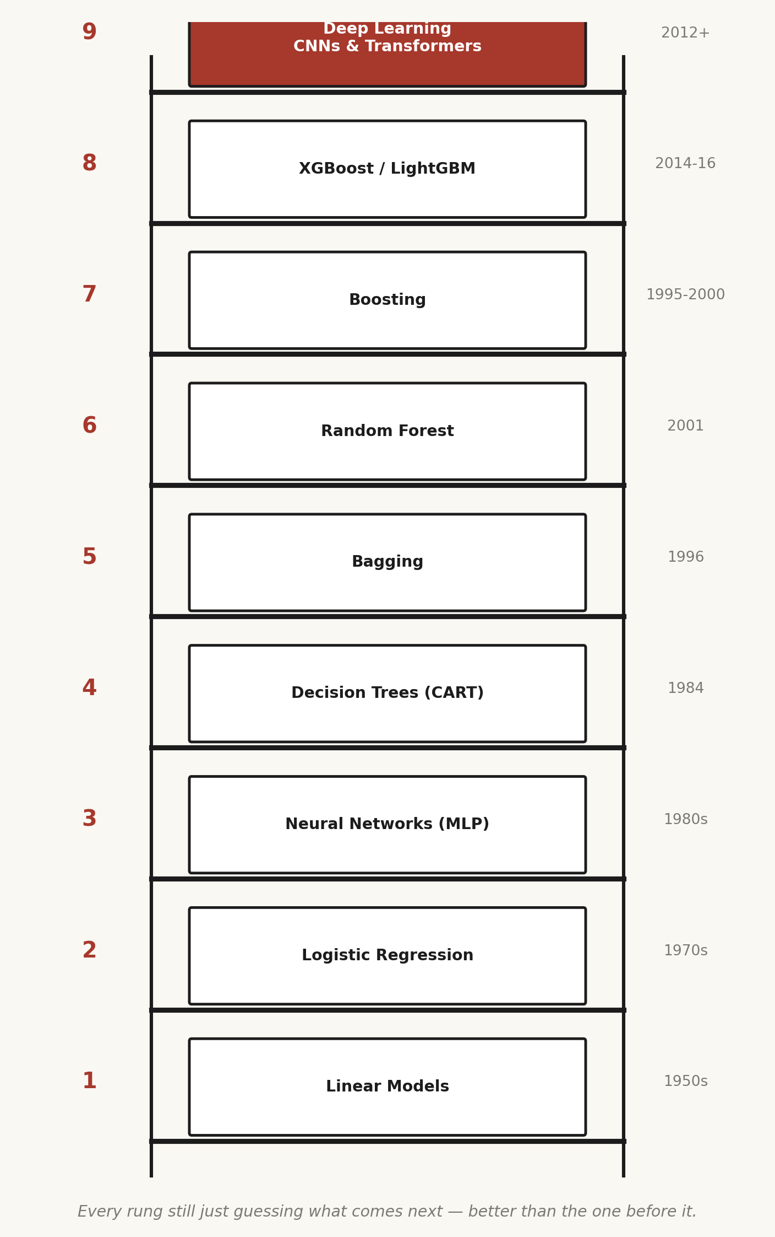
The ladder I climbed — every rung still just guessing what comes next, better than the one before it.
Rung 1 — Linear Models (1950s)
A weighted sum: multiply each input by an importance factor, add a baseline, get a prediction. The ancestor of every neural network since — GPT, Claude, Gemini all still have millions of these exact weighted sums stacked inside them. We just learned to bend the line.
ŷ = w₁x₁ + w₂x₂ + ... + wₙxₙ + b
The part nobody explained to me plainly at first: how does the machine actually find the right weights, w? It doesn't guess randomly forever. It starts with a loss function — a single number describing how wrong the current weights are, usually mean squared error, the average of (prediction − actual)² across every training example. Then it uses gradient descent: compute the slope of that loss with respect to each weight, and nudge every weight a small step in the direction that makes the loss smaller. Repeat thousands of times and the weights walk downhill into a configuration that fits the data. The learning rate controls the size of each step — too large and the walk overshoots and diverges, too small and it takes forever to arrive. That single walk-downhill idea, gradient descent, is the engine underneath every rung above this one, all the way to the largest transformer. I didn't fully respect how universal it was until I'd implemented it by hand for a one-variable regression and watched the loss curve fall in real time — that was the moment linear regression stopped being 'a line of best fit' and became 'the simplest possible instance of the exact same optimization loop that trains GPT.'
Rung 2 — Logistic Regression (1970s)
The line, passed through a sigmoid, now outputs a probability instead of a raw number. The first time a machine explicitly models uncertainty — "I'm 73% sure this is spam" instead of pretending certainty.
p = 1 / (1 + e^-(w·x + b))
The sigmoid squashes any real number into the range (0, 1), which is what lets the output be read as a probability. The loss function changes too — not squared error, but log loss (cross-entropy), which punishes a confident wrong answer far more harshly than a hesitant wrong answer. That asymmetry matters enormously in practice: a model that says '51% fraud' and is wrong costs you a little; a model that says '99% fraud' and is wrong costs you a lot, and log loss is built to reflect that. This is also the first rung where I had to learn to read a decision boundary — the line, now curved slightly by the sigmoid, that separates the two predicted classes — and to understand that logistic regression is still fundamentally linear underneath: it draws one straight boundary through the feature space, just wrapped in a probability.
Rung 3 — Neural Networks / MLP (1980s)
Stack linear models with a nonlinear activation between each layer, trained by backpropagation, and the whole thing bends into shapes a single line never could — edges become shapes become objects become meaning, the same trick your visual cortex pulls.
layer output = activation(W·x + b), stacked layer after layer
Two ideas had to click for this rung to stop feeling like magic. First: the universal approximation theorem, which says a neural network with even one hidden layer, given enough neurons, can approximate essentially any continuous function — the network's power comes from the nonlinear activation between layers (ReLU, sigmoid, tanh) breaking the whole stack out of being 'just one big linear model in disguise.' Without that nonlinearity, ten stacked linear layers collapse mathematically into one linear layer — depth would be pointless. Second: backpropagation, the algorithm that makes training a many-layered network tractable. It applies the chain rule from calculus, working backward from the loss at the output layer, computing how much each weight in every earlier layer contributed to that error, and updating all of them in a single efficient pass. Before backpropagation was popularized in the 1980s (Rumelhart, Hinton, Williams), nobody had an efficient way to assign blame across many layers — this is the single mechanical breakthrough that made 'deep' learning possible at all, decades before the compute existed to make it spectacular.
Rung 4 — Decision Trees, CART (1984)
A series of yes/no questions instead of a curve — the most human-readable model on the ladder, but prone to memorizing noise as if it were signal: overfitting.
A tree grows by repeatedly asking: which single yes/no question about the data, at this node, splits the remaining examples into the purest possible groups? Purity is measured with Gini impurity or entropy — both are ways of scoring how mixed the classes are within a group, and the tree greedily picks the split that reduces that mixture the most. Keep splitting and eventually every leaf contains a tiny handful of training examples, fit so perfectly that the tree has memorized the noise in the training set along with the real pattern — this is overfitting, the central disease of every model on this ladder, and the entire next four rungs exist largely as engineering responses to this one failure mode. Depth limits, minimum-samples-per-leaf, and pruning are all just different ways of telling the tree 'stop before you start memorizing.'
Rungs 5–6 — Bagging (1996) and Random Forest (2001)
Grow a hundred trees on random slices of data and features, let them vote. Democracy applied to models — no single overconfident tree dominates, and the workhorse of applied ML for two decades is born.
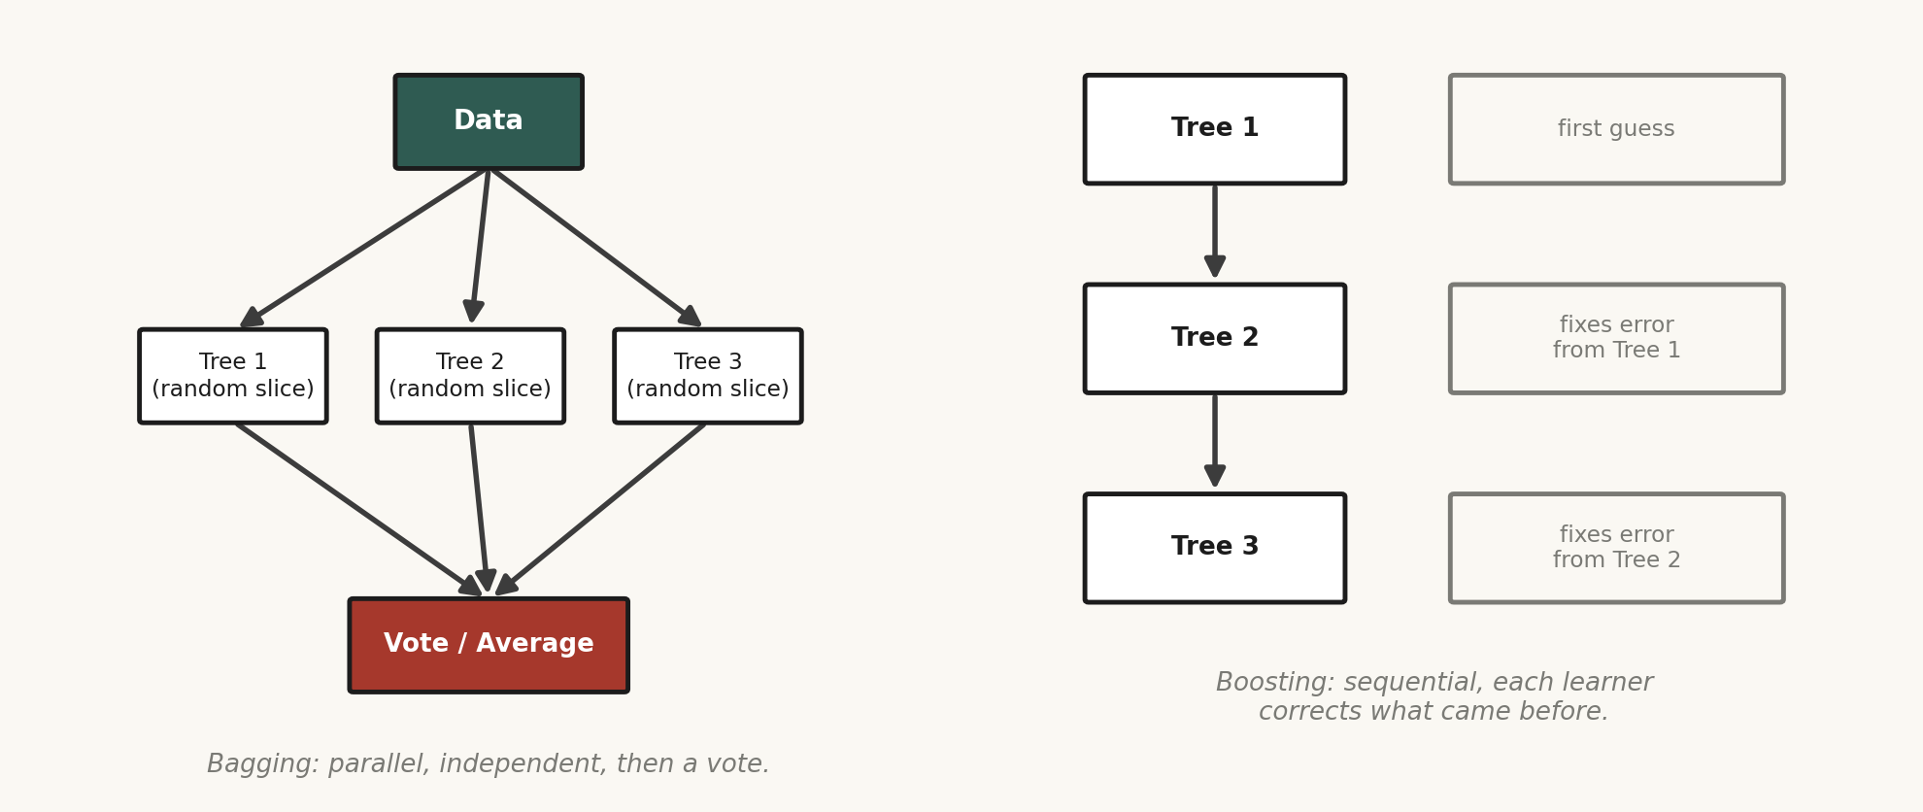
Bagging trains trees in parallel and votes; boosting trains trees in sequence, each one correcting the last.
Bagging (bootstrap aggregating) works because of a clean statistical fact: averaging many high-variance, low-bias models cancels out their individual noise while preserving their shared signal, as long as the errors aren't perfectly correlated. Bootstrap sampling — drawing random samples with replacement from the training set for each tree — is what decorrelates the trees in the first place; without it, every tree would just be a copy of the same overfit model. Random Forest pushes the decorrelation further by also restricting each split to consider only a random subset of features, so trees can't all lean on the one dominant variable and end up correlated anyway. The result, when I actually benchmarked it myself against a single deep tree on noisy data, was startling: individually mediocre trees, averaged, consistently beat one very deep, very overfit tree — my first real, hands-on proof that an ensemble of weak, diverse guesses can out-predict one strong, brittle guess.
Rung 7 — Boosting (1995–2000)
Build one weak tree, see exactly where it fails, build the next tree to fix those failures. A chain of humility — each learner admits what it doesn't know and hands the problem to the next.
F_m(x) = F_{m-1}(x) + η · h_m(x) where h_m fits the residual error of F_{m-1}
Where bagging runs trees in parallel and averages, boosting runs them in sequence and corrects. Each new tree, h_m, isn't trained to predict the target directly — it's trained to predict the residual, the gap between the current ensemble's prediction and the true answer. The learning rate η shrinks each correction so the ensemble improves gradually rather than overreacting to any single tree's fix, which is what keeps boosting from overfitting as fast as its raw power would otherwise suggest. AdaBoost, the earliest popular version, did this by reweighting misclassified examples so the next learner paid more attention to them; gradient boosting generalized the idea into fitting residuals directly via gradient descent on an arbitrary loss function, which is the version that scaled into everything after it.
Rung 8 — XGBoost / LightGBM (2014–2016)
Gradient boosting re-engineered for real-world speed. Quietly some of the most deployed models on Earth — a bank scoring your loan or an insurer pricing your premium is more likely running one of these than a flashy neural net.
What XGBoost actually added on top of plain gradient boosting is worth knowing precisely, because it's the difference between a research idea and a production workhorse: explicit L1/L2 regularization terms added directly into the loss function to penalize overly complex trees, a second-order (Newton's method) approximation of the loss for faster, more accurate convergence, and highly optimized handling of missing values and sparse data. LightGBM pushed speed further with histogram-based binning of continuous features (trading a little precision for a lot of speed) and leaf-wise tree growth instead of level-wise, which grows the single leaf that reduces loss the most at each step rather than growing every leaf at a given depth evenly. In every tabular-data project I've built — the trading systems, the risk scoring — this rung, not deep learning, was almost always my first and most reliable tool. Deep learning wins on unstructured data: images, audio, raw text. Gradient boosting still quietly wins on the rows-and-columns data that runs most of the world's actual business decisions.
Rung 9 — Deep Learning: CNNs and Transformers (2012+)
AlexNet (2012), trained on GPUs, crushed ImageNet and pivoted the field overnight. Then in 2017, "Attention Is All You Need" introduced the Transformer — every part of the input looking at every other part simultaneously, deciding mathematically how much to attend to each. That mechanism is what lets a model understand a pronoun on page three referring to a name on page one. Scale it up and you get GPT, Claude, every model reshaping the world as I write this.
Before transformers, sequence models like RNNs and LSTMs processed text one token at a time, in strict order, carrying a compressed memory forward — which meant they were slow to train (no parallelism across the sequence) and prone to forgetting information from far earlier in a long sequence, since it had to survive being repeatedly compressed through every intermediate step. The transformer's self-attention mechanism solves both problems at once by letting every token look directly at every other token in a single step, regardless of distance, and by processing the whole sequence in parallel rather than one step at a time. Concretely, every token is projected into three vectors — a Query, a Key, and a Value — and attention is computed as:
Attention(Q, K, V) = softmax(QKᵀ / √d_k) · V
Intuitively: the Query is what a token is 'looking for,' the Key is what every other token 'advertises' about itself, their dot product measures how well they match, softmax turns those match-scores into a clean probability distribution that sums to one, and the Value is the actual information pulled in, weighted by that distribution. Multi-head attention runs several of these Q-K-V projections in parallel with different learned weights, so different heads can specialize — one head tracking grammatical agreement, another tracking long-range topical relevance — and their outputs are concatenated back together. Because attention has no inherent sense of order (it treats the sequence as an unordered set unless told otherwise), positional encodings are added to each token's embedding to inject information about where it sits in the sequence. Stack a few dozen of these attention-plus-feedforward blocks, scale to billions of parameters, and train on a large enough slice of the internet, and this rung produces everything from GPT to Claude — but the atomic mechanism, underneath all of it, is still that one softmax-weighted lookup, repeated and stacked.
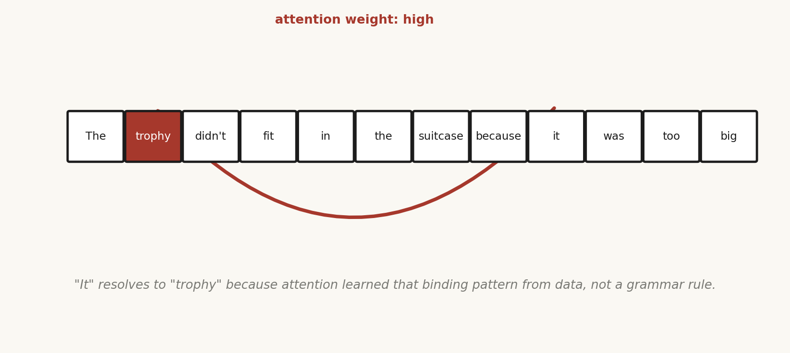
"It" resolves to "trophy" because attention learned that binding pattern from data, not a grammar rule.
Every rung does the exact same thing underneath. Predict. The tools got more elaborate. The core word never changed.
III½
What Actually Happens Inside the Sentence
When you type a sentence to Claude or GPT, the model doesn't read it the way you do. First comes tokenization — your sentence chopped into pieces, each mapped to a number. Understanding isn't in the room yet; it's still bookkeeping.
Most modern models use a subword scheme called byte-pair encoding (BPE) or a close relative — common words like "the" become a single token, but rarer words get split into fragments ("unbelievable" might become "un", "believ", "able"). This is a deliberate compromise: whole-word tokenization would need an impossibly huge vocabulary to cover every word in every language, while character-level tokenization would make sequences absurdly long and hard for attention to relate distant parts of. Subword tokenization lets the model handle any word, including ones it's never seen, by falling back to fragments, while keeping common words efficient as single units.
Then each number becomes an embedding — a long vector representing that token's meaning as a position in a mathematical space. Words that mean similar things end up near each other, geometrically. "King" minus "man" plus "woman" lands you near "queen" — not by rule, but because the geometry of meaning fell out of predicting text at scale.
Then comes attention: every token looks at every other token and decides, mathematically, how much to care about it. In "the trophy didn't fit in the suitcase because it was too big," the word "it" has to reach back and decide whether it means the trophy or the suitcase. Stack enough attention layers across enough tokens and the model builds something that functions, for all practical purposes, like context.
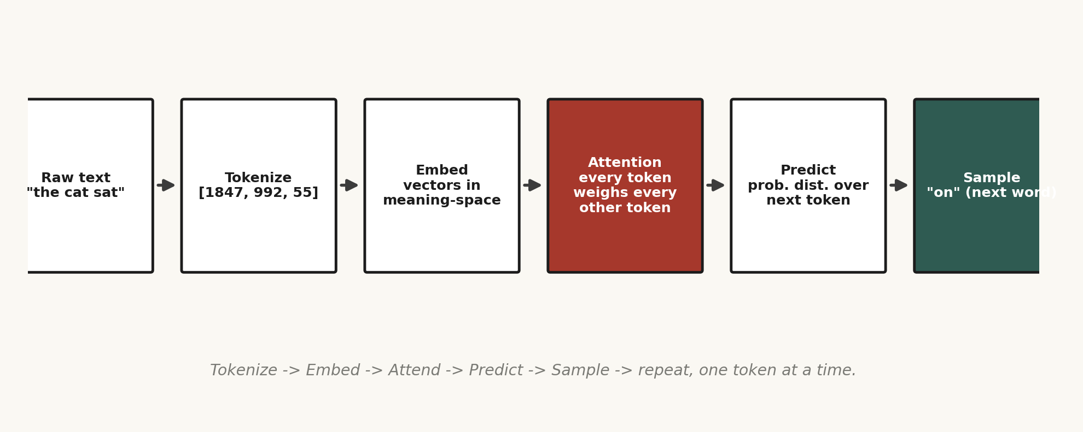
Text to prediction — the whole trick laid end to end.
And then, at the end of all that machinery, the model does the one thing this whole book is about. It predicts — a probability distribution over every possible next token, usually sampled rather than the single most likely one, so the output doesn't feel robotic. Then it does the whole thing again, one token later. That's the entire "magic": a staggeringly sophisticated autocomplete, run at a scale that starts to look like reasoning the longer the chain gets.
How the next token actually gets chosen
The raw output of the final layer is a set of numbers called logits, one per possible token in the vocabulary, and softmax converts them into a probability distribution. But the model rarely just picks the single highest-probability token every time (that's called greedy decoding, and it tends to produce flat, repetitive text). Instead, sampling strategies shape the choice: temperature scales the logits before softmax — a low temperature sharpens the distribution toward the most likely tokens (more deterministic, more repetitive), a high temperature flattens it toward more randomness (more creative, more error-prone). Top-k sampling restricts the choice to only the k most likely next tokens before sampling among them. Top-p (nucleus) sampling instead keeps the smallest set of tokens whose cumulative probability crosses a threshold p, which adapts naturally to how confident the model is at each step — a very confident distribution might only need one or two tokens in the nucleus, an uncertain one might need dozens. Every time I've tuned an application built on top of an LLM API, temperature and top-p were the two levers that mattered most for getting outputs that felt right for the task — near-zero temperature for a tool that must output valid, parseable JSON, higher temperature for brainstorming or creative copy.
Once I saw this pipeline clearly, hallucination stopped being mysterious. A model isn't a database that looks up facts and sometimes fails — it's a prediction engine that never stops predicting, even when it doesn't know something. Fluency was never coupled to truth. It was only ever coupled to probability. That's why assumption transparency — which I'll come back to in Part Two — isn't a nice-to-have. It's a patch over a structural fact about how these systems are built.
PART TWO
The Road
How I Learned to Use AI — and Do the Magic
IV
The Other Side of the Coin
Everything in Part One — that entire ladder — is only one side of the coin. The side of inventing: the researcher in the lab, the handful of labs on Earth with enough compute to train a frontier model from scratch. For a long time I thought that was the only side that mattered. If I wasn't building the model itself, I wasn't really "doing AI." I was just a tourist.
I was wrong, and figuring out why changed the direction of everything I build now. There is another side of the coin: using it. And this, to me, is the far more interesting half — not because it's easier, but because it's where the actual leverage lives right now for someone without a research lab or a warehouse of GPUs.
It isn't about who builds the fanciest new model anymore. Dozens of extraordinarily powerful models already sit out there, priced by the token, reachable from a laptop. The genuinely rare skill isn't inventing the engine — it's knowing how to drive it into a system that does something real, reliable, and valuable in the world.
Evolution never rewards the one who invents from nothing. It rewards the one who repurposes what already exists — a fin becomes a limb, a scale becomes a feather. AI is having its own version of that moment right now.
So that's where I found myself: not out-inventing a research lab, but taking models that already exist — genuinely world-class — and using them to build real things across worlds I had no business touching. Healthcare. Business analysis. Trading systems. AI didn't teach me those domains; it handed me the keys and trusted me to learn fast enough not to embarrass myself once inside.
The three ways to actually use a model
Once I committed to this side of the coin, I had to learn the real menu of options for pointing a pretrained model at a specific problem — because "just use AI" isn't a plan, it's three genuinely different engineering decisions with different costs:
- Prompting — shaping the model's behavior purely through the instructions and examples in the input, no weights touched at all. Cheapest, fastest to iterate, and, with a well-designed system prompt and a few examples (few-shot prompting), surprisingly far-reaching. This is where I start every single project now.
- Retrieval-Augmented Generation (RAG) — the model's own knowledge is frozen at its training cutoff and it has no memory of my specific data, so I hand it the relevant facts at query time instead: embed my documents, retrieve the closest ones to the current question, and stuff them into the prompt as grounding context. This is how I give a general-purpose model specific, current, private knowledge without retraining anything.
- Fine-tuning — actually adjusting the model's weights on a custom dataset so a behavior or style becomes baked in rather than instructed each time. The most expensive and slowest option, and in my experience the one most people reach for too early, before they've exhausted what prompting and RAG can already do for a fraction of the cost.
The order I just listed them in is also, deliberately, the order of the ladder I climb on every new project: start with the cheapest lever, and only reach for the next one when the cheaper one has genuinely run out of room.
IV½
Three Things Nobody Told Me Early Enough
Before the second ladder — the one about using AI instead of building it — three pieces of knowledge took me embarrassingly long to piece together. I wish someone had just told me plainly, so I'm telling you plainly.
The Bitter Lesson (Rich Sutton, 2019)
Across seventy years of AI research, the approaches that won were almost never the ones where humans cleverly hand-engineered domain knowledge into the system. They were the ones that gave a general-purpose method more data and more compute, and let it find the patterns itself. Human cleverness about what the answer should look like keeps getting outrun by raw scale plus a general method.
The practical consequence I had to absorb: when I'm building an agent, I now spend far less time hand-coding rigid rules for every edge case, and far more time giving the model good tools, good context, and the freedom to reason its own way to the answer. Every time I've fought this lesson — building an elaborate rule tree instead of trusting a well-prompted model with a good tool — the hand-built version eventually lost to a simpler, more general approach as the underlying models improved.
Scaling Laws (OpenAI, ~2020; DeepMind's "Chinchilla," 2022)
A model's performance improves in a remarkably predictable curve as parameters, data, and compute increase together — predictable enough to forecast a model's quality before training finishes. Intelligence, at least this prediction-shaped version of it, isn't a mysterious spark. It's a dial you can chart in advance.
Loss(N, D) ≈ A/N^α + B/D^β + E (N = parameters, D = training tokens)
The Chinchilla finding specifically corrected an earlier mistake: for a fixed compute budget, most labs had been training models that were too large relative to the amount of data they were fed. Chinchilla showed that model size and training data should scale roughly together — a smaller model trained on proportionally more data can outperform a larger model that was undertrained. I don't train frontier models myself, but this shapes how I think about my own smaller fine-tunes and from-scratch experiments: more data on a right-sized model consistently beats a bigger model starved of data.
RLHF — Reinforcement Learning from Human Feedback
A model trained purely to predict the next token will happily continue in the most statistically likely direction, which isn't the same as the most helpful or honest one. RLHF is the extra stage where humans rank responses, a reward model learns those preferences, and the main model is tuned — traditionally via a reinforcement learning algorithm called PPO (Proximal Policy Optimization) — to score well against them, teaching taste, not just fluency. A newer, simpler alternative called DPO (Direct Preference Optimization) achieves a similar effect without needing a separate reward model or the full reinforcement-learning loop, by directly optimizing the model on preference pairs — and I've watched this technique show up more and more in smaller open fine-tunes because it's dramatically cheaper to run than full RLHF. Every time a model declines something harmful or admits uncertainty instead of bluffing, that behavior was very likely shaped here.
Scale plus a general method produces raw predictive power along a knowable curve, and human feedback sculpts that power into something that behaves like a collaborator instead of an oracle.
V
The Evolution of Using AI
There's a road I keep climbing, one stage at a time, and most people alive right now are living through it without fully registering how strange it is.
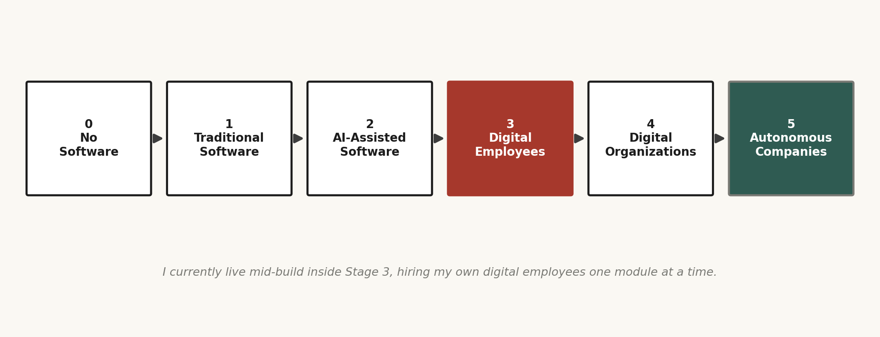
The road I keep climbing, one stage at a time.
Stage 0 — No Software
Just us, alone with the problem: a pen, a spreadsheet, and stubbornness. Slow and exhausting, but it teaches you the shape of a problem like nothing else.
Stage 1 — Traditional Software
Deterministic rule-followers — Excel, SAP, backend systems. Powerful but rigid; no judgment, no adaptation. If the world shifts outside the rules the programmer anticipated, it breaks with total, unearned confidence.
Stage 2 — AI-Assisted Software (where most of us live now)
We stopped writing every line ourselves. We describe what we want in plain language and let AI write the first pass — Copilot, Cursor, Claude Code. AI stopped sitting politely on the side of the desk and became the programmer sitting where the junior developer used to sit.
The skill this stage actually rewards isn't typing speed, it's specification — the clearer and more testable my description of what I want, the less back-and-forth correction the whole loop needs. I learned to write requirements the way I'd brief a very fast, very literal junior engineer: explicit inputs, explicit outputs, explicit edge cases, and a way to verify the result is actually correct rather than just plausible-looking.
Stage 3 — Digital Employees (already here, and where I actually live mid-build)
Humans stop just using AI and start hiring it. An AI Business Analyst, an AI Accountant, an AI Researcher — something that reasons about a novel situation, remembers what happened last week, and pulls the right tool at the right moment.
There's a huge difference between a "prompt wrapper" bolted onto a chatbot and an actual agent that deserves the name "employee." I've learned the difference the hard way — by building something, watching it fail exactly the way a fake employee would fail, and figuring out why. A real digital employee needs four things.
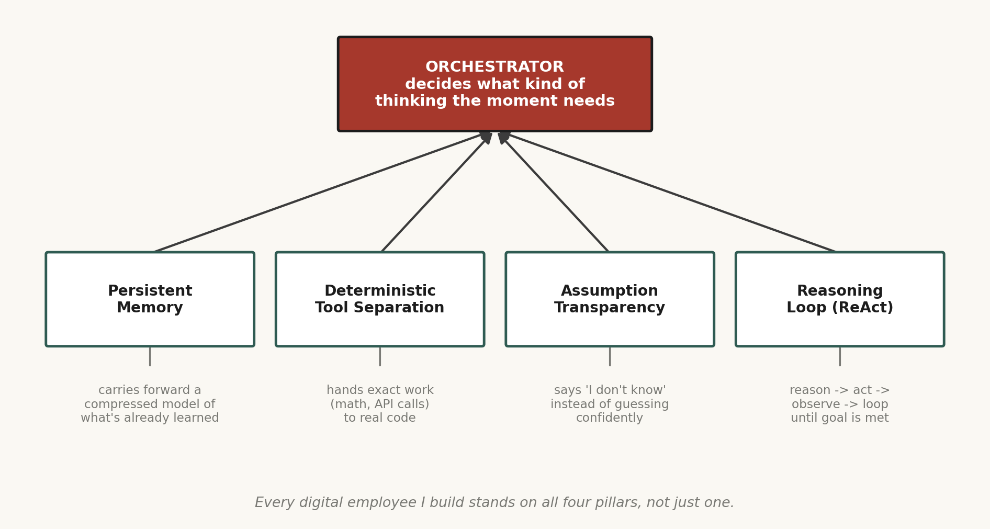
The four pillars I now build every agent on top of.
An orchestrator decides what kind of thinking the moment calls for, instead of running the same generic loop on everything. Persistent memory carries forward a compressed, evolving model of what's already been learned, instead of relearning from zero each session like a goldfish. Deterministic tool separation hands anything that must be exactly right — a tax calculation, a break-even formula, a schema-specific API call — to real code, not an LLM "vibing" its way to an approximately correct number; the model's job there is to decide which tool to call, with what inputs, and to sanity-check what comes back. And assumption transparency means the system says "I don't know" out loud instead of quietly filling the gap with a confident-sounding guess — arguably the most important of the four, because false confidence is exactly what turns a useful employee into a liability.
I'm building exactly this now — a system I call AICrew: digital employees reporting, conceptually, into a CEO agent. A Business Analyst, a Financial Analyst, a Research Scientist, a Software Engineer, a QA Engineer, each on that same four-part backbone.
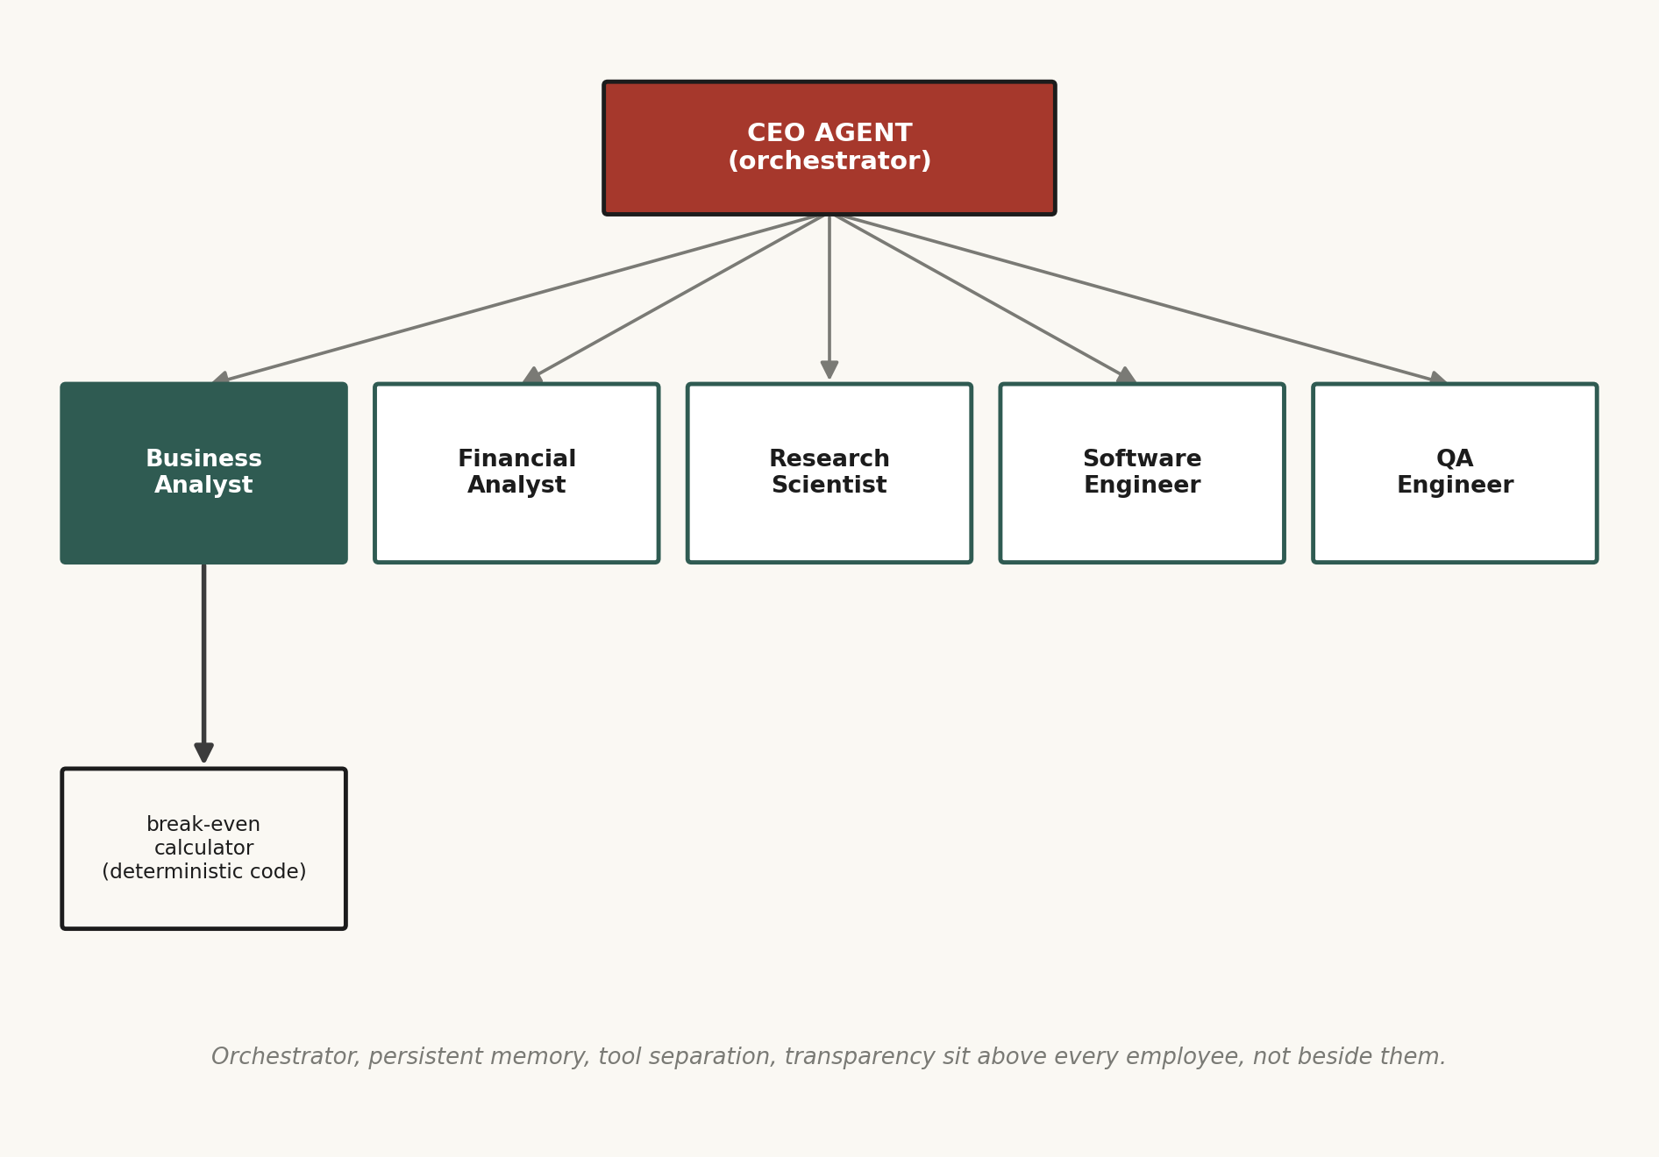
AICrew, laid out honestly — the orchestrator and the four pillars sit above every employee, not beside them.
How a digital employee actually decides what to do
Most working agents run on a loop researchers call ReAct — Reason plus Act, from a 2022 paper. The model reasons in plain text about what the situation calls for ("I need the company's fixed costs before I can compute a break-even point"), then acts by calling a real tool with specific arguments, then observes what that tool actually returned, then loops back to reasoning with the new information folded in. It keeps cycling until the goal is actually met, not just talked about.
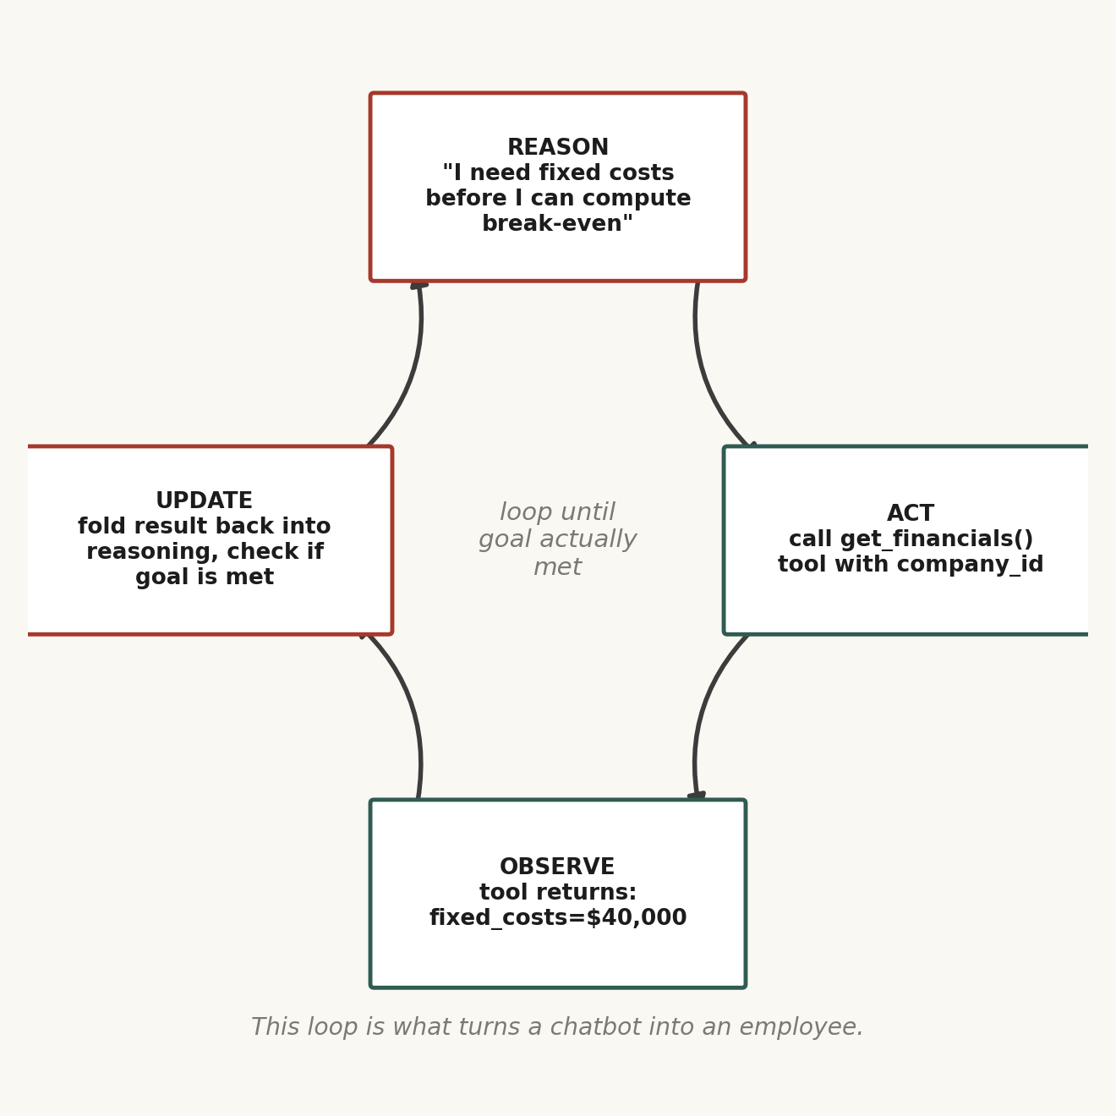
Reason. Act. Observe. Loop. The whole trick behind almost every agent I've built.
Written out the way I actually trace it while debugging one of my own agents, one cycle looks like this:
THOUGHT: I need fixed costs and contribution margin
before I can compute break-even units.
ACTION: call get_financials(company_id="acme")
OBSERVATION: {fixed_costs: 40000, price: 25, var_cost: 15}
THOUGHT: contribution margin = 25 - 15 = 10.
break-even units = 40000 / 10 = 4000.
ACTION: call breakeven_calculator(fixed=40000,
price=25, variable=15)
OBSERVATION: {breakeven_units: 4000, breakeven_revenue: 100000}
THOUGHT: goal satisfied — report the result.
Notice the arithmetic itself never happens inside the model's head — the model reasons about which tool to call and with what numbers, but the actual division is delegated to breakeven_calculator, a few lines of deterministic Python. That's deterministic tool separation, not as an abstract principle but as a literal line in the trace.
This loop is what turns a chatbot into an employee. A chatbot answers once, from memory, and stops. An agent running this loop goes and gets the real number instead of guessing it, notices the number contradicts its first assumption, and corrects course — the same self-correcting posture that made gradient boosting so powerful two chapters ago, now running at the level of a whole task instead of a single prediction.
Memory works alongside this loop through two mechanisms, often both at once. A vector store converts every important fact into an embedding and, when a new task arrives, retrieves the vectors closest in meaning — retrieval-augmented generation, RAG. Compression periodically summarizes everything that's happened into a smaller state, carrying forward the gist of a hundred interactions without the full weight of the transcripts. Retrieval finds the specific fact; compression preserves the shape of everything else.
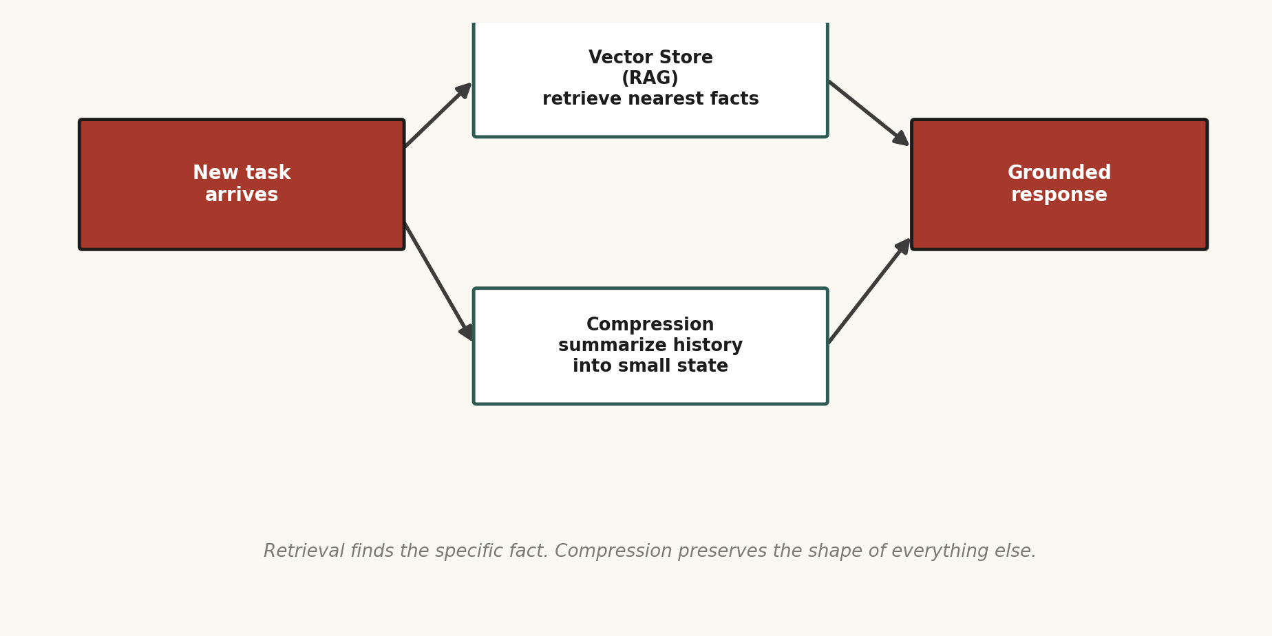
Retrieval finds the specific fact. Compression preserves the shape of everything else.
The distance metric behind that retrieval is almost always cosine similarity — measuring the angle between two embedding vectors rather than their raw distance, which matters because it makes the comparison insensitive to how long or short the original text was, only to what it means. In practice I chunk documents into overlapping passages before embedding them, because a single embedding for an entire long document blurs together too many different ideas to retrieve precisely — the size of that chunk, and how much it overlaps its neighbor, turned out to matter more to real-world retrieval quality than which embedding model I picked.
Stage 4 — Digital Organizations (emerging)
Not one AI employee but a team, coordinating like a real company. You say "launch a new product" and the organization moves — researching, running numbers, building, testing, documenting, with oversight only at the boundaries. The challenge here isn't intelligence anymore; it's coordination — how a dozen semi-autonomous agents share state without corrupting each other's work, and how a decision chain across five specialist agents gets audited after the fact when something goes wrong.
The pattern I keep returning to for this stage is hierarchical delegation rather than a flat swarm: one orchestrator agent breaks a large goal into subtasks and routes each to the specialist best suited for it, rather than every agent talking to every other agent in an unstructured mesh. A flat mesh scales quadratically in coordination overhead as agents are added; a hierarchy scales close to linearly, at the cost of the orchestrator becoming a single point of failure — which is exactly why the transparency pillar matters even more at this stage than at Stage 3: an orchestrator that hides its own uncertainty can silently misroute an entire chain of specialist work.
Stage 5 — Autonomous Companies (mostly future)
The horizon you can already see the outline of, the way you see a mountain range before any single tree on it. A company that keeps running, improving itself, hiring new specialist agents when a gap becomes obvious, humans stepping back to set the goals and the boundaries — the constitution — and watching it correct its own course. I don't think this arrives all at once on a single headline day. I think it arrives the way everything on this ladder has arrived: quietly, rung by rung, mostly unnoticed by anyone not already standing on it.
V½
Building the Business Analyst — My Break-Even Calculator, Rung by Rung
I don't trust an architecture until I've built the smallest possible version of it end to end. So before I let myself design the full AICrew system on paper, I forced myself to ship one tool, all the way through, for the very first employee: a break-even calculator inside the Business Analyst module. Here is exactly how I built it, in the order I actually did it.
Step 1 — Define the deterministic core first
Before writing a single prompt, I wrote the plain function the whole tool depends on, with no AI involved at all, because this number has to be exactly right every time:
def breakeven_units(fixed_costs, price, variable_cost):
contribution_margin = price - variable_cost
if contribution_margin <= 0:
raise ValueError(
"price must exceed variable cost")
return fixed_costs / contribution_margin
This is the deterministic tool separation pillar in its rawest form. The model will never be asked to do this division itself — its only job is deciding when to call this function and with which numbers.
Step 2 — Wrap it as a callable tool with a strict schema
Next I gave the tool a name, a description, and a strict input schema, because an LLM calling a tool needs the same clarity a junior engineer would need from an API spec — vague parameter names produce vague, wrong calls:
tool: breakeven_calculator
description: "Computes break-even units and revenue
from fixed costs, unit price, and unit variable cost."
parameters:
fixed_costs: number (required)
price: number (required)
variable_cost: number (required)
Step 3 — Give the orchestrator a reason to reach for it
I wrote the Business Analyst's system prompt to explicitly instruct it: whenever a break-even, margin, or viability question comes up, call breakeven_calculator rather than computing the number in its own head. This single instruction eliminated almost every arithmetic error I'd seen in my earlier, tool-less prototype — the model's raw mental math on multi-step financial formulas was fluent-sounding and occasionally just wrong, exactly the hallucination pattern from Part One's III½ showing up in a business context.
Step 4 — Force assumption transparency
I added an explicit rule: if any required number (fixed costs, price, variable cost) isn't in the conversation or retrievable from memory, the agent must ask for it or flag it as an assumption, never silently invent a plausible-sounding figure. This turned out to be the single highest-leverage rule in the whole build — it's the difference between a tool I can actually trust with a real business decision and a tool that produces confident nonsense on missing data.
Step 5 — Wire in memory, then test the whole loop
Finally I connected the tool call into the ReAct loop so a follow-up question ("what if I raise the price by two dollars") could reuse the company's fixed costs already retrieved earlier in the session instead of asking again — a small but real test of the memory pillar. Only once all four pillars were exercised, together, on this one small tool, did I let myself start sketching the Financial Analyst and Research Scientist employees on top of the same backbone.
The smallest concrete forcing function beats the most beautiful diagram, every single time.
VI
Two Roads, One Traveler
Here's the full road, start to finish, both sides of the coin laid end to end: paper, traditional software, AI writing software, AI employees, AI organizations, autonomous companies. And underneath every rung of that road, quietly, is the same word that ran the other ladder — the one about model architectures. Predict. A business analyst predicting whether a venture breaks even. A digital employee predicting which tool a task requires. An autonomous company predicting which move keeps it alive in a market that never holds still.
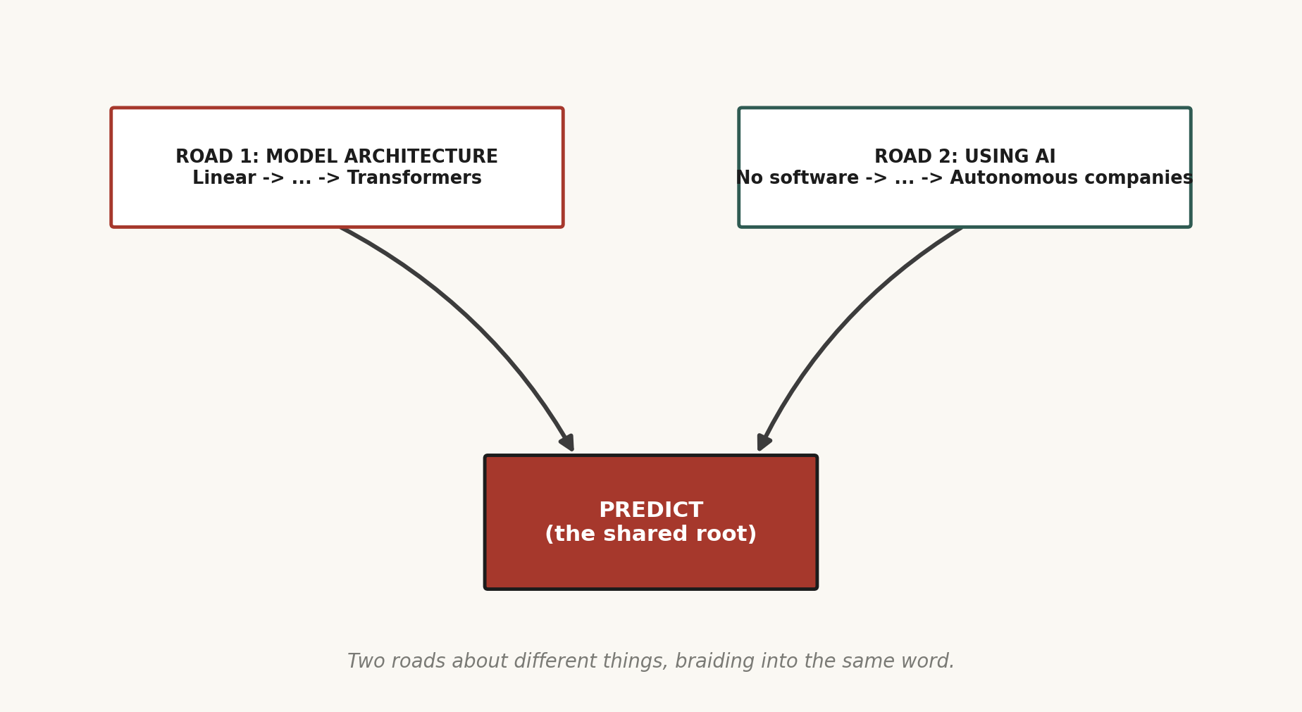
Two roads, seemingly about different things — architecture and organization — braiding into the same root.
When I zoom all the way out, I don't see a chart. I see a mirror. Somewhere on that path is exactly where I stand right now — not watching from the outside, but building inside it, one project at a time, one break-even calculator at a time before the next, bigger piece.
I think about my own mind the same way, honestly, because I don't believe the two are as separate as they look. An Observer that watches, an Interpreter that makes meaning of what's observed, a Narrator that turns it into a story — that architecture isn't so different from the orchestrator-memory-tool-transparency backbone I just described for a digital employee. Both are trying to solve the same problem: how do you reason about what's happening without confusing the reasoning for the happening itself.
This is also where my trading background stopped feeling like a separate interest and started feeling like the same subject wearing a third coat. Markets are, structurally, a prediction tournament with money as the scoreboard — and the Efficient Market Hypothesis (Eugene Fama, 1970s) says something sobering about that tournament: a liquid market's price already reflects almost everything knowable about it, because every trader with an edge has acted on it, and in acting on it, erased it. A model that predicts the next candle with genuine skill is worth more than almost anything else you could build — and that edge decays the moment enough people run the same model against the same market. A market reacts to being measured. The real skill was never finding a pattern. It's finding a pattern faster than the pattern erases itself.
Every evolutionary trading system I've built taught me a version of the bias-variance tradeoff from Part One in a much harsher, real-money form: a strategy overfit to historical price data will backtest beautifully and then bleed out the moment it meets live, unseen market structure — the exact same failure mode as a decision tree grown too deep, just measured in currency instead of accuracy. Walk-forward validation, where a strategy is tuned on one window of time and tested, unseen, on the next window forward, is the trading world's version of a held-out test set, and I trust a strategy's backtest exactly as much as I trust it, and not a percentage point more.
There's a tension in me I've stopped expecting to resolve. I understand architecture fast — sometimes fast enough that the understanding becomes a trap, a comfortable room I can sit in indefinitely without stepping into execution. Insight arrives quickly. Building it lags behind. Naming that gap out loud, over and over, is how I keep dragging myself back toward the smallest next concrete step instead of the next beautiful diagram.
VI½
The Toolkit I Actually Reach For
Theory earns its keep only when it survives contact with a real stack. So here, plainly, is the actual toolkit underneath everything described above — not a sales pitch for any one vendor, just the honest shape of what I reach for and when.
Models and access
For reasoning-heavy agent work I reach for a frontier hosted model through its API rather than trying to self-host something comparable — the economics rarely favor self-hosting until volume is very high, and the frontier models are simply better at the multi-step reasoning a real agent needs. For narrow, high-volume, latency-sensitive tasks (classification, extraction, a fixed-format response), a smaller and cheaper model, sometimes even a fine-tuned open-weight model I run myself, is the more honest engineering choice — using a frontier reasoning model for a task a five-dollar classifier could handle is a waste I've made and corrected more than once.
Orchestration
For anything beyond a single tool call, I need an explicit loop — the ReAct pattern from Part Two, implemented either by hand as a simple Python loop (call model, parse tool call, execute, feed result back) or through an agent framework that provides that loop, tool registration, and memory hooks out of the box. I've learned to write the loop by hand at least once for any new pattern before reaching for a framework, because debugging a framework's abstraction over a loop I don't understand is far harder than debugging a loop I wrote myself.
Memory
A vector database for the RAG half of memory — the mechanism only matters in that it needs to store embeddings and answer nearest-neighbor queries fast; the choice of embedding model matters more than the choice of database in my experience, because a poor embedding model retrieves poor neighbors no matter how fast the lookup is. For the compression half, I periodically ask the model itself to summarize the running session into a compact state object, which is a strange, recursive thing to do — using a predictor to compress the history of its own predictions — but it works, and it mirrors, more than I expected going in, the way a human mind consolidates a day's experience into a much smaller trace during sleep.
Deterministic tools
Anything with a right answer — arithmetic, a database query, an API call with a fixed schema, a regulatory calculation — becomes ordinary, boring, well-tested code, exposed to the model as a callable tool with a strict schema. I hold this line firmly: the moment I catch myself letting a model "estimate" something that has an exact, computable answer, I've reintroduced the exact failure mode Part One's III½ predicted — fluency mistaken for correctness.
Evaluation
The habit that took longest to build was testing an agent the way I'd test any other system — a fixed set of realistic scenarios with known-correct outcomes, run automatically every time I change a prompt or a tool, rather than eyeballing a handful of manual conversations and declaring victory. An agent that looks impressive on the three examples I happened to try and an agent that's actually reliable are two different claims, and only the first one is free.
VII
The Craft of the Prompt — What I Actually Do Before I Write One Word to a Model
Everyone who has used a chatbot thinks they know what a prompt is. Almost nobody who’s shipped a real product on top of one still believes that. A prompt isn’t a question. It’s the entire specification of a tiny, temporary employee you’re about to hire for one task and fire a few seconds later — and the quality of that hire is set entirely by what you tell them before they start.
The single biggest jump in output quality I’ve ever gotten from a prompt change didn’t come from clever wording. It came from chain-of-thought prompting — simply asking the model to reason step by step before giving a final answer, rather than jumping straight to a conclusion. The 2022 paper that popularized this (Wei et al., “Chain-of-Thought Prompting Elicits Reasoning in Large Language Models”) showed something that shouldn’t have been surprising in hindsight, given everything in Part One: a model that predicts one token at a time genuinely reasons better when it’s allowed to “think out loud” on the page first, because each intermediate token becomes extra context the model itself gets to condition on for the next prediction. Forcing an answer immediately denies the model the very scratch space that makes multi-step reasoning possible at all. This is also why modern “reasoning models” — the ones trained explicitly to produce long private reasoning traces before answering — are, at bottom, chain-of-thought turned into a trained behavior instead of a prompted one.
Few-shot prompting — showing the model two or three examples of the exact input-output pattern I want, rather than only describing it — almost always outperforms a purely descriptive instruction, because examples remove ambiguity that language can’t fully close. If I want a strict JSON schema back, I don’t just say “return JSON” — I show one complete, correctly-formatted example, and the model’s own in-context pattern-matching, the same geometry-of-meaning trick from Part One’s III½, does the rest.
Self-consistency takes chain-of-thought one step further: instead of asking for one reasoning path, I sample several independent reasoning paths at a higher temperature and take the answer that shows up most often across them — a direct echo of the bagging idea from Rung 5, democracy applied not to trees anymore but to a single model’s own reasoning attempts. I reach for this specifically on high-stakes, single-shot questions where I can afford three or five calls instead of one, and it has caught more silent arithmetic and logic slips than any other single technique in my toolkit.
Context engineering, which I now consider a more accurate term than “prompt engineering” for most real work, is the discipline of managing everything in the model’s context window, not just the instruction at the top: retrieved documents, prior turns, tool outputs, system rules, even the order those pieces appear in. Position matters more than people expect — models tend to weight information near the beginning and end of a long context more heavily than information buried in the middle, an effect researchers have called “lost in the middle.” I’ve learned to put my most load-bearing instructions at the very top or the very bottom of a prompt, never sandwiched deep inside a wall of retrieved text, and to actively prune stale context rather than letting a session’s history grow forever — exactly the compression pillar from Part Two’s Stage 3, applied at the level of a single prompt instead of a whole agent’s memory.
VII½
The Tool Ecosystem — MCP and the Wiring Between Model and World
A model, on its own, is a closed room with no windows — brilliant at reasoning over whatever’s already in its context, blind to anything that happened after its training cutoff, and physically incapable of doing anything in the world beyond emitting text. Every real agent I’ve ever built lives or dies on the wiring between that closed room and the outside world, and for a long time that wiring was bespoke and fragile — every application inventing its own private way of describing tools to a model.
The Model Context Protocol (MCP), introduced by Anthropic in late 2024, is the standardization I wish had existed when I started: an open protocol that lets any tool, database, or service describe itself to any compatible model in a consistent way, so a developer building a new integration writes it once and it works across any client that speaks the protocol, instead of once per application. Practically, an MCP server exposes a set of tools with names, descriptions, and strict input schemas — precisely the shape I hand-rolled myself for the break-even calculator in Part Two’s V½, just standardized so it isn’t reinvented from scratch on every project. The deeper shift this represents, the one that actually matters for how I design systems now, is that “which tools does my agent have access to” is becoming a question of which servers I connect, not how much custom integration code I’m willing to write — the same leverage jump that happened when APIs replaced screen-scraping, just one layer higher, for agents instead of scripts.
I hold the same discipline here that I hold everywhere else in this book: a tool’s description and schema are the entire interface the model reasons against, so a vague tool description produces the exact same failure mode as a vague human job description — confident, plausible-sounding misuse. The clearer the tool’s contract, the less the orchestrator has to guess.
VIII
Evaluation and Deployment — Where Most Projects Actually Die
Nobody’s demo fails. I’ve watched dozens of AI prototypes look extraordinary in a five-minute walkthrough and then quietly rot in production, and the gap between those two facts taught me more about this field than any paper did. A demo is three cherry-picked examples performed live by the person who built the thing. Production is thousands of examples performed by strangers who don’t know the system’s blind spots and have no reason to phrase their request the way you rehearsed it.
The discipline that closes that gap is building a real eval suite before I trust anything: a fixed, versioned set of realistic inputs paired with a rubric or a known-correct answer, run automatically every time a prompt, a tool, or a model version changes. For tasks with a verifiable right answer — the break-even calculator, a classification task, a structured extraction — the eval can score itself exactly. For open-ended tasks — a summary, a piece of written analysis — I either use a rubric a human scores against, or a second, carefully prompted model acting as an “LLM judge,” a technique that works surprisingly well as long as the judge’s rubric is as specific and concrete as the tool schemas from Part Two, and as long as I periodically spot-check the judge against my own human judgment so it doesn’t quietly drift.
Two failure modes recur constantly once something is live, and I’ve learned to actively watch for both. Prompt drift is what happens when a model provider silently updates the underlying model behind an API endpoint, and behavior that used to be reliable starts producing subtly different outputs — which is exactly why pinning to a specific model version, and re-running the eval suite before ever moving off a pin, is not paranoia, it’s the same discipline as regression testing in any other software system. Distribution shift is what happens when the real world drifts away from what the system was built and tested against — new slang, a new product line, a competitor’s name the model has never seen paired with the domain it’s being asked about — and the fix is never “hope the model generalizes,” it’s the same retrieval and memory machinery from Part Two’s Stage 3, kept continuously current rather than frozen at whatever the data looked like on launch day.
Cost and latency are not afterthoughts either, and I’ve made this mistake myself: reaching for the most powerful, most expensive model for every single call in a pipeline, when half those calls are simple classification steps a far smaller and cheaper model handles just as reliably. The honest engineering question, on every call in a system, is the same one I apply to picking a tool in the first place — what’s the cheapest, fastest component that reliably clears the bar this specific step actually needs, not the bar the flashiest model could clear if I threw it at everything.
VIII½
Open Weights, Closed Weights, and Running a Model on My Own Machine
One more decision I had to actually learn to make rather than default on: whether a project needs a hosted, closed-weight frontier model reached through an API, or an open-weight model I download and run myself. Closed models — the frontier systems from the major labs — are usually the strongest available at any given moment on genuinely hard, multi-step reasoning, and I never have to think about infrastructure; I pay per token and the provider handles everything underneath. Open-weight models — families like Llama, Mistral, Qwen, and others, whose weights are published for anyone to download — trade some of that frontier capability for control: no data leaves my machine, no per-token bill, and I can fine-tune the weights directly rather than only steering behavior through a prompt.
Running an open-weight model locally almost always means quantization — storing the model’s weights at lower numerical precision (8-bit or even 4-bit integers instead of the 16- or 32-bit floating point numbers used during training) to shrink both the memory footprint and the compute needed to run it, at the cost of a small, usually tolerable, drop in output quality. A 70-billion-parameter model that would need well over 140 gigabytes of memory at full precision can often run respectably on a single high-end consumer GPU once quantized to 4 bits — the difference between “needs a data center” and “runs on my desk,” for a real, if slightly blunted, amount of capability.
I’ve settled into a rule of thumb that mirrors the one I use for choosing a model size for any given task: closed, frontier, hosted models for reasoning-heavy agent work where I want the best available judgment and I’m not sensitive to sending data off my machine; smaller, often open, sometimes locally-run and quantized models for narrow, high-volume, latency- or privacy-sensitive tasks where “good enough, fast, and mine” beats “best possible, slower, and someone else’s.” Neither choice is more legitimate than the other. They’re both just different points on the same tradeoff curve I’ve been drawing, knowingly or not, since Part One’s very first rung: how much capability, for how much cost, at how much risk.
EPILOGUE
The Ocean I Fell Into
I didn't set out to explain AI to you like a textbook. There are enough textbooks, and most of them describe the ladder without ever mentioning that a person actually has to climb it, at 2 a.m., alone, unsure if the next rung will hold.
What I set out to do was show you what it feels like from the inside. The ocean I fell into, thinking it was one thing and finding it was a thousand. The one word — predict — running quietly under every rung of both ladders, the one about models and the one about how we use them. And the road I'm walking right now, brick by brick, module by module, agent by agent, not from a finished blueprint I'm merely executing, but genuinely figuring it out as I go — correcting the plan the same way a gradient-boosted tree corrects the mistake the tree before it made.
The future isn't something that's going to happen to us. It's something we're already inside of, building it with our own hands, one small piece at a time. Two sides of one coin — the invention and the use — and both of them, still, right now, being written.
ABOUT THE AUTHOR
Surya writes from the inside of the machines he takes apart. A self-directed builder and lifelong systems-thinker, he explores the architecture of artificial intelligence, markets, and mind with the same instinct: open it up, find the floor under the floor, and write down what's actually there. PREDICT is his field record of that pursuit — part confession, part documentary, part invitation to anyone standing at the base of the same mountain.

