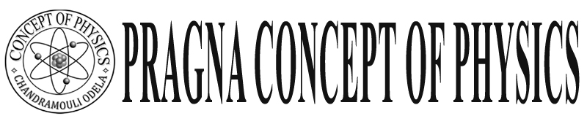Warangal

**Class: X ELECTRIC CURRENT FINAL TOUCH Sub : Physical Science WORKSHEET**

**I. Introduction**

1) Current the net charge flowering through a cross – section of a conductor in a unit time is called current. i = q/t or I = ne/t n = number of electrons e = charge of electron = 1.602 x 10-19 c

It is measuring with Ammeter always connect in series units coulomb / sec or Ampere

Drude – Lorentz explained about motion of electron in a conductor

Drift speed:- The arrange speed of electron in a conductor through lattice is called drift speed.

 $v_{d=}$. $v_{d=}$ draft speed A – Area I – current n - Density

The draft speed of electron in copper 0.07 mm/s

Voltage : ( Potential )or( Potential difference) The work done by electric force is called potential

V =  or v =  units J / c = volt It is measuring with Voltmeter always connect in parallel

E.M.F. of Battery: The work done by chemical force is called E.M.F. V or  = w/q. or =  units volt.

Why bulb will glow immediately when we connect to a battery.

When we switch on irrespective of length of the conductor an electric field is set up through out the conductor instantaneously due to the voltage of the source connected to the circuit.

The relation between E.M.F. drift speed. When E.M.F. increases drift speed also increases.

No in solids (conductors) they are fixed that arrangement is lattice but in liquids (Battery) the positive & negative both in motion

CURRNT DIRECTION IS ……POSSITIVE TO NEGATIVE

**2. Ohm’s law:**

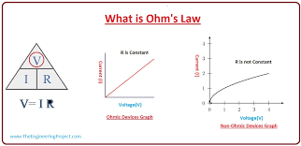 At a consent temperature the potential distance between two ends of a conductor is directly proportional to current passing through it. V  i, or V = I R (R= resistance)

Ohmic conductors

The conductors which obey the Ohm’s law are comic conduct

Eg- All metals …………..these are called linear conductor.

Non Ohmic conductors

The conductors which not obey the Ohm’s law are non Ohmic conductors

Ex: Semi conductors, Electrolytes L.E.D. Diode :

**Limitation:-** Not applicable for very high or law temperature & Semiconductor

Electric Shock: It is the combined effect of potential difference, current , Resistance, When there is a potential difference exist between one part to other part of human body.

As long as current flow continues in side the body more than 0.07 A. it leads to death.

**Note:- Birds does not get shock because they stand on only single wire. So there is no potential difference so no current pass through Bird**.

when Bird touch two wires then get sock

ohm’s law verification experiment …………observations.

When potential increases current also increases but Ratio is constant  is constant.

-Ohm’s law used……… in household wiring.

**Why we use parrel connection in household appliances but not in series.**

When appliances are in series it we switch on the all appliances will work current may consume more and if one not work remaining will not work.

Current may take more by all applications due to that wire get overload and damage.

So we should not connect in series.

3) **Resistance: ( R) units ohms**  symbol

The obstruction to the motion of electrons in a conductor

when Resistance increases current decreases

**Conductance:** The reciprocal of Resistance 1/R is called conductance. Unties  or  ‘mho’

**Resistance factors : ( R ) Experiments:**

1) **Nature:** It depends on nature of substance Ex: Ag is a good conductor

2) **Length (*l*) (** R $∝$ l ) length increases R increases ( Directly Proportional)

3) **Area of cross – section** ( R $∝$ 1/A) : When A increases R decreases R 1/A.

4) **Temperature** : ( R & T ) when T increases R also increases in conductor

Note in semi conductor T increases R decreases.

 R $∝$*l* / A R = *l* / A ( = specific resistance ) or Resistivity

1) Two wires of (A& B) 1 mm2 and 10 mm2 area of cross – section in which

The resistance is very more and current both are same length & nature.

If Areas of cross – section increases resistance Decreases 30 more Resistance is A

If Resistance is more current is less. So in B less Resistance and more current. More resistance create more heat

**Resistance series**: R = R1 + R2 + R3

n number of equal resistances are connected in series then Resultant

Resistance , $R_{s}$ = nR. ( R Individual Resistance ()

** Resistance Parallel :**   o r R =  Number 

The resultant resistance is 10 

Kirchaoo’s Laws: ( These are sued for only, DC currents)

 Ist law (KCL) Sum of the currents into the Junction must equal to sum of the current leaving from the junction.   
  i1 + I 2 + I3 = i4 = I 5

I Law ( K V L )

The algebraic sum of the increasing or decreasing in potential difference across various components of a closed circuit loop must be zero.



ABCDA : - V2 + I2 R2 - I1 R1 + V1 = 0

Electric Power : (P = V x 1 ) or P = i2 R or P = v2  / R

Electric Energy : ( E = p x t) household current units … KW H 1unit = 1 KWH = 3.6 X 10 6 J

Ex: A bulb marked 60 W and 120 v What does it mean,

A:It mean the bulb is connected to120v source and it will convert 60 Electrical energy is light energy in1sec The Resistance

P = V X I or P = V2 / R  R = V2 / p  =  R = 240 

**Overloading: -**

In our houses the main wires has potential difference is 240 V and the minimum and maximum

limit of currents are 5 to 20 A .

When the current drawn from the main is more than 20 A. Overheating occur and may cause of fire this is called overloading or (short circuit)

Overloading is different to factories and house hold current

**Fuse:** To protect appliances from overloading we should use fuse.

Fuse is a thin metallic wire of low melting point and high resistance. It should connect in series with main reply.

When current in the fuse more than 20 A it will heat and metl. Then circuit will open and prevent the flow of current to the household appliances. The fuse Generally made with Lead.

* Filament of bulb:

The filament of the bulb made up of with tungsten (w) it has high resistance & high melting point ( 34220c )