 **PRAGNA ACADEMY**

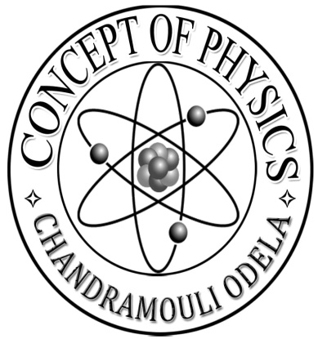



# REFLECTION OF LIGHT AT CURVED SURFACE

## CONCEPTUAL UNDERSTANDING(AS1)

* 1. State the differences between virtual image and real image (March-2019)
  2. The magnification of the image by the concave mirror is -1 mention the four characteristicsof image from the above information (March-2018, AUGUST-2022)
  3. The focal length of a concave mirror is 120cm. A man is standing in front of it at a distance of 40 cm. What are the characteristics of his image in that mirror (June 2017)
  4. Which property of concave mirror is used in making the Solar Cooker (June 2017)
  5. An object of height 5 cm is placed at 30cm distance on the principal axis in front of a concave mirror of focal length 20 cm find the image distance and size of the image(March 2016)
  6. Describe a setup showing how you heat a witnesses by using solar energy and Mirrors are make a solar heater cooker and explain the process of making explain how to you make solar cooker ?(June 2015)
  7. An object is placed beyond C and at C on the principal axis of a concave mirror. Write the characteristics of the image formed by the object?(AUGUST 2022)
  8. Assume that an object is kept a distance of 20 cm in front of a concave mirror. If its focal length is 30 cm then
     1. What is the image distance? b) What the magnification of mirror in this case?
  9. There is an object in front of a convex mirror at a distance of 5 cm if its focal length is 10 cm then a) what is the image distance? b) Whatis magnification?
  10. a) which mirror is used in the headlights of a car ?

1. Where is the bulb kept in car in regard with mirror?
2. The Light emitted by the bulb in the headlights of a car reflects when falls on mirror draw a diagram showing the same?
   1. How do you explain this when a student says I burn the paper in sunlight with a Spherical mirror?
   2. Write the differences between concave and convex Mirrors?
   3. Explain why convex Mirrors is used as rear view Mirrors in vehicles?
   4. Write the difference between virtual image and real image?

## ASKING QUESTIONS AND MAKING HYPOTHSIS (AS2)

1. Does focal length of a spherical mirror changes when it is completely immersed in the water Predict and write the reason. (March 2019)
2. Predict and write the reason. Why the value of the distance of the object is always negative in the mirror equation. (June 2017)
3. In the following cases calculate the magnification values for a concave mirror and predict the reasons?
   1. when the object is at the focal point of the mirror ?
   2. 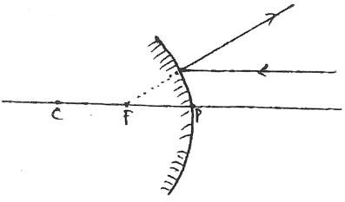when the object is between focal point and the pole?
4. Focal length of concave mirror in air is f, this is completely immersed in water, there be any change in it focal length or not? predict the reason?

5.What does the above picture suggest?

1. Predict what our daily life would be like without spherical Mirrors?
2. If concave mirror is used instead of convex Mirrors as rear view mirror of vehicles predict what will happen?

## EXPERIMENTATION AND FIELD INVESTIGATION(AS3)

1. How can you find out the focal length of concave mirror experimentally when there is no sunlight. (March 2017)
2. List the material required for conducting an experiment to find the focal length of a concave mirror explain the experimental procedure also. (June 2019)

## INFORMATION SKILLS AND PROJECTS (AS4)

1. The magnification of the image formed by the spherical mirror is m = -1.25 based on this information answer the following questions (March-2019, May-2022)
   1. Which kind of the mirror forms such image?
   2. Write the characteristics of the image?
   3. If the size of object is 2 cm then what is the size of the image?

IV) Write the position of the object on the principal axis?

1. A student conduct an experiment to observe characteristics of images formed by spherical mirror and record this observation as follows observe the table and answer the questions. (June 2018)

|  |  |  |  |  |  |
| --- | --- | --- | --- | --- | --- |
| S.  N | Position of the object | Position of the  Image | Enlarge  /diminished | Erected/  inverted | Real/ virtual |
| 1 | Between “P”,”F” | In the mirror | Enlarged | Erect | Virtual |
| 2 | Between “F”,”C” | Beyond “C” | Enlarged | Invert | Real |
| 3 | On” C” | On” C” | same size | Invert | Real |
| 4 | Beyond “C” | Between “F”,”C” | Diminished | Invert | Real |

1. About information belongs to which circle mirror?
2. In which situations magnification is less than 1?
3. An object of height 8 cm is placed at centre of curvature on principal Axis then where do you get the image and what is its height?
4. All real images are inverted justify by using above table?
5. If the magnification of concave mirror is‟– 1‟ Answer the following questions
6. a)State object distance image distance? b)Discuss nature of image?
7. A Students saw his face in the side mirror of a car? His image seemed smaller in the mirror?

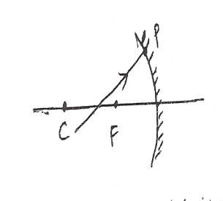a) Which mirror is that? b) What is the nature of the image he saw?

c) Draw a ray diagram showing the above image?

1. DiagramA light ray was incident on a concave mirror as shown in the picture the ray

reflects write answers to the following questions?

* 1. Which way does the light ray travelling parallel to the principal axis go when it is reflected by a concave mirror?
  2. Which way does the light ray travelling through focal Point go when reflected by a concave mirror?
  3. Draw the reflected ray at point P based on the answer to the above questions?

## COMMUNICATION THROUGH DRAWING,MODEL MAKING. (AS5)

1. 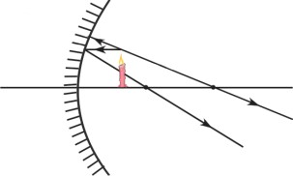The radius of curvature of a concave mirror is 6 CM draw the ray diagrams for an object placed on principal Axis at 8 cm and 4 cm distance from the pole of the mirror.(June 2019)
2. Complete the diagram and draw the image (March 2016)
3. Draw the ray diagram to show the information of image for the object of height 1 cm is placed 5cm distance in front of a convex mirror having the radius of curvature R= 5 cm (March 2017)
4. Draw a ray diagram for the virtual image formed when an object is kept on the principle axis of concave mirror?
5. Draw a diagram it magnification M is -1?
6. Draw a diagram of concave Mirrors (object in all positions).

## APPLICATIONS TO DAIIY LIFE AND USES (AS6)

1. Write any two uses of convex mirror in day to day life (June 2019)
2. Write any two uses of spherical Mirrors (March 2019)

# 2.CHEMICAL EQUATIONS

## CONCEPTUAL UNDERSTANDING(AS1)

1 Balance the following chemical reaction (March 2017)

Al + Fe2O3 Al2O3 + Fe

1. How do you test the nature of the solution formed by dissolving calcium oxide in water what is the nature of solution .MgO formed in this reaction( Mg = 24u O= 16u) (June 2019)
2. Balance the following chemical equation (June 2018)

Na + H2O NaOH + H2**O**

1. Write the equation for chemical decomposition reaction of silver chloride in the presence of Sunlight (June 2019)
2. Balance the following chemical equations (June 2017)
   1. Na + H2O NaOH + H2**O**
   2. K2 CO3 + HCl KCl + H2**O** + CO2
3. Balance the following chemical equations (March 2016)

C3H8+O2 CO2+H2O

1. On adding dilute hydrochloric acid to Copper oxide powder, the solution formed is blue- green write the new compound formed ?(March 2015 ).
2. How many grams of O2is required for combustion 480 gram of Mg? find the mass of 'Mgo'formed in this reaction.(Mg=24u,=16)? (June 2019).
3. Write the equation for the reaction of Zinc with hydrochloric acid and balance the equation Find out the number of molecules of hydrogen gas produced in this reaction, when one mole of HCl completely reacts at S.T.P (March 2017)

(gram molar volume is 22.4 litres at S.T.P avagardo's number is 6.023×1023)

1. Why should we balance a chemical equation? take anyone chemical equation and explanation the procedure of balancing it? (June 2015).
2. Balance the following chemical equations? (June 2016).

C3H8+5O2 3CO2+4H20

1. Calculate the volume,mass and number of moles of hydrogen liberated when 230 grams of sodium reacts with excess of water it STP(Na=23U,O=16U,H=1U)
2. Calculate the volume and number of molecules of CO2 liberated STP if 50 grams of caco3 is treated with dilute HCl with contains 7.3 grams of dissolved HCL gas.
3. Write the chemical equation of the reactions,when Hydrogen reacts with Oxygen and forms water. Balance the chemical equation?(May2022)

## ASKING QUESTIONS AND MAKING HYPOTHESIS (AS2)

1. If you keep an iron piece in solid state CUSO4 Crystal does it get any reaction guess the reason? (March 2018).
2. What happens if ironparticles are exposed to moist air? Write the chemical equation to represent that reaction? (June 2017).

## IV. INFORMATION SKILLS AND PROJECTS (AS4)

1. Observe the following balanced chemical equation and answer the given questions C 3 H 8 **(g)**+ 5O 2 **(g) 3** C O 2 **(g)**+ **4**H 2O **(g)**
   1. How many molecules of oxygen are involved in this chemical reaction?
   2. How many moles of propane on required to get 20 moles of water? (June 2018) 2.Write the products of given reaction, if any? (June 2016)
      1. Fecl2+Zn. ii) Zncl2+Fe
2. Mohan was working in a factory.He purchased a new cycle but kept it in the open even after duty hours.After 2 months he found that the cycle Chain and even the handles got rusted his friend advised him to apply a coating of Rust proof paint to the cycle and not to keep it in the open in future
   1. Why was the cycle rusted?
   2. How did the advice of the friend help Mohan? (June 2016)
3. i)CaCO3 CaO+CO2 ii)2AgBr 2Ag+Br2 Mention the types of reaction to which the above equation belong. Also mention, which of them is a photochemical reaction? (June 2016)
4. a) N2 +O2+HEAT 2NO

What information do you get from the above equation? Comment(March 2015)

b) Write an activity about how you conduct an experiment to show that more reactive metals replace less reactive metals from their compounds ?(March 2015). (AS3 QUESTION)

1. Dill sodium chloride react with deal Silver Nitrate Deccan form dissolved White coloured product.
   1. Write the balanced chemical equation?
   2. Write the name of right coloured product?
   3. Give another one example as same above?
   4. The chemical reaction is not possible if the reactance is in which state

# 3.ACIDS BASES AND SALT

## CONCEPTUAL UNDERSTANDING(AS1)

1. Write the molecular formula of common salt and baking soda which are widely used at home ?(June 2017)
2. What happens if the copper sulphate crystals taken into dry test tube are heated?(June 2016)
3. Why the soils of Agricultural lands get tested for PH?(March 2016)
4. Name the four chemicals that are obtained from common salt and write their molecular formulae?(March 2015)
5. a) Equal lengths or magnesium ribbons are taken into two test tubes X and Y. hydrochloric acid is added to test tube X and acetic acid is added to text tube Y. In which test tube, the reaction will be more Vigorous? Why?
   * 1. Name the four Chemicals that are obtained from common salt and write their molecular formulae?(March 2015)
6. Plaster of Paris should be stored in moisture proof contains explain? Why?
7. Two texttubes given to you one is acid and other one is base. How do identify the acid or base by using blue Litmus Paper?
8. Write the all chemical names and chemical formulas to produce common salt?
9. Write the name of 'x' this is a weak base and they can solve digestion problems?

## ASKING QUESTIONS AND MAKING HYPOTHSIS (AS2)

1. If you keep an iron piece in solid state copper sulphate crystals ,does it get any reaction? guess the reason?(March 2018)
2. Take some water in a test tube and add concentrated H2SO4 to it.Shake the test tube well. If you touch the bottom of the test tube you feel it as hot. Now instead of H2SO4,if you add NaOH pellets to water in another test tube and touch the bottom,what do you observe?(June 2015)
3. What value of PH in the mouth leads to tooth decay? Why? (March 2018)
4. Predict the reason does the "tooth decay start when the PH of mouth is lower than 5.5”?
5. Predict the reason "distilled water does not conduct electricity"?
6. Does the focal length of lens is same in all media? Guess and write.

## EXPERIMENTATION AND FIELD INVESTIGATION(AS3)

1. Mention the precautions to take while conducting an experiment to prove acids produce ions only in aqueous solutions (June 2018)
2. Write the required material and experimental procedure for the experiment hydrochloric acid react with zinc pieces and liberate H2 gas? (June 2018)
3. Which product will form when calcium oxide is dissolved in water? How do you find the nature of product? (March 2018)
4. List out the material for the experiment when hydrochloric acid reacts with sodium metal carbonate and evolves carbon dioxide write the experimental procedure ?(March 2018)
5. List out the materials required to test whether the solutions of given acids and bases contains ions are not explain the procedure of the experiment?( March 2017)
6. List out the material for the experiment to investigate whether all compounds containing hydrogen are acid or not and write the experimental procedure?( June 2019)
7. Compounds such as alcohol and glucose contain hydrogen but or not categories as acids describe an activity to prove it?
8. Write an activity to known weather the acid is stronger weak?
9. What is meant by crystallization of a substance? Describe an activity to show the water of Crystallization?

## INFORMATION SKILLS AND PROJECTS (AS4)

1. Observe the following table and answer the questions given below .The table containing the aqua solution of different substances with the same

|  |  |  |  |  |  |  |  |  |
| --- | --- | --- | --- | --- | --- | --- | --- | --- |
| Sample solution  (Acid/Base) | A | B | C | D | E | F | G | H |
| PH Value | 8.1 | 1.1 | 5.5 | 13.6 | 3.5 | 9.5 | 7 | 10 |

* 1. Which one of the above acid solution is the weakest acid? give a reason?
  2. Which one of the above solution is the strongest base? give reason?
  3. Which of the above two produce maximum heat when they react? what does that heat energy called?
  4. Which one of the above solutions has the PH equal to that of the distilled water? what is the name given to solutions of that PH value?(June 2017)

1. Observe the information given in the table and answer the questions given below the table

|  |  |  |
| --- | --- | --- |
| Substance  (in aqueous solution) | Colour change with blue Litmus | Colour change with red litmus |
| A | Red | No change |
| B | No change | Blue |
| C | No change | No change |

* 1. Which one of them may be the neutral salt among A,B,C?
  2. What may happen when some drops of phenolphthalein is added to the substance ? (March 2017)

3.

|  |  |  |  |  |  |  |
| --- | --- | --- | --- | --- | --- | --- |
| Sample  solution | Milk | Gastric  juice | Distilled  Water | NaOH  solution | Milk of  magnesia | Washing  soda |
| PH value | 6.8 | 1.2 | 7 | 14 | 10.5 | 12.6 |

Answer the following questions by using above information

1. which of the above is neutral solution?
2. which of the above is used to neutralize the acidity in stomach?
3. which is the strong acid among the above solutions?
4. what is the colour of phenolphthalein indicator in NaOH solution?( June 2019).
5. Read the information given in the table and answer the following questions.

|  |  |  |  |
| --- | --- | --- | --- |
| Solution | PH value | Reaction with  Phenolphthalein | Reaction with methyl Orange  Solution |
| HCl | 1 | No Colour change | Turn in to Red colour |
| Distilled water | 7 | No Colour change | No Colour change |
| NaOH | 13 | Turn in to Pink colour | Turn in to Yellow colour |
| Lemon Juice | 2.5 | No Colour change | Turn in to Red colour |
| NaCl | 7 | No Colour change | No Colour change |
| Baking Soda | 8 | Turn in to Pink colour | Turn in to Yellow colour |

* 1. List out the acids in the above table.
  2. What is the nature of the solution which gives pink colour with phenolphthalein solution?
  3. List out the neutral solutions in the above table.
  4. Name the strongest acid and the strongest base among the given solutions. (March 2016).

1. If the PH value of solutions X,Y and Z are 13,6 and 2 respectively then a)Which solution is a strong acid? why?
   * + 1. Which solution contains ions along with molecules of solution
       2. Which solution is strong base? why?
       3. Does the PH value of a solution increase or decrease when a base is added to it? Why ?
2. Solution X turned Blue litmus Red and solution Y turned Red litmus Blue.
   1. What products could be formed when x and y are mixed?
   2. Which gas is released when we put magnesium piece in solution X?
   3. Will any chemical reaction take place when zinc pieces are put in solution Y?

d)Which of the above solutions contain more hydrogen ions

1. The results of reactions of metals A,B,C,D,E with different solutions are given in the table below observe the table and write answers?

|  |  |  |  |  |  |
| --- | --- | --- | --- | --- | --- |
| Metal | SOLUTION | | | | |
| FeSO4 | CuSO4 | ZnSO4 | AgSO4 | Al(SO4)3 |
| A | No reaction | No reaction | No reaction | a layer is formed | No reaction |
| B | an Ash coloured substance settle  on the metal | a light brown layer isformed on the  metal | No reaction | a layer is formed | No reaction |
| C | No reaction | No reaction | No reaction | No reaction | No reaction |
| D | No reaction | ------ | No reaction | a layer is formed on  the metal | No reaction |
| E | --------- | a light brown layer is formed | fresh layer is formed | fresh layer is formed | No reaction |

* 1. Which is the highly reactive metal? Why? b) Which is the least reactive metal? Why?

1. Which metals form brown layer?
2. Arrange the metals A,B,C,D,E in the order of their reactivity?
3. Let A,B,C materials have given Red, Yellow, Red colours, when react with methyl orange respectively
4. Among A, B, C which are acids which are bases?
5. What is the change in colour when phenolphthalein added to be?

9.

|  |  |  |  |  |  |  |
| --- | --- | --- | --- | --- | --- | --- |
| Solution | A | B | C | D | E | F |
| PH value | 0 | 1 | 4 | 7 | 11 | 14 |

By observing the above table answer the following in A,B,C,D,E,F solutions

i) Which is strongest acid? ii) Which is weak Acid?

iii) Which is strong base? iv) Which is neutral?

1. Complete the following table.

|  |  |  |  |  |  |
| --- | --- | --- | --- | --- | --- |
| S.NO | Sample  solution | Redlitmus  paper | Blue Litmus  Paper | Phenolphthalein  solution | Methyl orange  solution |
| 1. | HCl |  |  |  |  |
| 2. | NaOH |  |  |  |  |

1. Observe the table and answer the following questions

Name of the substance distilled water vinegar Sodium Hydroxide PH value

* 1. Vinegar is added to distilled water if methyl orange indicator is added to this solution, what will be the colour of the solution?
  2. According to the given pH values what is the nature of the substances? (May 2022)

1. Observe the given information and write the answers from the following questions.

|  |  |  |  |  |  |  |  |  |
| --- | --- | --- | --- | --- | --- | --- | --- | --- |
| S.N | 1 | 2 | 3 | 4 | 5 | 6 | 7 | 8 |
| SOLUTION | HCl | NaOH | NH4OH | HNO3 | H2SO4 | CH3COOH | Mg(OH)2 | KOH |
| NATURE OF SOLUTION | ACID | BASE | BASE | ACID | ACID | ACID | BASE | BASE |

* 1. Which of the above solution turn the blue litmus into red?
  2. Which of the above solutions turn the red litmus into blue?
  3. Which of the above solutions change the colour of Methyl Orange indicator into (Orange) Yellow?
  4. Which of the above solutions change the colour phenolphthalein indicator?

## VI. APPLICATIONS TO DAIIY LIFE AND USES (AS6)

1. Write any four uses of washing soda? (June 2019)
2. Why do we use antacids? Write its nature? (March 2018)
3. Write the uses of following.

a) Bleaching powder b) Sodium Bicarbonate c) Sodium carbonate d) Plaster of Paris.

1. Daily life application of PH

# 4. REFRACTION OF LIGHT AT CURVED SURFACE

## CONCEPTUAL UNDERSTANDING(AS1)

1) A double concave lens with the refractive index n=1.5 is kept in the air its two spherical surfaces have R1= 20 cm and R2=60 cm.find the focal length of the lens, write the characteristics of the lens?( June 2019)

1. Explain the behaviour of light rays in any four situations of their incidence on a convex lens?( March 2016)
2. Write the characteristics of the image formed by a convex lens having focal length of 25 CM when an object is kept on the principal Axis at a distance of 50 cm and 75 cm?

4. +50 cm focal length by convex lens is recommended to correct the defect of vision of a man. find the power of the lens.( June 2017)

1. Write the characteristics of the image formed by a convex lens having focal length of 25 cm. when an object is kept on the principle Axis at a distance of 50 cm and 75 cm.

(March 2018)

1. 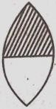What happens to the image it a convex lens is made up of two different transparent materials are shown in figure (March 2016).
2. How to change the focal length if the lenses immersed in water?
3. Write the image properties if a object height 5 cm is placed on 25 Cm distance in front of convex lens.
4. Write the differences between convex lens and concave lens.

## ASKING QUESTIONS AND MAKING HYPOTHSIS (AS2)

1. Focal length of the lens depends on its surrounding medium what happens if we use a liquid as surrounding media of refractive index equal to the refractive index of lens?

(June 2018)

1. The refractive index of a convex lens material is 1.46 the refractive index of benzene and water 1.5 and 1 respectively how does the lens behaves when it is kept benzene and water? Guess and write?(March 2018)
2. Two convex lenses of same focal lengths are fixed in a PVC pipe at a distance double to their focal length. what happens if a boy see the moon with the arrangement?( March 2018)
3. Predict and write rainwater drop is working as a lens.

## EXPERIMENTATION AND FIELD INVESTIGATION(AS3)

1. Write the list of materials required for the experiment to find the focal length of a convex lens? (June 2017)
2. Explain how the focal length of the lens depends upon the surrounding medium?

## INFORMATION SKILLS AND PROJECTS (AS4)

1. The ray diagrams showing the image formed by a convex lens or given in the following table from these diagrams complete the table

|  |  |  |  |  |  |
| --- | --- | --- | --- | --- | --- |
| S.NO | Ray diagrams showing the image formed by a convex lens | Object placed | Place of the image formed | Size of the image | Real /Virtual image |
| a |  |  |  |  |  |
| b |  |  |  |  |  |

1. Radii of biconvex lens are equal .let us keep an object at one of the centres of curvature. Refractive index of lens is 'N'. Assume lens in the air. Let us take are the radius of the curvature.
   1. How much is the focal length of the lens? b) What is the image distance?

c) Discuss the nature of the image.

3.A student conducted experiment with biconvex lens and prepared the following table

|  |  |  |  |  |  |
| --- | --- | --- | --- | --- | --- |
| Objective distance (u)Cm | 70 | 60 | 50 | 40 | 30 |
| Image distance (v)cm, | 14.5 | 15.2 | 16.2 | 17 | 20 |
| Focal length (f) cm | 12.01 | 12.12 | 12.13 | 11.92 | 12 |

Answer the following questions based on the information given in the above table

1. What is the reason you think for different values of focal length in the above table.
2. How do you decide the focal length of the above lens ?
3. Can you conduct an experiment to measure the image distance when the object distance is made 10 cm? WHY
4. What reaction have you identified among u,v and f?

4.A student focus the image of flame on a white screen by placing the flame of various distances from a convex lens. he noted his observation.

|  |  |  |
| --- | --- | --- |
| S. no | distance of flame from the lenses | distance of the screen from the lenses |
| 1 | 30 cm | 10 cm |
| 2 | 20 cm | 12 cm |
| 3 | 15 cm | 15 cm |
| 4 | 12 cm | 20 cm |
| 5 | 7.5 cm | 35 cm |

From the above table find the focal length of lens without using lens formula?

1. Which set of observation is incorrect and why ?
2. In which case the size of the object and image will be same? give reason for your answer?



1. Complete the following table if the object is placed at various position in front of a convex lenses.

|  |  |  |
| --- | --- | --- |
| Position of the object | Position of image | Nature of image |
| At infinity |  |  |
|  | Between F1 and 2F1 |  |
|  |  | Same size,real,inverted |
|  | Seen in the Lens |  |

1. Magnification of the image is formed by a lens is -1.25 then answer the following questions

(May 2022)

* 1. Mention the position of the object on the principle Axis?
  2. What is the height of the image of object sizes 2 cm?
  3. Mention the characteristics of the image?
  4. What kind of lens is used to get this image?

## COMMUNICATION THROUGH DRAWING,MODEL MAKING (AS5)

1. The focal length of a concave lens is 2 cm draw the ray diagram of an object placed on principle access at the C of lens and at a distance of 3 cm from its optic centre? (June 2019)
2. 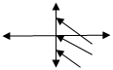Complete the following ray diagram (March 2019)
3. Draw Ray diagrams for a double concave lens of focal length 4 cm when objects are placed at 3 cm and 5 cm on principal Axis write characteristics of image? (June 2018)
4. 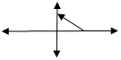Complete the ray diagram given below (March 2018)
5. Draw the ray diagram to find the images when an object is placed in front of the lens i)at a distance of 8 cm and ii) at a distance of 10 cm on the principal axis of a convex lens whose focal length is 4 cm write the characteristics of images in both the cases?(June 2017)

6..The focal of length convex lens is8cm ,when objects are placed at 4 cm distance from pole Draw the ray diagram of the image formed by the lens?(August-2022)

1. What happens to the image if a convex lens is made up of two different transparent materials as shown in figure? (March 201
2. An object is placed at the following distances from a convex lens of focal length 10 cm.
   1. 8 cm b) 15 cm c) 20 cm d) 25cm Which position of the object will produce?

i) A diminished ,real and inverted image. ii) A magnified, real and inverted image?

1. Amagnified ,virtual and erect image?
2. An image of same size as the object? Justify your answer in each case. (March 2015)
3. Using by convex lens a point images made on it principle Axis 'S'. let us assume that we know optical Centre 'P' and its focus 'f '.we also know PF less than PS .draw the ray diagram to identify the point source and give reasons ?
4. Draw the ray diagrams of convex lens for the following and describe the nature of image?

a) When the object is beyond "2F2" b) When the object is at "2F2"

c)When the object is between "2F2" and "F2".d) When the object is between F2 and optic centre

1. Complete the following ray diagram?

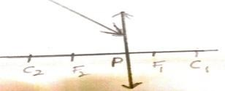

## APPLICATIONS TO DAIIY LIFE AND USES (AS6)

1. Write the applications of lens day to day life?
2. Write the uses of convex and concave lens?
3. Mention any four uses of lens in day to day life? (May 2022,August 2022)

# 5.HUMAN EYE AND COLOURFUL WORLD

## CONCEPTUAL UNDERSTANDING(AS1)

* 1. Explain the formation of rainbow? (March 2019)
  2. Write the reasons for sun appears red during the sunrise and sunset (June 2018)
  3. Which molecules of atmosphere act as scattering centres are responsible for the blue sky (June 2019)
  4. What happens if dispersion and scattering of light do not occur?( March 2019)
  5. How will you calculate the focal length of a biconcave lens that is used to correct the defect of hypermetropia? Explain it mathematically? (March 2017)

6. +50 cm focal length biconvex lens is recommended to correct the defect of vision of a man find the power of lens? (June 2016)

1. Least distance of distinct vision of a person is observed as 35 cm what lens is useful for him to see his surroundings clearly?why?(March 2016
2. What is the cause of presbyopia? (March 2015)
3. What is the unit of optical power? (March 2015)
4. Suggest reasons for the phenomenon associated with the following.
   1. the sky appearing blue. ? ii) Twinkling of stars.?(March 2015)
5. You are travelling in a bus beside a lake. water is sprinkling from a fountain. you observe a rainbow .But after travelling some distance it was not seen. How do you explain it?

( June 2015)

1. How do you correct the eye defect myopia?
2. Explain the correction of the eye defect hypermetropia?
3. Explain the formation of rainbow?
4. Explain briefly the reason for the blue of the sky?
5. Doctor suggested to use 4Dlens what is the focal length of the lens?
6. A person can see longest distance object but cannot see nearest distance objects clearly.State what type of vision defect and explain it with help of a diagram?(August2022)
7. Explain scattering of light and Dispersion of light?
8. A person is viewing an extended object. If a converging lens is placed in front of his eye.What will he feel that the size of object has increased why?
9. Explain the reasons
   1. Sun appear red colour during sunset and sunshine, sun appear white during noon hours on hot days certain directions Sky appear white colour.
10. Explain the two activities at the formation of artificial rainbow.
11. What would happen if clearly muscles do not function properly?(May-2022)

## ASKING QUESTIONS AND MAKING HYPOTHSIS (AS2)

1. What happens if ciliary muscle do not perform contraction and expansion ?guess and write?( June 2018)
2. What happens if the eye lens of a person cannot accommodate its focal length more than

2.4 cm?(March 2017)

1. What would happens if human eye lens does not undergo accommodation**?** (August2022)
2. In a classroom ,four Friends found out the focal length of a lens by conducting an experiment the value came out to be 12.1 cm, 12.2 Cm, 2.05 Cm, 12.3 Cm, the Friends discussed the reasons for the differences or defects mention those reason?
3. In which conditions does a rainbow form? why?(June 2015)
4. A Student got up at 12 o'clock in the night and switched on the tube light in his room .He felt difficulty in opening his eyes .Imagine the reason for the above?
5. Predict why the sky sometimes appearswhite.

## EXPERIMENTATION AND FIELD INVESTIGATION(AS3)

* 1. Mention the required materials and Chemicals for the experiment of scattering of light write the experimental procedure?(March 2018)
  2. How do you find experimentally the refraction index of material of a Prism?

## INFORMATION SKILLS AND PROJECTS (AS4)

|  |  |  |  |  |
| --- | --- | --- | --- | --- |
| Person A | Person B | Person C | Person D | Person E |
| maximum focal length of eye is less than 2.5cm | Cannot see near objects clearly | Minimum focal length of eye lens is greater than 2.27 CM | Lost the ability of accommodation of eye | The limits of the focal length of eye lens are from 2.5 to 2.27 cm |

1. Answer the following questions from the above information
   1. what is the defect of vision in D suffering from? Why does it happen?
   2. who is suffering with similar defect of a vision as of B
   3. who among the above do not have any defect of vision ?(June 2019)
2. Kishore wore spectacles when you saw through his specks the size of his eyes seemed bigger than their original size?

a) Which lens did he use? b)Explain the defect of vision (with the help of a diagram)

## COMMUNICATION THROUGH DRAWING,MODEL MAKING. (AS5)

1. A person is unable to see distinct objects show the defect of vision of the person with the help of ray diagrams? (March 2018)
2. An eye specialist suggested +2D lens to the person with defect in vision which kind of defect in vision does he have draw the diagram to show the defect of vision and its correction with a suitable lens? (June 2017)
3. Draw a ray diagram showing the correction of myopia eye defect?(March 2019)
4. Draw a ray diagram to show the angle of deviation when a Ray of light passes through a glass prism?(March 2015)
5. Draw the diagram of a lens which will be recommended by an eye doctor to a long sighted patient.(March 2015)
6. Draw the diagram ,showing the correction of defect of vision hypermetropia by using a convex lens. (June 2016)
7. Draw a diagram showing reaction of a Ray of light through a glass prism and mark the angle of deviation (or) draw a diagram to show the angle of deviation when a Ray of light passes through a glass prism.(June 2015)
8. If white light is incident on a Prism, it emerges 7 colours draw the diagram showing the above information?
9. Chandraiah , having defective vision consulted an eye doctor Who suggested him to use concave lens. Draw the pictures showing the defect of chandraiah vision and the related corrections by using a concave lens ?

12. Which type of eye defect in the given figure? What type of lens is used to correct this eye defect?

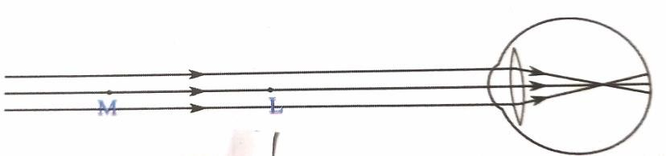

## APPLICATIONS TO DAIIY LIFE AND USES (AS6)

1. Write any two situations to observe Dispersion of light in your daily life? (June 2018)
2. Write the applications of lenses in day to day life?
3. How do you appreciate the working of culinary muscles in the eye?
4. How do you appreciate the role of molecules in the atmosphere for the blue colour of the sky?

# 6.STRUCTURE OF ATOM

## CONCEPTUAL UNDERSTANDING(AS1)

* 1. How does Hands rule help in writing electronic configuration of an atom?

Explain with a suitable example?(June 2019)

* 1. Write the electronic configuration of Na+andCl-?( March 2019)
  2. Write postulates and limitations of bohrs hydrogen atomic model? (June 2018)
  3. If n=3 mention the orbitals present in Shell and write maximum number of electrons in the Shell? (March 2018)
  4. The electron enters into 4S orbital after filling 3P orbital but not into 3d explainthereason ? (March 2018)
  5. Write the symbols of outermost shell of magnesium atom ?how many electrons are present in the outermost shell of magnesium?( June 2017)
  6. Write the names of the rules and the laws followed by you in writing thiselectronic configuration?( March 2017)
  7. Which principle is not followed in writing the electronic configuration of1S2 2S1 2P4 given reasons?(June 2015)
  8. Which colours do you observe when an iron rod is gradually heated to higher temperature? (June 2015)
  9. Write the electronic configuration of the atom of an element having atomic number 11, write the names of the rules and the laws followed by you in writing this electronic configuration ?(March 2017)
  10. For a better understanding about the electronic configuration in an atom, the teacher wrote shorthand notation nlx on the blackboard. Looking at this notation, what could be the probable questions that generate in the students mind? Write any two of them? (March 2015)
  11. Write the electronic configuration of 'Cr' and 'Cu'?
  12. What is nlxmethod?
  13. The electronic configuration of an atom is 1S2 2S2 2p6 3s1 what information that it gives?
  14. Explain the significance of three Quantum numbers in predicting the positions of an electron in and atom?(August2022)
  15. Explain aufbau principle with an example?
  16. Write the electronic configuration of atomic number 11. Name the principles and rules you followed in writing the electronic configuration?
  17. Write the difference between orbit and orbital?
  18. Explain what information given to the quantum numbers about an atom?
  19. Following orbital diagram shows the electronic configuration of nitrogen atom which rule does not support this? Write the correct electronic configuration

## ASKING QUESTIONS AND MAKING HYPOTHSIS (AS2)

1. What would be the electronic configuration of Carbon and N, if we do not follow Hund'srule?guess and write? (May2022)

## INFORMATION SKILLS AND PROJECTS (AS4)

* 1. The four Quantum numbers value of the 21st electron of SCANDIUM are given in the following table.

|  |  |  |  |
| --- | --- | --- | --- |
| **n** | **l** | **ml** | **ms** |
| **3** | **2** | **-2** | **+1/2** |

Write the values of four quantum numbers for the 20th electron of scandium in the form of the table. (March 2017)

* 1. Based on the information given the table answers the following questions

|  |  |  |  |  |  |
| --- | --- | --- | --- | --- | --- |
| S.NO | Shell | K | L | M | N |
| **1** | **n** | **1** | **2** | **3** | **4** |
| **2** | **l** | **0** | **0,1** | **0,1,2** | **0,1,2,3** |
| **3** | **ml** | **0** | **0** | **0** | **0** |
|  |  | **-1,0,1** | **-1,0,1** | **-1,0,1** |
|  | -2,-1,0,1,2 | **-2,-1,0,1,2** |
|  | **-3,-2,-1,0,1,2,3,** |

* + 1. for the 4th Main shell how many values are there for ml what are they? ii for sub-shell with n = 3, l =1, write the ml values?

1. write the Principal Quantum Number value for N shell. How many sub-shells are there in this main shell?
2. In the above table ml and l values are given. Write the formula that gives the relationship between‟ml„and‟l‟ based on those values. (June 2016)
   1. Observe the information provided in the table about Quantum numbers. the answers the questions given below it.

|  |  |  |
| --- | --- | --- |
| n | l | Ml |
| 1 | 0 | 0 |
| 2 | 0  1 | 0  -1,0,+1 |
| 3 | 0  1  2 | 0  -1,0,+1  -2,-1,0,+1,+2 |

* + 1. write the l values and symbol of the spherical shaped sub-shell?
    2. how many values that ml takes for l=2? what are they?
    3. write the symbols of the orbitals for l= 1 sub-shell ?
    4. What is the shape of the sub-shell for l=2 ?what is the maximum number of electrons that can occupy this sub-shell?(June 2017)
  1. Observe the given table and answer the following questions

|  |  |
| --- | --- |
| S.NO | Electronic configuration |
| 1 | 1S2 2S2 2p6 3S2 3P3 |
| 2 | 1S2 2S2 2p6 3S2 3P64s2 |
| 3 | 1S2 2S2 2p6 3S2 3P6 |

1. Mention the divalent element name.
2. Name the element belongs to 3rd period and VA group?(March 2019)
   1. Following orbital diagram shows the electron configuration of oxygen atom which rule does not support this ?

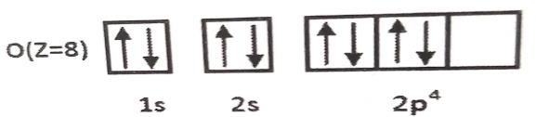

* 1. An electron in an atom has the following set of four Quantum numbers to which orbital it belongs to and name that element

|  |  |  |  |
| --- | --- | --- | --- |
| n | l | ml | ms |
| 2 | 0 | 0 | +1/2 |

* 1. The electronic configuration of an atom is 1S2 2S2 2p2

1. Which element atom is it?
2. In which orbital last electron is in?
3. What is the value of principal quantum number of first electron?
4. Write the electronic configuration of the same atom in the excited state?
   1. Complete the following table.

|  |  |  |  |  |
| --- | --- | --- | --- | --- |
| Sub  shell name | l value | Number of orbital | ml value | maximum number of electrons |
| S |  | 1 |  | 2 |
| P |  | 3 | -1,0,+1 |  |
| D | 2 |  | -2,-1,0,+1,+2 |  |
| F | 3 |  |  | 14 |

* 1. The electronic configuration of an atom' X' is 1S2 2S2 2p6 3S2 3P6then the answer the following questions.

1. what is the atomic number of element 'x'?
2. what is the name of the element 'x'?
3. How many electrons are present in the outermost shell of an atom?
4. how many shells are present in this atom of an element?
   1. If the electronic configurations of atoms A and B are 1S2 2S2 2p6 3S2 3P1and 1S2 2S2 2p6 3S23P5 respectively then.
5. Which atom forms Negative Ion?
6. Which atom forms positive ion?
7. What is the valency of atom 'A'?
8. What is molecular formula of the compound formed by atoms A and B?
   1. The electronic configuration of an atom is as follow 1S2 2s2 2p2.
9. Which elements atom is it?
10. Which orbital is the last electron in ?
11. When excited what could be the number of lone /single electrons in this atom?
12. What is the value of principal quantum numbers of two electron in the first box?

## COMMUNICATION THROUGH DRAWING,MODEL MAKING. (AS5)

* 1. Draw the shapes of S,P and d orbital‟s?(May-2022)
  2. Draw a neat diagram to show that increasing order of energy levels of orbitals?

# 7. CLASSIFICATION OF ELEMENTS

## CONCEPTUAL UNDERSTANDING(AS1)

1. Why the second ionization energy is more than the first ionizationenergy for any element?(June 2016)
2. Between a neutral atom and its cations which has bigger size? why?(June 2016)
3. Explain any four factors which influence the electron affinity?( electron gain enthalpy) March 2017)
4. How are the elements arranged into groups and periods in the modern periodic table elements in a group possess similar properties but elements in a period do not show similarities in their properties. why?(June 2017)
5. Write the factors that influence ionization energy and explain any three of them.(june 2018)
6. Write the electronic configuration of Na+ and Cl- ?
7. Why the second ionization energy is more than the first ionization energy for any element?(June 2016)
8. Give two examples Dobereiner's triads?
9. Write the correct increasing order of the atomic radius of O,F and N ?
10. An element has atomic number 19. where would you expect this element in the periodic table ?why?
11. The electronic configuration of sodium is 1s2 2s2 2P6 3s2 .what is the information that it gives?
12. Define the modern period law. Discuss the construction of the long form of the periodic table.
13. What is a periodic property?how do the following properties change in a group and Period?Explain?

a) Atomic radius b) Ionization energy c) Electron affinity g)Atomic size d)Electronegitivity e) Metallic property f) Non metallic property

1. Write the chemical formula of the compounds formed during the reaction 1A group element VII A group element D
2. Write the general electron configuration of 1A group to VIII A groups.
3. What are the silent features of mendeleeff's periodic table?
4. Explain how does the atomic size and ionization energy changes in groups and periods in the modern periodic table?( may 2022)

## ASKING QUESTIONS AND MAKING HYPOTHSIS (AS2)

1. A,B are two elements its compound material is A2B, then what will be the valence of A and B? (March 2018)
2. Why doberneer ,newlands and mendeleeff were not 100% successful in their classification of elements? why the modern table is relatevly a better classification? Predict the reason?( March 2016)
3. The atomic number of an element is 35 where would you expect the position of this element in the periodic table? why? (June 2015)

4 . Predic the reason for placing insert gases in the 18th group ?

1. How does the position of elements in the periodic table help you to predict its chemical properties? Explain with example?
2. The chemical formula A2B is the elements A and B then predit the valency of elements A and B ?

## IV. INFORMATION SKILLS AND PROJECTS (AS4)

1. Observe the given table and answer the following questions?

|  |  |
| --- | --- |
| **S.NO** | Electronic configuration |
| **1**  **2**  **3** | **1**S**2 2S2 2P6 3S2 3P3**  **1**S**2 2S2 2P6 3**S**2 3**P**6 4S2**  **1S2 2**S**2 2P6 3S2 3P6** |

1. Mention the divalent element name?
2. Name the element belongs to third period and 5A group?(March 2019)
3. Observe the given information answer the following questions?

|  |  |  |
| --- | --- | --- |
| Name of the element | Atomic number | Electronic Configuration |
| Sodium | 11 | **(**Ne**)3**s**S1** |
| Magnesium | 12 | **(**Ne**)3S**s**2** |
| Potassium | 19 | **(**Ar**)4S**s**1** |
| Calcium | 20 | **(**Ar**)4S**s**2** |

1. What is the valency of magnesium?
2. Which element has more electro-positivity?
3. Write the elements which belongs to third period?
4. Write the elements which belongs to first group? (June 2018)
5. 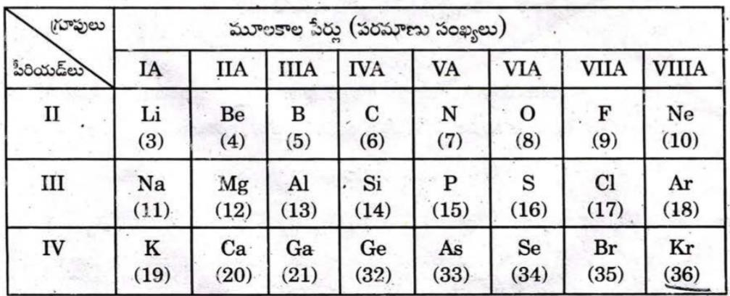Observe the following table.

Answer the following questions from the above information

1. which element possess the higher atomic radius in the above table?
2. Mention two pairs of elements which forms ionic bond?
3. Name the two elements having valence2?
4. which elements has electronic configuration of 1S2 2S2 2P4? (March 2018)
5. Observe the information provided in the table and answer the question given below

|  |  |  |  |  |  |  |
| --- | --- | --- | --- | --- | --- | --- |
| Elements | Na | **C** | **Ca** | **P** | **Ti** | **Ni** |
| atomic number | **11** | **6** | **20** | **15** | **22** | **28** |

1. what are the S- block elements in the table?
2. what are the P -block and D- block elements in the table?( June 2017)
3. Observe the electron configurations given below and write the group and period numbers of those elements. (March 2016)

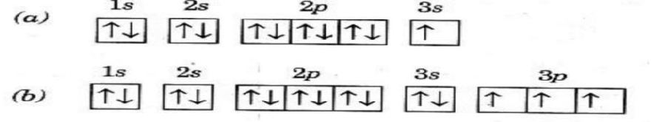

1. In the table given below names of some elements of families are given. Based on this fill the information in the empty boxes.( June 2015)

|  |  |  |  |  |  |  |
| --- | --- | --- | --- | --- | --- | --- |
| S.No | Name of the element family | Element | | valency shell  configuration | Valence  Electrons | Valency |
| From | To |  |  |  |
| 1 | alkali metal family | Li | Fr |  |  |  |
| 2 | alkali earth metal  family | Be | Ra |  |  |  |
| 3 | Carbon family | C | Fl |  |  |  |
| 4 | halogen family | F | At |  |  |  |

1. Two elements x and y belongs to groups 1 and 2 respectively in the same period of the periodic table compare these elements with respect to
2. Number of electrons in their outermost orbit?
3. Their atomic size and their valencies ?
4. Their ionization energy and metallic character?
5. Formula of their Chloride and sulphates? (March 2015)
6. An element„ X „ belongs to 3rd period and group 2 of the periodic table state

a) The number of Valence Electrons? b) The valency ?

1. Elements A,B,C and D have atomic number 1,8,11 and 19 respectively.Which element belongs to IA -group ?
2. An element X belongs to 3rd period and group 16 of the periodic table state its .as4
   1. Electronic configuration b)Valency
3. An element 'E' has following electronic configuration.

|  |  |  |
| --- | --- | --- |
| K | L | M |
| 2 | 8 | 7 |

* 1. To which group of the periodic table does element' E' belong?
  2. To which period of the periodic table element 'E' belong?
  3. State the number of valence electrons present in element 'E'?
  4. State the valence of the element.

1. Complete the following table.

|  |  |  |  |
| --- | --- | --- | --- |
| Element | Valency | group number | periodic number |
| Hydrogen | 1 |  |  |
| Neon |  |  | 2 |
| Potassium |  | 1 |  |
| Magnesium | 2 |  |  |

1. Write down the characteristics of the element having atomic number 17

i) Electronic configuration ii) Period number iii) Group number iv) Element family

v) Valence vi) Number of valence electrons vii) Metal or non-metal, viii) Block

1. The electronic configuration of A,B,C,D and E are as follows

A-1S2 2S2 2P1, B- 1S2 2S2 2P6 3S1 3P1, C- 1S2 2S2 2P6 3S1 3P6 D- 1S2 2S2 2P6 3S1 3P3, E- 1S2 2S2 2P6

Based on the above information answer the following questions

i) Which of these belongs to same group? ii) Which of these belongs to same period?

1. Name of the element E?iv) Which element belongs to S –Block? 15.

|  |  |  |  |  |  |  |  |  |
| --- | --- | --- | --- | --- | --- | --- | --- | --- |
| Group--- | 1 | 2 | 13 | 14 | 15 | 16 | 17 | 18 |
| Period |  |  |  |  |  |  |  |  |
| 1 | X |  | B | C | D | E |  |  |
| 2 | Y |  |  |  |  |  |  |  |
| 3 | Z |  |  |  |  |  |  |  |

Refer the above part of periodic table and answer the following questions

* 1. Element with the least atomic size?
  2. Write the electronic configuration of the elements B and E ?
  3. Identify the elements that have similar physical and chemical properties as the element Y ?
  4. Arranged elements increasing order of their electro negativity values?

1. Some elements belonging to second period of periodic table, and their atomic radius are given below observe them and write answers.

|  |  |  |  |  |  |  |
| --- | --- | --- | --- | --- | --- | --- |
| Second period elements | B | Be | O | N | Li | C |
| Atomic radii | 88 | 111 | 66 | 74 | 152 | 77 |

* 1. Write the elements in the ascending order of the atomic Radii?
  2. Which of the second period elements closer to the configuration of inert gas ?
  3. Which is the outermost orbit of all these elements?
  4. Which element atomic size bigger, beryllium or Carbon?why?

1. Write down the characteristics of the element having atomic number 17

a) electronic configuration b) Period number c)Group number d)Element family e)No.ofvalency electrons f)Valencyg)Metal (or ) non-metal h) Block

1. In period 2 element X is to the right of element Y then find which of the element have these properties?

i) Low nuclear charge ii) Low atomic size

iii) High ionization energy iv) High electronegativity v) More metallic character

# 8. CHEMICAL BONDING

## CONCEPTUAL UNDERSTANDING(AS1)

* 1. Explain the formation of N2 molecules using valance bond theory?(June 2019)
  2. Explain why bonding angle(HOH) in water is 1040 311 instead of 1090 281 ?( June 2018)
  3. Explain ionic bond with suitable example?
  4. Explain the formation of boron tri-fluoride molecule by hybridization?(June 2018)
  5. Explain the formation of boron tri- fluoride molecule with the help of valency bond theory? (March 2018)
  6. Write the Octate rule how does magnesium get stability while reacting with chlorine as per this rule?(June 2017)
  7. Write the names of any two compounds which have ionic bond (June 2016)
  8. Between a neutral atom and its cat ion which has bigger size? Why?(June 2016)
  9. Write difference between Sigma and Pi π bond?
  10. What type of bond is formed between X having electronic configuration 2,8,1 and 'Y' having electronic configuration 2, 8,7? Why ?
  11. Explain the formation of BeCl2 molecule using hybridization?
  12. Explain the formation of BF3 molecule using hybridization. ?
  13. Explain the formation of N2 molecule?

1. Explain the formation of O2 molecule using valency bond theory?
2. Write the difference between ionic bond and covalent bond?
3. How Lewis dot structure helps in understanding Bond formation between atoms?
4. Why do only valency electrons involved in the bond formation? Why not electrons in the inner shell?
5. Explain the formation of NH3 molecule with the help of hybridization?

19. Write the 'octet rule' how does Mg (12) get stability while reacting with chlorine as per this rule?( June 2017)

## ASKING QUESTIONS AND MAKING HYPOTHSIS (AS2)

1. Predict bond angle is BeCl2 is 1800 but in H2O is 1040 311. Why ?
2. Predict two elements A and B have atomic numbers 11 and17 respectively. Which atom can formcation and which can form and anion? Predict?
3. Predict the reasons for low melting point for covalent compounds when compared with Ioniccompounds?
4. Predict what happened if chemical bonds are not formed?
5. Predict and explain why noble gases are stable?

## INFORMATION SKILLS AND PROJECTS (AS4)

1. Answer the following questions using the given table.

|  |  |
| --- | --- |
| Atom | Group |
| C | IV A |
| N | V A |
| O | VI A |
| F | VII A |

1. How many lone pair elections are there in oxygen atom?
2. Which element has -1oxidization state?
3. Which element has- 2oxidization state?
4. Which element has one loan pair of electron?
5. In the elements of Oxygen Magnesium and Chlorine
   1. Which elements form ionic bond?
   2. Which elements form covalent bond? iii) Which element is form double bond with same element?

3. A , B and C are three elements which atomic number 6,11 and 17 respectively?

1. Which of these cannot form ionic bond? Why?
2. Which of these cannot form covalent bond?why?
3. Which of these can form ionic bond as well as covalent bond?

## COMMUNICATION THROUGH DRAWING,MODEL MAKING. (AS5)

1. Draw the structural diagram of ammonia molecule as per the valency shell electron pair repulsion theory? (March 2016)
2. Draw the diagram to show the formation of oxygen molecule by valency bond theory ?(March 2017)
3. Draw the structure of Methane molecule and mention bond angle?( March 2019, June 2015)
4. Represent each of the following molecules using Lewis notation.
5. Calcium and Chlorine to form Calcium Chloride.
6. Formation of Oxygen molecule from Oxygen atoms. (March 2015)
7. Show the formation of HCl molecule with Lewis dot structures using the information given below? (March 2017)
8. Draw the structure of the Methane molecule .write its bond angle .(March 2019)
9. Draw the shape of molecules and write the bond angles i)NH3 ii)CH4iii)O2iv)C2H4 v)C2H2 vi) BeCl2vii)H2O viii)BF3
10. Draw simple diagrams to show the arrangement of valency electrons in the following compounds i)CaO ii) H2O iii) C
11. Which chemical compounds has the following Lewis notation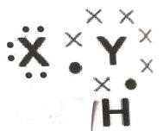
12. How many valance electrons does element Y have ?
13. What is the valency of element Y ?
14. What is the valency of element X ?
15. How many covalent bonds are there in the
16. Which group elements X and Y belongs?

# 9. ELECTRIC CURRENT

## CONCEPTUAL UNDERSTANDING(AS1)

1. How do the resistors6**Ω**,10**Ω**,10 **Ω**we connected in a circuit to get minimum resistance? Find the result of the circuit?
2. Wright two examples for ohmic and non-ohmic materials each?
3. What happens if the household electric appliances are connected in series?
4. write any two differences between ohmic and non-ohmic conductors ?
5. In a circular 60 volt battery three resisters R1=10**Ω**,R2=20**Ω**,R3=X**Ω** are connected in series if one ampere current flows in the circuit ,find the resistance in R3 by using kirchhoff's loop law.
6. Find the resultant resistance for the following given arrangement. Find the current, When this arrangement is connected with 9 volt battery? (March 2017)

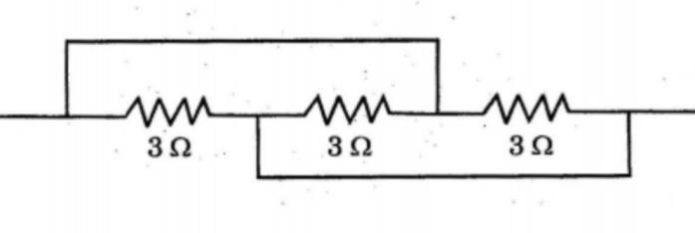

1. The resistance of **5Ω** ,15**Ω** ,20**Ω** and 10**Ω** are connected as shown in the circuit .find the resultant resistance of the circuit.

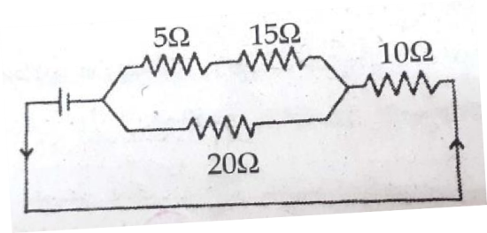

1. Three resistors A, B and C are connected as shown in the figure. Each of them dissipates energy to a maximum of 18 w. find the maximum current that can flow throw the three resistors.(march 2015)

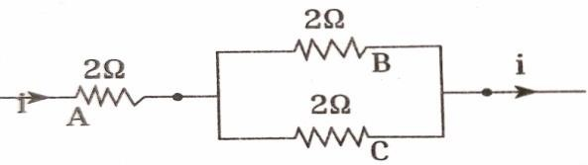

1. What are the factors affecting the resistance of an electric conductor? Explain any two factors.(June 2015)

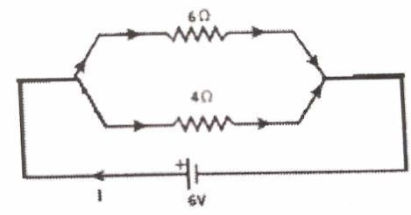10 Find I in the circuit

1. Differences between ohmic and non-ohmic conductors?
2. Deduce the expression for the equivalent resistence of 3 resisters connected in parallel?
3. A house has three tube lights two fans and a television each tube light draws 40 watts the fan draws 80 watts and TV draws 60 watts on the average all the tube lights are kept on for 5 hours two fans for 12 hours and the TV for 5 hours every day. Find the cost of electric energy used 30 days at the rate of rupees 3 per kilowatt hour.
4. 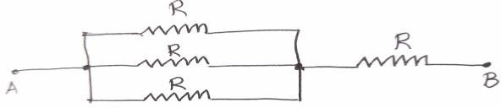A circuit is shown in the picture what is the equivalent resistance between A and B ?
5. What are the limitations of Ohm's Law?
6. What do you mean by electric shock explain how it takes place?

## ASKING QUESTIONS AND MAKING HYPOTHSIS (AS2)

1. What happens if we use a fuse made up of same wire which is used to make the electric circuit? (March 2017)
2. What happens if the household electric appliances are connected in series? (March 2019)
3. We frequently come across the boards saying "danger High Voltage" why the boards do not say "danger high electricity" predict and write the answer?
4. Predict why we consider tungsten as a suitable material for making the filament of a ball?
5. Predic are the headlights of a car connected in series are parallel ?why ?

## EXPERIMENTATION AND FIELD INVESTIGATION(AS3)

1. List out the material required for the experiment the effect of increasing of cross section of a conductor upon its resistance and write the experimental procedure? ( June 2019)
2. List out the material required in the experiment to show that the electric resistance depends upon the nature of the materials and write experimental procedure? (March 2019)
3. What is the relationship between length of conductor and its resistance? Write the experimental procedure to verify thats relationship? (June 2017)
4. List out the material required for the experiment the effect of increaseing of cross section of a conductor upon its resistance and write the experimental procedure?
5. How do you verify the resistance of a conductor of uniform cross section area is Professionalto the length of the conductor at constant temperature?(March 2015, August 2022).
6. Mention the required material in the experiment to Verify Ohm's law and write the experimental procedure? (May2022, August 2022)

## INFORMATION SKILLS AND PROJECTS (AS4)

1. Resistivity values of different substances are given below ?

|  |  |  |
| --- | --- | --- |
| Substance | Copper | Nichrome |
| **Ω**-m (at 20 degrees) | 1.68 x 10-8 | 1.10 x 10-6 |

i) What is used as conductor? why? ii)Which is used as heating element? why?

1. Deduce the expression for the equivalent resistance of three resistors connected in series?
2. An experiment is done to know a given material is ohmic or non-ohmic V - I graph is as shown from experimental observations by observing graph,answer the following questions ?

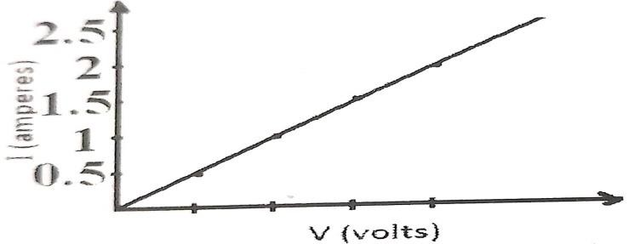

1. According to Ohm's law which type of material is it?
2. calculate the resistance for any two values of V on x -axis ?
3. calculate the current when 10 volts is applied across the resistance?
4. calculate the potential difference when there is a current of 4 amperes in the circuit?
5. A student has tabulated the flow of electricity of using different voltage materials, ammeter and voltmeter the graph based on the table is shown in the picture the measured voltage in

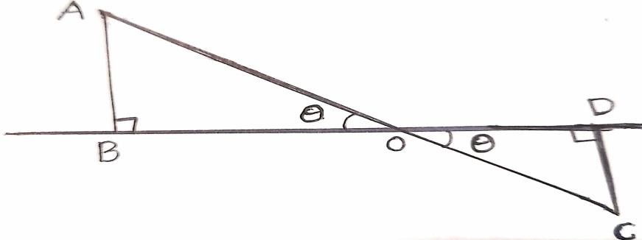volts and electricity in amperes answer the following questions based on the graph

1. What kind of material is taken by a student?
2. What is the resistance of the material taken?
3. If a potential difference of 20 volts is applied between the ends of the wire how much electric energy is used by the wire?

Iv) State the rule the graph has?

1. Student took Cuboidal rod and applied the same potential differences between its two ends he calculated the flowing electric energies for length breadth and height ?

|  |  |
| --- | --- |
| Measured to which potential difference is applied | Electric energy |
| Length | 2A |
| Breadth | 4A |
| Height | 6A |

Based on the above information find the ratio of Length breadth and height in the three Situations?

## COMMUNICATION THROUGH DRAWING,MODEL MAKING. (AS5)

1. 12 volt battery is connected in a circuit and to this 4 ohms 12 ohms resistors are connected in parallel 3 ohms resistor is connected in series to this arrangement draw the electric circuit from this information and find the current in the circuit? (June 2018)
2. Draw the electric circuit with the help of a battery, voltmeter, ameter, resistance and connecting wires? (March 2018)
3. Draw the experimental setup to verify that V/I is constant for a conductor? (March 2016).
4. Draw the circuit diagram showing different electric appliances in your house are connected, write names for the symbols used in the circuit ?

# 10. ELECTROMAGNETISM

## CONCEPTUAL UNDERSTANDING(AS1)

* 1. What happens when a current carrying coil is placed in a uniform magnetic field?( June 2019)
  2. What happens when magnetic flux passing through a coil changes continuously? Where does this process is used?( June 2019)
  3. Explain the working process of induction stove?( March 2019)
  4. Compare the magnetic field lines of force formed around a current carrying solenoid with the magnetic field lines of force of a bar magnet?( March 2017)
  5. With the help of the figure given below the teacher explained that magnetic fields lines are closed lines and not open lines. write the questions, which you will ask to test whether the given statement is right or wrong.( June 2015)
  6. State right hand rule with a labelled diagram.( March 2015)
  7. Explain why any two magnetic field lines are not intersect why?
  8. Explain the working process of electric motor?
  9. Explain the working process of
     1. AC generator ii) DC generator

## ASKING QUESTIONS AND MAKING HYPOTHSIS (AS2)

1. Imagine what would happen if the same wire used in the electric circuit and fuse?
2. Imagine what happens in the following cases with a coil of copper wire with thermal Insulation is connected to a galvanometer?
3. When the bar magnet is push it in coil of copper wire?
4. When the bar magnet is pulled from coil of copper wire?
5. When the ball did keep inside constant of coil?
6. When the coil is moved away from the bar magnet?

## EXPERIMENTATION AND FIELD INVESTIGATION(AS3)

1. List out the materials required for Oersted experiment and mention the precautions to be taken in the experiment?( March 2019)
2. List out the operators and experimental procedure for the experiment to observed a current carrying wire experience a magnetic force when it is kept in uniform magnetic field?( June 2017)
3. Write the experimental procedure and observations of the experiment that is to be formed to observe the magnetic field for amount due to solenoid? ( June 2017)
4. List out materials required for the Oersted experiment of electro magnetism write the procedure of the experiment what do you understand by this experiment?( March 2016)
5. Collect information of experiments done by Faraday (or) What is the information do you collect of experiments done by Faraday?
6. How can you prove experimentally that the current carrying conductor experience a force when it is kept in magnetic field?

## INFORMATION SKILLS AND PROJECTS (AS4)

* 1. 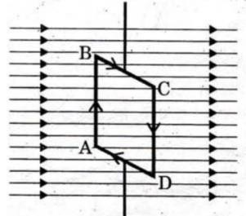Answer the following questions by observing above diagram ( March 2018)
     1. which device function of working does the above figure gives?
     2. what is the angle made by AB and CD with magnetic field?
     3. what are the directions of magnetic forces on sides AB and CD ?
     4. what is the net force acting on the rectangular coil?
  2. A coil made of insulated copper wire is connected to a galvanometer .what will happen to the deflection of the Galvanometer ,if this coil is moved towards a stationary bar magnet and then moved away from it give reasons for your answer and name the phenomenon involved (or )a coil of insulated copper wire is connected to a galvanometer. what happens ,

if a bar magnet is......

* + 1. pushed into the coil?
    2. with Drawn from inside the coil?
    3. held stationary inside the coil?(march 2015)

## COMMUNICATION THROUGH DRAWING,MODEL MAKING. (AS5)

* 1. 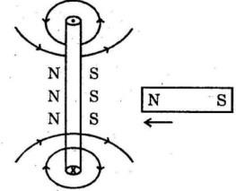Correct the diagram according to Lenz law and draw it again?( March 2017)
  2. Why the current carrying straight wire which is kept in a uniform magnetic field perpendicularly to the direction of the field bends a side? explain this process with a diagram showing the direction of force acting on the wire? (
  3. Draw the diagram showing the magnetic field lines of a bar magnet?( June 2016)
  4. Compare by drawing the diagrams of lines of force formed by bar magnet and lines of force formed by solenoid ?
  5. If the bar magnet is move towards the coil as shown in the picture electricity induced in the coil?

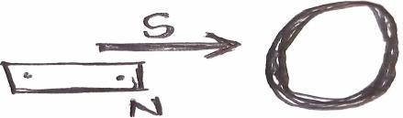

1. What is the direction of induced current?
2. Draw the magnetic field due to a bar magnet the direction of magnetic field due to induced current?

## APPLICATIONS TO DAIIY LIFE AND USES (AS6)

1. What is the use of slip-ring in AC motor?( June 2018)
2. Which energy we get from an electric motor? Write two daily life applications of the electric motor?( June 2017)
3. Write the applications of faraday's law of electromagnetic induction 4.Write the daily life applications of electromagnetism ?
4. Mention two daily life applications of electromagnetic induction?

# 11. PRINCIPLES OF METALLURGY

## CONCEPTUAL UNDERSTANDING(AS1)

* + 1. What are the essential conditions that iron articles get Rust?( June 2019)
    2. Write the differences between roasting and calcination? ( June 2016)
    3. What are the preventive methods do you take for rusting iron materials? ( June 2018)
    4. write the physical methods used for the concentration of the ore. explain the method used for concentration of the sulphide ore? ( June 2017)
    5. Arrange the metals Fe,Na,Ag and Zn in increasing order of their chemical reactivity? (March 2017)
    6. Give an examples with the chemical equation for the reduction of ores using more reactive metals? (March 2017)
    7. Explain purification of refining of crude metal? or write the short notes on each of the following? a)distillation b) poling C) liquation d) electrolysis. or state the methods used for the purification of crude metals. explain in which context these methods are used ? (June 2015)
    8. Arrange the metals Fe ,Na ,Ag and Zn in increasing order of their chemical reactivity?
    9. Write unit chemical formula of the following Ores?
       1. Copper iron pyrites b)Cinnabar
    10. Which method do you suggest for extraction of high reactivity metals ?why?
    11. Write short notes on froth flotation process?
    12. What is the difference between roasting and calcination give one example for each?
    13. State the order of reactivity of metals?
    14. Write the reasons for using non reactive metals in jewellery making?
    15. Explain the method used for cleaning sulphate ores?
    16. Write the two elements these are stored in kerosene?
    17. Write short notes of each of the following?
        1. Roasting b)Calcination c) smelting

## ASKING QUESTIONS AND MAKING HYPOTHSIS (AS2)

1. Predict what happens in the field of domestic use of metals if Alice were not Discovered? (June 2016)
2. a) N2(g)+O2(g)+Heat 2NO(g)

What information do you get from the above equation? comment.

* + - 1. write an activity about how you conduct an experiment to show that more reactive metals replace less reactive metals from their compounds( March 2015)

1. Predicted and write why is a reverberatory furnace better than other furnaces?
2. What would happen, if the metals like Copper and Iron do not get oxidised? Guess and write? (May 2022)
3. What would happen, if corrosion of metals is not prevented? (August 2022)

## EXPERIMENTATION AND FIELD INVESTIGATION(AS3)

1. Write the precautions to be taken in the experiment to show air and water are essential for rusting iron articles and also write the experimental procedure? ( March 2019)
2. Write the experimental procedure to prove that water and air essential for using of iron articles?( June 2016)

## INFORMATION SKILLS AND PROJECTS (AS4)

|  |  |  |
| --- | --- | --- |
| High reactivity | moderate reactivity | low reactivity |
| K,Na,Ca, Mg, Al | Zn,Fe,Pb,Cu | Ag, Au |

1. Observe the table and Answer the following questions?( June 2019)
2. Which of the above metals found even in Free State in nature?
3. Which of the above metal‟s ore are concentrated by using magnetic separation?
4. Four metals A,B,C and D are in turn added to the following solutions one by one the observations made or tabulated below. (March-2015)

|  |  |  |  |  |
| --- | --- | --- | --- | --- |
| Metal | Iron( II)sulphate | Copper  (II)sulphate | Zink sulphate | Silver nitrate |
| A | No reaction | ---- | ----- | ------ |
| B | Displacement | ----- | No reaction | ------- |
| C | No reaction | No reaction | No reaction | Displacement |
| D | No reaction | No reaction | No reaction | No reaction |

Answer the following based on the given information i)which is the most reactive metal? why?

1. what would be observed If B is added to a solution of copperII sulphate and why?
2. arrange the metals A,B,C and D in order of increasing the activity?
3. which one among a b c and d metals can be used to make containers that can be used to store any of the above solutions safely?
4. Fill the below table or formula metal,

|  |  |  |
| --- | --- | --- |
| Ore | Formula | Metal |
| Galina |  | Pb |
|  | CaCO3 | Ca |
| Carnalite | KCl,MgCl6H2O |  |
| Pyrolusite |  | Mn |
|  | NaCl |  |
|  |  | Al |

1. Classify the following into oxides sulphide sulphate separately?

|  |  |  |  |  |  |  |  |  |
| --- | --- | --- | --- | --- | --- | --- | --- | --- |
| Matter | Bauxite | Zinc blend | Pyrolusite | Zincite | Hematite | Cinnabar | Epsom salt | Galina |
| Formula | Al2O3 2H2O | ZnS | MnO2 | ZnO | Fe2O3 | HgS | MgSO47H2O | PbS |

## COMMUNICATION THROUGH DRAWING,MODEL MAKING. (AS5)

* + 1. Draw a neat labelled diagram of a reverberatoryfurnaces( March 2015)
    2. Draw a diagram of sulphide O concentration by froth flotation process and identify the components?

## APPLICATIONS TO DAIIY LIFE AND USES (AS6)

1. Write to precautions to prevent corrosion of metals in your daily life?
2. What is thermite process? mention its applications in daily life?
3. Where do we use handpicking and washing methods in our daily life give examples?

# 12. CARBON AND ITS COMPOUNDS

## CONCEPTUAL UNDERSTANDING(AS1)

* + 1. Explain the isomerism and catenation properties of Carbon? ( March 2018)
    2. write the atomic structure of the following carbon compounds

3, 7 - dibromo-4,-6-dichloro-oct-5-ene-1,2- diol ? ( March 2019)

* + 1. What are alkenes? Write the general formula of alkenes give a example for alkenes? (June 2017)
    2. Why do we call alkenes as paraffins explain the substitution reaction of alkanes? ( June 2016)
    3. Write any four characteristic features of homologues series of organic compounds? (March2016)
    4. Write the types of allotropes of carbon give any three examples of each? ( March 2016)
    5. How do you explain the role of oxygen in combustion process? (March 2015)
    6. a) why are vegetable oils healthy as compared to vegetable ghee?

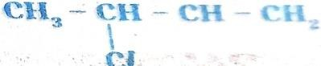b) write the IUPAC name of (March-2019)

* + 1. Write the IUPAC names of the following compounds
       1. Aldehydes is formed from the Ethane ii) Ketone is formed from butane

1. Chloride formed from propaneiv) Alcohol is formed from pentane.
   * 1. Explain the addition reaction of alkanes?
     2. Explain by which hybridization is formed CH4 C2H4C2H2 ?
     3. Explain cleansing action of soap?
     4. Distinguish between esterification and saponipication reactions of organic compounds ?
     5. Why does carbon form compounds mainly by covalent bonds?
     6. What is the saponipication reaction? Explain How soap is manufactured industrially?

## ASKING QUESTIONS AND MAKING HYPOTHSIS (AS2)

1. Why do the various micelles present in water do not come together to form a precipitate guess the reasons? (June 2019)
2. CH2 = CH2 + H2 CH3 CH3 is an addition reaction Predict and write the productsCH CH + H2 ?

## EXPERIMENTATION AND FIELD INVESTIGATION(AS3)

1.List out the materials required to conduct the experiment to understand the esterification reaction explain the procedure of the Experiment how can you identify that an Ester is formed in this reaction? ( March 2017)

## INFORMATION SKILLS AND PROJECTS (AS4)

|  |  |  |  |  |  |  |
| --- | --- | --- | --- | --- | --- | --- |
| Organic  compound | Methane | Ethane | Popene | Butene | PentYne | Hexyne |
| Formula | CH4 | C2H6 | C3H6 | C4H8 | C5H8 | C6H10 |

1. Observe the above table and answer the following questions ( March 2019) i)write the general formula of alkanes?
   1. mention the names of unsaturated hydrocarbons?
   2. write the homologous series of Alkynes? iv)write the formula of hexyne?
2. In the table given below, fill the information in the empty boxes and give answers to the following questions. (June 2015)

|  |  |  |  |  |
| --- | --- | --- | --- | --- |
| S.NO | Alkane | molecular  formula | structure | number of  carbons |
| 1 | Methane | CH4 |  |  |
| 2 |  | C2H6 |  |  |

|  |  |  |  |  |
| --- | --- | --- | --- | --- |
| 3 |  |  | H-(CH2)3-H |  |
| 4 |  |  |  | 4 |

1. Identify the functional groups in the following compounds and write IUPAC names Cl
   1. CH3-CH2-CH-CHO b) CH3-CH-C-CH3 CH3 O
2. Observe the table and answer the following questions

|  |  |  |  |  |
| --- | --- | --- | --- | --- |
| Alkane | Methane | Ethane | Propane | Butane |
| Molecular  formula | CH4 | C2H6 | C3H8 | C4H10 |

* 1. what is the general formula of alkanes?
  2. write the molecular formula of next alken comes after butane?
  3. How many carbons in pentane?
  4. howmany bonds present in methane?

## COMMUNICATION THROUGH DRAWING,MODEL MAKING. (AS5)

* + 1. Draw the structure of Methane molecule and mention bond angle? ( March 2019)

## APPLICATIONS TO DAIIY LIFE AND USES (AS6)

1. Mention any two uses of graphite in day to day life? (June 2019)
2. Write two uses of Ethanol in day to day life? (March 2018)
3. Wright two uses of non-tubes? (June 2017)
4. Wright two uses of fibre optics in day today life?( June 2016)