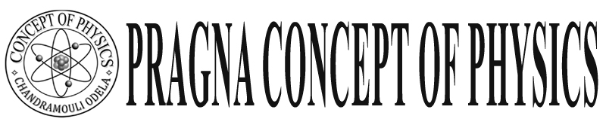Warangal

FINAL TOUCH

**Class: X Physics** ELECTRO MAGNETISM

1)**Magnetic flux:**- The number of magnetic force lines per unit area it is  . units webers or A-M. 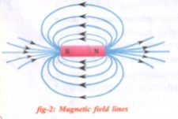

Note: - Where the force lines very more there the strength of the magnetic is more.

Eg: For bar magnet at poles more strength.

2) **Magnetic flux density: -**

The magnetic flux passing through a normal area perpendicular to plane is called magnetic flux density or magnetic field. It is B =  or  for $∅$ = BA. Units  or Tesla or N/A-M.  1 tesla = 104 Gouss

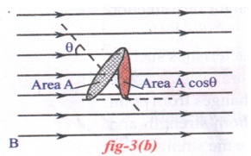 If the force lines not perpendicular to plane then the flux

 = BA cos  ( = the angle between normal line to flux)

When maximum  = 0 (force lines parallel to normal or force lines perpendicular to area).

= B.A

When minimum  = 90 force lines perpendicular to normal or force lines parallel to area)

3. **Oersted experiment**  :

He proved that current and magnets are mutually depend on each other.

Experiment:- Material require..d conclusion: every current carrying conductor can farm magnetic field around it.

Note:-1 When current is moving upward straight line the magnetic field lines are anti- clockwise direction.

Note:2 We can find the magnetic field (B) at a distance r around a current carrying wire B = $\frac{μ0}{2π}$.ir

4 Solenoid: A solenoid is a long wire wound on a closed packed helix. A long coil is called solenoid.

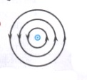 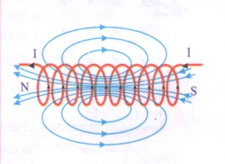

1) In solenoid the magnetic field lines are in straight like bar magnet.

2) Where the current in solenoid is in clockwise there South pole of magnetic lines will form other side north pole will form

Q. Are the magnetic force lines are closed loops?

A) Yes magnetic filed liens are closed loops, curves between north and south poles.

Out side the bar magnet they extend from north to south Inside the bar magnet they are south to north. These are imaginary lines. So magnetic lines of force are closed loops. This we can observe in solenoid

5) Magnetic force on moving charges or wire.

When a charge is moving then ohly magnetic and electric field forms around it. It not moving only electric field. If single charge moving in a magnetic field (B) F force act on charge F = q v B. sin  (  is angle between velocity of electron and magnetic field B 0

When  = 0 ( electron moving parallel to magnetic field) F=q v Bsin  No force act an charge (q) F = 0

## E:\CHANDANA -DTP_2017-18\CHANDANA -DTP_2017-18\WORK SHEET 2017-18\CM PHY WS X\4 IMAGE.jpg

Note:- Force will act when only electron moving perpendicular to the magnetic field . F = q v B .

Note:- On wire length F = Bil sin 

Q: Why T.V. screen destroyed when bar magnet keep near

A: This is due to the fact magnetic field exerts a force on a moving charge.

“Picture mean electrons reaching the screen these are effected by magnetic field produced by the bar magnet. “ The force on electron(moving charger) F = q v B. So the picture will destroyed when we kept the magnet.

Q. What happens when a current carrying wire / coil is placed in a uniform magnetic field?

A: It is gets deflected / rotate

1) When wire perpendicular to field force will act get defect

2) When wire is parallel no force will act no deflect.

6) **Electric Motor:**

“The Device which covert electric into mechanical energy”

**Principal**:

A current carrying wire kept in a magnetic field it experiences the force”

**D.C. Motor: -**

In D.C. Motor we should use commentator or commentator it is used for changing the current direction in armature

**A.C. Motor:-**

In this we no need to use commutator because A.C. Means alternatively charging current so no need to change direction so we use slip rings.

In our daily life:- Motor used fan, mixi, cooler, motor, rice mill etc.,

**Generator:-**

The device which convert mechanical energy to electrical energy.

Principal:- It works on the principle of electro magnetic induction.

A.C. current Frequency in India 50 Hz.

D. C. current Frequency O Hz .

**Faraday: (Electro magnetic induction)**

“Whenever there is a continuous change of magnetic flux linked with a closed coil, a current is generated in the coil” this current is called “ Induced current” this process of is called Electro magnetic induction.

**“Faraday”: -** The induce E.M.F generated in a closed loop is equal to the rate of change of magnetic flux passing through it.

 or  or  or 

**Experiment:-**

Observation: When a bar magnetic moving towards the coil then needle deflects one side. If south pole moves towards coil then needle deflect other side.

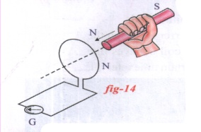

Lenz Law:-

‘ The induced current will appear in such a direction that it. Opposes the changes in the flux in the coil.

It is energy conservation law.

Q) What happens when a coil without current is made to rotate in a magnetic field?

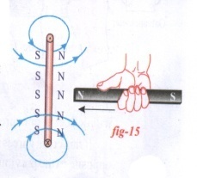A: When the coil rotated the magnetic flux change in the coil. So it can generated the electricity. It is induced current.