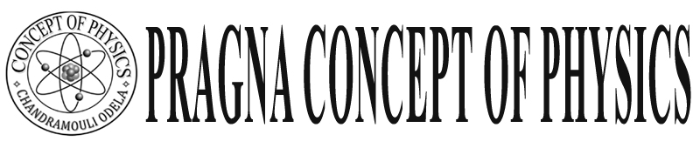

Warangal

**Final Touch**

**Class: X Refraction Important Exam concepts**

**I. Refraction:**

* It light ray passes form one medium to another medium it will bend.

* It is Denser to rarer it will bend away from normal, so it appears taller I <  r

Leman appears very bring when it is in water glass – because refraction derivation of image formation of curved surface 

Note for plane surface (  R = )

**Lenses:**





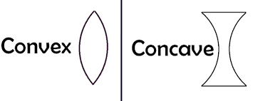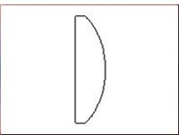

Piano – convex

**Rules: for ray diagrams:**

1) It light ray passes parallel principle axis after refraction passes though focus vice - verse

 Complete Ray diagrams 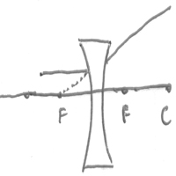

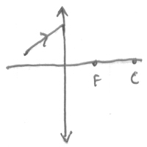 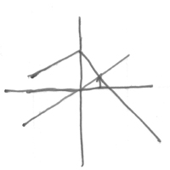 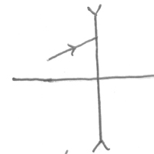 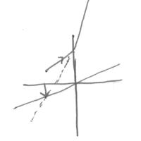

Ray diagrams of concave convex all

*Convex lens when objective at “F”

**Sign - Convention Characteristic Magnification**

 u =  1) Nature : Real & Inverted  **m > -1**

v = + 2) Position : At infinity

f = + 3) size : highly magnified R1 R1= +

 n R2 = ___

*Concave lens ray diagram:

**Sign - Convention Characteristic Magnification**

u =  Nature : Virtual exact Magnification

v = + Position : same sid( between P & F) m < + 1

f = + Size : Small

R1 = +

R2 = ___

*** Virtual and correct image we can see in lens

Uses :- Convex lens in microscope projector telescope, camera, Hypermetropia,

concave lens in mayopia.

Q: Why we use convex lens as simple microscope why not concave lens

Q: Concave lens always forms small and virtual image so. We unable to use concave to see big virtual image. So convex lens when object is between F & P

we can see big size virtual image.

**1) Focal length Experiments:**

Focal length of lens depends on surroundings medium when any lens kept in less refractive medium in that lenss act as a convex convening lens. Eg: Water deep in air act as a converging lens

**2) Why you take convex lens to find focal length.**

Because concave lens can form virtual image so we can’t measure the image distance so we can’t we Use  formula. So we can use convex to find focal length.

**Note:-**  to know focal length of lens depends on surroundings medium we should take convex only because it can only form image in less when object below its focal length. But concave can form image in lens even above the focal length. So we should guess the focal length of convex lens

Note: - We can find virtual image distance but by using f, & u

When convex lens cut into two equal parts vertically then focal lens of individual parts are 2f if we cut

Horizontally then the individual are f



**Combination of lenses: -**



When lens prepared by 3 materials it form 3 images

 Every part of lens can form full image



When two lenses are in contact the Combined focal length



 and power P = P1 + P2 - dP1P2

Focal length of Plano convex lens  from lens makes formula,

 =  (1/R1 – 1/R2 ) = in this R 1 plane R2 convex it is R2 = - R ( R1 = $∝$)_

  f = 