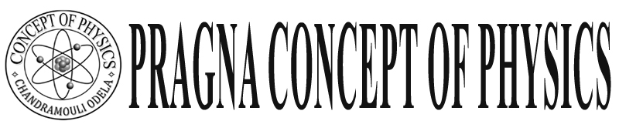Warangal

**Class: X Final Touch**

**Human Eye and colourful World**

**I. Human Eye :**

* The least distance of distinct vision is 25 cm and vision angle 60° or less then 60°.

* The least distance will change person to persons – for children it is 7 to 8 cm

* Human eye can form image on retina it is real inverted small size.

**Iris :** Muscular diagram and it is a opaque substance it is color part. Iris enables pupil to act as a variable aperture, Iris can control the intensity light enter to the eye with the help of changing the pupil size.

**Note:-** When we are in bright light the pupil size will be less . In low light size will be Increase.

Q: When we are in cinema hall suddenly if we come out side then we unable to see surroundings. Some time clearly

**ciliary muscles:-** These can change the focal length of eye lens.

* When we see far objects the focal length of eye is maximum. 2.5 cm and ciliary muscles are relaxed. y
* When we see the near objects the ciliary muscles are strained and focal length is minimum. 2.27cm.
* The adjusting of focal length according to the object distance is called accommodation

**Rods :-** Can identify the intensity of light - If absent of rods we may get night blindness …..Owl bird has more rods so it can see even in night times.

**Cones:- C**olour identify – We may get colour blindness, by absence cones

* Persistence of vision – 1/16 th part of a second.

**Note:- If the focal length of eye lens beyond the minimum and maximum limit we may get vision defects .**

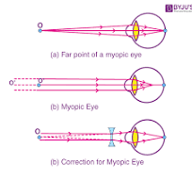**Mayopia:-** The person who can’t see far object clearly but can see near objects, The student who sit on back bench unable to see block board.

1. He can see only some distance clearly .
2. The far point of a person 2m then defect is mayopia they can read news paper Cleary.

REASON :

1. the excessive curvature of eye ball
2. the maximum focal length is less then 2.25cm
3. image forms in front of retina.

- Correction bi concave lens

The focal length is f = - D ( D for point)

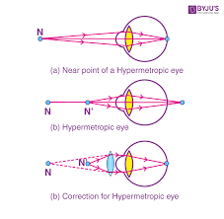Hypermetropia:- The person who can see far but not near objects clearly.

They not Read news papers clearly, but see block board from distance.

-Reason

1. Eye ball size increased

2. the minimum focal length increased then 2.27cm

3. image forms beyond the retina.

-Correction……………… convex lens. -Focal length f = 

1) Doctor advised to two persons A and B are - 1.5D and 2 D lens to convert their vision defects.

a) What are the vision defects A & n?

b) What are the lenses and their focal lengths?

c) Find the for and near point of them.

d) Draw the ray diagram for their corrections.

2) What happens when the eyes has minimum focal length greater then 2.27 cm

A: hypermetropia: In this case the rays from near object image forms beyond the retina.

3) What happens when the eyes has maximum focal – length less then 2.25 cm.

Myopia : In this case the rays from far objects image forms Infront of the retina.

**Presbyopia:** The persons who can’t see near object and far object clearly.

**Reason :** - Due toweaklingsof colliery muscles and diminishing flexibility of the eye lens.

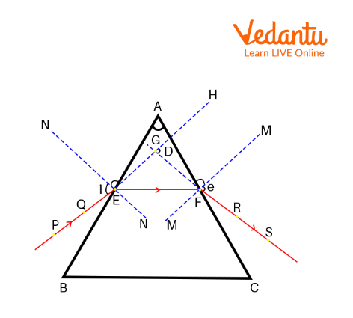

**Correction: -** bi – focal lens : - (upper concave, lower convex)

PQ Ray is called incident ray I, is incident angle

RS Emergent ray I (e) emergent angle

D Deviation angle A prism angle

EF are refracted angles .

At minimum deviation angle D i1, = i2 or r1 = r2

The Deviation angle between extended incident and Extended emerged ray.

Deviation angle first increases than decreases with increasing of incident angle

The prism refractive index is n= $\frac{Sin(A+D)}{sinA/2}$

The graph of minimum deviation angle I = i2 and r1 = r2

A + D = 2i , A = 27

A + D = 2 I or A = 2 r2

Dispersion : splitting of white light into colours VIBGYOR

Ex: Rainbow :

Rain bow is formed due to water drops stopped on dust after rain in primary rainbow red colour appear down Rainbow is circular shape when we see from 5 kg on earh bow shape.

* 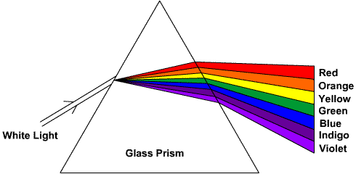More bending ( scattering ) is violet colour has mar refractive index
* More velocity is red colour less energy wave length more

In vacuumed all are same sped when rain medium

Red colour is more then Remaining.

**Scatteri :** blue sky ….. due to the oxygen and nitrogen

Why sun red during sunrise**…**…… more distance

Sky will appear block if there is no atmosphere….